**WeRateDogs: They rate dogs**

WeRateDogs do exactly what they say: they rate dogs! I decided to look into just how they rate dogs and made some interesting findings!

**Likes, retweets...**

WeRateDogs has a large following. So not surprisingly, the number of retweets of each dog *increases* with the number of likes. Who doesn't like to share dog pictures, eh?

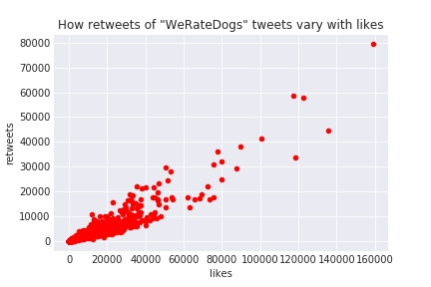

**Doggo, Floofer, Pupper, Puppo**

Who on earth even knew there was a dog stage?! WeRateDogs certainly did. And, looking at their data there seems to be (*just about*) a winning dog stage on average:

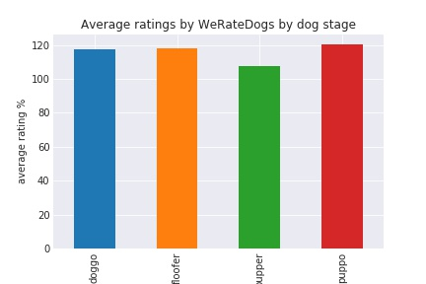

There we have it. Puppos seem to be the best rated, on average, by WeRateDogs. They are apparently the dog equivalent of a teenager, so I'm not quite sure how that happened!

**Sentiments**

Looking at the language used in the tweets, I put together a sentiment analysis to identify how strongly our Tweeters felt about the dogs in question. There were three categories: strong (using words such as powerful, majestic), medium (good, happy) and regular(...). Let's look at how the sentiments affected the average ratings:

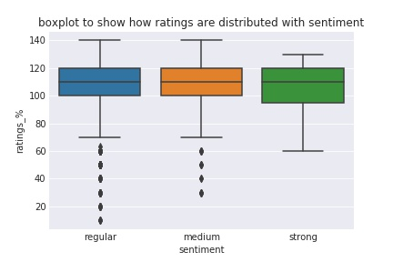

Well, what?! Strong sentiments in tweets might give us higher average ratings according to this boxplot, but they also received the lowest score too (not considering outliers).

**Which breed to breed?**

Golden retrievers were the most common dog breed in the dataset, with some 137 entries. They ranked pretty highly in mean and median ratings, with scores of **115.4%** and **120%** respectively, versus the dataset mean and median of **106.1%** and **110%**. A lot of the ratings have a score of over 100%, because well, they're dogs, so why not!  
  
So let's take a look at the highest rated, most liked (tweet-wise) golden retriever...

