
Course: Cloud Computing
Instructor: Sir Tariq Gouri
Name: Yasir Hussain (2280167)
Program: BSSE-7B
Final Labs
LAB-11

Task01: Use a template to provision an infrastructure
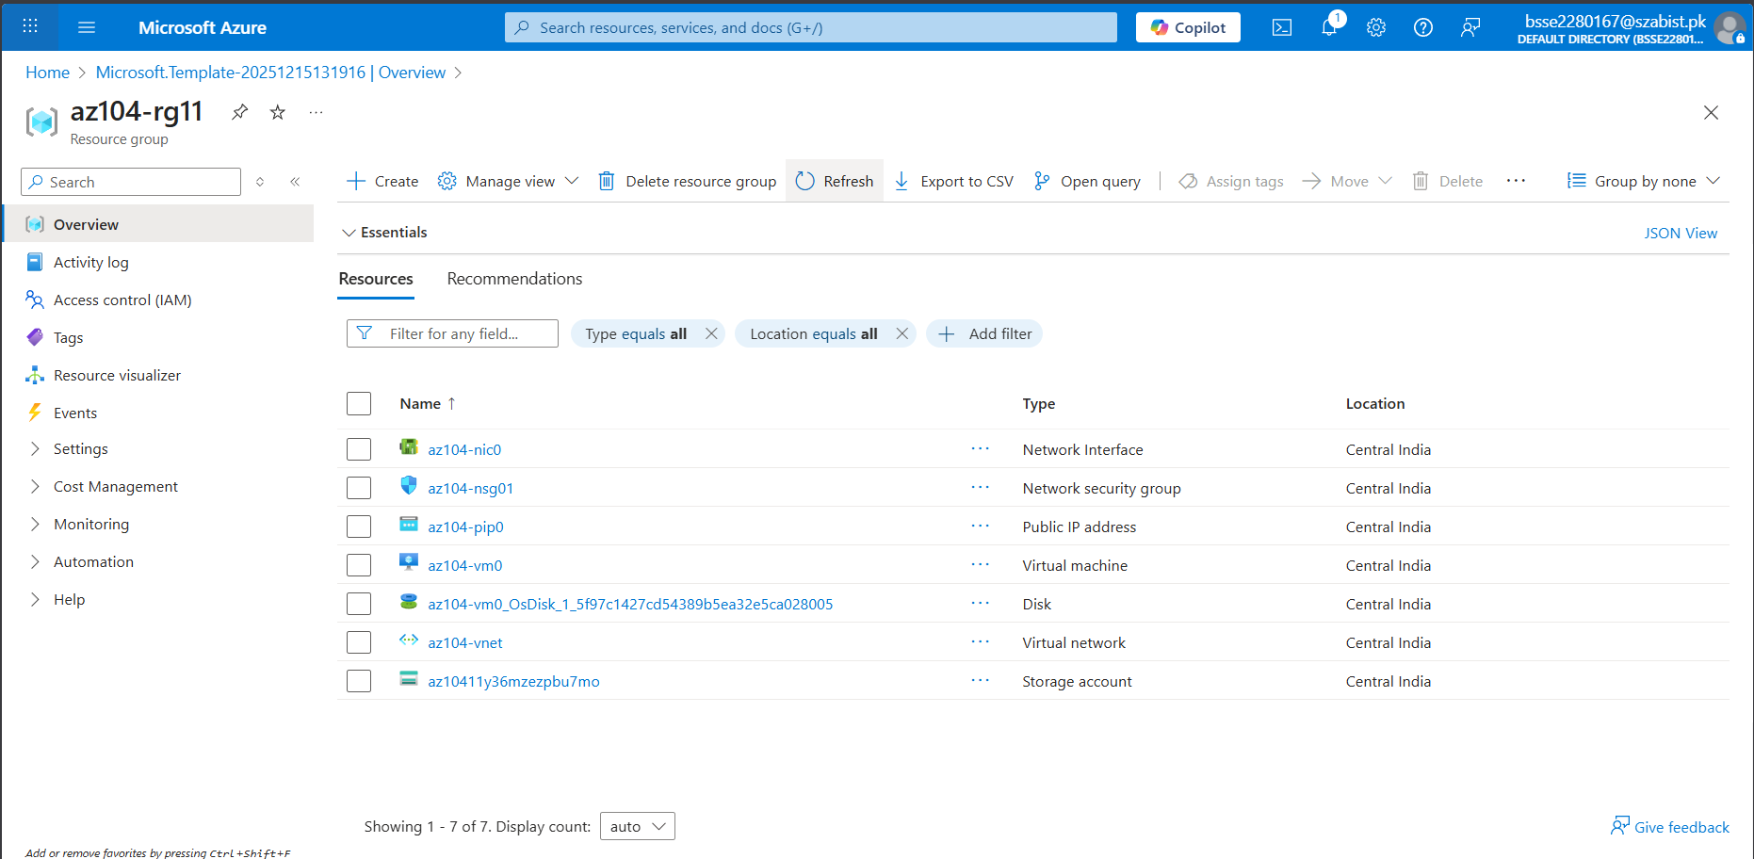
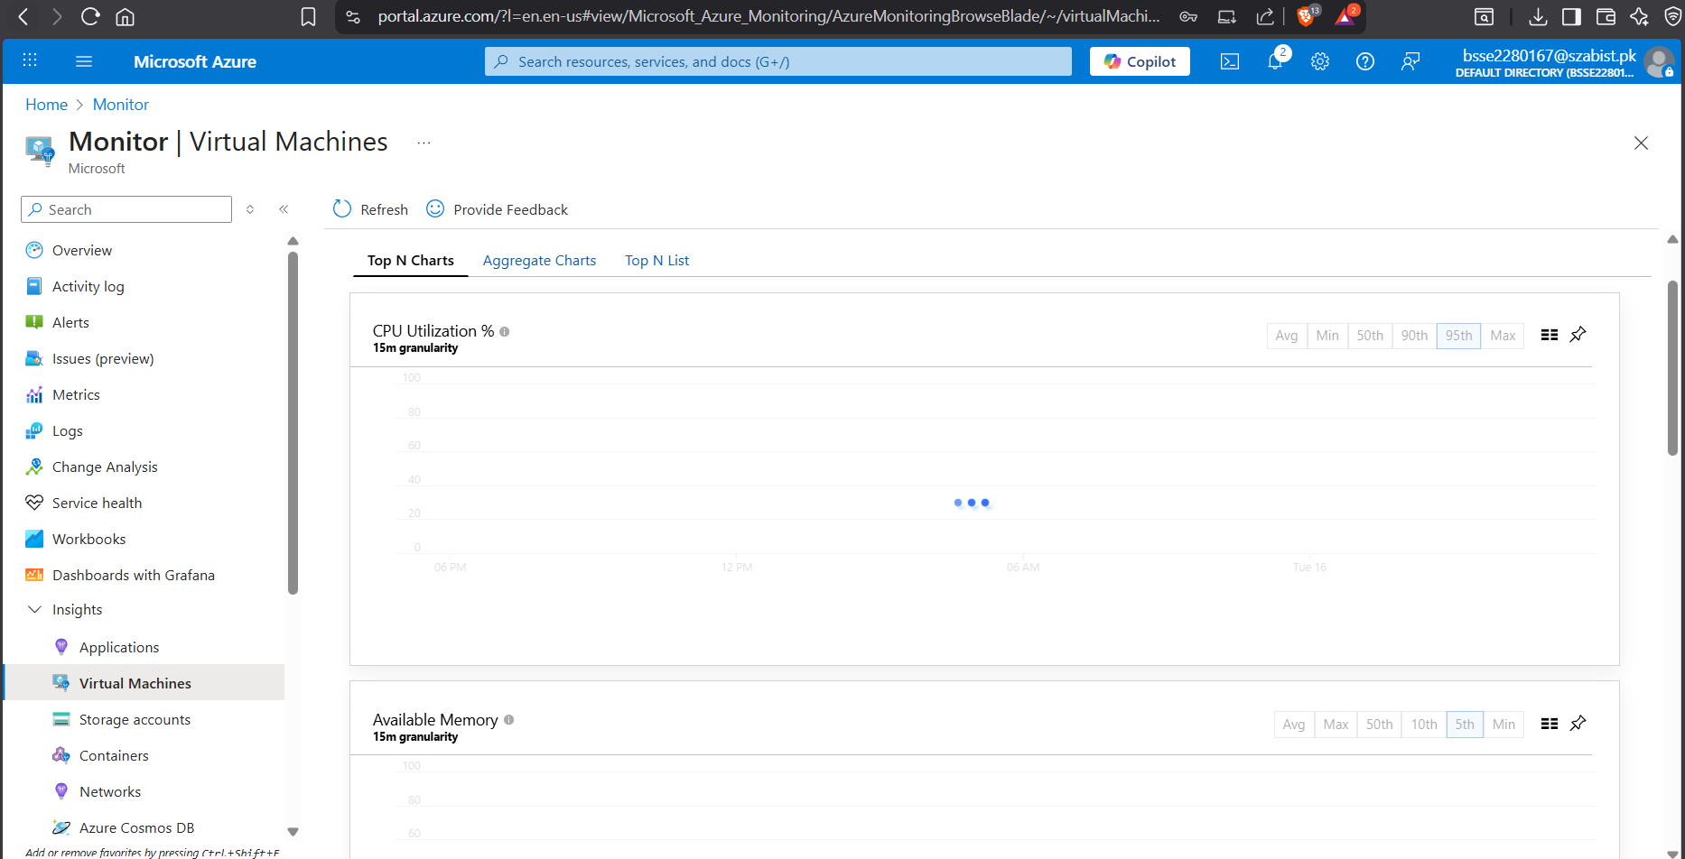
Task02: Create an alert
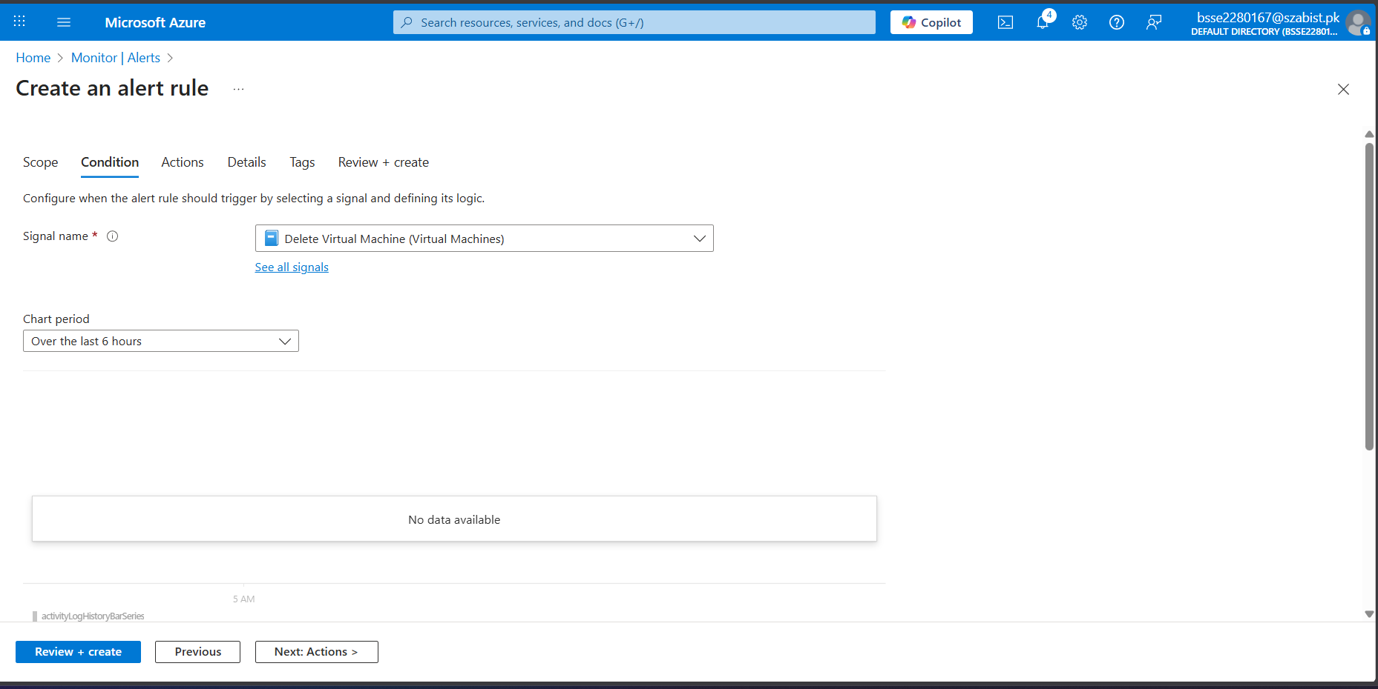
Task03: Configure action group notifications
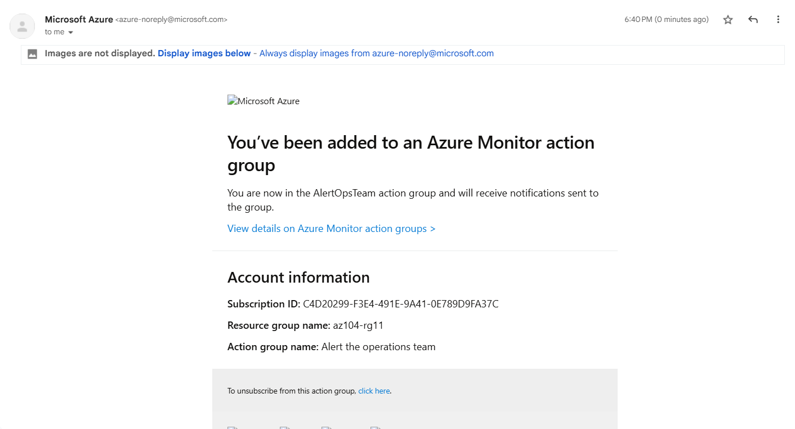
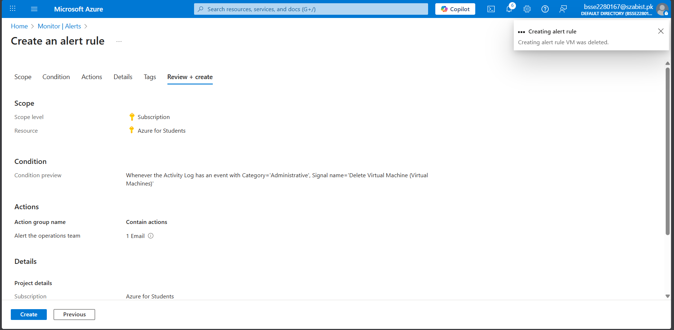
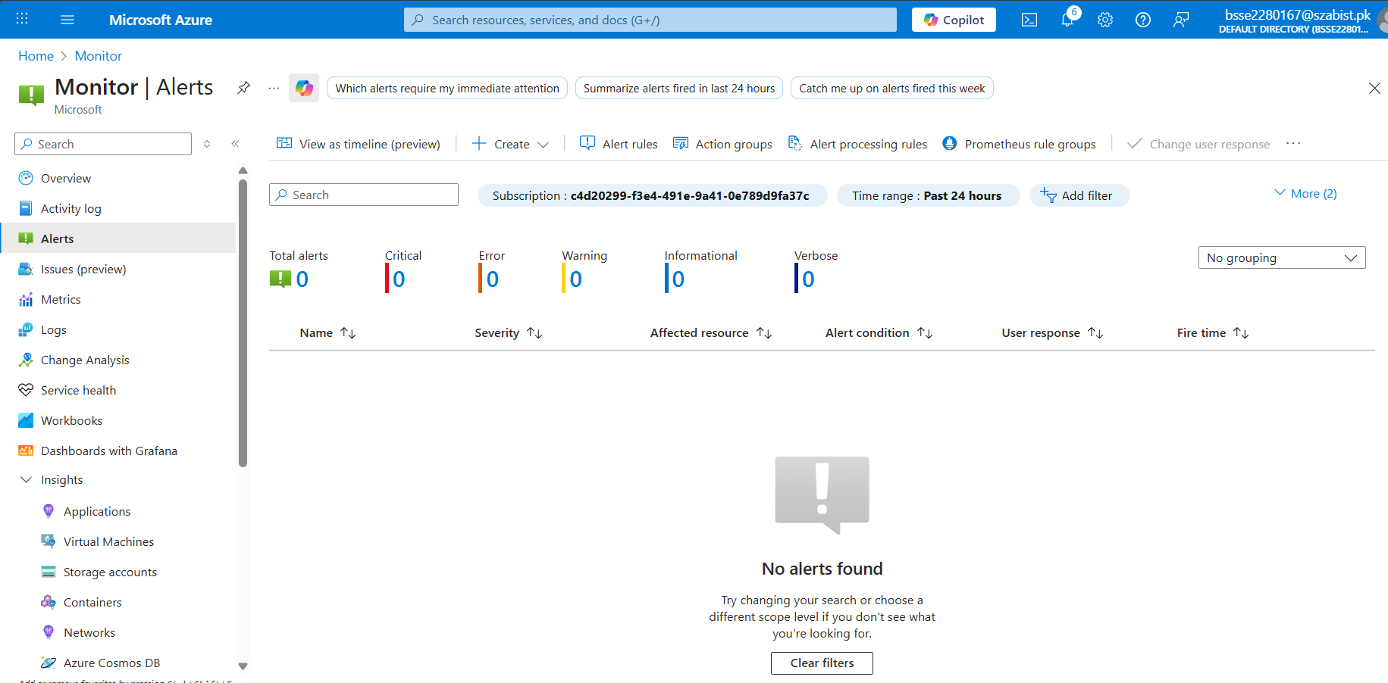
Task04: Trigger an alert and confirm it is working
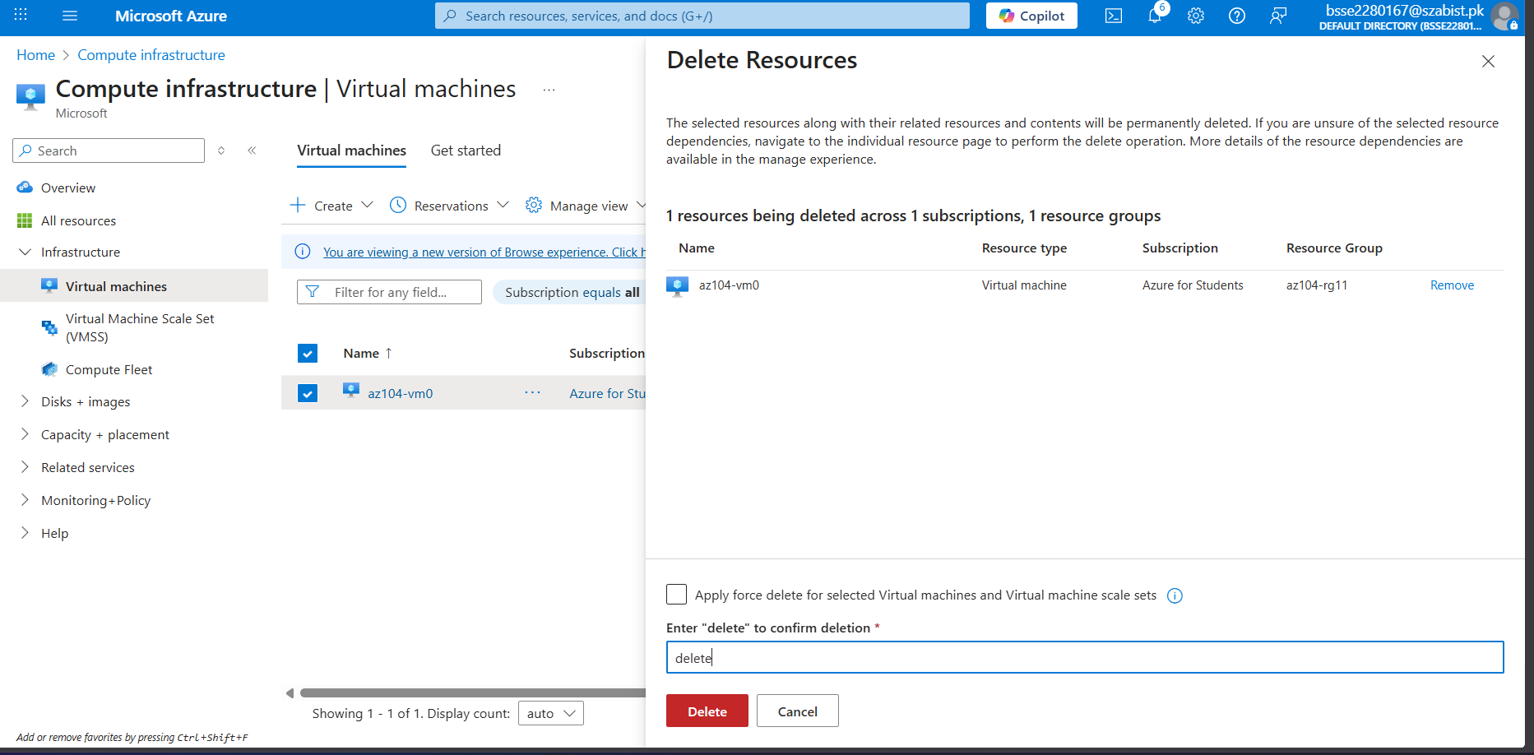
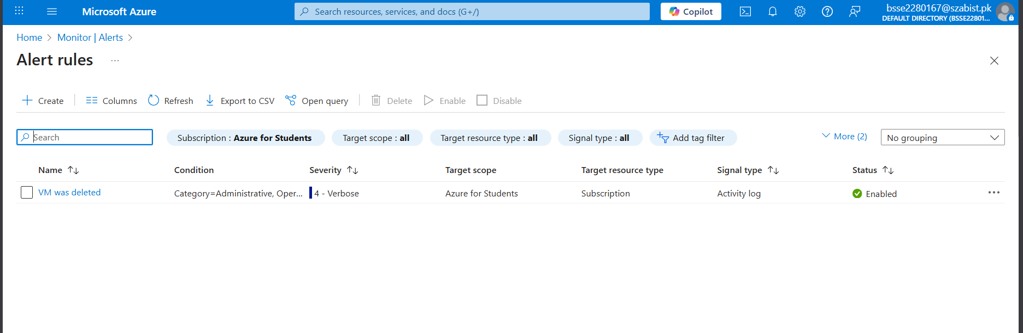
Task05: Configure an alert processing rule
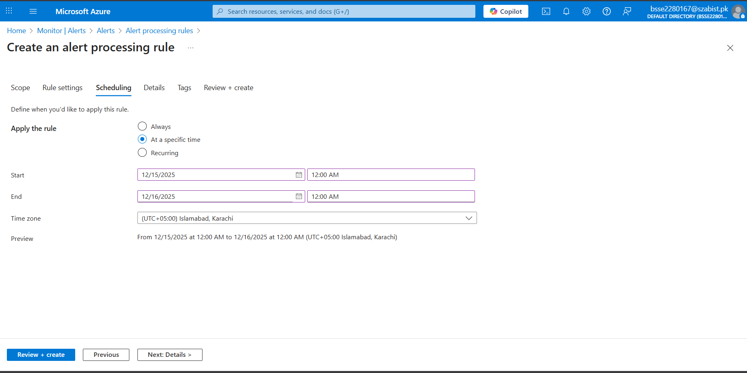
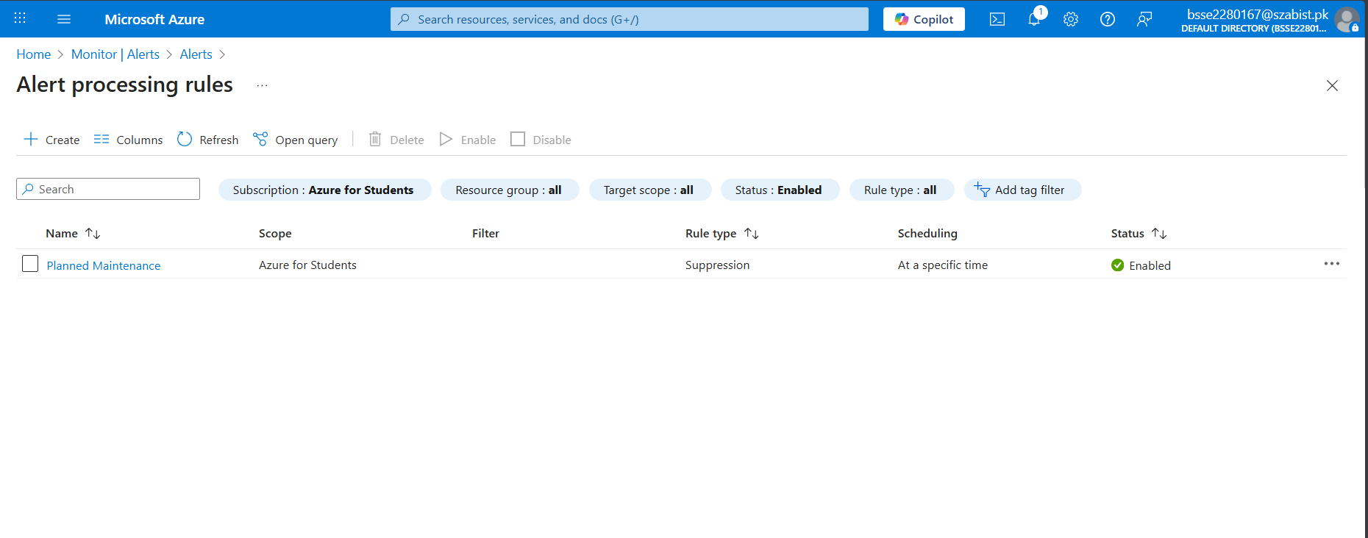
Task06: Use Azure Monitor log queries
