
Course: Cloud Computing
Instructor: Sir Tariq Gouri
Name: Yasir Hussain (2280167)
Program: BSSE-7B
Final Labs
LAB-02

Task01: Create and assign tags via the Azure portal.

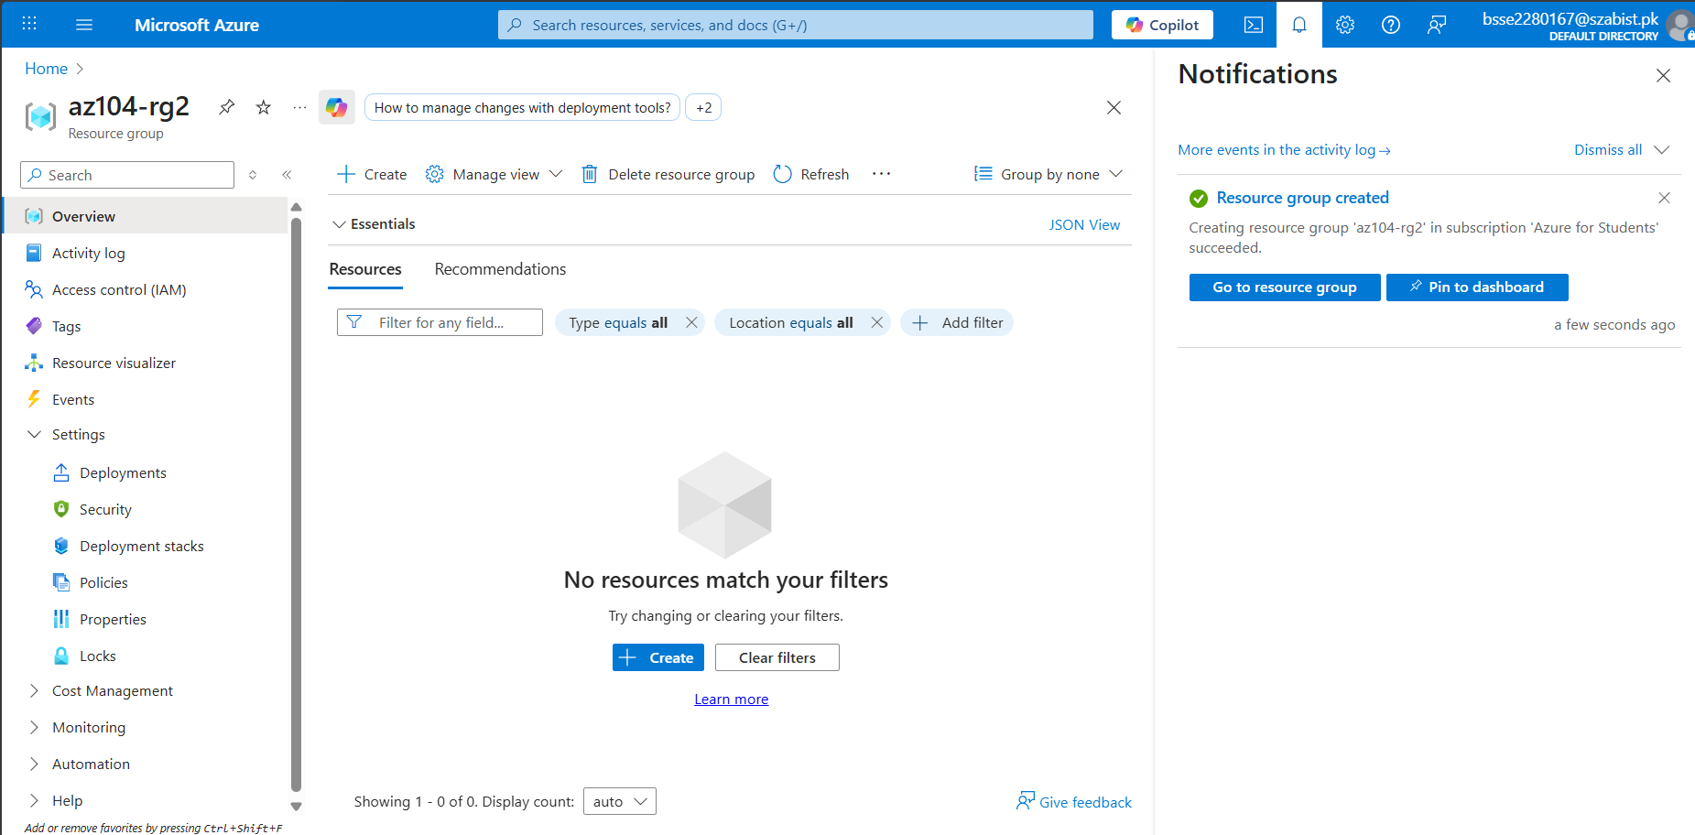

Task02: Enforce tagging via an Azure Policy.
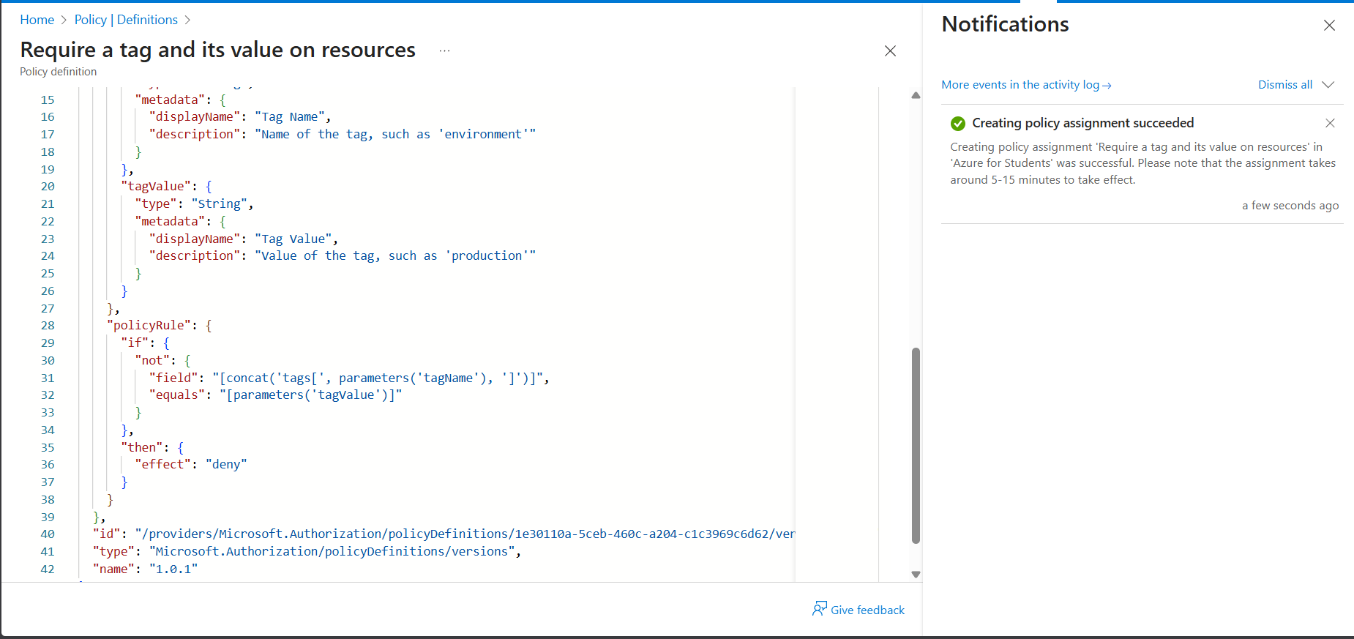

Task03: Apply tagging via an Azure Policy.
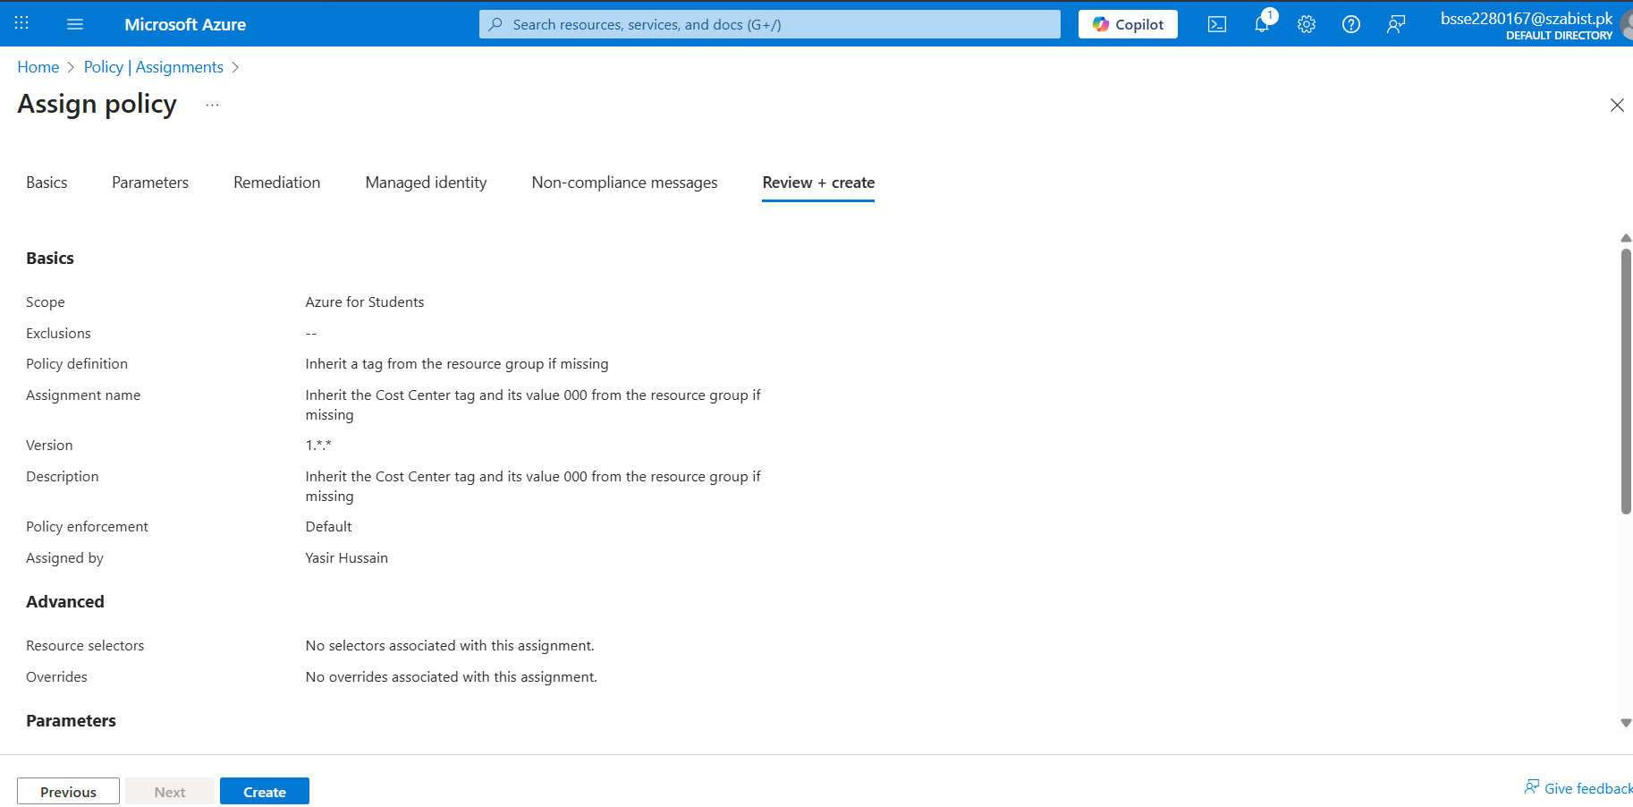
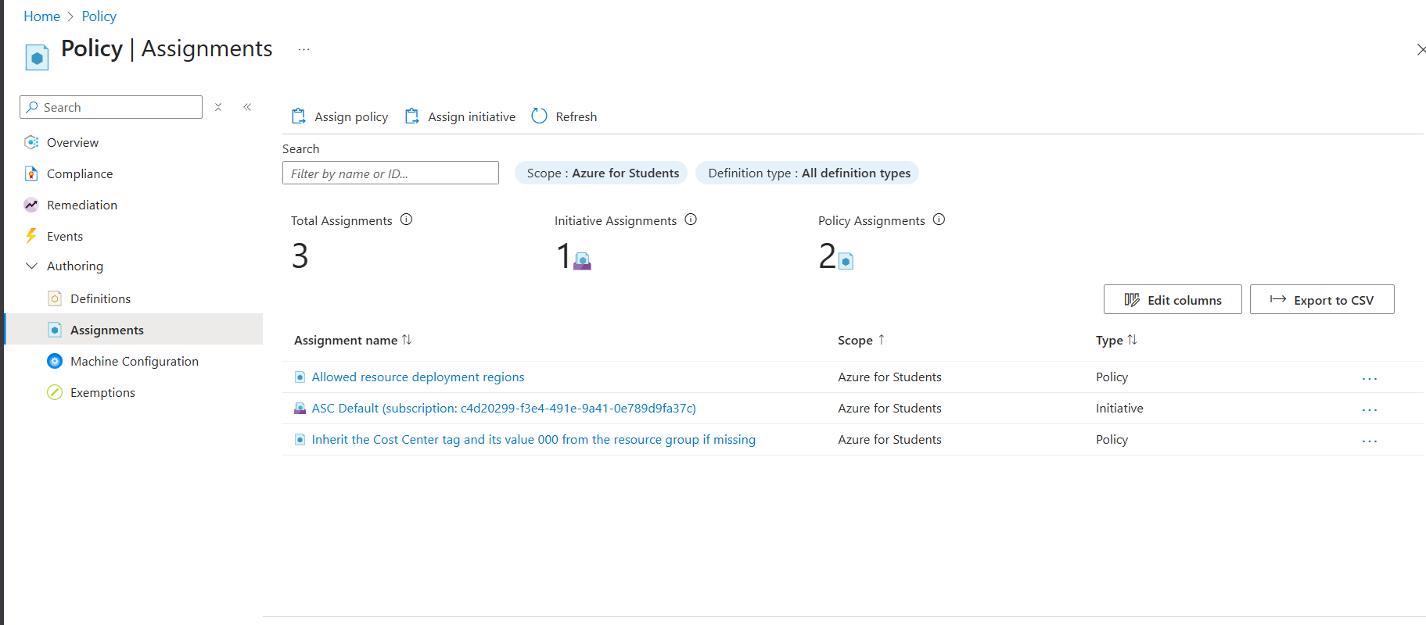

Task04: Configure and test resource locks.
