
Course: Cloud Computing
Instructor: Sir Tariq Gouri
Name: Yasir Hussain (2280167)
Program: BSSE-7B
Final Labs
LAB-04

Task01: Create CoreServicesVnet Using Azure Portal.
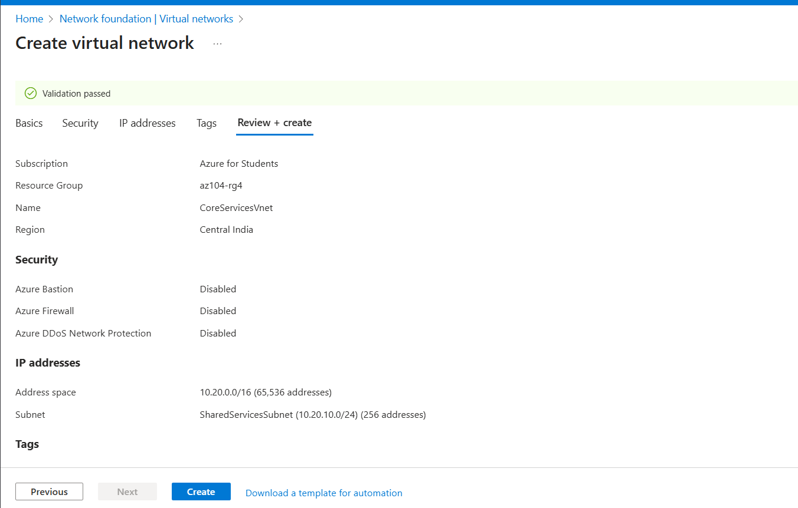
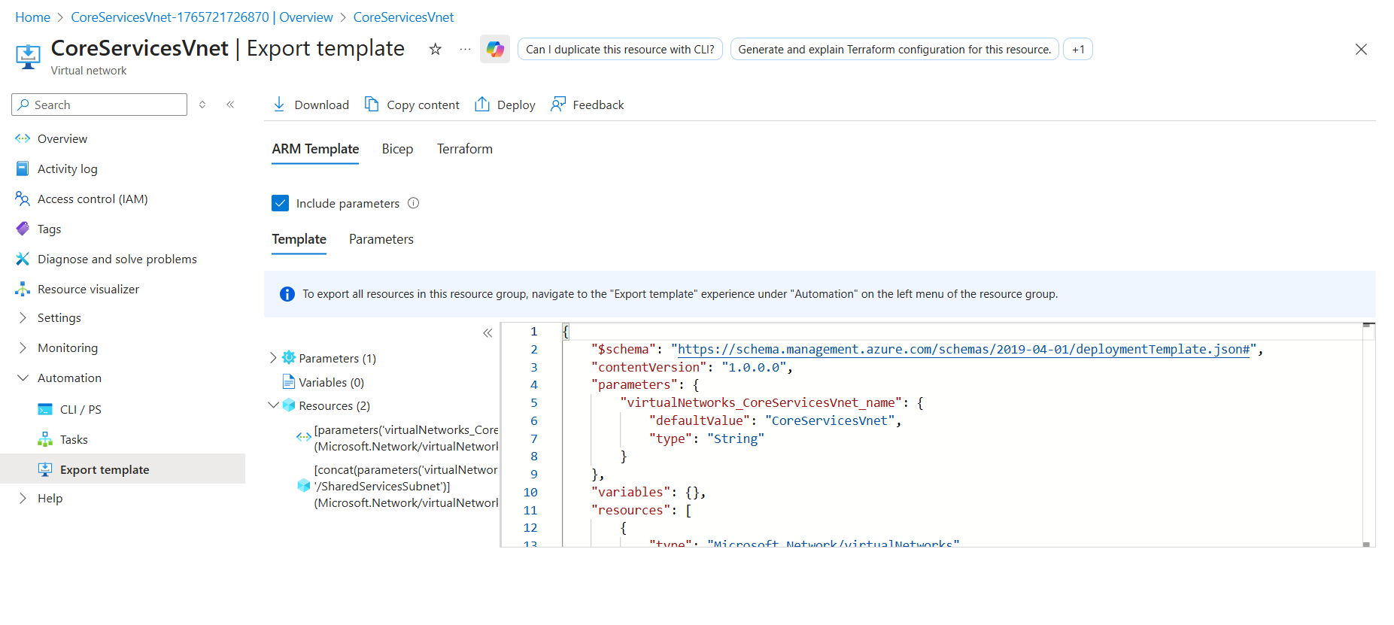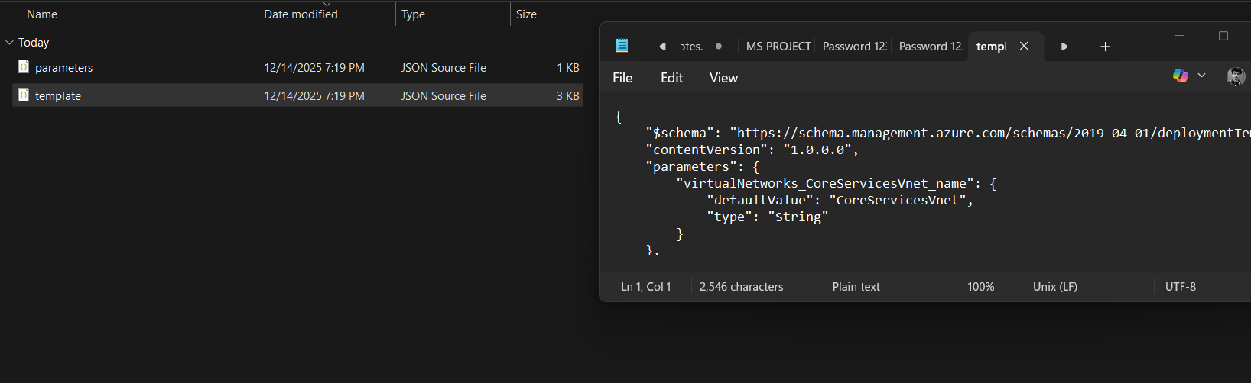
Task02: Create ManufacturingVnet using ARM Template.
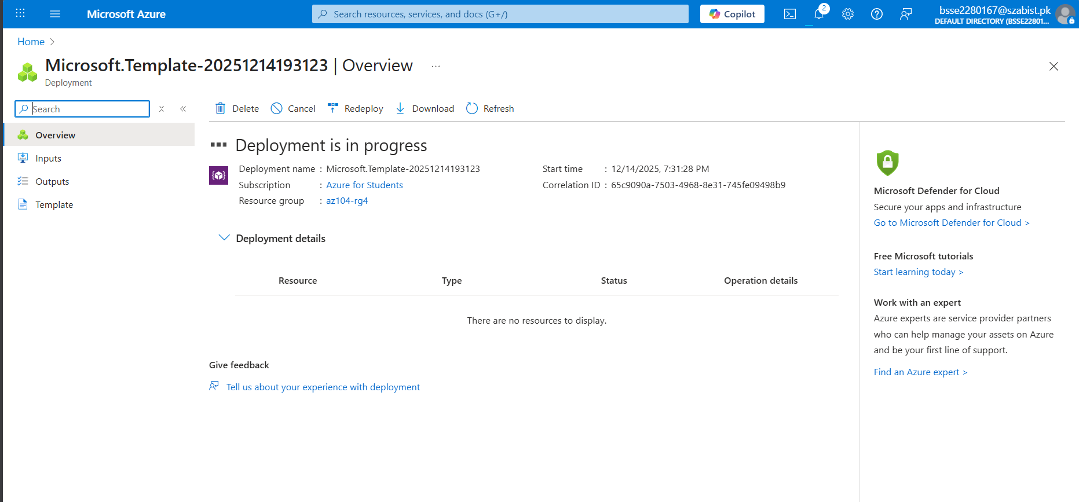

Task03: ASG + NSG Configuration.
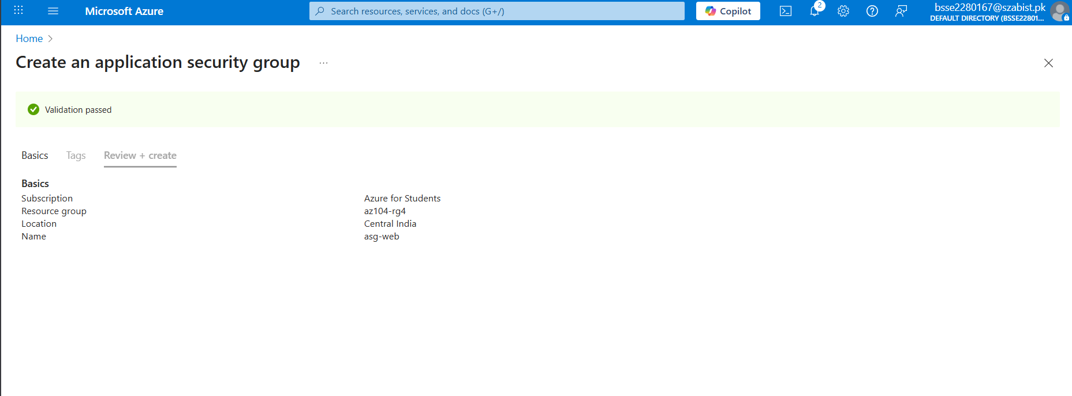
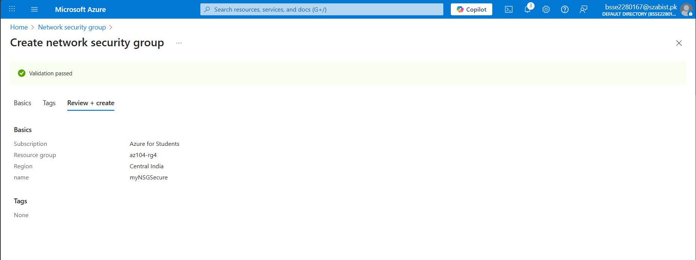
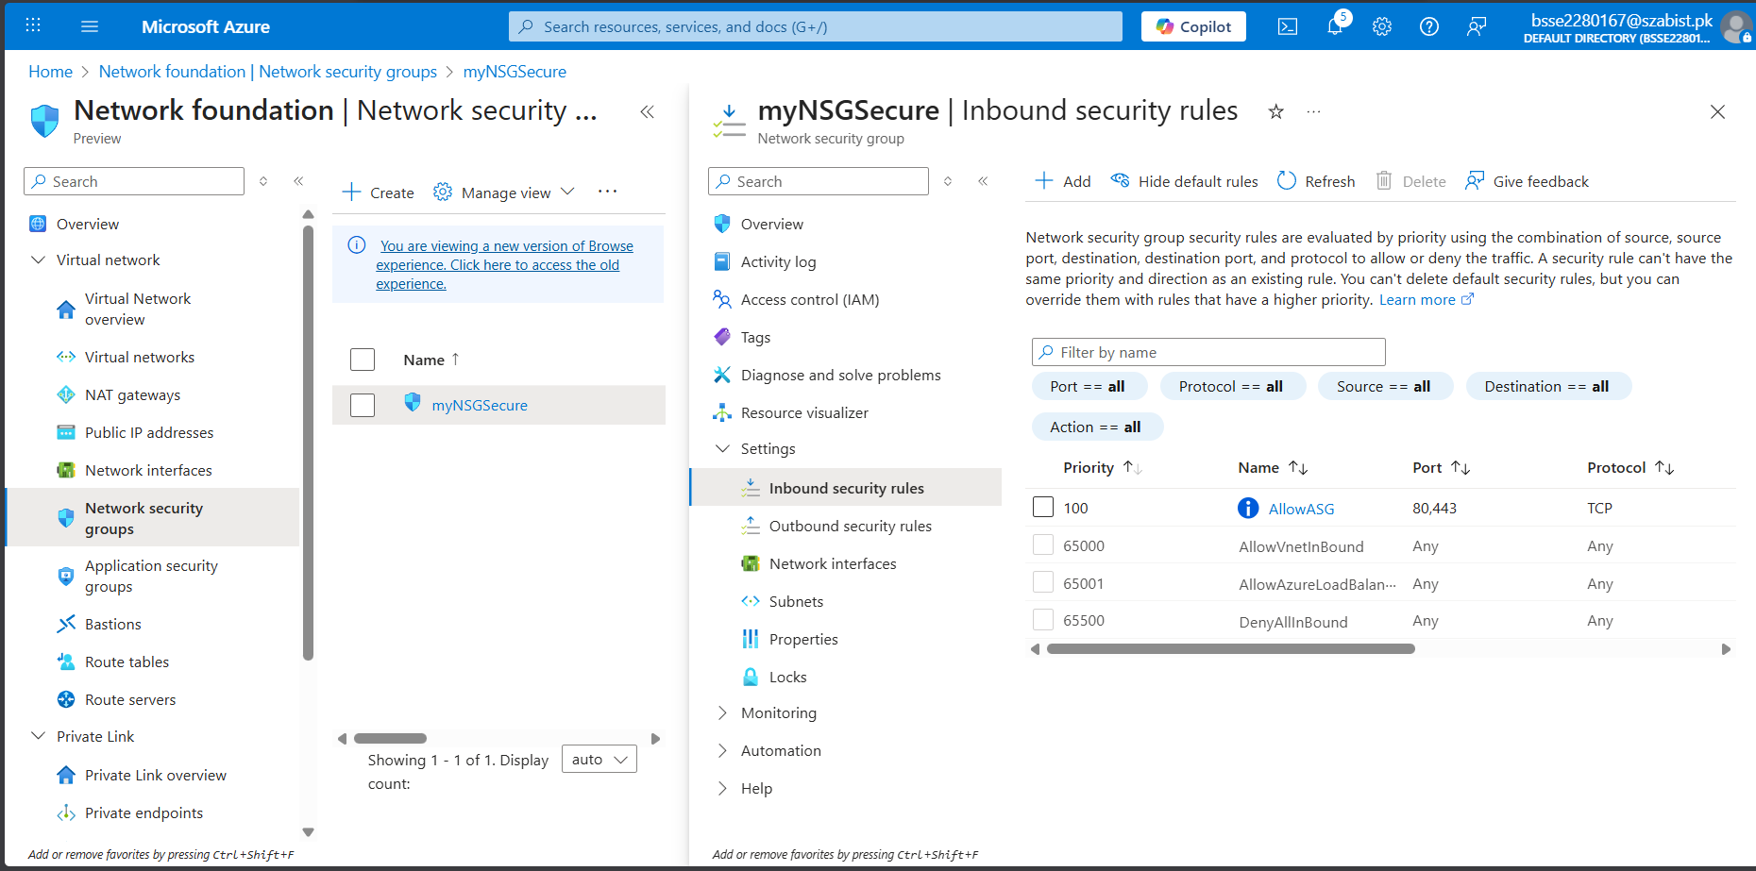

Task04: Azure DNS (Public + Private)
