
Course: Cloud Computing
Instructor: Sir Tariq Gouri
Name: Yasir Hussain (2280167)
Program: BSSE-7B
Final Labs
LAB-06
Task01: Create and Configure an Azure web app.
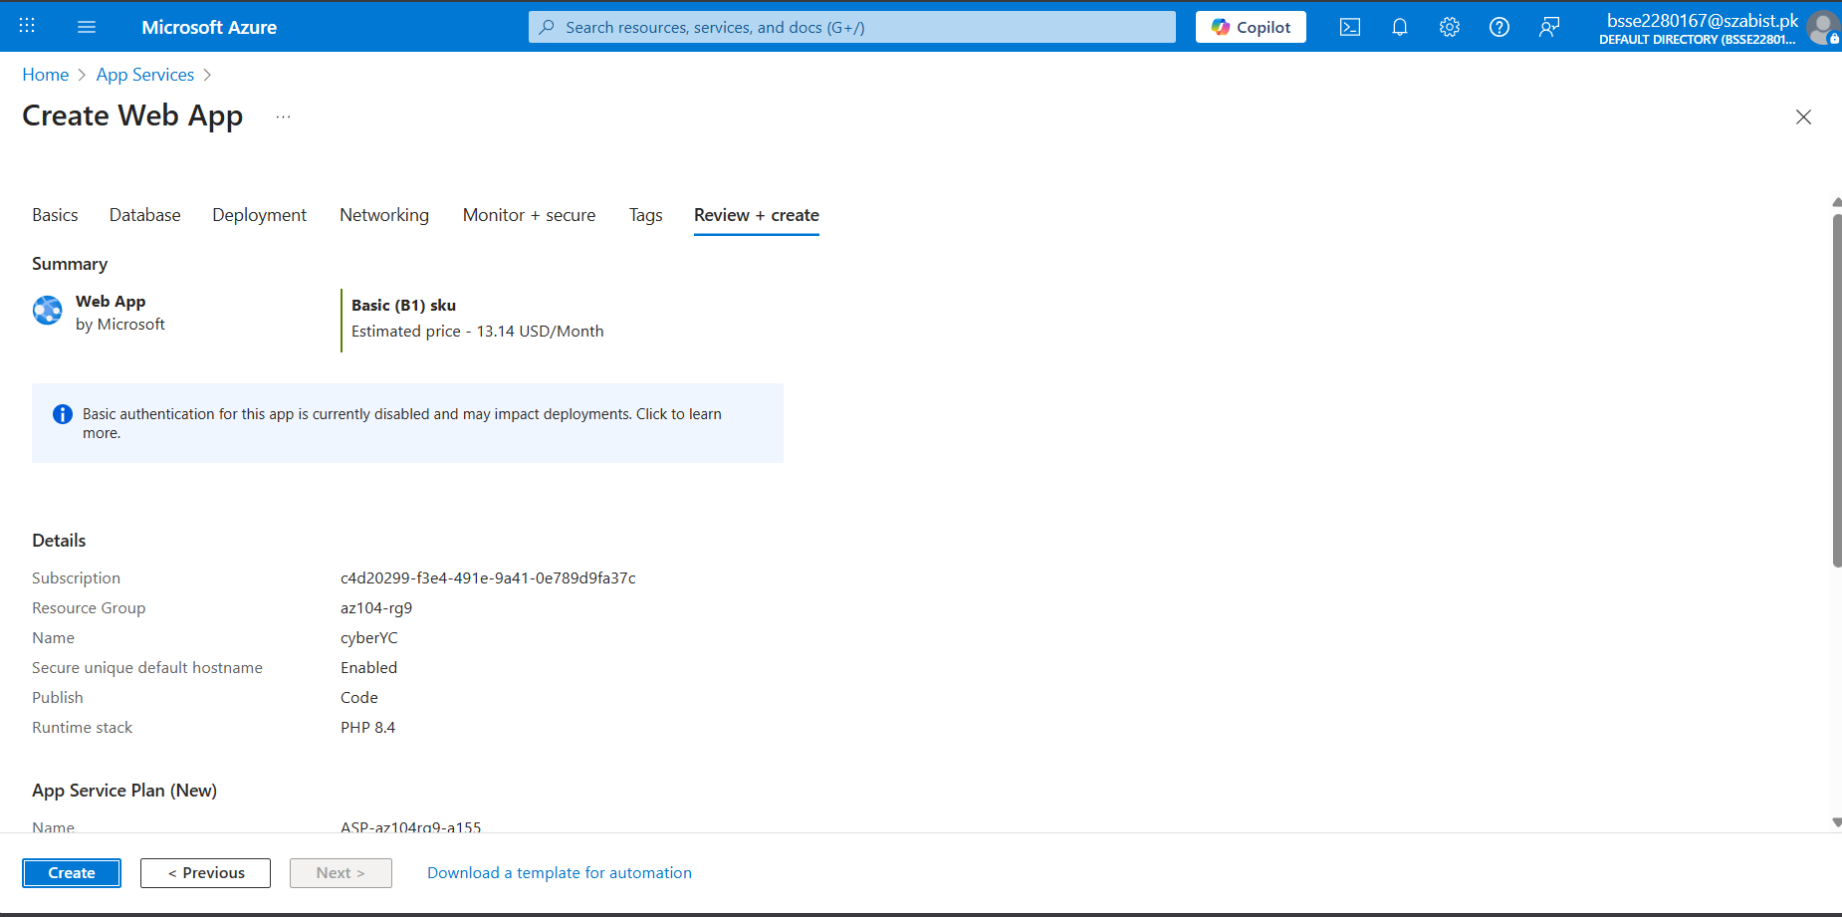

Task02: Create and Configure a Deployment slot
Due to student account we are not allowed to deploy so I will leave it here
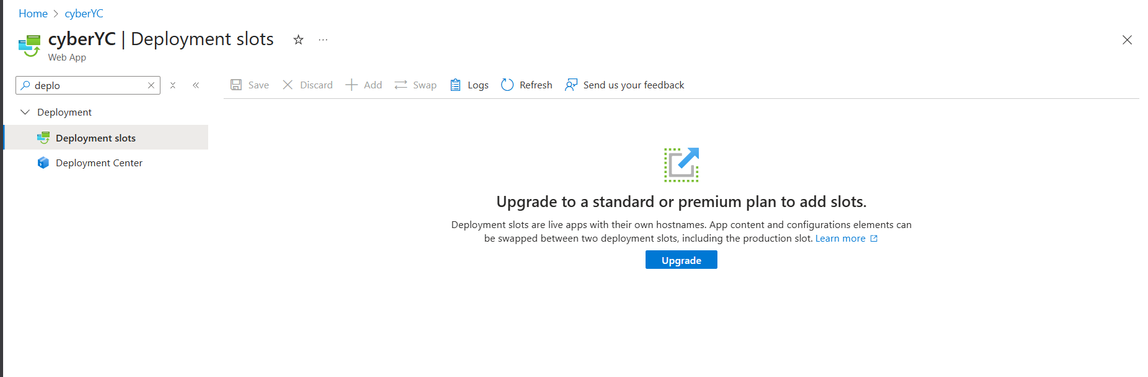

Task03: Configure Web App Deployment settings
Web is not deployed because earlier steps are not done
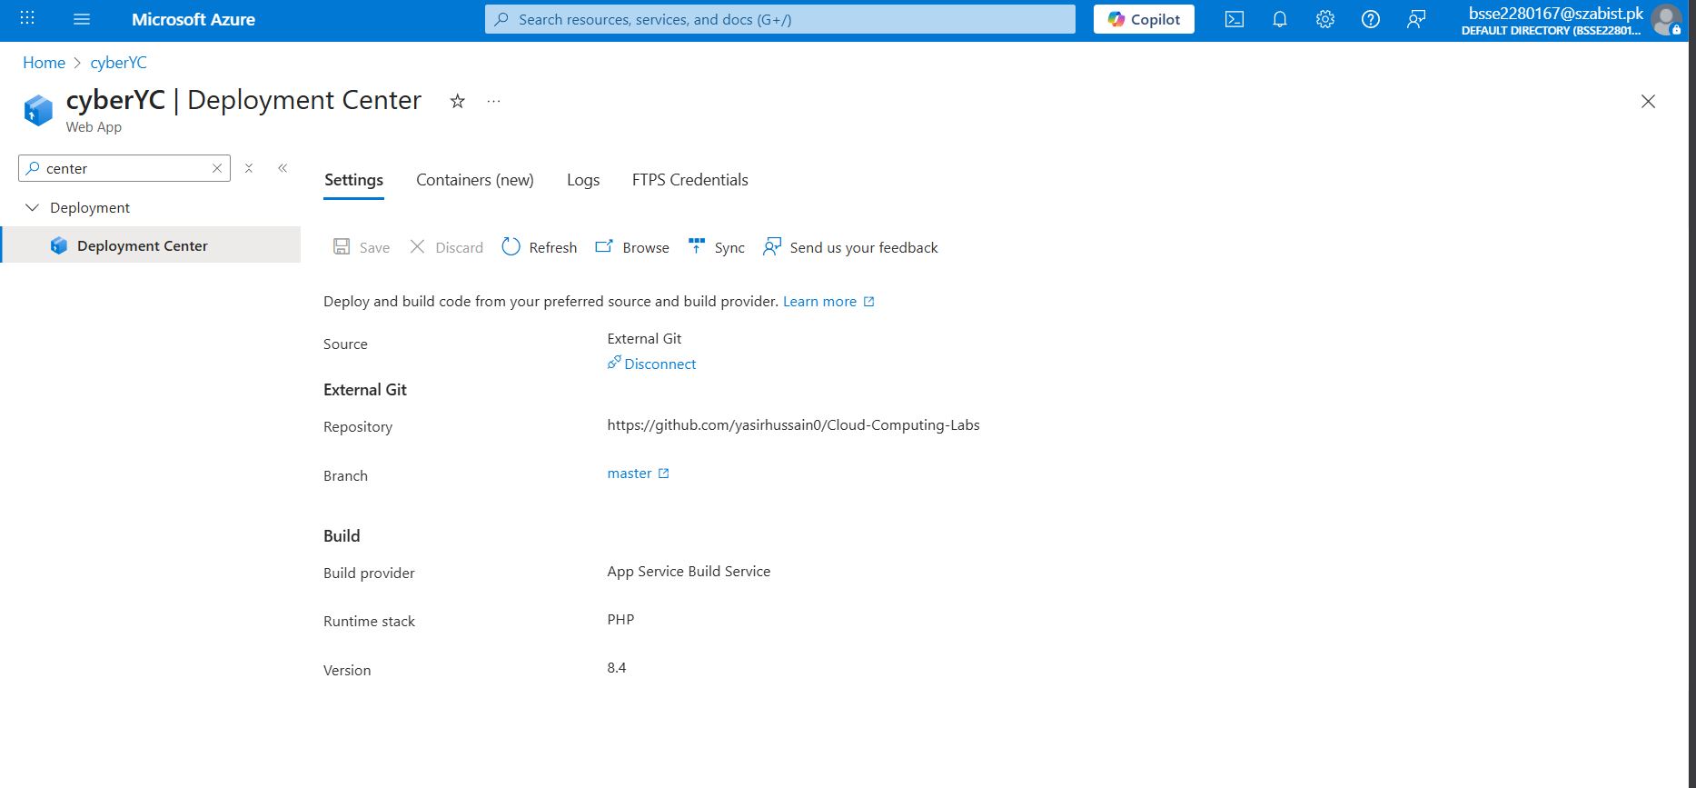
But I have done this for the task

Task04: Swap deployment slots
