
Course: Cloud Computing
Instructor: Sir Tariq Gouri
Name: Yasir Hussain (2280167)
Program: BSSE-7B
Final Labs
LAB-07
Task01: Deploy an Azure Container Instance using a Docker image.
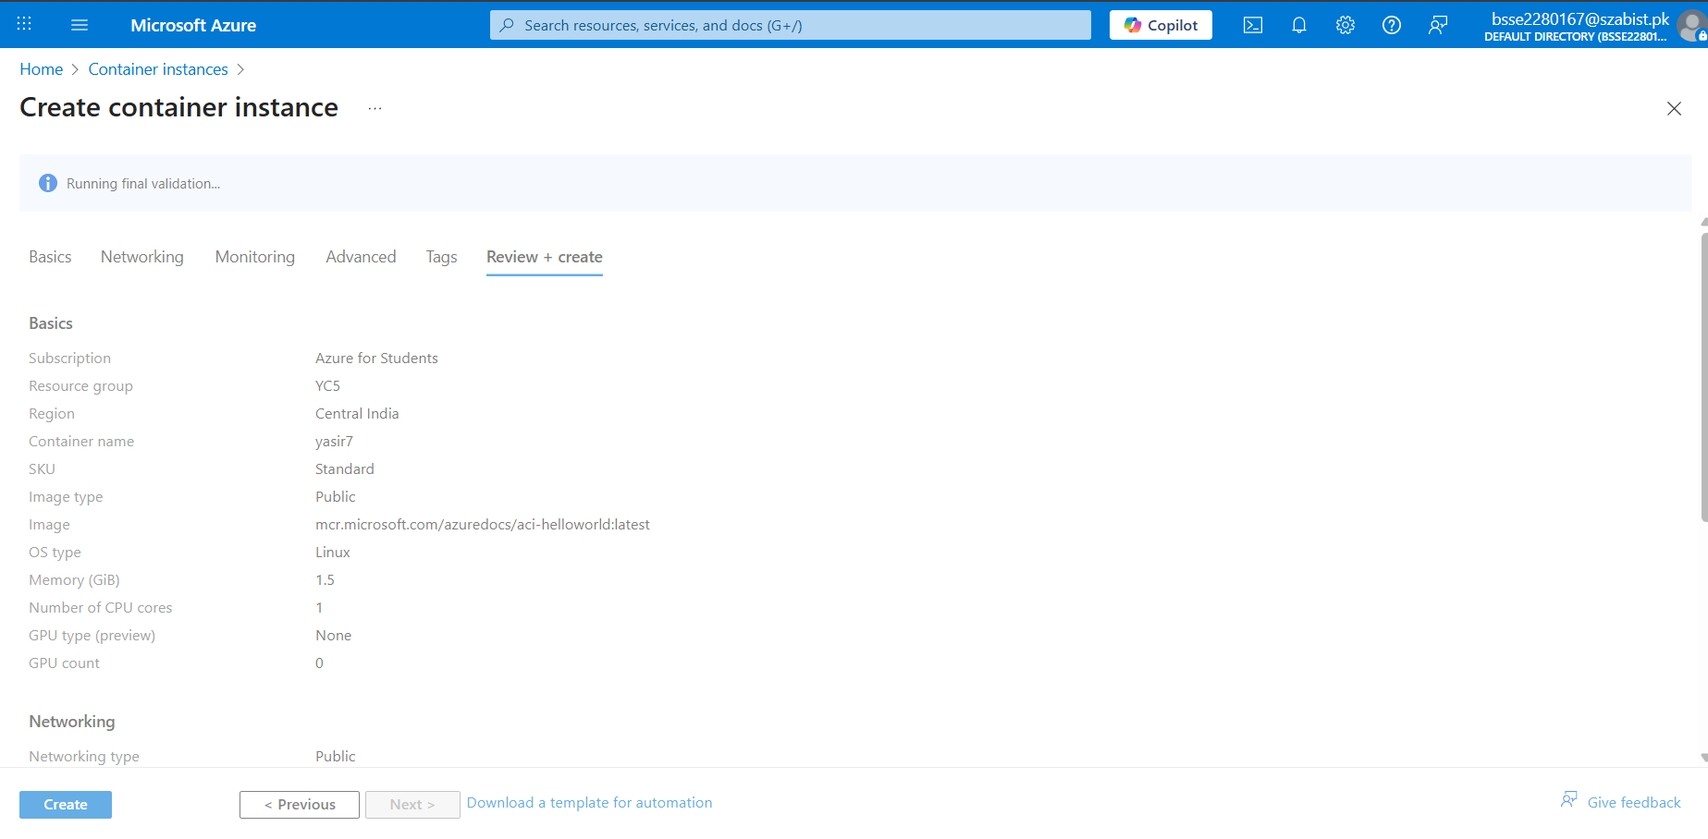
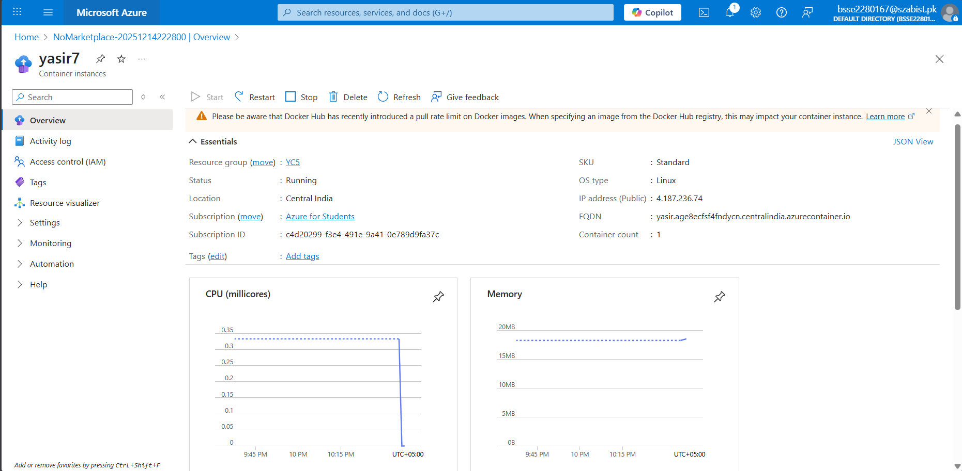

Task02: Test and verify deployment of an Azure Container Instance.
