
Course: Cloud Computing
Instructor: Sir Tariq Gouri
Name: Yasir Hussain (2280167)
Program: BSSE-7B
Final Labs
LAB-08
Task01: Create and configure an Azure Container App and environment
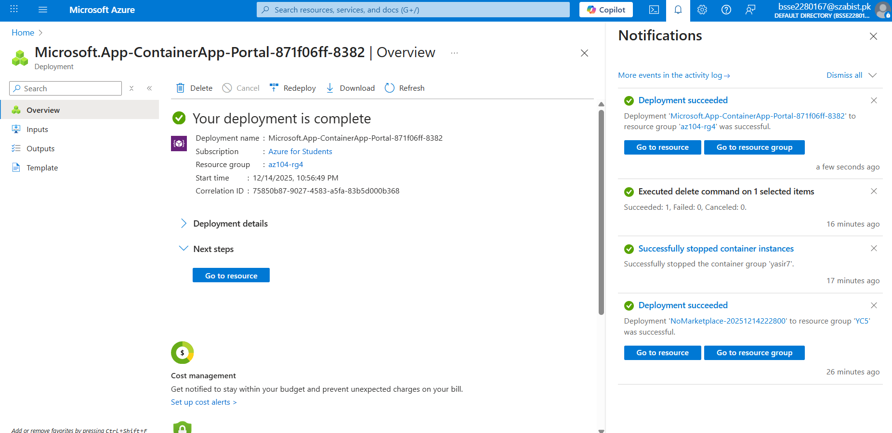

Task02: Test and verify deployment of the Azure Container App

