
Course: Cloud Computing
Instructor: Sir Tariq Gouri
Name: Yasir Hussain(2280167)
Program: BSSE-7B
Final Labs
LAB-01
Loha770199
Task01: Create a New User
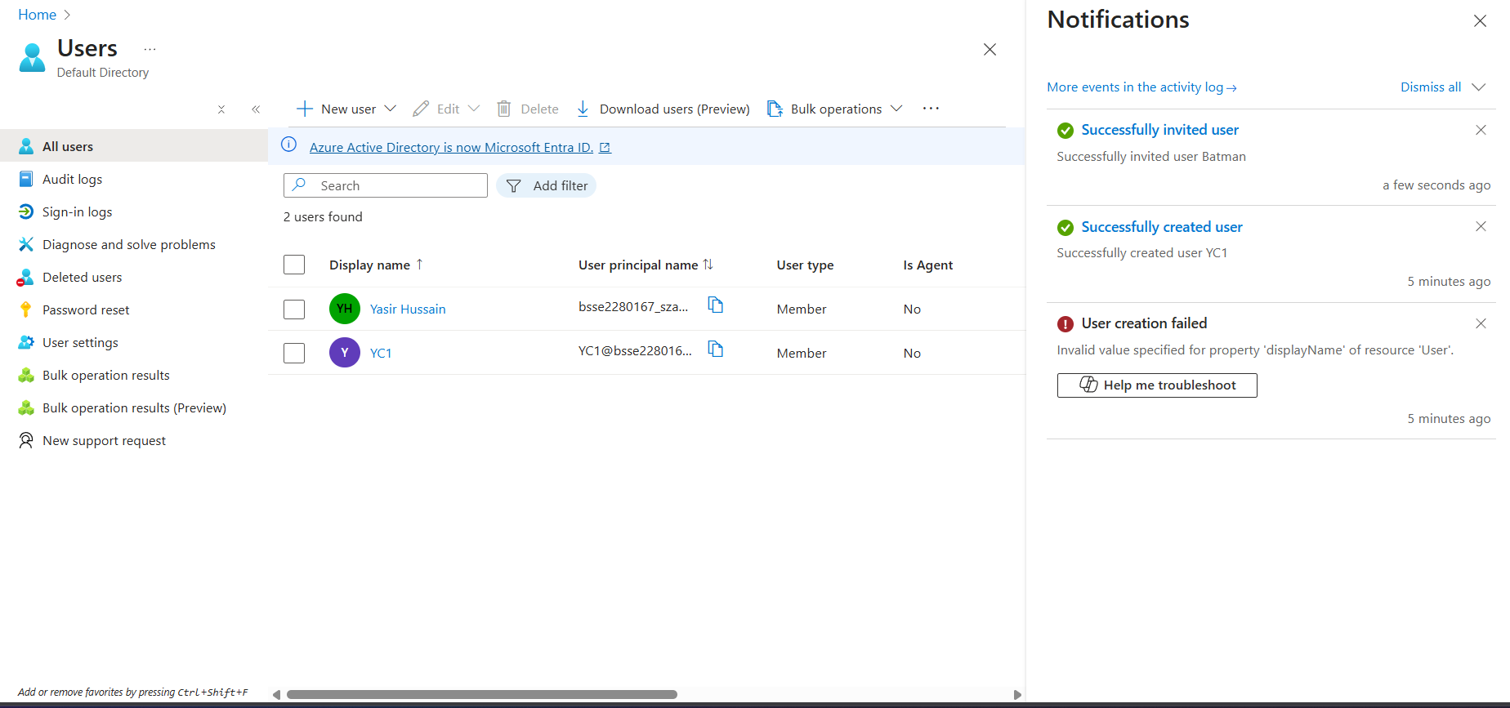

Task02:

