Course: Cloud Computing
Instructor: Sir Tariq gouri
Name: Yasir Hussain(2280167)
Program: BSSE-7B
LAB-01
Task-01: Create a virtual machine
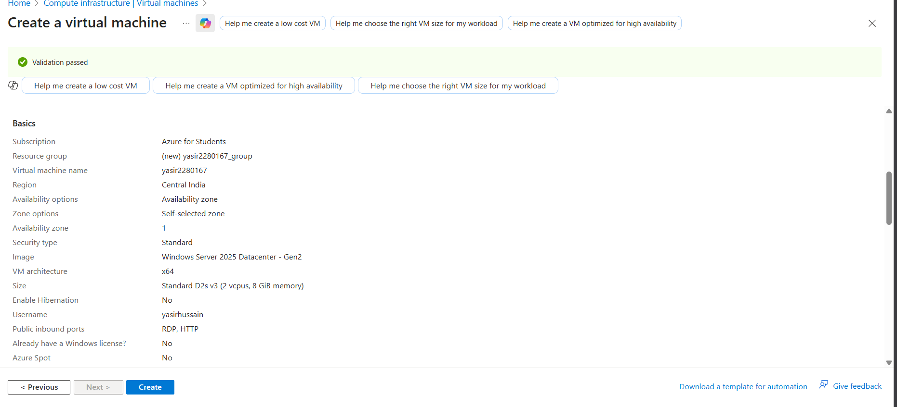
Task02:
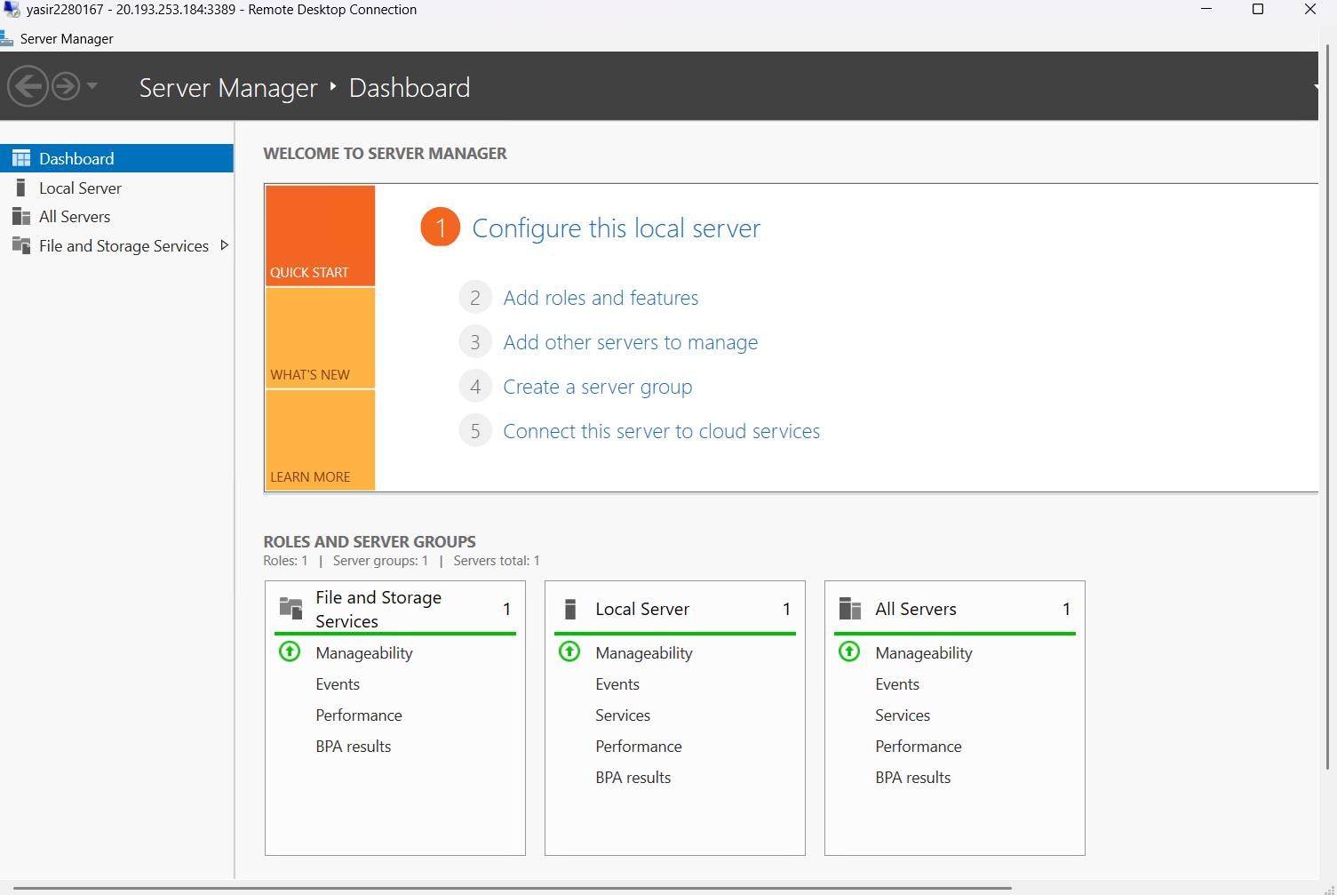
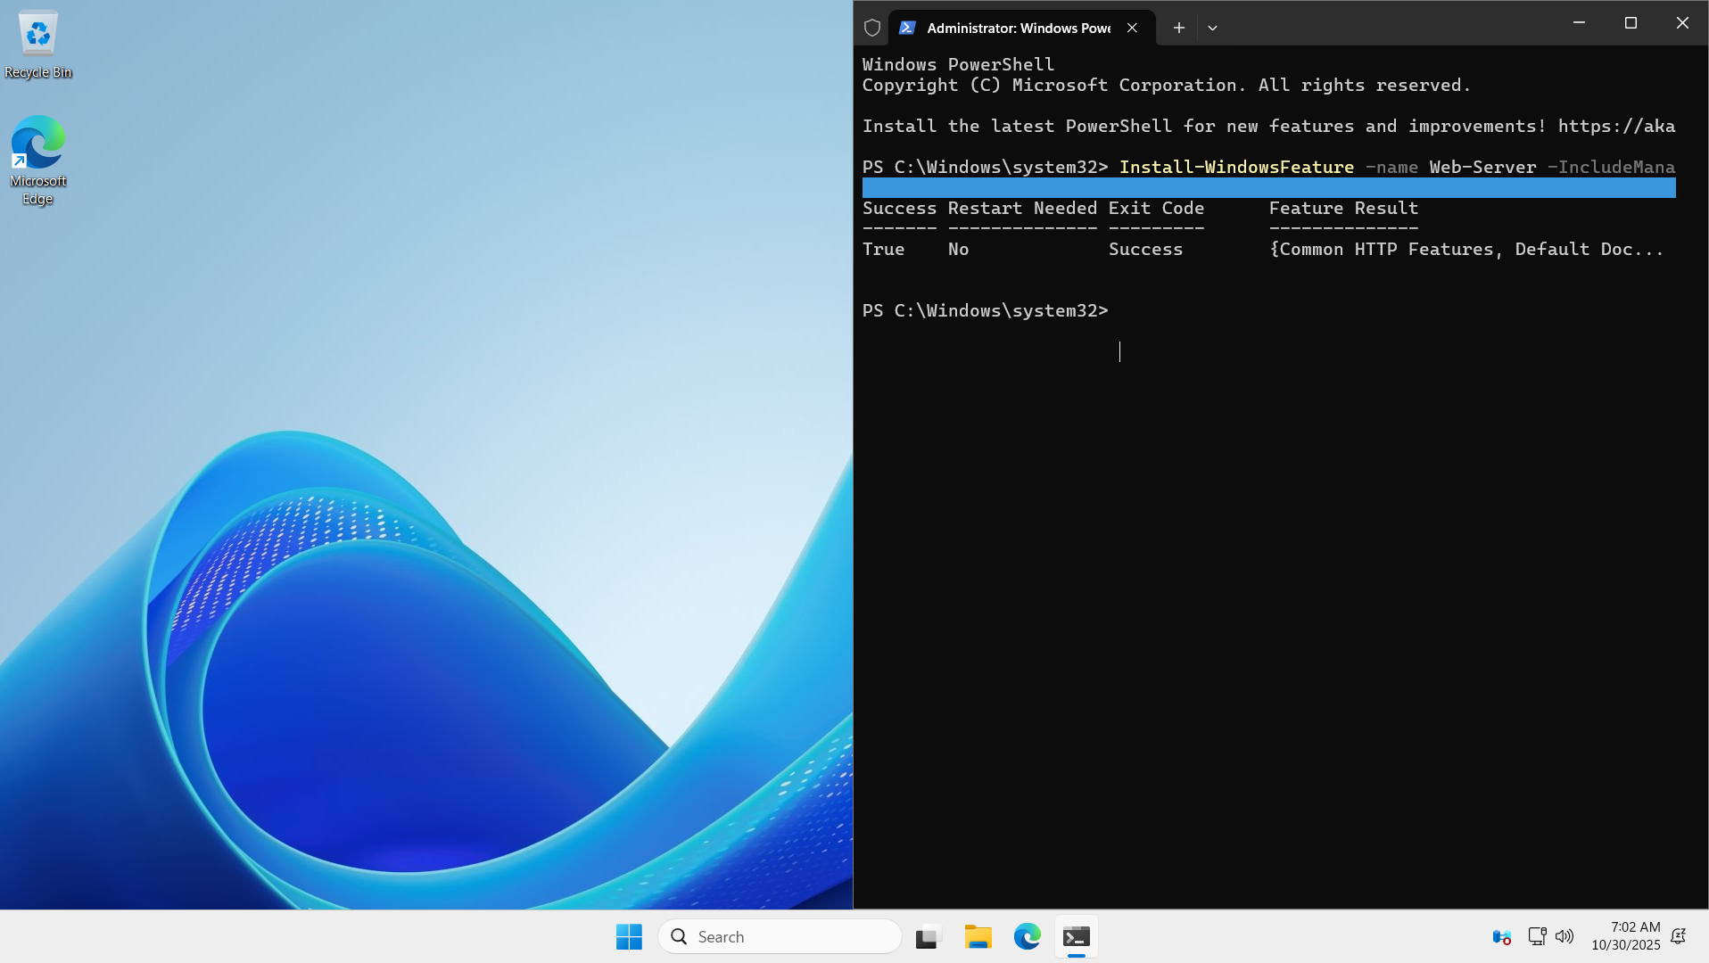
Task 3:


