NAME: Yasir Hussain
ID: 2280167
Section -B
LAB:02

Task 1 & 2 : create two machine
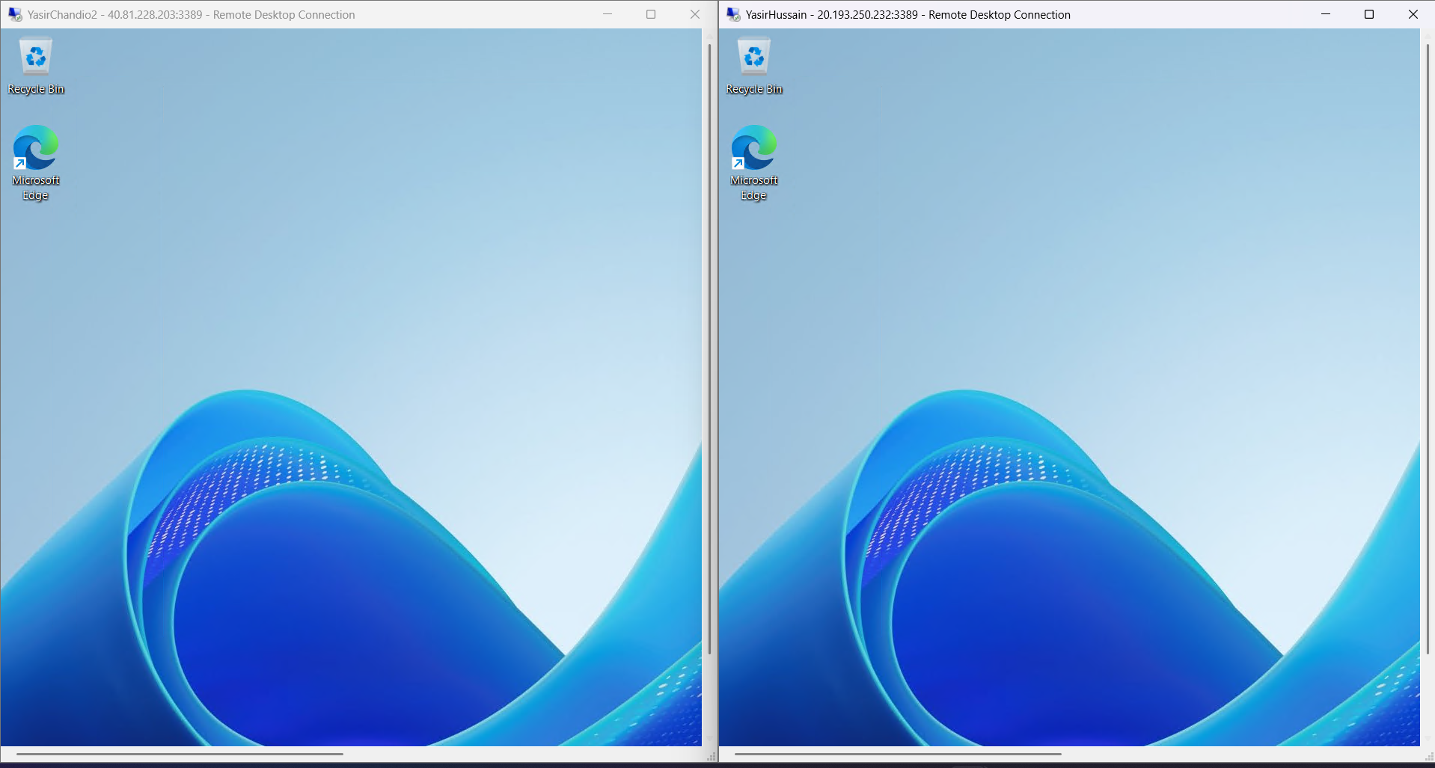
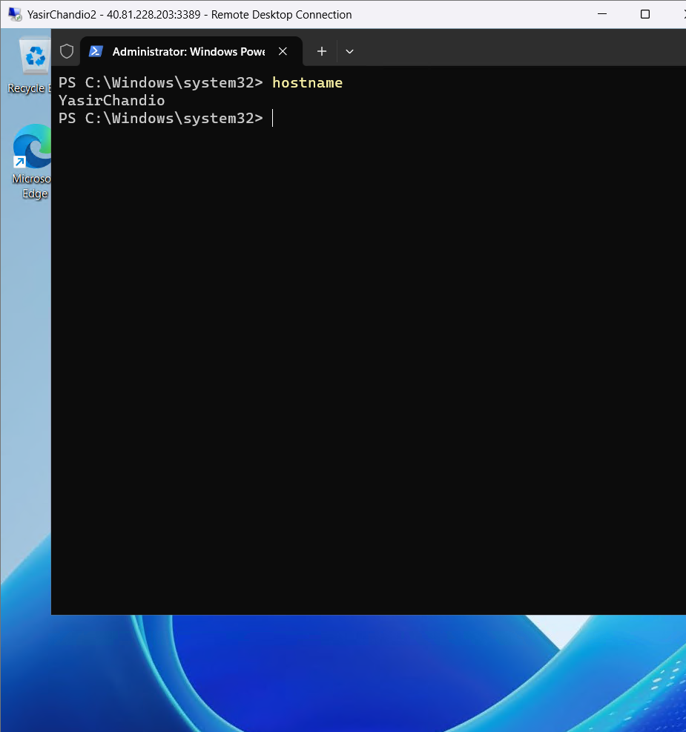
Task 3 : Machine 1 is pinging machine 2
