Course: Cloud Computing
Instructor: Sir Tariq gouri
Name: Yasir Hussain(2280167)
Program: BSSE-7B
LAB-04
Task01: Create a Web App
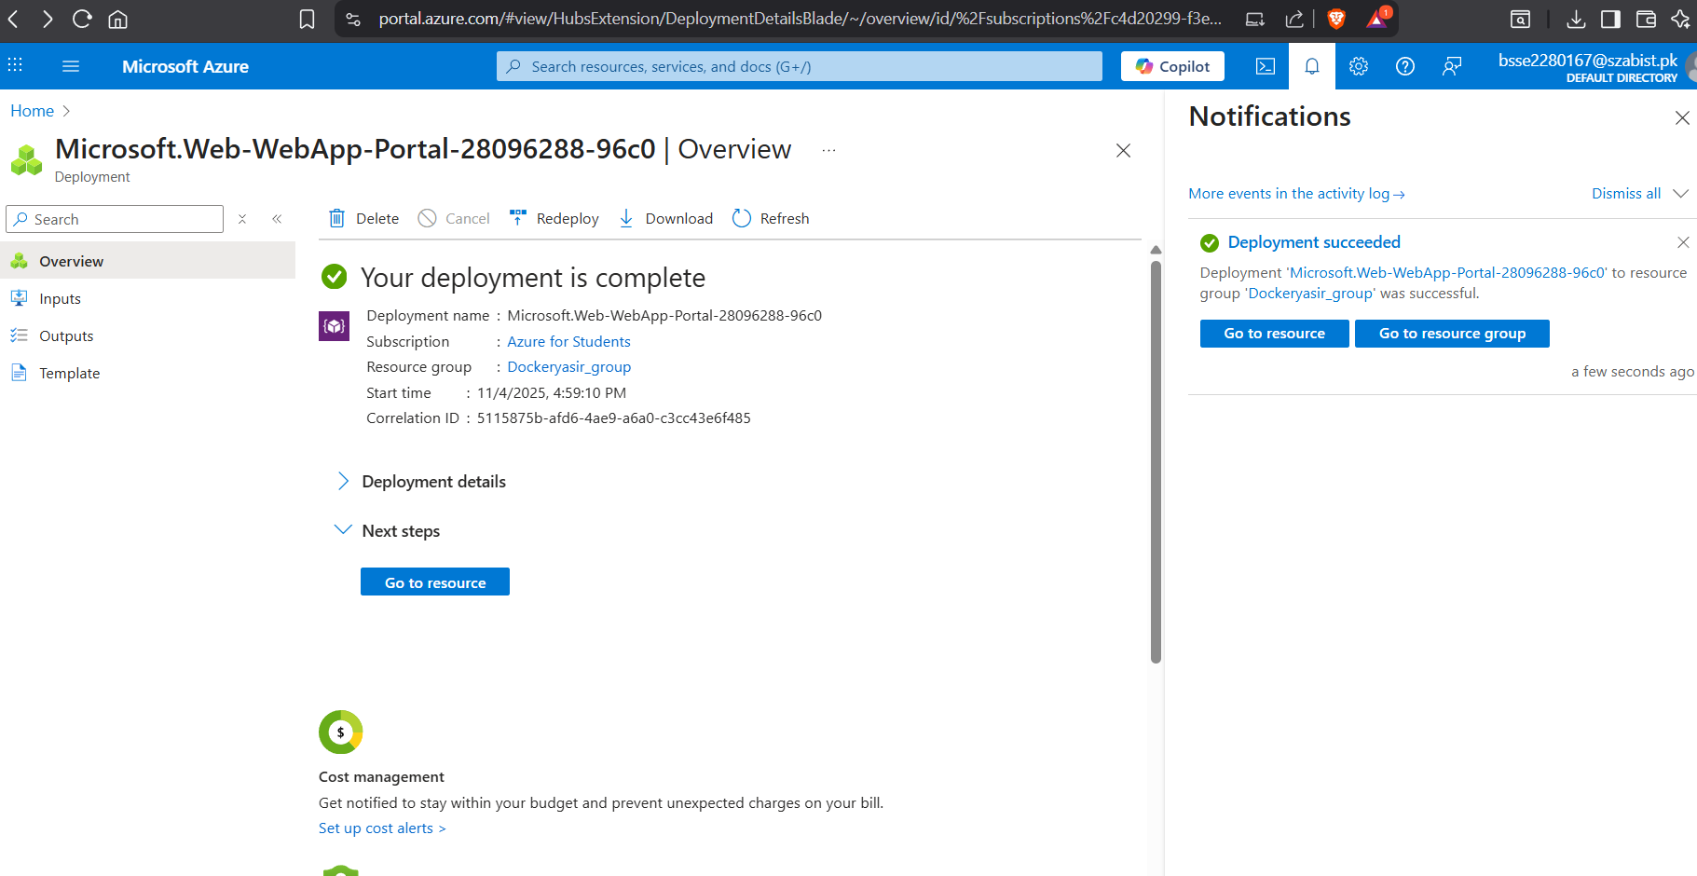
Task02: Test the Web App
