Course: Cloud Computing
Instructor: Sir Tariq gouri
Name: Yasir Hussain(2280167)
Program: BSSE-7B
LAB-01

Task01: 1: Create an Azure Key Vault
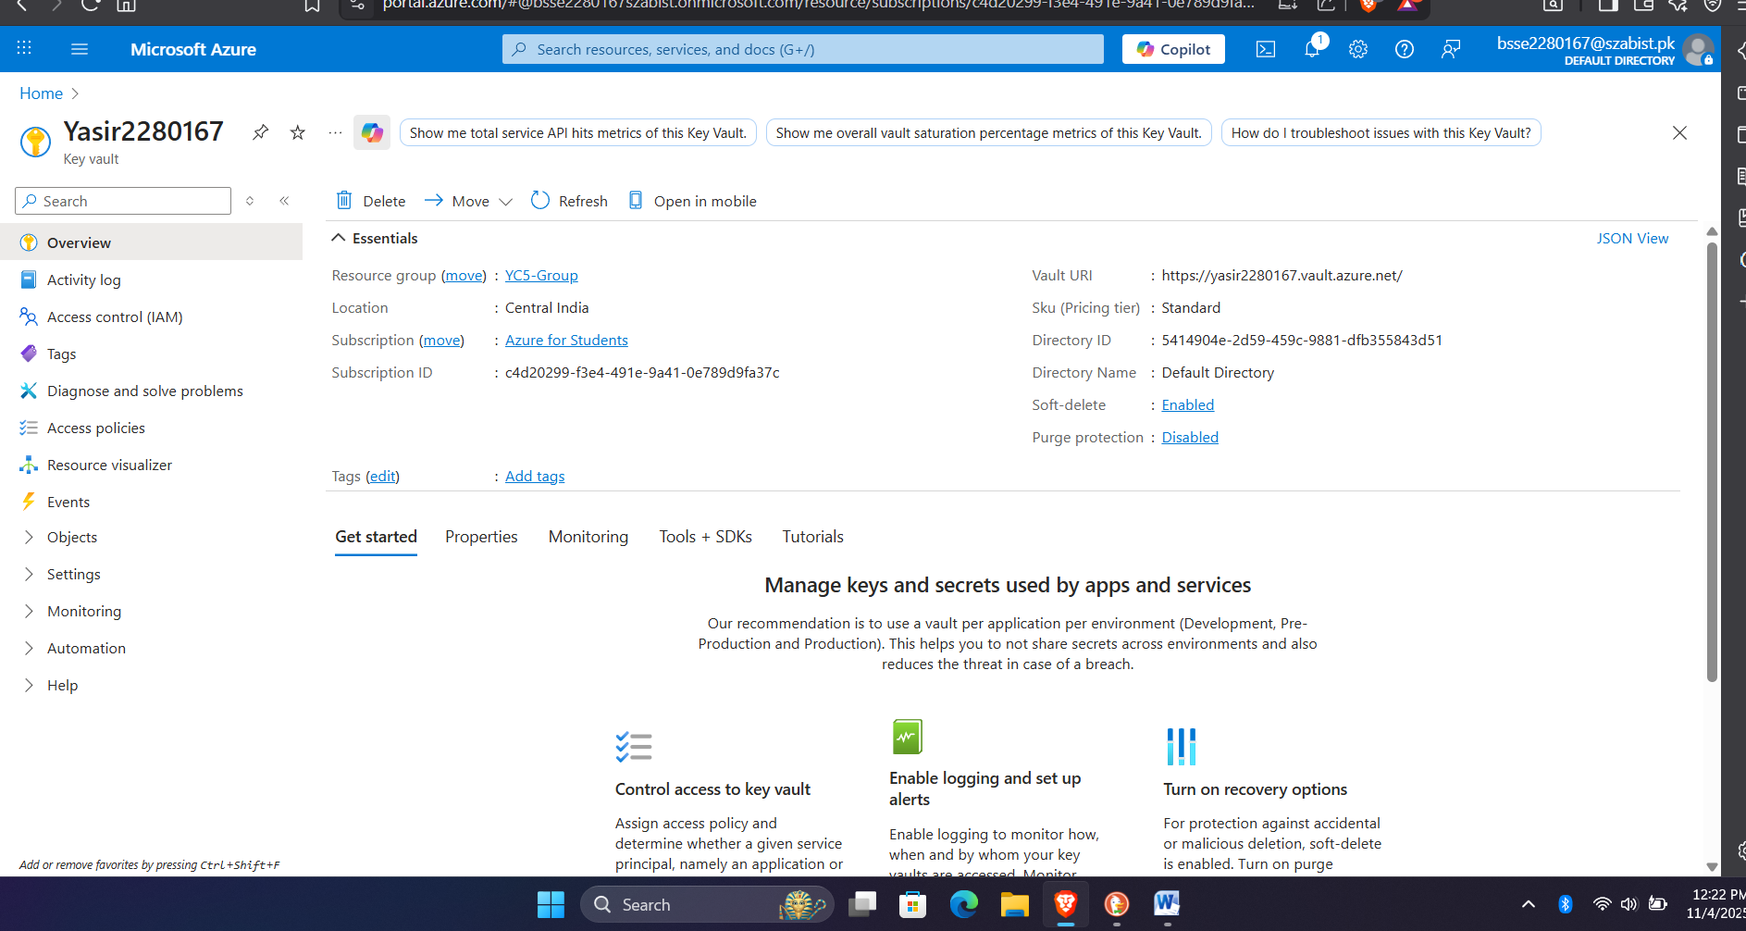
https://yasir2280167.vault.azure.net/

Task02: Add a secret to the Key Vault
