Course: Cloud Computing
Instructor: Sir Tariq gouri
Name: Yasir Hussain(2280167)
Program: BSSE-7B
LAB-01
Task01: Create a virtual machine
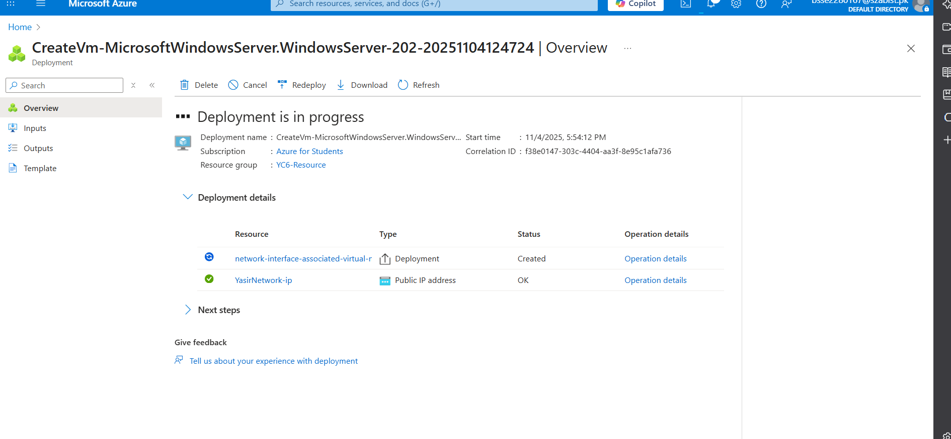

YasirNetwork
yasirnetwork619_z1
Task02: Create a network security group
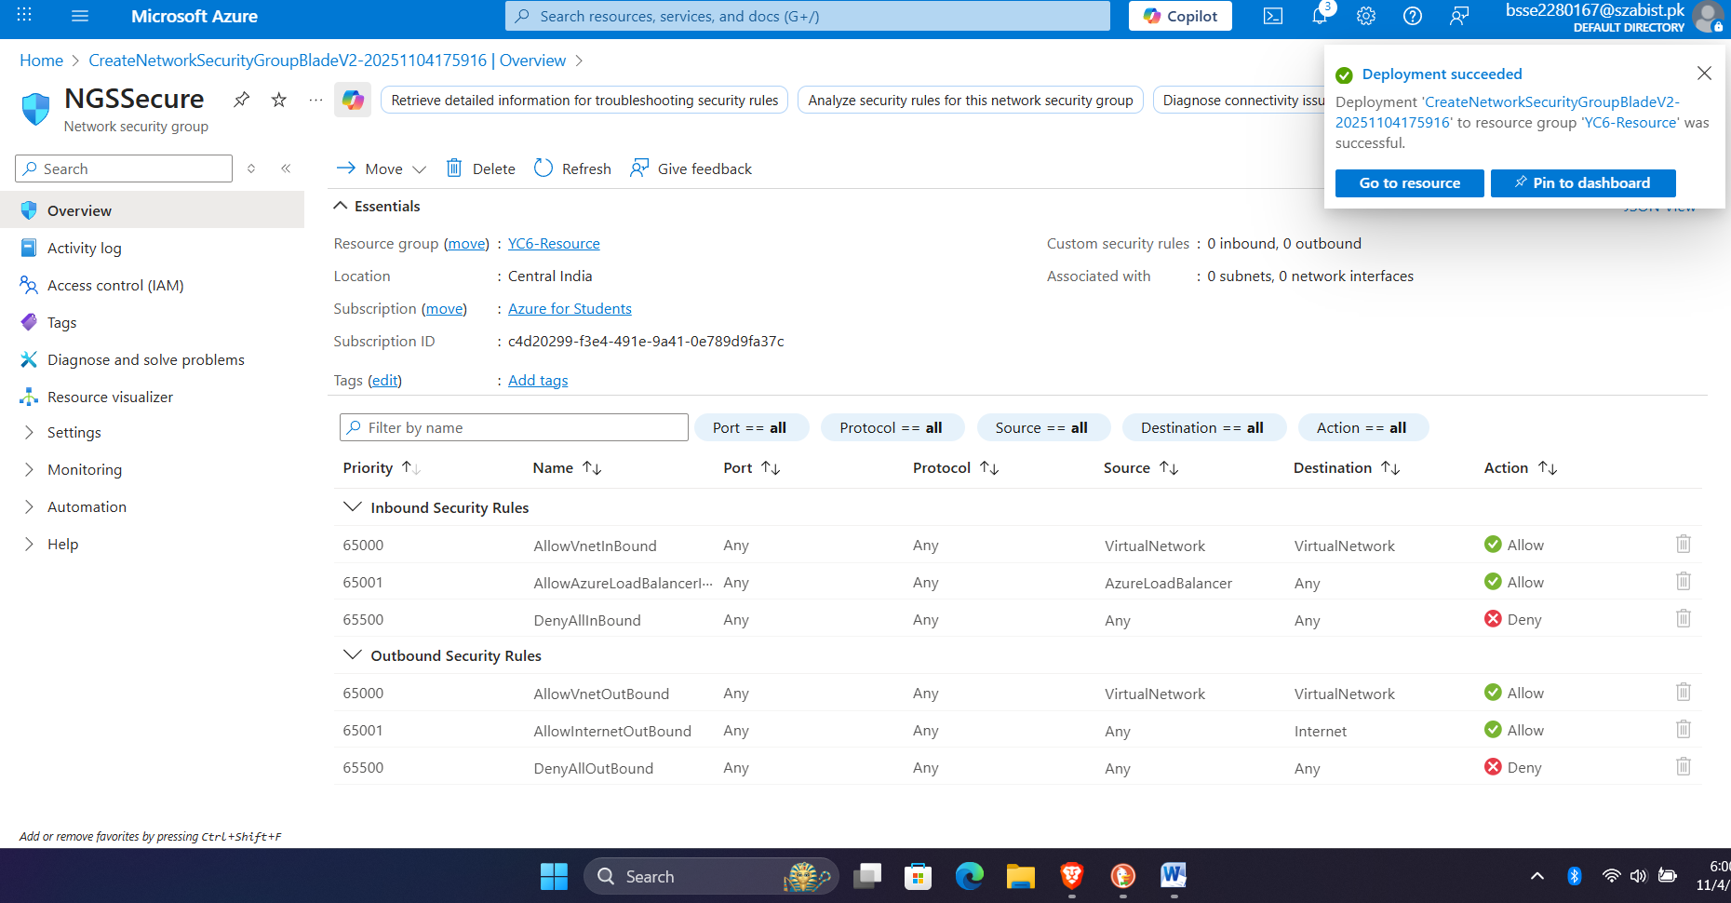
Task03: Configure an inbound security port rule to allow RDP
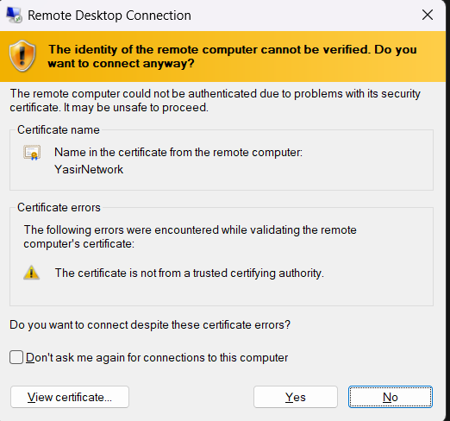
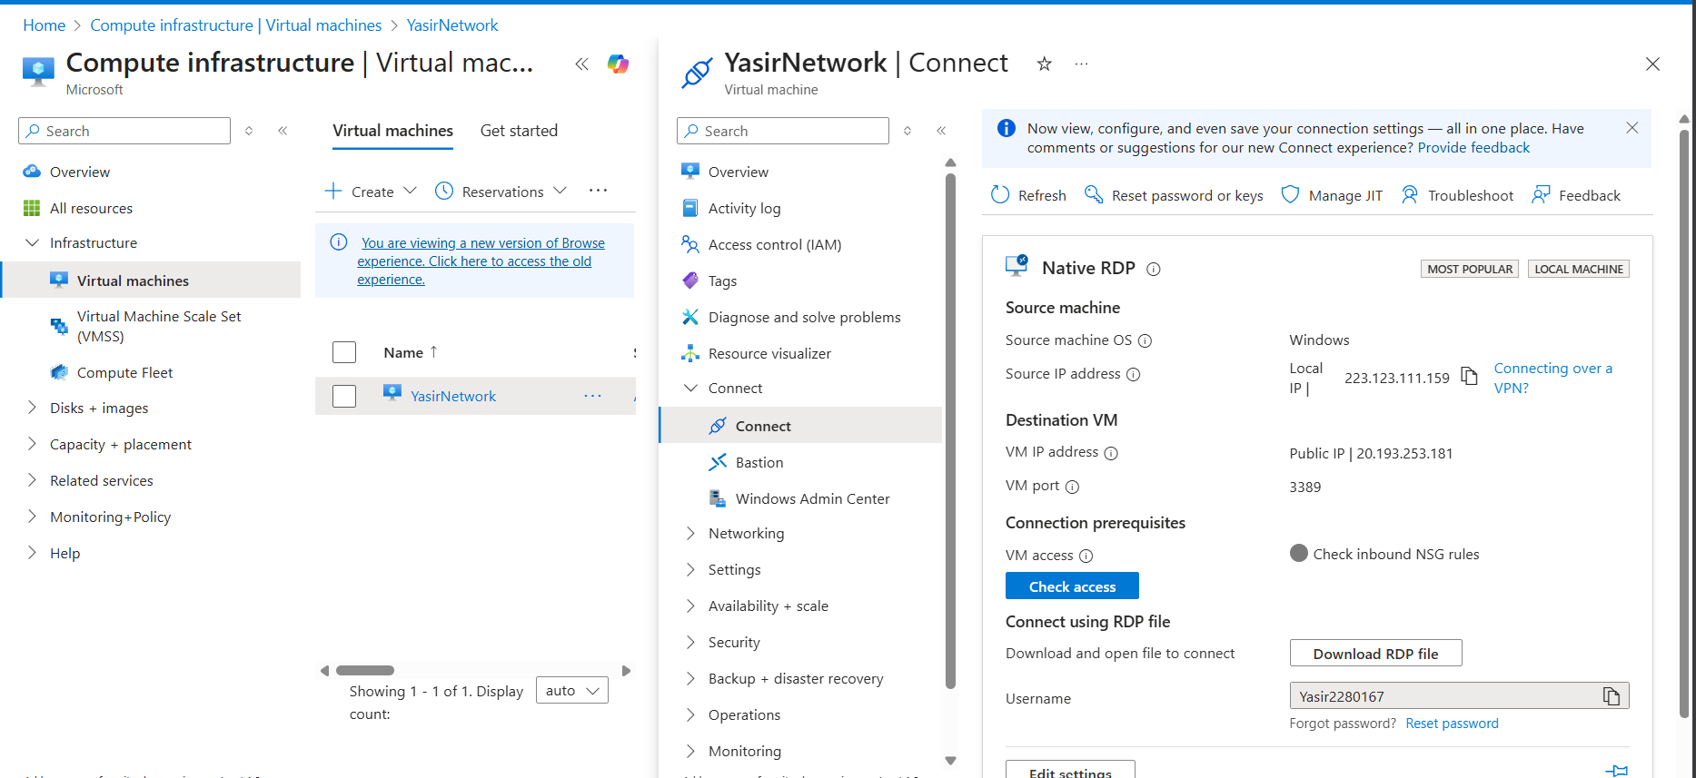
Task04: Configure an outbound security port rule to deny Internet access
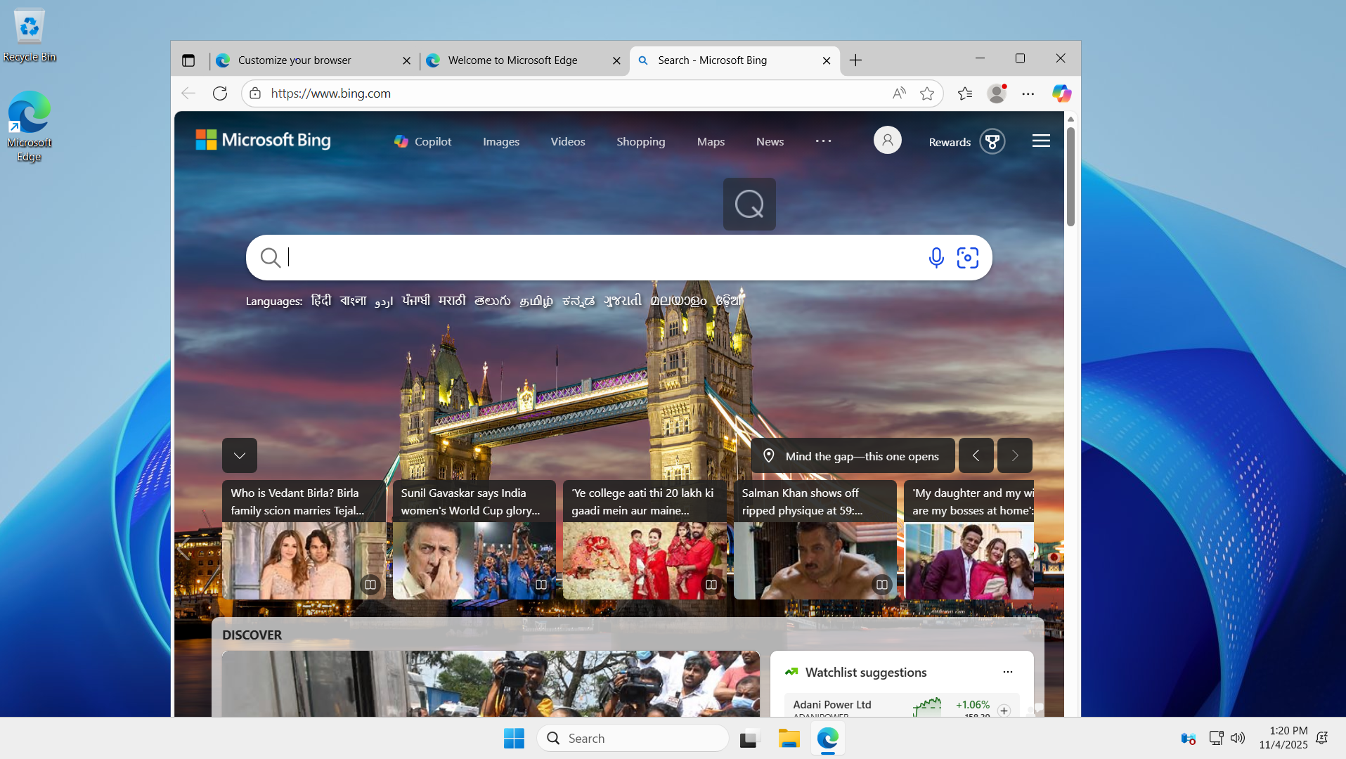
After outbond rule set
