Course: Cloud Computing
Instructor: Sir Tariq Gouri
Name: Yasir Hussain(2280167)
Program: BSSE-7B
LAB-01

Task01: View and assign roles
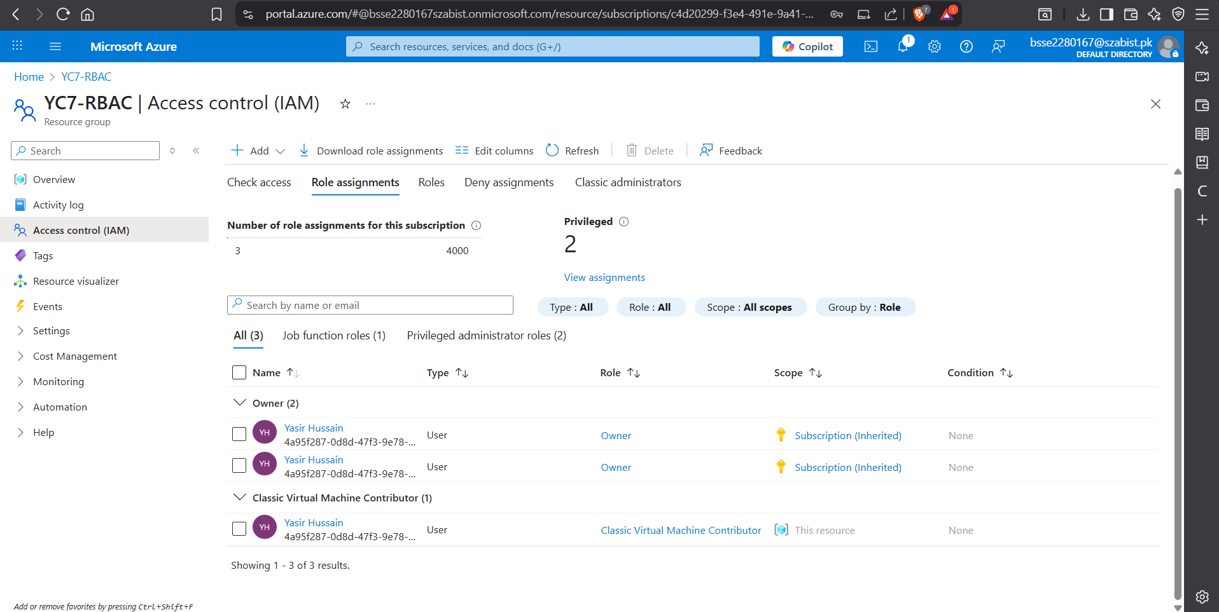
Task 2: Monitor role assignments and remove a role
