Course: Cloud Computing
Instructor: Sir Tariq Gouri
Name: Yasir Hussain(2280167)
Program: BSSE-7B
LAB-01
Task01: Add a Lock to the resource group and test deletion
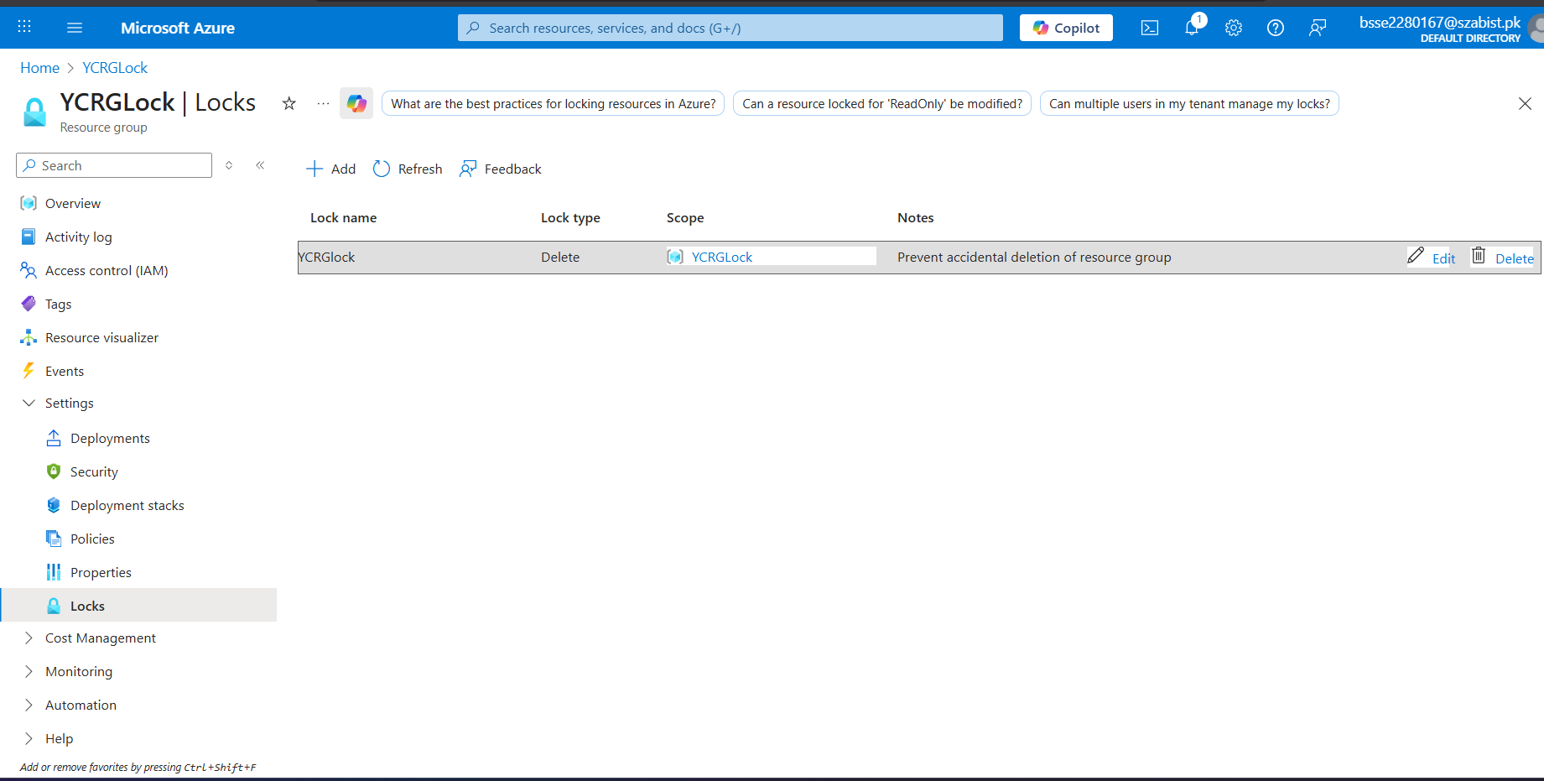
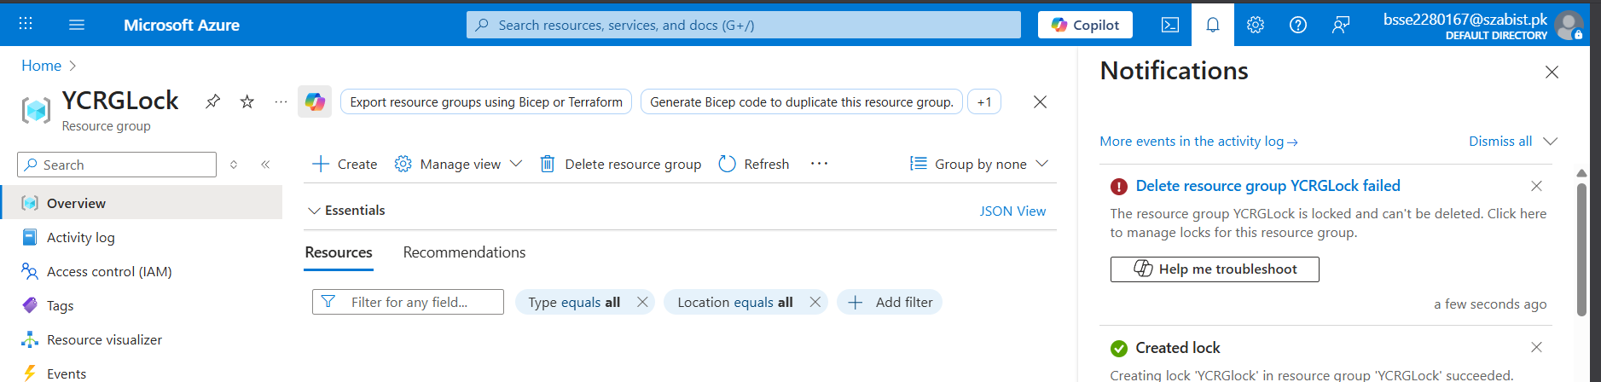
Task02: Test deleting a member of the resource group
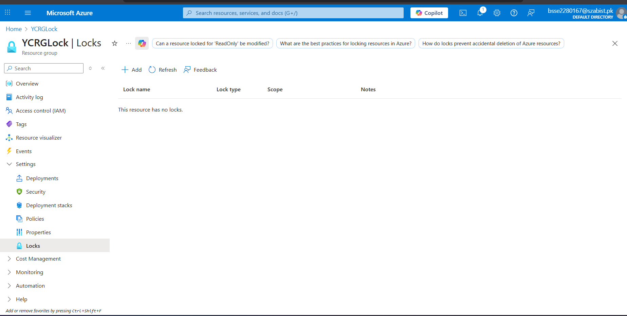
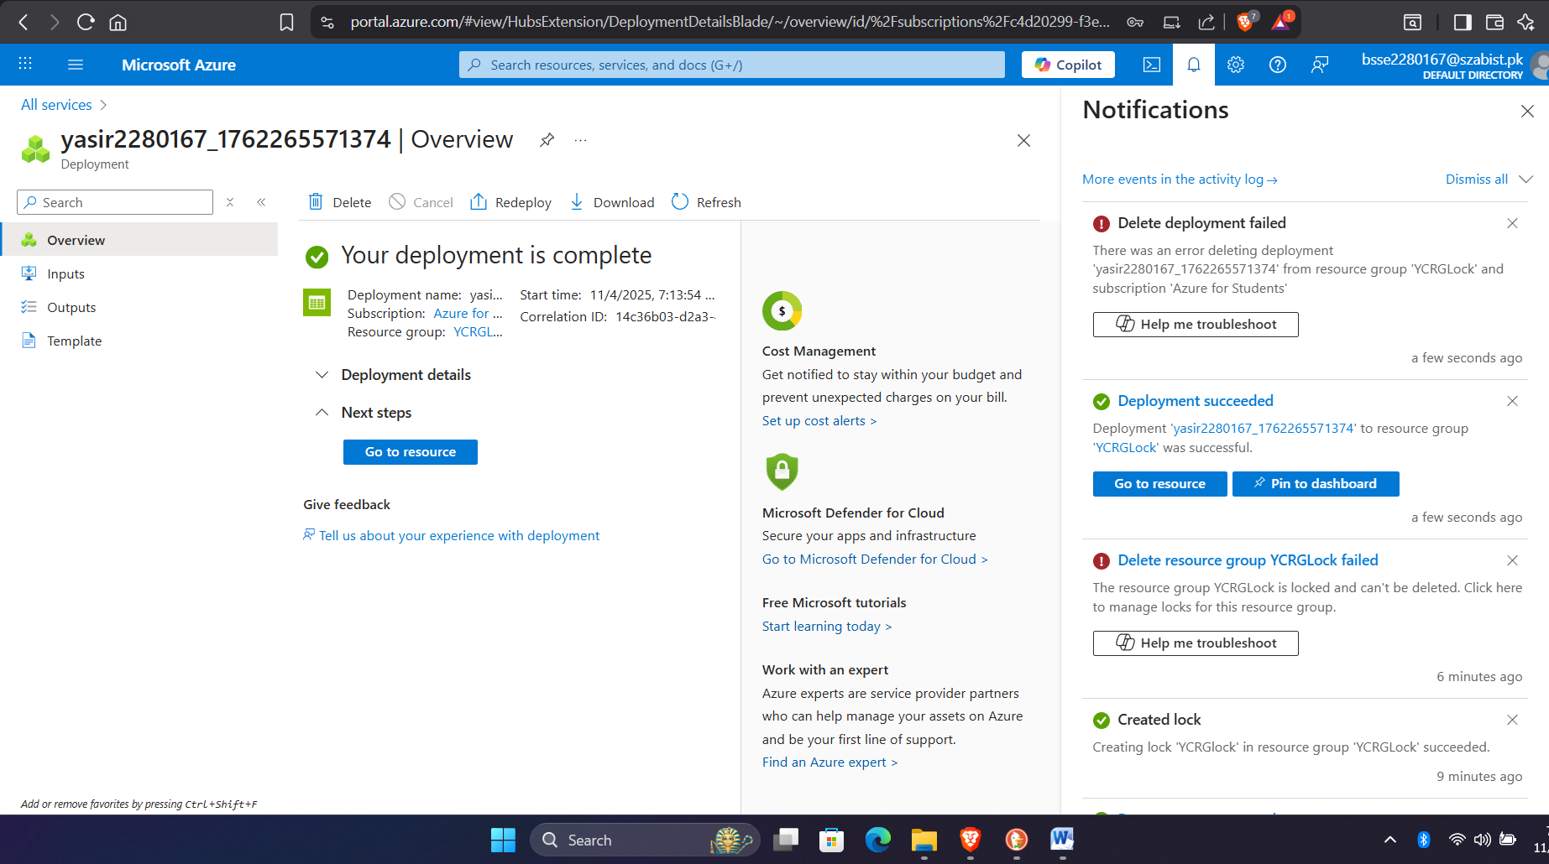
Task03: Remove the resource lock

