Course: Cloud Computing
Instructor: Sir Tariq Gouri
Name: Yasir Hussain(2280167)
Program: BSSE-7B
LAB-01
Task01: Create a Policy assignment.
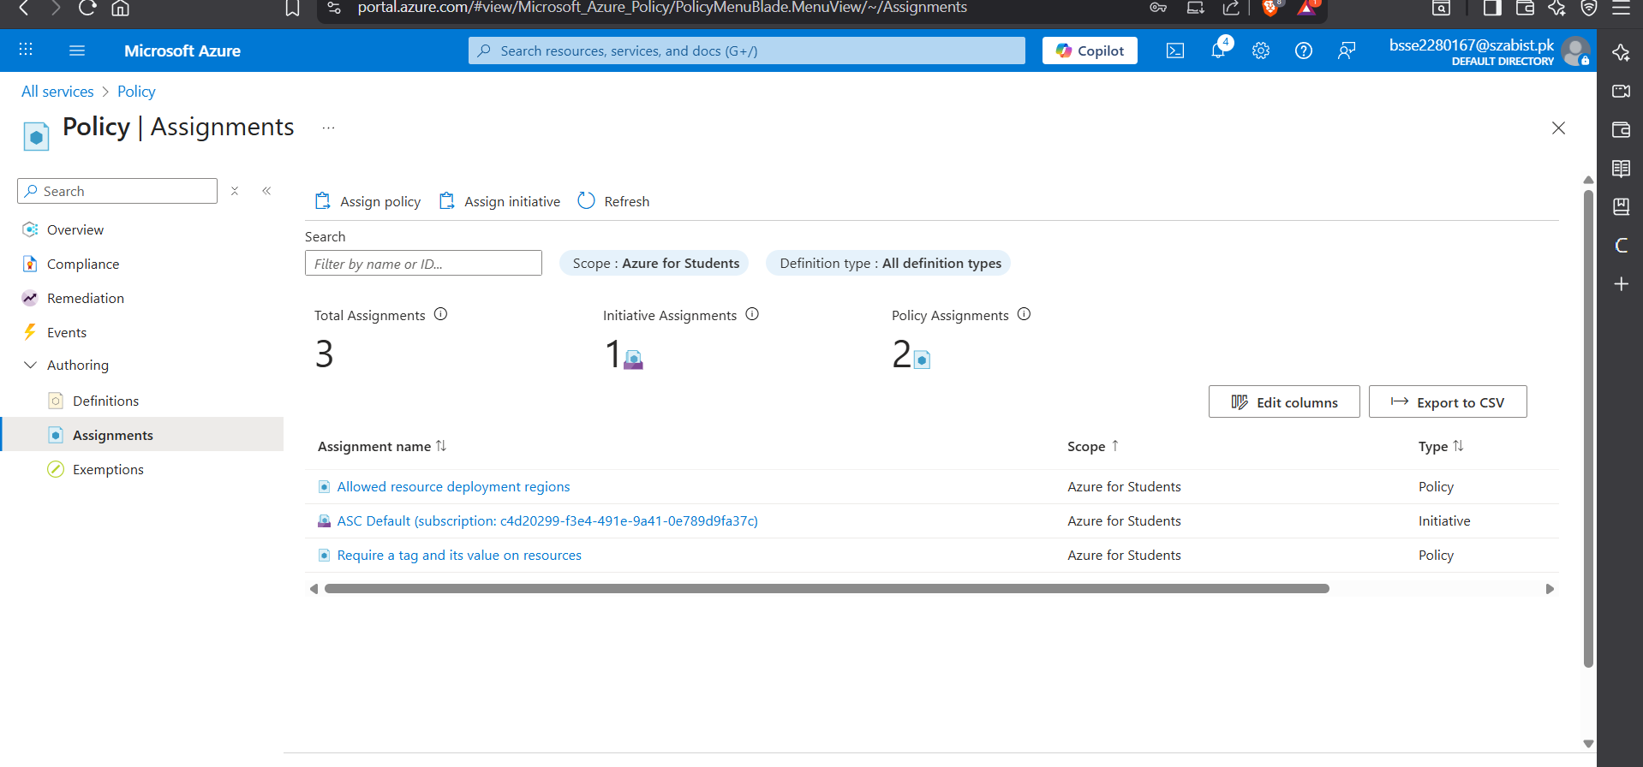
Task02: Create a storage account to test the required tagging
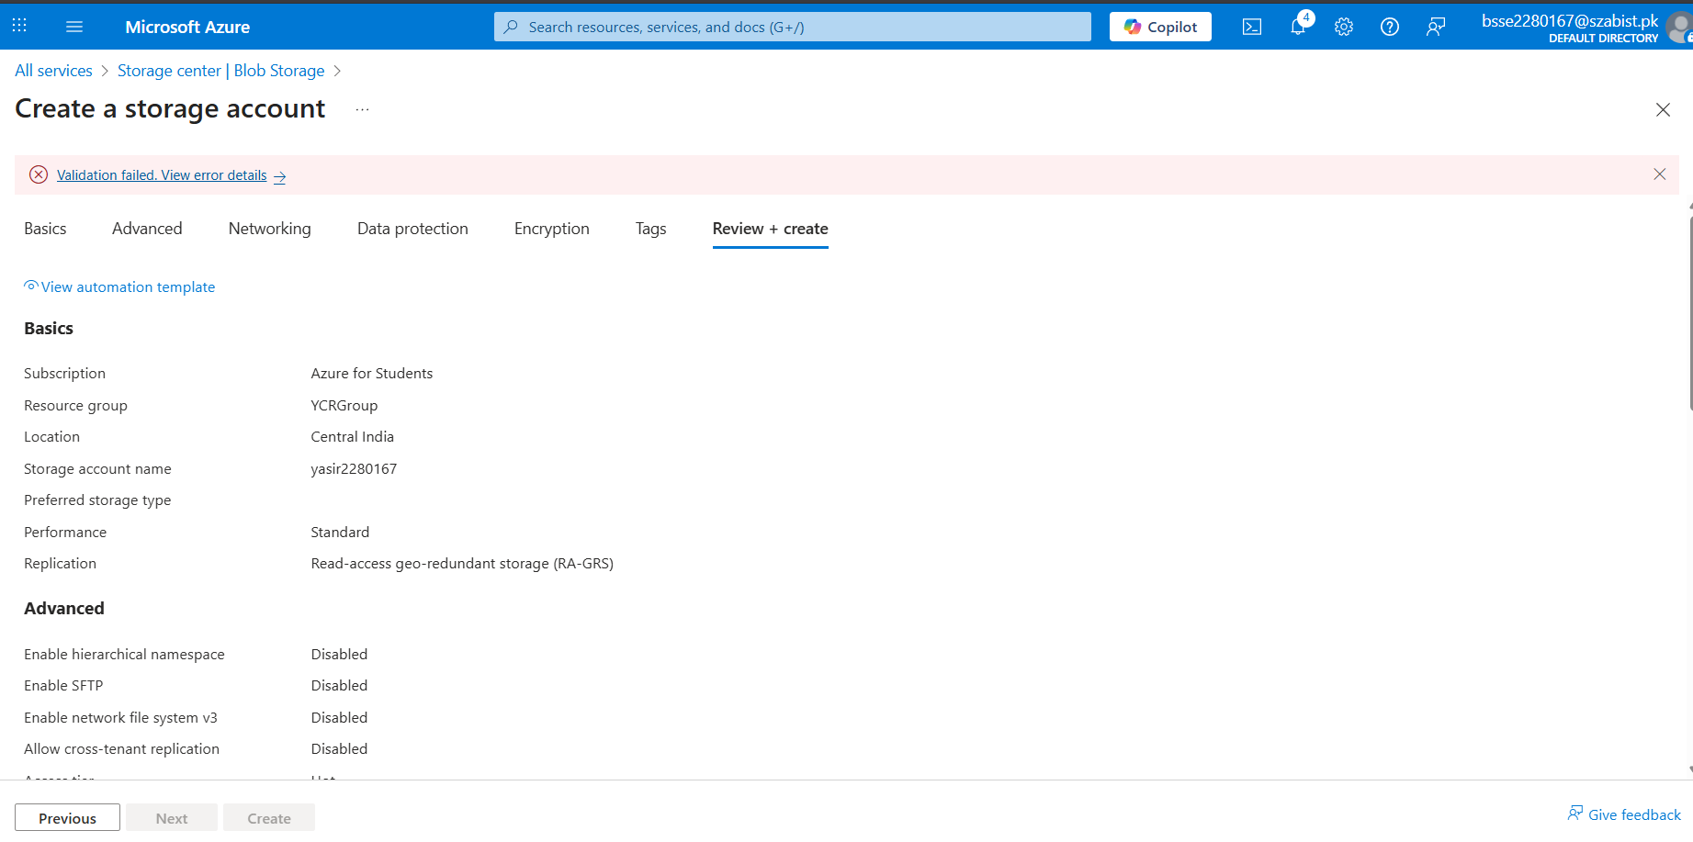
Task03: View all resources with a specific tag.
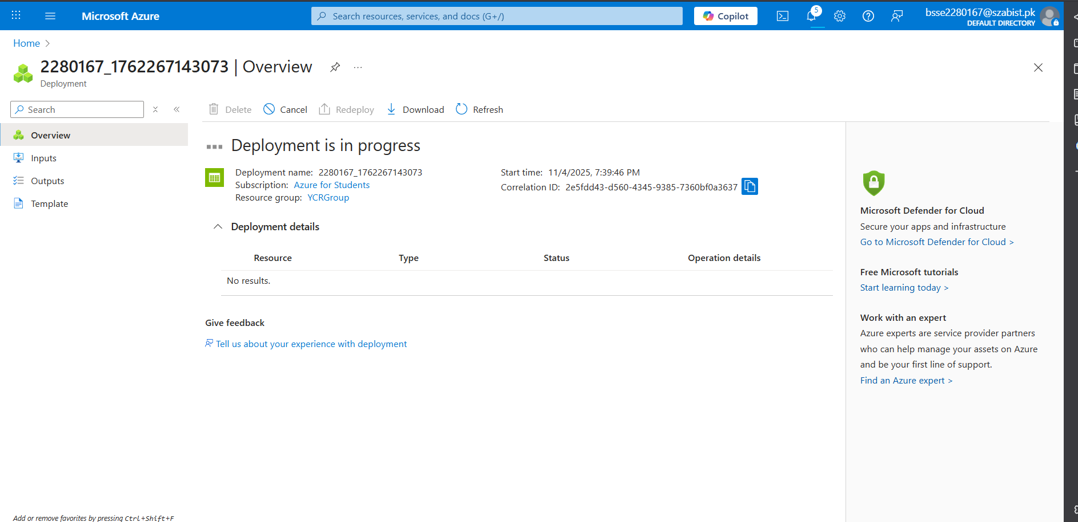
Task04: Delete the policy assignment.
