Course: Cloud Computing
Instructor: Sir Tariq Gouri
Name: Yasir Hussain(2280167)
Program: BSSE-7B
LAB-01
Task01: Create a Policy assignment.
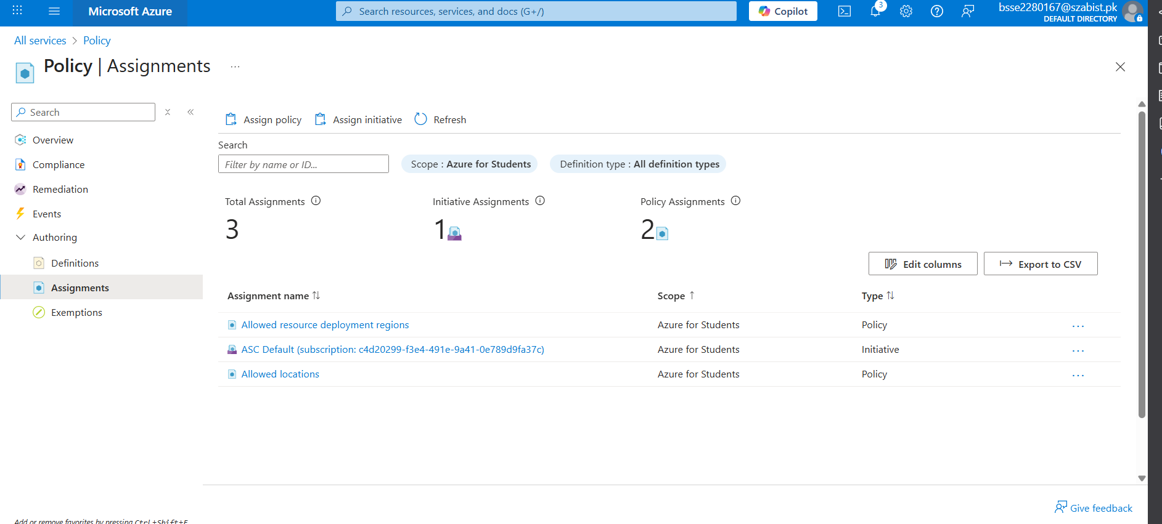
Task02: Test Allowed location policy
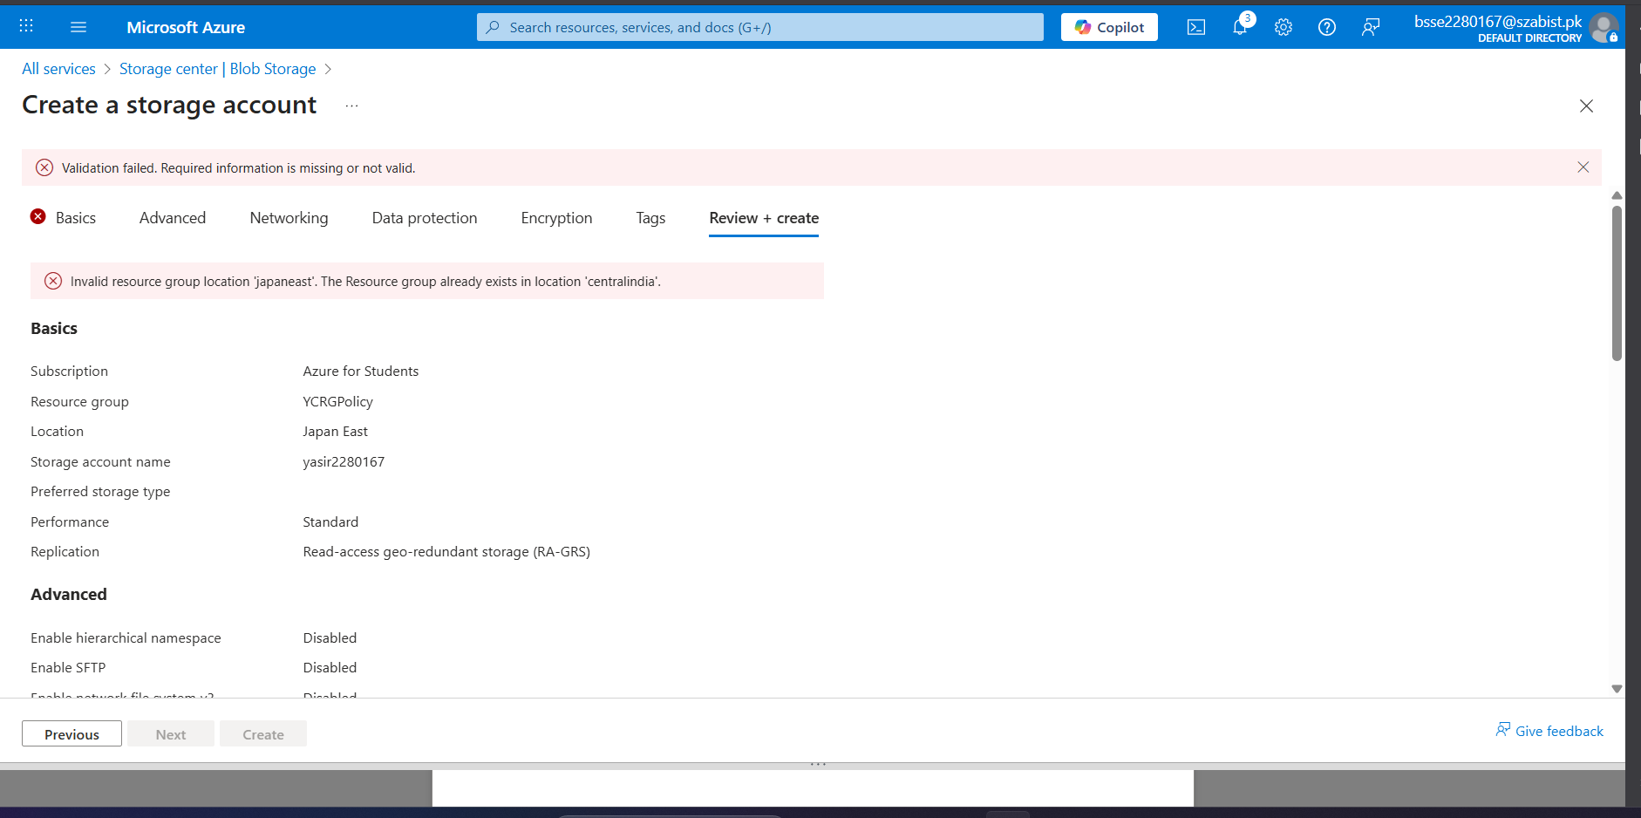
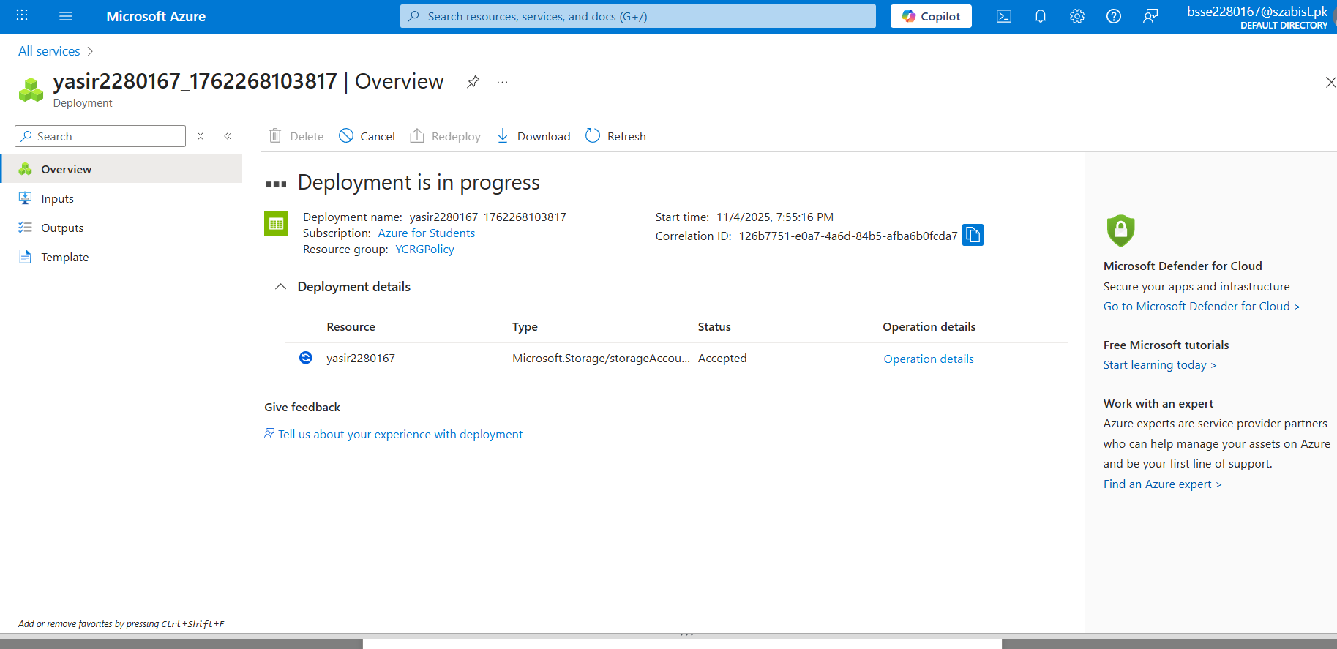
Task03: Delete the policy assignment
