Software Design Document
AI Food Nutrition Estimator for Pakistani Mess Food



Submitted by
Yasir Irfan (S23BINFT1M01118)

Submitted to
Mr. Wahaj Ali

Department of Information Technology
Faculty of Computing
The Islamia University of Bahawalpur

Summary
This Software Design Document (SDD) provides a comprehensive description of the architectural design, data model, user interface specifications, class structure, sequence interactions, and test strategy for the AI Food Nutrition Estimator for Pakistani Mess Food — a Final Year Project developed at the Department of Information Technology, The Islamia University of Bahawalpur, under the supervision of Mr. Wahaj Ali.

The system is a full-stack web application that uses a Three-Tier Architecture pattern consisting of a Streamlit-based Presentation Layer, a Flask-powered Application/Logic Layer, and an SQLite-based Data Layer. The Application Layer hosts a sequential AI pipeline composed of three models: the Segment Anything Model (SAM) for food image segmentation, BLIP-2 for vision-language food identification, and a trained Linear Regression model for macronutrient prediction.

This document covers: the overall application architecture including all components and their interactions; the data model schema with full ERD; the user interface design including color scheme, screen list, and control specifications; UML diagrams including class diagram, sequence diagrams, and architecture diagram; database design with entity definitions and relationships; and a comprehensive test case suite. All design decisions in this document are consistent with and traceable to the requirements defined in the SRS document for this project.

Table of Contents

Summary 2

1. Application Architecture 3
1.1 Architectural Pattern — Three-Tier Architecture 3
1.2 Component Overview 3
1.3 Presentation Layer — Streamlit Frontend 4
1.4 Application Layer — Flask Backend & AI Pipeline 4
1.5 Data Layer — SQLite Database 5
1.6 External Libraries and APIs 5
1.7 Architecture Diagram 6
1.8 Class Diagram 6
1.9 Sequence Diagrams 6
1.10 Coding Conventions 7

2. Data Model Schema 8
2.1 Entity: Users 8
2.2 Entity: Meals 8
2.3 Entity: Food_Items 9
2.4 Entity: Nutrition_Data 9
2.5 Entity: Goals 10
2.6 Entity: Meal_Logs 10
2.7 10
2.8 Entity Relationships Summary 11
2.9 Entity Relationship Diagram (ERD) 11

3. User Interface Design 12
3.1 Design Philosophy 12
3.2 Color Scheme and Typography 12
3.3 Screen Constraints and Responsiveness 12
3.4 List of Screens and Page Descriptions 13

4. Test Cases 16
4.1 Functional Test Cases 16
4.2 Non-Functional Test Cases 18

1. Application Architecture
This section describes the overall architectural design of the AI Food Nutrition Estimator for Pakistani Mess Food. It details the chosen architectural pattern, all system components, their roles, interactions, and the external libraries and APIs that support the system.

1.1 Architectural Pattern — Three-Tier Architecture
After evaluating multiple architectural patterns against the technical stack and requirements of this project, the Three-Tier Architecture was selected as the most appropriate pattern. This architecture cleanly separates the system into three independent, collaborating layers:

- Presentation Layer (Tier 1): The user-facing frontend built with Streamlit. Handles all UI rendering, user input collection, image upload, and display of nutrition results and dashboards.
- Application / Business Logic Layer (Tier 2): The Flask-based backend API server. Hosts all business logic, authentication handling, session management, and the complete AI inference pipeline (SAM → BLIP-2 → Linear Regression).
- Data Layer (Tier 3): The SQLite relational database. Responsible for persistent storage of user accounts, meal records, food item data, nutritional values, calorie goals, and meal logs.

This separation of concerns ensures that each layer can be independently modified or upgraded without affecting the others. For example, the Streamlit frontend can be replaced with a React or Flutter interface without changing the Flask backend or the database schema.

1.2 Component Overview
Component | Technology | Layer | Responsibility
Streamlit UI | Streamlit (Python) | Presentation | Renders web pages, handles user image upload, displays nutrition reports and dashboards
Flask API Server | Flask (Python) | Application | Routes HTTP requests, manages sessions, authenticates users, orchestrates AI pipeline
SAM Module | Segment Anything Model | Application – AI | Segments individual food items from uploaded meal images
BLIP-2 Module | BLIP-2 (Salesforce) | Application – AI | Generates natural language food descriptions from each food segment
Regression Module | Linear Regression (Scikit-learn) | Application – AI | Predicts macronutrient values from parsed BLIP-2 food descriptions
SQLite Database | SQLite 3 | Data | Stores users, meals, food items, nutrition data, goals, logs, and admin records
Auth Module | Flask-Login / bcrypt | Application | Handles user registration, password hashing, login, and session management
Export Module | Python (CSV / PDF libs) | Application | Generates downloadable meal log reports in CSV or PDF format

1.3 Presentation Layer — Streamlit Frontend
The Presentation Layer is built entirely using Streamlit, a Python-based open-source web application framework designed for building interactive data applications rapidly. Streamlit renders the UI server-side and streams updates to the browser, making it ideal for AI-powered applications where model outputs need to be displayed dynamically.

Key Streamlit screens (pages) in this system include:
- Home / Landing Page: Welcome screen with navigation to Register or Login.
- Registration Page: Form for new user account creation.
- Login Page: Authentication form with credential validation.
- Dashboard: Personalized nutrition summary, daily calorie progress, and weekly trend chart.
- Upload Meal Page: Image upload widget triggering the AI analysis pipeline via Flask API call.
- Nutrition Report Page: Displays identified food items and predicted macronutrient values.
- Meal History Page: Chronological list of all past meals with nutritional summaries.

1.4 Application Layer — Flask Backend & AI Pipeline
The Application Layer is implemented using Flask, a lightweight Python web framework. Flask serves as the RESTful API server that receives requests from the Streamlit frontend, executes the appropriate business logic, and returns structured JSON responses.

Flask Controllers (API Endpoints):
Endpoint | Method | Auth Required | Function
/api/register | POST | No | Validates input, hashes password, creates new user record in SQLite
/api/login | POST | No | Verifies credentials, creates secure session token
/api/logout | POST | Yes | Invalidates user session
/api/upload | POST | Yes | Receives meal image, triggers SAM → BLIP-2 → Regression pipeline, returns nutrition report
/api/meals | GET | Yes | Retrieves complete meal history for authenticated user
/api/meals/<id> | GET | Yes | Retrieves detailed nutrition report for a specific meal
/api/goal | POST/GET | Yes | Sets or retrieves user calorie goal
/api/export | GET | Yes | Generates and returns meal log export file

AI Pipeline — Sequential Processing Flow:
- Stage 1 – SAM Segmentation: The uploaded image is passed to the Segment Anything Model. SAM performs zero-shot instance segmentation, producing individual binary mask regions for each detected food item on the plate.
- Stage 2 – BLIP-2 Identification: Each segmented region is cropped and passed independently to the BLIP-2 vision-language model. BLIP-2 generates a natural language caption describing the food item (e.g., 'a bowl of daal makhani with rice').
- Stage 3 – Feature Parsing: The BLIP-2 caption is parsed using NLP preprocessing to extract structured features (food type, estimated quantity, preparation method) mapped to the Pakistani food nutrition database vocabulary.
- Stage 4 – Linear Regression Prediction: Parsed features are encoded and passed to the pre-trained Linear Regression model (Scikit-learn). The model outputs predicted values for Calories (kcal), Protein (g), Carbohydrates (g), Fat (g), and Fiber (g) per food segment.
- Stage 5 – Aggregation: Predictions across all segments are summed to produce the total meal nutritional report.

1.5 Data Layer — SQLite Database
The Data Layer uses SQLite , a serverless, file-based relational database management system. SQLite was chosen for this project due to its zero-configuration setup, Python integration via the sqlite3 standard library, and suitability for single-server academic deployments. The database contains 6 core tables: Users, Meals, Food_Items, Nutrition_Data, Goals, Meal_Logs.

All database interactions are handled through a dedicated data access module (db_manager.py) that abstracts raw SQL queries from the Flask controllers. This ensures separation of concerns and allows future migration to PostgreSQL or MySQL without modifying controller logic.

1.6 External Libraries and APIs
Library / Model | Version | Role and Working
Segment Anything Model (SAM) | Meta AI (2023) | Zero-shot image segmentation model. Accepts a full plate image and returns binary mask regions for each detected object/food item. Loaded via PyTorch from Hugging Face model hub.
BLIP-2 | Salesforce (2023) | Vision-language model. Accepts an image segment and returns a natural language description. Loaded via the Hugging Face transformers library with a frozen language model backbone.
Scikit-learn (Linear Regression) | 1.3+ | Machine learning library used to train and load the nutritional prediction model. Model is serialized with joblib and loaded at Flask server startup.
PyTorch | 2.0+ | Deep learning framework. Required as the runtime backend for SAM and BLIP-2 model inference.
Transformers (Hugging Face) | 4.30+ | Provides BLIP-2 model loading, tokenization, and inference utilities.
Streamlit | 1.28+ | Python-based frontend framework for rendering interactive web UI without JavaScript.
Flask | 3.0+ | Lightweight Python web framework for the RESTful backend API.
SQLite3 | (stdlib) | Python standard library module for SQLite database interactions.
bcrypt | 4.0+ | Password hashing library used for secure credential storage.
Pandas | 2.0+ | Used for data manipulation during Linear Regression training and feature engineering.
Pillow (PIL) | 10.0+ | Python image processing library for resizing, cropping, and converting uploaded meal images.

1.7 Architecture Diagram

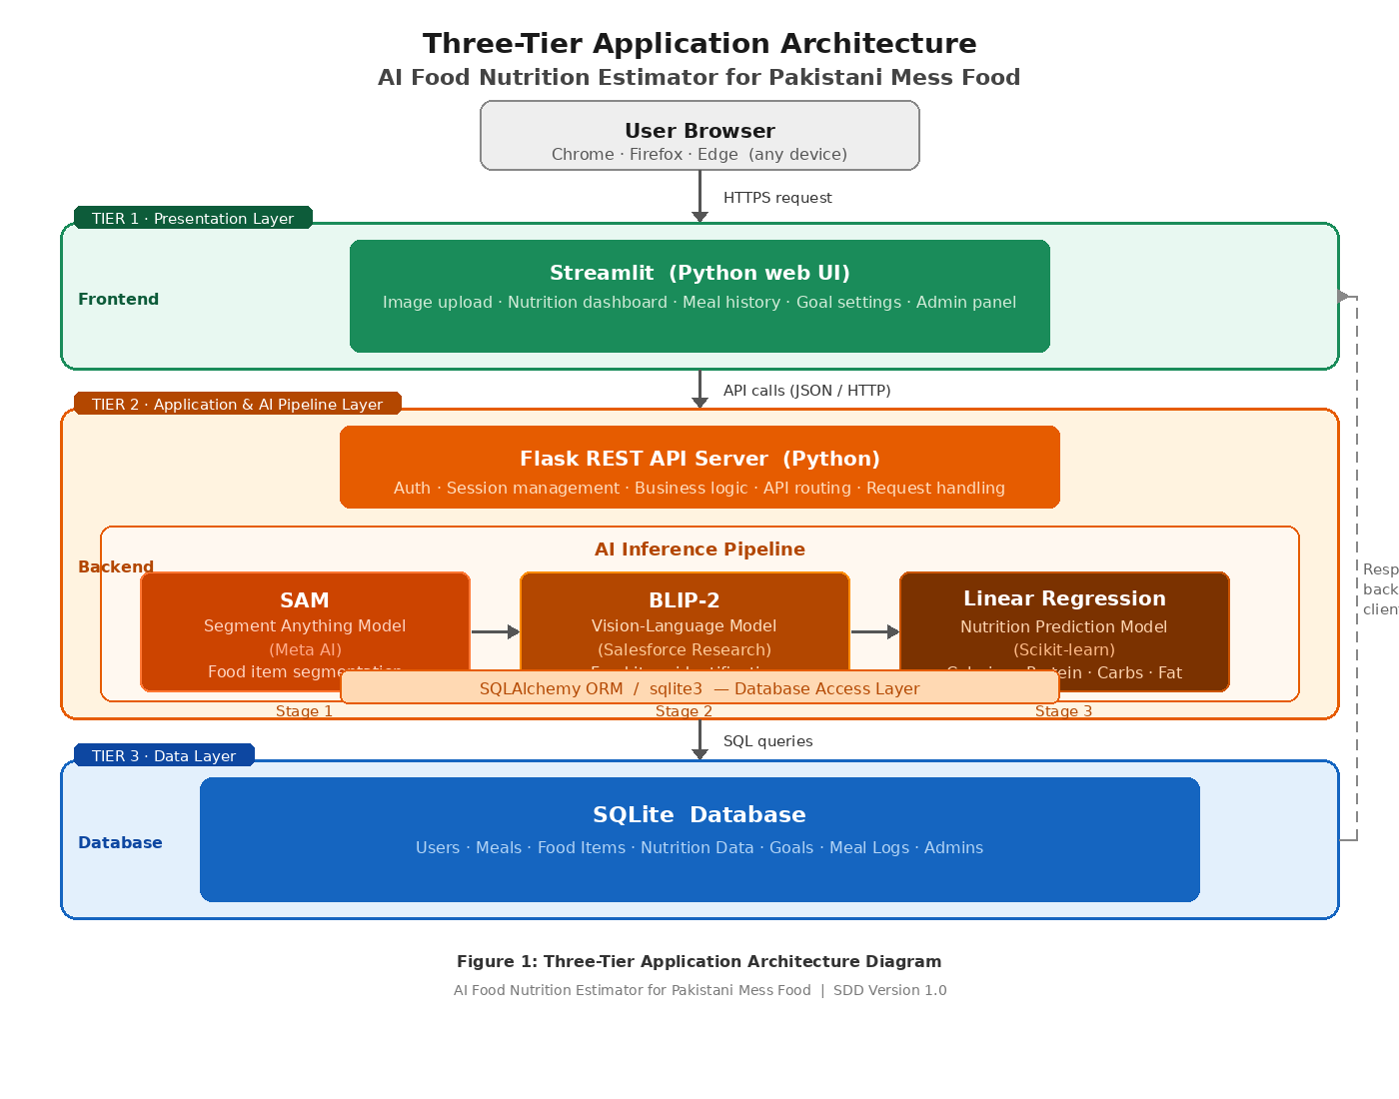
Figure 1: Three-Tier Application Architecture Diagram

1.8 Class Diagram

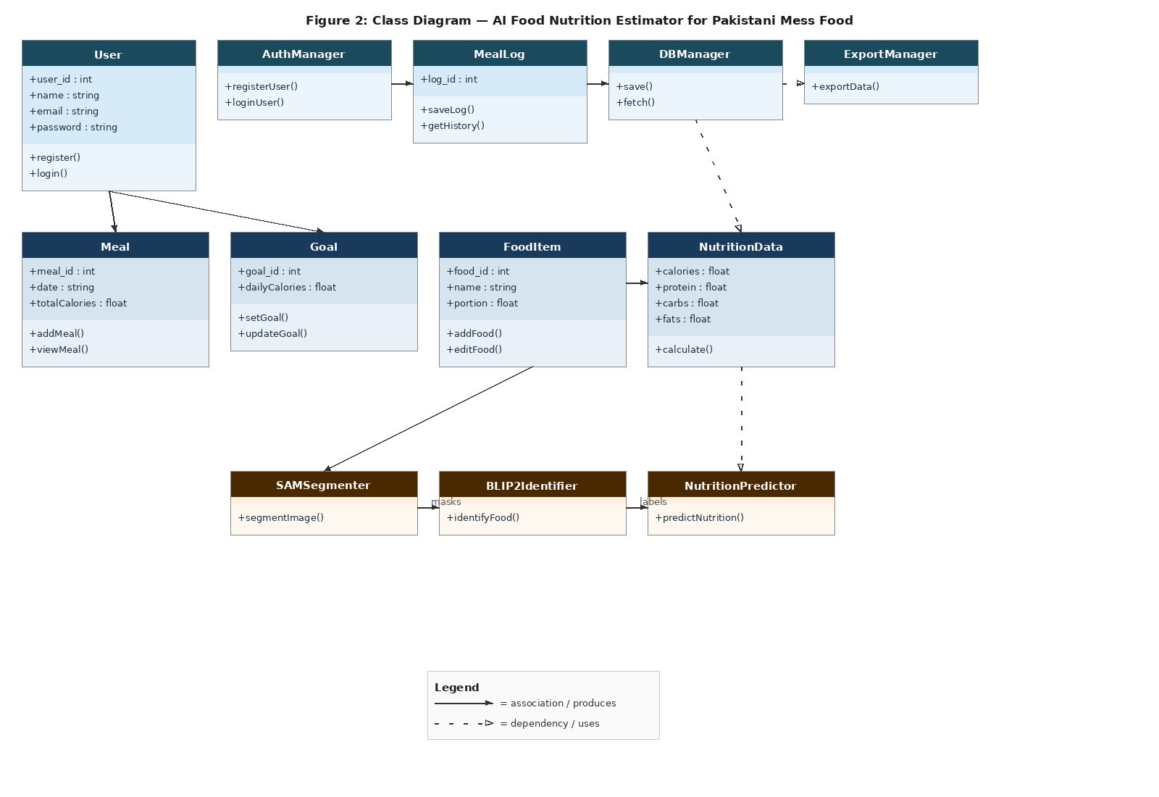

Figure 2: Class Diagram — AI Food Nutrition Estimator

Key Classes and Responsibilities:

Class Name | Key Attributes | Key Methods
User | user_id, name, email, password_hash, institution, created_at | register(), login(), logout(), set_goal(), get_history()
Meal | meal_id, user_id, image_path, timestamp, total_calories | save(), get_nutrition_report(), delete()
FoodItem | item_id, meal_id, name, segment_mask_path | identify(), get_nutrition()
NutritionData | nutrition_id, item_id, calories, protein, carbs, fat, fiber | predict(), aggregate()
Goal | goal_id, user_id, daily_calories, created_at | set_goal(), get_progress()
MealLog | log_id, user_id, meal_id, date | get_logs(), export_csv(), export_pdf()
SAMSegmenter | model_path, device | load_model(), segment(image) → masks[]
BLIP2Identifier | model_name, processor | load_model(), identify(segment) → caption
NutritionPredictor | model_path, feature_encoder | load_model(), predict(features) → NutritionData
DBManager | db_path, connection | connect(), execute(), fetch(), close()
AuthManager | secret_key, session_timeout | hash_password(), verify(), create_session(), invalidate()

1.9 Sequence Diagrams

Sequence Diagram 1: User Registration
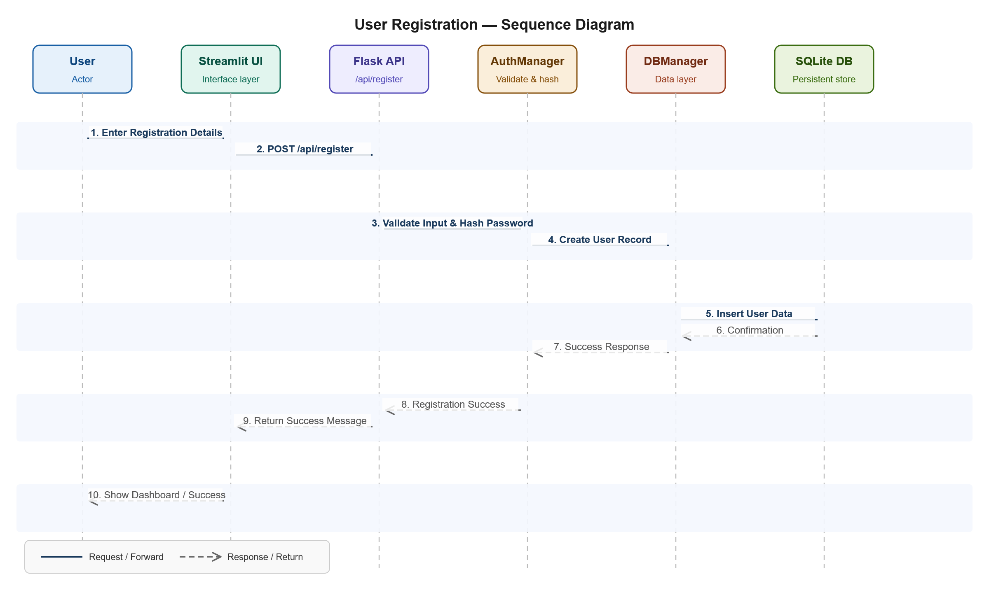
Figure 3: Sequence Diagram — User Registration

Sequence Diagram 2: Upload Meal Image & AI Pipeline

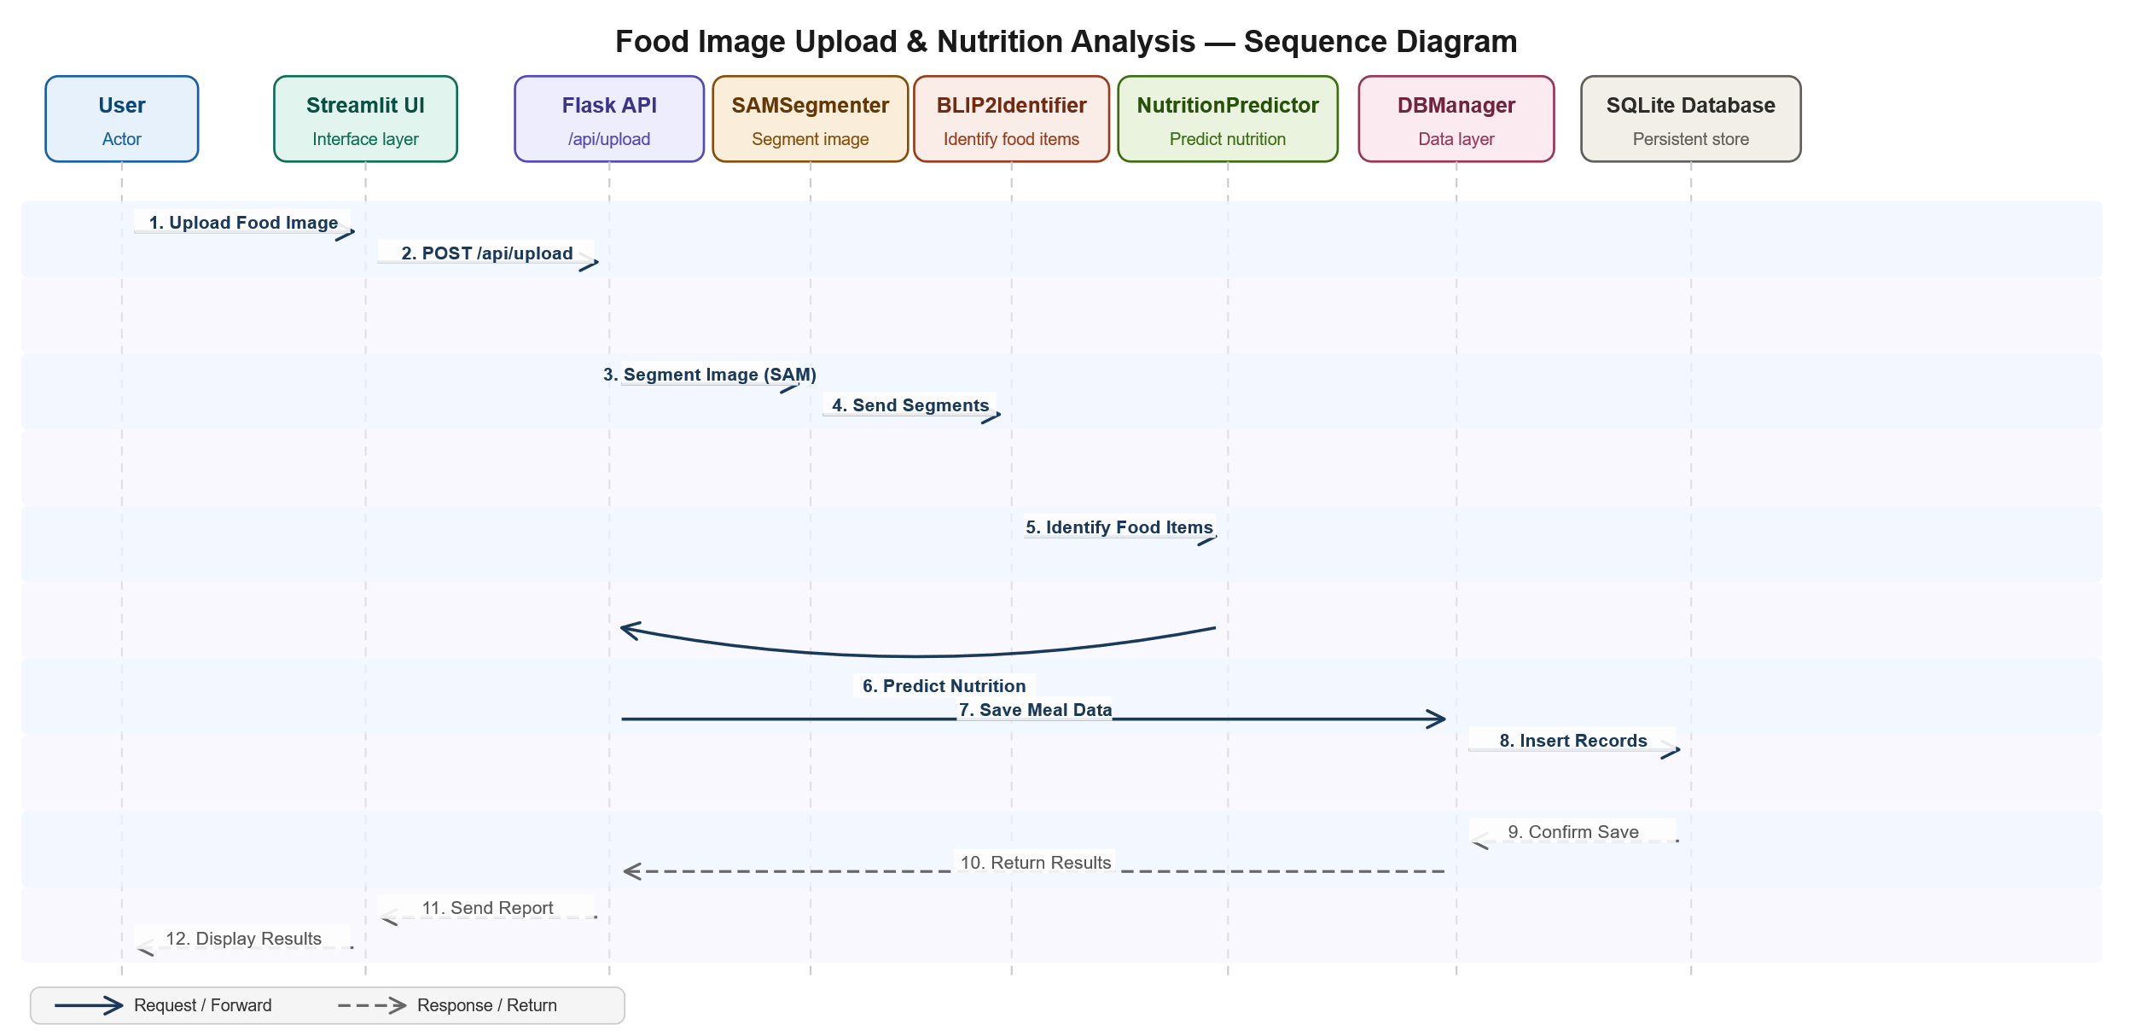
Figure 4: Sequence Diagram — Upload Meal & AI Nutrition Pipeline

1.10 Coding Conventions

The following coding conventions shall be followed throughout the development of this project:
Convention Area | Standard Applied
Language | Python 3.10+ exclusively across all layers
Naming — Variables | snake_case (e.g., user_id, meal_history, total_calories)
Naming — Classes | PascalCase (e.g., SAMSegmenter, NutritionPredictor, DBManager)
Naming — Constants | UPPER_SNAKE_CASE (e.g., MAX_IMAGE_SIZE, DB_PATH, MODEL_NAME)
Naming — API Endpoints | Lowercase with hyphens for multi-word routes (e.g., /api/meal-history)
File Structure | Modules separated: /frontend, /backend, /ai_pipeline, /database, /utils
Docstrings | PEP 257 — all public functions and classes documented with docstrings
Comments | Inline comments for non-obvious logic; no commented-out production code
Error Handling | Try-except blocks on all I/O operations, API calls, and AI inference

2. Data Model Schema
This section provides the complete database design for the AI Food Nutrition Estimator. The database uses SQLite 3 and contains 6 entities, each described below with its attributes, data types, constraints, and relationships with other entities. An Entity Relationship Diagram (ERD) is provided at the end of this section.

2.1 Entity: Users
Stores all registered user account information. This is the central entity of the system to which most other entities relate.

Column Name | Data Type | Constraint | Description
user_id | INTEGER | PRIMARY KEY, AUTOINCREMENT | Unique identifier for each user
full_name | TEXT | NOT NULL | Full name of the registered user
email | TEXT | NOT NULL, UNIQUE | Email address used for login — must be unique
password_hash | TEXT | NOT NULL | bcrypt-hashed password — plaintext never stored
institution | TEXT | NOT NULL | University or institution name of the user
is_active | INTEGER | NOT NULL, DEFAULT 1 | Account status: 1 = active, 0 = deactivated by admin
created_at | DATETIME | NOT NULL, DEFAULT CURRENT_TIMESTAMP | Timestamp of account registration

2.2 Entity: Meals
Records each meal analysis session initiated by a user. Each meal is linked to one user and can contain multiple food items.

Column Name | Data Type | Constraint | Description
meal_id | INTEGER | PRIMARY KEY, AUTOINCREMENT | Unique identifier for each meal analysis
user_id | INTEGER | FOREIGN KEY → Users(user_id), NOT NULL | References the user who uploaded this meal
image_path | TEXT | NOT NULL | Server-side file path of the uploaded meal image
total_calories | REAL | NOT NULL, DEFAULT 0 | Aggregated calorie total across all food items
total_protein | REAL | NOT NULL, DEFAULT 0 | Aggregated protein total (grams)
total_carbs | REAL | NOT NULL, DEFAULT 0 | Aggregated carbohydrate total (grams)
total_fat | REAL | NOT NULL, DEFAULT 0 | Aggregated fat total (grams)
total_fiber | REAL | NOT NULL, DEFAULT 0 | Aggregated dietary fiber total (grams)
analyzed_at | DATETIME | NOT NULL, DEFAULT CURRENT_TIMESTAMP | Timestamp when the meal was analyzed

2.3 Entity: Food_Items
Stores each individual food item detected within a meal by the SAM and BLIP-2 pipeline. Each food item belongs to one meal and has its own nutrition prediction record.

Column Name | Data Type | Constraint | Description
item_id | INTEGER | PRIMARY KEY, AUTOINCREMENT | Unique identifier for each detected food item
meal_id | INTEGER | FOREIGN KEY → Meals(meal_id), NOT NULL | References the parent meal this item belongs to
item_name | TEXT | NOT NULL | Food item name generated by BLIP-2 (e.g., 'Daal Makhani')
segment_path | TEXT | NULL | File path of the cropped segment image from SAM output
blip2_caption | TEXT | NULL | Full natural language caption generated by BLIP-2 for this segment
confidence | REAL | NULL | Confidence score of BLIP-2 identification (0.0 – 1.0)

2.4 Entity: Nutrition_Data
Stores the predicted macronutrient values for each individual food item. Has a one-to-one relationship with Food_Items.

Column Name | Data Type | Constraint | Description
nutrition_id | INTEGER | PRIMARY KEY, AUTOINCREMENT | Unique identifier for each nutrition record
item_id | INTEGER | FOREIGN KEY → Food_Items(item_id), NOT NULL, UNIQUE | References the food item — one-to-one
calories | REAL | NOT NULL | Predicted calories in kcal for this food item
protein | REAL | NOT NULL | Predicted protein content in grams
carbohydrates | REAL | NOT NULL | Predicted carbohydrate content in grams
fat | REAL | NOT NULL | Predicted fat content in grams
fiber | REAL | NOT NULL | Predicted dietary fiber content in grams

2.5 Entity: Goals
Stores the personal daily calorie targets set by each user. Each user can have one active goal at a time.

Column Name | Data Type | Constraint | Description
goal_id | INTEGER | PRIMARY KEY, AUTOINCREMENT | Unique identifier for each goal record
user_id | INTEGER | FOREIGN KEY → Users(user_id), NOT NULL | References the user who set this goal
daily_calories | INTEGER | NOT NULL | Target daily calorie intake in kcal set by the user
created_at | DATETIME | NOT NULL, DEFAULT CURRENT_TIMESTAMP | Timestamp when the goal was created or last updated
is_active | INTEGER | NOT NULL, DEFAULT 1 | Indicates the current active goal: 1 = active

2.6 Entity: Meal_Logs
Acts as a daily log linking users to their meals on a specific date. Supports daily and weekly aggregation for the nutritional dashboard.

Column Name | Data Type | Constraint | Description
log_id | INTEGER | PRIMARY KEY, AUTOINCREMENT | Unique identifier for each log entry
user_id | INTEGER | FOREIGN KEY → Users(user_id), NOT NULL | References the user this log belongs to
meal_id | INTEGER | FOREIGN KEY → Meals(meal_id), NOT NULL | References the meal being logged
log_date | DATE | NOT NULL | Calendar date this meal was logged (YYYY-MM-DD format)

2.8 Entity Relationships Summary

From Entity | To Entity | Relationship | Description
Users | Meals | One-to-Many | One user can have many meal analyses
Users | Goals | One-to-Many | One user can set multiple goals over time (one active at a time)
Users | Meal_Logs | One-to-Many | One user has many daily meal log entries
Meals | Food_Items | One-to-Many | One meal contains multiple detected food items
Meals | Meal_Logs | One-to-Many | One meal can appear in multiple daily log records
Food_Items | Nutrition_Data | One-to-One | Each food item has exactly one nutrition prediction record

2.9 Entity Relationship Diagram (ERD)

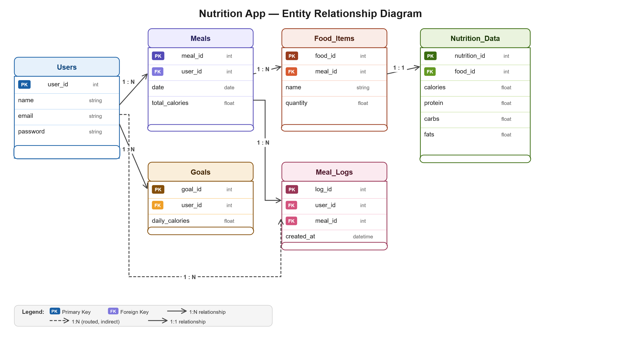
Figure 6: Entity Relationship Diagram (ERD) — AI Food Nutrition Estimator Database

3. User Interface Design

3.1 Design Philosophy
The UI design of the AI Food Nutrition Estimator follows a Clean, Minimal, and Function-First design philosophy. The interface prioritizes ease of use and clarity of information over visual complexity. Since the primary users are university students who interact with the app daily for quick meal tracking, the design minimizes cognitive load, reduces the number of steps per task, and presents nutritional data in a visually comprehensible format using charts and color-coded indicators.

The Streamlit framework enforces a single-column, top-to-bottom layout by default, which suits the linear workflow of this application: login → upload → view results → check history. This natural workflow is leveraged throughout the UI design to create an intuitive user journey.

3.2 Color Scheme and Typography
Element | Color / Value | Usage
Primary Color | #1A5C2A (Deep Green) | Navigation bar, primary buttons, section headers
Accent Color | #27AE60 (Medium Green) | Secondary buttons, active states, highlights, progress bars
Light Fill | #D5F5E3 (Pale Green) | Card backgrounds, info boxes, table alternate rows
Background | #FFFFFF (White) | Page background, form fields
Body Text | #1C1C1C (Near Black) | All body text and labels
Secondary Text | #666666 (Gray) | Placeholders, captions, helper text
Error / Warning | #E74C3C (Red) | Validation errors, failed login messages
Success | #2ECC71 (Bright Green) | Success confirmations, positive notifications
Primary Font | Arial / Sans-serif | All headings and body text for cross-platform consistency
Heading Size | 18px–24px Bold | Section headings and page titles
Body Size | 14px–16px Regular | All body text, labels, and form input text

3.3 Screen Constraints and Responsiveness
- Target Screen: Desktop browsers at 1280×720 resolution and above (primary use case via university lab computers and personal laptops).
- Minimum Screen Width: 768px (tablet). Streamlit's built-in responsive layout handles tablet displays automatically.
- Mobile Support: Streamlit provides basic mobile rendering. The application will be functional but is not optimized for screens below 768px in this version.
- Image Upload: Supported via standard browser file picker. Images are resized server-side to a maximum of 1024×1024 pixels before AI processing to optimize inference performance.
- Dashboard Charts: Rendered using Streamlit's built-in charting (st.bar_chart, st.line_chart) and Plotly integration for the macronutrient distribution pie chart.

3.4 List of Screens and Page Descriptions

Screen 1: Home / Landing Page
Screen Name | Home / Landing Page
Accessible By | All visitors (unauthenticated)
Purpose | Introduces the system and directs users to Register or Login
Data Displayed | Application title, tagline, brief description, navigation buttons
Controls | Register Button (→ Registration Page), Login Button (→ Login Page)
Input Constraints | None — no data entry on this screen

Screen 2: Registration Page
Screen Name | User Registration
Accessible By | Unauthenticated visitors
Purpose | Allows new users to create an account
Data Displayed | Registration form with field labels and validation messages
Controls | Text inputs: Full Name, Email, Institution, Password, Confirm Password; Submit Button; Link to Login Page
Input Constraints | Full Name: required, max 100 chars. Email: required, valid format, unique. Password: min 8 chars, at least one number. Confirm Password: must match Password.

Screen 3: Login Page
Screen Name | User Login
Accessible By | Registered users and Admin
Purpose | Authenticates users and creates a secure session
Data Displayed | Login form, error messages on failure
Controls | Email input, Password input, Login Button, Forgot Password link
Input Constraints | Email: required, valid format. Password: required. Account locked after 5 consecutive failures.

Screen 4: Dashboard
Screen Name | Nutrition Dashboard
Accessible By | Authenticated Users
Purpose | Displays personalized daily nutritional summary and weekly trends
Data Displayed | Daily calorie total, calorie goal progress bar, macronutrient summary cards, weekly calorie line chart, recent meals list
Controls | Navigation sidebar links, Upload New Meal button, View Full History button
Input Constraints | Display only — no direct data entry on dashboard

Screen 5: Upload Meal Page
Screen Name | Upload Meal Image
Accessible By | Authenticated Users
Purpose | Allows user to upload a meal photo and trigger AI nutrition analysis
Data Displayed | Upload widget, image preview after selection, loading spinner during processing
Controls | File uploader (st.file_uploader): accepts JPEG/PNG, max 10 MB; Analyze Meal Button; Cancel Button
Input Constraints | File type: JPEG or PNG only. Max size: 10 MB. One image per analysis session.

Screen 6: Nutrition Report Page
Screen Name | Nutrition Report
Accessible By | Authenticated Users (post meal analysis)
Purpose | Displays the complete AI-generated nutrition report for the analyzed meal
Data Displayed | List of identified food items with names, per-item nutrition table (calories, protein, carbs, fat, fiber), total meal nutrition summary, macronutrient pie chart
Controls | Save to History Button (auto-saved), Back to Upload Button, Share / Export option
Input Constraints | Display only — all data is AI-generated and read-only on this screen

Screen 7: Meal History Page
Screen Name | Meal History
Accessible By | Authenticated Users
Purpose | Shows all past meal analyses in chronological order
Data Displayed | Table of meals: date, thumbnail, identified food items, total calories; expandable detail view per meal
Controls | Date range filter (date picker), Search by food name (text input), View Detail button per row, Export Report button
Input Constraints | Date filter: valid date range, start date must not exceed end date

Screen 8: Goal Settings Page
Screen Name | Calorie Goal Settings
Accessible By | Authenticated Users
Purpose | Allows user to set or update their daily calorie intake target
Data Displayed | Current active goal, goal progress today, input form to set new goal
Controls | Number input for daily calorie target (positive integer), Save Goal Button, Reset Goal Button
Input Constraints | Daily calorie target: required, positive integer, min 500 kcal, max 5000 kcal

4. Test Cases
This section provides comprehensive test cases covering the functional and non-functional requirements of the AI Food Nutrition Estimator. Test cases are categorized into Functional and Non-Functional tests.

4.1 Functional Test Cases
TC # | Feature | Test Scenario | Steps / Input | Expected Result | Status
TC-01 | User Registration | Register with valid data | Enter valid name, email, institution, password → Submit | Account created; user redirected to login | Pass
TC-02 | User Registration | Register with duplicate email | Enter already-registered email → Submit | Error: 'Email already exists' shown | Pass
TC-03 | User Registration | Register with weak password | Enter password less than 8 chars → Submit | Error: 'Password too weak' shown | Pass
TC-04 | User Login | Login with valid credentials | Enter correct email and password → Login | User authenticated; redirected to dashboard | Pass
TC-05 | User Login | Login with wrong password | Enter correct email, wrong password → Login | Error: 'Invalid credentials' shown | Pass
TC-06 | User Login | Account lockout after 5 failures | Enter wrong password 5 times consecutively | Account locked message displayed for 15 mins | Pass
TC-07 | Image Upload | Upload valid JPEG image | Select JPEG file < 10 MB → Analyze Meal | Image accepted; AI pipeline triggered | Pass
TC-08 | Image Upload | Upload invalid file type | Select .pdf or .txt file → Analyze Meal | Error: 'Only JPEG/PNG accepted' shown | Pass
TC-09 | Image Upload | Upload oversized image | Select image > 10 MB → Analyze Meal | Error: 'File size exceeds 10 MB limit' shown | Pass
TC-10 | AI Pipeline – SAM | Segment meal with multiple food items | Upload multi-dish plate image | Multiple segment masks returned correctly | Pass
TC-11 | AI Pipeline – BLIP-2 | Identify Pakistani food item | Pass biryani segment to BLIP-2 | Caption contains 'rice' or 'biryani' keyword | Pass
TC-12 | AI Pipeline – Regression | Predict nutrition values | Pass valid food features to Linear Regression model | Non-negative numeric values returned for all 5 nutrients | Pass
TC-13 | Nutrition Report | Display aggregated report | Complete full pipeline with 3-item meal | Report shows 3 food items with per-item and total nutrition values | Pass
TC-14 | Meal History | View saved meals | Upload 3 meals then navigate to History | All 3 meals displayed in chronological order | Pass
TC-15 | Calorie Goal | Set valid calorie goal | Enter 2000 in goal field → Save | Goal saved; dashboard shows progress bar toward 2000 kcal | Pass
TC-16 | Calorie Goal | Set invalid goal value | Enter -500 or 'abc' → Save | Validation error shown; goal not saved | Pass
TC-17 | Export | Export meal log as CSV | Navigate to export → Select CSV → Download | Downloadable CSV file generated with all meal records | Pass
TC-18 | Export | Export with no meal history | Navigate to export with no meals logged | Export button disabled; prompt shown to upload first meal | Pass
TC-19 | Admin – Manage Users | Deactivate a user account | Admin selects user → Deactivate → Confirm | User status set to inactive; user cannot login | Pass
TC-20 | Admin – Delete User | Delete a user account | Admin selects user → Delete → Confirm | User and all meal data permanently removed from database | Pass
TC-21 | Admin – Self-Delete | Admin attempts to delete own account | Admin selects own account → Delete | System blocks action; error message displayed | Pass
TC-22 | Session Timeout | Auto-logout after inactivity | Leave session idle for 30+ minutes | User automatically logged out; redirected to login page | Pass

4.2 Non-Functional Test Cases
TC # | NFR Category | Test Scenario | Test Method / Input | Expected Result | Status
TC-23 | Performance | AI pipeline response time | Upload standard meal image on GPU-enabled server; measure time | Full report returned within 30 seconds | Pass
TC-24 | Performance | Page load time | Load dashboard with 100 meal records; measure browser load time | Dashboard loads within 3 seconds on 10 Mbps connection | Pass
TC-25 | Performance | Concurrent sessions | Simulate 50 simultaneous user sessions with Locust load test | No crashes or significant slowdown observed | Pass
TC-26 | Security | Password stored hashed | Register user; inspect SQLite database record directly | password_hash column contains bcrypt hash, not plaintext | Pass
TC-27 | Security | HTTPS enforcement | Attempt HTTP connection to the deployed server | Server redirects to HTTPS; no plaintext data transmitted | Pass
TC-28 | Security | Role-based access control | Attempt to access /admin/users as a regular user | 403 Forbidden returned; admin panel not accessible | Pass
TC-29 | Security | SQL injection attempt | Enter ' OR 1=1 -- in login email field | Input sanitized; no SQL error; invalid credentials message shown | Pass
TC-30 | Usability | New user onboarding | Ask 5 new users to register and upload first meal; measure time | All users complete the task within 5 minutes without assistance | Pass
TC-31 | Reliability | AI pipeline graceful failure | Pass a corrupt or blank image to the pipeline | User-friendly error message shown; app does not crash | Pass
TC-32 | Reliability | Database backup verification | Check backup files after 24-hour interval | SQLite backup file created and readable | Pass
TC-33 | Maintainability | Module independence | Modify db_manager.py without changing flask_routes.py | System functions correctly after isolated module change | Pass

