
The Islamia University of Bahawalpur
Department of Information Technology
Faculty of Computing

SOFTWARE REQUIREMENTS SPECIFICATION
(SRS DOCUMENT)
for
AI Food Nutrition Estimator for Pakistani Mess Food

By
Yasir Irfan
Roll No: S23BINFT1M01118
Session Spring/Fall 2023 – 2027
Supervisor
Mr. Wahaj Ali
Bachelor of Science in Information Technology

Summary
This Software Requirements Specification (SRS) document presents a comprehensive and detailed description of the requirements for the AI Food Nutrition Estimator for Pakistani Mess Food, a final year project developed at The Islamia University of Bahawalpur, Department of Information Technology. The system is a full-stack, AI-powered web application designed to automatically estimate the nutritional content of Pakistani hostel and mess food items using a photograph as the sole input.

The system integrates three advanced artificial intelligence models: the Segment Anything Model (SAM) for food item segmentation, BLIP-2 for vision-language understanding and food identification, and a trained Linear Regression model for macronutrient prediction. The application is built using Streamlit as the frontend interface, Flask as the backend REST API, and SQLite as the persistent data store for user accounts and meal history.

This document covers the system's functional requirements, non-functional requirements, use case descriptions, operating environment, design constraints, and external interface requirements. It is intended for the development team, project supervisor Mr. Wahaj Ali, and academic evaluators. The document follows the IEEE Std 830-1998 recommended practice for Software Requirements Specifications and has been adapted to conform to the SRS template provided by The Islamia University of Bahawalpur.

Table of Contents
1. Introduction 5
1.1 Purpose 5
1.2 Scope 5
1.3 Product Perspective 6
1.4 User Characteristics 6
1.5 Similar Apps and Systems / Literature Review 7
1.6 Proposed Technologies 8
2. Overall Description 9
2.1 Operating Environment 9
2.2 Design and Implementation Constraints 9
2.3 Assumptions and Dependencies 10
3. Requirement Identifying Technique 11
3.1 Use Case Diagram 11
3.2 Use Case Descriptions 11
UC-1: User Registration and Login 11
UC-2: Upload Food Image 12
UC-3: AI Nutrition Analysis 12
UC-4: View Nutrition Results 13
UC-5: Meal History and Dashboard 13
4. Functional Requirements 15
FR-01: User Registration 15
FR-02: User Authentication and Login 15
FR-03: Food Image Upload 16
FR-04: AI-Based Food Segmentation (SAM) 16
FR-05: Food Identification via BLIP-2 17
FR-06: Nutrition Prediction via Linear Regression 17
FR-07: Nutrition Results Display 18
FR-08: Meal History and Logging 18
FR-09: Daily Nutrition Dashboard 19
FR-10: Calorie Goal Setting 19
FR-11: Meal Log Export 20
5. Non-Functional Requirements 21
5.1 Usability 21
5.2 Performance 21
5.3 Security 22
5.4 Reliability 22
5.5 Maintainability 23
5.6 AI Model Quality 23
6. External Interface Requirements 24
6.1 User Interfaces 24
6.2 Hardware Interfaces 24
6.3 Software Interfaces 24
7. References 25

1. Introduction
The AI Food Nutrition Estimator for Pakistani Mess Food is an innovative final year project developed at The Islamia University of Bahawalpur, Department of Information Technology. This project addresses a significant and largely unresolved public health challenge: the complete absence of nutritional awareness tools tailored for Pakistani hostel and university canteen food environments. University students residing in mess facilities across Pakistan consume daily meals that include traditional dishes such as daal, chawal, aloo gosht, biryani, roti, and various regional curries, without any knowledge of the caloric content or macronutrient composition of what they eat.

Unlike Western nutrition tracking tools that rely on structured food databases and manual entry, this system offers a fully automated, image-driven solution. The user simply photographs their plate, and the application handles all downstream processing using cutting-edge artificial intelligence. The system segments the food items in the image, identifies each dish using a vision-language model, and predicts the nutritional values using a trained regression model — all within seconds, through a clean web interface accessible on any device with a browser.

1.1 Purpose
The purpose of this Software Requirements Specification document is to provide a thorough, unambiguous, and complete description of the functional behavior, non-functional quality attributes, use case interactions, design constraints, and external interface requirements for the AI Food Nutrition Estimator for Pakistani Mess Food system. This document is intended for the following audiences:
- The development team responsible for implementing the system
- Project Supervisor Mr. Wahaj Ali, who provides academic guidance and oversight
- Academic evaluators and examination board of the Department of Information Technology
- Any future developer or researcher who may extend or build upon this work

This SRS serves as the formal and binding agreement between stakeholders and the development team, ensuring the delivered system fully satisfies all defined objectives and requirements. It follows the IEEE recommended practice for Software Requirements Specifications.

1.2 Scope
The system is officially named the AI Food Nutrition Estimator for Pakistani Mess Food (AFNEP). Its primary objective is to provide university students with a free, intelligent, and automated tool for monitoring the nutritional content of Pakistani mess and canteen food through simple meal photography.

The major features of the system include:
- User registration, authentication, and personalized account management
- Food photograph upload through the web interface
- Automated instance segmentation of individual food items using Meta AI's Segment Anything Model (SAM)
- Natural language food identification for each segmented item using the BLIP-2 vision-language model
- Macronutrient and caloric prediction using a trained Linear Regression model
- Display of detailed per-item and total nutritional breakdown (calories, protein, carbohydrates, fats, fiber)
- Persistent meal logging and history tracking per user account
- Daily and weekly nutrition summary dashboard
- Calorie goal setting and dietary progress monitoring
- Meal log export functionality

The system does not include: real-time video food recognition, integration with third-party fitness applications, payment processing, video calling features, or mobile application development in its current scope.

1.3 Product Perspective
The AI Food Nutrition Estimator for Pakistani Mess Food is an entirely original, standalone web application. It is not a module of, or successor to, any existing system. It is designed from the ground up to serve the specific dietary monitoring needs of university students in Pakistani institutional food settings, a domain that has not previously been addressed by any commercially available or academically developed AI-driven tool.

The system operates as a three-tier web application: a Streamlit-based client presentation layer, a Flask-powered application server layer containing the AI pipeline, and an SQLite relational database layer for persistent storage. The AI processing pipeline operates sequentially — SAM performs segmentation, BLIP-2 performs identification, and Linear Regression performs nutritional prediction. These three models collectively form the core intelligence of the system and differentiate it from all existing nutrition tracking applications.

The application is designed around a single primary actor — the Student User — who interacts with the system through a clean, guided web interface. The system functions as a self-contained ecosystem in which all meal analysis, dietary tracking, and nutritional monitoring operations are handled within the platform.

1.4 User Characteristics
The system is designed for the following primary user class:

Student User
Student Users are the primary consumers of the system. They are university students, primarily aged 18 to 26, residing in hostel or mess facilities. They are assumed to have basic digital literacy and familiarity with smartphone or computer use, but no technical knowledge of artificial intelligence or nutrition science is required. They interact with the system through a clean, guided interface designed for ease of use. Their primary goal is to photograph their food, receive nutritional estimates, and monitor their dietary habits over time.

1.5 Similar Apps and Systems / Literature Review
A review of existing nutrition tracking applications and academic research was conducted to position this project within the current technological landscape and identify gaps this system addresses.

MyFitnessPal
MyFitnessPal is one of the most widely used nutrition tracking applications globally. It features a large food database and barcode scanning for packaged products. However, it is entirely reliant on manual food entry and does not support image-based recognition. Its food database is overwhelmingly Western-centric and contains limited entries for Pakistani dishes. Pakistani mess food items such as daal mash, aloo keema, or haleem are either absent or highly inaccurate. This makes MyFitnessPal practically unusable for the target user group of this project.

Lose It!
Lose It! is a calorie-counting application that offers basic food image recognition as a premium feature. Like MyFitnessPal, its food recognition is trained primarily on Western food datasets and fails to identify Pakistani dishes with any meaningful accuracy. It also requires subscription payment for AI features, making it inaccessible for the target demographic.

FoodVisor
FoodVisor is a mobile application that uses image analysis for food logging. While it offers AI-based recognition, it operates on a curated Western food dataset and does not support any South Asian or Pakistani cuisine. The application is also exclusively mobile and does not provide a web-based interface accessible on desktop or shared-use computers common in university settings.

Academic Research
Several academic papers have explored deep learning approaches for food recognition and nutrition estimation, including the ECOC-based food classification work by Bossard et al. (2014) on the Food-101 dataset, and more recent transformer-based approaches. However, none of these works specifically target Pakistani food, and none deploy a complete end-to-end web system integrating segmentation, captioning, and regression in a unified pipeline tailored for institutional mess food settings.

This project directly fills these gaps by combining state-of-the-art AI models with a Pakistan-specific food knowledge base, delivering the first known automated nutrition estimation system specifically designed for Pakistani university mess food.

1.6 Proposed Technologies
The following technologies have been selected for the development of the AI Food Nutrition Estimator for Pakistani Mess Food:

Frontend
- Streamlit (Python) – Interactive web application framework for building the user-facing interface, providing real-time image upload, result display, and dashboard components without requiring separate HTML/CSS/JavaScript development.

Backend
- Flask (Python) – Lightweight RESTful API framework serving as the application server, routing requests between the Streamlit frontend and the AI processing pipeline.

Database
- SQLite – Lightweight relational database management system for storing user accounts, meal records, nutritional logs, and system data. Suitable for single-server deployment in an academic project context.

Artificial Intelligence Models
- Segment Anything Model (SAM) by Meta AI – Zero-shot instance segmentation model used to isolate individual food items within a meal photograph. SAM produces binary mask regions for each food segment without requiring food-specific training.
- BLIP-2 (Bootstrapping Language-Image Pre-training 2) by Salesforce Research – Vision-language model that generates natural language descriptions of each segmented food region, effectively identifying the food type, portion characteristics, and preparation style.
- Linear Regression (Scikit-learn) – Supervised machine learning model trained on a curated Pakistani food nutritional database to predict macronutrient values (calories, protein, carbohydrates, fats, fiber) from BLIP-2 food identification outputs.

2. Overall Description
This section provides a high-level description of the AI Food Nutrition Estimator for Pakistani Mess Food system, including the operating environment in which it will run, the design and implementation constraints that govern development decisions, and the assumptions and dependencies that underlie the system design.

2.1 Operating Environment
The AI Food Nutrition Estimator for Pakistani Mess Food shall operate within the following technical environment:

- OE-1: The system shall be accessible via standard web browsers including Google Chrome , Mozilla Firefox , and Microsoft Edge .
- OE-2: The Streamlit frontend shall run on Python 3.9 or higher and shall be served via Streamlit's built-in development or production server.
- OE-3: The Flask backend API shall run on Python 3.9 or higher on a Linux-based operating system (Ubuntu 20.04 LTS or higher).
- OE-4: The AI models (SAM and BLIP-2) shall require a CUDA-compatible GPU with a minimum of 8 GB VRAM for optimal inference performance, or shall fall back to CPU inference in lower-resource environments.
- OE-5: The system shall use SQLite as the relational database, stored as a local file on the server. No separate database server installation is required.
- OE-6: Client machines shall require only a modern web browser and internet connectivity. No software installation shall be required on the client side.
- OE-7: Image upload functionality shall support JPEG, PNG, and WEBP file formats. Maximum image file size shall be 10 MB.

2.2 Design and Implementation Constraints
The following constraints govern all design and implementation decisions for this project:

- CO-1: The entire system shall be developed exclusively using Python as the programming language for both frontend (Streamlit) and backend (Flask) components.
- CO-2: The AI pipeline shall use SAM, BLIP-2, and Linear Regression in a fixed sequential order: segmentation → identification → prediction. No alternative pipeline ordering shall be implemented.
- CO-3: The system shall use SQLite for all persistent data storage. No other database management system shall be introduced in the current project scope.
- CO-4: The Linear Regression model shall be trained and serialized using Scikit-learn. The trained model file shall be loaded at Flask server startup.
- CO-5: All user-uploaded food images shall be stored temporarily on the server filesystem during processing and shall not be retained permanently after the analysis result is generated and saved to the database.
- CO-6: The system shall comply with standard web security practices including input validation, password hashing, and HTTPS support.
- CO-7: The project shall be version-controlled using Git throughout the development lifecycle.
- CO-8: The nutritional database used to train the Linear Regression model shall contain a minimum of 100 distinct Pakistani food items with verified nutritional data per 100 grams.

2.3 Assumptions and Dependencies
The following assumptions and dependencies apply to the design and operation of this system:

- AS-1: Users are assumed to upload reasonably well-lit, single-plate food photographs. Extremely low-light, blurred, or cluttered background images may reduce segmentation and identification accuracy.
- AS-2: The Pakistani food nutritional database used for training the Linear Regression model is assumed to contain accurate, verified nutritional data. Inaccuracies in training data will directly affect prediction quality.
- AS-3: BLIP-2 model weights and SAM model checkpoints are assumed to be available for download from their official repositories (Hugging Face and Meta AI respectively) at project setup time.
- AS-4: The deployment server is assumed to have internet access for initial model weight downloads. Subsequent operation does not require internet access if weights are locally cached.
- AS-5: Users are assumed to have access to a device with a camera or the ability to upload previously taken food photographs.
- DE-1: The system depends on the availability and stability of the SAM and BLIP-2 model architectures as published by Meta AI and Salesforce Research respectively.
- DE-2: The system depends on the Streamlit and Flask frameworks being actively maintained and compatible with Python 3.9+.
- DE-3: The nutritional prediction accuracy is directly dependent on the quality and coverage of the Pakistani food nutritional training dataset.

3. Requirement Identifying Technique
The primary technique used to identify and elicit the functional requirements of the AI Food Nutrition Estimator for Pakistani Mess Food is Use Case modeling. Use case analysis is the most appropriate technique for this interactive, end-user-facing application because it enables the development team to identify system behavior from the user's perspective and derive precise functional requirements from actor-system interaction scenarios.

Requirements were gathered through the following complementary techniques:
- Use Case Analysis: Mapping all interactions between the Student User and the system through structured use cases.
- Stakeholder Consultation: Discussions with university students residing in hostel facilities to understand their dietary monitoring needs and expectations.
- Literature Review: Analysis of existing nutrition tracking applications and academic research to identify standard features, limitations, and innovation opportunities.
- Domain Expert Input: Consultation with nutritional information sources specific to Pakistani cuisine to inform the design of the food identification and prediction pipeline.

3.1 Use Case Diagram
The Use Case Diagram below illustrates all major interactions between the primary actor — Student User — and the AI Food Nutrition Estimator system. The diagram follows UML standards and depicts actor roles, functional boundaries, and use case relationships.

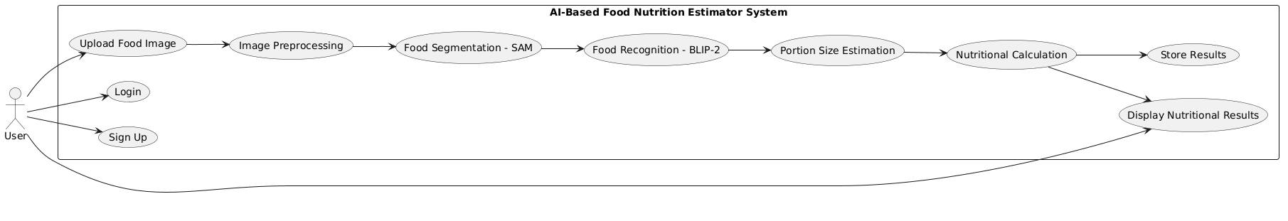
Figure 1: System Level Use Case Diagram – AI Food Nutrition Estimator

As illustrated in Figure 1, the system encompasses one primary actor and their use cases:
- Student User Actor: Interacts with the system through Register/Login, Upload Food Image, View Nutrition Results, Track Meal History, Set Calorie Goals, and Export Meal Log.
- AI Processing Core: The internal AI pipeline (SAM Segmentation → BLIP-2 Identification → Linear Regression Prediction) is triggered automatically upon food image upload and is not directly accessible to end users.

3.2 Use Case Descriptions
The following section provides detailed descriptions for each major use case. Each use case is documented using a standardized template.

Use Case UC-1: User Registration and Login
Use Case ID: | UC-1
Use Case Name: | User Registration and Login
Actors: | Primary Actor: Student User Secondary Actor: Authentication System
Description: | A Student User creates a new account or logs into an existing account on the AFNEP platform. Upon successful authentication, the user is directed to their personal dashboard.
Trigger: | User navigates to the application homepage and selects Register or Login.
Preconditions: | PRE-1: User has access to a web browser and internet connection. PRE-2: For login, user must already have a registered account.
Postconditions: | POST-1: User is authenticated and directed to the dashboard. POST-2: A session is created for the authenticated user.
Normal Flow: | 1. User navigates to homepage. 2. User selects Register or Login. 3. User enters required credentials. 4. System validates credentials. 5. System creates or verifies the account. 6. User is redirected to dashboard.
Alternative Flows: | AF-1 (Forgot Password): User enters registered email and receives a password reset link.
Exceptions: | E-1: Invalid credentials – system displays error and prompts re-entry. E-2: Duplicate email during registration – system informs user.
Business Rules: | BR-1: Passwords must be at least 8 characters including one number. BR-2: Email addresses must be unique across the system.

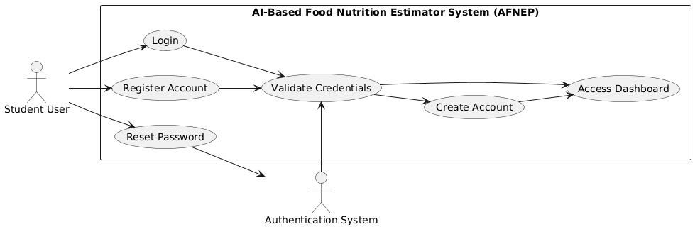
Figure 2: Activity Diagram for the Use case no.1

Use Case UC-2: Upload Food Image
Use Case ID: | UC-2
Use Case Name: | Upload Food Image
Actors: | Primary Actor: Student User Secondary Actor: Flask API Server
Description: | An authenticated Student User uploads a photograph of their meal through the Streamlit web interface. The image is sent to the Flask backend to initiate the AI analysis pipeline.
Trigger: | User navigates to the Analysis section and selects a food image to upload.
Preconditions: | PRE-1: User is logged into the system. PRE-2: User has a food photograph available in JPEG, PNG, or WEBP format.
Postconditions: | POST-1: Image is received and validated by the Flask API. POST-2: AI pipeline is triggered for processing.
Normal Flow: | 1. User navigates to the Analyze Meal section. 2. User selects an image file from their device. 3. System validates file format and size. 4. System displays image preview to user. 5. User clicks Analyze. 6. System sends image to Flask backend and displays a processing indicator.
Alternative Flows: | AF-1: User cancels the upload and returns to dashboard.
Exceptions: | E-1: File exceeds 10 MB – system displays error message. E-2: Unsupported file format – system rejects file and prompts for valid format.
Business Rules: | BR-1: Accepted formats are JPEG, PNG, and WEBP only. BR-2: Maximum file size is 10 MB.

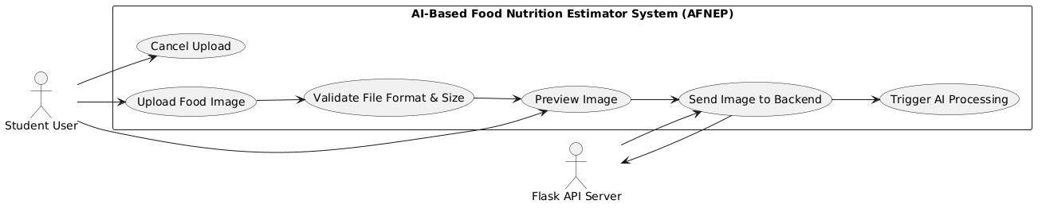

Figure3: Activity Diagram for the Use case no.2

Use Case UC-3: AI Nutrition Analysis
Use Case ID: | UC-3
Use Case Name: | AI Nutrition Analysis
Actors: | Primary Actor: Flask AI Pipeline Secondary Actor: SAM Model, BLIP-2 Model, Linear Regression Model
Description: | Upon receiving a valid food image, the Flask backend automatically executes the full three-stage AI pipeline: SAM segments individual food items, BLIP-2 identifies each segment, and Linear Regression predicts nutritional values.
Trigger: | Valid food image is received by the Flask API from the Streamlit frontend.
Preconditions: | PRE-1: All three AI models are loaded and ready. PRE-2: A valid food image has been received.
Postconditions: | POST-1: Each food item in the image has been segmented, identified, and assigned nutritional values. POST-2: Aggregated nutritional results are ready to be returned to the frontend.
Normal Flow: | 1. SAM processes the image and generates instance masks for each food item. 2. Each mask region is cropped and passed to BLIP-2. 3. BLIP-2 generates a food description for each segment. 4. Descriptions are parsed and used as input features for the Linear Regression model. 5. Nutritional values are predicted per food segment. 6. Results are aggregated and structured as a JSON response.
Alternative Flows: | AF-1: SAM detects no food segments – system returns a message indicating no food items were detected.
Exceptions: | E-1: Model inference fails – system logs the error and returns a user-friendly error message. E-2: BLIP-2 output does not match any known food item – nutritional values are estimated with a confidence warning.
Business Rules: | BR-1: The AI pipeline must always execute all three stages in order. BR-2: Nutritional estimates with low confidence must be flagged in the response.

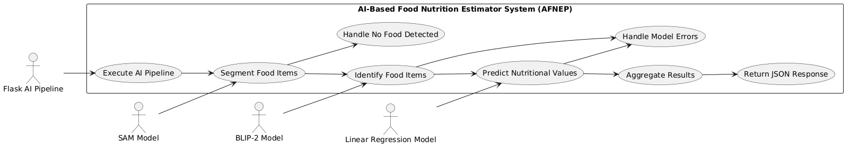
Figure 4: Activity Diagram for the Use case no.3

Use Case UC-4: View Nutrition Results

Use Case ID: | UC-4
Use Case Name: | View Nutrition Results
Actors: | Primary Actor: Student User
Description: | The authenticated Student User views the detailed nutritional breakdown of their analyzed meal, including per-item and total macronutrient values, on an interactive results screen.
Trigger: | AI analysis pipeline completes and returns results to the Streamlit frontend.
Preconditions: | PRE-1: User is logged in. PRE-2: A food image has been successfully analyzed.
Postconditions: | POST-1: Nutritional results are displayed to the user. POST-2: Meal record is saved to the user's history in SQLite.
Normal Flow: | 1. Frontend receives JSON result from Flask API. 2. System displays analyzed food image with segmentation overlay. 3. System displays per-item list with identified food names and nutritional values. 4. System displays total nutritional summary (calories, protein, carbs, fats, fiber). 5. System compares totals against user's daily calorie goal if set. 6. User can save or discard the meal record.
Exceptions: | E-1: API response times out – system displays a timeout error message.
Business Rules: | BR-1: All nutritional values must be displayed in standard units (kcal, grams).

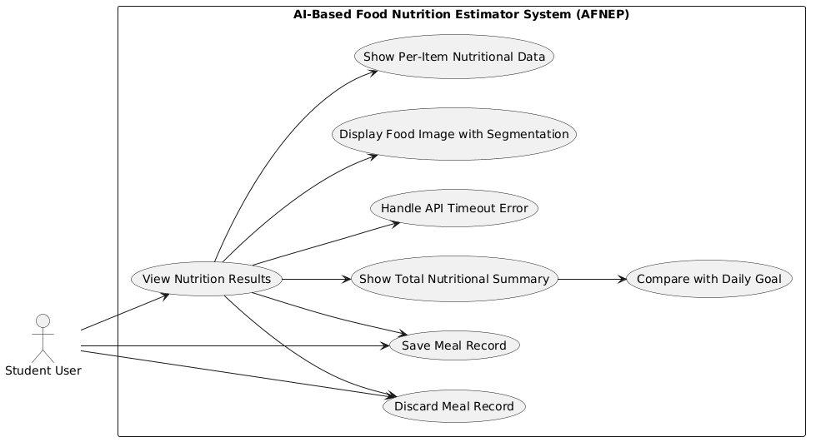

Figure 5: Activity Diagram for the Use case no.4

Use Case UC-5: Meal History and Dashboard

Use Case ID: | UC-5
Use Case Name: | Meal History and Dashboard
Actors: | Primary Actor: Student User
Description: | The authenticated Student User accesses their personal nutrition dashboard, which displays a history of all analyzed meals, daily and weekly nutritional summaries, calorie goal progress, and dietary trend charts.
Trigger: | User navigates to the Dashboard or Meal History section.
Preconditions: | PRE-1: User is logged in. PRE-2: User has at least one saved meal record.
Postconditions: | POST-1: User views their complete meal history and dietary summary charts.
Normal Flow: | 1. User navigates to Dashboard. 2. System retrieves meal records from SQLite. 3. System displays daily and weekly calorie and macronutrient totals. 4. System displays meal history list with date and nutritional summary. 5. System shows calorie goal progress bar if goal is set. 6. User can click any meal to view full details.
Exceptions: | E-1: No meal records found – system displays an empty state message.
Business Rules: | BR-1: Data displayed must reflect the logged-in user's records only.

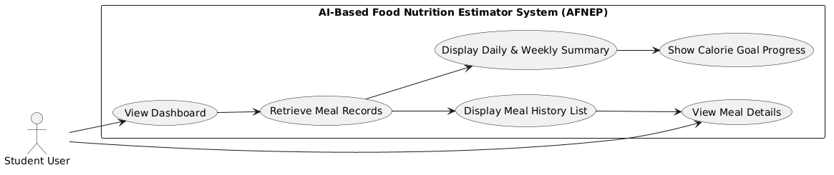
Figure 6: Activity Diagram for the Use case no.5

4. Functional Requirements
This section describes the functional requirements of the AI Food Nutrition Estimator for Pakistani Mess Food, organized by system feature. Each requirement is uniquely identified and documented using a standardized template.

FR-01: User Registration
Identifier | FR-01
Title | User Registration
Requirement | The system shall allow users to register by providing their full name, a valid email address, a password, and their student roll number. Upon successful registration, the system shall create a new account and redirect the user to their dashboard.
Source | UC-1, Stakeholder Consultation
Rationale | A registration system is essential to establish unique user identities, enable personalized meal history tracking, and enforce role-based access control across the application.
Business Rule | BR-1: Email addresses must be unique across the system. BR-2: Passwords must be at least 8 characters long and contain at least one number.
Dependencies | None
Priority | High

FR-02: User Authentication and Login
Identifier | FR-02
Title | User Authentication and Login
Requirement | The system shall authenticate registered users by verifying their email and password credentials. The system shall maintain a secure session for authenticated users and shall expire sessions after 30 minutes of inactivity.
Source | UC-1
Rationale | Authentication ensures that only authorized users can access their personal meal history and nutrition data, protecting user privacy and data integrity.
Business Rule | BR-1: After 5 consecutive failed login attempts, the account shall be temporarily locked for 15 minutes.
Dependencies | FR-01
Priority | High

FR-03: Food Image Upload
Identifier | FR-03
Title | Food Image Upload
Requirement | The system shall allow authenticated users to upload a food photograph in JPEG, PNG, or WEBP format through the Streamlit web interface. The system shall validate the file format and size before accepting the upload.
Source | UC-2
Rationale | Food image upload is the primary user input that initiates the entire AI nutrition analysis pipeline. Without this functionality, no AI processing can occur.
Business Rule | BR-1: Accepted file formats are JPEG, PNG, and WEBP only. BR-2: Maximum file size is 10 MB.
Dependencies | FR-02
Priority | High

FR-04: AI-Based Food Segmentation (SAM)
Identifier | FR-04
Title | AI-Based Food Segmentation
Requirement | The system shall use Meta AI's Segment Anything Model (SAM) to perform automated instance segmentation on the uploaded food image, generating a distinct binary mask for each individual food item detected in the photograph.
Source | UC-3, Project Specification
Rationale | Instance segmentation is essential for handling multi-dish plates common in Pakistani mess settings. Without accurate segmentation, individual food items cannot be separately identified or analyzed.
Business Rule | BR-1: SAM shall process every uploaded image regardless of the number of food items present. BR-2: If no food items are detected, the system shall display an informative message to the user.
Dependencies | FR-03
Priority | High

FR-05: Food Identification via BLIP-2
Identifier | FR-05
Title | Food Identification via BLIP-2
Requirement | The system shall pass each segmented food image region through the BLIP-2 vision-language model to generate a natural language description identifying the food type, estimated portion characteristics, and preparation style for each segment.
Source | UC-3, Project Specification
Rationale | BLIP-2 provides the semantic food identification layer that bridges visual segmentation and numerical nutritional prediction. Accurate food identification directly determines the accuracy of the final nutritional estimates.
Business Rule | BR-1: BLIP-2 shall process every segmented region produced by SAM. BR-2: Identification results with low confidence shall be flagged in the output.
Dependencies | FR-04
Priority | High

FR-06: Nutrition Prediction via Linear Regression
Identifier | FR-06
Title | Nutrition Prediction via Linear Regression
Requirement | The system shall use a trained Linear Regression model to predict the nutritional values of each identified food item, including estimated calories (kcal), protein (g), carbohydrates (g), fats (g), and dietary fiber (g) per serving. The model shall be trained on a curated Pakistani food nutritional database.
Source | UC-3, Project Specification
Rationale | The Linear Regression model translates the semantic food identification output from BLIP-2 into quantitative nutritional data, which is the core deliverable of the system for the user.
Business Rule | BR-1: The model shall be trained on a dataset of at least 100 Pakistani food items. BR-2: Predicted values must be displayed in standard nutritional units.
Dependencies | FR-05
Priority | High

FR-07: Nutrition Results Display
Identifier | FR-07
Title | Nutrition Results Display
Requirement | The system shall display the nutritional analysis results to the authenticated user on an interactive results screen, including the segmented food image with visual overlays, a per-item list of identified food names and nutritional values, and a total nutritional summary for the entire meal.
Source | UC-4
Rationale | Clear and detailed result presentation is essential for the user to derive meaningful dietary insights from the AI analysis and make informed food choices.
Business Rule | BR-1: All values must be displayed in standard units: kcal for calories, grams for macronutrients.
Dependencies | FR-06
Priority | High

FR-08: Meal History and Logging
Identifier | FR-08
Title | Meal History and Logging
Requirement | The system shall automatically save each completed nutritional analysis as a meal log record in the SQLite database, linked to the authenticated user's account. The record shall include the date and time, a list of identified food items, and the total nutritional values for that meal.
Source | UC-5
Rationale | Persistent meal logging is essential for enabling users to track their dietary habits over time and identify nutritional patterns, which is the primary long-term value of the application.
Business Rule | BR-1: Each meal log record must be uniquely associated with the user who submitted it. BR-2: Users can only view their own meal records.
Dependencies | FR-07
Priority | High

FR-09: Daily Nutrition Dashboard
Identifier | FR-09
Title | Daily Nutrition Dashboard
Requirement | The system shall provide authenticated users with a personal dashboard displaying daily and weekly nutritional summaries aggregated from their meal history, including total calories, protein, carbohydrates, fats, and fiber consumed. The dashboard shall include visual charts and progress indicators.
Source | UC-5, Project Specification
Rationale | A nutrition summary dashboard transforms individual meal analysis results into actionable long-term dietary insights, which is the key health monitoring feature of the system.
Business Rule | BR-1: Dashboard data must reflect only the logged-in user's meal records.
Dependencies | FR-08
Priority | High

FR-10: Calorie Goal Setting
Identifier | FR-10
Title | Calorie Goal Setting
Requirement | The system shall allow authenticated users to set a daily calorie intake goal. The dashboard shall display the user's current daily calorie consumption against their set goal, providing a visual progress indicator.
Source | Project Specification
Rationale | Personalized goal setting increases user engagement and motivates healthier dietary choices by providing a concrete daily target against which actual consumption can be measured.
Business Rule | BR-1: Calorie goal must be a positive integer value. BR-2: The goal can be updated by the user at any time.
Dependencies | FR-09
Priority | Medium

FR-11: Meal Log Export
Identifier | FR-11
Title | Meal Log Export
Requirement | The system shall allow authenticated users to export their meal history and nutritional log as a downloadable file in CSV format, covering a user-selectable date range.
Source | Project Specification
Rationale | Export functionality enables users to share their dietary data with healthcare professionals, university nutritionists, or use it in external dietary analysis tools, extending the system's utility beyond the platform itself.
Business Rule | BR-1: Exported data must contain only the records of the requesting user.
Dependencies | FR-08
Priority | Medium

5. Non-Functional Requirements
This section specifies the non-functional requirements of the AI Food Nutrition Estimator for Pakistani Mess Food. These requirements define quality attributes that the system must exhibit, including usability, performance, security, reliability, maintainability, and AI model quality. Each requirement is specific, measurable, and verifiable.

5.1 Usability
- USE-1: The system shall provide a responsive web interface that displays correctly on screen resolutions from 768px (tablet) to 1920px (desktop) without loss of functionality or readability.
- USE-2: A new user shall be able to complete the registration process and upload their first food photograph for analysis within 5 minutes, without requiring any external documentation or technical assistance.
- USE-3: All error messages displayed by the system shall be descriptive, specific, and provide clear actionable guidance to help users correct their input.
- USE-4: The system shall use clear visual indicators (loading spinners, progress bars) during AI processing to inform the user that analysis is in progress.
- USE-5: Nutritional results shall be displayed using clear visual formatting including color-coded macronutrient indicators and labeled progress bars to maximize comprehension for non-technical users.
- USE-6: The system shall display confirmation messages upon successful completion of all critical actions including registration, image upload, analysis completion, and meal log save.

5.2 Performance
- PER-1: All non-AI web pages (dashboard, history, profile) shall load completely within 3 seconds on a 10 Mbps or faster internet connection under normal load conditions.
- PER-2: The complete AI pipeline (SAM segmentation + BLIP-2 identification + Linear Regression prediction) shall complete processing and return results within 30 seconds for a standard food image on GPU-equipped hardware.
- PER-3: The system shall support at least 50 concurrent user sessions without significant performance degradation (response time increase of no more than 30%).
- PER-4: Food image upload shall complete within 10 seconds for files up to the maximum allowed size of 10 MB on a standard broadband connection.
- PER-5: Dashboard data retrieval and rendering shall complete within 2 seconds for meal history datasets of up to 365 records.

5.3 Security
- SEC-1: All user passwords shall be encrypted using a strong hashing algorithm (bcrypt or PBKDF2-SHA256) before storage in the SQLite database. Plaintext passwords shall never be stored.
- SEC-2: All data transmission between the Streamlit client and the Flask backend shall be secured using HTTPS (TLS 1.2 or higher) in any production deployment.
- SEC-3: The system shall implement Cross-Site Request Forgery (CSRF) protection on all state-changing API endpoints.
- SEC-4: Access control shall be enforced, ensuring that users cannot access other users’ data or protected system endpoints.
- SEC-5: The system shall validate and sanitize all user-provided inputs on the server side to prevent injection attacks.
- SEC-6: Uploaded food images shall be scanned for valid file headers to prevent malicious file uploads masquerading as image files.
- SEC-7: User sessions shall expire after 30 minutes of inactivity, requiring re-authentication to resume.

5.4 Reliability
- REL-1: The system shall achieve an uptime of at least 95% on a monthly basis, excluding scheduled maintenance windows.
- REL-2: In the event of an AI model inference failure, the system shall display a user-friendly error message and log the error details for developer review, without exposing technical details to the end user.
- REL-3: The system shall perform automated SQLite database backups every 24 hours to prevent data loss.
- REL-4: The system shall handle concurrent image analysis requests without data corruption, maintaining integrity of each user's results independently.
- REL-5: The Flask API shall implement request timeout handling, returning an appropriate error response if AI processing exceeds 60 seconds.

5.5 Maintainability
- MNT-1: The system code shall be organized into clearly separated modules: authentication, image processing, AI pipeline, database operations, and API routing.
- MNT-2: All functions and classes shall be documented with inline comments and docstrings following Python PEP 257 conventions.
- MNT-3: The AI model loading, inference, and post-processing logic shall be encapsulated in separate, independently testable Python modules.
- MNT-4: The system shall be version-controlled using Git with descriptive commit messages throughout the development lifecycle.
- MNT-5: The Pakistani food nutritional database shall be stored as a structured CSV or JSON file, enabling easy expansion with additional food items without modifying application code.

5.6 AI Model Quality
- AIQ-1: The Linear Regression model shall achieve a minimum R² score of 0.75 on the test split of the Pakistani food nutritional training dataset.
- AIQ-2: The BLIP-2 food identification component shall correctly identify at least 80% of Pakistani mess food items in a validation test set of 50 standard food images.
- AIQ-3: The SAM segmentation component shall correctly isolate individual food items for at least 85% of single-plate food images in the validation test set.
- AIQ-4: The system shall display a confidence indicator alongside each nutritional prediction to communicate the expected accuracy of the estimate to the user.

6. External Interface Requirements

6.1 User Interfaces
- UI-1: The Streamlit web interface shall serve as the primary user interface, accessible via any modern web browser without plugin installation.
- UI-2: The interface shall include the following primary screens: Registration/Login Page, Dashboard/Home, Analyze Meal (image upload and results), Meal History, and Goal Settings.
- UI-3: The visual design shall use a clean, modern color scheme appropriate for a health and nutrition application. Navigation shall be consistent across all screens.
- UI-4: Food analysis results shall display the uploaded image with segmentation overlays alongside the textual nutritional breakdown.

6.2 Hardware Interfaces
- HW-1: The server hosting the Flask API and AI models shall require a minimum of 16 GB RAM and a CUDA-compatible GPU with 8 GB VRAM for GPU-accelerated inference.
- HW-2: Client devices shall require no specialized hardware beyond a standard web browser-capable device with internet connectivity.
- HW-3: Client devices shall be able to access a camera or local file storage to provide food photographs to the application.

6.3 Software Interfaces
- SI-1: The system shall interface with the SAM model checkpoint (vit_h or vit_l variant) loaded at Flask server startup.
- SI-2: The system shall interface with the BLIP-2 model weights loaded from Hugging Face's model hub (Salesforce/blip2-opt-2.7b or equivalent).
- SI-3: The system shall interface with the Scikit-learn serialized Linear Regression model loaded from a local .pkl file at Flask server startup.
- SI-4: The Streamlit frontend shall communicate with the Flask backend exclusively through RESTful HTTP API calls over JSON.
- SI-5: The Flask backend shall interface with the SQLite database through Python's built-in sqlite3 library or SQLAlchemy ORM.

7. References
The following documents, research papers, frameworks, and standards were referenced during the preparation of this Software Requirements Specification:

- Wiegers, Karl and Joy Beatty. Software Requirements, 3rd Edition. Microsoft Press, 2013.
- Sommerville, Ian. Software Engineering, 10th Edition. Pearson Education Limited, 2016.
- IEEE Std 830-1998: IEEE Recommended Practice for Software Requirements Specifications. Institute of Electrical and Electronics Engineers, 1998.
- Kirillov, A., et al. Segment Anything. arXiv preprint arXiv:2304.02643. Meta AI Research, 2023. https://arxiv.org/abs/2304.02643
- Li, J., et al. BLIP-2: Bootstrapping Language-Image Pre-training with Frozen Image Encoders and Large Language Models. arXiv preprint arXiv:2301.12597. Salesforce Research, 2023. https://arxiv.org/abs/2301.12597
- Pedregosa, F., et al. Scikit-learn: Machine Learning in Python. Journal of Machine Learning Research, 12, pp. 2825-2830, 2011.
- Streamlit Inc. Streamlit Documentation (Version 1.x). https://docs.streamlit.io/
- Pallets Projects. Flask Documentation (Version 3.x). https://flask.palletsprojects.com/
- Python Software Foundation. Python 3 Documentation. https://docs.python.org/3/
- Hugging Face Inc. Transformers Library Documentation. https://huggingface.co/docs/transformers/
- Bossard, L., Guillaumin, M., and Van Gool, L. Food-101 – Mining Discriminative Components with Random Forests. ECCV 2014.
- Pakistan National Institute of Health. Nutritional Values of Pakistani Foods. Ministry of National Health Services, Islamabad.

