|  |  |  |  |  |
| --- | --- | --- | --- | --- |
| **A VEHICLE TRACKING SYSTEM USING ANDROID DEVICE** | | | | |
|  | |  |  | |
|  | |  |  | |
|  | |  |  | |
|  | |  |  | |
|  | |  |  | |
|  | |  |  | |
|  | | | | |
|  | | **Submitted By** |  | |
|  | Name: Yasir Uddin Ahamed  Roll No.: 11508010  Reg.: 11508010  Session: 2014-15 | | |  |
|  | |  |  | |
| *A Report Submitted for Partial Fulfillment for the Degree of*  *Bachelor of Science in Computer Science and Engineering* | | | | |
|  | |  |  | |
|  | |  |  | |
| **Comilla University – 3506** | | | | |
|  | |  |  | |
|  | | **November, 2020** |  | |

**COMILLA UNIVERSITY :: COMILLA-3506**

**BONAFIDE CERTIFICATE**

This is to certify that the project entitled, **“A VEHICLE TRACKING SYSTEM USING ANDROID DEVICE”** and submitted by **“YASIR UDDIN AHAMED”** in partial fulfillment of the requirements of **CSE-3108** Project Work embodies the work done by him under my supervision.

**KHALIL AHAMMAD**

**SUPERVISOR**

Assistant Professor,

Department of Computer Science and

Engineering.

Comilla University, Comilla.

**MD. HASAN HAFIZUR RAHMAN**

**CHAIRMAN, EXAM COMMITTEE**

Associate Professor,

Department of Computer Science and

Engineering.

Comilla University, Comilla

**ABSTRACT**

In the era of technology, everything is going to be dependent on smart technologies. This project is such an effort that will make life secured and easier. In this project, the movement of any equipped vehicle from any location at any time is tracked using an effective vehicle tracking system. The suggested system took use of a common technology called Android OS that integrates a smartphone application with another smartphone application through API. This will be simple to prepare and affordable in comparison to other options. The system uses GPS technology, which is one of the most used methods for tracking. An application is installed into the driver’s mobile, and its location must be detected and tracked in real time. This is used by the vehicle tracking system to get geographic coordinates. The vehicle's position is transmitted and updated to a database through internet. Another smartphone application is also being developed to track the vehicle's location in real time. The automobile is displayed on the map on the smartphone app using the Google Maps API. Users will be able to use the smartphone application to continually track a moving vehicle on demand and determine the expected distance and time for the vehicle to arrive at a specific destination. This article includes experimental findings of the vehicle tracking system as well as some experiences with practical implementations in order to demonstrate the system's viability and efficacy.

**Acknowledgment**

This is a project report on **“A Vehicle Tracking System Using Android Device”**. I would very much like to thank my beloved Comilla University, without its support the project would not complete. I am very thankful to my project supervisor, ‘Khalil Ahammad, Assistant Professor, Dept. Of CSE, Comilla University’ for his invaluable guidance and assistance.

I also thank most sincerely our head of the department ‘Partha Chakrabarty’, Associate Professor, Dept. Of CSE, Comilla University and I am very thankful to all other mentors from our department for their support and cooperation.

It is a privilege for us to express our gratitude to Vice-Chancellor of our beloved Comilla University to provide us an excellent environment to complete our education.

I also like to show my gratitude to my seniors who helped me in many ways. At last, I want to thank my beloved classmates who always inspired me to go ahead. I always got their full support.

Very thankfully

Yasir Uddin Ahamed

**TABLE OF CONTENT**

**ABSTRACT**

**ACKNOWLEDGMENT**

**Chapter 1: Introduction 9**

1.1 Motivation 9

1.2 Problem Statement 9

1.3 Aims and Objectives 10

1.4 Project Outline 10

**Chapter 2: Literature Review 11**

2.1 Overview of Existing System 11

2.2 Proposed System 11

2.3 Required Technology 12

2.3.1 Software Requirement 12 2.3.2 Hardware Requirement 12

**Chapter 3: Design 13**

3.1 Data Flow Diagram 13

3.1.1 DFD level – 0 13

3.1.2 DFD level – 1 14

3.1.2 DFD level 2 14

3.2 Use Case Diagram 15

3.3 Activity Diagram 16

3.4 Entity Relationship Diagram 16

3.5 Database Scheme 17

**Chapter 4: implementation 18**

4.1 Application 18

4.2 Driver’s Bus Selection 19

4.3 Driver’s Map Page 20

4.4 Student’s Sign in 21

4.5 Student’s Map Page 22

4.6 Finding Vehicle 23

**Chapter 5: Conclusion and Future Direction 24**

5.1 Conclusion 24

5.2 Future Direction 24

**REFERANCES 25**

**LIST OF FIGURES**

**Chapter 3:**

Fig 3.1: DFD Level – 0 13

Fig 3.2: DFD Level – 1 14

Fig 3.3: DFD Level – 2 14

Fig 3.4: Use Case Diagram 15

Fig 3.5 Activity Diagram 16

Fig 3.6 ER Diagram 17

**Chapter 4:**

Fig 4.1: First Page 18

Fig 4.2: Driver’s Login Page 19

Fig 4.3: Driver’s Map Page 20

Fig 4.4: Student’s Sign In Page 21

Fig 4.5: Student’s Map Page 22

Fig 4.6: Finding Vehicle 23

**LIST OF ABBREVEATION**

* API - Application Programming Interface
* APP - Application
* GPS - Global Positioning System
* GUI - Graphical User Interface
* IDE - Integrated development environment
* I/O - Innovation in the Open
* IOS - iPhone Operating System
* LCD - Liquid Crystal Display
* PDA - Personal Digital Assistant

**Chapter 1**

**Introduction**

Vehicle Tracking System Using Android Device is a system which is used to track an institutional vehicle in real time. It is developed to eliminate suffering of the consumer and make their life easy and comfortable.

* 1. **Motivation**

Android is a very popular digital multitasking device that contains a complete user-friendly operating system. It is easy to operate, low-cost and user friendly. For that reason more and more developers are choosing android as their software development platform. It is so much popular among the users and developers that it is prospering every day in term of its application. And everyone is turning on their choice to android. It has a powerful infrastructure to build any type of application. It is one of the main reasons to develop this project using android platform. In this digital era time management is very important for everyone. No one don’t want to lose any time at all. They are being inhabited in automated systems and thus they try to be comfortable in day-to-day life. Waiting for vehicle is one of the painful works for them. Guardians always spend time in tension that their children have reach their destination safe or not. College going students got troubled to know that the college vehicle will arrive or not, which is faster to reach the exam hall, college bus or local transport. It cost a lot of time and energy too. Sometime people get sick for the temperature or dust. To reduce this major problem, this vehicle tracking system will be very helpful.

* 1. **Problem Statement**

Google Map is providing us a real time image of an area. It also locate the user and show nearby streets, buildings, places etc. But it does not show location of other device location. But using the location of a device other devices can locate that device. This system will allow multiple users to receive real-time location of a device and track it. It works through an android app to track another device. Now people will just locate the vehicle driver’s device to track the vehicle he is driving.

**1.3 Aims and Objectives**

1. Raise of the attendance of students/employee of an institution.

2. Use everyone’s android operated smartphones in a productive way.

3. Increase certainty of a workflow.

4. Decrease tension of family members for school going kids.

* 1. **Project Outline**

This project report will be structured as follows: Chapter 2 introduces the Literature Review containing background knowledge and related works in this field. In Chapter 3, we present an overall interpretation of the methodology and design of the project work. Chapter 4, discuss about the results and how we implemented the application. Finally in Chapter 5, we conclude this project report with the future objectives for our system and an overall epilogue.

**Chapter 2**

**Literature Review**

**2.1 Overview of existing system**

Generally, the traditional way to know the location of a vehicle is to call someone in the vehicle and ask them where he is now. There are some existing projects to track a vehicle from a particular device such as a single mobile device or a single computer in which the system is installed, but it has not reached to the general user level. This project is a modification of the idea of tracking vehicle through a single device. Google map can provide a real time image of any location in an android device. Google map is a web-based mapping service developed by google. It is available in three platform, Android, Web and IOS. It was determined as the most popular app for smartphone in 2003. It provides GPS based turn-by-turn navigation with real time satellite image of roads, rivers, areas, borders etc. People use it to locate his location alongside the surroundings. Most of all other existing system is developed based on google map.

**2.2 Proposed System**

The system that is proposed is to eradicate suffering of the users to waiting for vehicles. In recent time, it is seen that a certain number of accidents happened on the roadside. Another vehicle lost control and went over the people who were waiting for their vehicle. And one of the most irritating work is waiting. It cost a lot of time and energy too. Sometime people get sick for the temperature or dust. This system will reduce their sufferings and make everyone’s life comfortable. In this project, to track a vehicle we will use GPS from an android device which will be in the vehicle. This android device will send its location. The user of the system will collect the location and see this on their mobile device. Driver’s device will continuously be sending its location and user’s device will continuously collect the device and show on the map. Thus, everyone will be able to see movement of the vehicle.

**2.3 Required Technology**

The Vehicle Tracking System works through an android application. To run this application a device is required that on runs on Android 4 or higher. These are technologies used to implement the application.

**GPS-** GPS means a space-based satellite navigation system provides location and time information in all weather. The Global Positioning System (GPS) is a satellite-based Navigation system developed.

The GPS does not require the user to transmit any data, and it operates independently of any telephonic or internet reception, though these technologies can enhance the usefulness of the GPS positioning information.

**Google Maps API**- A API is a set of methods and tools that can be used for building software applications. By using the Google Maps API, it is possible to embed Google Maps into an external app or website, on to which site-specific data can be overlaid.

**2.3.1 Software Requirement**

1. Operating System: Windows 8 or Higher

2. Database: Firebase

3. Front-End: XML

4. Back end: Java 8

5 IDE: Android Studio 4.0.1

**2.3.2 Hardware Requirement**

1. Storage Memory – 10 GB

2. RAM – 8 GB or Higher

**Chapter 3**

**Design**

* 1. **Data Flow Diagram**

**3.1.1. DFD - Level 0 (Context Diagram)**

Data flow diagram (DFD) – level 0 is often called context diagram. It is very simple diagram to describe a system within a glance. It’s very useful for non-technical people to understand a system. It shows just relation between external entities and system relationship. It shows overview of the whole system in a single process.

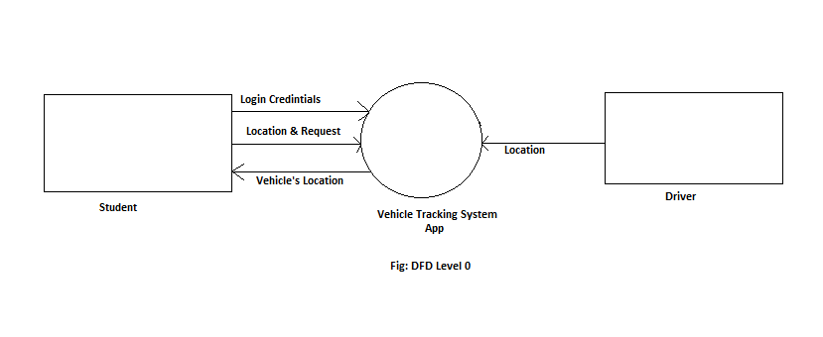

Fig 3.1: DFD Level 0

**3.1.2. DFD - Level 1**

Data flow diagram (DFD) – level 1 provides more detailed breakout of pieces of DFD - level 0. It notates each of the main sub processes that together form the complete system. It is the exploded representation of context diagram.

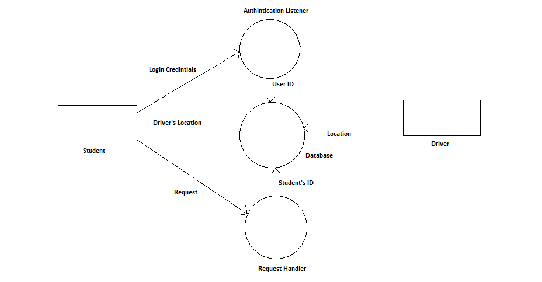

Fig 3.2: DFD Level 1

**3.1.3. DFD – Level 2**

Data flow diagram (DFD) – level 2 provides more detailed breakout of pieces of DFD – level 1. It notates almost full system elements relation as sub processes.

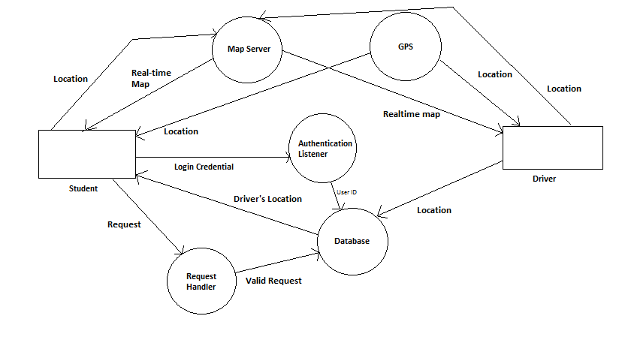

Fig 3.3: DFD Level 2

**3.2 Use Case Diagram**

Use case diagram defines interaction between persons and system as functional requirements for IT application. It shows us different ways of interaction between user and system. A basic flow of events is used in a use case.

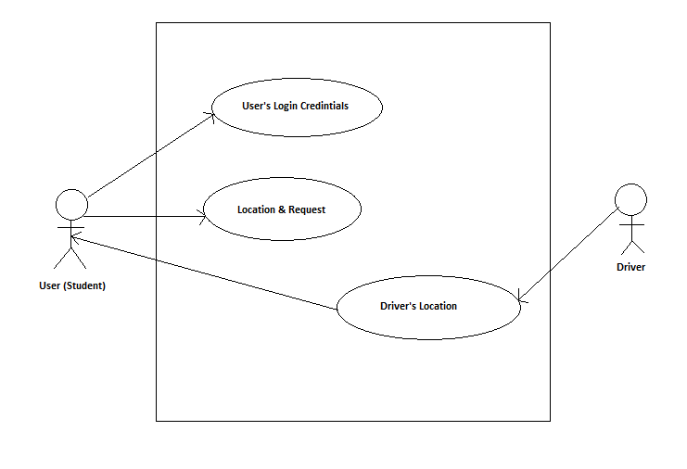

Fig 3.4: Use Case Diagram

**3.3 Activity Diagram**

An activity diagram is a flow chart that represent flow from one activity to another.

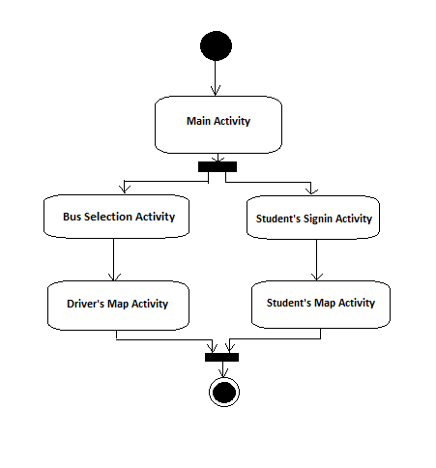

Fig 3.5: Activity Diagram

**3.4 Entity Relationship Diagram (ERD)**

Entity Relationship Model captures the relationship between real world entities in a database. It represents the concept of the database. Here, in this project only two entities remain, Student and Driver. A student must be added with a driver, one and only one. But a driver can be connected to zero or more students.

In a ‘Driver’ Entity, there are two attribute, *User ID* and *location*. Location is also combination of two attributes, *latitude* and *longitude*.

In a ‘Student’ entity, like driver there are two attribute, *User ID* and *location*. As like as driver’s location, it also contains *latitude* and *longitude.* An ER diagram is given below.

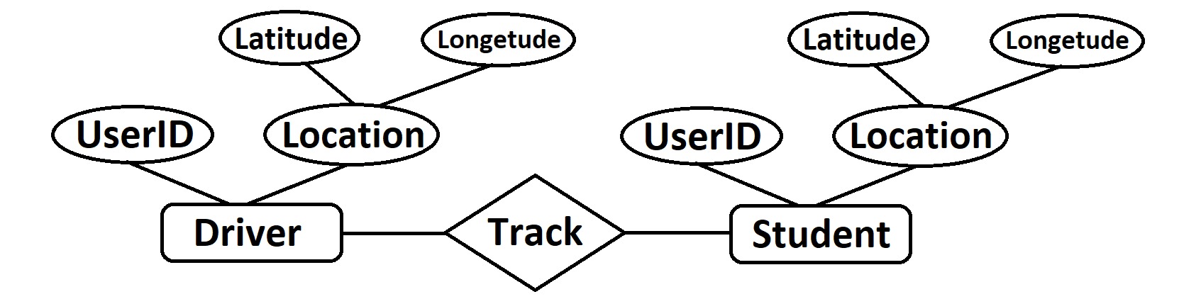

Fig 3.6: An Entity Relationship Diagram

**3.5 Database Scheme:**

In this project, a graphical database called *Firebase* is used because it is secured, easy to use, real time and most importantly, it is specially developed for being integrated with android apps. It saves its data in JSON format, so it’s a NoSQL database. It saves it’s data in a *Tree* structure.

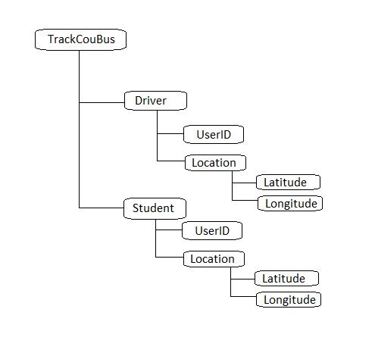

Figure 3.7: Database Scheme

**Chapter 4**

**Implementation**

The implementation phase constructs, installs, and operates the new system. In this phase, ewe make sure that the system works efficiently and effectively. The system consists of several layout and several activities, google map, several button, some text field for user email and password.

**4.1 Application**

There are two apps, one for *Driver* and another one *Student*. If the user is the driver, then he will open *Driver* app. Otherwise, the user will open *Student* app.

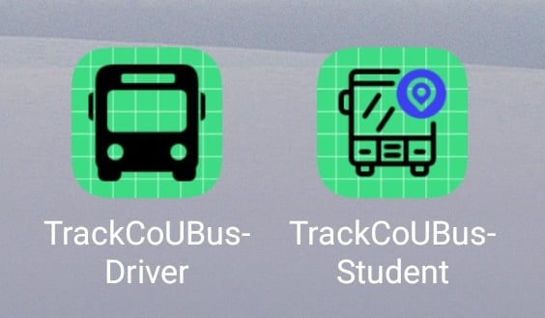

Fig 4.1: First page

**4.2 Driver’s Bus Selection Page**

In this page, some button will appear, to select the bus. The driver will select his bus button to upload in this section.That will go to a Map.

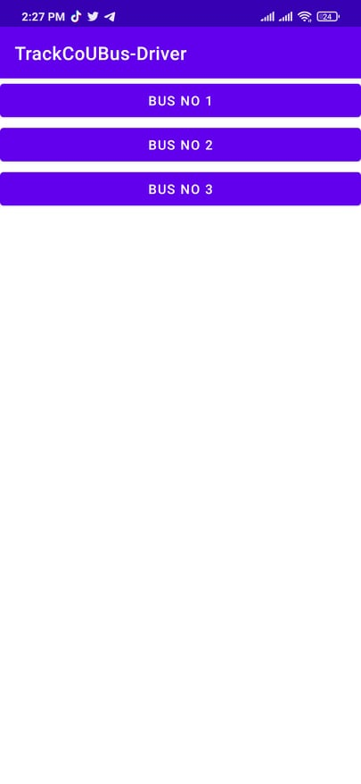

Fig 4.2: Driver’s Login Page

**4.3 Driver’s Map Page**

In this page, a map will be appeared with two buttons. One is *GPS* button at the top right corner, the other is *Logout* button at the bottom of the app. It will show driver’s current location. If the location is not refreshed automatically, then press the GPS button. If driver wants to logout, he will press logout.

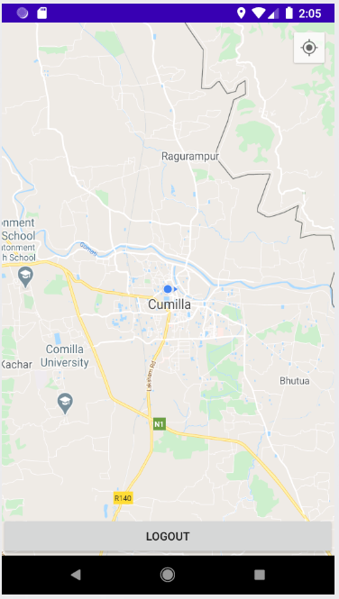

Fig 4.3: Driver’s Map Page

**4.4 Student’s Sign in Page**

In this page, two text field and two button will appear, the text fields are *Email* and *Password.* And the buttons are *Sign in* and *Sign Up.*

If student has existing login credentials, then he will provide email and password in the corresponding field and tap Sign In. If he does not have any existing credentials, then he will provide his email and password and tap Sign Up. Both will go to a Map.

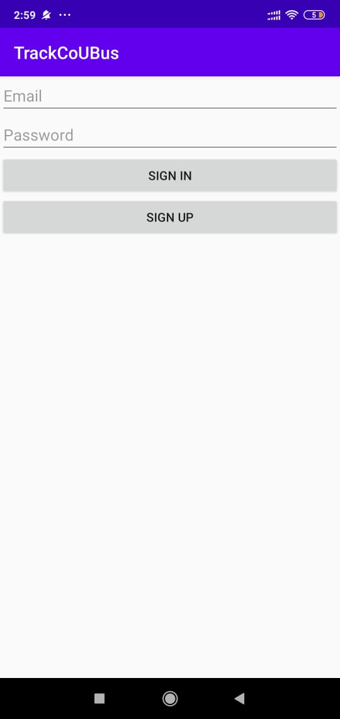

Fig 4.4: Student’s Sign In Page

**4.5 Student’s Selection Bus and Map Page**

In the bus selection page, alike driver app some button will appear, to select the bus which the student wants to track. After tapping the required bus, a map will appear.

In the map page, a map will be appeared with three buttons. One is *GPS* button at the top right corner, another one is *Sign Out* button at the top left of the app and the other one is *Find Bus* button at the bottom of the app. It will show student’s current location. If the location is not refreshed automatically, then press the GPS button. If student wants to logout, he will press sign out. To track the vehicle, just tap the Find Bus.

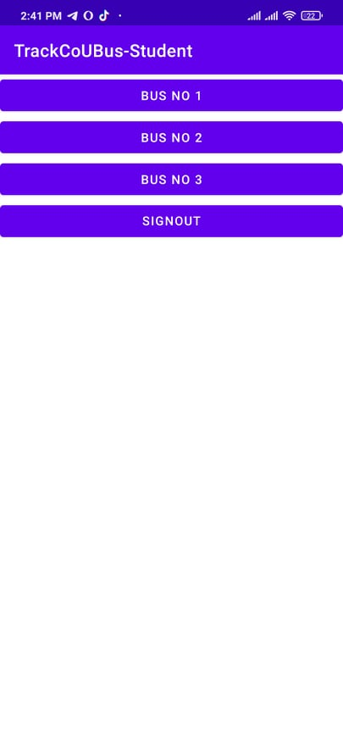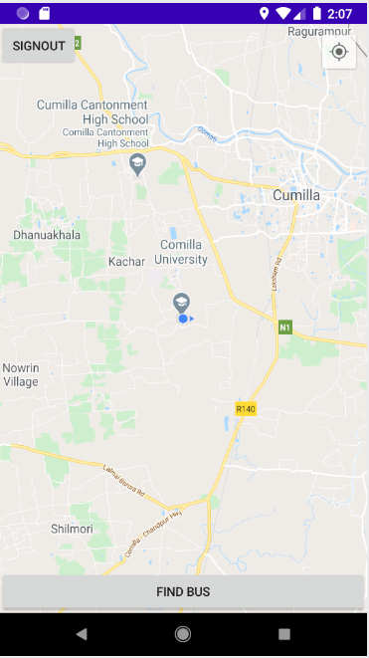

Fig 4.5: Student’s Map Page

**4.6 Finding Vehicle**

When the *Find Bus* button is tapped, the button will change its label as “Finding Bus” and there will two markers appear, one is purple and other is red. The purple one is student’s location and the red one is vehicle’s location.

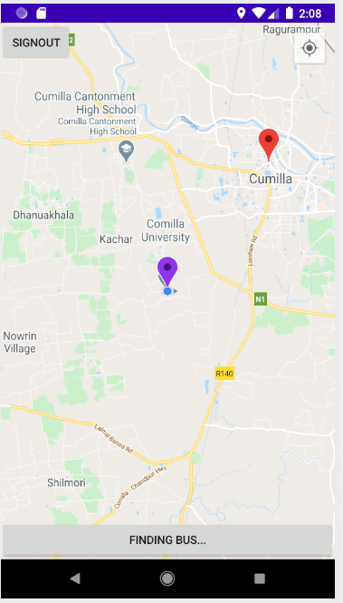

Fig 4.6: Finding Vehicle

**Chapter 5**

**Conclusion and Future Direction**

**5.1 Conclusion**

Vehicle tracking system makes better fleet management and which in turn brings large profits. Better scheduling or route planning can enable you handle larger jobs loads within a particular time.

The main purpose of this project is to locate the vehicle for various useful purposes. In this digital era, where using internet-based maps like google maps are common scenario, attaining behind time is not an option. Even many companies (like UBER, Pathao etc.) are making taxi renting process digital to save time of their customer. Every system is being controlled through internet to make efficient and reduce trouble for users. People don’t get hesitated to go to a new place because they have online map and because of which they can keep tracking where are they going. This project is an addition to the online map service. Using this map, people can know about their vehicle and do their work according to that information. This might give people mental satisfaction, efficiency in their daily routine and make them less worrying. Everything is getting digital now-a-days to make people’s lives easier. This project is another attempt to do the same.

**5.2 Future Direction**

There are many more scope to extend this application. As an android device is full of sensors, also more sensors can be added through earphone jack and USB jack, many state of a vehicle can be shown by this app. Amount of fuel, the speed of the car, if any accident occurred or not, if a massage from the driver is needed to be sent to all his passengers these features can be added very easily to the project. The database used in this project is resourceful, so if someone needs to personalization through machine learning, it can be very possible. As it is android, a complete open-source OS and the device is using a complete processor, many feature can be easily added to this project, even AI analysis is also can be added in future is someone want to add. This project is a very start, there are many more way to extend this project.

**References:**

1. Brett D. McLaughlin, Dave West, Gary Pollice, “Headfirst Object-Oriented Analysis and Design”, 1st Edition, O’Reilly Media Inc., USA, 2007.
2. Chen, H., Chiang, Y. Chang, F. H. Wang, “Toward Real-Time Precise Point Positioning: Differential GPS Based on IGS Ultra Rapid Product”, SICE Annual Conference, The Grand Hotel, Taipei, Taiwan August 18-21, (2010).
3. Herbert Schildt, “JAVA, A Beginner’s Guide” 6th edition, McGraw Hill, USA, 2014.
4. Dr. Rajiv Chopra, “Database Management System (DBMS)” 5th Edition, S Chand, India, 2016.
5. William Stalling, “Wireless Communication and Networks”, 2nd edition, prentice hall of India, 2005.