X-Ray KUB AP View

Findings:

Radiopaque shadows are noted at the left renal region at L2/3 level and UB region.
The ureteric lines are para-vertebral lines are observed meticulously.
The pedicles of the vertebral bodies are normal.
The region of the ala of the sacrum is normal also.
Normal pattern of the bowel gas distribution is noted.

IMPRESSION:
Radiopaque shadows are noted at the left renal region at L2/3 level and UB region.
Suggestion: USG and IVU correlation plz.

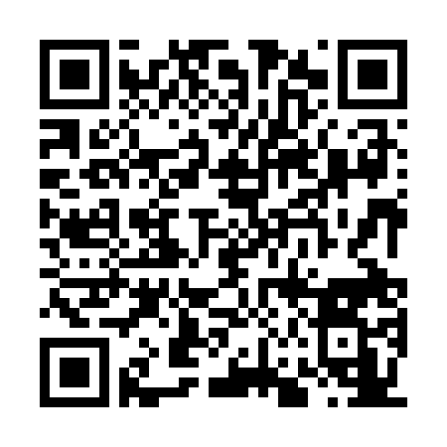
Click here to view the image

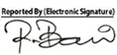
Dr. Md. Razibul Bari
Asst. Professor & Ex-Head Department of Radiology & Imaging, SSKMC
MBBS. M. Phil (Radiology & Imaging) (BSMMU) PhD, University of Tokyo, Japan Advanced training in CT scan & MRI (University of Tokyo)
BMDC Reg No: A41925
Mobile: 01711115355

