X-ray foot AP and oblique views

Findings:

Fracture of the 5 metatarsal bone is noted.
Bone density appears normal.
The joint spaces are maintained.
Articular margins are normal.
Soft tissue swelling is noted.

IMPRESSION:
Fracture of the 5 metatarsal bone is noted.

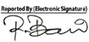
Dr. Md. Razibul Bari
Asst. Professor & Ex-Head Department of Radiology & Imaging, SSKMC
MBBS. M. Phil (Radiology & Imaging) (BSMMU) PhD, University of Tokyo, Japan Advanced training in CT scan & MRI (University of Tokyo)
BMDC Reg No: A41925
Mobile: 01711115355
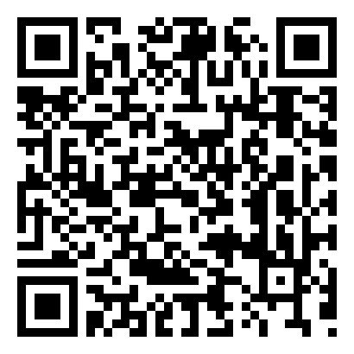
Scan to view images

