Upload AP

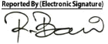
Dr. Md. Razibul Bari
Asst. Professor & Ex-Head Department of Radiology & Imaging, SSKMC
MBBS. M. Phil (Radiology & Imaging) (BSMMU)
PhD, University of Tokyo, Japan Advanced Training in CT scan & MRI (University of Tokyo)
BMDC Reg. No: A41925
Mobile: 01711115355
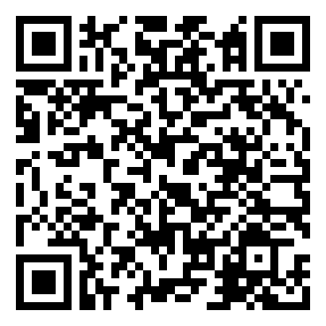
Scan to view images

