need report

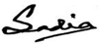
Mehedy Hasan Richad
MBBS
It Support Eng
BMDC Reg No: A-801565468
Mobile: 01516544911

