Fracture Report
X-ray of the [right/left] [body part] shows a [transverse/oblique/spiral/comminuted] fracture involving the [bone name] at its [proximal/mid/distal] portion. The fracture fragments show [no/mild/moderate/severe] displacement with [no/significant] angulation. Joint spaces appear [normal/abnormal], and surrounding soft tissue swelling is [present/absent]. No associated dislocation or foreign body is noted. Overall findings are consistent with a [type of fracture] of the [bone name]. Orthopedic consultation and appropriate immobilization are advised, with follow-up imaging recommended after treatment.

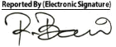
Dr. Md. Razibul Bari
Asst. Professor & Ex-Head Department of Radiology & Imaging, SSKMC
MBBS. M. Phil (Radiology & Imaging) (BSMMU)
PhD, University of Tokyo, Japan Advanced Training in CT scan & MRI (University of Tokyo)
BMDC Reg. No: A41925
Mobile: 01711115355
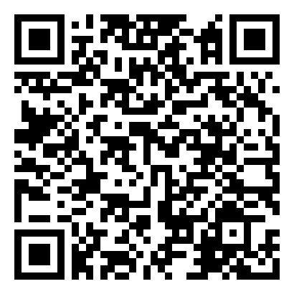
Scan to view images

