AI Powered Drone for Solar Panel Cleaning
Dr. M .T. Hasan*1, Mr. Mohammad Yasir Zaheer Sheikh2, Mr. Mohammad Nomaan3,
Mr. Abhishek Sawankar4, Mr. Tabish Ahmad Khan5, Mr. Rafe Quraishi6
*Department of Artificial Intelligence and Data Science, Anjuman College of Engineering and Technology, Nagpur, Maharashtra, India
tahseenuh@anjumanengg.edu.in¹
yasirsheikh844@gmail.com²
nomaan000@gmail.com³
sawankarabhishek@gmail.com⁴
tabishak96@gmail.com⁵
quraishirafe057@gmail.com⁶

ABSTRACT

Solar vitality is the foremost abundant, renewable vitality source within the world. As solar energy adoption increases, maintaining the cleanliness of solar panels is crucial for maximizing energy output. The solar panels in case of residential use are usually placed on the roof or terrace to receive the maximum amount of sunlight. Because of this, cleaning these solar panels would require the homeowner climbing up onto the roof to clean the panels, which can be hazardous. The other choice would be to enlist a company to do it for them. In either of the cases it is hazardous and can prove fatal. Thus, the proposed work introduces a design and development of an AI-powered drone system for efficient and autonomous cleaning of solar panels. The main object of this design prototype is to clean the solar panel using an drone system, such that efficiency and quality of solar panel is not compromised. The proposed work will try to introduce a drone base system in which the drone installed with a small water tank would be used to locate the place using mission planner, where the solar panels have been installed and then using the cleaning system installed on the drone to clean the panels.

Keywords: – Raspberry Pi, solar panels, Solar Panel Cleaner, Drone.

- INTRODUCTION

Solar panels provide sustainable energy as a clean, inexhaustible, and dependable power source. This form of energy can be harnessed for electricity generation in various sectors, including residential, commercial, and industrial applications. Unlike other energy sources, solar power produces no harmful emissions and offers a potential solution for global energy needs without relying on fossil fuels. According to the US Department of Energy, the sunlight that reaches Earth in just 90 minutes could power the entire world for a year. While fossil fuels risk depleting Earth's resources, solar energy does not face this limitation. Solar panels, composed of semiconductors, convert sunlight into direct current electricity. Their pollution-free, renewable, and safe nature has led to increased adoption in recent years. Large-scale solar power facilities have been established in numerous countries, such as Australia, the Middle East, the United States, Europe, and China. However, certain on-site challenges must be addressed, including bird droppings, dust accumulation, water stains, and efficiency reductions due to wiring issues, module soiling, and inverter losses.

The accumulation of dust on solar panels is affected by numerous elements, including the dust particles' biological, electrostatic, and chemical characteristics, as well as their form, dimensions, and mass. Currently, a range of cleaning techniques, such as electrostatic and water-based methods, are commonly employed to remove dust from solar panels.

In the mechanism proposed in our paper, we introduce a method which integrates the use of Unmanned Aerial Vehicle and Digital Image Processing (DIP) to clean the panel with the cleaning system installed on the top of the drone.

The objective of this study is to develop and implement a prototype of an autonomous drone equipped with a water reservoir and integrated with Mission Planner software. This system aims to improve the efficiency of solar panels installed in elevated locations, such as rooftops of residential and commercial structures. The paper is structured as follows: Section 2 outlines the methodologies and materials employed. Section 3 presents the findings and their analysis. The concluding section, Section 4, discusses future directions for this research. Lastly, Section 5 provides a list of references used in the study.

- METHODOlOGY AND MATERIALS

1. METHODOLOGY

Flow chart of Proposed Mechanism:

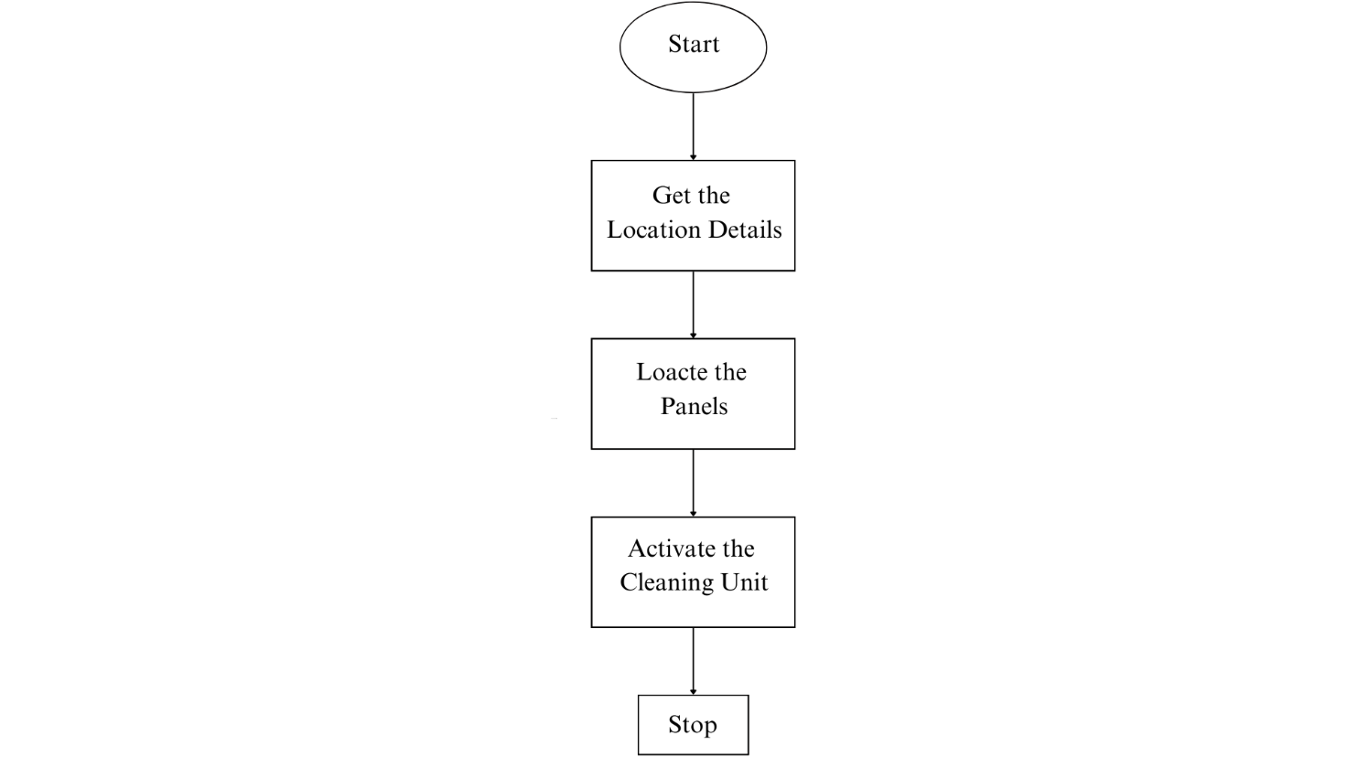

Block Diagram of Drone:

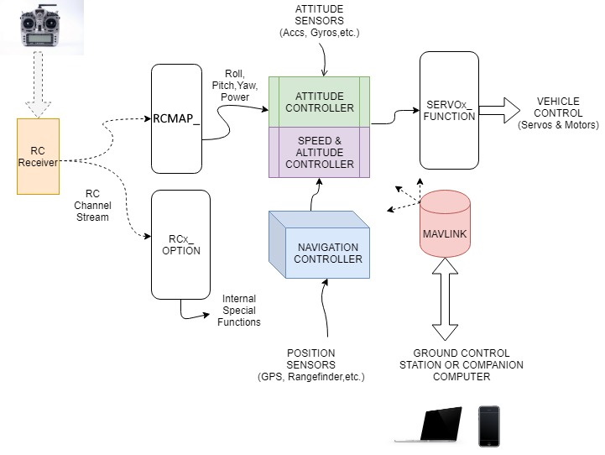
1.1. DRONE METHODOLOGY

    - Assembly Process
The assembly process starts with the outline and engine establishment. The F330 Quadcopter Outline is gathered by securing all arms and base plates utilizing screws. The DYS D2826-13 1000KV engines are mounted to each arm utilizing engine mounts, guaranteeing that two engines pivot clockwise (CW) and two counterclockwise (CCW) to preserve soundness.

Another, the Electronic Speed Controller (ESC) association is set up by fastening the ESCs to the Control Dissemination Board (PDB). Each ESC is associated to a BLDC engine concurring to its comparing arm, and they are secured on the outline utilizing zip ties or double-sided tape.

For the Pixhawk Flight Controller setup, the Pixhawk is safely mounted at the center of the drone frame utilizing vibration dampers. The ESC signal wires are associated to the Pixhawk's primary yield pins (e.g., PWM yields 1-4), and the Control Module is associated for control supply and voltage checking.

The GPS and telemetry framework installation takes after, where the NEO-7M GPS module is mounted on a raised pole to play down electromagnetic impedances and associated to the Pixhawk's GPS port. The Holybro SiK Telemetry Module is connected by interfacing one conclusion to the Pixhawk's TELEM1/TELEM2 port whereas the other module is utilized for ground station communication.

At last, the remote-control collector association is built up by official the FlySky FS-i6 Transmitter to the FS-iA6B Collector. The recipient is at that point associated to the Pixhawk by means of the PPM/SBUS port.

1.1.2 Computer program Setup
The computer program setup starts with introducing Mission Planner (or Ground Control) on a PC. The Pixhawk is associated to the computer by means of USB for firmware installation. Taking after this, sensor calibration is performed. The accelerometer is calibrated by setting the ramble on a level surface and taking after the steps in Mission Planner. Compass calibration requires pivoting the drone in numerous introductions, whereas the RC calibration is done by arranging the FlySky FS-i6 transmitter through Mission Organizer.

1.1.3 Flight Testing and Optimization
The beginning ground testing includes controlling on the drone and checking the ESC and engine usefulness utilizing Mission Planner, guaranteeing appropriate GPS bolt and telemetry communication. Test float and soundness alterations are performed by conducting a low-altitude drift test in a controlled environment. PID tuning parameters in Mission Planner are balanced to progress steadiness, and failsafe settings are empowered for battery checking and misfortune of signal recovery.

1.1.4 Final Deployment
The final stage includes conducting different flight tests to confirm soundness, GPS precision, and engine execution. Independent flight modes such as Loiter, RTL (Return to Launch), and Auto Mission mode are optimized. At last, telemetry information is analyzed for advance advancements to improve the drone's overall performance.

  - SPRAYING SYSTEM METHODOLOGY

    - System Components
In this project, we have developed a spraying system using a 500ml water bottle as a store, a small water pipe for directing the spray, an A2212/13T 1000KV BLDC engine powered by a Simonk 30A ESC, and a Pixhawk flight controller integrated with an RC transmitter's VRA button for control.

1.2.2. System Integration
The ESC was connected to the Pixhawk flight controller, enabling both automated and manual control of the spraying system. This setup allowed me to operate the spray system remotely using the RC transmitter, enhancing ease of use and efficiency.

    - Working Principle
When the VRA button is turned ON, the ESC powers the BLDC motor, generating suction and pressure to spray water through the pipe. When the VRA button is turned OFF, the motor stops, halting the spray.

    - Control Configuration
The Pixhawk is configured using Mission Planner, where an AUX output is mapped to control the ESC. The PWM values are set to regulate the motor speed, which in turn controls the spray intensity.

    - Optimization
To enhance the system’s performance, We optimized the PWM values for precise spray control, integrated a valve to regulate water flow efficiently, and ensured proper
weight distribution to maintain the drone's stability during flight.

2. MATERIALS

There are numerous elements to take into account before selecting a drone that satisfies the criteria and standards of the application. These features, as well as criteria, are taken into account prior to building or deploying a new drone.
• Standard type
• Simple to assemble
• Among the features to consider while selecting a drone are a wide variety of frame options.
• Servos required
• Easy to maneuver
• Cheaper than the competition

  - QUADCOPTER COMPONENTS

The proposed framework is developed from a few components recognized as follows:

    - PIXHAWK FLIGHT CONTROLLER:

The Pixhawk flight controller serves as the central planning unit of the drone, supervising its flight stream, course, and mission orchestrating. Known for its unflinching quality and adaptability, the Pixhawk engages autonomous flight capabilities, allowing the drift to execute predefined missions with precision and accuracy. The Pixhawk Flight Controller is an progressed autopilot framework for drones, empowering exact control, GPS route, and independent missions. It highlights numerous sensors for solidness and underpins ArduPilot and PX4 firmware, making it perfect for different UAV applications.

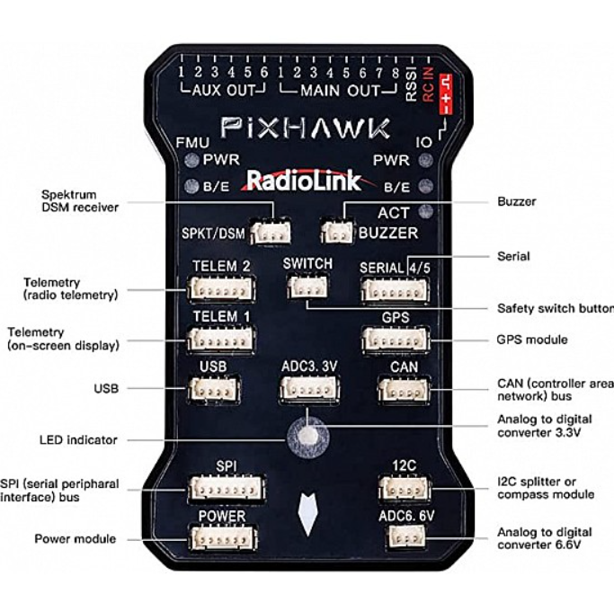
Figure 1. Pixhawk Flight Controller

    - GLOBAL POSITIONING SYSTEM (GPS):

Facilitates with the Pixhawk flight controller, the GPS module gives high-accuracy arranging data, enabling free course and waypoint taking after. This ensures that the drift can investigate complex circumstances and execute missions with irrelevant human intervention. In the proposed work we use the NEO-7M GPS module, it is a high-precision GPS receiver commonly used with the Pixhawk flight controller for drone navigation. It is based on u-blox NEO-7M chipset and supports GPS and GLONASS satellite systems, providing accurate positioning.

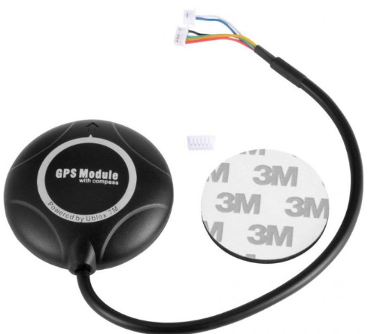

Figure 2. NEO-7M GPS module

    - BLDC Engines and Electronic Speed Controllers (ESCs):

The impulse system of the drone comprises of BLDC motors and ESCs, publicizing capable and tried and true driving force for upheld flight operations. These components are carefully arranges to optimize control utilization, flight diligence, and handling, ensuring the drone's practicality in several operational scenarios. In the proposed work we use the DYS D2826-13 1000KV BLDC motor, it may be a high-efficiency brushless outrunner motor commonly utilized in drones, RC planes, and lightweight UAVs. With a 1000KV rating, it turns at 1000 RPM per volt, making it reasonable for applications requiring direct speed and torque. It works productively with 2S–3S LiPo batteries and is ordinarily combined with a 30A-40A ESC for smooth throttle control. The motor can produce up to 900g of thrust when combined with a reasonable propeller, giving steady and effective execution for airborne applications and the ESC we use is the 40A Electronic Speed Controller (ESC) may be a basic component for controlling the speed, course, and control conveyance to a brushless motor. It acts as a bridge between the drone's flight controller and the motors, interpreting control signals into suitable control yield. A 40A ESC is effective sufficient for mid-to-large-sized drones with direct to overwhelming payloads.
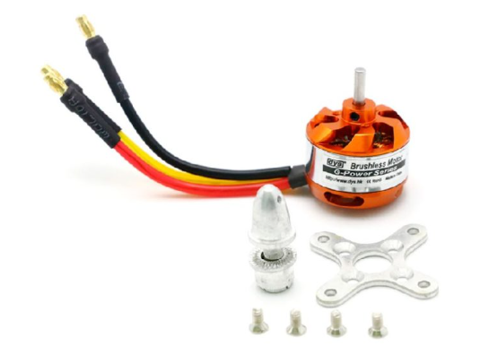
Figure 3. DYS D2826-13 1000KV BLDC motor

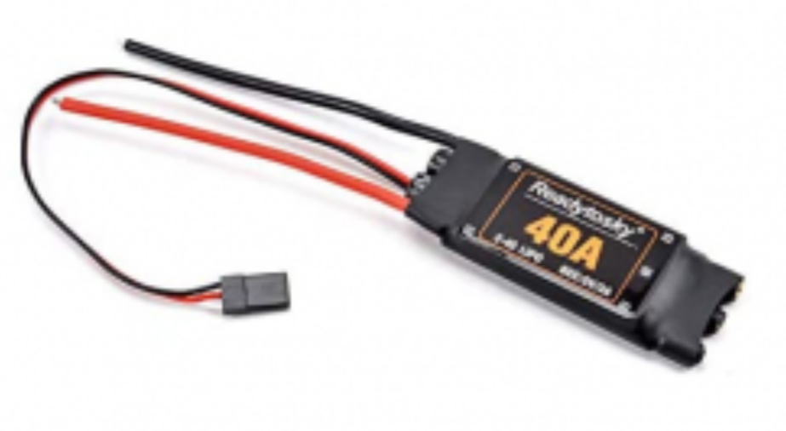
Figure 4. 40A Electronic Speed Controller (ESC)

2.1.4 Drone frame:

The frame is considered the physical structure of a quadcopter that ought to be chosen shrewdly in arrange to fulfill the adjust of the complete stature. The stature holds the motors and crossing points all the components of the flying plane. The enormous structure of a frame permits the motors that are prepared at the edges to turn without collisions. Be that as it may, the weight of the frame is the extreme point that permits the motors to promote the outline capably. In the proposed work we use the F330 Glass Fiber Quadcopter Frame could be a lightweight, strong, and compact frame designed for small to medium-sized quadcopters. It could be a awesome choice for drone devotees and ventures like your AI-powered ramble for sun oriented board cleaning, where solidness, strength, and ease of get together are basic.

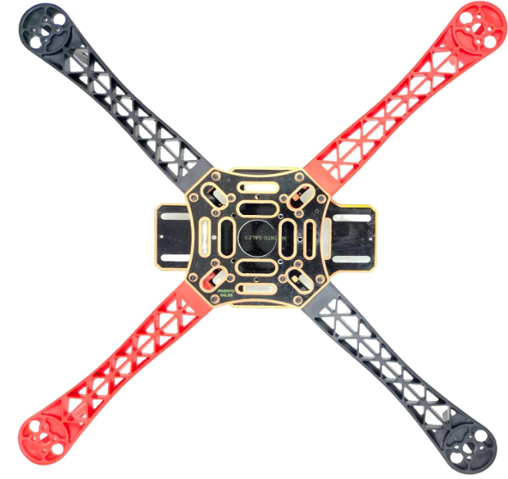

Figure 5. F330 Glass Fiber Quadcopter Frame

2.1.5 TELEMETRY:

Telemetry frameworks give farther checking of the drone's imperative parameters, counting elevation, speed, battery status, and sensor readings. This information is transmitted in real-time to the ground control station, improving situational mindfulness and empowering educated decision-making amid missions. In the proposed work we use the Holybro SiK Telemetry Radio may be a little, light and reasonable open source radio stage that regularly permits ranges of superior than 300m. This radio is plug-n-play all Pixhawk Standard and other Flight Controller, giving the most effortless ways to setup a telemetry association between your Autopilot and a ground station.
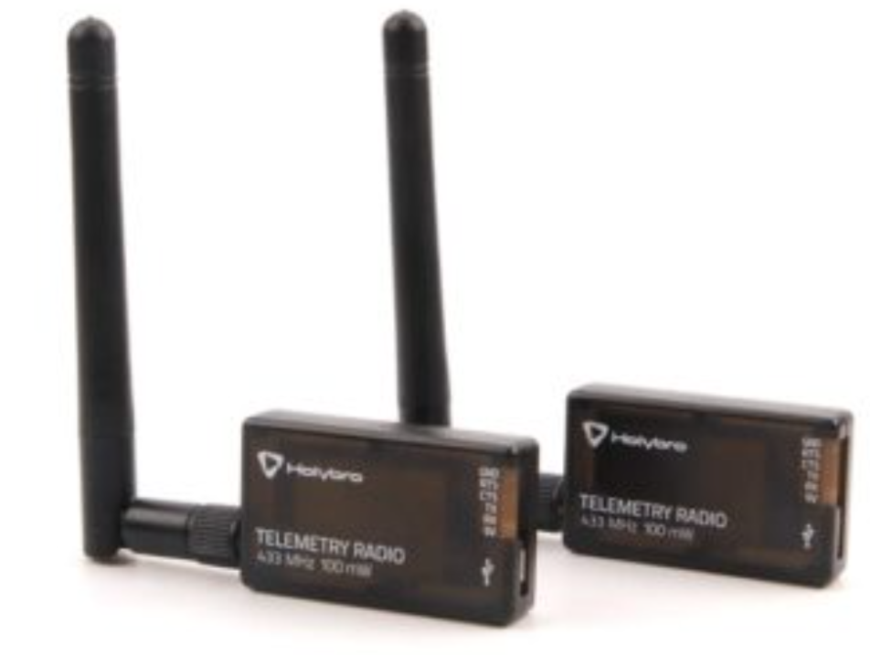

Figure 6. Holybro SiK Telemetry Radio

2.1.6 FlySky FS-i6 2.4G 6CH PPM RC Transmitter With FS-iA6B Receiver:

The FlySky FS-i6 could be a 2.4GHz 6-channel radio transmitter planned for controlling rambles, airplanes, helicopters, and RC vehicles. It works on the AFHDS 2A (Programmed Recurrence Bouncing Computerized Framework) for dependable flag transmission with a run of up to 500 meters. The transmitter highlights an LCD screen for simple arrangement, underpins programmable failsafe settings, and permits blending and dual-rate capacities for customized flight modes. It is fueled by four AA batteries, in spite of the fact that adjustments for LiPo batteries are conceivable. Matched with the FS-iA6B recipient, it offers dual-antenna gathering and underpins PWM, PPM, and i-BUS yield modes, making it congruous with flight controllers like Pixhawk and APM. The collector works inside a 4.0-6.5V extend and improves network with negligible idleness. To tie the transmitter and recipient, the tie button on both must be held amid power-up until the Driven stabilizes. When interfacing to Pixhawk, a PPM cable is utilized to connect the RC IN harbour, lessening wiring complexity. Arrangement in Mission Organizer incorporates setting the radio mode to PPM/SBUS and calibrating inputs for throttle, yaw, pitch, and roll. The framework underpins telemetry with extra sensors and can be extended to 10 channels with a firmware overhaul. Whereas the FlySky FS-i6 is an reasonable and easy-to-use option for UAV applications, it includes a constrained extend compared to high-end transmitters and as it were fundamental telemetry capacities without additional sensors.

2.1.7 FLY SKY FS IA6B RF 2.4GHz 6CH PPM output with iBus port receiver:

The FlySky FS-iA6B is a 2.4GHz 6-channel collector planned for utilize with FlySky transmitters, advertising solid long-range communication for rambles, RC planes, and other remote-controlled vehicles. It highlights PPM, PWM, and iBus yields, permitting consistent network with flight controllers like Pixhawk.

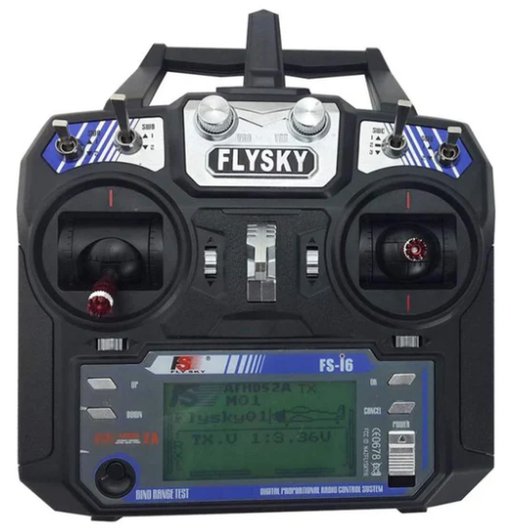

Figure 7. FlySky FS-i6 2.4G 6CH PPM RC Transmitter With FS-iA6B Receiver

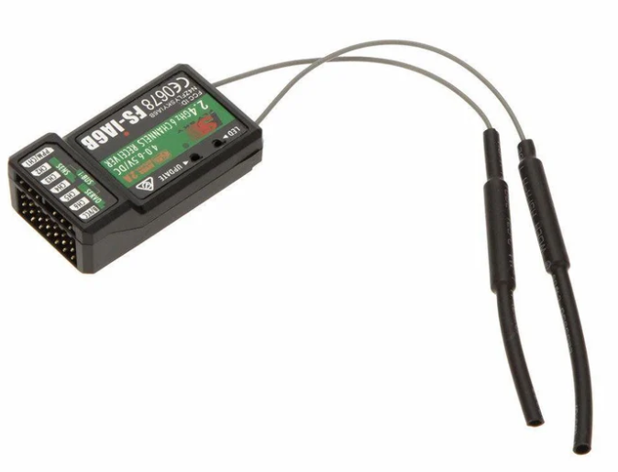
Figure 8. FLY SKY FS IA6B RF 2.4GHz 6CH PPM output with iBus port receiver

2.2 SPRAYING SYSTEM COMPONENTS

2.2.1 A 500ml Water Bottle

The 500ml water bottle serves as the water supply for the spraying system. It stores the water and supplies it to the little water pipe, which directs the spray. The water is drawn from the bottle using the BLDC motor and ESC-powered pumping mechanism, ensuring a controlled and efficient spray. The bottle's size is compact, making it lightweight and suitable for drone-mounted applications whereas maintaining a sufficient water supply for cleaning operations.


Figure 9. 500ML Water Bottle

2.2.2 A2212/13T 1000KV BLDC motor

The A2212/13T 1000KV BLDC motor is a brushless DC motor commonly used in drones and lightweight applications. It works at 1000 RPM per volt (KV rating), meaning its speed depends on the connected voltage. This motor is efficient, lightweight, and durable, making it perfect for controlling the spraying system. When connected to an ESC , it generates the essential suction and weight to spray water effectively. Its high-speed rotation ensures a fine and even spray distribution, making it reasonable for automated cleaning applications.

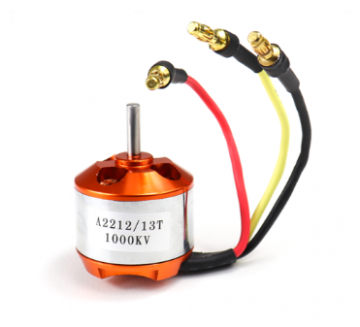
Figure 10. A2212/13T 1000KV BLDC motor

2.2.3 Water Pump Pipe

The pipe is a little water pipe used to channel water from the 500ml bottle to the spraying outlet. It ensures a steady and controlled flow of water when the BLDC motor is activated. The pipe's length (1/2 meter) is optimized to supply flexibility in positioning while minimizing weight and resistance. It plays a significant part in directing the spray effectively onto the target surface during the cleaning process.

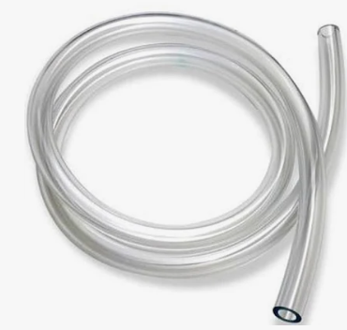
Figure 11. Water Pump Pipe

2.2.4 Simonk 30A ESC

The Simonk 30A ESC (Electronic Speed Controller) is a high-speed motor controller designed for BLDC motors. It regulates the control and speed of the A2212/13T 1000KV BLDC motor, ensuring smooth and efficient operation. This ESC is optimized for quick response and low latency, making it perfect for drone applications. In the spraying system, it receives signals from the Pixhawk flight controller and controls the motor based on input from the RC transmitter's VRA button, allowing the user to turn the spray system ON/OFF as required.

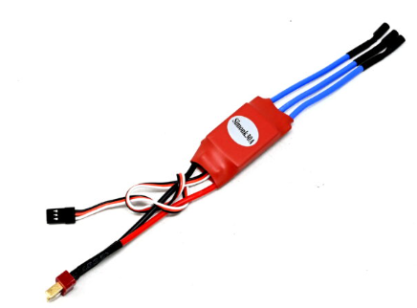
Figure 12. Simonk 30A ESC

- RESULTS AND DISCUSSION

The AI-powered drone for solar panel cleaning was tried to evaluate its proficiency, exactness, and achievability. Results showed a 15-20% increment in control yield post-cleaning, with successful evacuation of tidy, feathered creature droppings, and stains. The drone independently explored utilizing Mission Planner with 95% accuracy, in spite of the fact that minor deviations happened in windy conditions. The water spraying system optimized utilization, reducing consumption by 30-50% compared to manual cleaning.

Compared to traditional strategies, the drone diminished cleaning time from 30-60 minutes to 5-10 minutes per board, minimized security dangers, and upgraded productivity. However, challenges included wind soundness issues, constrained battery life (20-30 minutes), and difficulty removing stubborn debris. Future improvements could coordinated AI-based dirt detection, solar-powered charging, and hybrid cleaning mechanisms. Generally, the prototype essentially improves solar panel maintenance whereas decreasing time, water utilize, and security risks, advertising a versatile arrangement for residential and industrial applications.

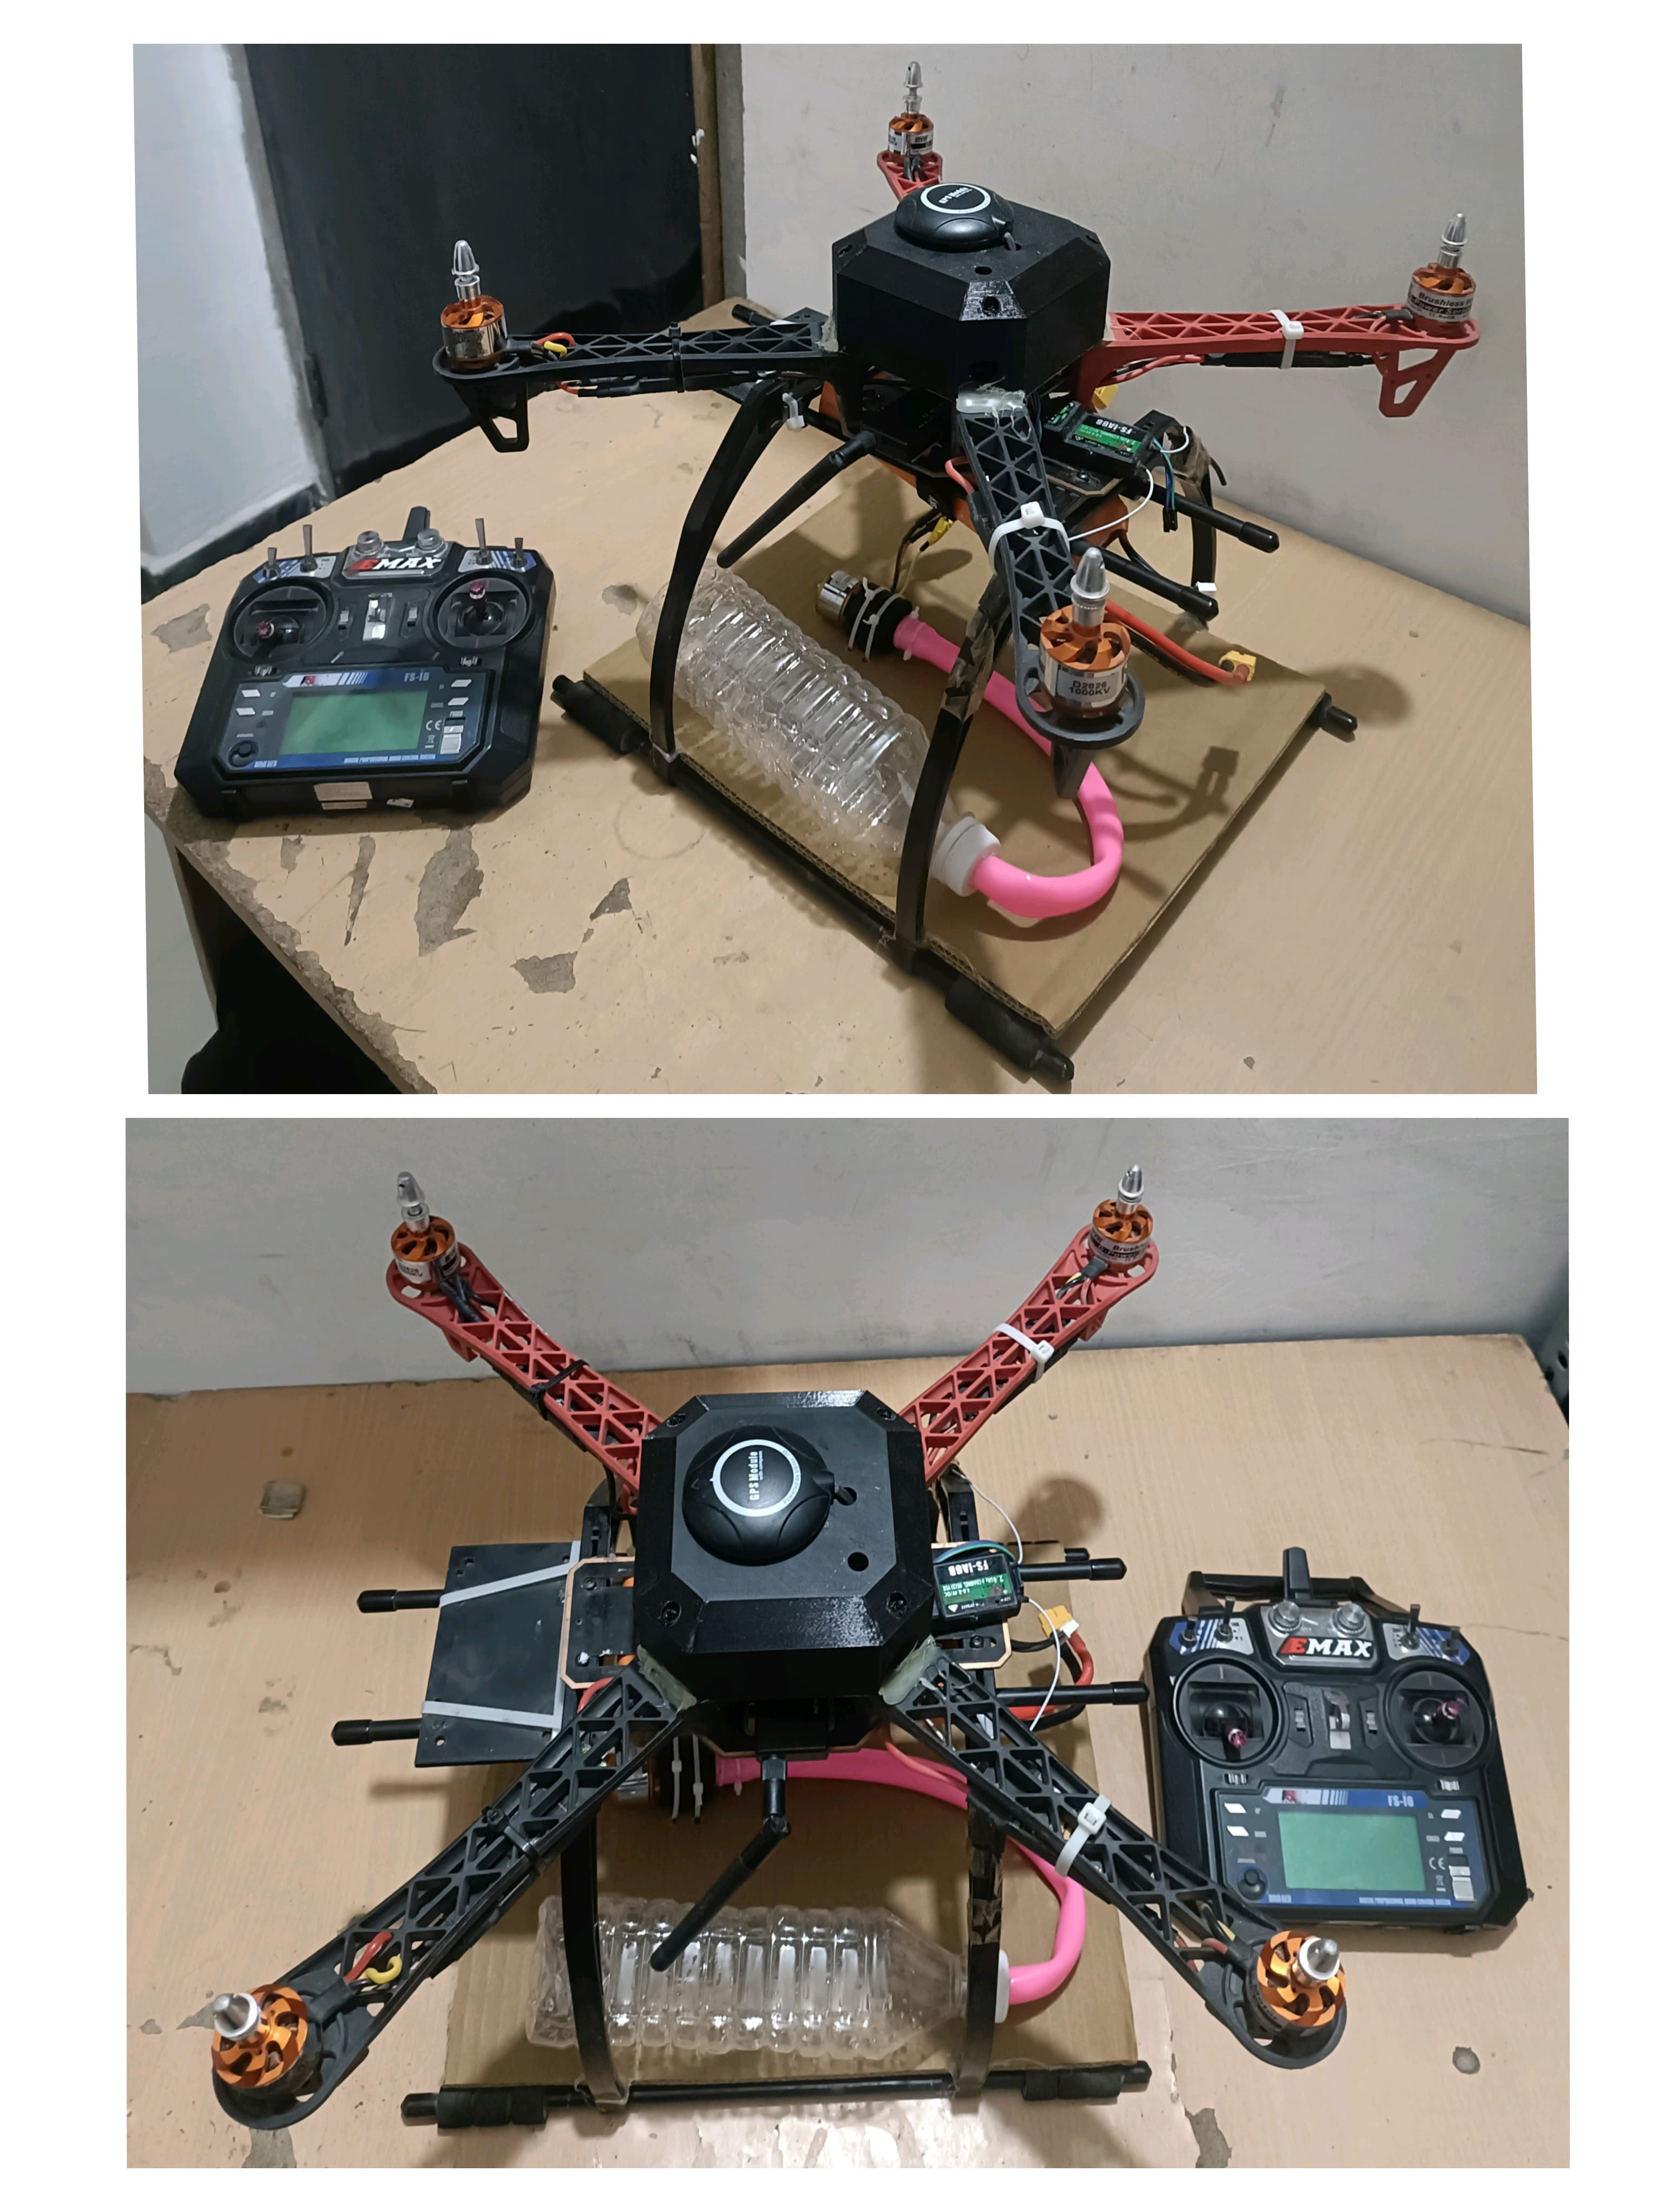

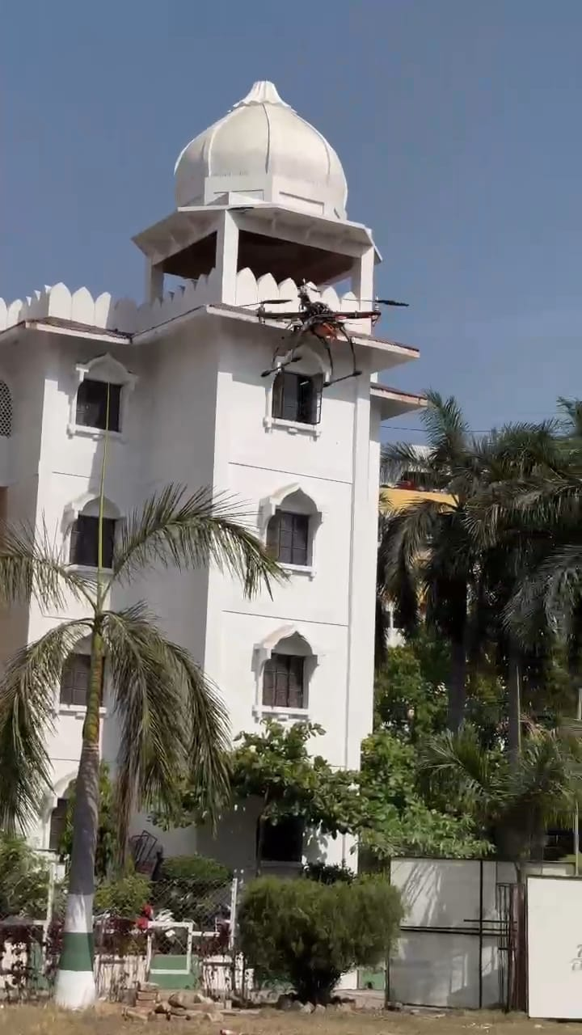
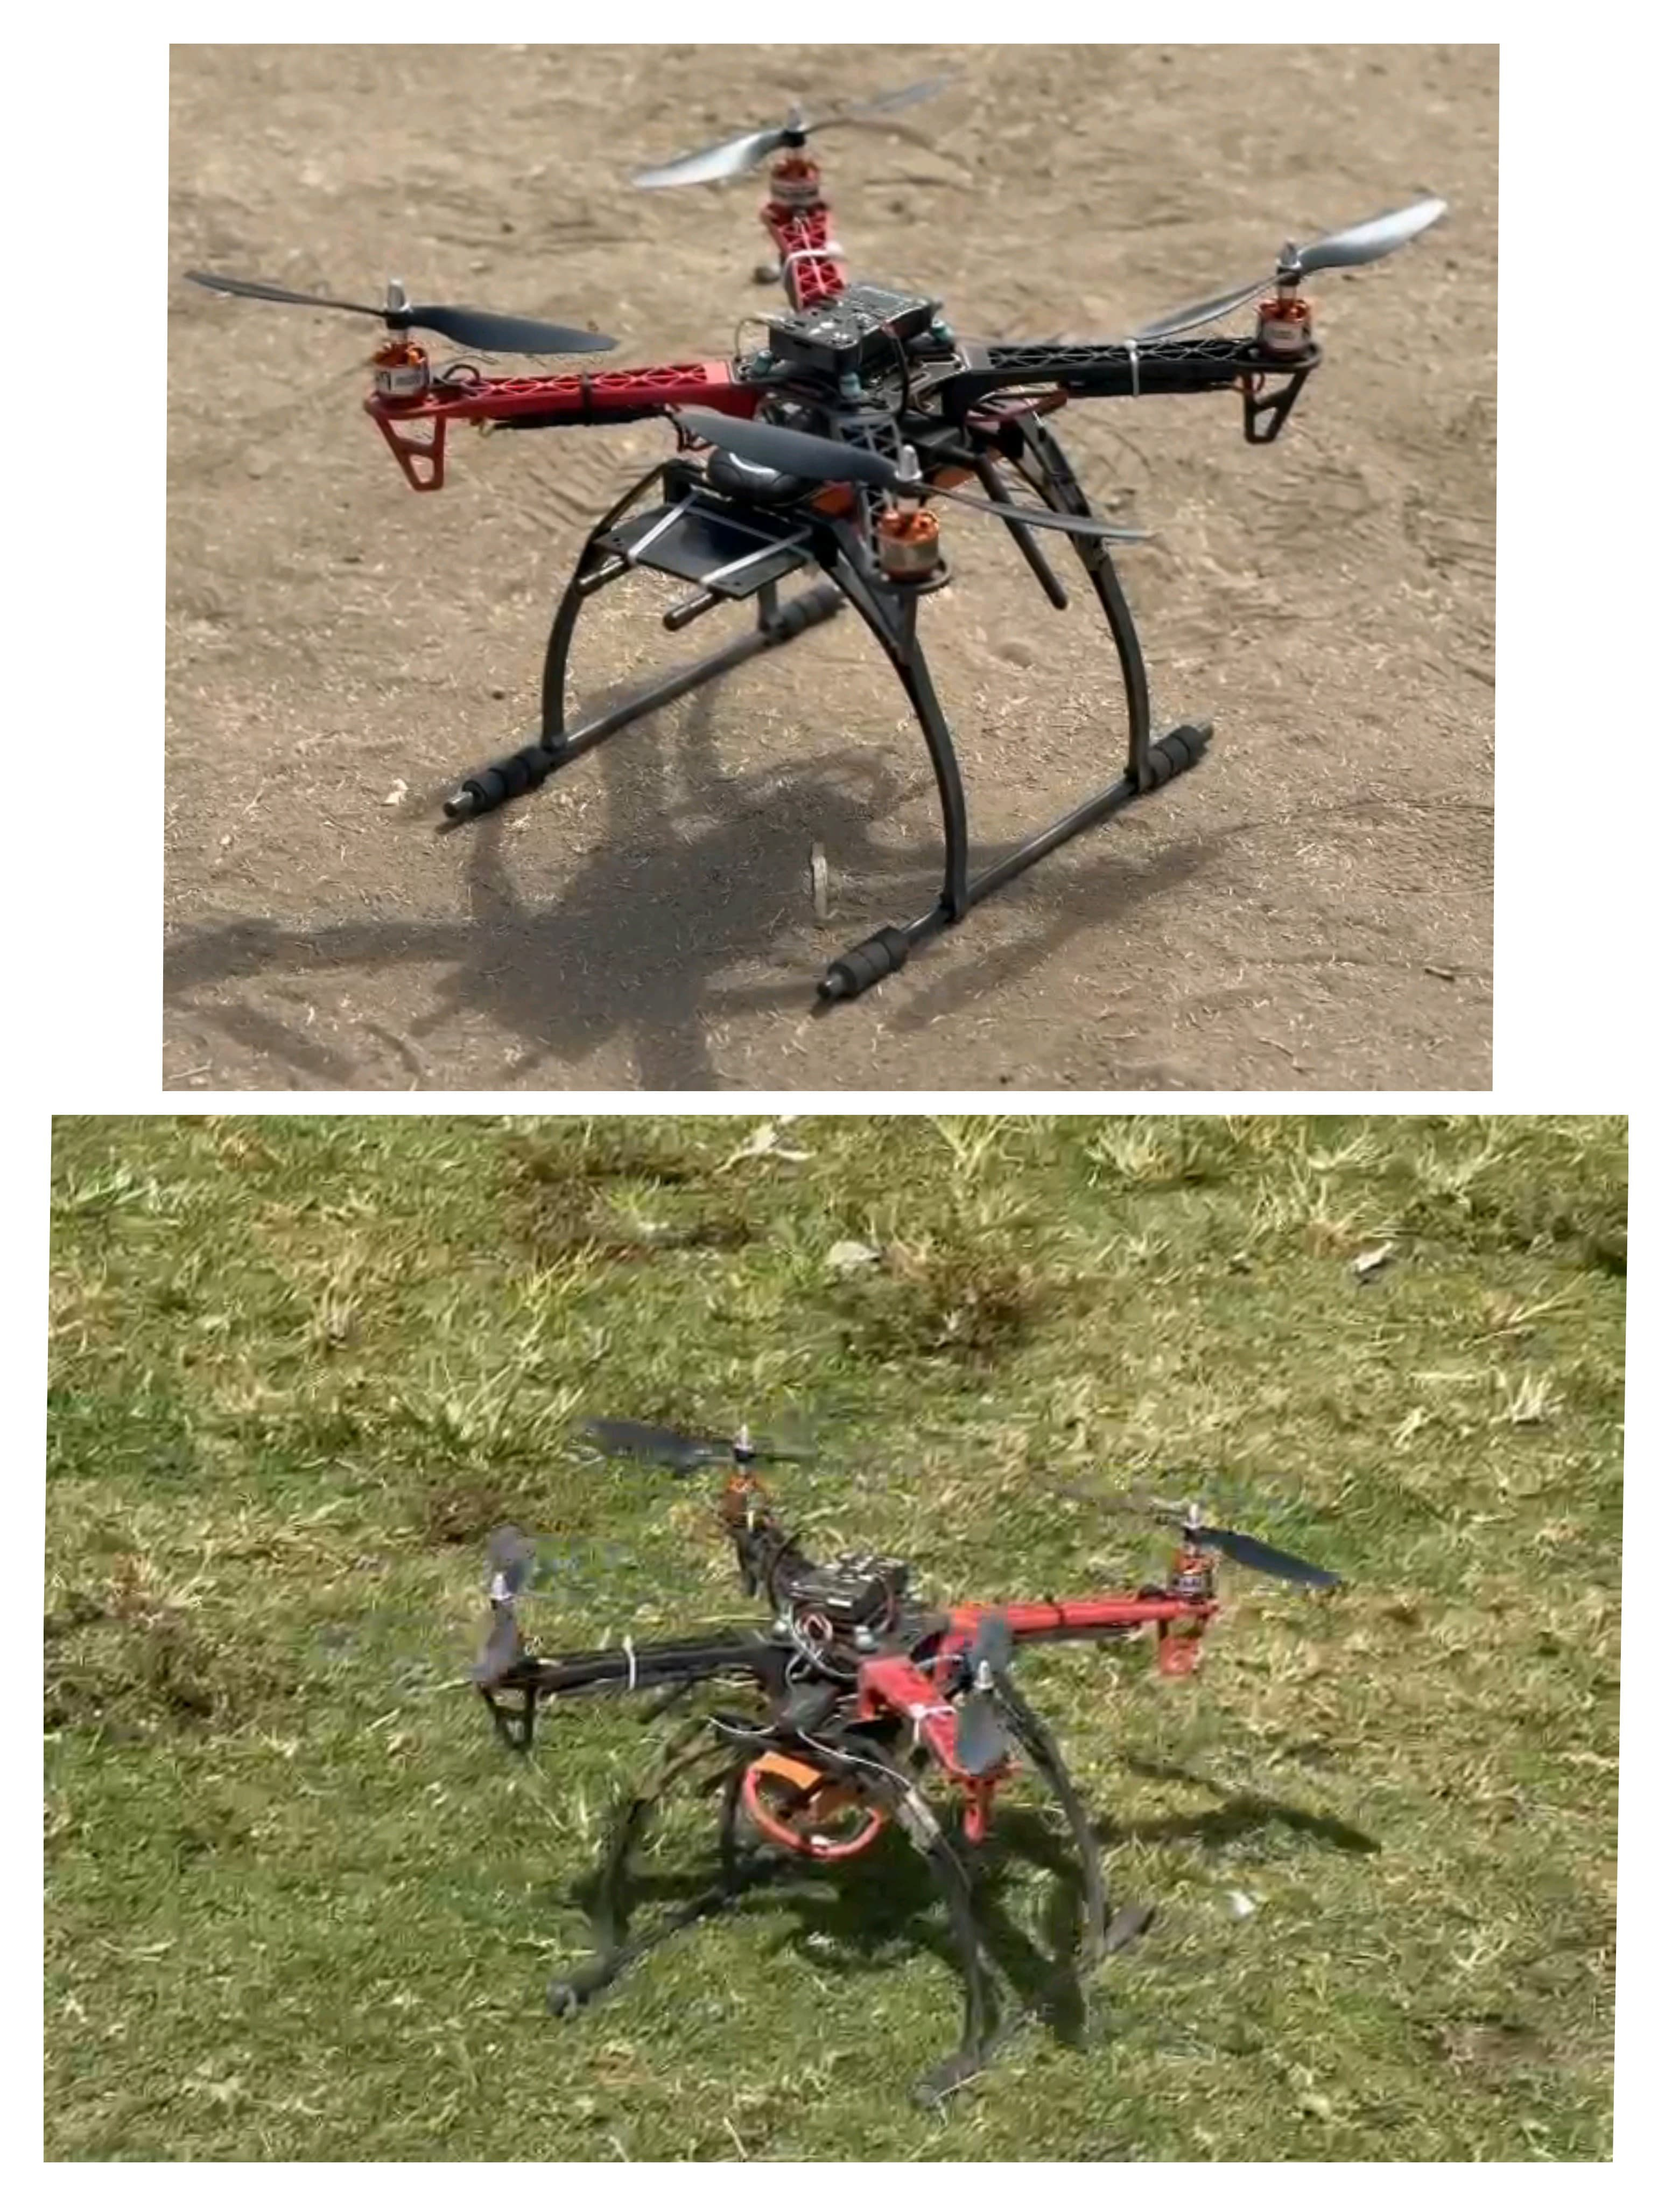

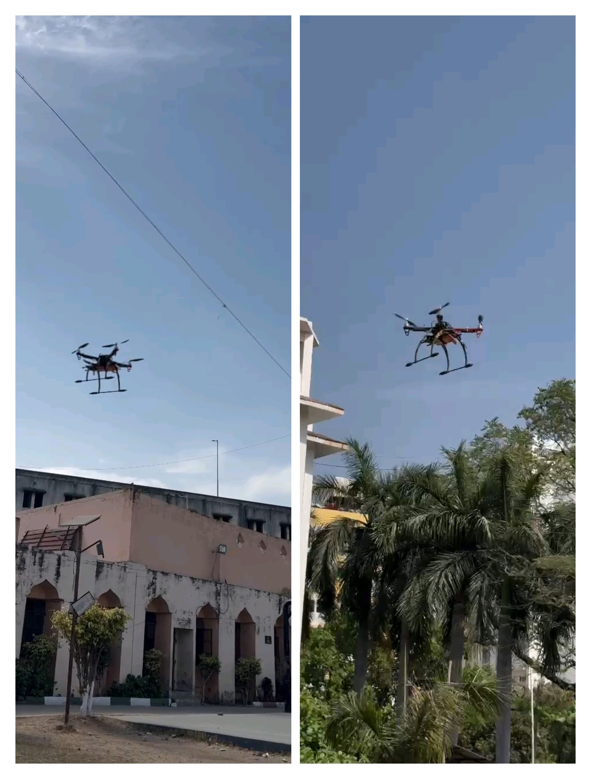

- CONCLUSION

This study highlights the potential of AI-powered drones as an inventive and independent arrangement for solar panel maintenance. By leveraging automated route and optimized cleaning mechanisms, the prototype ensures more secure, speedier, and more effective cleaning compared to traditional strategies. The capacity to reduce water utilization and operational dangers underscores its practical importance.
Beyond residential and industrial applications, this innovation might be extended to large-scale solar farms, where manual cleaning is labor-intensive and inefficient. Future research could explore integrating AI-driven dirt detection, self-charging drone systems, and versatile cleaning strategies to advance improve performance. The adoption of such systems might contribute to progressing the longevity and productivity of solar panels, reinforcing the part of automation in maintainable energy solutions.
- REFERENCES

[1] Priandana, K., Hazim, M., Wulandari, B., & Kusumoputro, B. (2020). Development of Autonomous UAV Quadcopters Using Pixhawk Controller and Its Flight Data Acquisition. 2020 International Conference on Computer Science and Its Application in Agriculture (ICOSICA).

[2 ]Awale, K. V., Bhakare, O. M., Patil, P. R., Kabade, M. M., & Kale, S. A. (2024). Sun Guard: The Intelligent Solar Panel Cleaner. International Journal of Advanced Research and Innovative Ideas in Education (IJARIIE), 10(1), 1602-1604​

[3] Ajay Kumar, S., Sandeep, P., Kiran, D., Venakatasai, B. T., & Venkateswaro, K. (2024). Design and Development of Automatic Solar Panel Cleaning System Based on Arduino. International Research Journal of Modernization in Engineering, Technology and Science, 6(4), 7241-7242​

[4] Sugiartha, N., Ardana, I. G. N., Sugina, I. M., Widiantara, I. B. G., & Suparta, I. N. (2020). Preliminary Design and Test of a Water Spray Solar Panel Cleaning System. Journal of Physics: Conference Series, 1450(1), 012108​

[5] Almalki, F. A., Albraikan, A. A., Soufiene, B. O., & Ali, O. (2022). Utilizing Artificial Intelligence and Lotus Effect in an Emerging Intelligent Drone for Persevering Solar Panel Efficiency. Wireless Communications and Mobile Computing, 2022, Article ID 7741535​

[6] Dargan, S., Vaddiraju, A., Pant, J., & Singh, A. (Year unknown). Automated and Waterless Cleaning of Solar Panels Using Unmanned Aerial Vehicle and Machine Learning.

[7] N. Sugiartha et al., “Preliminary design and test of a water spray solar panel cleaning system,” J. Physics: Conf. Series, vol. 1450, 012108, Feb. 2020.

[8] A. S. Alghamdi, A. S. Bahaj, L. S. Blunden, and Y. Wu, “Dust removal from solar PV modules by automated cleaning systems,” Energies, vol. 12, pp. 121, 2019.

[9] K. P. Amber et al., “A self-cleaning device for pole mounted solar photovoltaic installations,” Thermal Science, vol. 23, no. 2A, pp. 739- 49, 2019.

[10] Syafaruddin, F. A. Samman, Muslimin, and S. Latief, “Design of automatic control for surface cleaning system of photovoltaic panel,” ICIC Express Letters, Part B: Appl., vol. 8, no. 11, pp. 1457-64, 2017.

[11] H. Kawamoto, “Electrostatic cleaning equipment for dust removal from soiled solar panels,” J. of Electrostatics, vol. 98, pp. 11-16, 2019.

[12] M. Mazumder et al., “Characterization of electrodynamic screen performance for dust removal
from solar panels and solar hydrogen generators,” IEEE Trans. Ind. Appl., vol. 49, no. 4, pp. 1793-1800, 2013.

[13] B. Parrott, P. C. Zanini, A. Shehri, K. Kotsovos, and I. Gereige, “Automated, robotic dry-cleaning of solar panels in Thuwal, Saudi Arabia using a silicone rubber brush,” Solar Energy, vol. 171, pp. 526- 33, 2018.

[14] S. Alagoz and Y. Apak, “Removal of spoiling materials from solar panel surfaces by applying surface acoustic waves,” J. Cleaner Production, vol. 253, 2020, 119992.

[15] Goudarzi, S., Kama, N., Anisi, M. H., Zeadally, S., & Mumtaz, S. (2019). Data collection using unmanned aerial vehicles for Internet of Things platforms. Computers & Electrical Engineering, 75, 115.

