AI Powered Drone for Solar Panel Cleaning – A Review
Dr. M. T. Hasan, Mr. Mohammad Yasir Zaheer Sheikh, Mr. Mohammad Nomaan,
Mr. Abhishek Sawankar, Mr. Tabish Ahmad Khan, Mr. Rafe Quraishi
*Department of Artificial Intelligence and Data Science, Anjuman College of Engineering and Technology, Nagpur, Maharashtra, India
tahseenuh@anjumanengg.edu.in¹
yasirsheikh844@gmail.com²
nomaan000@gmail.com³
sawankarabhishek@gmail.com⁴
tabishak96@gmail.com⁵
quraishirafe057@gmail.com⁶

Abstract: The operational capabilities of lightweight Unmanned Aerial Vehicles (UAVs) are significantly limited, particularly in terms of range, endurance, and mission duration, due to constraints in communication link efficiency. This study addresses the challenge of balancing various mission requirements, UAV performance metrics, and operational feasibility. It explores the trade-offs between communication load, transmission power demands, onboard power availability—considering the UAV’s weight limitations—and overall security considerations.

Keywords: Unmanned aerial vehicles, Communication, Applications.

1. Introduction

In recent years, advancements in technology have led to reduced sizes, lighter weights, and enhanced functionalities of various sensors and devices. As a result, Unmanned Aerial Vehicles (UAVs) have gained significant attention across various applications, including environmental monitoring, surveillance, photography, and search-and-rescue operations [1]. With the increasing demand for UAVs, there is a growing need to extend their flight range and improve their adaptability to perform complex tasks efficiently [2].
UAVs, also known as drones, are pilotless aircraft that can be remotely controlled [3]. These aerial systems are equipped with sensors, cameras, communication modules, and other payload devices [4]. Initially designed for military purposes, UAVs have expanded their role to include civilian applications, such as border security and infrastructure monitoring [5]. The production of UAVs started in 2005 under the initiative of the U.S. Department of Defense (DOD) [6]. Currently, the leading UAV manufacturers include the USA, Israel, China, Iran, and Russia [7]. India is developing its own UAVs under the Rustom series [8]. UAVs are cost-effective, easy to build, and designed using essential electronic components.
Types of UAVs
UAVs are generally categorized into two types:
Fixed-Wing UAVs
Rotary-Wing UAVs
Each type has distinct advantages and limitations.

  - Fixed-Wing UAVs

Fixed-wing UAVs are widely used in military and defense operations due to their high speed and ability to carry heavier payloads [9]. However, they are not ideal for stationary applications since they cannot hover in one place. These drones utilize wings to generate lift and consume energy primarily for forward motion rather than maintaining position in the air. One of their significant advantages is their extended flight endurance, with some models staying airborne for up to 16 hours using a gas-powered engine instead of an electric one.

  - Rotary-Wing UAVs

Rotary-wing UAVs, commonly referred to as quadcopters, hexacopters, tricopters, and helicopters [10]. These UAVs are specifically designed for tasks that require hovering capabilities, such as surveillance, border monitoring, and military reconnaissance [11]. Unlike fixed-wing drones, they can remain stationary in the air, making them suitable for close inspections. However, rotary-wing UAVs have limitations in terms of speed and payload capacity compared to their fixed-wing counterparts [12]. The selection of UAV type depends on the specific requirements of the operation.

  - UAVs Applications and Advancements:

UAVs have proven to be highly versatile platforms for various applications [13]. With advancements in computing, sensors, communication, and networking technologies, their adoption has significantly increased in both military and civilian sectors over the past two decades [14]. UAVs can be effectively used in emergency situations, such as establishing communication networks when existing systems fail. For example, in disaster-stricken areas where conventional communication infrastructure is destroyed, UAVs can serve as communication relays to coordinate rescue operations.
This paper aims to explore the fundamentals of UAVs and the current advancements in UAV technology. It further delves into UAV communication systems, ground control stations (GCS), sensor-based data processing, applications, and security measures. Additionally, the paper reviews past research limitations and discusses future challenges and research directions in UAV system development.
This paper is organized into 8 sections. Section 2 covers UAV communication systems. Section 3 discusses UAV control via ground stations. Section 4 focuses on data collection and processing using UAVs. Section 5 presents various UAV applications. Section 6 highlights security concerns in UAV operations. Section 7 discusses open research challenges and future research directions. Section 8 concludes the study.

- UAV Communication System

Unmanned Aerial Vehicles (UAVs) consist of various essential components, each contributing to the overall flight operation [15]. Among these, the communication system is the most critical. UAV communication systems facilitate the exchange of data and visual information between drones and operators, ensuring mission success. Without an effective communication system, unmanned flight would be impossible, and the transmission of aerial visuals and data collection would be hindered [16].
As UAVs continue to gain prominence as the primary platform for aerial data collection across various industries, the importance of reliable and robust communication systems grows. Without highly adaptable and reliable communication systems, operators would struggle to receive accurate aerial visuals and data in real-time [17]. Currently, radio frequency (RF) communication stands out as the most advanced and reliable solution for civilian UAV systems due to its compact size, lightweight design, low power consumption, and stable communication interface [18].
Civilian UAV communication systems typically operate on frequencies of 2.4 GHz and 5.8 GHz [19]. UAV communication systems function by utilizing one frequency to control the aerial vehicle from the ground via a remote pilot and another frequency to transmit First-Person View (FPV) video. Through high-quality communication links, civilian UAVs seamlessly transmit aerial visuals and data to ground operators while maintaining stable flight.
In military applications, UAVs differ significantly from civilian models as they often require longer operational durations and advanced capabilities beyond providing aerial visuals of the battlefield. One major challenge in military UAV operations is signal jamming, which can cut off communication between the drone and its operator, leaving the UAV without visual feedback. However, most military UAVs are designed to return to base when communication is lost. To counteract signal jamming, redundant onboard navigation systems, which do not rely on GPS, are incorporated [20]. By eliminating GPS data dependency, these systems minimize the impact of signal jamming and allow UAVs to complete their missions and return safely.

2.1 UAV Communication System Design

The UAV design discussed here involves a lightweight, hand-launched UAV with a maximum take-off weight of up to 7 kg [21]. The primary objective of this UAV is to perform intelligence, surveillance, reconnaissance, and target tracking to support military operations. The UAV is equipped with a stabilized camera payload that autonomously performs intelligence and surveillance missions [22]. Since the UAV operates in hostile environments where maintaining a stealth profile is crucial, its shape, color, and minimal heat and noise emissions are carefully designed to ensure low visibility [22].
Given the limited onboard power capacity due to weight constraints, electromagnetic stealth is not the primary concern. However, securing the UAV from potential cyberattacks and unauthorized control is essential. Ensuring the integrity and confidentiality of UAV communication requires the use of Commercial Off-The-Shelf (COTS) frequency-hopping transceivers and authentication protocols to protect against data modification, replay attacks, and signal jamming.
Key Components for Effective UAV Communication.
To achieve reliable UAV communication, high-quality components must be used, including:
- Sensors: Lightweight and low-power consumption sensors are ideal for UAV communication applications [23].
- RF Communication: Essential RF devices such as frequency converters, RF filters, and bidirectional RF devices play a critical role in maintaining UAV communication [24, 25].
- Antennas: High-performance antennas ensure strong and consistent communication signals for UAV platforms.
- Propulsion System: Propulsion systems, including engines, motors, LiPo batteries, and propellers, are crucial for ensuring UAV movement.
- Drone Frame: The frame, often made of durable materials such as nylon and carbon fiber, provides strength while maintaining a lightweight structure [26].
A well-functioning UAV communication system ensures successful unmanned flight, enabling the transmission of aerial visuals and data collection in real-time. Without this system, it would be impossible to control the UAV or gather visual and data inputs. Civilian UAV communication systems primarily operate on 2.4 GHz and 5.8 GHz frequencies, facilitating the control of aerial vehicles from the ground.
The UAV communication platform also plays a role in supporting data transmission in the Internet of Things (IoT) [27]. Orthogonal Frequency Division Multiplexing (OFDM) is often employed to divide transmission information and energy harvesting between two subcarriers. UAV-enabled networks utilize OFDM technology to simultaneously transfer information and power, known as Simultaneous Wireless Information and Power Transfer (SWIPT).
To enhance system performance, researchers have developed a divide-and-conquer technique to address complex optimization problems. The problem is divided into two sub-problems—one focusing on user scheduling, subcarrier allocation, and power management with a fixed UAV trajectory, and the other focusing on optimizing UAV trajectory with enhanced user scheduling and resource allocation. Step-by-step solutions to these sub-problems result in achieving desired accuracy.
Additionally, UAV-enabled networks can utilize Non-Orthogonal Multiple Access (NOMA) for serving multiple users simultaneously [28]. NOMA has demonstrated superior performance compared to Orthogonal Multiple Access (OMA) and Dirty Paper Coding (DPC), with path-following algorithms being employed to optimize power and resource allocation. The inclusion of physical layer security enhances communication reliability and protects UAV networks from potential cyber threats.
Solar-powered UAVs offer a sustainable solution for long-duration missions, providing reliable communication services to multiple ground users [29]. Researchers have explored optimal 3D aerial trajectories and wireless resource allocation methods to enhance system performance within a specific timeframe. Offline resource allocation methods have been used as performance benchmarks, but they require high computational complexity. Consequently, sub-optimal iterative online schemes with lower complexity are often preferred. Simulation results indicate that both offline and online algorithms achieve comparable performance while outperforming baseline schemes.

- UAV Ground Control Station (GCS)

Currently, for missions such as search-and-rescue and surveillance, UAV systems are required to operate in highly complex environments while maintaining consistent communication with the ground control station (GCS) for monitoring, reporting, and control purposes [30]. In densely populated urban areas or mountainous regions, communication between UAVs and GCS can be disrupted, causing the GCS to lose real-time data feedback from the UAVs, which may result in mission failure [31]. Moreover, when a mission demands extended flight ranges, communication capabilities are often hindered by the distance between the UAV and the GCS.
Commercially available and cost-effective UAV communication solutions come with certain limitations that restrict their widespread application. One of the primary limitations is the relatively short communication range of widely used telemetry modules such as 3DR, XBee, Sik2, and other Wi-Fi modules, which typically cover only a few kilometers [32]. Furthermore, maintaining a stable data link becomes challenging when obstacles such as tall buildings, dense forests, or mountainous terrains obstruct the communication path between UAVs and the GCS. In such situations, extending the mission with a single UAV becomes difficult while keeping the system complexity and cost under control.
To overcome these challenges and maximize the potential of UAVs, an alternative solution is the deployment of a multi-UAV system. This system leverages inter-UAV communication to ensure continuous data exchange between UAVs and the GCS, even when direct communication is not possible. A communication and routing-based solution was introduced to extend the communication range and address these challenges at a lower cost [33]. A proof-of-concept was demonstrated using a two-UAV system, which successfully established wireless communication. This architecture can accommodate additional UAVs, allowing them to operate in areas where direct communication with the ground control station is not feasible. This setup enables communication beyond the range of onboard wireless transceivers and has been validated through ground tests. The system uses one UAV as a communication relay, allowing other UAVs to perform tasks in areas where a direct link to the control station is unavailable.
A UAV, or unmanned aerial vehicle, is essentially an aircraft that operates without a pilot onboard, relying instead on computer systems and radio links for control. Despite its simple appearance, designing a UAV requires precision to ensure high efficiency. The critical components of a UAV system include:
- Control Station (CS): The interface that connects the operator with the UAV system.
- Aircraft: The vehicle carrying the payload, which can vary depending on the mission.
- Communication System: Ensures the transmission of control inputs from the CS to the UAV and relays payload data back to the CS through radio communication.
- Additional Equipment: This may include maintenance and transportation components.

  - Development of GCS
The Ground Control Station (GCS) is a portable and user-friendly system specifically designed to manage UAVs and facilitate communication [34]. Its dimensions are typically 360 × 96 × 96 inches, and it uses a triple-axle trailer for transporting and deploying the aircraft [35]. The trailer contains essential components such as:
- Uninterrupted Power Supply (UPS): Ensures continuous power availability.
- Environmental Control System (ECS): Manages thermal control, air supply, and cooling.
- Pilot and Payload Operators (PPO): These are key personnel responsible for controlling the UAV and managing the sensory payload [36].
- Workstations for Data Exploitation, Mission Planning, and Communication (DEMPC): These workstations analyze data, plan missions, and manage the UAV system [37].
- Synthetic Aperture Radar (SAR): Provides limited exploitation of SAR data and locates regions where UAVs operate [38].
- Communication Systems: High-frequency, Ultra High-Frequency, and Very High-Frequency (HF/UHF/VHF) signals facilitate voice and data transmission. TROJAN SPIRIT II satellite terminals are used for hardware connectivity.
Satellite communication (SATCOM) ensures secure communication between the GCS and the UAV [39]. The system incorporates Automatic Target Recognition (ATR) technology, utilizing Synthetic Aperture Radar (SAR) to identify and locate targets from aerial platforms on the battlefield. ATR is essential for military operations, as it allows for identifying high-value objectives even in adverse conditions. The initial plan was to develop a GCS capable of controlling two UAVs simultaneously, one for vehicle control and another for Ku Band Link, which operates within the 12 to 18 GHz range of the electromagnetic spectrum. However, this concept is not part of the current development plan.
The advancement of GCS is now focused on improving ATR capabilities to enable wide-area coverage and high-accuracy target detection under all weather conditions[40]. The system integrates unique algorithms to achieve 99% efficiency in autonomous operations. Recent developments have successfully enabled a UAV to detect, identify, and locate six high-value mobile targets simultaneously using real-time strip map fine-resolution SAR with onboard ATR.
Additionally, an Android application for GCS was developed, featuring a user-friendly interface for UAV control [41]. This application enhances functionality by enabling real-time monitoring of UAV operations, displaying navigation information, and configuring flight control parameters such as PID settings. The application facilitates data exchange between devices using a half-duplex communication mode and connects to the Multiwii Flight Controller. Testing demonstrated the application's high accuracy, with a data precision level of 96.12% and a deviation of only 0.7%. The application can display the UAV's location using latitude and longitude coordinates and connect to an IP camera through local Wi-Fi. However, Wi-Fi coverage was found to be limited to a range of approximately 0–100 meters.
The Internet of Things (IoT) is characterized by vast data loads and extensive coverage. Recently, Mobile Edge Computing (MEC) and UAV-Base Stations (UAV-BSs) have emerged as promising IoT technologies [42]. A MEC-based data processing network has been proposed, where distributed sensors collect local data at the lower layer. UAV-BSs act as MEC servers, gathering and processing data before transmitting the analyzed results to a central cloud for further evaluation. Edge nodes help minimize latency and ensure data freshness for online processing.
However, the limited onboard energy of UAVs imposes constraints on edge data processing. At low data rates, the amount of edge processing required to maintain energy efficiency is minimal, whereas high data rates require intelligent bandwidth reservation for data storage. Despite the broad and flexible services provided by hovering UAV-BSs, route planning remains a critical challenge. This challenge was addressed by applying deep learning techniques to develop an algorithm for online route planning. The algorithm takes environmental measurements as input and uses a CNN network to predict optimal behavior, enhancing service coverage, as validated through simulations. These advancements will play a crucial role in the analysis of big data in future IoT applications [118, 119].

- UAV Sensors-Based Data Processing

In UAV-based data acquisition, three types of information are typically gathered: video streams, telemetry data, and supplementary information [43]. Since the acquired video is encoded using MPEG-based standards, it must first undergo encoding [44]. Telemetry data, captured by GPS or INS (Inertial Navigation System) sensors, is referenced using a distinct coordinate frame, which requires standardization [45]. Additionally, to obtain accurately referenced GCPs (Ground Control Points) for UAV system adjustments or for ensuring the precision of orthomosaic images, USGS DEM (Digital Elevation Model) and USGS DOQQ (Digital Orthophoto Quarter Quadrangle) reference images must be co-registered. This ensures that the 3D GCPs (Global Climate Perspective System) can be effectively computed.
UAVs Are Primarily Based on Five Types of Sensors;

  - RGB Sensor or Camera

UAVs (Unmanned Aerial Vehicles) often employ remotely controlled models equipped with RGB cameras. These cameras, along with navigation sensors such as GPS or IMU, form essential components of the UAV survey system [46, 47]. A variety of RGB cameras are available in the market, catering to diverse applications. Choosing the right RGB camera is crucial for successful UAV operations. Important factors to consider include the camera's lens quality (to minimize geometric distortion), resolution, and the quality of CCD (Charged Coupled Device) or CMOS (Complementary Metal Oxide Semiconductor) sensors, which influence pixel size and noise levels.

  - Multispectral Sensor or Camera

Multispectral cameras, known for their lightweight design, are commonly used alongside RGB cameras in UAV-based systems [48]. These sensors are particularly beneficial for agricultural and vegetation analysis [49]. Multispectral cameras can detect water levels in farmland and facilitate leaf-level disease assessment [50]. One significant advantage is the ability to capture high-resolution data (often better than 30 cm GCD—Ground Control Distance), which is not typically possible with conventional multispectral systems [51]. However, due to the additional hardware required for capturing extra bands beyond the RGB spectrum, multispectral cameras tend to be more expensive.

  - Hyperspectral Sensor

Hyperspectral sensors capture images across hundreds of narrow bands (usually 5–10 nm bandwidth) [52, 53]. Most hyperspectral sensors operate as linear array cameras [54], capturing a vast volume of data, which is extremely useful for diverse applications [55]. UAV-based hyperspectral systems typically have a narrower spectral range (400 nm to 1100 nm or 1100 nm to 2500 nm) compared to aerial hyperspectral systems. However, with careful flight planning, UAV-based hyperspectral sensors can achieve image resolutions of 2 cm to 5 cm or even lower.

  - Thermal Infrared Sensor

Thermal infrared sensors, which are also lightweight, operate within a wavelength range of 3 µm to 35 µm [56, 57]. These sensors are widely used to measure surface temperature and estimate thermal emissions. A key challenge lies in determining engine temperature and emissivity by analyzing heat concentration and its distribution. Thermal sensors are typically used in real-time applications, with the qualified capture rate determined beforehand [58]. These sensors serve numerous applications in agriculture, environmental monitoring, and other fields.
Although the geometric characteristics of thermal cameras are similar to conventional point-of-view cameras [59], thermal images generally exhibit fewer textures than RGB images. Consequently, photogrammetry and Structure-from-Motion (SfM) techniques often struggle due to a lack of interest points. Therefore, it is recommended to align an RGB camera with the thermal camera and capture images simultaneously to utilize the default orientations of the thermal camera.

  - LiDAR

LiDAR (Light Detection and Ranging) sensors are renowned for their accuracy in collecting geometric data [60]. These sensors are extensively used in forestry, cultural heritage documentation, and Building Information Modeling (BIM). Both the academic and commercial sectors have made significant advances in mobile, terrestrial, and aerial LiDAR technologies. UAV-based LiDAR systems often encounter inaccuracies in GPS or IMU data, leading to platform instability during flights. Even with well-calibrated lightweight LiDAR systems, the accuracy of the resulting point clouds remains limited. To address this, highly accurate UAV-based LiDAR systems are usually integrated with differential GPS stations [61], ensuring high-precision GPS measurements. LiDAR sensors, despite their high cost, provide unmatched accuracy.
UAVs are increasingly deployed in various fields, and the concept of formation flights is steadily gaining traction [62]. However, managing multiple UAVs with formation control remains challenging due to the complexity of distributed control theories. To address this, formation control models and algorithms are developed and validated using MATLAB/Simulink before being exported as C++ code. This code is then implemented within a Qt-based simulation framework and Ground Control System (GCS), where manual communication disruptions can be simulated to evaluate system robustness.

  - UAV LiDAR Sensor for Forensic Evidence Detection

UAVs equipped with LiDAR systems facilitate accurate data collection, improving planning and understanding of urban infrastructure [113]. LiDAR technology enables UAVs to capture geometric and spectral data effectively. Photogrammetry, the science of measuring objects through photographs, assists in creating maps, drawings, and 3D models of real-world environments. LiDAR technology uses ultraviolet, visible, and infrared light to capture images of nearby objects. UAVs equipped with infrared-based LiDAR systems prove highly effective for forensic applications. These UAVs can capture high-quality images of crime scenes, map areas, and record evidence. Traditional crime investigation methods are time-consuming, whereas UAV technology enhances efficiency in forensic investigations by allowing the examination of hard-to-reach areas and detailed scene assessments [114].

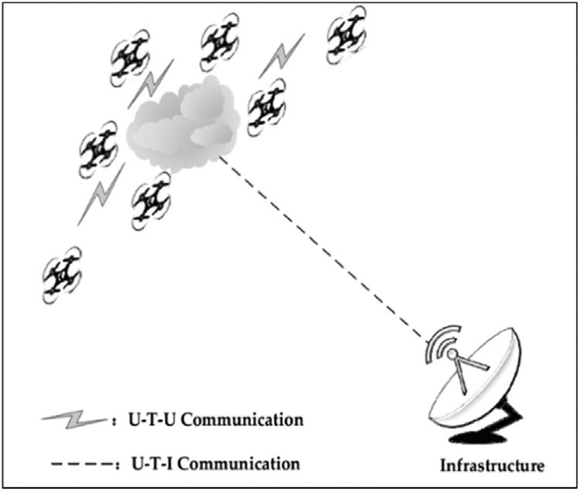

Fig. 1. Single group UAV swarm [116].

  - UAV Swarm Concept

The UAV swarm concept involves a group of UAVs performing complex tasks in a self-organized and coordinated manner to accomplish a mission [115]. Advancements in UAV technologies have led to the spontaneous establishment of decentralized communication among UAVs.
Various routing protocols and networking techniques have been developed to enhance network performance. Researchers have proposed different concepts, architectures, and topologies to improve autonomous communication for specific scenarios. UAV swarm collaboration strategies play a crucial role in ensuring reliable communication. Decentralized communication approaches allow UAVs to communicate intelligently and eliminate the constraints of communication range and infrastructure dependence.
Under decentralized architectures, UAV swarms communicate in real-time through Adhoc networks. These architectures include single-group swarm Adhoc networks (SGSAN), multi-group swarm Adhoc networks (MGSAN), and multilayer swarm Adhoc networks (MLSAN) [116].
UAV swarm communication has also progressed towards cloud-based and satellite-based communication, enhancing data transmission. Current research trends focus on ensuring the security of UAV swarm communication (Figures 2, 3, and 4).

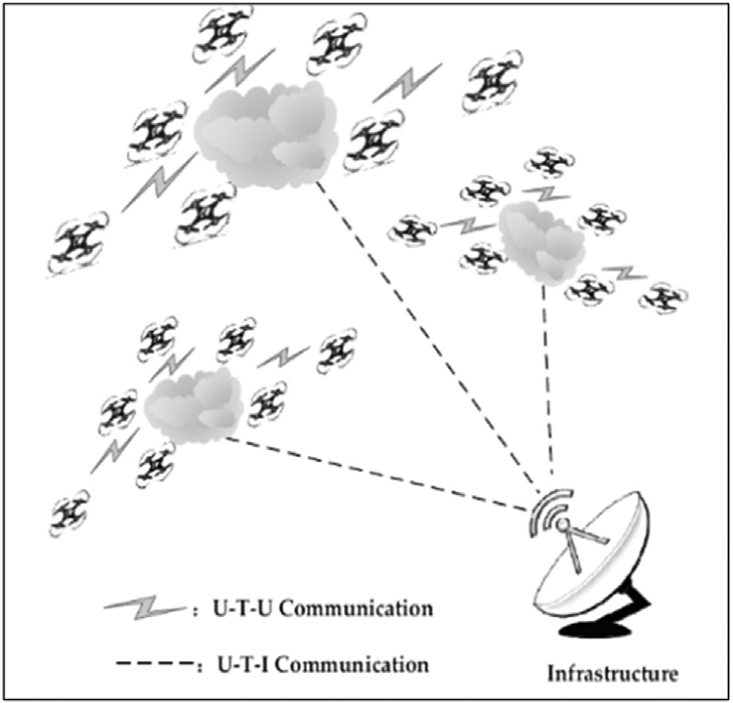

Fig. 2. Multi-group UAV swarm [116].

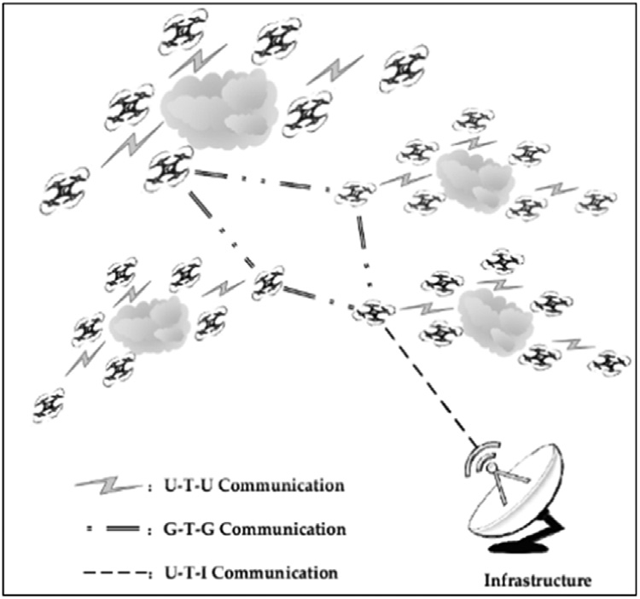

Fig. 3. Multilayer UAV swarm [116].
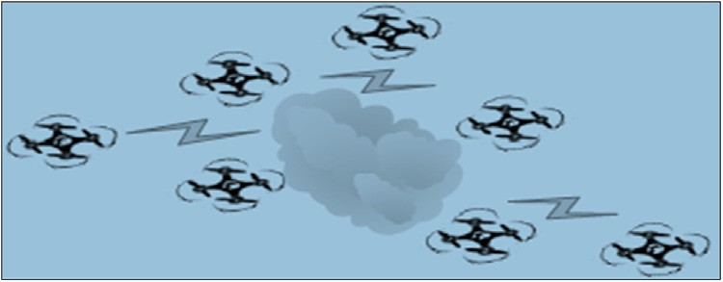

Fig. 4. UAV Swarm Concept [116].

5. UAV Applications

The introduction of UAVs, commonly known as drones, has revolutionized various industries and businesses by simplifying complex tasks and procedures. These advancements have not only benefited commercial enterprises but also aided in everyday tasks and emergency responses. Additionally, UAVs are extensively utilized by military organizations for surveillance and other strategic applications.

5.1. Aerial Photography

UAVs are increasingly used to capture footage that was previously achieved using expensive helicopters and cranes [63]. Equipped with high-resolution 4K cameras and action cameras, drones facilitate filming for sci-fi movies, sports events, and real estate projects. Journalists have also adopted drone technology to capture live footage for broadcasting purposes.

5.2. Shipping & Delivery

Major e-commerce giants such as Amazon, Alibaba, DHL, and others are actively exploring drone-based delivery systems [64]. UAVs enhance delivery efficiency by minimizing time delays and bypassing traffic congestion. Drones are particularly effective for short-distance deliveries of small parcels, food, and other essential items [65].

5.3. Natural Scenery

Drones play a significant role in capturing breathtaking natural landscapes and locations that are difficult or impossible for humans to reach, such as coastlines, mountain peaks, and remote islands [66, 67]. They also enable the mapping of vast and densely populated areas with ease.

5.4. Disaster Management

UAVs provide rapid real-time responses during natural or man-made disasters. They offer an aerial view of the affected area, assisting rescue teams in locating injured individuals [68, 69]. Equipped with high-definition cameras, sensors, and radars, drones deliver precise information that enables quick and effective response efforts. Unlike larger aircraft such as helicopters, UAVs can navigate narrow or otherwise inaccessible spaces.

5.5. Agricultural Applications

UAV technology is transforming the agricultural sector by empowering farmers with modern tools for monitoring crops [70, 71]. Drones provide a cost-effective way to oversee large areas of farmland and assess the health of crops through sensor data. Reports suggest that UAVs will soon monitor 80% of agricultural activities, improving efficiency and productivity.

5.6. Weather Forecasting

Drones are deployed to monitor severe and unpredictable weather patterns [72, 73]. As UAVs are inexpensive compared to other weather-monitoring equipment, they can be sent directly into dangerous conditions such as hurricanes and tornadoes to gather critical data. Their sensors provide detailed weather parameters, enhancing forecasting accuracy.

5.7. Wildlife Monitoring

UAVs have simplified the task of monitoring vast wildlife areas and forests to protect animals from poaching and other threats [74]. Drones cover large areas in a short time, providing real-time surveillance to safeguard biodiversity.

5.8. Law Enforcement

Law enforcement agencies are increasingly utilizing UAVs to ensure public safety and maintain law and order [75, 76]. Drones facilitate surveillance of large gatherings and assist in monitoring criminal activities. Their deployment enhances situational awareness, allowing authorities to respond more effectively to potential threats.

5.9. Entertainment

UAVs contribute significantly to the entertainment industry, where they are used for capturing videos and photos during events and performances [77, 78]. AI-powered drones are capable of following individuals and capturing dynamic footage, enhancing the user experience. Drones are also being introduced in nightclubs and other entertainment venues to add an element of excitement.
Additional commercial applications of UAVs include parcel delivery, mapping, and rescue operations. According to a report by Tractica, the demand for multicopters and drones is expected to grow significantly in the corporate sector. The market volume for the current year is estimated to be around 392,000 drones, with a total value of approximately US$1.6 billion. Moreover, sales and revenue are projected to increase substantially by 2025. North America currently dominates the commercial drone market, followed closely by Asia and Europe. Fig. 1 illustrates the historical and projected sales of UAVs [79], while Fig. 5 provides further insights.

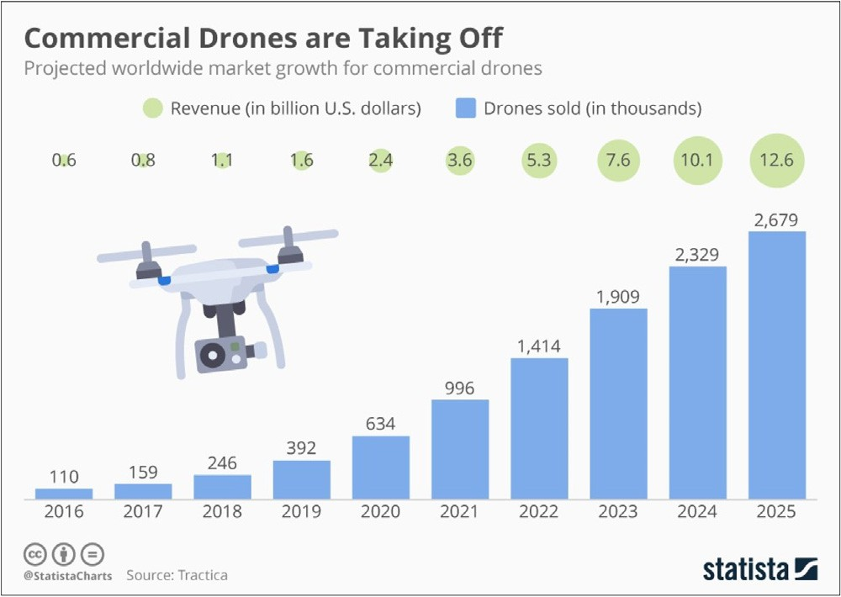
Fig. 5. Sale of UAV according to Tractica [79].

5.10. Military Applications

UAVs play a crucial role in military operations, providing intelligence and surveillance capabilities [117]. Swarm UAVs are employed to gather information about enemy activities, while smaller UAVs assist in bomb detection and reconnaissance missions. Developed by the US, these UAVs enhance situational awareness and contribute to safeguarding human lives. UAVs are also deployed for large-scale geographic surveillance, providing real-time intelligence in high-risk areas.
Researchers have evaluated the performance of small and mid-sized UAVs to improve their autonomy and operational efficiency [80]. They addressed system-related challenges and enhanced closed-system solutions by optimizing algorithms based on environmental conditions. Pareto optimization was applied to refine flight routes, ensuring better sensor utilization and higher performance standards.
A multi-UAV decision-making framework was developed through real UAV and Wireless Sensor Network (WSN) experiments as part of the AWARE Project [81]. This framework supports multiple UAVs in executing various tasks such as surveillance, sensor deployment, and fire threat confirmation. The framework's distributed decision-making system enhances task allocation, dispute resolution, and plan refinement. The trials demonstrated that this framework effectively manages challenging situations like disaster response and national security operations.
One of the project’s notable achievements was the seamless integration of autonomous UAVs from different manufacturers, enabling minimal development efforts. Moreover, the performance of the platform remained unaffected during task execution and Human-Machine Interface (HMI) restarts due to its robust distributed decision-making architecture. Even in the absence of a communication layer, UAV collaboration was successfully maintained through distributed protocols.

6. UAV Security

UAVs rely on a network provided by the service provider to transmit data between the ground station and the organization [82]. These UAVs use various communication technologies, including GPS, Infrared, Bluetooth, Wi-Fi, and ZigBee. However, these technologies are vulnerable to security threats from hackers [83, 84]. Recent studies reveal that UAVs have been compromised using a "channel hop" attack to manipulate their interface.
Wi-Fi and GPS jammers are often used to disrupt UAV communication by launching GPS spoofing attacks [85, 86]. In such attacks, fake signals are transmitted to the receiver, misleading the UAV’s system and corrupting data. This can negatively impact the UAV’s operations, especially when connected to open Wi-Fi systems at airports, cafes, or train stations, making them vulnerable to data theft, including usernames and passwords. Since the
frequency and complexity of these attacks are expected to rise, it is essential for manufacturers and governments to work collaboratively to protect UAV systems. Furthermore, security regulations and safety guidelines must be enforced, and proper training should be provided to UAV operators. To maintain security and privacy, manufacturers should introduce stricter usage policies and regulations for UAVs, ensuring the protection of personal information and preventing breaches.

6.1. Hacking Methods

Hacking refers to gaining unauthorized access to a system or network to copy, modify, or destroy data for personal gain. UAVs connected to wireless networks are highly susceptible to hacking attacks, and several methods can be employed to compromise legitimate UAV operations [87]. Below are a few common hacking methods:

6.2. Trojan Horse Virus

A Trojan horse virus is malicious software or code that monitors network activity and damages system records and hard drives [88]. This type of attack spreads quickly, causing extensive damage and allowing hackers to gain remote control over the system. Implementing strong malware protection is an effective method to mitigate the risk of these attacks.

6.3. Distributed Denial of Service (DDoS)

A DDoS attack involves overwhelming a system by flooding it with excessive requests, preventing legitimate users from accessing services [89]. Once an attacker gains access to the system, it uses compromised devices to spread the attack to other vulnerable systems.

6.4. Password Theft

Another way of compromising UAV security is through password theft. Passwords, typically consisting of 8 to 16 characters, including letters, numbers, and symbols, provide a layer of security [90]. However, while complex passwords enhance security, they are often difficult to remember. Dictionary attacks exploit weak passwords by scanning for open ports and using a list of commonly used words to gain unauthorized access.

6.5. Man-In-The-Middle (MITM) Attacks

MITM attacks occur when an attacker intercepts communication between two parties to copy or alter sensitive information without their knowledge [91]. Often, attackers use phishing emails or fraudulent websites to deceive users [92]. Other types of MITM attacks include URL manipulation, rogue DNS servers, ARP poisoning, and MAC address spoofing.

6.6. Intrusion Detection Systems (IDS)

Intrusion detection is another method hackers use to access a system without the owner’s consent, exploiting resources or blocking access to legitimate users [93]. The system can be tricked into granting unauthorized access to an intruder [94]. Firewalls, encryption methods, and authentication protocols serve as the initial defense against these intrusions.

6.7. Defense Against Hacking

Several techniques can be utilized to safeguard UAVs from cyber threats and prevent unauthorized access. The following solutions can significantly enhance UAV security [95]:
a) Encryption
b) Defense against DDoS
c) Intrusion Detection Systems (IDSs).

6.8. Encryption

Encryption techniques convert plain text into unreadable data to secure information during transmission [96]. Only authorized recipients can decrypt the data, making it an effective safeguard against unauthorized access. Encryption is widely used to protect sensitive information such as credit card details and social security numbers.

6.9. Defense Against DDoS Attacks

DDoS prevention techniques can be categorized into preventive and reactive methods [97]. Reactive methods, also known as "Early Warning Systems," identify and mitigate threats after an attack is detected. These systems use a database of known attack signatures to recognize and neutralize incoming threats.
A researcher proposed a protocol using a stochastic game-based model [98], addressing security challenges where the attacker’s identity remains unknown. Despite using false data injection attacks, the challenge persisted. To overcome this, the researcher developed a Delayed-Action-Game (DAG) model that effectively utilizes off-the-shelf tools to secure H-UAV models. The DAG model also focuses on the hidden information range of UAVs and can determine the operator’s geolocation in real-time. Furthermore, the researcher implemented machine learning techniques within the protocol, allowing the system to analyze geolocation data and process it based on geographical features. The proposed H-UAV protocol was validated through case studies, where experimental results demonstrated its effectiveness. These results were evaluated through subjective feedback, showcasing the protocol’s ability to enhance security. The DAG model’s parallel computing capability also reduced processing time, ensuring improved efficiency.

7. Open Research Issues

UAV networking plays a critical role in ensuring seamless communication and providing Quality of Service (QoS) during operations. However, an efficient routing protocol for establishing reliable communication paths is still lacking [13]. Since UAVs consume a significant amount of energy during data transmission, reception, and hovering, it is essential to develop energy-efficient multicast routing protocols. Addressing QoS service delivery remains a significant challenge in UAV communications. To mitigate delays and prevent route failures, future research should focus on designing and developing advanced algorithms [99, 100]. Another pressing challenge is maintaining link stability in UAV communication. Due to the UAV’s continuous hovering, frequent disconnections from the base station occur, making link stability a major concern that needs further investigation and improvement [101].
Currently, UAVs are extensively used in real-time video streaming for sports broadcasts and service delivery. However, ensuring a high-quality experience (QoE) for end-users poses challenges for service providers [102, 103]. Since QoE is based on user satisfaction, integrating this feature into UAV systems is crucial for gathering user feedback and improving service delivery to retain customers. Nevertheless, incorporating a QoE domain into UAV systems remains a complex challenge [104, 105, 120]. Laghari et al. proposed a QoE model for UAV environments to ensure better QoS delivery, but their model has yet to be tested in real-time environments [106].
The limited battery life of UAVs is another constraint, restricting flight duration and increasing power consumption in tasks such as communication and video recording [107]. This limitation poses significant challenges for real-time streaming and continuous monitoring. Implementing a solar-powered UAV body to recharge during hovering could significantly increase operational time, particularly in agricultural fields where operations primarily take place during daylight hours [108].
Ground Control Stations (GCS) are responsible for continuously checking the reliability of the network architecture and simulating vehicle control [109]. To enhance UAV operations, the development of more efficient algorithms is essential, as current algorithms are insufficient for handling these operations [110]. Moreover, GCS systems should be equipped to detect possible collisions between vehicles or with external objects, providing alternate path guidance to avoid such incidents. This requires a more powerful GCS capable of managing large amounts of information while offering an improved user interface [111, 112].

8. Conclusion

This paper presented a comprehensive review of UAV systems, focusing on communication design and the methods used to transmit data to ground stations. Additionally, it explored the role of sensors in data processing and highlighted various applications along with security concerns. Key definitions and concepts related to UAV systems were discussed, along with an in-depth analysis of the development of communication systems and Ground Control Stations (GCS). The paper also analyzed security threats and different types of attacks that can disrupt UAV communication systems. Lastly, potential research areas were identified to facilitate future advancements in UAV systems and communication, ultimately contributing to the enhancement of UAV technology for industrial applications.

References
- Phil. Chamberlain, Drones and Journalism, 4, Taylor & Francis, 2017.
- Vu Phi Tran, Fendy Santoso, Matt Garratt, Sreenatha Anavatti, Distributed Artificial neural networks-based adaptive strictly negative imaginary formation controller for unmanned aerial vehicles in time-varying environments, IEEE Trans. Ind. Inf. (2020).
- Nicoletta Bloise, Stefano Primatesta, Roberto Antonini, Gian Piero Fici, Marco Gaspardone, Giorgio Guglieri, Alessandro Rizzo, A survey of unmanned air- craft system technologies to enable safe operations in urban areas, in: 2019 International Conference on Unmanned Aircraft Systems (ICUAS), IEEE, 2019,
pp. 433–442.
- Nahina Islam, Md Mamunur Rashid, Faezeh Pasandideh, Biplob Ray, Steven Moore, Rajan Kadel, A review of applications and communication technologies for Internet of Things (IoT) and Unmanned Aerial Vehicle (UAV) based sustainable smart farming, Sustainability 13 (4) (2021) 1821.
- David Nodland, Hassan Zargarzadeh, Sarangapani Jagannathan, Neural network-based optimal adaptive output feedback control of a helicopter UAV, IEEE Trans. Neural Netw. Learn. Syst. 24 (7) (2013) 1061–1073.
- C.A. Mendenhall, Integrating the Unmanned Aircraft System Into the National Airspace System, National Defense Univ Norfolk Va Joint Advanced Warfighting school, 2011.
- Michael J. Boyle, The race for drones, Orbis 59 (1) (2015) 76–94.
- Rajesh Mahadevappa, T. Virupaksha, L.N. Raghavendra, A practical approach to enhance the flight endurance of a fixed-wing UAV, in: Proceedings of the National Aerospace Propulsion Conference, Singapore, Springer, 2020, pp. 297–309.
- Navid Ali Khan, Noor Zaman Jhanjhi, Sarfraz Nawaz Brohi, Anand Nayyar, Emerging use of UAV’s: secure communication protocol issues and challenges, in: Drones in Smart-Cities, Elsevier, 2020, pp. 37–55.
- Omar I.Dallal Bashi, W.Z. Hasan, N. Azis, S. Shafie, Hiroaki Wagatsuma, Unmanned aerial vehicle quadcopter: a review, J. Comput. Theor. Nanosci. 14 (12) (2017) 5663–5675.
- Aakif Mairaj, Asif I. Baba, Ahmad Y. Javaid, Application specific drone simulators: recent advances and challenges, Simul. Modell. Pract. Theory 94 (2019) 100–117.
- Alireza Malehmir, Lars Dynesius, Kent Paulusson, Alex Paulusson, Henrik Johansson, Mehrdad Bastani, Mats Wedmark, Paul Marsden, The potential of ro- tary-wing UAV-based magnetic surveys for mineral exploration: a case study from central Sweden, Lead. Edge 36 (7) (2017) 552–557.
- Telmo Adão, Jonáš Hruška, Luís Pádua, José Bessa, Emanuel Peres, Raul Morais, Joaquim João Sousa, Hyperspectral imaging: a review on UAV-based sensors, data processing and applications for agriculture and forestry, Remote Sens. 9 (11) (2017) 1110.
- Kai Daniel, Christian Wietfeld, Using Public Network Infrastructures for UAV Remote Sensing in Civilian Security Operations, Dortmund University (Germany FR), 2011.
- Ramon A.Suarez Fernandez, Jose Luis Sanchez-Lopez, Carlos Sampedro, Hriday Bavle, Martin Molina, Pascual Campoy, Natural user interfaces for human-drone multi-modal interaction, in: 2016 International Conference on Unmanned Aircraft Systems (ICUAS), IEEE, 2016, pp. 1013–1022.
- S. Sudhakar, Varadarajan Vijayakumar, C. Sathiya Kumar, V. Priya, Logesh Ravi, V. Subramaniyaswamy, Unmanned Aerial Vehicle (UAV) based Forest Fire Detection and monitoring for reducing false alarms in forest-fires, Comput. Commun. 149 (2020) 1–16.
- Zhipeng Zhou, Javier Irizarry, Ying Lu, A multidimensional framework for unmanned aerial system applications in construction project management, J. Manage. Eng. 34 (3) (2018) 04018004.
- Riccardo Costanzi, Davide Fenucci, Vincenzo Manzari, Michele Micheli, Luca Morlando, Daniele Terracciano, Andrea Caiti, Mirko Stifani, Alessandra Tesei, Interoperability among unmanned maritime vehicles: review and first in-field experimentation, Front. Robotics AI 7 (2020).
- Jafet Morales, Gerson Rodriguez, Grant Huang, David Akopian, Toward UAV control via cellular networks: delay profiles, delay modeling, and a case study within the 5-mile range, IEEE Trans. Aerosp. Electron. Syst. 56 (5) (2020) 4132–4151.
- Michael Warren, Melissa Greeff, Bhavit Patel, Jack Collier, Angela P. Schoellig, Timothy D. Barfoot, There’s no place like home: visual teach and repeat for emergency return of multirotor UAVs during GPS failure, IEEE Robotics Autom. Lett. 4 (1) (2018) 161–168.
- Konstantinos Kanistras, Kimon P. Valavanis, Matthew J. Rutherford, The history of circulation control, in: Foundations of Circulation Control Based Small-Scale Unmanned Aircraft, Springer, Cham, 2018, pp. 19–25.
- Sudhir Kumar Chaturvedi, Raj Sekhar, Saikat Banerjee, Hutanshu Kamal, Comparative review study of military and civilian unmanned aerial vehicles (uavs), Incas Bull. 11 (3) (2019) 183–198.
- Imad Jawhar, Nader Mohamed, Jameela Al-Jaroodi, Dharma P. Agrawal, Sheng Zhang, Communication and networking of UAV-based systems: classification and associated architectures, J. Netw. Comput. Appl. 84 (2017) 93–108.
- Baohua Shao, Mark S. Leeson, PaFiR: particle Filter Routing–A predictive relaying scheme for UAV-assisted IoT communications in future innovated networks, Internet Things (2019) 100077.
- Asif Ali Laghari, M. Sulleman Memon, Agha Sheraz Pathan, RFID based toll deduction system, IJ Inform.n Technol. Comput. Sci. 4 (2012) 40–46.
- Heda, Giriraj, Sayan Mandal, and S.N. Omkar. "Design, analysis and development of engine mount for a hybrid unmanned aerial vehicle."
- Zhenyu Na, Jun Wang, Chungang Liu, Mingxiang Guan, Zihe Gao, Join trajectory optimization and communication design for UAV-enabled OFDM networks, Ad. Hoc. Netw. 98 (2020) 102031.
- Ali Arshad Nasir, Hoang Duong Tuan, Trung Q. Duong, H. Vincent Poor, UAV-enabled communication using NOMA, IEEE Trans. Commun. 67 (7) (2019) 5126–5138.
- Yan Sun, Dongfang Xu, Derrick Wing Kwan Ng, Linglong Dai, Robert Schober, Optimal 3D-trajectory design and resource allocation for solar-powered UAV communication systems, IEEE Trans. Commun. 67 (6) (2019) 4281–4298.
- Nozhan Hosseini, Hosseinali Jamal, Jamal Haque, Thomas Magesacher, David W. Matolak, UAV command and control, navigation and surveillance: a review of potential 5G and satellite systems, in: 2019 IEEE Aerospace Conference, IEEE, 2019, pp. 1–10.
- Francisco Fabra, Willian Zamora, Julio Sangüesa, Carlos T. Calafate, Juan-Carlos Cano, Pietro Manzoni, A distributed approach for collision avoidance between multirotor UAVs following planned missions, Sensors 19 (10) (2019) 2404.
- Mason Itkin, Mihui Kim, H. Sø/1SOPS widel, UAV-Based Remote Sens. 1 (1) (2018) 191.
- Haque Nawaz, Husnain Mansoor Ali, Asif Ali Laghari, UAV communication networks issues: a review, Arch. Comput. Meth. Eng. (2020) 1–21.
- Robert Reid, Andrew Cann, Calum Meiklejohn, Liam Poli, Adrian Boeing, Thomas Braunl, Cooperative multi-robot navigation, exploration, mapping and object detection with ROS, in: 2013 IEEE Intelligent Vehicles Symposium (IV), IEEE, 2013, pp. 1083–1088.
- Mekonen H. Halefom, Tailoring an Airworthiness Document to Unmanned Aircraft Systems: A Case Study of MIL-HDBK-516C, Virginia Tech, 2020.
- Jithin Jagannath, Anu Jagannath, Sean Furman, Tyler Gwin, Deep Learning and Reinforcement Learning For Autonomous Unmanned Aerial Systems: Roadmap for Theory to Deployment, arXiv preprint, 2020.
- Mustafa Demir, Nathan J. McNeese, Nancy J. Cooke, Team communication behaviors of the human-automation teaming, in: 2016 IEEE International Multi-
-Disciplinary Conference on Cognitive Methods in Situation Awareness and Decision Support (CogSIMA), IEEE, 2016, pp. 28–34.
- M. Grasso, A. Renga, G. Fasano, M.D. Graziano, M. Grassi, A. Moccia, Design of an end-to-end demonstration mission of a Formation-Flying Synthetic Aperture Radar (FF-SAR) based on microsatellites, Adv. Space Res. (2020).
- Torsten Mack, Peter Kunz, Mechanically Steered and Horizontally Polarized Antenna For Aerial vehicles, and Associated Systems and Methods, U.S. Patent Application, 2020 16/859filed September 17.

- Huang Yao, Rongjun Qin, Xiaoyu Chen, Unmanned aerial vehicle for remote sensing applications—A review, Remote Sens. 11 (12) (2019) 1443.
- Mochamad Mobed Bachtiar, Fernando Ardilla, Abdi Alghifara Felinanda, Android Application Design as Ground Control Station (GCS) and waypoint navigation in Unmanned Aerial Vehicle (UAV), in: 2019 International Electronics Symposium (IES), IEEE, 2019, pp. 299–306.
- Shuo Wan, Jiaxun Lu, Pingyi Fan, Khaled B. Letaief, Towards big data processing in iot: path planning and resource management of UAV base stations in mobile-edge computing system, IEEE Internet Things J. (2019).
- Norbert Haala, Michael Cramer, Florian Weimer, Martin Trittler, Performance test on UAV-based photogrammetric data collection, Int. Arch. Photogramm. Remote Sens. Spat. Inf. Sci. 38 (6) (2011).
- Muhammad Naveed, Sameer Qazi, QoE analysis of real-time video streaming over 4G-LTE for UAV-based surveillance applications, in: International Conference on Intelligent Technologies and Applications, Singapore, Springer, 2019, pp. 443–458.
- M. Raja, Gaurav Asthana, Ajay Singh, Ashna Singhal, Pallavi Lakra, Design of accurate navigation system by integrating INS and GPS modules, INCAS Bull. 11
(4) (2019) 139–154.
- Víctor González-Jaramillo, Andreas Fries, Jörg Bendix, AGB estimation in a tropical mountain forest (TMF) by means of RGB and multispectral images using an unmanned aerial vehicle (UAV), Remote Sens. 11 (12) (2019) 1413.
- Eleftherios Lygouras, Antonios Gasteratos, Konstantinos tarchanidis, and athanasios mitropoulos. "ROLFER: a fully autonomous aerial rescue support system, Microprocess. Microsyst. 61 (2018) 32–42.
- Klaus Schneider-Zapp, Manuel Cubero-Castan, Dai Shi, Christoph Strecha, A new method to determine multi-angular reflectance factor from lightweight mul- tispectral cameras with sky sensor in a target-less workflow applicable to UAV, Remote Sens. Environ. 229 (2019) 60–68.
- Matthew Wallhead, Heping Zhu, John Sulik, William Stump, A workflow for extracting plot-level biophysical indicators from aerially acquired multispectral imagery, Plant Health Prog. 18 (2) (2017) 95–96.
- Tingting Chen, Weiguang Yang, Huajian Zhang, Bingyu Zhu, Ruier Zeng, Xinyue Wang, Shuaibin Wang, et al., Early detection of bacterial wilt in peanut plants through leaf-level hyperspectral and unmanned aerial vehicle data, Comput. Electron. Agric. 177 (2020) 105708.
- Paolo Tarolli, Simon M. Mudd, Remote Sensing of Geomorphology. Vol. 23, Elsevier, 2019.
- Pablo Horstrand, Raúl Guerra, Aythami Rodríguez, María Díaz, Sebastián López, José Fco López, A UAV platform based on a hyperspectral sensor for image capturing and on-board processing, IEEE Access 7 (2019) 66919–66938.
- Chuanqi Xie, Ce Yang, A review on plant high-throughput phenotyping traits using UAV-based sensors, Comput. Electron. Agric. 178 (2020) 105731.
- A.-.K. Mahlein, Matheus T. Kuska, Jan Behmann, Gerrit Polder, Achim Walter, Hyperspectral sensors and imaging technologies in phytopathology: state of the art, Annu. Rev. Phytopathol. 56 (2018) 535–558.
- Hamed Gholizadeh, John A. Gamon, Christopher J. Helzer, Jeannine Cavender-Bares, Multi-temporal assessment of grassland 𝛼-and 𝛽-diversity using hyper- spectral imaging, Ecol. Appl. 30 (7) (2020) e02145.
- Julia Kelly, Natascha Kljun, Per-Ola Olsson, Laura Mihai, Bengt Liljeblad, Per Weslien, Leif Klemedtsson, Lars Eklundh, Challenges and best practices for deriving temperature data from an uncalibrated UAV thermal infrared camera, Remote Sens. 11 (5) (2019) 567.
- Mehdi Khoshboresh Masouleh, Reza Shah-Hosseini, Development and evaluation of a deep learning model for real-time ground vehicle semantic segmentation from UAV-based thermal infrared imagery, ISPRS J. Photogramm. Remote Sens. 155 (2019) 172–186.
- E. Wardihani, Magfur Ramdhani, Amin Suharjono, Thomas Agung Setyawan, Sidiq Syamsul Hidayat, Sarono Widodo Helmy, Eddy Triyono, F. Saifullah, Real-time forest fire monitoring system using unmanned aerial vehicle, J. Eng. Sci. Technol. 13 (6) (2018) 1587–1594.
- Enas Ismail, Arcangelo Merla, Modeling thermal infrared imaging data for differential diagnosis, in: Application of Infrared to Biomedical Sciences, Springer, Singapore, 2017, pp. 477–515.
- Joyce, Michael. "Evaluating American marten habitat quality using airborne light detection and ranging (LiDAR) data." (2018).
- Vanessa Sousa da Silva, Carlos Alberto Silva, Midhun Mohan, Adrián Cardil, Franciel Eduardo Rex, Gabrielle Hambrecht Loureiro, Danilo Roberti Alves de Almeida, et al., Combined impact of sample size and modeling approaches for predicting stem volume in eucalyptus spp. forest plantations using field and LiDAR data, Remote Sens. 12 (9) (2020) 1438.
- Wenxuan Zheng, Honglun Wang, Hongxia Ji, Jianfa Wu, UAV formation flight and collision warning with centralized control of ground control station, in: 2019 IEEE International Conference on Unmanned Systems (ICUS), IEEE, 2019, pp. 103–108.
- Santiago Martínez, Juan Ortiz, Ma Luz Gil, Ma Teresa Rego, Recording complex structures using close range photogrammetry: the cathedral of Santiago De Compostela, Photogramm. Record 28 (144) (2013) 375–395.
- Christopher S. Tang, Lucas P. Veelenturf, The strategic role of logistics in the industry 4.0 era, Transp. Res. Part E: Logist. Transp. Rev. 129 (2019) 1–11.
- Thomas. Kirschstein, Comparison of energy demands of drone-based and ground-based parcel delivery services, Transp. Res.Part D: Transp. Environ. 78 (2020) 102209.
- C.L. Kang, Y. Cheng, F. Wang, M.M. Zong, J. Luo, J.Y. Lei, The application of Uav oblique photogrammetry in smart tourism: a case study of Longji terraced scenic SPOT in Guangxi Province, Int. Arch. Photogramm., Remote Sens. Spat. Inf. Sci. 42 (2020) 575–580.
- L.I.N. Jiayuan, Z.H.O.U. Xingxia, D.E.N.G. Shunjie, D.U. Xiaolin, W.A.N.G. Meimei, L.I. Xinjuan, Inspecting unattended irrigation canals of Dujiangyan in mountainous area with UAV remote sensing technology, in: 2019 8th International Conference on Agro-Geoinformatics (Agro-Geoinformatics), IEEE, 2019,
pp. 1–5.
- Hazel M. Taylor, Christian Dondrup, Katrin S. Lohan, Introducing a scalable and modular control framework for low-cost monocular robots in hazardous environments, in: 2019 IEEE/RSJ International Conference on Intelligent Robots and Systems (IROS), IEEE, 2019, pp. 6421–6426.
- Hyewon Kim, Woojung Kim, Sang Don Kim, Damage assessment of rice crop after toluene exposure based on the vegetation index (VI) and UAV multispectral imagery, Remote Sens. 13 (1) (2021) 25.
- Mohammad Fatin Fatihur Rahman, Shurui Fan, Yan Zhang, Lei Chen, A comparative study on application of unmanned aerial vehicle systems in agriculture, Agriculture 11 (1) (2021) 22.
- Imran Charania, Xinrong Li, Smart farming: agriculture’s shift from a labor intensive to technology native industry, Internet Things 9 (2020) 100142.
- Benjamin R. Jordan, Collecting field data in volcanic landscapes using small UAS (sUAS)/drones, J. Volcanol. Geotherm. Res. 385 (2019) 231–241.
- S. Ahirwar, R. Swarnkar, S. Bhukya, G. Namwade, Application of drone in agriculture, Int. J. Curr. Microbiol. Appl. Sci. 8 (01) (2019) 2500–2505.
- Kye Adams, Allison Broad, David Ruiz-García, Andrew R. Davis, Continuous wildlife monitoring using blimps as an aerial platform: a case study observing marine megafauna, Aust. Zool. 40 (3) (2020) 407–415.
- Chai K. Toh, Julio A. Sanguesa, Juan C. Cano, Francisco J. Martinez, Advances in smart roads for future smart cities, Proc. R. Soc. A 476 (2233) (2020) 20190439.
- Muhammad Ibrar, Jianing Mi, Shahid Karim, Asif Ali Laghari, Shakir Muhammad Shaikh, Vishal Kumar, Improvement of large-vehicle detection and monitoring on CPEC route, 3D Res. 9 (3) (2018) 45.
- Jessica R. Cauchard, Alex Tamkin, Cheng Yao Wang, Luke Vink, Michelle Park, Tommy Fang, James A. Landay, drone. io: a gestural and visual interface for human-drone interaction, in: 2019 14th ACM/IEEE International Conference on Human-Robot Interaction (HRI), IEEE, 2019, pp. 153–162.
- Maria De Marsico, Alessandro Spagnoli, Using hands as an easy UAV joystick for entertainment applications, in: Proceedings of the 13th Biannual Conference of the Italian SIGCHI Chapter, Designing the next interaction, 2019, pp. 1–9.
- https://www.statista.com/chart/17201/commecial-drones-projected-growth/ [accessed on 1/6/2021]
- Christian Ruf, Markus Zwick, Sten Morawietz, Peter Stuetz, in: Enhancing Automated Aerial Reconnaissance Onboard UAVs Using Sensor Data Processing-Char- acteristics and Pareto Front Optimization, AIAA Scitech 2019 Forum, 2019, p. 1541.
- Iván Maza, Fernando Caballero, Jesús Capitán, José Ramiro Martínez-de-Dios, Aníbal Ollero, Experimental results in multi-UAV coordination for disaster management and civil security applications, J. Intell. Robot. Syst. 61 (1–4) (2011) 563–585.
- Jun Li, Yifeng Zhou, Louise Lamont, Communication architectures and protocols for networking unmanned aerial vehicles, in: 2013 IEEE Globecom Workshops (GC Wkshps), IEEE, 2013, pp. 1415–1420.

- Muhammad Asghar Khan, Ijaz Mansoor Qureshi, Fahimullah Khanzada, A hybrid communication scheme for eﬃcient and low-cost deployment of future flying ad-hoc network (FANET), Drones 3 (1) (2019) 16.
- Chaitanya Rani, Hamidreza Modares, Raghavendra Sriram, Dariusz Mikulski, Frank L. Lewis, Security of unmanned aerial vehicle systems against cyber-physical attacks, J. Defense Model. Simul. 13 (3) (2016) 331–342.
- Daojing He, Sammy Chan, Mohsen Guizani, Communication security of unmanned aerial vehicles, IEEE Wirel. Commun. 24 (4) (2016) 134–139.
- Riddhi V. Karpe, Sukanya Kulkarni, Software defined radio based global positioning system jamming and spoofing for vulnerability analysis, in: 2020 Interna- tional Conference on Electronics and Sustainable Communication Systems (ICESC), IEEE, 2020, pp. 881–888.
- Bora Ly, Romny Ly, Cybersecurity in unmanned aerial vehicles (UAVs), J. Cyber Secur. Technol. (2020) 1–18.
- Li Li, Kangye Qu, Kuo-Yi Lin, A survey on attack resilient of UAV motion planning, in: 2020 IEEE 16th International Conference on Control & Automation (ICCA), IEEE, 2020, pp. 558–563.
- Aakif Mairaj, Subhrajit Majumder, Ahmad Y. Javaid, Game theoretic strategies for an unmanned aerial vehicle network host under DDoS attack, in: 2019 International Conference on Unmanned Aircraft Systems (ICUAS), IEEE, 2019, pp. 120–128.
- Panagiotis Vamvakas, Eirini Eleni Tsiropoulou, Symeon Papavassiliou, Exploiting prospect theory and risk-awareness to protect UAV-assisted network operation,
EURASIP J. Wirel. Commun. Netw. 2019 (1) (2019) 286.
- Susheela Dahiya, Manik Garg, Unmanned aerial vehicles: vulnerability to cyber attacks, in: International Conference on Unmanned Aerial System in Geomatics, Cham, Springer, 2019, pp. 201–211.
- Tejasvi Alladi, Naren Naren, Gaurang Bansal, Vinay Chamola, Mohsen Guizani, SecAuthUAV: a novel authentication scheme for UAV-base station scenario, IEEE Trans. Veh. Technol. (2020).
- Gaurav Choudhary, Vishal Sharma, Ilsun You, Kangbin Yim, Ray Chen, Jin-Hee Cho, Intrusion detection systems for networked unmanned aerial vehicles: a survey, in: 2018 14th International Wireless Communications & Mobile Computing Conference (IWCMC), IEEE, 2018, pp. 560–565.
- Aditya Raj Singh, Harbhajan Singh, Abhineet Anand, Vulnerability assessment, risk, and challenges associated with automated vehicles based on artificial intelligence, in: Advances in Communication and Computational Technology, Springer, Singapore, 2021, pp. 1323–1337.
- Charan Gudla, Md Shohel Rana, Andrew H. Sung, Defense techniques against cyber attacks on unmanned aerial vehicles, in: Proceedings of the International Conference on Embedded Systems, Cyber-physical Systems, and Applications (ESCS), The Steering Committee of The World Congress in Computer Science, Computer Engineering and Applied Computing (WorldComp), 2018, pp. 110–116.
- Sukhrob Atoev, Oh-Jun Kwon, Chee-Yong Kim, Suk-Hwan Lee, Young-Rak Choi, Ki-Ryong Kwon, The secure UAV communication link based on OTP encryption technique, in: 2019 Eleventh International Conference on Ubiquitous and Future Networks (ICUFN), IEEE, 2019, pp. 1–3.
- Jean-Philippe Condomines, Ruohao Zhang, Nicolas Larrieu, Network intrusion detection system for UAV ad-hoc communication: from methodology design to real test validation, Ad. Hoc. Netw. 90 (2019) 101759.
- Mahmoud Elfar, Haibei Zhu, Mary L. Cummings, Miroslav Pajic, Security-aware synthesis of human-UAV protocols, in: 2019 International Conference on Robotics and Automation (ICRA), IEEE, 2019, pp. 8011–8017.
- Md Zoheb Hassan, Md Jahangir Hossain, Julian Cheng, Victor CM Leung, Statistical-QoS guarantee for IoT network driven by laser-powered UAV relay and RF backscatter communications, IEEE Trans. Green Commun. Netw. (2020).
- Jingjing Yao, Nirwan Ansari, QoS-aware power control in internet of drones for data collection service, IEEE Trans. Veh. Technol. 68 (7) (2019) 6649–6656.
- I.V. Kovalev, A.A. Voroshilova, M.V. Karaseva, On the problem of the manned aircraft modification to UAVs, J. Phys.: Conf. Ser. 1399 (5) (2019) 055100.
- Asif Ali Laghari, Hui He, Muhammad Shafiq, Asiya Khan, Application of quality of experience in networked services: review, trend & perspectives, Syst. Practice Action Res. 32 (5) (2019) 501–519.
- Hermes J. Loschi, Vania V. Estrela, D. Jude Hemanth, Sandro R. Fernandes, Yuzo Iano, Asif Ali Laghari, Asiya Khan, Hui He, Robert Sroufe, Communications requirements, video streaming, communications links and networked UAVs, Imaging Sens. Unmanned Aircraft Syst. 2 (2020) 6.
- Asif Ali Laghari, Hui He, Shahid Karim, Himat Ali Shah, Nabin Kumar Karn, Quality of Experience Assessment of Video Quality in Social Clouds, Wireless Communications and Mobile Computing 2017, 2017.
- Sajida Karim, Hui He, Asif Ali Laghari, Arif Hussain Magsi, Rashid Ali Laghari, in: Quality of Service (QoS): Measurements of Image Formats in Social Cloud Computing, Multimedia Tools and Applications, 2020, pp. 1–26.
- A. Laghari, A.I. Khan, H. Hui, Quality of Experience (QoE) and Quality of Service (QoS), UAV Systems, 2019.
- Bouziane Brik, Adlen Ksentini, Maha Bouaziz, Federated learning for UAVs-enabled wireless networks: use cases, challenges, and open problems, IEEE Access 8 (2020) 53841–53849.
- Fadi Al-Turjman, Hadi Zahmatkesh, Ibrhaim Al-Oqily, Reda Daboul, Optimized unmanned aerial vehicles deployment for static and mobile targets’ monitoring, Comput. Commun. 149 (2020) 27–35.
- Xiongzhe Han, J.Alex Thomasson, Tianyi Wang, Vaishali Swaminathan, Autonomous mobile ground control point improves accuracy of agricultural remote sensing through collaboration with UAV, Inventions 5 (1) (2020) 12.
- Mo Elsayed, Moataz Mohamed, The impact of airspace regulations on unmanned aerial vehicles in last-mile operation, Transp. Rese. Part D: Transp. Environ. 87 (2020) 102480.
- System and Method of Collision Avoidance in Unmanned Aerial Vehicles, U.S. Patent Application, 2020 16/526,734, filed April 2.
- Greg Baker, Tom Bridgwater, Paul Bremner, Manuel Giuliani, Towards an Immersive User Interface For Waypoint Navigation of a Mobile Robot, arXiv preprint, 2020.
- E. Aldao, L.M. González-de Santos, H. González-Jorge, LiDAR based detect and avoid system for UAV navigation in UAM corridors, Drones 6 (8) (2022) Art. no. 8Aug, doi:10.3390/drones6080185.
- S. Blau, J. Sterenberg, P. Weeden, F. Urzedo, R. Wright, C. Watson, Exploring non-invasive approaches to assist in the detection of clandestine human burials: developing a way forward, Forensic Sci. Res. 3 (4) (2018) 320–342 Oct..
- H. Nawaz, H.M. Ali, M.H. Mahar, Swarm of unmanned aerial vehicles communication using 802.11g and 802.11n, Int. J. Comp. Sci. Netw. Secur. 19 (4) (2019) 289–292.
- X. Chen, J. Tang, S. Lao, Review of unmanned aerial vehicle swarm communication architectures and routing protocols, Appl. Sci. 10 (10) (2020) Art. no. 10Jan., doi:10.3390/app10103661.
- Haque Nawaz, Husnain Mansoor Ali, Shafiq-ur-Rehman Massan, Applications of unmanned aerial vehicles: a review, 3C Tecnol. (2019) 85–105 vol. Special IssueNov., doi:10.17993/3ctecno.2019.specialissue3.85-105.
- Asif Ali Laghari, Kaishan Wu, Rashid Ali Laghari, Mureed Ali, Abdullah Ayub Khan, A review and state of art of Internet of Things (IoT), Arch. Comput. Meth. Eng. (2021) 1–19.
- Xiaowei Wang, Shoulin Yin, Muhammad Shafiq, Asif Ali Laghari, Shahid Karim, Omar Cheikhrouhou, Wajdi Alhakami, Habib Hamam, A New V-net Con- volutional Neural Network Based On Four-Dimensional Hyperchaotic System For Medical Image Encryption, Security and Communication Networks, 2022 2022.
- Asif Ali Laghari, Hui He, Asiya Khan, Rashid Ali Laghari, Shoulin Yin, Jiachi Wang, Crowdsourcing platform for QoE evaluation for cloud multimedia services, Comput. Sci. Inf. Syst. (2022) 38 00.

