AI-Powered Drone for Solar Panel Cleaning
A
Synopsis submitted to


RASHTRASANT TUKADOJI MAHARAJ NAGPUR UNIVERSITY, NAGPUR

In fulfillment for the Degree of
Bachelor of Technology
In
Artificial Intelligence & Data Science
Under The Faculty of Engineering

By
Mohammad Yasir Zaheer Sheikh

Supervisor
Dr.M.T.Hasan


Department of Artificial Intelligence & Data Science
Anjuman College of Engineering& Technology, Nagpur
September 2024

AI-Powered Drone for Solar Panel Cleaning
A
Synopsis submitted to


RASHTRASANT TUKADOJI MAHARAJ NAGPUR UNIVERSITY, NAGPUR

In fulfillment for the Degree of
Bachelor of Technology
In
Artificial Intelligence & Data Science
Under The Faculty of Engineering

By
Mohammad Yasir Zaheer Sheikh

Supervisor
Dr.M.T.Hasan


Department of Artificial Intelligence & Data Science
Anjuman College of Engineering& Technology, Nagpur
September 2024

ABSTRACT– This project is about the design and development of a AI powered drone based solar panel cleaning system which reduces human intervention. As solar energy adoption increases, maintaining the cleanliness of solar panels is crucial for maximizing energy output. The solar panels in case of residential use are usually placed on the roof or terrace to receive the maximum amount of sunlight. Because of this, cleaning these solar panels would require the homeowner climbing up onto the roof to clean the panels, which can be hazardous. The other option would be to hire a company to do it for them. In either of the cases it is hazardous and can prove fatal. The proposed work will try to introduce a drone base artificial intelligence powered system in which the drone installed with a small water tank would be used to locate the place using AI , where the solar panels have been installed and then using the cleaning system installed on the drone to clean the panels.

Keywords – Arduino, solar panels, machine learning, Solar Panel Cleaner, Drone.

INTRODUCTION - The Growing interest in renewable energy has resulted to significant expansion of the solar Photo-voltaic (PV) sector over the past decade. Because photovoltaic energy is a technology available. It has become a common investment for both businesses and residential consumers. This demand has therefore stimulated studies to increase the general output strength of PV systems. Any material that spreads through the atmosphere involves particles of soil and dust (suspended dust), smoke, fog, and particles called dust. Stab formed from terrestrial inorganic and organic substances. Dust is made up of substances such as storms of sand, bacteria, smoke from factories, pollen, forest fires and vapours from volcanoes. Many precious studies have verified that the deposition of airborne dust on the photovoltaic indoor modules decreases the cell glazing transmission. It also results in a substantial degradation of PV modules ' solar conversion effectiveness. The dust deposition on the outdoor PV studies focused on the glazing transparency performance However, it is not always as simple to clean solar panels. First of all, there is the accessibility problem. Because photovoltaic panels are often located on hazardous and hard to achieve areas, it may be difficult to manually wash them and it requires time to do it securely. Secondly, cleaning a panel only once a year may not have a important effect on the annual energy output for the easy reason that in a short time, dirt stacks up again, making the difference negligible. Especially hiring the manpower for cleaning the PV panel is difficult task now a days

Now a day’s energy is generated from both renewable and non-renewable resources. But the generation of electricity from a renewable resource is more authentic and less harmful than the non-renewable resource. Solar energy is the amplest source of renewable energy. Generation of electricity using sun energy that is possible by the solar panels. Solar energy is the abundant renewable energy on earth which doesn’t pollute the environment while producing the energy using Solar Photo Voltaic (PV) panel. Efficiency of the PV panel depends on the amount of light falls on it, due to the azimuth angle of solar panel, deposition of dust on PV panel reduces the efficiency of the energy generated. But the efficiency of solar panels is ostentatious by environmental effects like dust accumulation, temperature and humidity. Therefore, it is essential to have regular and proper cleaning of panel. In general cleaning is done by manually. This type of cleaning is not uniform and has the following drawbacks like damage of panels, injuries to people and movement difficulties. To increase the efficiency of the PV panel, periodically it has to be cleaned.
This project aims to address these challenges by developing an AI-powered drone specifically designed for solar panel cleaning. In the mechanism proposed in our paper, we introduce a method which integrates the use of Unmanned Aerial Vehicle and Machine Learning to locate the exact location of solar panels and then clean the panel with the cleaning system installed on the top of the drone .

AIM– To design and develop an AI-Powered Drone for Solar Panel Cleaning
OBJECTIVES –
- To increase solar panel energy output in remote places at a cheap cost, and without the use of physical labor.
- To improve the efficiency of solar panels.
- To remove the human intervention to clean solar panels effectively.
- To develop an AI-powered drone that autonomously cleans solar panels, optimizing efficiency and removing human intervention for enhanced solar energy production.

LITERATURE SURVEY
1) Yuliya Zatsarinnaya, Denis Amirov and Maksim Elaev developed “Solar Panel Cleaning System Based on the Arduino Microcontroller” – 2020.
The solution of the problem provides for the adoption of hydroelectric power plants, which are ubiquitous in Russia, and the construction of wind and solar power plants. One of the problems with the deep penetration of solar energy into the Russian energy system is the high cost of generating electricity at a renewable energy facility. Solar module layouts in open areas lead to the contamination of surfaces that receive emission. As a result, offering different designs for cleaning PV modules is still relevant. In this paper, both schemes of solar panel cleaning systems that have been considered are not only easy to assemble and, easy to control, but also adaptable to operating conditions. Changing or adding links allows you to apply the design at various scales, both in a private household and in a solar station. For example, replacing the electric motor with a more powerful one, and replacing the GT-2 belt with a wider width, can allow such a system to be used on several panels, not just one. Effective use of decontamination systems promotes widespread use of renewable energy sources. In conclusion, the energy stored during the cleaning process must be greater than the energy required in order to operate the electric motor. Ultimately, it is crucial that this condition is met.
2) Md. Rawshan Habib1, Md Shahnewaz Tanvir , Ahmed Yousuf Suhan, Abhishek Vadher , Sanim Alam, Tahsina Tashrif Shawmee, Koushik Ahmed, and Abdelrhman Alrashed describes the concept of “Automatic Solar Panel Cleaning System Based on Arduino for Dust Removal” – 2021.
In this paper, an automatic solar panel cleaning system is proposed and built with easily available components. The proposed system is inexpensive and does not require any water to do the cleaning operation. Thus, wastage of water is avoided here. And this feauture makes this system applicable in the desert areas and where no water source is available. This proposed cleaning system is based on two steps mechanisim where exhuast fans do the first part which is remove dust from the surface though air blowing. The second part is done by wiper. This feature ensure the safety of the panel because any type of scratch is not seen duting the experimental tests. Experimentally the cleaning system is capable of serving its purpose.
3) Santosh Kumar S, Shivashankar, KeshavaMurthy has developed “Solar Powered PV Panel Cleaning Robot” – 2020.
This paper proposes a solar panel cleaning robot which periodically cleans PV panel autonomously, the surface of the panel is cleaned by blowing air, spraying the liquid and wiping out the dust with wiper and drying the wet content on the panel using cylindrical brush. The proposed robot is controlled remotely by Internet of Things (IoT) which reduces the human effort in the solar plant and can be remotely monitored. The production of solar energy is reduced because of the deposition of the dust on the panel. The propose Solar PV panel cleaning robot aims to remove the dust on the panel by blowing the air. Using liquid to clean and wiped out by using the cylindrical brush. The movement of the robot is remotely monitored by using the Blynk app, robot is self-powered by solar Panel and battery. It has found that the power generation has increased in the solar plants and production is increased when compared the manual cleaning. The prevention of manual shifting of robot from one row to another will be avoided. The proposed system aim has to overcome these problems and increase the efficiency of the solar power generation 6

4) Nawat Ronnaronglit, Noppadol Maneerat developed a concept of “A CLEANING ROBOT FOR SOLAR PANELS” – 2019.
Developing the Solar Panel Cleaning Robots can be used to work instead human especially it is not necessary to have a supervisor for working control and reduce a risk of damage from moving a robot. However, Solar Frames Connected Robot still has defect which limited size of solar panel and not easy to move. This research aims to design and develop the Solar Panel Cleaning Robots by studying Solar Panel Cleaning Robots movement which work suitable in Thailand, Wireless Joystick, Sensor Sonar using Gear Motor and ARDUINO microcontroller. The robot will clean a solar cell by using a rotary brush with water spray to improve cleaning system. Result of studying Solar Panel Cleaning Robots movement by using Gear Motor can operate at a surface level of 0-30 degrees Celsius and cleaning system by using rotary brush.
PROPOSED APPROACH:
PROBLEM STATEMENT: The expense of fuel is rising every day, thus many are turning to electric and solar energy. Solar panels are installed on the roofs of many vehicles. For greater power generation efficiency, solar panels should be cleaned every couple of days or twice a week. Conventionally manpower is utilized to physically clean the panels .This is hazardous and can turn to be fatal at times. More relying on humans brings in all the shortcoming involving the humans which includes carelessness, being unpredictable and moody to name a few.
EXISTING SYSTEM: In the existing system, there is no proper system to clean the solar panels. Firstly, in the case of residential use, solar panels are usually placed on the roof or terrace to receive the maximum amount of sunlight. Because of this, cleaning these solar panels would result in the homeowner climbing up onto the roof to clean the panels, which can be hazardous. The other option would be to hire a company to do it for them.
- Reliance on humans brings in all the shortcoming involving the humans which includes carelessness, being unpredictable and moody to name a few.
- The system can be hazardous as panels are place on the roof top and a minimal carelessness could turn to be fatal.
PROPOSED SYSTEM:
The proposed work will try to introduce a drone base artificial intelligence powered system in which the drone installed with a small water tank would be used to locate the place using AI , where the solar panels have been installed and then using the cleaning system installed on the drone to clean the panels
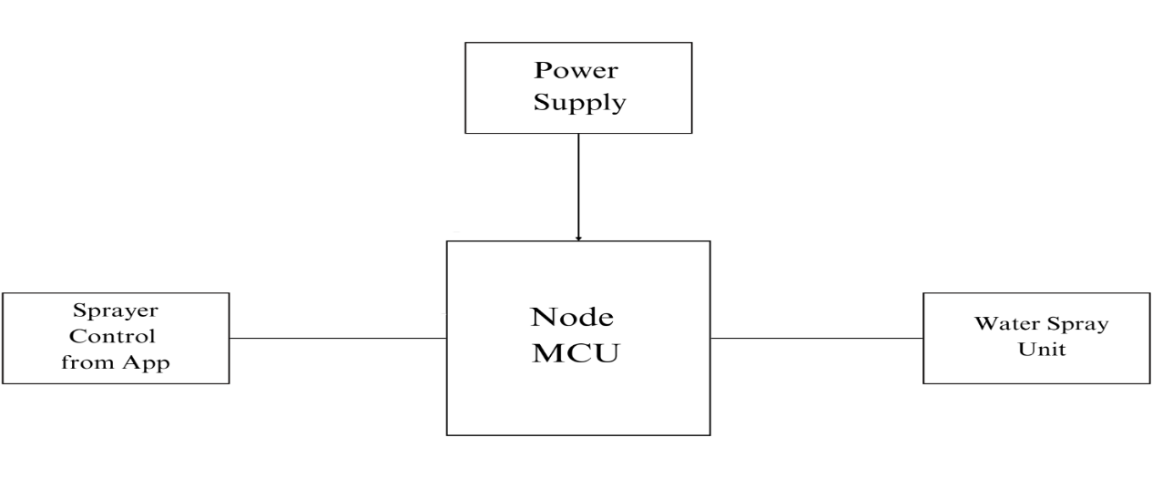
Fig. 1. Cleaning Unit
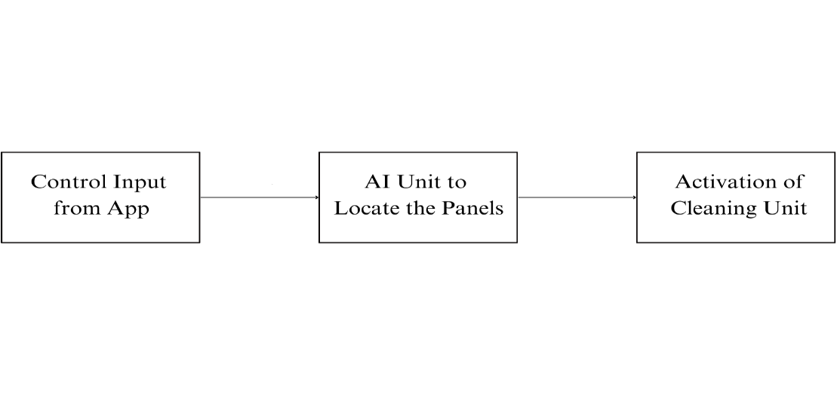
Fig. 2. AI Block
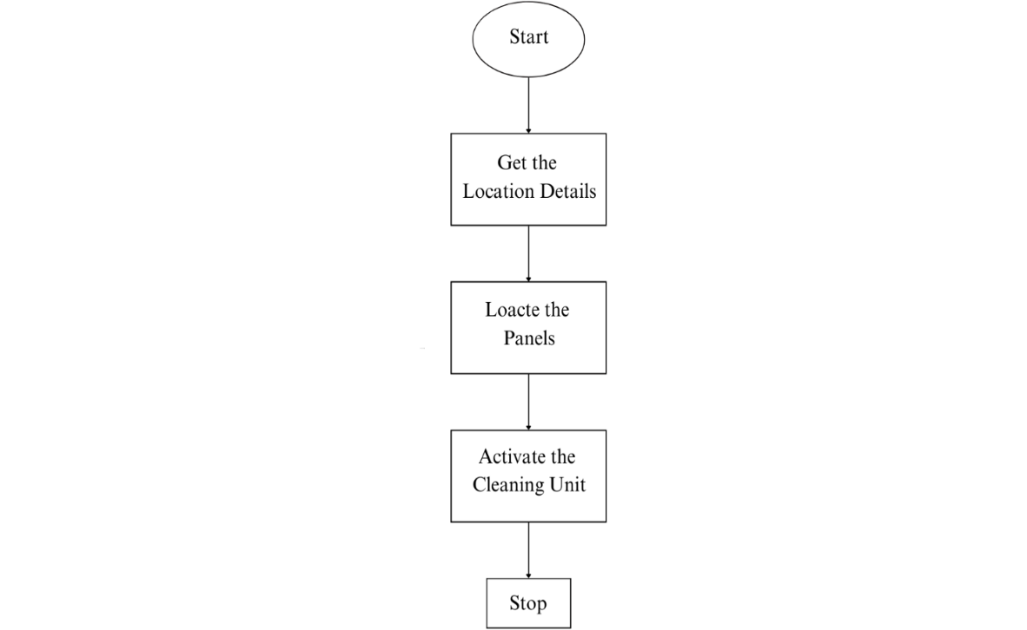
Fig. 3. Flow Chart
EXPECTED OUTCOMES:
- The proposed system help to clean the solar panel effectively.
- Human intervention can be reduced.
- The system helps to avoid manual work.
- The proposed work helps to avoid dust associated with the solar panel through frequent and efficient cleaning

PLAN OF RESEARCH WORK:
Sr. No. | Period (Months) | Work to be Done | Publications | Type
1 | July | Topic/Area selection | 1 | Review
2 | August | Literature Review |  | Review
3 | September | Data collection |  | Review
4 | October | Study and analysis of existing  protocol/Algorithm |  | Review
5 | November | Improving the existing protocol/Progress work | 1 | Own Work
6 | December | Review and Modifications |  | Own Work
7 | January | Tests, Results and Parameters analysis |  | Own Work
8 | February | Comparison with existing work |  | Own Work
9 | March | Thesis Writing &Submission |  | Own Work
10 | April | Thesis Writing &Submission |  | Own Work

REFERENCES:
[1] Manju B, Abdul Bari, and Pavan C M, “Automatic solar panel cleaning system,” International Journal of Advances in Scientific Research and Engineering, vol. 4, no. 7, July 2018.
[2] K. S. Margaret, T. Bathirnath, V. Dinesh Kumar, and N. Praveen Kumar, “Automatic solar panel cleaning robot,” International Journal of Emerging Research in Management and Technology, vol.45,no.5, pp. 691-703, Oct.2018.
[3] Nirav Savani, Zalak Korat, and Harsh Kikani, “Design and analysis of integrated solar panel cleaning system”, International Research Journal of Engineering and Technology, vol. 6, no.4, Apr. 2019.
[4] Ras Al Khaimah, United Arab Emirates, and Yacouba Moumouni, “Portable robot for cleaning photovoltaic system,” in Proc. IEEE Appl. Power. Conf., 2017, pp.335-342.
[5]Miqdam T. Chaichan and Hussein A. Kazem, “Experimental evaluation of dust composition impact on photovoltaic performance in Iraq,” Energy Sources, Part A: Recovery, Utilization, and Environmental Effects, DOI: 10.1080/15567036.2020.1746444.
[6] Abdelilah Said Soukaina, Medaghri Alaoui and Abdelfettah Barhdadi,” Innovative low cost cleaning technique for PV modules on solar tracker”, 2018 6th International Renewable and Sustainable Energy Conference (IRSEC),May.2016,pp.715-720.
[7] Amit Kumar Mondal and Kamal Bansal, “A brief history and future aspects in automatic cleaning systems for solar voltaic panels,” Advanced Robotics, vol. 29, no. 8, pp.515-524, 2016.
[8] Sugiartha, N., Ardana, I.G.N., Sugina, I.M., Widiantara, I.B.G., Suparta, I.N., & Adi, I.K. (2020). Preliminary design and test of a water spray solar panel cleaning system. Journal of Physics: Conference Series, 1450(1), 012108. https://doi.org/10.1088/1742-6596/1450/1/012108​
[9] Almalki, F.A., Albraikan, A.A., Soufiene, B.O., & Ali, O. (2022). Utilizing Artificial Intelligence and Lotus Effect in an Emerging Intelligent Drone for Persevering Solar Panel Efficiency. Wireless Communications and Mobile Computing, Article ID 7741535. https://doi.org/10.1155/2022/7741535

Mohammad Yasir Zaheer Sheikh Dr.M.T.Hasan
Supervisor
(Associate Professor, AI&DS Dept., ACET, Nagpur)

