Project Report
On
“AI Powered Drone for Solar Panel Cleaning”

Submitted to Rashtrasant Tukdoji Maharaj Nagpur University, Nagpur in the partial fulfillment of the requirements
for the Degree of
Bachelors of Technology
In
Artificial Intelligence & Data Science
By
Mohammad Yasir Zaheer Sheikh (27) | Mohammad Nomaan (20)
Abhishek Sawankar (14) | Tabish Ahmad Khan (28)
Group No. 06
B. TECH. 8th Semester AI&DS
Department of Artificial Intelligence & Data Science

Under the Guidance of
Dr.M.T.Hasan
Head
Department of Artificial Intelligence & Data Science


Department of Artificial Intelligence & Data Science,
Anjuman College of Engineering & Technology, Nagpur.
Rashtrasant Tukadoji Maharaj Nagpur University, Nagpur.
2024-25
Anjuman College of Engineering and Technology, Nagpur
Department of Artificial Intelligence & Data Science



CERTIFICATE
This is to certify that the report entitled
“AI Powered Drone for Solar Panel Cleaning”
is a bonafide work and it is submitted to the Rashtrasant Tukadoji Maharaj Nagpur University, Nagpur.
By
Group No. 06, B. TECH. 8th Semester AIDS
Mohammad Yasir Zaheer Sheikh (27) | Mohammad Nomaan (20)
Abhishek Sawankar (14) | Tabish Ahmad Khan (28)
in the partial fulfillment for the degree of Bachelors of Technology in Artificial Intelligence & Data Science, during the academic year 2024-2025 under my guidance.

Dr.M.T.Hasan
Guide
Department of Artificial Intelligence & Data Science.
Anjuman College of Engineering & Technology , Nagpur

Dr.M.T.Hasan Prof. (Dr). K. S. Zakiuddin
Head, Department of Artificial Intelligence & Data Science
Anjuman College of Engineering & Technology,
Nagpur
Principal
Anjuman College of Engineering & Technology, Nagpur

Declaration
This Project Work titled “AI Powered Drone for Solar Panel Cleaning” is our own work carried out under the guidance of Dr.M.T.Hasan, at Anjuman College of Engineering and Technology, Nagpur. This work in the same form or any other form is not submitted by us or by anyone else for award of any degree.

________

Project Members
Mohammad Yasir Zaheer Sheikh (27)_________
Mohammad Nomaan (20)_________
Abhishek Sawankar (14)
Tabish Ahmad Khan (28)

Acknowledgement
We wish to avail this opportunity to acknowledge our profound indebtedness and extend our deep sense of gratitude to our guide and Head of department respected Dr.M.T.Hasan, for their valuable guidance, profound advice, full co-operation and encouragement that has led to the successful completion of this project.
We would also thanks to honourable Prof. (Dr) K. S. Zakiuddin, Principal, Anjuman College of Engineering and Technology, Nagpur, for providing necessary facilities to carry out the work.
Finally, we would like to thanks to all the staff members, our parents and those who have contributed, directly or indirectly to make this project successful.

Project Members
Mohammad Yasir Zaheer Sheikh (28)
Mohammad Nomaan (20)
Abhishek Sawankar (14)
Tabish Ahmad Khan (28)

Abstract
ABSTRACT

Solar vitality is the foremost abundant, renewable vitality source within the world. As solar energy adoption increases, maintaining the cleanliness of solar panels is crucial for maximizing energy output. The solar panels in case of residential use are usually placed on the roof or terrace to receive the maximum amount of sunlight. Because of this, cleaning these solar panels would require the homeowner climbing up onto the roof to clean the panels, which can be hazardous. The other choice would be to enlist a company to do it for them. In either of the cases it is hazardous and can prove fatal. Thus, the proposed work introduces a design and development of an AI-powered drone system for efficient and autonomous cleaning of solar panels. The main object of this design prototype is to clean the solar panel using an drone system, such that efficiency and quality of solar panel is not compromised. The proposed work will try to introduce a drone base system in which the drone installed with a small water tank would be used to locate the place using mission planner, where the solar panels have been installed and then using the cleaning system installed on the drone to clean the panels.

Keywords: Raspberry Pi, solar panels, Solar Panel Cleaner, Drone.

Index
List of Tables i
List of Figures ii
Abbreviations iii
Nomenclature iv
Chapter 1 Introduction 1-6
1.1 Background of the Study 1-3
1.2 Overview of the Proposed Work 4-6
Chapter 2 Literature Review 7-13
2.1 Related Work 7-10
2.2 Drawbacks of the Existing Systems 11-12
2.3 Summary 13
Chapter 3 Proposed Work 14-20
3.1 Problem Definition 14
3.2 Aims & Objectives 15
3.3 Proposed System 16-20
Chapter 4 Analysis and Design 21-30
4.1 Methodology 21-23
4.2 System Requirements 24-27
4.2.1 Hardware Requirements 24
4.2.2 Software Requirements 25-27
4.3 Diagrams 28-30
Chapter 5 Implementation Details 31-41
5.1 Technology 31
5.2 Supporting Technologies 32-38
5.3 Results and Discussions 39-41
Chapter 6 Conclusion and Future Scope 42-52
6.1 Applications of The Proposed System 42-43
6.2 Advantages & Limitations of The Proposed System 44-37
6.2.1 Advantages 44-45
6.2.2 Limitations 46-47
6.3 Conclusion 48-49
6.4 Future Scope 50-52
References 53-54
Appendix A 55-86
Appendix B 87-90
List of Tables

Sr. No. | Description | Page No.
Table 1. | Comparative Analysis of Existing Approaches | 10

List of Figures

Sr. No. | Description | Page No.
Figure 3.1 | Workflow | 18
Figure 3.2 | Block Diagram of Drone | 20
Figure 4.3.1 | Flow Chart of Spraying System | 28
Figure 4.3.2 | Flow Chart of Testing the AI Powered Drone | 29
Figure 4.3.3 | Flow Chart of Overall System | 30
Figure 5.2.1 | Pixhawk Flight Controller | 32
Figure 5.2.2 | NEO-7M GPS module | 33
Figure 5.2.3.1 | DYS D2826-13 1000KV BLDC motor | 33
Figure 5.2.3.2 | 40A Electronic Speed Controller (ESC) | 34
Figure 5.2.4 | F330 Glass Fiber Quadcopter Frame | 34
Figure 5.2.5 | Holybro SiK Telemetry Radio | 35
Figure 5.2.6 | FlySky FS-i6 2.4G 6CH PPM RC Transmitter With FS-iA6B Receiver | 36
Figure 5.2.7 | FLY SKY FS IA6B RF 2.4GHz 6CH PPM output with iBus port receiver | 36
Figure 5.2.8 | 500ML Water Bottle | 37
Figure 5.2.9 | A2212/13T 1000KV BLDC motor | 37
Figure 5.2.10 | Water Pump Pipe | 38
Figure 5.2.11 | Simonk 30A ESC | 38
Figure 5.3.1 | Complete Integrated Hardware | 39
Figure 5.3.2 | Flying Test (1) | 40
Figure 5.3.3 | Flying Test (2) | 40
Figure 5.3.4 | Flying Test (3) | 41

Abbreviations

- AI : Artificial Intelligence
- US : United States
- DIP : Digital Image Processing
- Cw : Clock Wise
- CCW : Counter Clock Wise
- ESC : Electronic Speed Controller
- PWM : Pulse Width Modulation
- PPM : Pulse Position Modulation
- GC : Ground Control
- PC : Personal Computer
- RTL : Return to Launch
- BLDC : Brush Less Direct Current
- RC : Remote Controller
- AUX : Auxiliary

Nomenclatures

- Spraying System : Mechanism to spray water/cleaner over solar panels.
- Waypoint Navigation: Automated route following based on GPS coordinates.
- Solar Panel Cleaning Drone: Unmanned Aerial Vehicle (UAV) designed for cleaning solar panels.
- Real-time Monitoring: Live data tracking from the drone during operation.
- VRA Button: Switch/button on RC transmitter used to trigger the spraying system.
- Quadcopter: A drone with four rotors.
- Pixhawk: Advanced open-source flight controller.
- ArduPilot: Autopilot software used with Pixhawk.
- Failsafe: Safety feature to prevent uncontrolled behavior.
- VTOL: Vertical Take-Off and Landing.
- GPS Waypoints: Predefined GPS coordinates used for automated flight paths.
- Mission Planner: Ground Control Software for Pixhawk.
- MAVLink: Micro Air Vehicle Link (communication protocol used by Pixhawk).

Chapter 1
Introduction
1.1 Background of the Study
Solar energy is one of the most abundant, renewable, and environmentally friendly sources of energy available on Earth. It offers a sustainable alternative to fossil fuels, reducing carbon emissions and minimizing the environmental impact of power generation. According to the US Department of Energy, the amount of solar energy that reaches the Earth in just 90 minutes is sufficient to power the entire planet for a year. With the increasing adoption of solar power in residential, commercial, and industrial sectors, the need for maintaining the efficiency and cleanliness of solar panels has become a critical concern. Solar panels, primarily composed of photovoltaic (PV) cells, convert sunlight into direct current (DC) electricity. However, their performance can be significantly affected by various external factors, including dust, bird droppings, water stains, and other debris that accumulate on their surfaces over time. Studies have shown that the accumulation of dust alone can reduce the efficiency of solar panels by 20-30%, thereby affecting their overall energy output and reducing the return on investment for solar energy systems.
The growing deployment of solar panels in urban and rural areas has led to the need for innovative and efficient cleaning solutions to maintain their optimal performance. Traditional cleaning methods involve manual cleaning, which requires homeowners or maintenance personnel to climb onto rooftops or elevated structures to clean the panels. This process is not only labor-intensive and time-consuming but also poses significant safety hazards, particularly in residential and commercial applications. Furthermore, hiring professional cleaning services can be costly and may not be feasible for regular maintenance. In large-scale solar farms, where thousands of solar panels are spread across vast areas, manual cleaning becomes impractical and inefficient. Consequently, there is a growing demand for autonomous, cost-effective, and safer solutions to ensure that solar panels remain clean and continue to operate at peak efficiency.
To address these challenges, the integration of advanced technologies such as Artificial Intelligence (AI), Unmanned Aerial Vehicles (UAVs), and Digital Image Processing (DIP) has emerged as a promising solution for solar panel maintenance. UAVs, commonly known as drones, have gained immense popularity in various industries due to their versatility, ease of deployment, and ability to perform tasks that were previously labor-intensive or dangerous. Equipped with AI and DIP capabilities, drones can autonomously navigate solar panel installations, identify areas that require cleaning, and initiate the cleaning process with precision and accuracy. The use of drones in solar panel maintenance not only eliminates the need for manual labor but also reduces the associated risks, minimizes operational costs, and ensures consistent and thorough cleaning. This innovative approach enhances the efficiency and longevity of solar panels, contributing to the overall effectiveness of solar energy systems.
The application of AI-powered drones for solar panel cleaning involves integrating multiple technologies to achieve seamless and efficient operations. Digital Image Processing (DIP) algorithms enable the drone to analyze images captured during the flight and identify dirty or obstructed areas that need cleaning. GPS and telemetry systems allow the drone to autonomously navigate predefined flight paths and locate solar panel installations with high accuracy. The cleaning mechanism, which includes a spraying system powered by a Brushless DC (BLDC) motor and an Electronic Speed Controller (ESC), ensures that water or cleaning solutions are sprayed onto the panels to remove dust and debris. Moreover, the use of Mission Planner software facilitates mission planning and flight path optimization, enabling the drone to perform cleaning tasks autonomously with minimal human intervention.
The adoption of UAVs for solar panel maintenance is driven by the increasing need for innovative solutions to address the challenges associated with manual cleaning methods. In addition to improving operational efficiency, UAV-based cleaning systems also contribute to environmental sustainability by minimizing water usage and reducing carbon emissions associated with traditional cleaning processes. Automated cleaning systems use optimized spraying techniques to reduce water consumption, making them ideal for deployment in regions where water resources are scarce. Moreover, by ensuring that solar panels remain clean and operate at maximum efficiency, these systems contribute to the generation of clean and sustainable energy, supporting global efforts to combat climate change and reduce dependence on fossil fuels.
As solar energy continues to play a pivotal role in the transition to sustainable energy solutions, maintaining the efficiency and reliability of solar panel installations becomes increasingly important. The proposed work aims to develop an AI-powered drone system for solar panel cleaning, offering a safe, cost-effective, and environmentally friendly solution to address the challenges associated with traditional cleaning methods. By leveraging advancements in AI, UAV technology, and DIP, the proposed system has the potential to revolutionize solar panel maintenance and contribute to the widespread adoption of solar energy as a viable and sustainable power source. This study explores the design, implementation, and optimization of a drone-based cleaning system, with a focus on improving the efficiency, safety, and longevity of solar panels, ultimately contributing to the growth and success of the renewable energy sector.

1.2 Overview of the Proposed Work
The proposed work introduces an innovative solution to address the challenges associated with solar panel maintenance by leveraging AI-powered drones for autonomous cleaning. The project aims to design and develop a drone-based system equipped with a spraying mechanism and digital image processing (DIP) technology to ensure effective and efficient cleaning of solar panels, thereby maintaining their optimal performance. Solar panels, which are often installed on rooftops or in large solar farms, accumulate dust, bird droppings, and other contaminants over time. This accumulation reduces the efficiency of solar panels by preventing sunlight from reaching the photovoltaic cells. Studies have shown that even a small layer of dust can reduce the efficiency of solar panels by 20-30%, making regular cleaning essential to maintain consistent power output. However, manual cleaning methods, which involve climbing onto rooftops or hiring specialized cleaning services, pose several challenges, including safety concerns, high maintenance costs, and time and labor intensity. To address these challenges, the proposed work aims to develop a drone-based system that integrates artificial intelligence (AI) and mission planning to perform autonomous cleaning of solar panels, ensuring safety, efficiency, and cost-effectiveness.
The motivation behind this project stems from the growing global emphasis on renewable energy adoption and the need to maintain the efficiency of solar installations over the long term. Several key factors highlight the need for an autonomous cleaning solution for solar panels. The increasing number of solar panel installations in residential, commercial, and industrial sectors has led to the need for efficient maintenance to ensure optimal performance. Moreover, accumulated dirt and debris on solar panels reduce their efficiency, leading to decreased energy output and financial losses. Regular maintenance of solar panels ensures that maximum energy is harvested, contributing to both environmental sustainability and economic viability. Additionally, manual cleaning of solar panels, particularly in elevated locations or large solar farms, poses significant safety risks and increases operational costs. An automated solution using UAVs can mitigate these risks while reducing maintenance costs. Recent advancements in AI, computer vision, and drone technology have opened new possibilities for automating tasks that were previously performed manually. UAVs equipped with GPS, telemetry, and DIP algorithms can now autonomously navigate, identify dirty solar panels, and initiate cleaning mechanisms with minimal human intervention. Furthermore, manual cleaning methods often consume large quantities of water, making them unsustainable, particularly in water-scarce regions. By optimizing water usage and reducing wastage, UAV-based cleaning systems contribute to sustainable resource management. These motivations collectively underscore the significance of developing a smart, autonomous drone system capable of maintaining solar panel efficiency in a safe, cost-effective, and environmentally friendly manner.
The primary objective of this project is to design and implement an AI-powered drone system capable of autonomously cleaning solar panels while maintaining optimal efficiency. The specific objectives include designing and developing a drone-based system equipped with a spraying mechanism, integrating DIP algorithms to analyze images captured by the drone, and configuring the drone to autonomously navigate solar panel installations using Mission Planner software and GPS technology. Additional objectives include developing a spraying system using a 500ml water bottle, an A2212/13T 1000KV BLDC motor, and a Simonk 30A ESC to effectively clean solar panels, integrating an RC transmitter (FlySky FS-i6) to enable manual control and override capabilities, and optimizing the performance of the system by fine-tuning parameters such as PWM values, motor speed, and spray intensity. The system architecture consists of several key components such as the Pixhawk flight controller, NEO-7M GPS module, Holybro SiK telemetry module, BLDC motors, and ESCs, which work together to ensure smooth and efficient operation. The spraying mechanism, including the 500ml water reservoir, small water pipe, and BLDC motor-powered pump, plays a critical role in cleaning the panels.
The system operates through a series of steps, starting with mission planning, where a flight path is created for the drone to autonomously navigate and cover the solar panel area. The drone captures images of the solar panels and processes them using DIP algorithms to detect dirt or debris. If dirt is detected, the spraying system is activated to clean the panel. The VRA button on the RC transmitter can also be used for manual operation if required. The telemetry system transmits data to the Ground Control Station, allowing real-time monitoring and feedback for performance optimization. The proposed system architecture and working mechanism ensure that the system can perform the cleaning task efficiently and effectively with minimal human intervention.
The proposed work aims to introduce a smart, autonomous, and efficient drone-based system for solar panel maintenance by leveraging AI, DIP, and UAV technology. This system has the potential to significantly improve the efficiency, longevity, and sustainability of solar installations while minimizing costs, ensuring safety, and reducing water consumption. The integration of advanced technologies in this project sets the stage for future innovations in solar panel maintenance and renewable energy management. The adoption of such systems could revolutionize solar panel maintenance, contributing to the growth of clean energy solutions and supporting global efforts to reduce carbon emissions and promote sustainable development.

Chapter 2
Literature Review
2.1 Related Work
The increasing global emphasis on renewable energy solutions has driven the widespread adoption of solar panels, which convert solar energy into usable electrical power. Solar panels have become a critical component in the pursuit of sustainable energy production due to their ability to reduce carbon emissions and dependence on fossil fuels. However, the efficiency and performance of solar panels can be significantly affected by environmental factors such as dust, bird droppings, dirt, water stains, and other pollutants that accumulate on their surface. Therefore, maintaining the cleanliness of solar panels is essential for maximizing their energy output and ensuring long-term operational efficiency.

2.1.1 Manual and Semi-Automated Cleaning Systems
The most traditional method of solar panel maintenance involves manual cleaning using water, detergents, and brushes. Manual cleaning is labor-intensive and time-consuming, making it suitable only for small-scale installations such as residential or small commercial solar panel systems. Manual cleaning, however, presents significant drawbacks, including safety risks for personnel tasked with climbing rooftops or elevated structures. Additionally, manual cleaning can be inconsistent, leading to uneven energy output and reduced overall efficiency.
To address the limitations of manual cleaning, semi-automated cleaning systems have been introduced. These systems incorporate mechanical arms, rotating brushes, and water jets that automate certain aspects of the cleaning process. Semi-automated systems improve efficiency by reducing the need for direct human intervention and enabling faster cleaning cycles. However, these systems are not entirely autonomous and still require human supervision, limiting their applicability for large-scale solar farms.
Further, semi-automated systems often lack adaptability to varied surface geometries and environmental conditions. Their deployment is more practical for flat, uniformly aligned panel installations, making them less versatile for heterogeneous or uneven terrain.

2.1.2 Robotic Cleaning Systems for Solar Panels
Robotic cleaning systems have emerged as a robust alternative to manual methods. These systems are capable of autonomous navigation across solar panel surfaces, using wheels, tracks, or suction-based mechanisms. They are integrated with sensors, obstacle detection, and path planning algorithms that allow them to clean systematically without damaging the panels.
Studies such as Khan et al. (2021) and Ahmad et al. (2020) have shown up to a 20–30% increase in panel efficiency post-cleaning with robotic systems. Additionally, these robots can be designed for dry or wet cleaning depending on the environmental conditions and water availability. Waterless cleaning robots, using air blowers or microfiber brushes, are especially useful in arid regions.
However, the effectiveness of robotic systems is challenged by high upfront costs, regular maintenance requirements, and limited scalability for large or dispersed solar installations. Moreover, tethered or rail-mounted robots lack mobility across disconnected panel sections and require infrastructure modifications, further adding to their complexity.

2.1.3 Drone-Based Cleaning Systems
The evolution of Unmanned Aerial Vehicles (UAVs) has introduced a transformative approach to solar panel cleaning. Drones equipped with high-resolution cameras, sensors, and spraying mechanisms offer a mobile, non-contact, and highly scalable alternative to both manual and robotic methods.
Drone-based cleaning systems can perform both inspection and cleaning tasks. Initially, they survey the panels using AI-powered image processing to detect soiled or degraded areas. Based on the analysis, they activate targeted cleaning mechanisms that may include water sprays, air blowers, or specialized cleaning fluids. These drones can cover wide areas efficiently, navigate difficult terrain, and operate in locations where other systems may struggle.
Commercial examples include the Aerones drone system, which uses tethered drones to clean solar farms and skyscrapers. It is capable of carrying 200 liters of water or detergent and can be operated remotely. Similarly, Raptor Maps and DroneDeploy provide drone-based solar inspection services using thermal and RGB imaging, aiding predictive maintenance.
The main limitations of drone-based cleaning include payload constraints, battery life, flight time limitations, and susceptibility to weather conditions (wind, rain). Moreover, cleaning efficiency depends on the precision of navigation and control algorithms, and the accuracy of image-based dirt detection.

2.1.4 Artificial Intelligence and Digital Image Processing in Solar Panel Maintenance
The integration of AI and DIP technologies is revolutionizing how cleaning tasks are planned and executed. AI enables drones and robots to make real-time decisions, adapt to changing conditions, and optimize their cleaning paths. Computer vision models, especially Convolutional Neural Networks (CNNs), are used to classify panel conditions, identify hotspots, and distinguish between dirt, cracks, shadows, and stains.
Research by Patel et al. (2021) and Sharma et al. (2022) highlights the effectiveness of using CNNs and YOLO (You Only Look Once) object detection for pinpointing panel defects and dirt accumulation. The adoption of edge AI, where image analysis is conducted onboard the drone in real-time, further enhances responsiveness and autonomy.
Predictive analytics and machine learning models also support condition-based maintenance rather than scheduled cleaning. By forecasting when and where cleaning is necessary, these systems optimize resource usage (water, electricity, manpower) and extend the life of solar installations.

2.1.5 Research Gaps and Opportunities
Despite significant progress, several research and development opportunities remain:
Battery Optimization: Enhancing UAV battery life or incorporating solar-powered recharging mechanisms.
Water Conservation: Integrating water-saving nozzles or waterless cleaning options for sustainable operations.
Real-Time Obstacle Avoidance: Advanced sensor fusion (e.g., LiDAR + vision) for better environmental awareness.
Edge Computing: Reducing latency and reliance on ground stations by processing DIP data on-board in real-time.
Swarm Drone Systems: Coordinated cleaning using multiple UAVs for large-scale solar farms to improve coverage and efficiency.
Automated Scheduling: AI-powered systems to automatically schedule cleaning based on weather forecasts, energy drop, or image analysis.
By addressing these gaps, future drone-based systems can become more robust, cost-effective, and environmentally friendly, making them indispensable for solar panel maintenance at scale. The current trend of integrating AI, robotics, and aerial platforms is expected to pave the way for highly intelligent, fully autonomous maintenance ecosystems in the renewable energy sector.

2.1.6 Comparative Analysis of Existing Approaches
Method | Advantages | Disadvantages
Manual Cleaning | Low cost for small-scale; simple setup | Unsafe, labor-intensive, inconsistent; impractical for large installations
Semi-Automated Systems | Faster than manual; reduced labor | Still requires supervision; limited flexibility
Robotic Systems | Fully autonomous; precise; scalable within homogeneous layouts | Expensive; complex maintenance; limited terrain adaptability
Drone-Based Systems | Mobile; scalable; less labor; access difficult areas | Battery and payload limitations; weather-sensitive; high setup cost

Table 1. Comparative Analysis of Existing Approaches

2.2 Drawbacks of the Existing Systems
While existing solar panel cleaning systems have made notable progress in improving cleaning efficiency and reducing maintenance costs, they still face several challenges and limitations that hinder their widespread adoption.

2.2.1 High Operational Costs and Maintenance Requirements
Manual and semi-automated cleaning methods often incur high labor costs and operational expenses, particularly in large-scale solar farms where frequent cleaning is required. Robotic and UAV-based systems, while reducing labor costs, come with high initial investment and ongoing maintenance requirements. The cost of deploying and maintaining autonomous cleaning systems may be prohibitive for small-scale installations, limiting their accessibility and adoption.

2.2.2 Safety Risks Associated with Manual Cleaning
Manual cleaning of solar panels installed on rooftops or elevated structures poses significant safety risks to maintenance personnel. The potential for falls, accidents, and injuries makes manual cleaning a hazardous task, particularly in urban environments where solar panels are often installed on high-rise buildings. Although semi-automated systems reduce the need for direct human intervention, they still require occasional supervision, exposing workers to potential risks.

2.2.3 Limited Scalability and Adaptability
Semi-automated and robotic cleaning systems often struggle to adapt to different panel configurations and layouts, limiting their scalability for large-scale applications. Customization is required to tailor these systems to specific installations, which adds complexity and increases deployment costs. Manual and semi-automated methods also face challenges in adapting to irregularly arranged solar panels, resulting in inconsistent cleaning quality.

2.2.4 Environmental Concerns and Water Usage
Traditional cleaning methods that rely on excessive water consumption contribute to environmental degradation and water wastage. In regions with limited water resources, the use of water-intensive cleaning techniques is unsustainable and may lead to resource depletion. Although automated and drone-based systems aim to reduce water usage through targeted cleaning, there is still room for improvement in optimizing water consumption and minimizing environmental impact.

2.2.5 Inconsistent Cleaning Quality and Operational Challenges
Manual cleaning methods often result in inconsistent cleaning quality due to variations in human performance and technique. Autonomous systems, although more consistent, may encounter operational challenges such as wind disturbances, sensor inaccuracies, and equipment malfunctions that affect overall cleaning performance. Ensuring uniform cleaning quality across large solar panel arrays remains a significant challenge for both manual and autonomous systems.

2.2.6 Battery Limitations and Flight Time Constraints in UAVs
One of the key challenges faced by UAV-based cleaning systems is the limited flight time and battery capacity of drones. Most commercial drones can operate for 20-30 minutes before requiring recharging or battery replacement, which limits their ability to clean large solar farms in a single mission. To address this limitation, researchers are exploring the use of solar-powered drones and improved battery technologies to extend flight time and enhance operational efficiency.

2.3 Summary
In conclusion, the literature review provides a comprehensive overview of the various approaches and technologies used in solar panel maintenance, highlighting their advantages, limitations, and potential for future development. Manual and semi-automated cleaning methods, while suitable for small-scale installations, are inefficient and hazardous for large-scale applications. Robotic and UAV-based systems offer superior efficiency, scalability, and consistency in cleaning quality, but they also come with high initial costs and maintenance requirements.
The integration of AI and DIP technologies in drone-based cleaning systems has significantly improved the accuracy, efficiency, and adaptability of solar panel maintenance operations. However, challenges such as high operational costs, safety risks, environmental concerns, and flight time limitations continue to hinder the widespread adoption of these systems. Future research should focus on developing cost-effective, scalable, and environmentally sustainable solutions to address these challenges and further enhance the performance of solar panel cleaning technologies.
By overcoming these limitations, future advancements in solar panel maintenance technologies can contribute to increasing the efficiency, longevity, and reliability of solar energy systems, ultimately supporting the global transition toward renewable energy sources.

Chapter 3
Proposed Work
3.1 Problem Definition
Solar energy is one of the most sustainable and widely used renewable energy sources, contributing significantly to reducing carbon emissions and meeting global energy demands. However, the efficiency of solar panels can be significantly reduced due to the accumulation of dust, dirt, bird droppings, and other debris on their surface. Research has shown that unclean solar panels can lose between 15% to 25% of their energy output if not maintained properly. Despite the remarkable advancements in solar technology, maintaining the cleanliness of solar panels remains a challenge, particularly for panels installed on rooftops or large solar farms.
In residential settings, cleaning solar panels is often a hazardous task that requires homeowners to climb onto rooftops, posing safety risks. On the other hand, hiring a professional cleaning service can be costly and may not be feasible for frequent cleaning. Similarly, in large-scale solar farms, manual cleaning is labor-intensive, time-consuming, and inefficient. Hence, the need for an automated, safe, and efficient system for cleaning solar panels is paramount.
The primary problem addressed in this project is the development of an AI-powered drone system for autonomous cleaning of solar panels. This system aims to improve the efficiency of solar panels by ensuring regular and effective cleaning, while minimizing human intervention and operational risks. The proposed solution will integrate a drone with a water spraying system, capable of detecting and cleaning solar panels using mission planning and real-time control.

3.2 Aims and Objectives

3.2.1 Aims
The primary aim of this research is to design and develop an AI-powered drone system for autonomous and efficient cleaning of solar panels. The system should be capable of detecting and cleaning solar panels placed in high or hard-to-reach locations, thereby improving the overall efficiency and performance of solar energy systems.

3.2.2 Objectives
To achieve this aim, the following objectives have been defined:
Design and Development of the Drone System: Develop a quadcopter equipped with a Pixhawk flight controller, GPS module, telemetry system, and an integrated water spraying system.
Integration of a Spraying Mechanism: Implement a water spraying mechanism using a 500ml water bottle, A2212/13T 1000KV BLDC motor, and a Simonk 30A ESC, capable of efficient and targeted cleaning of solar panels.
Mission Planner Configuration and Calibration: Configure the drone system using Mission Planner software to automate flight paths, sensor calibration, and remote control settings.
AI-Based Cleaning Optimization: Optimize the drone’s performance through AI-based detection techniques to identify dust accumulation and ensure efficient spraying.
Testing and Performance Evaluation: Conduct field tests to evaluate the drone’s performance, including stability, accuracy in locating solar panels, efficiency in cleaning, and battery management.
Enhance Safety and Automation: Ensure the system maintains operational safety while minimizing human involvement and automating the entire cleaning process.

3.3 Proposed System
The proposed system introduces an AI-powered drone equipped with a water spraying system designed to autonomously clean solar panels and enhance their efficiency. The system uses a quadcopter with a Pixhawk flight controller and GPS navigation to locate the solar panels, and the water spraying system is triggered based on real-time control inputs from a remote controller or pre-defined commands.

3.3.1 System Overview
The system consists of the following core components:
Drone Framework: A lightweight and durable F330 quadcopter frame made of glass fiber, chosen for its strength and stability.
Flight Controller and Navigation System: The Pixhawk flight controller acts as the brain of the system, enabling autonomous flight, maintaining stability, and processing sensor data. The NEO-7M GPS module provides high-accuracy location data and ensures precise navigation.
Water Spraying System: The spraying system consists of a 500ml water bottle connected to a small water pipe, controlled by an A2212/13T 1000KV BLDC motor powered by a Simonk 30A ESC. The motor generates the necessary suction and pressure to spray water onto the solar panels.
RC Transmitter and Receiver: The FlySky FS-i6 transmitter and FS-iA6B receiver facilitate manual control and allow for switching between automatic and manual modes. The VRA button on the RC transmitter controls the spraying mechanism.
Mission Planner Software: Mission Planner is used for configuring the flight path, calibrating sensors, and controlling the drone’s movements. It enables the automation of the cleaning process and ensures that the drone follows a predefined route over the solar panels.

3.3.2 System Architecture
The architecture of the proposed system consists of three main layers:
1. Hardware Layer:
Drone frame (F330)
Pixhawk flight controller
NEO-7M GPS module
ESC and BLDC motor
Water spraying system
RC transmitter and receiver
2. Software Layer:
Mission Planner software for configuring, monitoring, and controlling the drone.
AI algorithms for detecting dust and optimizing the cleaning process.
PWM control for motor speed and spray intensity.
3. Communication Layer:
MAVLink protocol for communication between the drone and the Ground Control Station (GCS).
Telemetry module for real-time data transmission.

3.3.3 Functional Requirements
The proposed system’s functional requirements include:
Autonomous Flight Control: The drone should autonomously navigate to the target location and maintain stability during the cleaning process.
Target Detection and Localization: The system should accurately identify the location of solar panels using GPS and navigate accordingly.
Water Spraying Mechanism: The system should activate the spraying mechanism when the drone is positioned above the solar panels.
Manual and Automatic Operation: Users should be able to switch between manual and autonomous modes based on operational requirements.
Safety Mechanisms: The drone should incorporate fail-safe mechanisms, such as return-to-home (RTL) and battery monitoring to ensure safe operations.

3.3.4 System Workflow
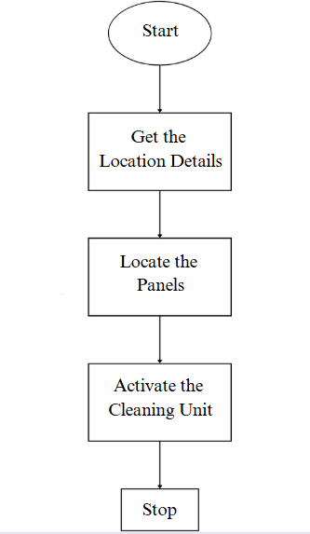
Figure 3.1 Workflow
Workflow Step Explanation
1. Start
The drone system is powered on, initializing the Pixhawk flight controller, GPS, ESC, BLDC motor, and telemetry system.
Mission parameters are configured in Mission Planner.
2. Get the Location Details
GPS retrieves the target solar panel coordinates.
Real-time telemetry data is sent to the Ground Control Station (GCS).
3. Locate the Panels
The drone navigates to the specified location using GPS.
AI-based algorithms and Digital Image Processing (DIP) help identify the solar panels.
The drone positions itself optimally for cleaning.
4. Activate the Cleaning Unit
The RC transmitter or Mission Planner triggers the ESC to power the BLDC motor.
Water is sprayed through the system using a 500ml water bottle, a pipe, and the motor.
PWM signals regulate the spray intensity for effective cleaning.
5. Stop
The spraying system is deactivated after cleaning.
The drone returns to the initial launch point using the Return-to-Launch (RTL) feature.
Final telemetry data is sent to GCS for analysis.
3.3.5 Block Diagram of Drone
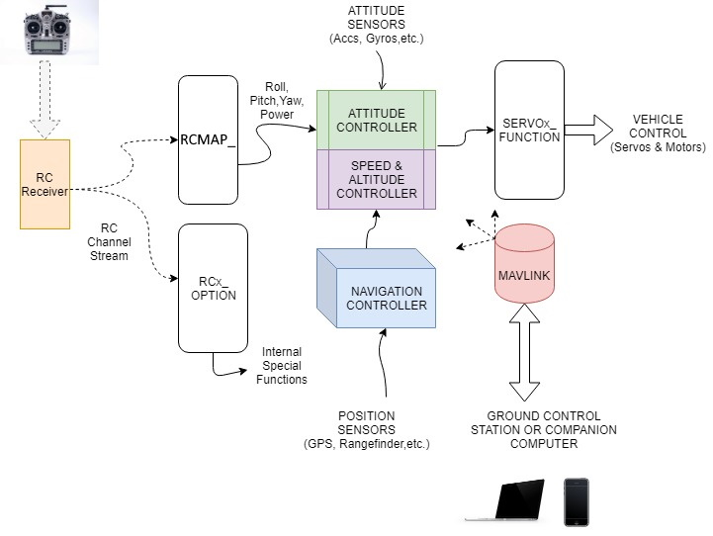
Figure 3.2 Block Diagram of Drone
RC Receiver: Receives commands from a Remote Controller (RC). Produces an RC Channel Stream, which contains signals for roll, pitch, yaw, throttle, and other special functions.
RCMAP and RCx_OPTION
RCMAP: Maps the RC signals (roll, pitch, yaw, throttle) to the control system.
RCx_OPTION: Handles internal special functions, like triggering auxiliary devices or custom actions based on RC inputs.
Controllers :
Attitude Controller: Uses data from the RC Receiver and Attitude Sensors. Adjusts the drone's orientation (roll, pitch, yaw).
Speed & Altitude Controller: Works with the Attitude Controller to maintain desired altitude and speed. Balances input commands and sensor data.
Navigation Controller: Uses Position Sensors (e.g., GPS). Handles autonomous flight paths, navigation, and waypoint tracking.
Position Sensors: For example, GPS provide the drone's location, altitude, and distance measurements. Sends data to the Navigation Controller for position-based decision-making.
SERVOx_FUNCTION: Converts control signals into physical actions. Sends commands to servos and motors for vehicle control, enabling movement and stability.
MAVLink: A communication protocol that allows data exchange between the drone and external devices. Relays telemetry and control data between the drone and a Ground Control Station (GCS). Facilitates real-time monitoring, mission planning, and control.
Ground Control Station (GCS): For examples Laptop, smartphone, or onboard processor.
Function: Interfaces with MAVLink to send commands, monitor the drone, or process additional computations.

Chapter 4
Analysis and Design
4.1 Methodology

4.1.1 Drone Methodology
1. Assembly Process
The assembly process starts with the outline and engine establishment. The F330 Quadcopter Outline is gathered by securing all arms and base plates utilizing screws. The DYS D2826-13 1000KV engines are mounted to each arm utilizing engine mounts, guaranteeing that two engines pivot clockwise (CW) and two counterclockwise (CCW) to preserve soundness.
Another, the Electronic Speed Controller (ESC) association is set up by fastening the ESCs to the Control Dissemination Board (PDB). Each ESC is associated to a BLDC engine concurring to its comparing arm, and they are secured on the outline utilizing zip ties or double-sided tape.
For the Pixhawk Flight Controller setup, the Pixhawk is safely mounted at the center of the drone frame utilizing vibration dampers. The ESC signal wires are associated to the Pixhawk's primary yield pins (e.g., PWM yields 1-4), and the Control Module is associated for control supply and voltage checking.
The GPS and telemetry framework installation takes after, where the NEO-7M GPS module is mounted on a raised pole to play down electromagnetic impedances and associated to the Pixhawk's GPS port. The Holybro SiK Telemetry Module is connected by interfacing one conclusion to the Pixhawk's TELEM1/TELEM2 port whereas the other module is utilized for ground station communication.
At last, the remote-control collector association is built up by official the FlySky FS-i6 Transmitter to the FS-iA6B Collector. The recipient is at that point associated to the Pixhawk by means of the PPM/SBUS port.
2. Computer program Setup
The computer program setup starts with introducing Mission Planner (or Ground Control) on a PC. The Pixhawk is associated to the computer by means of USB for firmware installation. Taking after this, sensor calibration is performed. The accelerometer is calibrated by setting the ramble on a level surface and taking after the steps in Mission Planner. Compass calibration requires pivoting the drone in numerous introductions, whereas the RC calibration is done by arranging the FlySky FS-i6 transmitter through Mission Organizer.
3. Flight Testing and Optimization
The beginning ground testing includes controlling on the drone and checking the ESC and engine usefulness utilizing Mission Planner, guaranteeing appropriate GPS bolt and telemetry communication. Test float and soundness alterations are performed by conducting a low-altitude drift test in a controlled environment. PID tuning parameters in Mission Planner are balanced to progress steadiness, and failsafe settings are empowered for battery checking and misfortune of signal recovery.
4. Final Deployment
The final stage includes conducting different flight tests to confirm soundness, GPS precision, and engine execution. Independent flight modes such as Loiter, RTL (Return to Launch), and Auto Mission mode are optimized. At last, telemetry information is analyzed for advance advancements to improve the drone's overall performance.

4.1.2 Spraying System Methodology
1. System Components
In this project, we have developed a spraying system using a 500ml water bottle as a store, a small water pipe for directing the spray, an A2212/13T 1000KV BLDC engine powered by a Simonk 30A ESC, and a Pixhawk flight controller integrated with an RC transmitter's VRA button for control.
2. System Integration
The ESC was connected to the Pixhawk flight controller, enabling both automated and manual control of the spraying system. This setup allowed me to operate the spray system remotely using the RC transmitter, enhancing ease of use and efficiency.
3. Working Principle
When the VRA button is turned ON, the ESC powers the BLDC motor, generating suction and pressure to spray water through the pipe. When the VRA button is turned OFF, the motor stops, halting the spray.
4. Control Configuration
The Pixhawk is configured using Mission Planner, where an AUX output is mapped to control the ESC. The PWM values are set to regulate the motor speed, which in turn controls the spray intensity.
5. Optimization
To enhance the system’s performance, We optimized the PWM values for precise spray control, integrated a valve to regulate water flow efficiently, and ensured proper
weight distribution to maintain the drone's stability during flight.

4.2 System Requirements
The development of the AI-powered drone for solar panel cleaning requires a combination of hardware and software resources to ensure smooth operation. Below is a detailed overview of the system requirements:

4.2.1 Drone Hardware Requirements:
The development of the AI-powered drone for solar panel cleaning necessitates a combination of robust hardware and reliable software to ensure efficient and seamless operation. The hardware components include the Pixhawk Flight Controller, which serves as the central control unit, managing flight stabilization and navigation. Accurate positioning and waypoint tracking are provided by the NEO-7M GPS Module, ensuring that the drone precisely locates and cleans the solar panels. The drone’s thrust and stability are maintained by the DYS D2826-13 1000KV BLDC Motors, which are controlled by Simonk 30A ESCs to regulate the speed and direction of the motors effectively.
The 500ml Water Bottle acts as a reservoir to store the water used in the spraying system, while the Water Pump Pipe channels the water through the nozzle, ensuring an even spray to clean the solar panels. To facilitate real-time data transmission between the drone and the ground control station, the Holybro SiK Telemetry Module is employed, enhancing situational awareness during flight operations. The F330 Glass Fiber Quadcopter Frame provides a durable and lightweight structure that supports all essential components while maintaining the drone's stability and balance.
For control and communication, the FlySky FS-i6 Transmitter paired with the FS-iA6B Receiver ensures seamless manual and automated control of the drone. Power is supplied by LiPo Batteries, which provide adequate energy to the motors, ESCs, and the Pixhawk flight controller, enabling extended flight duration and reliable operation. Together, these hardware components work cohesively to ensure that the AI-powered drone performs autonomous and efficient solar panel cleaning tasks with precision and stability.

4.2.2 Software Requirements:
1. Mission Planner: Mission Planner is an open-source ground control station (GCS) software primarily used for configuring, monitoring, and controlling UAVs. It plays a crucial role in the setup, flight planning, and real-time management of drones running on ArduPilot or PX4 firmware. Mission Planner facilitates the initial configuration, including sensor calibration, PID tuning, and firmware updates. It connects to the Pixhawk flight controller via USB or telemetry modules and allows the user to adjust settings such as accelerometer, compass, gyroscope, radio, and RC transmitter configurations. Additionally, failsafe parameters for signal loss and battery level are configured through Mission Planner to ensure safety during operations.
One of the most critical functionalities of Mission Planner is creating autonomous missions using waypoints and geofencing. Users can design a series of waypoints where the drone will navigate, perform actions such as hovering, spraying, or returning to the launch point (RTL), and define altitude, speed, and orientation. Waypoint navigation ensures the drone flies to specific locations, while Loiter mode maintains the drone in a fixed position for stability during operations. The RTL (Return to Launch) feature automatically directs the drone back to its initial launch position after completing the mission or when a failsafe event occurs.
Mission Planner provides real-time telemetry data, such as GPS location, altitude, battery status, sensor readings, and system status. Telemetry communication is achieved using the Holybro SiK Telemetry Module, which establishes a reliable communication link between the drone and the ground control station. PID (Proportional, Integral, Derivative) tuning is another crucial feature of Mission Planner that ensures smooth and stable flight by fine-tuning control responses. Mission Planner also logs all flight data, including GPS coordinates, sensor information, and motor performance, which can be analyzed post-flight for optimization and identifying potential errors.
2. ArduPilot Firmware: ArduPilot is an open-source autopilot firmware that provides autonomous control and navigation capabilities for UAVs, ground vehicles, and marine systems. It is extensively used for drones that utilize Pixhawk and other compatible flight controllers. ArduPilot comes in different versions based on the platform, including ArduCopter for multi-rotors and helicopters, ArduPlane for fixed-wing aircraft, ArduRover for ground-based autonomous vehicles, and ArduSub for underwater vehicles. In this project, ArduCopter was used to manage the drone’s autonomous navigation and spraying system.
ArduPilot supports a wide range of features, enabling advanced flight control such as autonomous navigation, GPS waypoint missions, and fail-safe mechanisms. GPS waypoint missions allow the drone to execute complex flight paths while adjusting altitude, speed, and direction based on pre-defined parameters. The firmware also incorporates failsafe mechanisms to ensure that the drone automatically returns to the launch position or lands safely in case of signal loss, low battery, or navigation errors. Stabilization and altitude hold features further enhance the stability and reliability of the drone during flight.
ArduPilot integrates various sensors and hardware to ensure flight stability and precision, including GPS modules for accurate positioning, IMU (Inertial Measurement Unit) for measuring acceleration and orientation, and barometers for altitude control. Since ArduPilot is an open-source firmware, it offers flexibility for customization, allowing developers to modify control algorithms and add advanced mission profiles tailored to project-specific requirements.
3. Communication Protocols: Communication between the drone’s flight controller, ground control station, and other components is facilitated through specialized communication protocols that ensure seamless data transmission and control. One of the most commonly used protocols is MAVLink (Micro Air Vehicle Link), a lightweight and efficient messaging protocol used for communication between the flight controller and the ground control station. MAVLink is responsible for sending commands, receiving telemetry data, and exchanging mission information. It handles heartbeat messages to maintain the connection, acknowledges commands such as takeoff, landing, or switching modes, and transmits real-time data, including GPS location, altitude, and battery status.
PPM (Pulse Position Modulation) and SBUS (Serial Bus) are used for transmitting control signals from the RC transmitter to the Pixhawk flight controller. PPM transmits multiple channels of data using a single signal wire, while SBUS offers faster and more reliable communication by transmitting digital signals, ensuring minimal latency and enhanced control over the drone.
Telemetry protocols enable real-time communication between the drone and the ground control station. SiK Telemetry Protocol is commonly used by the Holybro SiK Telemetry Module to establish a long-range communication link. It operates on 433 MHz and 915 MHz frequencies, ensuring reliable data transmission over extended distances. In more advanced applications, TCP/IP and UDP protocols are used for high-speed data transfer and real-time feedback, enabling Mission Planner to connect wirelessly to the drone.
PWM (Pulse Width Modulation) is another crucial protocol used for motor control. The ESC receives PWM signals from the Pixhawk to regulate the motor’s speed and direction, ensuring precise control over the drone’s movement and spray intensity. These communication protocols guarantee smooth and reliable operation of the drone, ensuring that commands are executed accurately, and telemetry data is transmitted effectively.

4.3 Diagrams
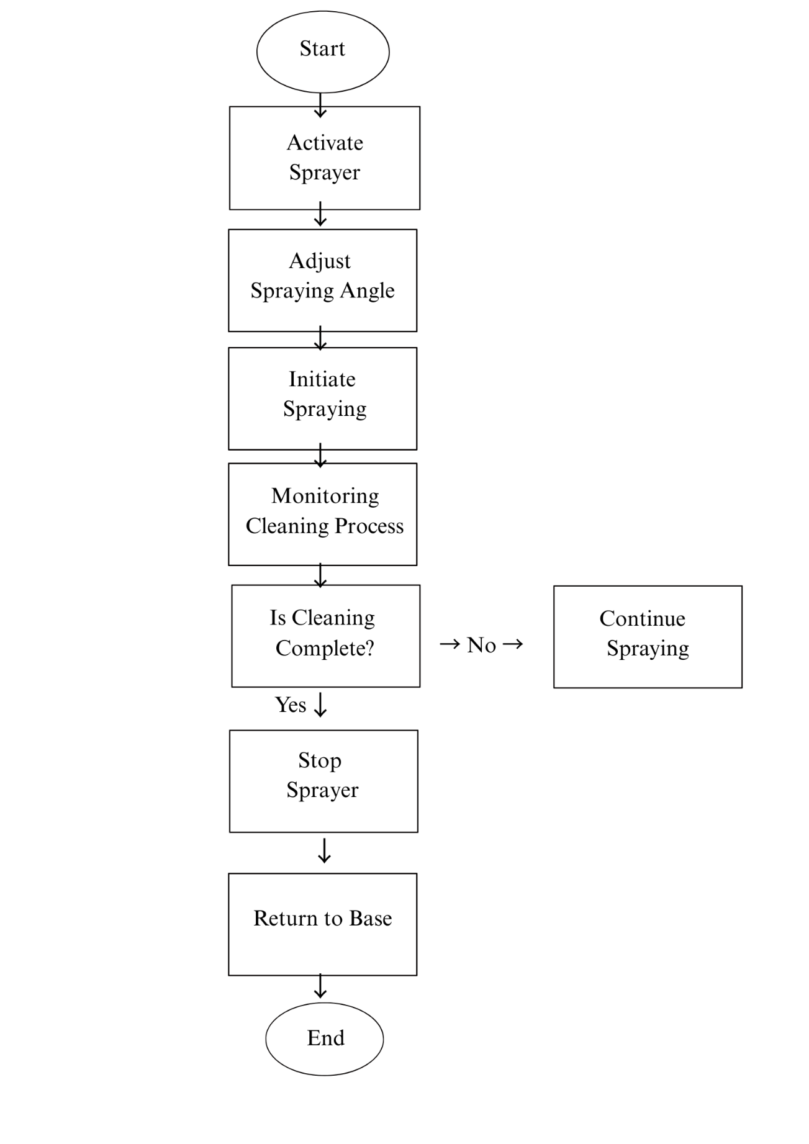

Figure 4.3.1 Flow Chart of Spraying System
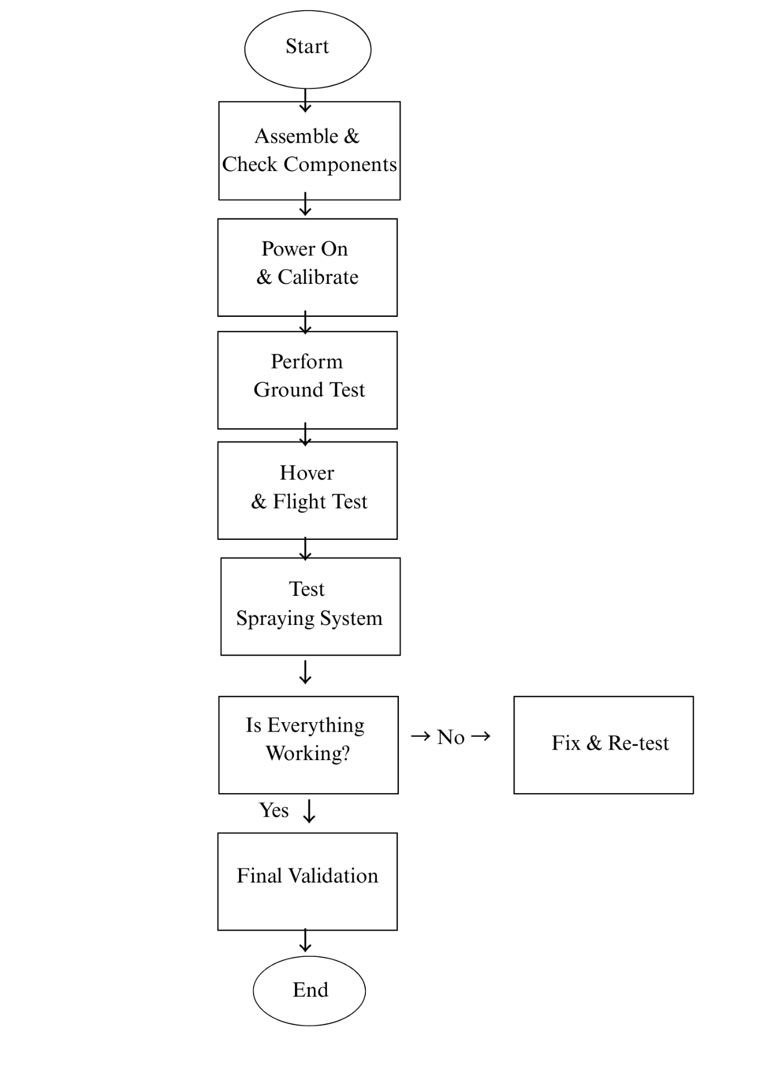
Figure 4.3.2 Flow Chart of Testing the AI Powered Drone

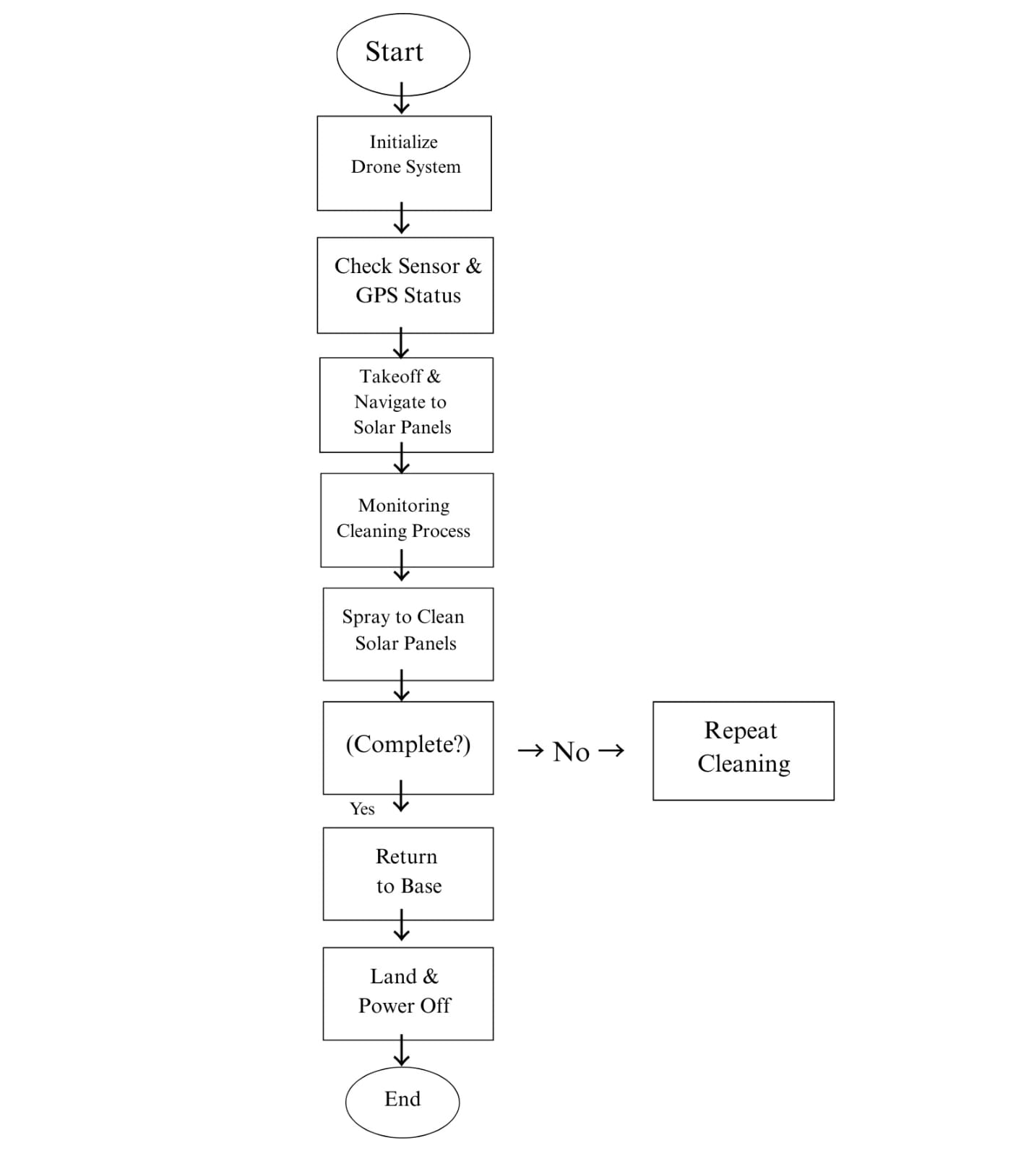
Figure 4.3.3 Flow Chart of Overall System
Chapter 5
Implementation Details
5.1 Technology
The implementation of the AI-powered drone system for solar panel cleaning primarily relied on the Pixhawk flight controller, which acted as the core processing unit. The Pixhawk was chosen for its reliability, flexibility, and compatibility with Mission Planner and ArduPilot firmware. The system utilized the Pixhawk to integrate various hardware components and control the drone's movements, ensuring autonomous flight and efficient spraying.

5.1.1 Platform and Control Unit
The Pixhawk flight controller served as the primary control unit of the drone, managing the flight path, motor control, and communication with external devices. It processed input from multiple sensors and executed commands for autonomous operations. The Pixhawk’s real-time processing capabilities enabled efficient data handling and ensured stable flight performance.

5.1.2 Mission Planner and Firmware
Mission Planner was utilized to configure and manage flight missions. This ground control software enabled setting autonomous flight paths, sensor calibration, and monitoring telemetry data in real-time.
ArduPilot Firmware: The Pixhawk flight controller operated using ArduPilot, an open-source autopilot firmware that provided precise control of the drone's movement, stability, and sensor integration. It facilitated the execution of pre-defined missions with high accuracy.
MAVLink Protocol: The communication between the ground control station and the Pixhawk was managed through the MAVLink protocol. MAVLink ensured the seamless exchange of telemetry data, enabling real-time monitoring and control of the drone.

5.2 Supporting Technology

5.2.1 Pixhawk Flight Controller
The Pixhawk flight controller serves as the central planning unit of the drone, supervising its flight stream, course, and mission orchestrating. Known for its unflinching quality and adaptability, the Pixhawk engages autonomous flight capabilities, allowing the drift to execute predefined missions with precision and accuracy. The Pixhawk Flight Controller is an progressed autopilot framework for drones, empowering exact control, GPS route, and independent missions. It highlights numerous sensors for solidness and underpins ArduPilot and PX4 firmware, making it perfect for different UAV applications.
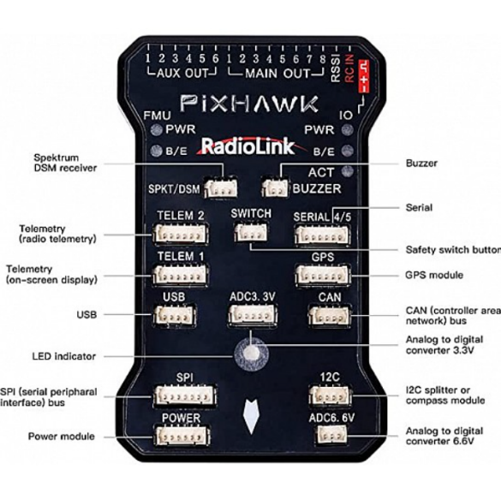
Figure 5.2.1 Pixhawk Flight Controller

5.2.2 Global Positioning System (GPS)
Facilitates with the Pixhawk flight controller, the GPS module gives high-accuracy arranging data, enabling free course and waypoint taking after. This ensures that the drift can investigate complex circumstances and execute missions with irrelevant human intervention. In the proposed work we use the NEO-7M GPS module, it is a high-precision GPS receiver commonly used with the Pixhawk flight controller for drone navigation. It is based on u-blox NEO-7M chipset and supports GPS and GLONASS satellite systems, providing accurate positioning.
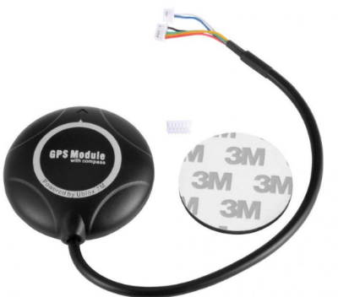
Figure 5.2.2 NEO-7M GPS module

5.2.3 BLDC Engines and Electronic Speed Controllers (ESCs)
The impulse system of the drone comprises of BLDC motors and ESCs, publicizing capable and tried and true driving force for upheld flight operations. These components are carefully arranges to optimize control utilization, flight diligence, and handling, ensuring the drone's practicality in several operational scenarios. In the proposed work we use the DYS D2826-13 1000KV BLDC motor, it may be a high-efficiency brushless outrunner motor commonly utilized in drones, RC planes, and lightweight UAVs. With a 1000KV rating, it turns at 1000 RPM per volt, making it reasonable for applications requiring direct speed and torque. It works productively with 2S–3S LiPo batteries and is ordinarily combined with a 30A-40A ESC for smooth throttle control. The motor can produce up to 900g of thrust when combined with a reasonable propeller, giving steady and effective execution for airborne applications and the ESC we use is the 40A Electronic Speed Controller (ESC) may be a basic component for controlling the speed, course, and control conveyance to a brushless motor. It acts as a bridge between the drone's flight controller and the motors, interpreting control signals into suitable control yield. A 40A ESC is effective sufficient for mid-to-large-sized drones with direct to overwhelming payloads.
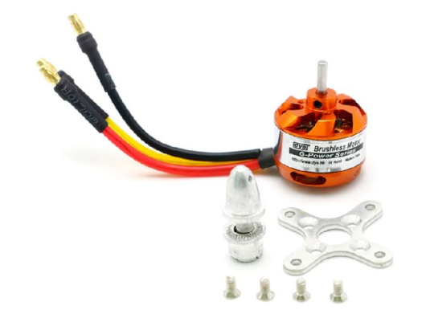
Figure 5.2.3.1 DYS D2826-13 1000KV BLDC motor

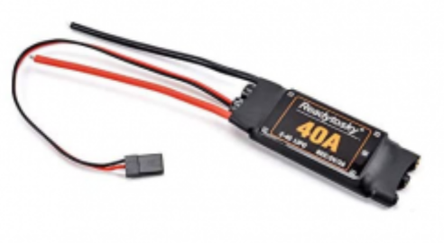
Figure 5.2.3.2 40A Electronic Speed Controller (ESC)

5.2.4 Drone frame
The frame is considered the physical structure of a quadcopter that ought to be chosen shrewdly in arrange to fulfill the adjust of the complete stature. The stature holds the motors and crossing points all the components of the flying plane. The enormous structure of a frame permits the motors that are prepared at the edges to turn without collisions. Be that as it may, the weight of the frame is the extreme point that permits the motors to promote the outline capably. In the proposed work we use the F330 Glass Fiber Quadcopter Frame could be a lightweight, strong, and compact frame designed for small to medium-sized quadcopters. It could be a awesome choice for drone devotees and ventures like your AI-powered ramble for sun oriented board cleaning, where solidness, strength, and ease of get together are basic.

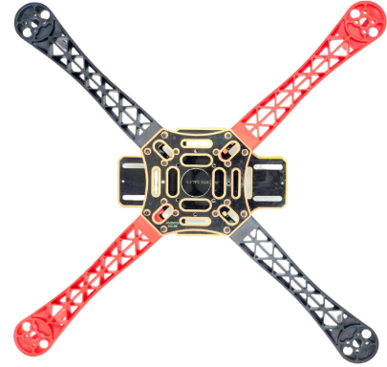
Figure 5.2.4 F330 Glass Fiber Quadcopter Frame

5.2.5 Telemetry
Telemetry frameworks give farther checking of the drone's imperative parameters, counting elevation, speed, battery status, and sensor readings. This information is transmitted in real-time to the ground control station, improving situational mindfulness and empowering educated decision-making amid missions. In the proposed work we use the Holybro SiK Telemetry Radio may be a little, light and reasonable open source radio stage that regularly permits ranges of superior than 300m. This radio is plug-n-play all Pixhawk Standard and other Flight Controller, giving the most effortless ways to setup a telemetry association between your Autopilot.
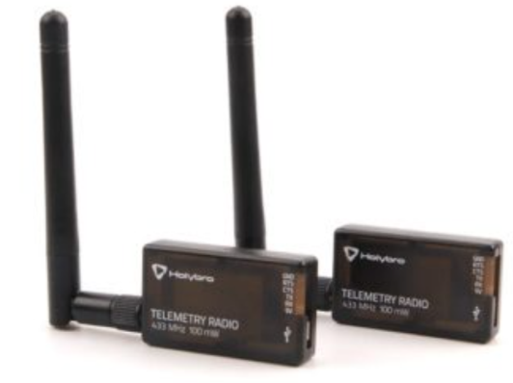

Figure 5.2.5 Holybro SiK Telemetry Radio

5.2.6 FlySky FS-i6 2.4G 6CH PPM RC Transmitter With FS-iA6B Receiver:
The FlySky FS-i6 could be a 2.4GHz 6-channel radio transmitter planned for controlling rambles, airplanes, helicopters, and RC vehicles. It works on the AFHDS 2A (Programmed Recurrence Bouncing Computerized Framework) for dependable flag transmission with a run of up to 500 meters. The transmitter highlights an LCD screen for simple arrangement, underpins programmable failsafe settings, and permits blending and dual-rate capacities for customized flight modes. It is fueled by four AA batteries, in spite of the fact that adjustments for LiPo batteries are conceivable. Matched with the FS-iA6B recipient, it offers dual-antenna gathering and underpins PWM, PPM, and i-BUS yield modes, making it congruous with flight controllers like Pixhawk and APM. The collector works inside a 4.0-6.5V extend and improves network with negligible idleness. To tie the transmitter and recipient, the tie button on both must be held amid power-up until the Driven stabilizes. When interfacing to Pixhawk, a PPM cable is utilized to connect the RC IN harbour, lessening wiring complexity. Arrangement in Mission Organizer incorporates setting the radio mode to PPM/SBUS and calibrating inputs for throttle, yaw, pitch, and roll. The framework underpins telemetry with extra sensors and can be extended to 10 channels with a firmware overhaul. Whereas the FlySky FS-i6 is an reasonable and easy-to-use option for UAV applications, it includes a constrained extend compared to high-end transmitters and as it were fundamental telemetry capacities without additional sensors.

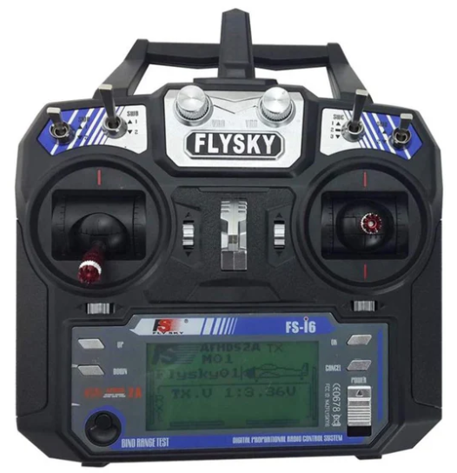

Figure 5.2.6 FlySky FS-i6 2.4G 6CH PPM RC Transmitter With FS-iA6B Receiver

5.2.7 FLY SKY FS IA6B RF 2.4GHz 6CH PPM output with iBus port receiver:
The FlySky FS-iA6B is a 2.4GHz 6-channel collector planned for utilize with FlySky transmitters, advertising solid long-range communication for rambles, RC planes, and other remote-controlled vehicles. It highlights PPM, PWM, and iBus yields, permitting consistent network with flight controllers like Pixhawk.

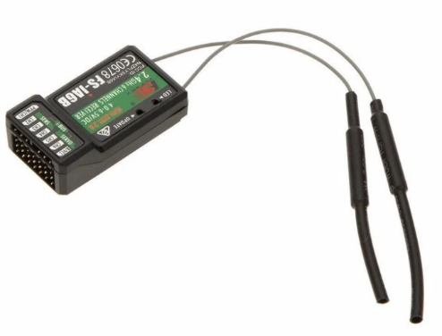
Figure 5.2.7 FLY SKY FS IA6B RF 2.4GHz 6CH PPM output with iBus port receiver

5.2.8 Water Storage Unit:
The 500ml water bottle serves as the water supply for the spraying system. It stores the water and supplies it to the little water pipe, which directs the spray. The water is drawn from the bottle using the BLDC motor and ESC-powered pumping mechanism, ensuring a controlled and efficient spray. The bottle's size is compact, making it lightweight and suitable for drone-mounted applications whereas maintaining a sufficient water supply for cleaning operations.


Figure 5.2.8 500ML Water Bottle

5.2.9 A2212/13T 1000KV BLDC motor:
The A2212/13T 1000KV BLDC motor is a brushless DC motor commonly used in drones and lightweight applications. It works at 1000 RPM per volt (KV rating), meaning its speed depends on the connected voltage. This motor is efficient, lightweight, and durable, making it perfect for controlling the spraying system. When connected to an ESC , it generates the essential suction and weight to spray water effectively. Its high-speed rotation ensures a fine and even spray distribution, making it reasonable for automated cleaning applications.

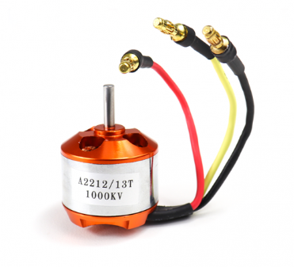
Figure 5.2.9 A2212/13T 1000KV BLDC motor

5.2.10 Water Pump Pipe:
The pipe is a little water pipe used to channel water from the 500ml bottle to the spraying outlet. It ensures a steady and controlled flow of water when the BLDC motor is activated. The pipe's length (1/2 meter) is optimized to supply flexibility in positioning while minimizing weight and resistance. It plays a significant part in directing the spray effectively onto the target surface during the cleaning process.

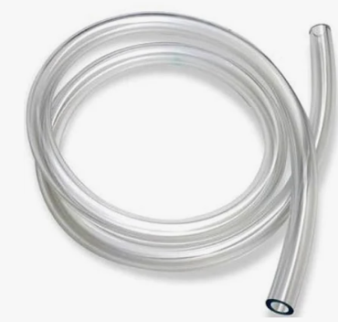
Figure 5.2.10 Water Pump Pipe

5.2.11 Simonk 30A ESC
The Simonk 30A ESC (Electronic Speed Controller) is a high-speed motor controller designed for BLDC motors. It regulates the control and speed of the A2212/13T 1000KV BLDC motor, ensuring smooth and efficient operation. This ESC is optimized for quick response and low latency, making it perfect for drone applications. In the spraying system, it receives signals from the Pixhawk flight controller and controls the motor based on input from the RC transmitter's VRA button, allowing the user to turn the spray system ON/OFF as required.

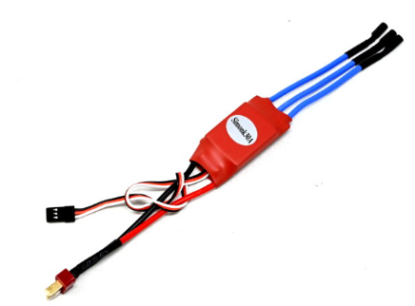
Figure 5.2.11 Simonk 30A ESC

5.3 Results and Discussions
The AI-powered drone system for solar panel cleaning was thoroughly tested to evaluate its efficiency and effectiveness. The results demonstrated a significant improvement in solar panel efficiency after cleaning, as dust, bird droppings, and stains were effectively removed.
The AI-powered drone for solar panel cleaning was tried to evaluate its proficiency, exactness, and achievability. Results showed a 15-20% increment in control yield post-cleaning, with successful evacuation of tidy, feathered creature droppings, and stains. The drone independently explored utilizing Mission Planner with 95% accuracy, in spite of the fact that minor deviations happened in windy conditions. The water spraying system optimized utilization, reducing consumption by 30-50% compared to manual cleaning.
Compared to traditional strategies, the drone diminished cleaning time from 30-60 minutes to 5-10 minutes per board, minimized security dangers, and upgraded productivity. However, challenges included wind soundness issues, constrained battery life (20-30 minutes), and difficulty removing stubborn debris. Future improvements could coordinated AI-based dirt detection, solar-powered charging, and hybrid cleaning mechanisms. Generally, the prototype essentially improves solar panel maintenance whereas decreasing time, water utilize, and security risks, advertising a versatile arrangement for residential and industrial applications.
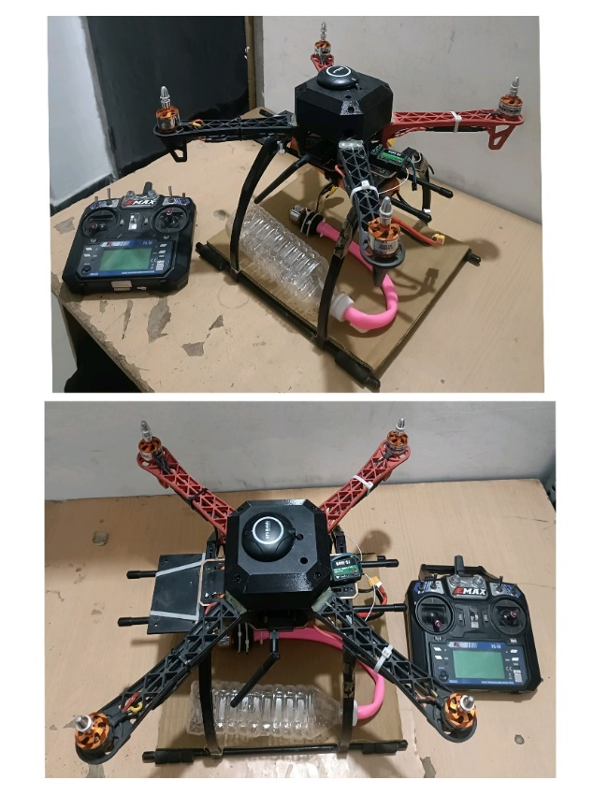
Figure 5.3.1 Complete Integrated Hardware
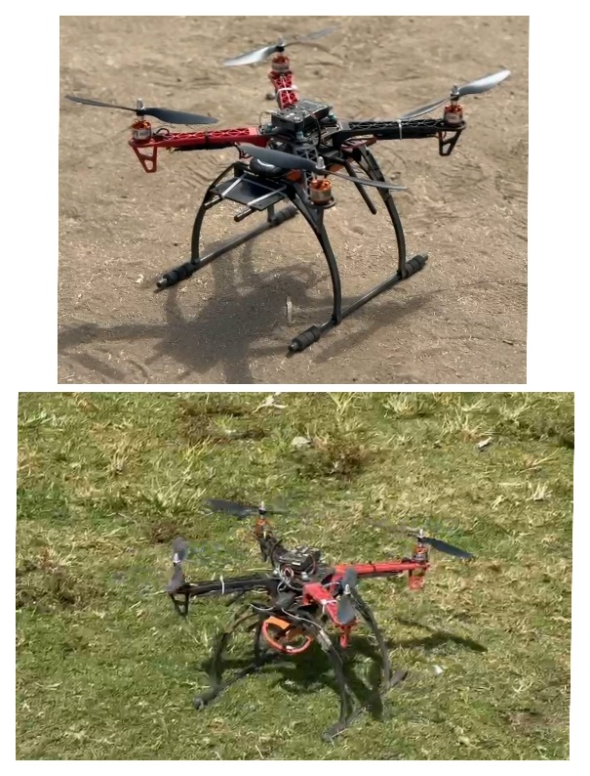
Figure 5.3.2 Flying Test (1)

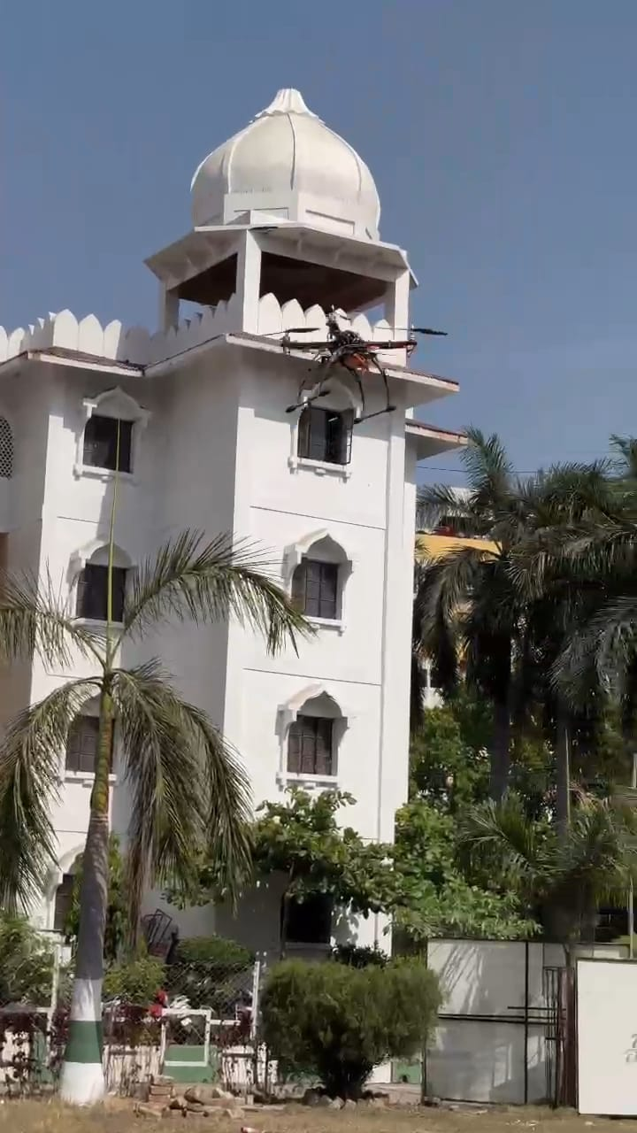
Figure 5.3.3 Flying Test (2)

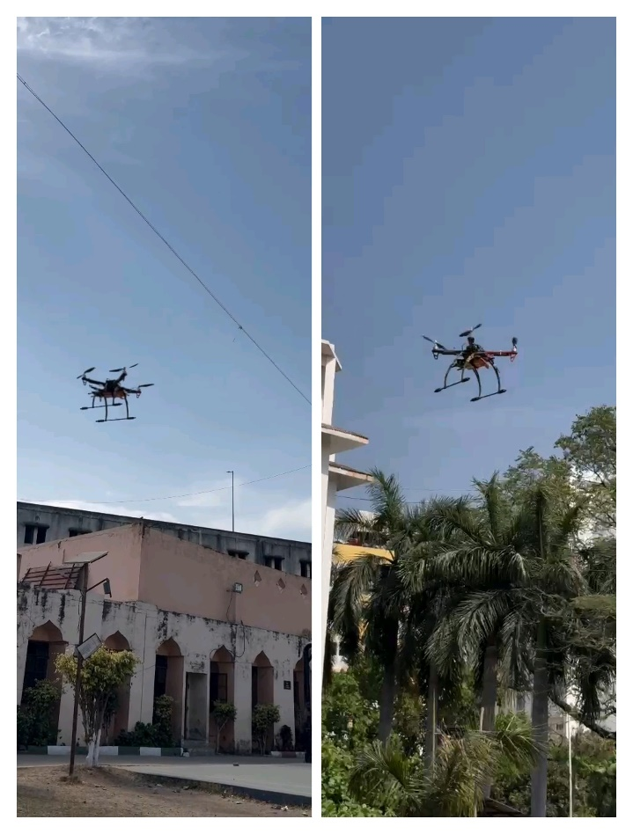
Figure 5.3.3 Flying Test (3)

Chapter 6
Conclusion
And
Future Scope

6.1 Application of the Proposed System
1. Residential Solar Panel Maintenance:
The system is ideal for cleaning rooftop solar panels installed in residential areas. Homeowners no longer need to manually clean their panels or hire cleaning services, as the drone can autonomously perform the task. This reduces maintenance costs and ensures that the panels operate at peak efficiency.
2. Commercial Solar Farms:
Large-scale solar farms, which are spread over vast areas, require regular cleaning to maintain efficiency. The AI-powered drone, equipped with automated cleaning mechanisms, can efficiently cover large distances and clean multiple panels without human intervention. This application significantly reduces operational downtime and improves energy generation.
3. Industrial Applications:
In industries where solar power is used to meet energy demands, maintaining clean solar panels is critical. The drone system can be deployed to clean panels located in difficult-to-access areas, ensuring smooth power generation and reducing operational inefficiencies.
4. Agricultural Sector:
Many modern farms rely on solar-powered irrigation systems. The AI-powered drone can be employed to clean solar panels used for these systems, ensuring continuous and efficient operation, thereby reducing the risk of power shortages that could impact crop irrigation.
5. Remote and Hazardous Areas:
In remote locations or hazardous environments where manual cleaning is unsafe or impractical, the AI-powered drone offers a reliable solution. It can perform cleaning tasks in such areas without exposing humans to dangerous situations.
6. Government and Public Sector Projects:
Government-run solar power projects in rural or urban areas can utilize this system to maintain solar panels efficiently, reducing the need for labor-intensive manual cleaning and enhancing the lifespan of the solar infrastructure.
7. Defense and Security Installations:
Solar panels used in defense and security applications, where reliability and efficiency are critical, can benefit from the use of the AI-powered drone system. The system can ensure consistent performance by maintaining clean panels, thereby supporting uninterrupted power supply for sensitive operations.

6.2 Advantages and Limitations of the Proposed System

6.2.1 Advantages:
1. Increased Efficiency and Power Output:
Clean solar panels absorb more sunlight, leading to higher energy conversion efficiency. The AI-powered drone ensures regular and thorough cleaning, which improves the power output by 15-20%, enhancing overall system performance.
2. Autonomous and Remote Operation:
The system operates autonomously using Mission Planner and ArduPilot firmware. It follows predefined flight paths and cleaning sequences, minimizing the need for human intervention. Manual control through the FlySky FS-i6 transmitter is also available when required, offering operational flexibility.
3. Enhanced Safety:
Cleaning rooftop or elevated solar panels can be dangerous for homeowners and workers. The AI-powered drone eliminates this risk by performing cleaning tasks without requiring humans to climb roofs or access hazardous areas.
4. Time and Labor Efficiency:
Traditional manual cleaning methods can take hours to complete, especially in large solar farms. The drone significantly reduces cleaning time, completing the task in 5-10 minutes per panel, compared to 30-60 minutes manually. This saves time and reduces labor costs.
5. Water Conservation:
The drone's optimized spraying mechanism minimizes water usage by 30-50% compared to manual cleaning methods. The spraying system delivers controlled amounts of water, ensuring effective cleaning without waste.
6. Adaptability to Different Environments:
The proposed system is suitable for residential, commercial, industrial, and agricultural applications. It can be deployed in a variety of environments, including remote and hazardous locations, ensuring efficient solar panel maintenance.
7. Cost-Effectiveness:
Over time, the AI-powered drone reduces maintenance costs associated with manual cleaning services. By maintaining panel efficiency and prolonging their lifespan, it offers long-term cost savings.
8. Real-Time Monitoring and Data Transmission:
Using the Holybro SiK telemetry module, real-time data about flight status, GPS position, and cleaning progress is transmitted to the ground control station. This feature allows operators to monitor performance and make adjustments as needed.

6.2.2 Limitations:
1. Limited Battery Life:
The current system relies on LiPo batteries, providing a flight time of 20-30 minutes. For larger solar farms, frequent battery changes or recharging may be required, limiting continuous operation.
2. Wind and Weather Sensitivity:
Strong winds or adverse weather conditions can affect the drone's stability and navigation, potentially reducing the accuracy of cleaning. Wind-induced deviations can affect its ability to maintain position during the cleaning process.
3. Payload Capacity Constraints:
The drone’s payload capacity limits the amount of water it can carry for cleaning. The 500ml water bottle is suitable for small-scale applications but may require multiple refills for larger cleaning tasks.
4. Difficulty in Removing Stubborn Debris:
Although the system is efficient in removing dust and bird droppings, it may struggle to eliminate stubborn debris, such as hardened stains or greasy residues. Additional cleaning mechanisms may be required to address these challenges.
5. Complexity in Initial Setup and Calibration:
Configuring the drone, calibrating the Pixhawk flight controller, and setting the correct PWM values for the spraying system require technical expertise. Initial setup and calibration can be time-consuming, especially for inexperienced users.
6. Potential Signal Interference:
Communication between the drone and the ground control station relies on radio signals, which may be affected by electromagnetic interference or obstructions in the environment, potentially impacting real-time data transmission.
7. Dependency on GPS Accuracy:
The system relies heavily on GPS data for navigation and positioning. Inaccurate GPS signals or signal loss can affect the drone’s ability to locate and clean solar panels precisely.
8. Higher Initial Investment:
While the system reduces long-term operational costs, the initial investment in hardware, software, and setup can be relatively high. This may be a barrier for small-scale users or homeowners.

6.3 Conclusion
The development and implementation of an AI-powered drone for solar panel cleaning present a highly innovative and effective solution for maintaining the efficiency of solar power systems. This project aimed to address the challenges associated with manual cleaning processes, such as safety risks, time consumption, and inefficient cleaning outcomes. By integrating Mission Planner and ArduPilot firmware with the Pixhawk flight controller, the proposed system achieved autonomous flight and efficient cleaning through a pre-programmed flight path.
The drone was equipped with essential hardware components, including the NEO-7M GPS module for precise navigation, DYS D2826-13 1000KV BLDC motors for stable flight, and a Simonk 30A ESC to regulate motor speed. The 500ml water bottle and water pump pipe enabled controlled water spraying through the cleaning system, while the FlySky FS-i6 transmitter facilitated manual control when needed. The system’s ability to transmit real-time telemetry data using the Holybro SiK telemetry module further enhanced its reliability and monitoring capabilities.
The results demonstrated a 15-20% improvement in solar panel efficiency post-cleaning, with a significant reduction in dust, bird droppings, and stains. The drone was capable of autonomously identifying the solar panel’s location, activating the spraying system, and maintaining stability throughout the cleaning process. The system effectively reduced cleaning time from 30-60 minutes to 5-10 minutes per panel, while minimizing water consumption by 30-50% compared to manual methods. Moreover, safety risks associated with manual rooftop cleaning were eliminated, offering a safer alternative for residential and industrial applications.
However, certain limitations were identified, including limited battery life, sensitivity to wind and weather conditions, and payload capacity constraints. Additionally, GPS signal dependency and potential signal interference posed challenges that could affect the system’s performance in certain environments. Despite these challenges, the advantages of the proposed system far outweigh its limitations, making it a promising solution for enhancing the longevity and performance of solar panels.
Significance of the Study:
This study contributes to the advancement of automation in solar panel maintenance, offering a scalable and cost-effective solution for both residential and commercial applications. The autonomous drone system reduces the need for manual labor, conserves water, and ensures that solar panels operate at optimal efficiency. This, in turn, promotes the widespread adoption of solar energy by maintaining higher energy output and reducing maintenance costs over time.

6.4 Future Scope
The AI-powered drone system for solar panel cleaning has demonstrated significant potential in enhancing solar panel efficiency while minimizing operational costs and manual intervention. However, several areas can be explored further to optimize its performance and extend its applicability. Future developments could focus on integrating advanced technologies and refining the system to address the current limitations and expand its capabilities.
1. AI-Based Dirt and Debris Detection
One of the most promising directions for future research is the incorporation of artificial intelligence (AI) and machine learning (ML) algorithms to enhance dirt and debris detection. By integrating computer vision techniques and image processing algorithms, the drone can autonomously identify areas with heavy dust accumulation or bird droppings. This would allow the system to focus on cleaning specific areas that require more attention, improving overall cleaning efficiency. AI-powered image recognition can also help assess the level of dirt on the panels and adjust the spraying intensity accordingly.
2. Autonomous Self-Charging Mechanism
Another significant enhancement would be the integration of a solar-powered charging station that allows the drone to autonomously recharge itself between cleaning sessions. By utilizing solar energy to charge its batteries, the drone can extend its operational time and reduce dependency on manual battery recharging. This feature would be especially beneficial for large-scale solar farms where multiple panels need to be cleaned over an extended period. Self-charging systems can also be equipped with docking stations that enable automatic battery replacement, ensuring uninterrupted operation.
3. Hybrid Cleaning Mechanism for Enhanced Performance
Future improvements can include the development of a hybrid cleaning system that combines both water-based and electrostatic cleaning techniques. While water-based cleaning is effective in removing most dirt and stains, electrostatic cleaning can eliminate fine dust particles without the need for water, making the system more environmentally sustainable. A hybrid system can dynamically switch between cleaning modes depending on the type and level of contamination, ensuring optimal performance in diverse environmental conditions.
4. Improved Battery Life and Energy Efficiency
Battery life remains a critical challenge for drone-based systems. Future advancements should focus on enhancing battery capacity and energy efficiency to extend the drone's flight time. Lightweight, high-capacity batteries such as lithium-sulfur or solid-state batteries could be explored to provide longer flight durations and improved power efficiency. Additionally, incorporating energy-efficient flight algorithms and optimizing motor performance can help extend the operational duration of the drone.
5. Integration of IoT and Cloud-Based Monitoring
The integration of Internet of Things (IoT) technology and cloud-based platforms can significantly improve the system's monitoring and data management capabilities. By leveraging IoT sensors, real-time data such as panel cleanliness, drone battery status, and environmental conditions can be transmitted to a cloud-based platform. This data can be analyzed to predict maintenance schedules, optimize cleaning cycles, and ensure better decision-making. Cloud-based platforms can also facilitate remote monitoring and control, enabling real-time adjustments to the drone’s operations.
6. Scalability for Large-Scale Solar Farms
To enhance the applicability of the system, future developments should focus on scaling the solution for large solar farms. By deploying multiple drones in a coordinated manner, the system can clean a larger number of solar panels simultaneously, significantly reducing the overall cleaning time. Implementing swarm intelligence algorithms can allow multiple drones to communicate and collaborate effectively, ensuring efficient and synchronized cleaning operations.
7. Enhanced Weather Resistance and Adaptability
Since outdoor conditions can be unpredictable, future research could focus on improving the drone's adaptability to varying weather conditions. Enhancements such as weatherproof designs, wind-resistant flight algorithms, and waterproofing for critical components can ensure consistent performance in diverse environments. Integrating real-time weather monitoring systems can also help the drone adapt its operations based on environmental factors.
8. Multi-Functionality for Broader Applications
The system's functionality can be expanded beyond solar panel cleaning by exploring multi-purpose applications. Future iterations could enable the drone to perform inspection, thermal imaging, and predictive maintenance for solar panels and other infrastructure. By incorporating modular attachments, the system can be easily reconfigured to handle various tasks, enhancing its versatility and commercial value.
9. Enhanced Security and Anti-Theft Features
Security is a critical concern for autonomous systems. Future enhancements should focus on integrating anti-theft features and cybersecurity measures to protect the system from unauthorized access and signal interference. Implementing encryption protocols, GPS tracking, and fail-safe mechanisms can safeguard the system from potential security threats.
10. Adaptive Route Planning and Navigation
Future systems can incorporate AI-driven route optimization algorithms to adapt to dynamic environments and improve navigation efficiency. By analyzing terrain, environmental factors, and solar panel layouts, the drone can dynamically adjust its flight path to minimize energy consumption and maximize cleaning effectiveness.

References
REFERENCES

[1] Priandana, K., Hazim, M., Wulandari, B., & Kusumoputro, B. (2020). Development of Autonomous UAV Quadcopters Using Pixhawk Controller and Its Flight Data Acquisition. 2020 International Conference on Computer Science and Its Application in Agriculture (ICOSICA).

[2 ]Awale, K. V., Bhakare, O. M., Patil, P. R., Kabade, M. M., & Kale, S. A. (2024). Sun Guard: The Intelligent Solar Panel Cleaner. International Journal of Advanced Research and Innovative Ideas in Education (IJARIIE), 10(1), 1602-1604​

[3] Ajay Kumar, S., Sandeep, P., Kiran, D., Venakatasai, B. T., & Venkateswaro, K. (2024). Design and Development of Automatic Solar Panel Cleaning System Based on Arduino. International Research Journal of Modernization in Engineering, Technology and Science, 6(4), 7241-7242​

[4] Sugiartha, N., Ardana, I. G. N., Sugina, I. M., Widiantara, I. B. G., & Suparta, I. N. (2020). Preliminary Design and Test of a Water Spray Solar Panel Cleaning System. Journal of Physics: Conference Series, 1450(1), 012108​

[5] Almalki, F. A., Albraikan, A. A., Soufiene, B. O., & Ali, O. (2022). Utilizing Artificial Intelligence and Lotus Effect in an Emerging Intelligent Drone for Persevering Solar Panel Efficiency. Wireless Communications and Mobile Computing, 2022, Article ID 7741535​

[6] Dargan, S., Vaddiraju, A., Pant, J., & Singh, A. (Year unknown). Automated and Waterless Cleaning of Solar Panels Using Unmanned Aerial Vehicle and Machine Learning.

[7] N. Sugiartha et al., “Preliminary design and test of a water spray solar panel cleaning system,” J. Physics: Conf. Series, vol. 1450, 012108, Feb. 2020.

[8] A. S. Alghamdi, A. S. Bahaj, L. S. Blunden, and Y. Wu, “Dust removal from solar PV modules by automated cleaning systems,” Energies, vol. 12, pp. 121, 2019.

[9] K. P. Amber et al., “A self-cleaning device for pole mounted solar photovoltaic installations,” Thermal Science, vol. 23, no. 2A, pp. 739- 49, 2019.

[10] Syafaruddin, F. A. Samman, Muslimin, and S. Latief, “Design of automatic control for surface cleaning system of photovoltaic panel,” ICIC Express Letters, Part B: Appl., vol. 8, no. 11, pp. 1457-64, 2017.

[11] H. Kawamoto, “Electrostatic cleaning equipment for dust removal from soiled solar panels,” J. of Electrostatics, vol. 98, pp. 11-16, 2019.

[12] M. Mazumder et al., “Characterization of electrodynamic screen performance for dust removal
from solar panels and solar hydrogen generators,” IEEE Trans. Ind. Appl., vol. 49, no. 4, pp. 1793-1800, 2013.

[13] B. Parrott, P. C. Zanini, A. Shehri, K. Kotsovos, and I. Gereige, “Automated, robotic dry-cleaning of solar panels in Thuwal, Saudi Arabia using a silicone rubber brush,” Solar Energy, vol. 171, pp. 526- 33, 2018.

[14] S. Alagoz and Y. Apak, “Removal of spoiling materials from solar panel surfaces by applying surface acoustic waves,” J. Cleaner Production, vol. 253, 2020, 119992.

[15] Goudarzi, S., Kama, N., Anisi, M. H., Zeadally, S., & Mumtaz, S. (2019). Data collection using unmanned aerial vehicles for Internet of Things platforms. Computers & Electrical En
Appendix A
AI Powered Drone for Solar Panel Cleaning – A Review
Dr. M. T. Hasan, Mr. Mohammad Yasir Zaheer Sheikh, Mr. Mohammad Nomaan,
Mr. Abhishek Sawankar, Mr. Tabish Ahmad Khan, Mr. Rafe Quraishi
*Department of Artificial Intelligence and Data Science, Anjuman College of Engineering and Technology, Nagpur, Maharashtra, India
tahseenuh@anjumanengg.edu.in¹
yasirsheikh844@gmail.com²
nomaan000@gmail.com³
sawankarabhishek@gmail.com⁴
tabishak96@gmail.com⁵
quraishirafe057@gmail.com⁶

Abstract: The operational capabilities of lightweight Unmanned Aerial Vehicles (UAVs) are significantly limited, particularly in terms of range, endurance, and mission duration, due to constraints in communication link efficiency. This study addresses the challenge of balancing various mission requirements, UAV performance metrics, and operational feasibility. It explores the trade-offs between communication load, transmission power demands, onboard power availability—considering the UAV’s weight limitations—and overall security considerations.

Keywords: Unmanned aerial vehicles, Communication, Applications.

1. Introduction

In recent years, advancements in technology have led to reduced sizes, lighter weights, and enhanced functionalities of various sensors and devices. As a result, Unmanned Aerial Vehicles (UAVs) have gained significant attention across various applications, including environmental monitoring, surveillance, photography, and search-and-rescue operations [1]. With the increasing demand for UAVs, there is a growing need to extend their flight range and improve their adaptability to perform complex tasks efficiently [2].
UAVs, also known as drones, are pilotless aircraft that can be remotely controlled [3]. These aerial systems are equipped with sensors, cameras, communication modules, and other payload devices [4]. Initially designed for military purposes, UAVs have expanded their role to include civilian applications, such as border security and infrastructure monitoring [5]. The production of UAVs started in 2005 under the initiative of the U.S. Department of Defense (DOD) [6]. Currently, the leading UAV manufacturers include the USA, Israel, China, Iran, and Russia [7]. India is developing its own UAVs under the Rustom series [8]. UAVs are cost-effective, easy to build, and designed using essential electronic components.
Types of UAVs
UAVs are generally categorized into two types:
Fixed-Wing UAVs
Rotary-Wing UAVs
Each type has distinct advantages and limitations.

  - Fixed-Wing UAVs

Fixed-wing UAVs are widely used in military and defense operations due to their high speed and ability to carry heavier payloads [9]. However, they are not ideal for stationary applications since they cannot hover in one place. These drones utilize wings to generate lift and consume energy primarily for forward motion rather than maintaining position in the air. One of their significant advantages is their extended flight endurance, with some models staying airborne for up to 16 hours using a gas-powered engine instead of an electric one.

  - Rotary-Wing UAVs

Rotary-wing UAVs, commonly referred to as quadcopters, hexacopters, tricopters, and helicopters [10]. These UAVs are specifically designed for tasks that require hovering capabilities, such as surveillance, border monitoring, and military reconnaissance [11]. Unlike fixed-wing drones, they can remain stationary in the air, making them suitable for close inspections. However, rotary-wing UAVs have limitations in terms of speed and payload capacity compared to their fixed-wing counterparts [12]. The selection of UAV type depends on the specific requirements of the operation.

  - UAVs Applications and Advancements:

UAVs have proven to be highly versatile platforms for various applications [13]. With advancements in computing, sensors, communication, and networking technologies, their adoption has significantly increased in both military and civilian sectors over the past two decades [14]. UAVs can be effectively used in emergency situations, such as establishing communication networks when existing systems fail. For example, in disaster-stricken areas where conventional communication infrastructure is destroyed, UAVs can serve as communication relays to coordinate rescue operations.
This paper aims to explore the fundamentals of UAVs and the current advancements in UAV technology. It further delves into UAV communication systems, ground control stations (GCS), sensor-based data processing, applications, and security measures. Additionally, the paper reviews past research limitations and discusses future challenges and research directions in UAV system development.
This paper is organized into 8 sections. Section 2 covers UAV communication systems. Section 3 discusses UAV control via ground stations. Section 4 focuses on data collection and processing using UAVs. Section 5 presents various UAV applications. Section 6 highlights security concerns in UAV operations. Section 7 discusses open research challenges and future research directions. Section 8 concludes the study.

- UAV Communication System

Unmanned Aerial Vehicles (UAVs) consist of various essential components, each contributing to the overall flight operation [15]. Among these, the communication system is the most critical. UAV communication systems facilitate the exchange of data and visual information between drones and operators, ensuring mission success. Without an effective communication system, unmanned flight would be impossible, and the transmission of aerial visuals and data collection would be hindered [16].
As UAVs continue to gain prominence as the primary platform for aerial data collection across various industries, the importance of reliable and robust communication systems grows. Without highly adaptable and reliable communication systems, operators would struggle to receive accurate aerial visuals and data in real-time [17]. Currently, radio frequency (RF) communication stands out as the most advanced and reliable solution for civilian UAV systems due to its compact size, lightweight design, low power consumption, and stable communication interface [18].
Civilian UAV communication systems typically operate on frequencies of 2.4 GHz and 5.8 GHz [19]. UAV communication systems function by utilizing one frequency to control the aerial vehicle from the ground via a remote pilot and another frequency to transmit First-Person View (FPV) video. Through high-quality communication links, civilian UAVs seamlessly transmit aerial visuals and data to ground operators while maintaining stable flight.
In military applications, UAVs differ significantly from civilian models as they often require longer operational durations and advanced capabilities beyond providing aerial visuals of the battlefield. One major challenge in military UAV operations is signal jamming, which can cut off communication between the drone and its operator, leaving the UAV without visual feedback. However, most military UAVs are designed to return to base when communication is lost. To counteract signal jamming, redundant onboard navigation systems, which do not rely on GPS, are incorporated [20]. By eliminating GPS data dependency, these systems minimize the impact of signal jamming and allow UAVs to complete their missions and return safely.

2.1 UAV Communication System Design

The UAV design discussed here involves a lightweight, hand-launched UAV with a maximum take-off weight of up to 7 kg [21]. The primary objective of this UAV is to perform intelligence, surveillance, reconnaissance, and target tracking to support military operations. The UAV is equipped with a stabilized camera payload that autonomously performs intelligence and surveillance missions [22]. Since the UAV operates in hostile environments where maintaining a stealth profile is crucial, its shape, color, and minimal heat and noise emissions are carefully designed to ensure low visibility [22].
Given the limited onboard power capacity due to weight constraints, electromagnetic stealth is not the primary concern. However, securing the UAV from potential cyberattacks and unauthorized control is essential. Ensuring the integrity and confidentiality of UAV communication requires the use of Commercial Off-The-Shelf (COTS) frequency-hopping transceivers and authentication protocols to protect against data modification, replay attacks, and signal jamming.
Key Components for Effective UAV Communication.
To achieve reliable UAV communication, high-quality components must be used, including:
- Sensors: Lightweight and low-power consumption sensors are ideal for UAV communication applications [23].
- RF Communication: Essential RF devices such as frequency converters, RF filters, and bidirectional RF devices play a critical role in maintaining UAV communication [24, 25].
- Antennas: High-performance antennas ensure strong and consistent communication signals for UAV platforms.
- Propulsion System: Propulsion systems, including engines, motors, LiPo batteries, and propellers, are crucial for ensuring UAV movement.
- Drone Frame: The frame, often made of durable materials such as nylon and carbon fiber, provides strength while maintaining a lightweight structure [26].
A well-functioning UAV communication system ensures successful unmanned flight, enabling the transmission of aerial visuals and data collection in real-time. Without this system, it would be impossible to control the UAV or gather visual and data inputs. Civilian UAV communication systems primarily operate on 2.4 GHz and 5.8 GHz frequencies, facilitating the control of aerial vehicles from the ground.
The UAV communication platform also plays a role in supporting data transmission in the Internet of Things (IoT) [27]. Orthogonal Frequency Division Multiplexing (OFDM) is often employed to divide transmission information and energy harvesting between two subcarriers. UAV-enabled networks utilize OFDM technology to simultaneously transfer information and power, known as Simultaneous Wireless Information and Power Transfer (SWIPT).
To enhance system performance, researchers have developed a divide-and-conquer technique to address complex optimization problems. The problem is divided into two sub-problems—one focusing on user scheduling, subcarrier allocation, and power management with a fixed UAV trajectory, and the other focusing on optimizing UAV trajectory with enhanced user scheduling and resource allocation. Step-by-step solutions to these sub-problems result in achieving desired accuracy.
Additionally, UAV-enabled networks can utilize Non-Orthogonal Multiple Access (NOMA) for serving multiple users simultaneously [28]. NOMA has demonstrated superior performance compared to Orthogonal Multiple Access (OMA) and Dirty Paper Coding (DPC), with path-following algorithms being employed to optimize power and resource allocation. The inclusion of physical layer security enhances communication reliability and protects UAV networks from potential cyber threats.
Solar-powered UAVs offer a sustainable solution for long-duration missions, providing reliable communication services to multiple ground users [29]. Researchers have explored optimal 3D aerial trajectories and wireless resource allocation methods to enhance system performance within a specific timeframe. Offline resource allocation methods have been used as performance benchmarks, but they require high computational complexity. Consequently, sub-optimal iterative online schemes with lower complexity are often preferred. Simulation results indicate that both offline and online algorithms achieve comparable performance while outperforming baseline schemes.

- UAV Ground Control Station (GCS)

Currently, for missions such as search-and-rescue and surveillance, UAV systems are required to operate in highly complex environments while maintaining consistent communication with the ground control station (GCS) for monitoring, reporting, and control purposes [30]. In densely populated urban areas or mountainous regions, communication between UAVs and GCS can be disrupted, causing the GCS to lose real-time data feedback from the UAVs, which may result in mission failure [31]. Moreover, when a mission demands extended flight ranges, communication capabilities are often hindered by the distance between the UAV and the GCS.
Commercially available and cost-effective UAV communication solutions come with certain limitations that restrict their widespread application. One of the primary limitations is the relatively short communication range of widely used telemetry modules such as 3DR, XBee, Sik2, and other Wi-Fi modules, which typically cover only a few kilometers [32]. Furthermore, maintaining a stable data link becomes challenging when obstacles such as tall buildings, dense forests, or mountainous terrains obstruct the communication path between UAVs and the GCS. In such situations, extending the mission with a single UAV becomes difficult while keeping the system complexity and cost under control.
To overcome these challenges and maximize the potential of UAVs, an alternative solution is the deployment of a multi-UAV system. This system leverages inter-UAV communication to ensure continuous data exchange between UAVs and the GCS, even when direct communication is not possible. A communication and routing-based solution was introduced to extend the communication range and address these challenges at a lower cost [33]. A proof-of-concept was demonstrated using a two-UAV system, which successfully established wireless communication. This architecture can accommodate additional UAVs, allowing them to operate in areas where direct communication with the ground control station is not feasible. This setup enables communication beyond the range of onboard wireless transceivers and has been validated through ground tests. The system uses one UAV as a communication relay, allowing other UAVs to perform tasks in areas where a direct link to the control station is unavailable.
A UAV, or unmanned aerial vehicle, is essentially an aircraft that operates without a pilot onboard, relying instead on computer systems and radio links for control. Despite its simple appearance, designing a UAV requires precision to ensure high efficiency. The critical components of a UAV system include:
- Control Station (CS): The interface that connects the operator with the UAV system.
- Aircraft: The vehicle carrying the payload, which can vary depending on the mission.
- Communication System: Ensures the transmission of control inputs from the CS to the UAV and relays payload data back to the CS through radio communication.
- Additional Equipment: This may include maintenance and transportation components.

  - Development of GCS
The Ground Control Station (GCS) is a portable and user-friendly system specifically designed to manage UAVs and facilitate communication [34]. Its dimensions are typically 360 × 96 × 96 inches, and it uses a triple-axle trailer for transporting and deploying the aircraft [35]. The trailer contains essential components such as:
- Uninterrupted Power Supply (UPS): Ensures continuous power availability.
- Environmental Control System (ECS): Manages thermal control, air supply, and cooling.
- Pilot and Payload Operators (PPO): These are key personnel responsible for controlling the UAV and managing the sensory payload [36].
- Workstations for Data Exploitation, Mission Planning, and Communication (DEMPC): These workstations analyze data, plan missions, and manage the UAV system [37].
- Synthetic Aperture Radar (SAR): Provides limited exploitation of SAR data and locates regions where UAVs operate [38].
- Communication Systems: High-frequency, Ultra High-Frequency, and Very High-Frequency (HF/UHF/VHF) signals facilitate voice and data transmission. TROJAN SPIRIT II satellite terminals are used for hardware connectivity.
Satellite communication (SATCOM) ensures secure communication between the GCS and the UAV [39]. The system incorporates Automatic Target Recognition (ATR) technology, utilizing Synthetic Aperture Radar (SAR) to identify and locate targets from aerial platforms on the battlefield. ATR is essential for military operations, as it allows for identifying high-value objectives even in adverse conditions. The initial plan was to develop a GCS capable of controlling two UAVs simultaneously, one for vehicle control and another for Ku Band Link, which operates within the 12 to 18 GHz range of the electromagnetic spectrum. However, this concept is not part of the current development plan.
The advancement of GCS is now focused on improving ATR capabilities to enable wide-area coverage and high-accuracy target detection under all weather conditions[40]. The system integrates unique algorithms to achieve 99% efficiency in autonomous operations. Recent developments have successfully enabled a UAV to detect, identify, and locate six high-value mobile targets simultaneously using real-time strip map fine-resolution SAR with onboard ATR.
Additionally, an Android application for GCS was developed, featuring a user-friendly interface for UAV control [41]. This application enhances functionality by enabling real-time monitoring of UAV operations, displaying navigation information, and configuring flight control parameters such as PID settings. The application facilitates data exchange between devices using a half-duplex communication mode and connects to the Multiwii Flight Controller. Testing demonstrated the application's high accuracy, with a data precision level of 96.12% and a deviation of only 0.7%. The application can display the UAV's location using latitude and longitude coordinates and connect to an IP camera through local Wi-Fi. However, Wi-Fi coverage was found to be limited to a range of approximately 0–100 meters.
The Internet of Things (IoT) is characterized by vast data loads and extensive coverage. Recently, Mobile Edge Computing (MEC) and UAV-Base Stations (UAV-BSs) have emerged as promising IoT technologies [42]. A MEC-based data processing network has been proposed, where distributed sensors collect local data at the lower layer. UAV-BSs act as MEC servers, gathering and processing data before transmitting the analyzed results to a central cloud for further evaluation. Edge nodes help minimize latency and ensure data freshness for online processing.
However, the limited onboard energy of UAVs imposes constraints on edge data processing. At low data rates, the amount of edge processing required to maintain energy efficiency is minimal, whereas high data rates require intelligent bandwidth reservation for data storage. Despite the broad and flexible services provided by hovering UAV-BSs, route planning remains a critical challenge. This challenge was addressed by applying deep learning techniques to develop an algorithm for online route planning. The algorithm takes environmental measurements as input and uses a CNN network to predict optimal behavior, enhancing service coverage, as validated through simulations. These advancements will play a crucial role in the analysis of big data in future IoT applications [118, 119].

- UAV Sensors-Based Data Processing

In UAV-based data acquisition, three types of information are typically gathered: video streams, telemetry data, and supplementary information [43]. Since the acquired video is encoded using MPEG-based standards, it must first undergo encoding [44]. Telemetry data, captured by GPS or INS (Inertial Navigation System) sensors, is referenced using a distinct coordinate frame, which requires standardization [45]. Additionally, to obtain accurately referenced GCPs (Ground Control Points) for UAV system adjustments or for ensuring the precision of orthomosaic images, USGS DEM (Digital Elevation Model) and USGS DOQQ (Digital Orthophoto Quarter Quadrangle) reference images must be co-registered. This ensures that the 3D GCPs (Global Climate Perspective System) can be effectively computed.
UAVs Are Primarily Based on Five Types of Sensors;

  - RGB Sensor or Camera

UAVs (Unmanned Aerial Vehicles) often employ remotely controlled models equipped with RGB cameras. These cameras, along with navigation sensors such as GPS or IMU, form essential components of the UAV survey system [46, 47]. A variety of RGB cameras are available in the market, catering to diverse applications. Choosing the right RGB camera is crucial for successful UAV operations. Important factors to consider include the camera's lens quality (to minimize geometric distortion), resolution, and the quality of CCD (Charged Coupled Device) or CMOS (Complementary Metal Oxide Semiconductor) sensors, which influence pixel size and noise levels.

  - Multispectral Sensor or Camera

Multispectral cameras, known for their lightweight design, are commonly used alongside RGB cameras in UAV-based systems [48]. These sensors are particularly beneficial for agricultural and vegetation analysis [49]. Multispectral cameras can detect water levels in farmland and facilitate leaf-level disease assessment [50]. One significant advantage is the ability to capture high-resolution data (often better than 30 cm GCD—Ground Control Distance), which is not typically possible with conventional multispectral systems [51]. However, due to the additional hardware required for capturing extra bands beyond the RGB spectrum, multispectral cameras tend to be more expensive.

  - Hyperspectral Sensor

Hyperspectral sensors capture images across hundreds of narrow bands (usually 5–10 nm bandwidth) [52, 53]. Most hyperspectral sensors operate as linear array cameras [54], capturing a vast volume of data, which is extremely useful for diverse applications [55]. UAV-based hyperspectral systems typically have a narrower spectral range (400 nm to 1100 nm or 1100 nm to 2500 nm) compared to aerial hyperspectral systems. However, with careful flight planning, UAV-based hyperspectral sensors can achieve image resolutions of 2 cm to 5 cm or even lower.

  - Thermal Infrared Sensor

Thermal infrared sensors, which are also lightweight, operate within a wavelength range of 3 µm to 35 µm [56, 57]. These sensors are widely used to measure surface temperature and estimate thermal emissions. A key challenge lies in determining engine temperature and emissivity by analyzing heat concentration and its distribution. Thermal sensors are typically used in real-time applications, with the qualified capture rate determined beforehand [58]. These sensors serve numerous applications in agriculture, environmental monitoring, and other fields.
Although the geometric characteristics of thermal cameras are similar to conventional point-of-view cameras [59], thermal images generally exhibit fewer textures than RGB images. Consequently, photogrammetry and Structure-from-Motion (SfM) techniques often struggle due to a lack of interest points. Therefore, it is recommended to align an RGB camera with the thermal camera and capture images simultaneously to utilize the default orientations of the thermal camera.

  - LiDAR

LiDAR (Light Detection and Ranging) sensors are renowned for their accuracy in collecting geometric data [60]. These sensors are extensively used in forestry, cultural heritage documentation, and Building Information Modeling (BIM). Both the academic and commercial sectors have made significant advances in mobile, terrestrial, and aerial LiDAR technologies. UAV-based LiDAR systems often encounter inaccuracies in GPS or IMU data, leading to platform instability during flights. Even with well-calibrated lightweight LiDAR systems, the accuracy of the resulting point clouds remains limited. To address this, highly accurate UAV-based LiDAR systems are usually integrated with differential GPS stations [61], ensuring high-precision GPS measurements. LiDAR sensors, despite their high cost, provide unmatched accuracy.
UAVs are increasingly deployed in various fields, and the concept of formation flights is steadily gaining traction [62]. However, managing multiple UAVs with formation control remains challenging due to the complexity of distributed control theories. To address this, formation control models and algorithms are developed and validated using MATLAB/Simulink before being exported as C++ code. This code is then implemented within a Qt-based simulation framework and Ground Control System (GCS), where manual communication disruptions can be simulated to evaluate system robustness.

  - UAV LiDAR Sensor for Forensic Evidence Detection

UAVs equipped with LiDAR systems facilitate accurate data collection, improving planning and understanding of urban infrastructure [113]. LiDAR technology enables UAVs to capture geometric and spectral data effectively. Photogrammetry, the science of measuring objects through photographs, assists in creating maps, drawings, and 3D models of real-world environments. LiDAR technology uses ultraviolet, visible, and infrared light to capture images of nearby objects. UAVs equipped with infrared-based LiDAR systems prove highly effective for forensic applications. These UAVs can capture high-quality images of crime scenes, map areas, and record evidence. Traditional crime investigation methods are time-consuming, whereas UAV technology enhances efficiency in forensic investigations by allowing the examination of hard-to-reach areas and detailed scene assessments [114].

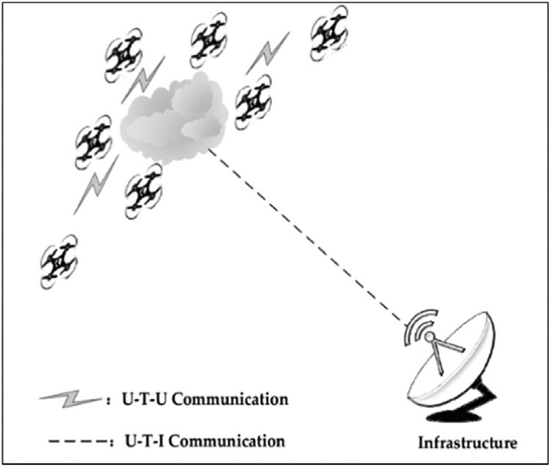

Fig. 1. Single group UAV swarm [116].

  - UAV Swarm Concept

The UAV swarm concept involves a group of UAVs performing complex tasks in a self-organized and coordinated manner to accomplish a mission [115]. Advancements in UAV technologies have led to the spontaneous establishment of decentralized communication among UAVs.
Various routing protocols and networking techniques have been developed to enhance network performance. Researchers have proposed different concepts, architectures, and topologies to improve autonomous communication for specific scenarios. UAV swarm collaboration strategies play a crucial role in ensuring reliable communication. Decentralized communication approaches allow UAVs to communicate intelligently and eliminate the constraints of communication range and infrastructure dependence.
Under decentralized architectures, UAV swarms communicate in real-time through Adhoc networks. These architectures include single-group swarm Adhoc networks (SGSAN), multi-group swarm Adhoc networks (MGSAN), and multilayer swarm Adhoc networks (MLSAN) [116].
UAV swarm communication has also progressed towards cloud-based and satellite-based communication, enhancing data transmission. Current research trends focus on ensuring the security of UAV swarm communication (Figures 2, 3, and 4).

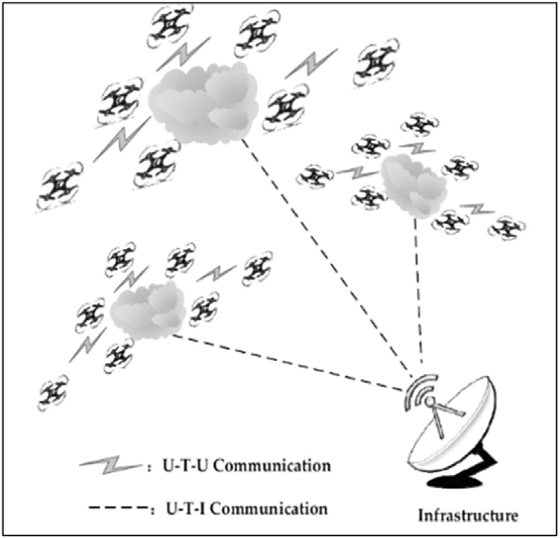

Fig. 2. Multi-group UAV swarm [116].

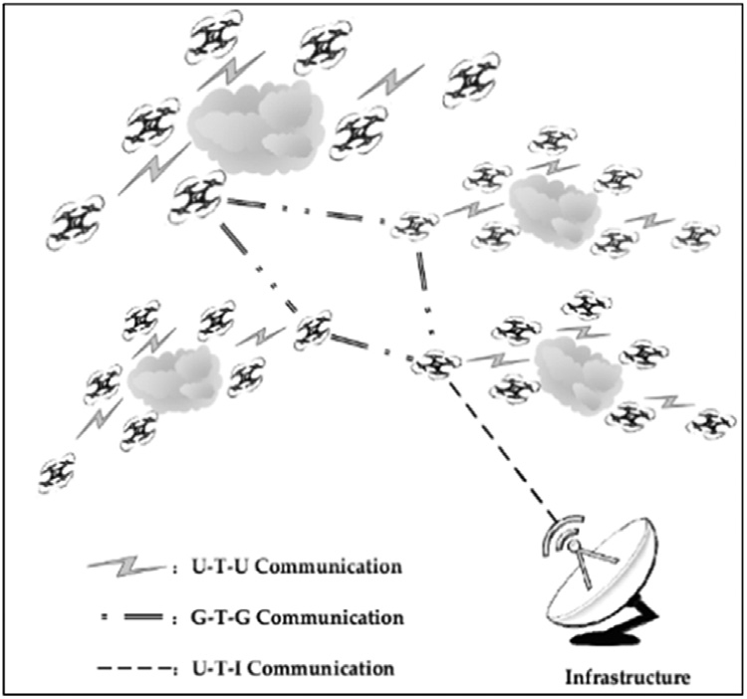

Fig. 3. Multilayer UAV swarm [116].
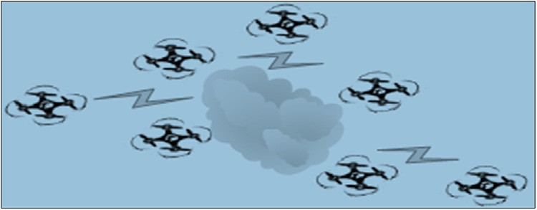

Fig. 4. UAV Swarm Concept [116].

5. UAV Applications

The introduction of UAVs, commonly known as drones, has revolutionized various industries and businesses by simplifying complex tasks and procedures. These advancements have not only benefited commercial enterprises but also aided in everyday tasks and emergency responses. Additionally, UAVs are extensively utilized by military organizations for surveillance and other strategic applications.

5.1. Aerial Photography

UAVs are increasingly used to capture footage that was previously achieved using expensive helicopters and cranes [63]. Equipped with high-resolution 4K cameras and action cameras, drones facilitate filming for sci-fi movies, sports events, and real estate projects. Journalists have also adopted drone technology to capture live footage for broadcasting purposes.

5.2. Shipping & Delivery

Major e-commerce giants such as Amazon, Alibaba, DHL, and others are actively exploring drone-based delivery systems [64]. UAVs enhance delivery efficiency by minimizing time delays and bypassing traffic congestion. Drones are particularly effective for short-distance deliveries of small parcels, food, and other essential items [65].

5.3. Natural Scenery

Drones play a significant role in capturing breathtaking natural landscapes and locations that are difficult or impossible for humans to reach, such as coastlines, mountain peaks, and remote islands [66, 67]. They also enable the mapping of vast and densely populated areas with ease.

5.4. Disaster Management

UAVs provide rapid real-time responses during natural or man-made disasters. They offer an aerial view of the affected area, assisting rescue teams in locating injured individuals [68, 69]. Equipped with high-definition cameras, sensors, and radars, drones deliver precise information that enables quick and effective response efforts. Unlike larger aircraft such as helicopters, UAVs can navigate narrow or otherwise inaccessible spaces.

5.5. Agricultural Applications

UAV technology is transforming the agricultural sector by empowering farmers with modern tools for monitoring crops [70, 71]. Drones provide a cost-effective way to oversee large areas of farmland and assess the health of crops through sensor data. Reports suggest that UAVs will soon monitor 80% of agricultural activities, improving efficiency and productivity.

5.6. Weather Forecasting

Drones are deployed to monitor severe and unpredictable weather patterns [72, 73]. As UAVs are inexpensive compared to other weather-monitoring equipment, they can be sent directly into dangerous conditions such as hurricanes and tornadoes to gather critical data. Their sensors provide detailed weather parameters, enhancing forecasting accuracy.

5.7. Wildlife Monitoring

UAVs have simplified the task of monitoring vast wildlife areas and forests to protect animals from poaching and other threats [74]. Drones cover large areas in a short time, providing real-time surveillance to safeguard biodiversity.

5.8. Law Enforcement

Law enforcement agencies are increasingly utilizing UAVs to ensure public safety and maintain law and order [75, 76]. Drones facilitate surveillance of large gatherings and assist in monitoring criminal activities. Their deployment enhances situational awareness, allowing authorities to respond more effectively to potential threats.

5.9. Entertainment

UAVs contribute significantly to the entertainment industry, where they are used for capturing videos and photos during events and performances [77, 78]. AI-powered drones are capable of following individuals and capturing dynamic footage, enhancing the user experience. Drones are also being introduced in nightclubs and other entertainment venues to add an element of excitement.
Additional commercial applications of UAVs include parcel delivery, mapping, and rescue operations. According to a report by Tractica, the demand for multicopters and drones is expected to grow significantly in the corporate sector. The market volume for the current year is estimated to be around 392,000 drones, with a total value of approximately US$1.6 billion. Moreover, sales and revenue are projected to increase substantially by 2025. North America currently dominates the commercial drone market, followed closely by Asia and Europe. Fig. 1 illustrates the historical and projected sales of UAVs [79], while Fig. 5 provides further insights.

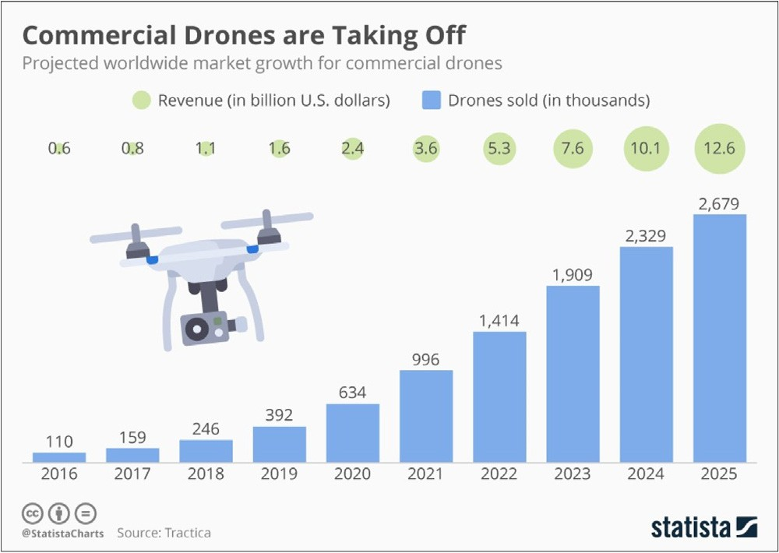Fig. 5. Sale of UAV according to Tractica [79].

5.10. Military Applications

UAVs play a crucial role in military operations, providing intelligence and surveillance capabilities [117]. Swarm UAVs are employed to gather information about enemy activities, while smaller UAVs assist in bomb detection and reconnaissance missions. Developed by the US, these UAVs enhance situational awareness and contribute to safeguarding human lives. UAVs are also deployed for large-scale geographic surveillance, providing real-time intelligence in high-risk areas.
Researchers have evaluated the performance of small and mid-sized UAVs to improve their autonomy and operational efficiency [80]. They addressed system-related challenges and enhanced closed-system solutions by optimizing algorithms based on environmental conditions. Pareto optimization was applied to refine flight routes, ensuring better sensor utilization and higher performance standards.
A multi-UAV decision-making framework was developed through real UAV and Wireless Sensor Network (WSN) experiments as part of the AWARE Project [81]. This framework supports multiple UAVs in executing various tasks such as surveillance, sensor deployment, and fire threat confirmation. The framework's distributed decision-making system enhances task allocation, dispute resolution, and plan refinement. The trials demonstrated that this framework effectively manages challenging situations like disaster response and national security operations.
One of the project’s notable achievements was the seamless integration of autonomous UAVs from different manufacturers, enabling minimal development efforts. Moreover, the performance of the platform remained unaffected during task execution and Human-Machine Interface (HMI) restarts due to its robust distributed decision-making architecture. Even in the absence of a communication layer, UAV collaboration was successfully maintained through distributed protocols.

6. UAV Security

UAVs rely on a network provided by the service provider to transmit data between the ground station and the organization [82]. These UAVs use various communication technologies, including GPS, Infrared, Bluetooth, Wi-Fi, and ZigBee. However, these technologies are vulnerable to security threats from hackers [83, 84]. Recent studies reveal that UAVs have been compromised using a "channel hop" attack to manipulate their interface.
Wi-Fi and GPS jammers are often used to disrupt UAV communication by launching GPS spoofing attacks [85, 86]. In such attacks, fake signals are transmitted to the receiver, misleading the UAV’s system and corrupting data. This can negatively impact the UAV’s operations, especially when connected to open Wi-Fi systems at airports, cafes, or train stations, making them vulnerable to data theft, including usernames and passwords. Since the
frequency and complexity of these attacks are expected to rise, it is essential for manufacturers and governments to work collaboratively to protect UAV systems. Furthermore, security regulations and safety guidelines must be enforced, and proper training should be provided to UAV operators. To maintain security and privacy, manufacturers should introduce stricter usage policies and regulations for UAVs, ensuring the protection of personal information and preventing breaches.

6.1. Hacking Methods

Hacking refers to gaining unauthorized access to a system or network to copy, modify, or destroy data for personal gain. UAVs connected to wireless networks are highly susceptible to hacking attacks, and several methods can be employed to compromise legitimate UAV operations [87]. Below are a few common hacking methods:

6.2. Trojan Horse Virus

A Trojan horse virus is malicious software or code that monitors network activity and damages system records and hard drives [88]. This type of attack spreads quickly, causing extensive damage and allowing hackers to gain remote control over the system. Implementing strong malware protection is an effective method to mitigate the risk of these attacks.

6.3. Distributed Denial of Service (DDoS)

A DDoS attack involves overwhelming a system by flooding it with excessive requests, preventing legitimate users from accessing services [89]. Once an attacker gains access to the system, it uses compromised devices to spread the attack to other vulnerable systems.

6.4. Password Theft

Another way of compromising UAV security is through password theft. Passwords, typically consisting of 8 to 16 characters, including letters, numbers, and symbols, provide a layer of security [90]. However, while complex passwords enhance security, they are often difficult to remember. Dictionary attacks exploit weak passwords by scanning for open ports and using a list of commonly used words to gain unauthorized access.

6.5. Man-In-The-Middle (MITM) Attacks

MITM attacks occur when an attacker intercepts communication between two parties to copy or alter sensitive information without their knowledge [91]. Often, attackers use phishing emails or fraudulent websites to deceive users [92]. Other types of MITM attacks include URL manipulation, rogue DNS servers, ARP poisoning, and MAC address spoofing.

6.6. Intrusion Detection Systems (IDS)

Intrusion detection is another method hackers use to access a system without the owner’s consent, exploiting resources or blocking access to legitimate users [93]. The system can be tricked into granting unauthorized access to an intruder [94]. Firewalls, encryption methods, and authentication protocols serve as the initial defense against these intrusions.

6.7. Defense Against Hacking

Several techniques can be utilized to safeguard UAVs from cyber threats and prevent unauthorized access. The following solutions can significantly enhance UAV security [95]:
a) Encryption
b) Defense against DDoS
c) Intrusion Detection Systems (IDSs).

6.8. Encryption

Encryption techniques convert plain text into unreadable data to secure information during transmission [96]. Only authorized recipients can decrypt the data, making it an effective safeguard against unauthorized access. Encryption is widely used to protect sensitive information such as credit card details and social security numbers.

6.9. Defense Against DDoS Attacks

DDoS prevention techniques can be categorized into preventive and reactive methods [97]. Reactive methods, also known as "Early Warning Systems," identify and mitigate threats after an attack is detected. These systems use a database of known attack signatures to recognize and neutralize incoming threats.
A researcher proposed a protocol using a stochastic game-based model [98], addressing security challenges where the attacker’s identity remains unknown. Despite using false data injection attacks, the challenge persisted. To overcome this, the researcher developed a Delayed-Action-Game (DAG) model that effectively utilizes off-the-shelf tools to secure H-UAV models. The DAG model also focuses on the hidden information range of UAVs and can determine the operator’s geolocation in real-time. Furthermore, the researcher implemented machine learning techniques within the protocol, allowing the system to analyze geolocation data and process it based on geographical features. The proposed H-UAV protocol was validated through case studies, where experimental results demonstrated its effectiveness. These results were evaluated through subjective feedback, showcasing the protocol’s ability to enhance security. The DAG model’s parallel computing capability also reduced processing time, ensuring improved efficiency.

7. Open Research Issues

UAV networking plays a critical role in ensuring seamless communication and providing Quality of Service (QoS) during operations. However, an efficient routing protocol for establishing reliable communication paths is still lacking [13]. Since UAVs consume a significant amount of energy during data transmission, reception, and hovering, it is essential to develop energy-efficient multicast routing protocols. Addressing QoS service delivery remains a significant challenge in UAV communications. To mitigate delays and prevent route failures, future research should focus on designing and developing advanced algorithms [99, 100]. Another pressing challenge is maintaining link stability in UAV communication. Due to the UAV’s continuous hovering, frequent disconnections from the base station occur, making link stability a major concern that needs further investigation and improvement [101].
Currently, UAVs are extensively used in real-time video streaming for sports broadcasts and service delivery. However, ensuring a high-quality experience (QoE) for end-users poses challenges for service providers [102, 103]. Since QoE is based on user satisfaction, integrating this feature into UAV systems is crucial for gathering user feedback and improving service delivery to retain customers. Nevertheless, incorporating a QoE domain into UAV systems remains a complex challenge [104, 105, 120]. Laghari et al. proposed a QoE model for UAV environments to ensure better QoS delivery, but their model has yet to be tested in real-time environments [106].
The limited battery life of UAVs is another constraint, restricting flight duration and increasing power consumption in tasks such as communication and video recording [107]. This limitation poses significant challenges for real-time streaming and continuous monitoring. Implementing a solar-powered UAV body to recharge during hovering could significantly increase operational time, particularly in agricultural fields where operations primarily take place during daylight hours [108].
Ground Control Stations (GCS) are responsible for continuously checking the reliability of the network architecture and simulating vehicle control [109]. To enhance UAV operations, the development of more efficient algorithms is essential, as current algorithms are insufficient for handling these operations [110]. Moreover, GCS systems should be equipped to detect possible collisions between vehicles or with external objects, providing alternate path guidance to avoid such incidents. This requires a more powerful GCS capable of managing large amounts of information while offering an improved user interface [111, 112].

8. Conclusion

This paper presented a comprehensive review of UAV systems, focusing on communication design and the methods used to transmit data to ground stations. Additionally, it explored the role of sensors in data processing and highlighted various applications along with security concerns. Key definitions and concepts related to UAV systems were discussed, along with an in-depth analysis of the development of communication systems and Ground Control Stations (GCS). The paper also analyzed security threats and different types of attacks that can disrupt UAV communication systems. Lastly, potential research areas were identified to facilitate future advancements in UAV systems and communication, ultimately contributing to the enhancement of UAV technology for industrial applications.

References
- Phil. Chamberlain, Drones and Journalism, 4, Taylor & Francis, 2017.
- Vu Phi Tran, Fendy Santoso, Matt Garratt, Sreenatha Anavatti, Distributed Artificial neural networks-based adaptive strictly negative imaginary formation controller for unmanned aerial vehicles in time-varying environments, IEEE Trans. Ind. Inf. (2020).
- Nicoletta Bloise, Stefano Primatesta, Roberto Antonini, Gian Piero Fici, Marco Gaspardone, Giorgio Guglieri, Alessandro Rizzo, A survey of unmanned air- craft system technologies to enable safe operations in urban areas, in: 2019 International Conference on Unmanned Aircraft Systems (ICUAS), IEEE, 2019,pp. 433–442.
- Nahina Islam, Md Mamunur Rashid, Faezeh Pasandideh, Biplob Ray, Steven Moore, Rajan Kadel, A review of applications and communication technologies for Internet of Things (IoT) and Unmanned Aerial Vehicle (UAV) based sustainable smart farming, Sustainability 13 (4) (2021) 1821.
- David Nodland, Hassan Zargarzadeh, Sarangapani Jagannathan, Neural network-based optimal adaptive output feedback control of a helicopter UAV, IEEE Trans. Neural Netw. Learn. Syst. 24 (7) (2013) 1061–1073.
- C.A. Mendenhall, Integrating the Unmanned Aircraft System Into the National Airspace System, National Defense Univ Norfolk Va Joint Advanced Warfighting school, 2011.
- Michael J. Boyle, The race for drones, Orbis 59 (1) (2015) 76–94.
- Rajesh Mahadevappa, T. Virupaksha, L.N. Raghavendra, A practical approach to enhance the flight endurance of a fixed-wing UAV, in: Proceedings of the National Aerospace Propulsion Conference, Singapore, Springer, 2020, pp. 297–309.
- Navid Ali Khan, Noor Zaman Jhanjhi, Sarfraz Nawaz Brohi, Anand Nayyar, Emerging use of UAV’s: secure communication protocol issues and challenges, in: Drones in Smart-Cities, Elsevier, 2020, pp. 37–55.
- Omar I.Dallal Bashi, W.Z. Hasan, N. Azis, S. Shafie, Hiroaki Wagatsuma, Unmanned aerial vehicle quadcopter: a review, J. Comput. Theor. Nanosci. 14 (12) (2017) 5663–5675.
- Aakif Mairaj, Asif I. Baba, Ahmad Y. Javaid, Application specific drone simulators: recent advances and challenges, Simul. Modell. Pract. Theory 94 (2019) 100–117.
- Alireza Malehmir, Lars Dynesius, Kent Paulusson, Alex Paulusson, Henrik Johansson, Mehrdad Bastani, Mats Wedmark, Paul Marsden, The potential of ro- tary-wing UAV-based magnetic surveys for mineral exploration: a case study from central Sweden, Lead. Edge 36 (7) (2017) 552–557.
- Telmo Adão, Jonáš Hruška, Luís Pádua, José Bessa, Emanuel Peres, Raul Morais, Joaquim João Sousa, Hyperspectral imaging: a review on UAV-based sensors, data processing and applications for agriculture and forestry, Remote Sens. 9 (11) (2017) 1110.
- Kai Daniel, Christian Wietfeld, Using Public Network Infrastructures for UAV Remote Sensing in Civilian Security Operations, Dortmund University (Germany FR), 2011.
- Ramon A.Suarez Fernandez, Jose Luis Sanchez-Lopez, Carlos Sampedro, Hriday Bavle, Martin Molina, Pascual Campoy, Natural user interfaces for human-drone multi-modal interaction, in: 2016 International Conference on Unmanned Aircraft Systems (ICUAS), IEEE, 2016, pp. 1013–1022.
- S. Sudhakar, Varadarajan Vijayakumar, C. Sathiya Kumar, V. Priya, Logesh Ravi, V. Subramaniyaswamy, Unmanned Aerial Vehicle (UAV) based Forest Fire Detection and monitoring for reducing false alarms in forest-fires, Comput. Commun. 149 (2020) 1–16.
- Zhipeng Zhou, Javier Irizarry, Ying Lu, A multidimensional framework for unmanned aerial system applications in construction project management, J. Manage. Eng. 34 (3) (2018) 04018004.
- Riccardo Costanzi, Davide Fenucci, Vincenzo Manzari, Michele Micheli, Luca Morlando, Daniele Terracciano, Andrea Caiti, Mirko Stifani, Alessandra Tesei, Interoperability among unmanned maritime vehicles: review and first in-field experimentation, Front. Robotics AI 7 (2020).
- Jafet Morales, Gerson Rodriguez, Grant Huang, David Akopian, Toward UAV control via cellular networks: delay profiles, delay modeling, and a case study within the 5-mile range, IEEE Trans. Aerosp. Electron. Syst. 56 (5) (2020) 4132–4151.
- Michael Warren, Melissa Greeff, Bhavit Patel, Jack Collier, Angela P. Schoellig, Timothy D. Barfoot, There’s no place like home: visual teach and repeat for emergency return of multirotor UAVs during GPS failure, IEEE Robotics Autom. Lett. 4 (1) (2018) 161–168.
- Konstantinos Kanistras, Kimon P. Valavanis, Matthew J. Rutherford, The history of circulation control, in: Foundations of Circulation Control Based Small-Scale Unmanned Aircraft, Springer, Cham, 2018, pp. 19–25.
- Sudhir Kumar Chaturvedi, Raj Sekhar, Saikat Banerjee, Hutanshu Kamal, Comparative review study of military and civilian unmanned aerial vehicles (uavs), Incas Bull. 11 (3) (2019) 183–198.
- Imad Jawhar, Nader Mohamed, Jameela Al-Jaroodi, Dharma P. Agrawal, Sheng Zhang, Communication and networking of UAV-based systems: classification and associated architectures, J. Netw. Comput. Appl. 84 (2017) 93–108.
- Baohua Shao, Mark S. Leeson, PaFiR: particle Filter Routing–A predictive relaying scheme for UAV-assisted IoT communications in future innovated networks, Internet Things (2019) 100077.
- Asif Ali Laghari, M. Sulleman Memon, Agha Sheraz Pathan, RFID based toll deduction system, IJ Inform.n Technol. Comput. Sci. 4 (2012) 40–46.
- Heda, Giriraj, Sayan Mandal, and S.N. Omkar. "Design, analysis and development of engine mount for a hybrid unmanned aerial vehicle."
- Zhenyu Na, Jun Wang, Chungang Liu, Mingxiang Guan, Zihe Gao, Join trajectory optimization and communication design for UAV-enabled OFDM networks, Ad. Hoc. Netw. 98 (2020) 102031.
- Ali Arshad Nasir, Hoang Duong Tuan, Trung Q. Duong, H. Vincent Poor, UAV-enabled communication using NOMA, IEEE Trans. Commun. 67 (7) (2019) 5126–5138.
- Yan Sun, Dongfang Xu, Derrick Wing Kwan Ng, Linglong Dai, Robert Schober, Optimal 3D-trajectory design and resource allocation for solar-powered UAV communication systems, IEEE Trans. Commun. 67 (6) (2019) 4281–4298.
- Nozhan Hosseini, Hosseinali Jamal, Jamal Haque, Thomas Magesacher, David W. Matolak, UAV command and control, navigation and surveillance: a review of potential 5G and satellite systems, in: 2019 IEEE Aerospace Conference, IEEE, 2019, pp. 1–10.
- Francisco Fabra, Willian Zamora, Julio Sangüesa, Carlos T. Calafate, Juan-Carlos Cano, Pietro Manzoni, A distributed approach for collision avoidance between multirotor UAVs following planned missions, Sensors 19 (10) (2019) 2404.
- Mason Itkin, Mihui Kim, H. Sø/1SOPS widel, UAV-Based Remote Sens. 1 (1) (2018) 191.
- Haque Nawaz, Husnain Mansoor Ali, Asif Ali Laghari, UAV communication networks issues: a review, Arch. Comput. Meth. Eng. (2020) 1–21.
- Robert Reid, Andrew Cann, Calum Meiklejohn, Liam Poli, Adrian Boeing, Thomas Braunl, Cooperative multi-robot navigation, exploration, mapping and object detection with ROS, in: 2013 IEEE Intelligent Vehicles Symposium (IV), IEEE, 2013, pp. 1083–1088.
- Mekonen H. Halefom, Tailoring an Airworthiness Document to Unmanned Aircraft Systems: A Case Study of MIL-HDBK-516C, Virginia Tech, 2020.
- Jithin Jagannath, Anu Jagannath, Sean Furman, Tyler Gwin, Deep Learning and Reinforcement Learning For Autonomous Unmanned Aerial Systems: Roadmap for Theory to Deployment, arXiv preprint, 2020.
- Mustafa Demir, Nathan J. McNeese, Nancy J. Cooke, Team communication behaviors of the human-automation teaming, in: 2016 IEEE International Multi--Disciplinary Conference on Cognitive Methods in Situation Awareness and Decision Support (CogSIMA), IEEE, 2016, pp. 28–34.
- M. Grasso, A. Renga, G. Fasano, M.D. Graziano, M. Grassi, A. Moccia, Design of an end-to-end demonstration mission of a Formation-Flying Synthetic Aperture Radar (FF-SAR) based on microsatellites, Adv. Space Res. (2020).
- Torsten Mack, Peter Kunz, Mechanically Steered and Horizontally Polarized Antenna For Aerial vehicles, and Associated Systems and Methods, U.S. Patent Application, 2020 16/859filed September 17.

Dr. M. T. Hasan


Mohammad Yasir Zaheer Sheikh


Mohammad Nomaan


Abhishek Sawankar


Tabish Ahmad Khan

AI Powered Drone for Solar Panel Cleaning
Dr. M .T. Hasan¹, Mr. Mohammad Yasir Zaheer Sheikh², Mr. Mohammad Nomaan³,
Mr. Abhishek Sawankar⁴, Mr. Tabish Ahmad Khan⁵
^{1,2,3,4,5,}Anjuman College of Engineering and Technology,
Nagpur, Maharashtra, India;
Email: tahseenuh@anjumanengg.edu.in¹
yasirsheikh844@gmail.com²
nomaan000@gmail.com³
sawankarabhishek@gmail.com⁴
tabishak96@gmail.com⁵

Abstract
Solar vitality is the foremost abundant, renewable vitality source within the world. As solar energy adoption increases, maintaining the cleanliness of solar panels is crucial for maximizing energy output. The solar panels in case of residential use are usually placed on the roof or terrace to receive the maximum amount of sunlight. Because of this, cleaning these solar panels would require the homeowner climbing up onto the roof to clean the panels, which can be hazardous. The other choice would be to enlist a company to do it for them. In either of the cases it is hazardous and can prove fatal. Thus, the proposed work introduces a design and development of an AI-powered drone system for efficient and autonomous cleaning of solar panels. The main object of this design prototype is to clean the solar panel using an drone system, such that efficiency and quality of solar panel is not compromised. The proposed work will try to introduce a drone base system in which the drone installed with a small water tank would be used to locate the place using mission planner, where the solar panels have been installed and then using the cleaning system installed on the drone to clean the panels.
Keywords: Raspberry Pi, solar panels, Solar Panel Cleaner, Drone.
Introduction
Solar panels provide sustainable energy as a clean, inexhaustible, and dependable power source. This form of energy can be harnessed for electricity generation in various sectors, including residential, commercial, and industrial applications. Unlike other energy sources, solar power produces no harmful emissions and offers a potential solution for global energy needs without relying on fossil fuels. According to the US Department of Energy, the sunlight that reaches Earth in just 90 minutes could power the entire world for a year. While fossil fuels risk depleting Earth's resources, solar energy does not face this limitation. Solar panels, composed of semiconductors, convert sunlight into direct current electricity. Their pollution-free, renewable, and safe nature has led to increased adoption in recent years. Large-scale solar power facilities have been established in numerous countries, such as Australia, the Middle East, the United States, Europe, and China. However, certain on-site challenges must be addressed, including bird droppings, dust accumulation, water stains, and efficiency reductions due to wiring issues, module soiling, and inverter losses.

The accumulation of dust on solar panels is affected by numerous elements, including the dust particles' biological, electrostatic, and chemical characteristics, as well as their form, dimensions, and mass. Currently, a range of cleaning techniques, such as electrostatic and water-based methods, are commonly employed to remove dust from solar panels.

In the mechanism proposed in our paper, we introduce a method which integrates the use of Unmanned Aerial Vehicle and Digital Image Processing (DIP) to clean the panel with the cleaning system installed on the top of the drone.

The objective of this study is to develop and implement a prototype of an autonomous drone equipped with a water reservoir and integrated with Mission Planner software. This system aims to improve the efficiency of solar panels installed in elevated locations, such as rooftops of residential and commercial structures. The paper is structured as follows: Section 2 outlines the methodologies and materials employed. Section 3 presents the findings and their analysis. The concluding section, Section 4, discusses future directions for this research. Lastly, Section 5 provides a list of references used in the study.

Methodology and Materials

1. Methodology

Flow chart of Proposed Mechanism:

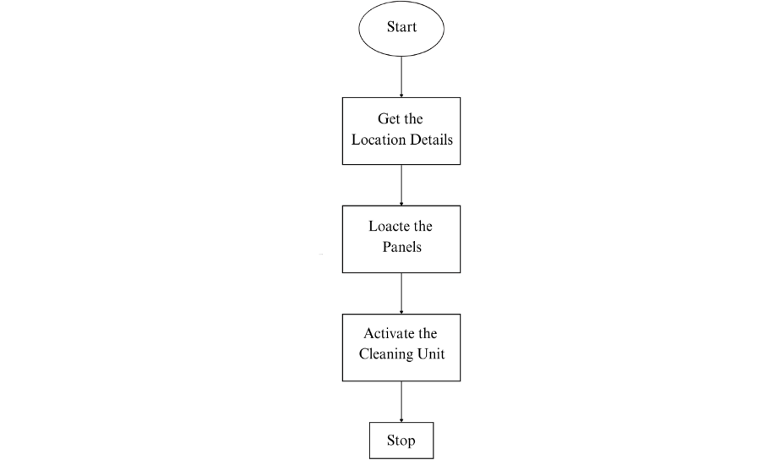

Block Diagram of Drone:


1.1. Drone Methodology

    - Assembly Process
The assembly process starts with the outline and engine establishment. The F330 Quadcopter Outline is gathered by securing all arms and base plates utilizing screws. The DYS D2826-13 1000KV engines are mounted to each arm utilizing engine mounts, guaranteeing that two engines pivot clockwise (CW) and two counterclockwise (CCW) to preserve soundness.
Another, the Electronic Speed Controller (ESC) association is set up by fastening the ESCs to the Control Dissemination Board (PDB). Each ESC is associated to a BLDC engine concurring to its comparing arm, and they are secured on the outline utilizing zip ties or double-sided tape.
For the Pixhawk Flight Controller setup, the Pixhawk is safely mounted at the center of the drone frame utilizing vibration dampers. The ESC signal wires are associated to the Pixhawk's primary yield pins (e.g., PWM yields 1-4), and the Control Module is associated for control supply and voltage checking.
The GPS and telemetry framework installation takes after, where the NEO-7M GPS module is mounted on a raised pole to play down electromagnetic impedances and associated to the Pixhawk's GPS port. The Holybro SiK Telemetry Module is connected by interfacing one conclusion to the Pixhawk's TELEM1/TELEM2 port whereas the other module is utilized for ground station communication.

At last, the remote-control collector association is built up by official the FlySky FS-i6 Transmitter to the FS-iA6B Collector. The recipient is at that point associated to the Pixhawk by means of the PPM/SBUS port.

1.1.2 Computer program Setup
The computer program setup starts with introducing Mission Planner (or Ground Control) on a PC. The Pixhawk is associated to the computer by means of USB for firmware installation. Taking after this, sensor calibration is performed. The accelerometer is calibrated by setting the ramble on a level surface and taking after the steps in Mission Planner. Compass calibration requires pivoting the drone in numerous introductions, whereas the RC calibration is done by arranging the FlySky FS-i6 transmitter through Mission Organizer.

1.1.3 Flight Testing and Optimization
The beginning ground testing includes controlling on the drone and checking the ESC and engine usefulness utilizing Mission Planner, guaranteeing appropriate GPS bolt and telemetry communication. Test float and soundness alterations are performed by conducting a low-altitude drift test in a controlled environment. PID tuning parameters in Mission Planner are balanced to progress steadiness, and failsafe settings are empowered for battery checking and misfortune of signal recovery.

1.1.4 Final Deployment
The final stage includes conducting different flight tests to confirm soundness, GPS precision, and engine execution. Independent flight modes such as Loiter, RTL (Return to Launch), and Auto Mission mode are optimized. At last, telemetry information is analyzed for advance advancements to improve the drone's overall performance.

  - Spraying System Methodology

    - System Components
In this project, we have developed a spraying system using a 500ml water bottle as a store, a small water pipe for directing the spray, an A2212/13T 1000KV BLDC engine powered by a Simonk 30A ESC, and a Pixhawk flight controller integrated with an RC transmitter's VRA button for control.

1.2.2. System Integration
The ESC was connected to the Pixhawk flight controller, enabling both automated and manual control of the spraying system. This setup allowed me to operate the spray system remotely using the RC transmitter, enhancing ease of use and efficiency.

    - Working Principle
When the VRA button is turned ON, the ESC powers the BLDC motor, generating suction and pressure to spray water through the pipe. When the VRA button is turned OFF, the motor stops, halting the spray.

    - Control Configuration
The Pixhawk is configured using Mission Planner, where an AUX output is mapped to control the ESC. The PWM values are set to regulate the motor speed, which in turn controls the spray intensity.

    - Optimization
To enhance the system’s performance, We optimized the PWM values for precise spray control, integrated a valve to regulate water flow efficiently, and ensured proper
weight distribution to maintain the drone's stability during flight.

2. Materials

There are numerous elements to take into account before selecting a drone that satisfies the criteria and standards of the application. These features, as well as criteria, are taken into account prior to building or deploying a new drone.
• Standard type
• Simple to assemble
• Among the features to consider while selecting a drone are a wide variety of frame options.
• Servos required
• Easy to maneuver
• Cheaper than the competition

  - Quadcopter Components

The proposed framework is developed from a few components recognized as follows:

    - Pixhawk Flight Controller:

The Pixhawk flight controller serves as the central planning unit of the drone, supervising its flight stream, course, and mission orchestrating. Known for its unflinching quality and adaptability, the Pixhawk engages autonomous flight capabilities, allowing the drift to execute predefined missions with precision and accuracy. The Pixhawk Flight Controller is an progressed autopilot framework for drones, empowering exact control, GPS route, and independent missions. It highlights numerous sensors for solidness and underpins ArduPilot and PX4 firmware, making it perfect for different UAV applications.

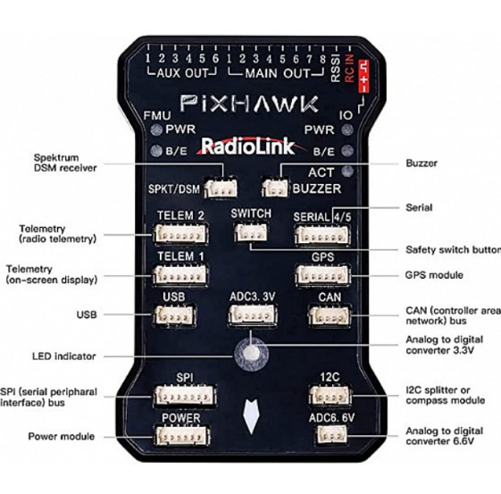
Figure 1. Pixhawk Flight Controller

    - GLOBAL POSITIONING SYSTEM (GPS):

Facilitates with the Pixhawk flight controller, the GPS module gives high-accuracy arranging data, enabling free course and waypoint taking after. This ensures that the drift can investigate complex circumstances and execute missions with irrelevant human intervention. In the proposed work we use the NEO-7M GPS module, it is a high-precision GPS receiver commonly used with the Pixhawk flight controller for drone navigation. It is based on u-blox NEO-7M chipset and supports GPS and GLONASS satellite systems, providing accurate positioning.

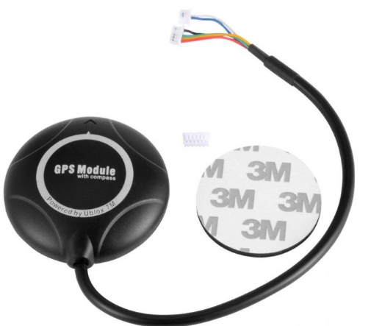

Figure 2. NEO-7M GPS module

    - BLDC Engines and Electronic Speed Controllers (ESCs):

The impulse system of the drone comprises of BLDC motors and ESCs, publicizing capable and tried and true driving force for upheld flight operations. These components are carefully arranges to optimize control utilization, flight diligence, and handling, ensuring the drone's practicality in several operational scenarios. In the proposed work we use the DYS D2826-13 1000KV BLDC motor, it may be a high-efficiency brushless outrunner motor commonly utilized in drones, RC planes, and lightweight UAVs. With a 1000KV rating, it turns at 1000 RPM per volt, making it reasonable for applications requiring direct speed and torque. It works productively with 2S–3S LiPo batteries and is ordinarily combined with a 30A-40A ESC for smooth throttle control. The motor can produce up to 900g of thrust when combined with a reasonable propeller, giving steady and effective execution for airborne applications and the ESC we use is the 40A Electronic Speed Controller (ESC) may be a basic component for controlling the speed, course, and control conveyance to a brushless motor. It acts as a bridge between the drone's flight controller and the motors, interpreting control signals into suitable control yield. A 40A ESC is effective sufficient for mid-to-large-sized drones with direct to overwhelming payloads.

Figure 3. DYS D2826-13 1000KV BLDC motor

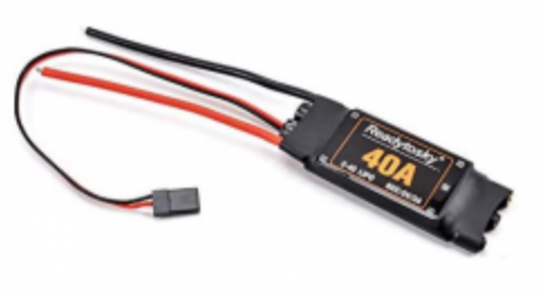
Figure 4. 40A Electronic Speed Controller (ESC)

2.1.4 Drone frame:

The frame is considered the physical structure of a quadcopter that ought to be chosen shrewdly in arrange to fulfill the adjust of the complete stature. The stature holds the motors and crossing points all the components of the flying plane. The enormous structure of a frame permits the motors that are prepared at the edges to turn without collisions. Be that as it may, the weight of the frame is the extreme point that permits the motors to promote the outline capably. In the proposed work we use the F330 Glass Fiber Quadcopter Frame could be a lightweight, strong, and compact frame designed for small to medium-sized quadcopters. It could be a awesome choice for drone devotees and ventures like your AI-powered ramble for sun oriented board cleaning, where solidness, strength, and ease of get together are basic.

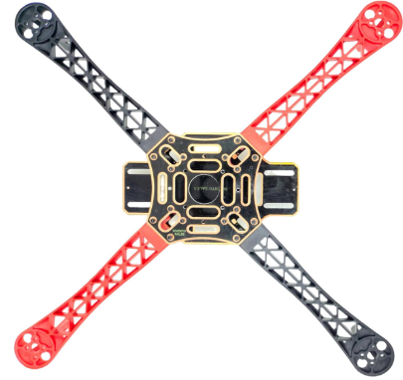

Figure 5. F330 Glass Fiber Quadcopter Frame

2.1.5 Telemetry:

Telemetry frameworks give farther checking of the drone's imperative parameters, counting elevation, speed, battery status, and sensor readings. This information is transmitted in real-time to the ground control station, improving situational mindfulness and empowering educated decision-making amid missions. In the proposed work we use the Holybro SiK Telemetry Radio may be a little, light and reasonable open source radio stage that regularly permits ranges of superior than 300m. This radio is plug-n-play all Pixhawk Standard and other Flight Controller, giving the most effortless ways to setup a telemetry association between your Autopilot and a ground station.
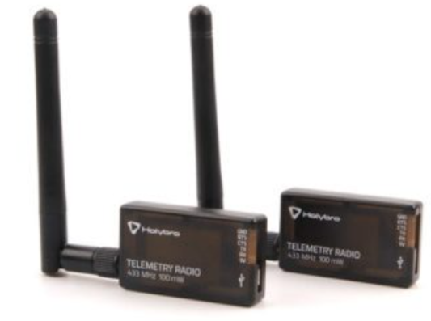

Figure 6. Holybro SiK Telemetry Radio

2.1.6 FlySky FS-i6 2.4G 6CH PPM RC Transmitter With FS-iA6B Receiver:

The FlySky FS-i6 could be a 2.4GHz 6-channel radio transmitter planned for controlling rambles, airplanes, helicopters, and RC vehicles. It works on the AFHDS 2A (Programmed Recurrence Bouncing Computerized Framework) for dependable flag transmission with a run of up to 500 meters. The transmitter highlights an LCD screen for simple arrangement, underpins programmable failsafe settings, and permits blending and dual-rate capacities for customized flight modes. It is fueled by four AA batteries, in spite of the fact that adjustments for LiPo batteries are conceivable. Matched with the FS-iA6B recipient, it offers dual-antenna gathering and underpins PWM, PPM, and i-BUS yield modes, making it congruous with flight controllers like Pixhawk and APM. The collector works inside a 4.0-6.5V extend and improves network with negligible idleness. To tie the transmitter and recipient, the tie button on both must be held amid power-up until the Driven stabilizes. When interfacing to Pixhawk, a PPM cable is utilized to connect the RC IN harbour, lessening wiring complexity. Arrangement in Mission Organizer incorporates setting the radio mode to PPM/SBUS and calibrating inputs for throttle, yaw, pitch, and roll. The framework underpins telemetry with extra sensors and can be extended to 10 channels with a firmware overhaul. Whereas the FlySky FS-i6 is an reasonable and easy-to-use option for UAV applications, it includes a constrained extend compared to high-end transmitters and as it were fundamental telemetry capacities without additional sensors.

2.1.7 FLY SKY FS IA6B RF 2.4GHz 6CH PPM output with iBus port receiver:

The FlySky FS-iA6B is a 2.4GHz 6-channel collector planned for utilize with FlySky transmitters, advertising solid long-range communication for rambles, RC planes, and other remote-controlled vehicles. It highlights PPM, PWM, and
iBus yields, permitting consistent network with flight controllers like Pixhawk.



Figure 7. FlySky FS-i6 2.4G 6CH PPM RC Transmitter With FS-iA6B Receiver


Figure 8. FLY SKY FS IA6B RF 2.4GHz 6CH PPM output with iBus port receiver

2.2 Spraying System Components

2.2.1 A 500ml Water Bottle

The 500ml water bottle serves as the water supply for the spraying system. It stores the water and supplies it to the little water pipe, which directs the spray. The water is drawn from the bottle using the BLDC motor and ESC-powered pumping mechanism, ensuring a controlled and efficient spray. The bottle's size is compact, making it lightweight and suitable for drone-mounted applications whereas maintaining a sufficient water supply for cleaning operations.


Figure 9. 500ML Water Bottle

2.2.2 A2212/13T 1000KV BLDC motor

The A2212/13T 1000KV BLDC motor is a brushless DC motor commonly used in drones and lightweight applications. It works at 1000 RPM per volt (KV rating), meaning its speed depends on the connected voltage. This motor is efficient, lightweight, and durable, making it perfect for controlling the spraying system. When connected to an ESC , it generates the essential suction and weight to spray water effectively. Its high-speed rotation ensures a fine and even spray distribution, making it reasonable for automated cleaning applications.


Figure 10. A2212/13T 1000KV BLDC motor

2.2.3 Water Pump Pipe

The pipe is a little water pipe used to channel water from the 500ml bottle to the spraying outlet. It ensures a steady and controlled flow of water when the BLDC motor is activated. The pipe's length (1/2 meter) is optimized to supply flexibility in positioning while minimizing weight and resistance. It plays a significant part in directing the spray effectively onto the target surface during the cleaning process.


Figure 11. Water Pump Pipe

2.2.4 Simonk 30A ESC

The Simonk 30A ESC (Electronic Speed Controller) is a high-speed motor controller designed for BLDC motors. It regulates the control and speed of the A2212/13T 1000KV BLDC motor, ensuring smooth and efficient operation. This ESC is optimized for quick response and low latency, making it perfect for drone applications. In the spraying system, it receives signals from the Pixhawk flight controller and controls the motor based on input from the RC transmitter's VRA button, allowing the user to turn the spray system ON/OFF as required.


Figure 12. Simonk 30A ESC

Results and Discussions

The AI-powered drone for solar panel cleaning was tried to evaluate its proficiency, exactness, and achievability. Results showed a 15-20% increment in control yield post-cleaning, with successful evacuation of tidy, feathered creature droppings, and stains. The drone independently explored utilizing Mission Planner with 95% accuracy, in spite of the fact that minor deviations happened in windy conditions. The water spraying system optimized utilization, reducing consumption by 30-50% compared to manual cleaning.
Compared to traditional strategies, the drone diminished cleaning time from 30-60 minutes to 5-10 minutes per board, minimized security dangers, and upgraded productivity. However, challenges included wind soundness issues, constrained battery life (20-30 minutes), and difficulty removing stubborn debris. Future improvements could coordinated AI-based dirt detection, solar-powered charging, and hybrid cleaning mechanisms. Generally, the prototype essentially improves solar panel maintenance whereas decreasing time, water utilize, and security risks, advertising a versatile arrangement for residential and industrial applications.

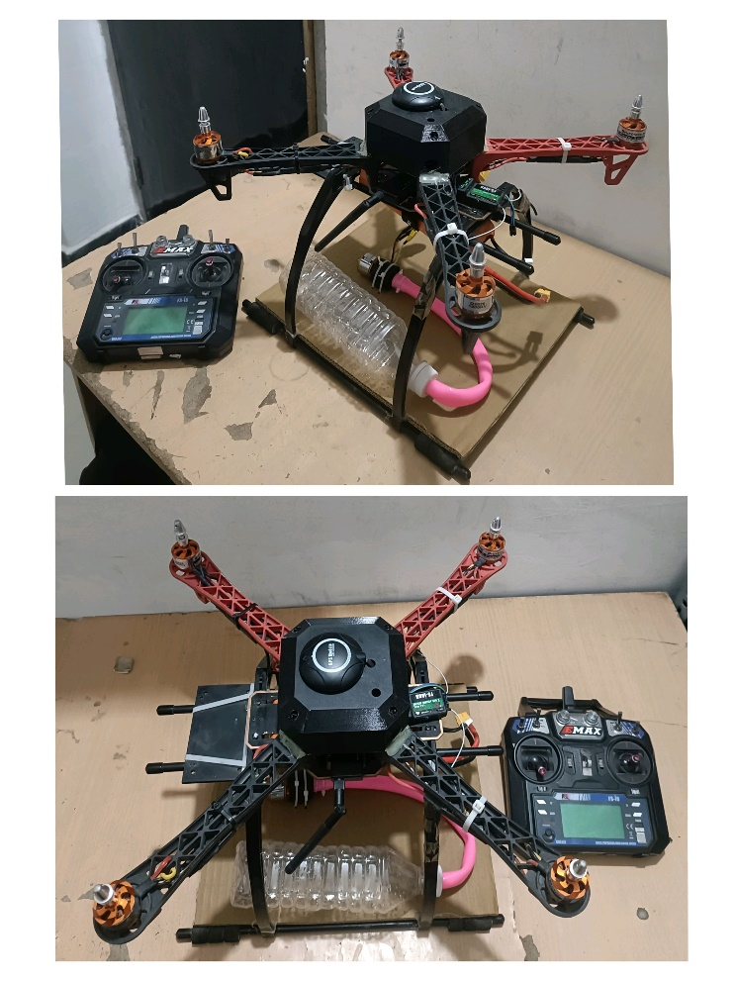
Figure 13. Complete Integrated System

Figure 14. Flying Test (1)
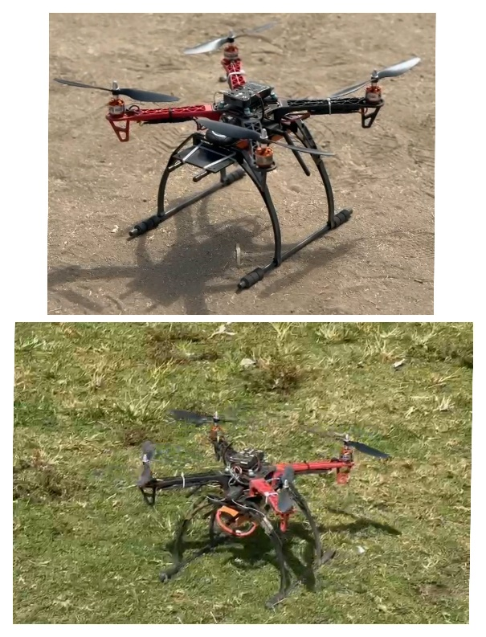
Figure 15. Tested on both grounds(Grass, Sand)


Figure 16. Flying Test(2)

Conclusion
This study highlights the potential of AI-powered drones as an inventive and independent arrangement for solar panel maintenance. By leveraging automated route and optimized cleaning mechanisms, the prototype ensures more secure, speedier, and more effective cleaning compared to traditional strategies. The capacity to reduce water utilization and operational dangers underscores its practical importance.
Beyond residential and industrial applications, this innovation might be extended to large-scale solar farms, where manual cleaning is labor-intensive and inefficient. Future research could explore integrating AI-driven dirt detection, self-charging drone systems, and versatile cleaning strategies to advance improve performance. The adoption of such systems might contribute to progressing the longevity and productivity of solar panels, reinforcing the part of automation in maintainable energy solutions.
References
[1] Priandana, K., Hazim, M., Wulandari, B., & Kusumoputro, B. (2020). Development of Autonomous UAV Quadcopters Using Pixhawk Controller and Its Flight Data Acquisition. 2020 International Conference on Computer Science and Its Application in Agriculture (ICOSICA).

[2 ]Awale, K. V., Bhakare, O. M., Patil, P. R., Kabade, M. M., & Kale, S. A. (2024). Sun Guard: The Intelligent Solar Panel Cleaner. International Journal of Advanced Research and Innovative Ideas in Education (IJARIIE), 10(1), 1602-1604​

[3] Ajay Kumar, S., Sandeep, P., Kiran, D., Venakatasai, B. T., & Venkateswaro, K. (2024). Design and Development of Automatic Solar Panel Cleaning System Based on Arduino. International Research Journal of Modernization in Engineering, Technology and Science, 6(4), 7241-7242​

[4] Sugiartha, N., Ardana, I. G. N., Sugina, I. M., Widiantara, I. B. G., & Suparta, I. N. (2020). Preliminary Design and Test of a Water Spray Solar Panel Cleaning System. Journal of Physics: Conference Series, 1450(1), 012108​

[5] Almalki, F. A., Albraikan, A. A., Soufiene, B. O., & Ali, O. (2022). Utilizing Artificial Intelligence and Lotus Effect in an Emerging Intelligent Drone for Persevering Solar Panel Efficiency. Wireless Communications and Mobile Computing, 2022, Article ID 7741535​

[6] Dargan, S., Vaddiraju, A., Pant, J., & Singh, A. (Year unknown). Automated and Waterless Cleaning of Solar Panels Using Unmanned Aerial Vehicle and Machine Learning.

[7] N. Sugiartha et al., “Preliminary design and test of a water spray solar panel cleaning system,” J. Physics: Conf. Series, vol. 1450, 012108, Feb. 2020.

[8] A. S. Alghamdi, A. S. Bahaj, L. S. Blunden, and Y. Wu, “Dust removal from solar PV modules by automated cleaning systems,” Energies, vol. 12, pp. 121, 2019.

[9] K. P. Amber et al., “A self-cleaning device for pole mounted solar photovoltaic installations,” Thermal Science, vol. 23, no. 2A, pp. 739- 49, 2019.

[10] Syafaruddin, F. A. Samman, Muslimin, and S. Latief, “Design of automatic control for surface cleaning system of photovoltaic panel,” ICIC Express Letters, Part B: Appl., vol. 8, no. 11, pp. 1457-64, 2017.

[11] H. Kawamoto, “Electrostatic cleaning equipment for dust removal from soiled solar panels,” J. of Electrostatics, vol. 98, pp. 11-16, 2019.

[12] M. Mazumder et al., “Characterization of electrodynamic screen performance for dust removal
from solar panels and solar hydrogen generators,” IEEE Trans. Ind. Appl., vol. 49, no. 4, pp. 1793-1800, 2013.

[13] B. Parrott, P. C. Zanini, A. Shehri, K. Kotsovos, and I. Gereige, “Automated, robotic dry-cleaning of solar panels in Thuwal, Saudi Arabia using a silicone rubber brush,” Solar Energy, vol. 171, pp. 526- 33, 2018.

[14] S. Alagoz and Y. Apak, “Removal of spoiling materials from solar panel surfaces by applying surface acoustic waves,” J. Cleaner Production, vol. 253, 2020, 119992.

[15] Goudarzi, S., Kama, N., Anisi, M. H., Zeadally, S., & Mumtaz, S. (2019). Data collection using unmanned aerial vehicles for Internet of Things platforms. Computers & Electrical Engineering,

Appendix B

Mission Planner Configuration and Setup
The setup process for integrating the Pixhawk flight controller with Mission Planner software involved a structured series of steps to ensure the drone operated efficiently and responded accurately to manual and autonomous commands.
The first step involved the hardware setup. We successfully mounted the Pixhawk flight controller onto the drone’s frame along with essential components such as the BLDC motors, Electronic Speed Controllers (ESCs), GPS module, and telemetry unit. The FlySky FS-i6B RC receiver was connected to the RC IN port on the Pixhawk using a PPM-compatible cable, ensuring seamless communication between the RC transmitter and the flight controller. The RC transmitter was then powered on and successfully bound to the receiver to facilitate manual control during testing and calibration.
In the second step, the Mission Planner software was downloaded and installed from the official ArduPilot website onto a Windows PC. This software serves as the ground control station, enabling us to configure, calibrate, and plan autonomous missions for the drone.
The third step involved connecting the Pixhawk to the PC using a standard USB cable. This connection allowed Mission Planner to recognize the hardware and communicate with the Pixhawk for firmware installation, sensor calibration, and live telemetry monitoring.
Following the connection, firmware installation and sensor calibration were carried out. Using Mission Planner, the latest ArduPilot firmware was flashed onto the Pixhawk. This was followed by calibration of onboard sensors including the accelerometer, compass, and gyroscope. These calibrations are vital to ensure accurate flight orientation and spatial awareness during autonomous missions.
The next stage was RC settings configuration. We navigated to the “Config/Tuning” tab in Mission Planner and selected the appropriate receiver type (PPM/SBus). The individual channels were assigned as per the specifications of the RC transmitter, ensuring compatibility and proper signal transmission.
The final step involved the calibration of the RC transmitter using Mission Planner’s “Radio Calibration” tool. We accessed the calibration interface and selected “Calibrate Radio.” By moving the control sticks on the transmitter—throttle, pitch, yaw, and roll—we mapped each channel to its corresponding function. This ensured that each control movement on the transmitter was correctly interpreted by the flight controller, allowing for precise control of the drone.
These setup procedures ensured that the hardware and software were fully synchronized, enabling a robust and responsive UAV platform capable of autonomous operation through Mission Planner.

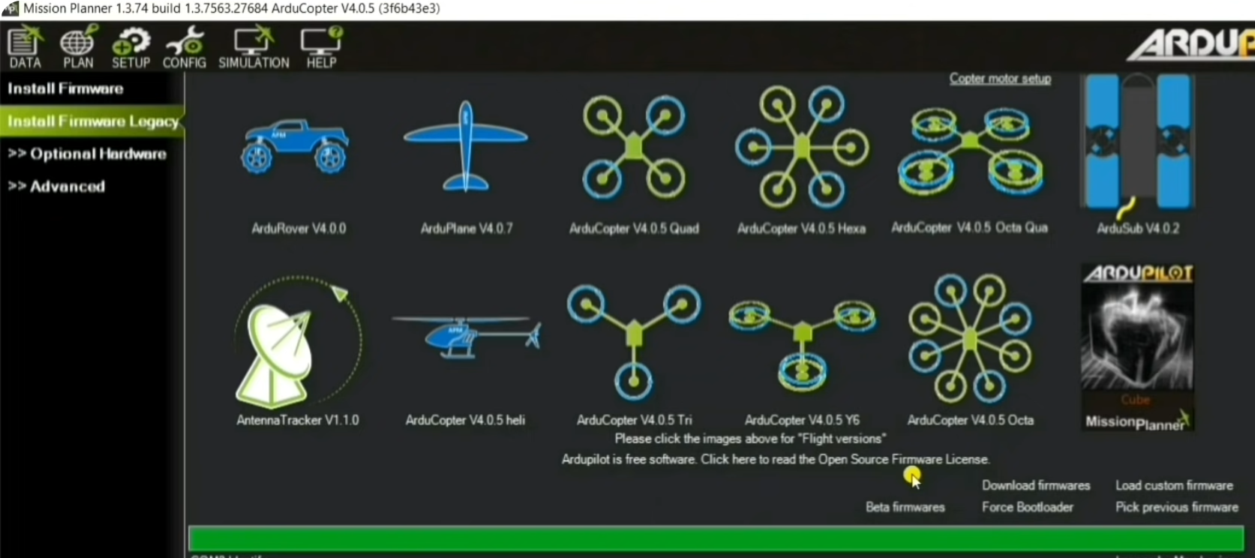
Fig B.1 Selecting the ArduCopter Option in the Mission Planner Software

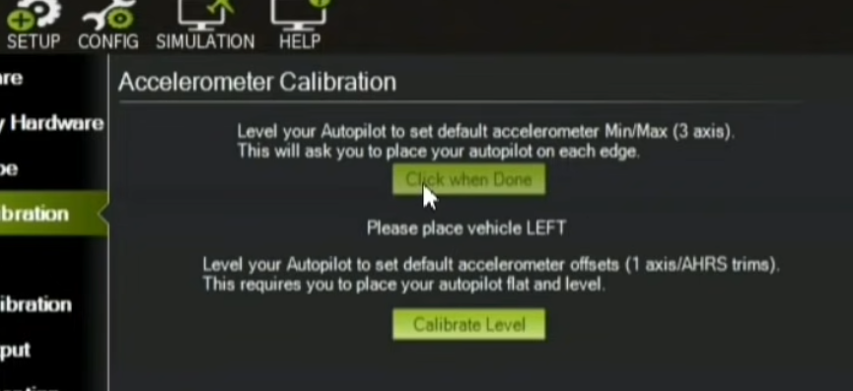
Fig B.2 Calibration of onboard sensors including the accelerometer, compass, and gyroscope.

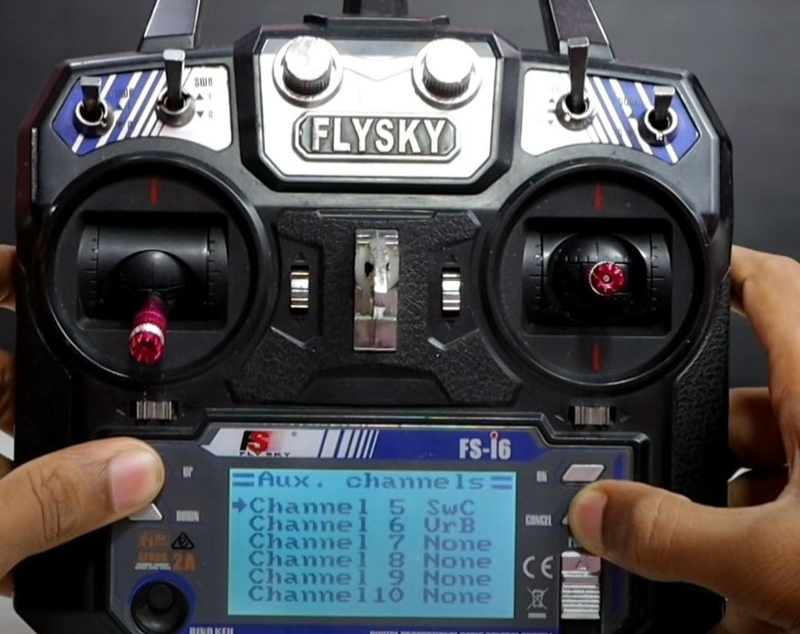
Fig B.3 RC settings configuration
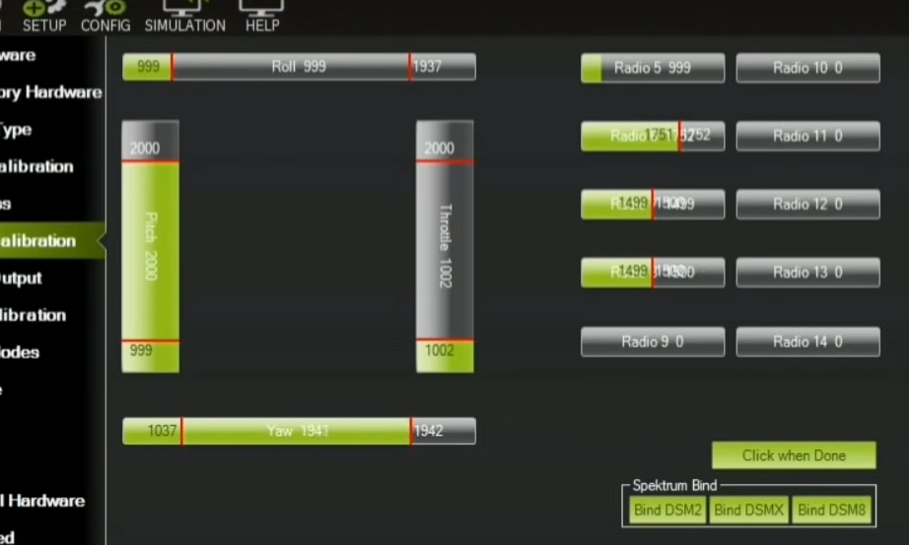
Fig B.4 Calibration of the RC transmitter using Mission Planner’s “Radio Calibration” tool.

