

**SE4050**

**Deep Learning**

**4th Year, 1st Semester**

**Lab 08**Submitted to

Sri Lanka Institute of Information Technology

**IT21169144**

In partial fulfillment of the requirements for the

Bachelor of Science Special Honors Degree in Information Technology

04/10/2024

Question 1:

Code Snippet Edit

Markov_Decision_Process File:

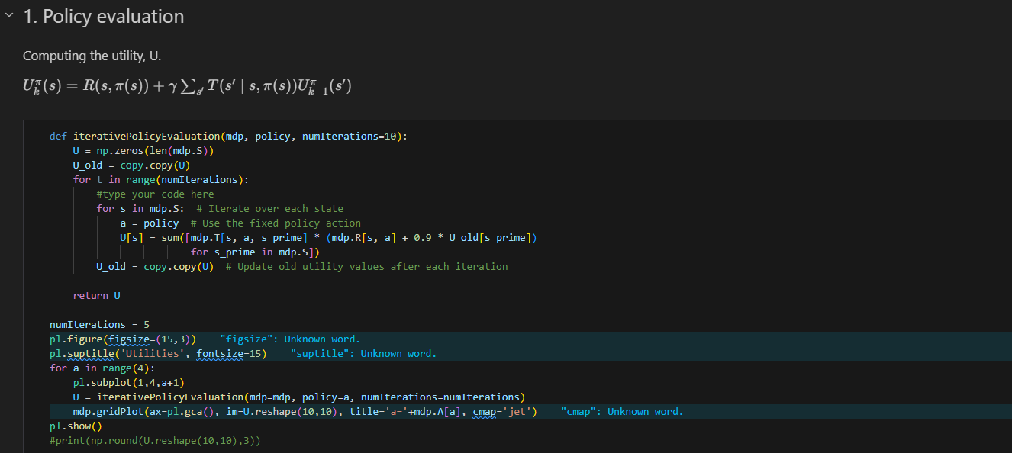

Gridworld File:

