
PROJECT REPORT
News Classification with Machine Learning Algorithms and Deep Learning

Group 1:
Abdul Basit (BSE-23F-045) [Lead]
Rohma Ikhlas (BSE-23F-099)
Yousra Kanwal (BSE-23F-182)

Course: Data Structures
Section: BS-SE(3A)
Course Instructor: Sir Muhammad Ameen Chahjro
Date: 7/January/2025

Introduction
In today’s world of vast information, automating news classification is essential. This project uses machine learning (ML) and deep learning (DL) algorithms to categorize news articles into topics like sports, health, and science.
Under the exceptional guidance of Sir Muhammad Ameen Chahjro, whose unmatched expertise and dedication have been truly inspiring, we were able to successfully implement and test algorithms such as:
- Naive Bayes
- Logistic Regression
- K-Nearest Neighbors
- Random Forest
- Deep Learning

Scrapping data and making Dataset
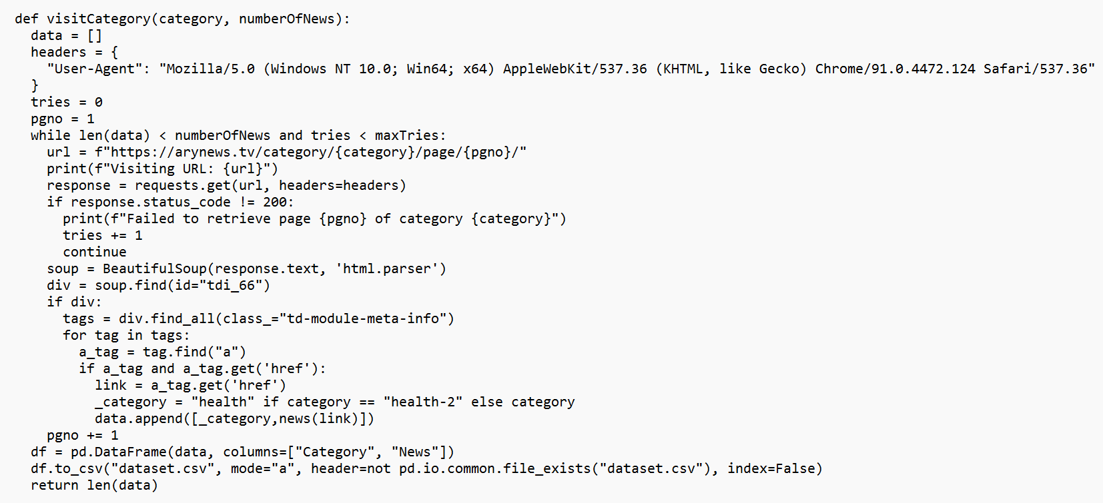
Working:
First we will visit each category news page and then collect each news and each page has 9 news and for 5000 news per category this has to visit 5000/9 pages in order to collect equal data for each category, this helps us to balance dataset while scraping.

Cleaning the dataset
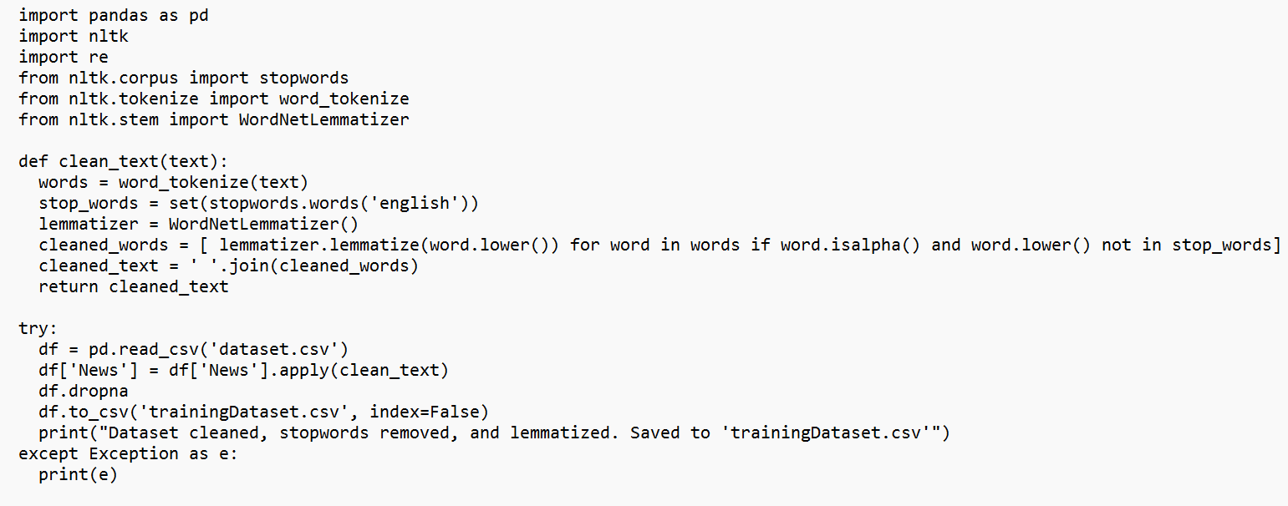
Working:
We now have to remove stopwords and lemmatize our dataset in order to make our algorithms perform better.
We use NLTK a popular python natural language processing library. After cleaning and lemmatizing we saved our CSV file as trainingDataset.csv

Plotting bar graph for null values:
Now we have plotted bar graph for each category before and after dropping null values.
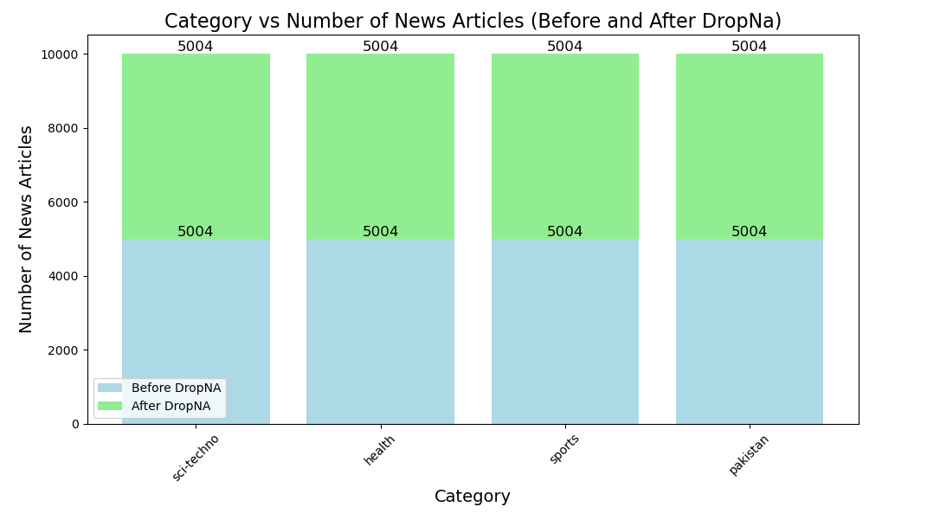
As we can see here there are 4 bars on each bar there is another bar for “After dropping NA” both are same means there were no null values and our dataset is now ready to be used by ML/DL Algorithms.

Using NaiveBayes Algorithm:
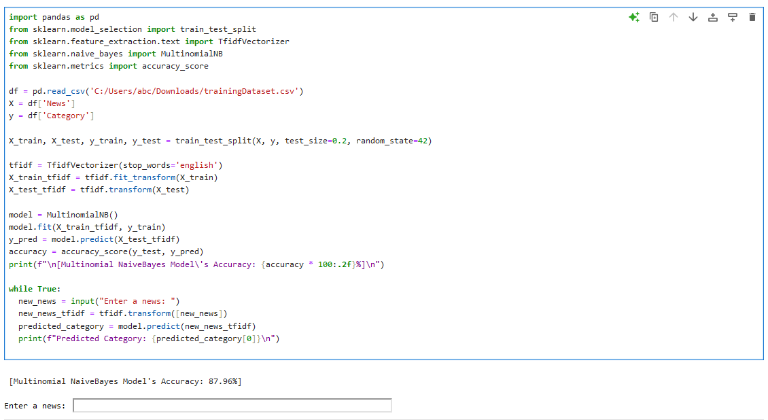
This algorithm has accuracy of 87.96%.
Now we can take input from user to test our NaiveBayes model
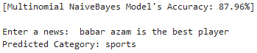
As we can see it classified our new input news as sports correctly!

Using Logistics Regression:
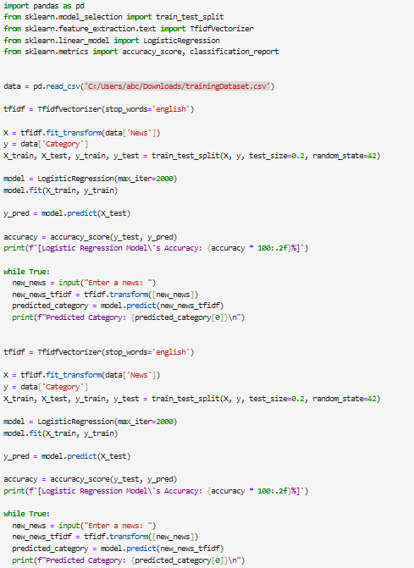
This algorithm is 88.01% accurate this is the highest performing ML algorithm so far for our dataset.
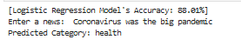
We can see our user given input news was classified correctly has “health”.

Using K-Nearest Neighbor:
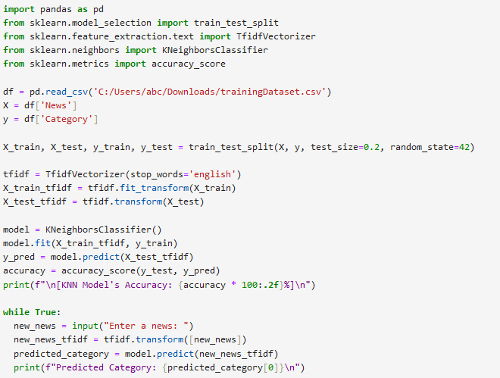
This model has 84.02% accuracy and it classified our news correctly as “Sci-Techno”.

Using Random Forest
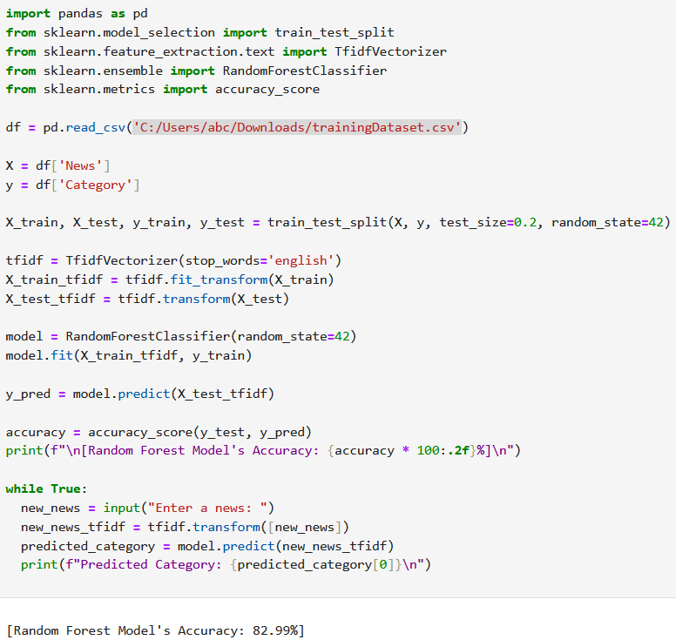

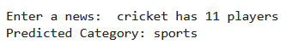
The random forest has accuracy of 82.99%
This classified our news as sports correctly!

Using Deep Learning:
We used Sequential and Adam optimizer for training our model.

With 10 epochs:
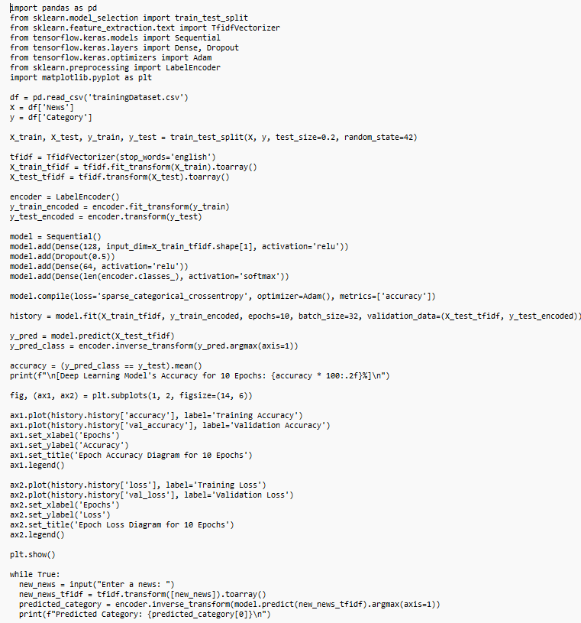

With 20 epochs:
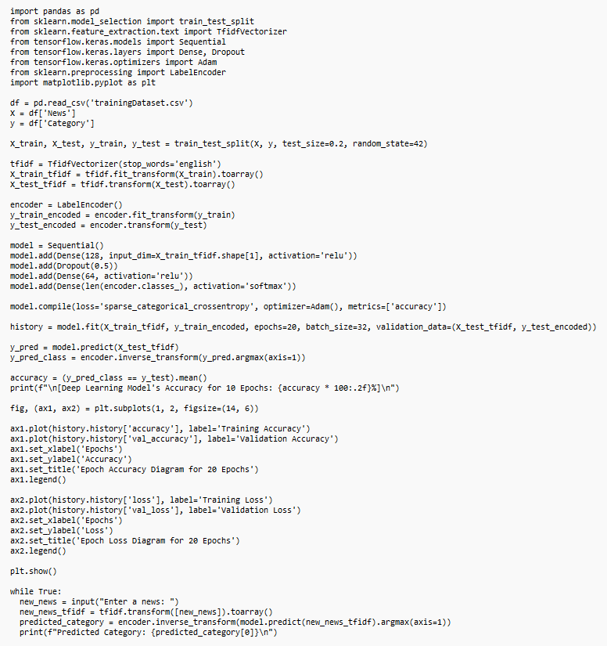

Now we plotted Accuracy and Loss graphs for 10 and 20 epochs.

