DOCUMENTATION

London Stock Exchange Group Sri Lanka - Exchange House



**AYS FONSEKA**

PART 01 – Scripting

1.Sign into the console.

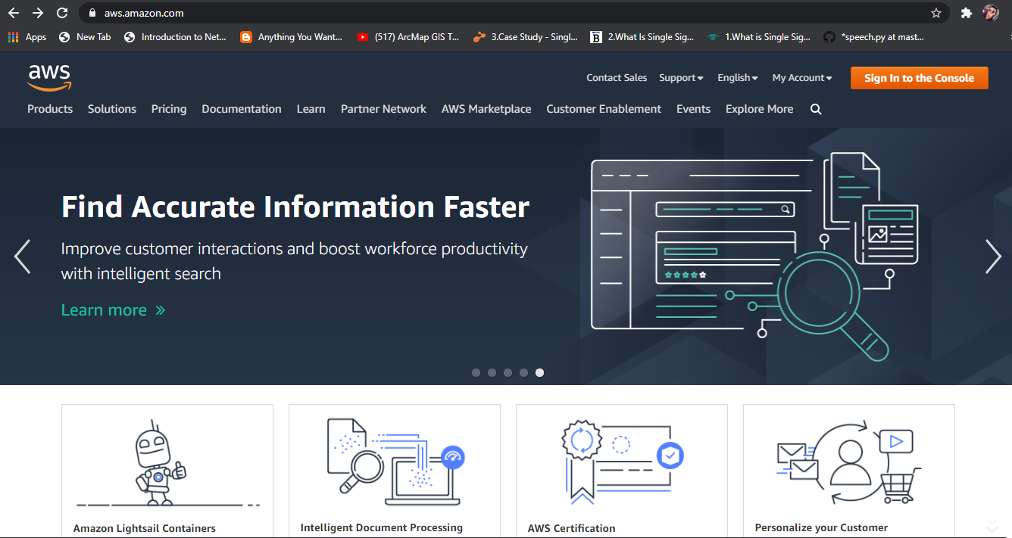

2. Select or search for EC2 instance.

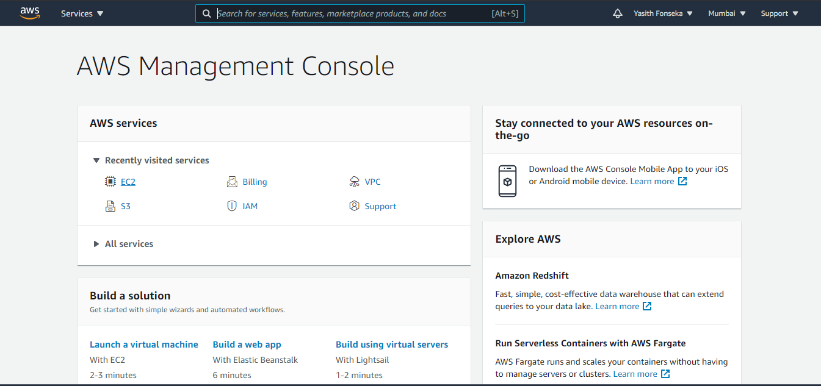

3. Select your region

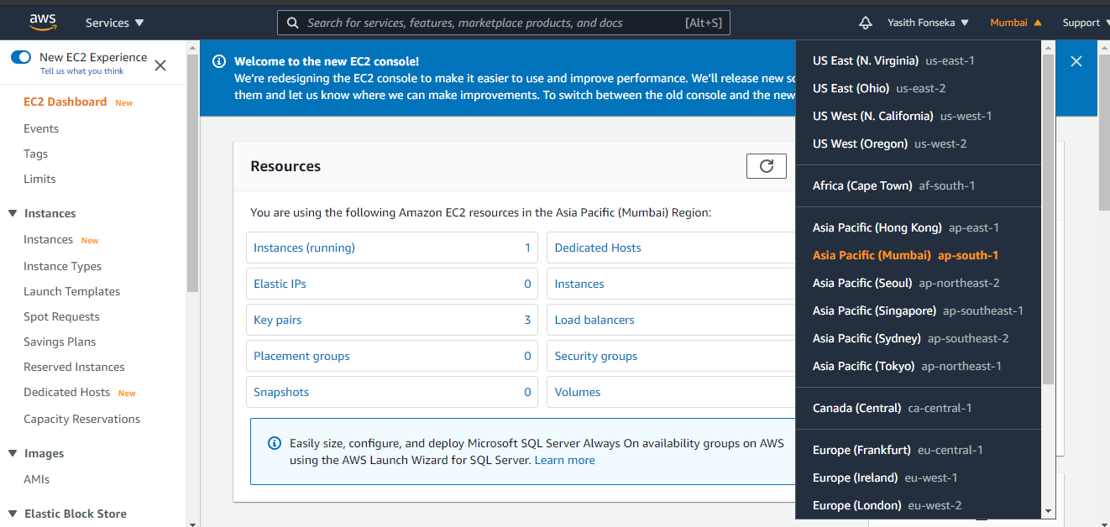

4. Select “Instances” tab

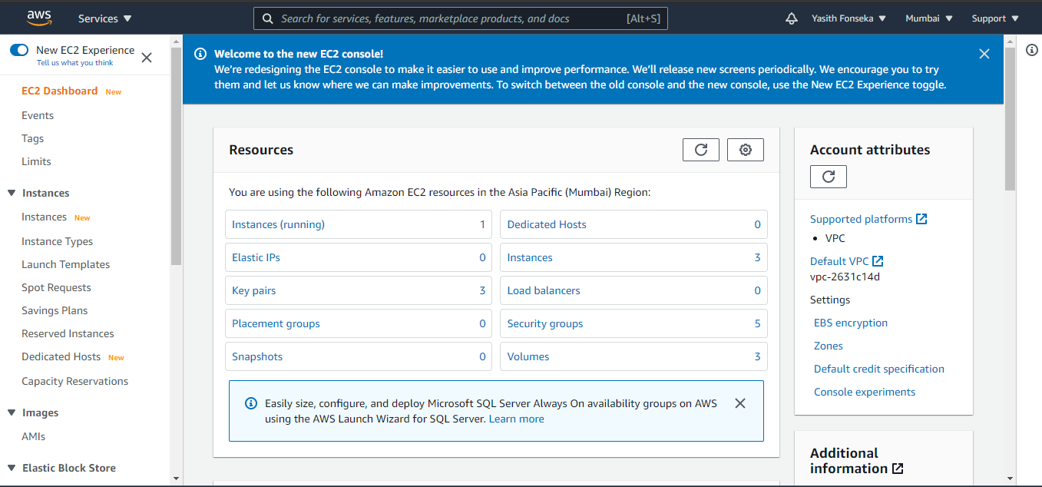

5. Select “LAUNCH INSTANCES ”

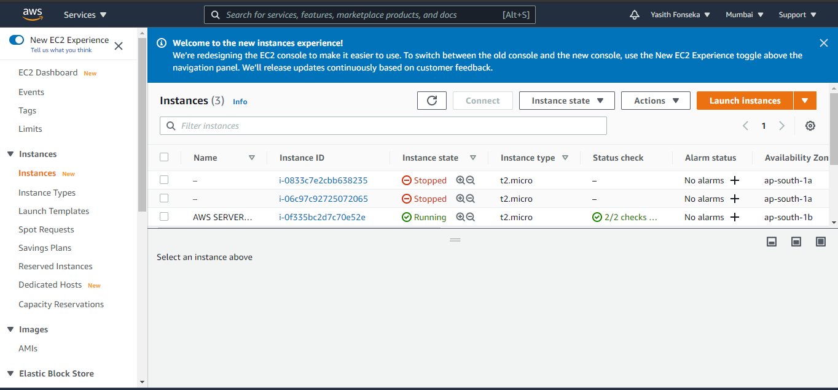

6. Choose “**Amazon Linux 2 AMI (HVM)**”

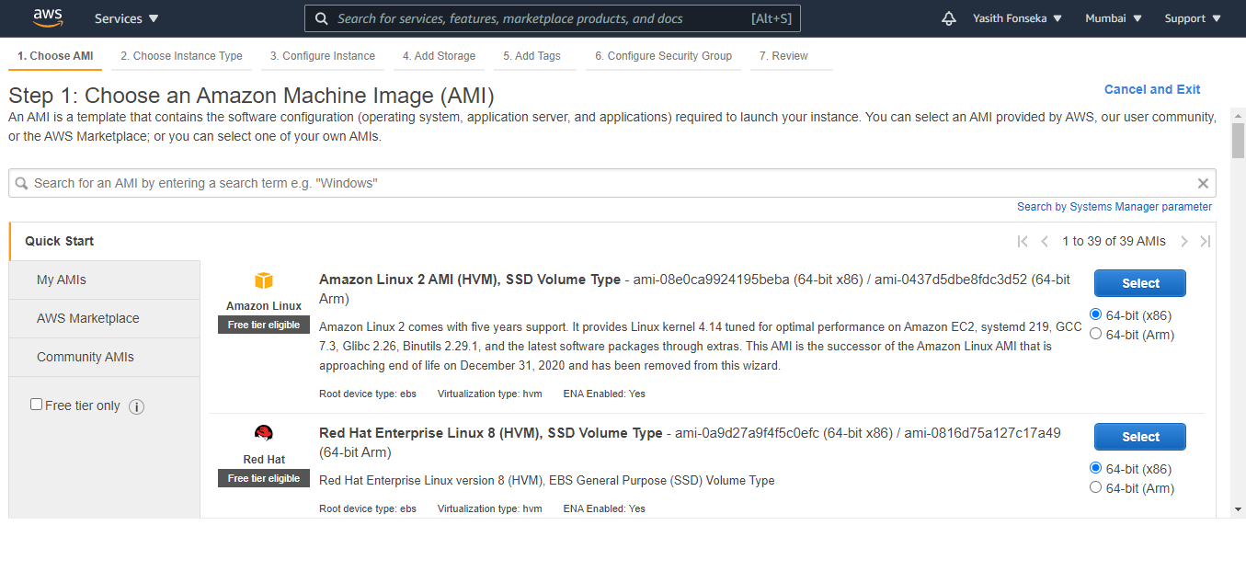

7. Selected “Free Tier Eligible” one and clicked “Configure Instance Details”.

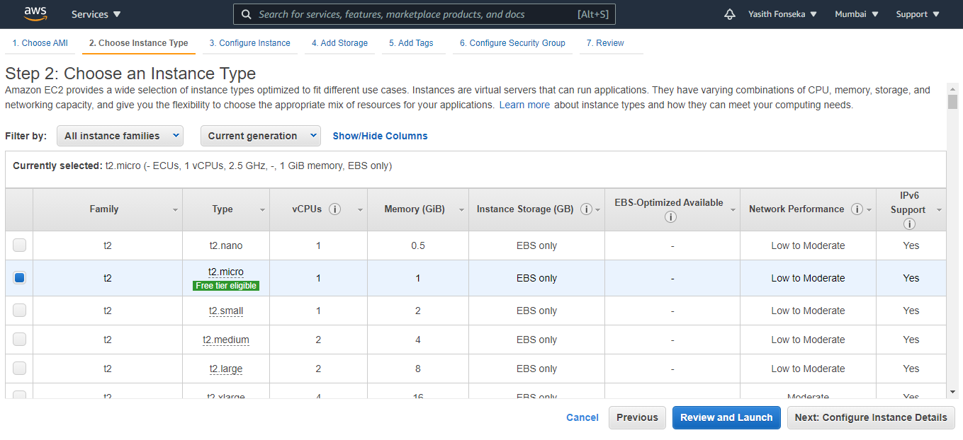

8. Kept this as it is and clicked “Add Storge”

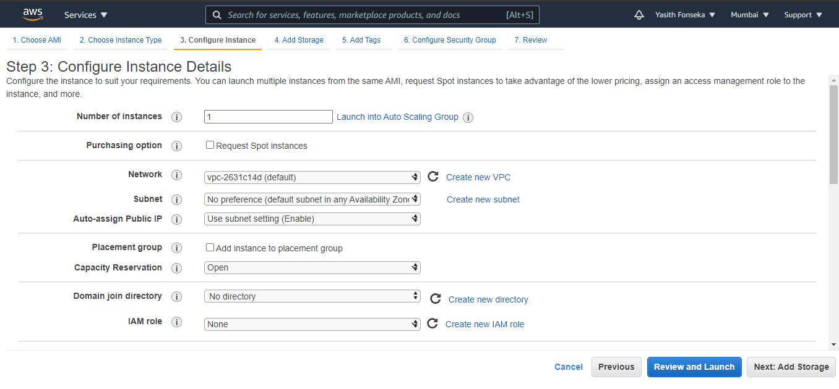

9. This one also kept as it is and clicked “Add Tags”

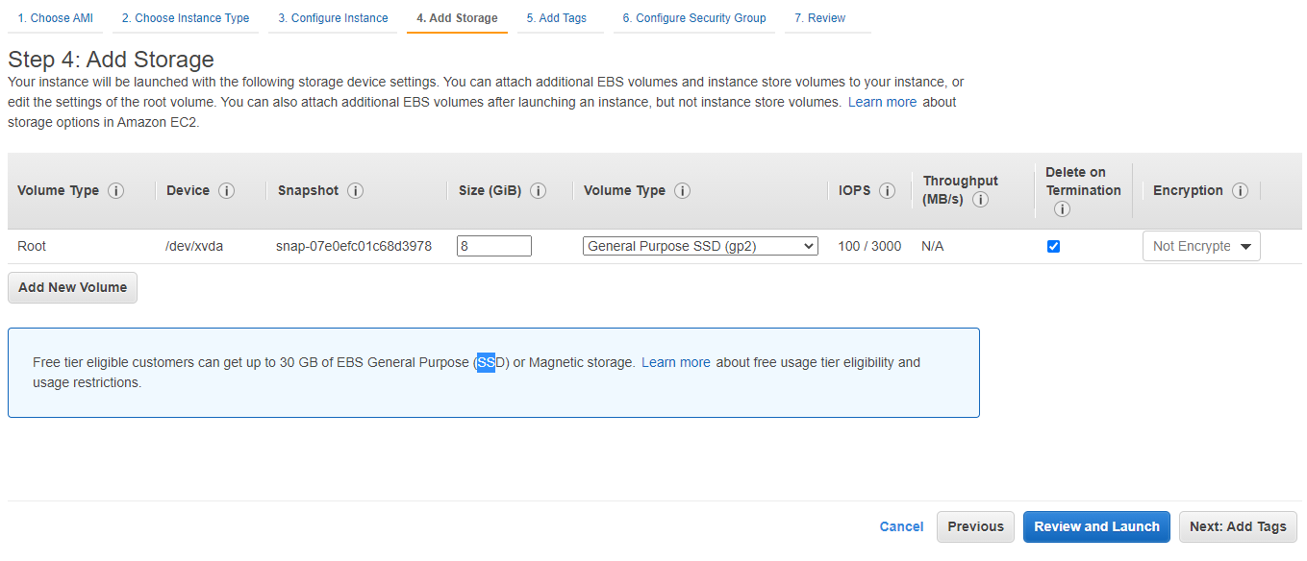

10. Kept as it is and clicked “Configure Security Groups”

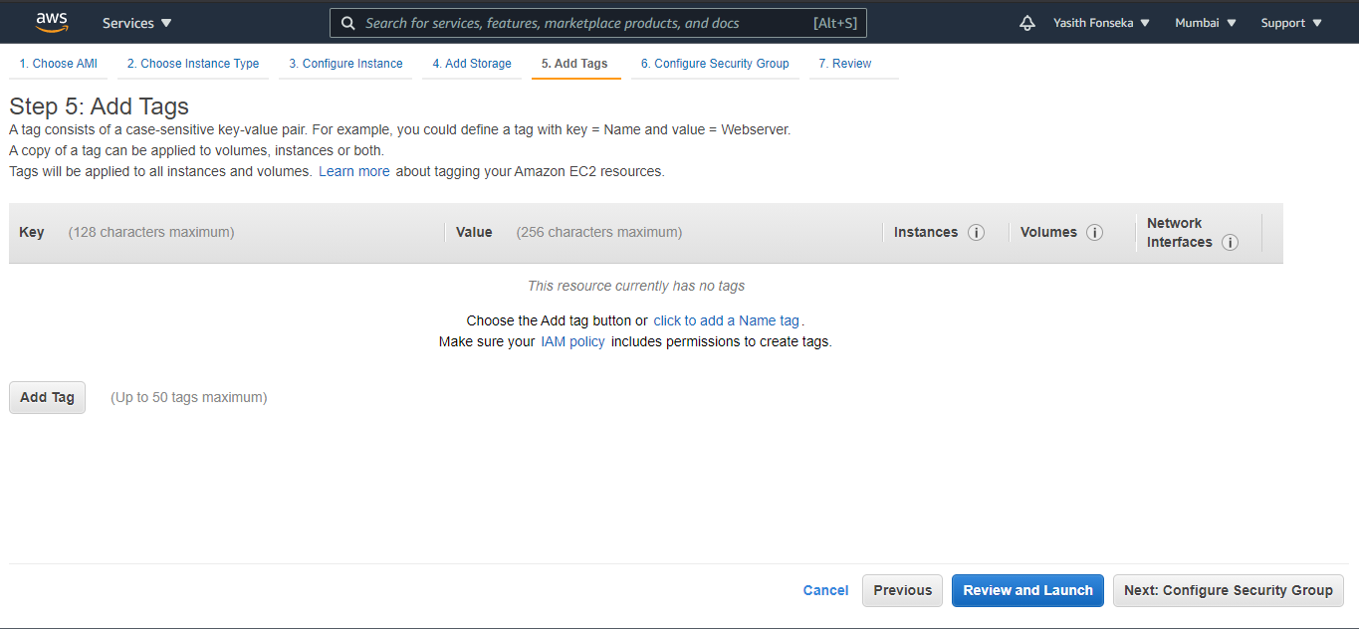

11. Here need to add a rule. For that click Add Rule button and select “Custom TCP rule and fill as shown below.

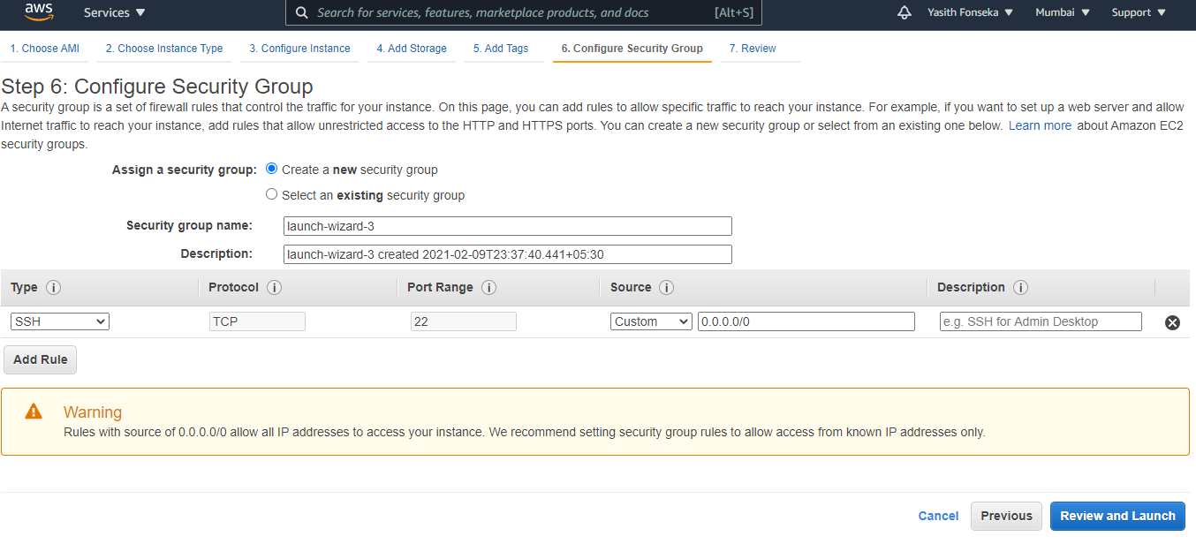

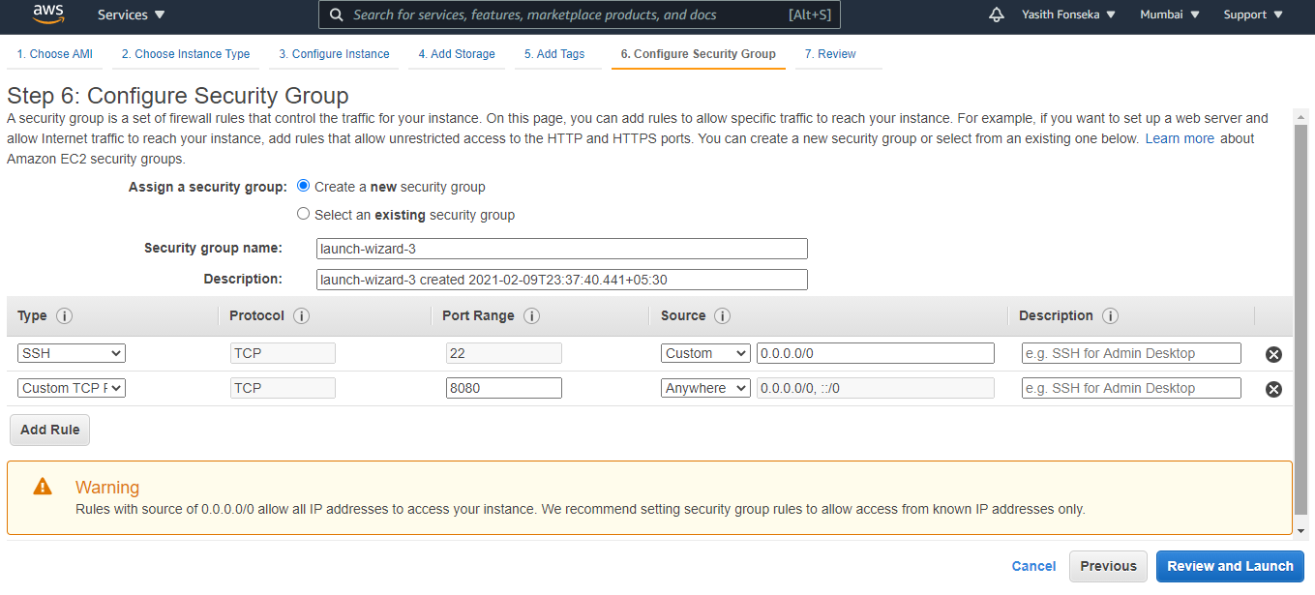

12. Keep it as it is and click “Launch”

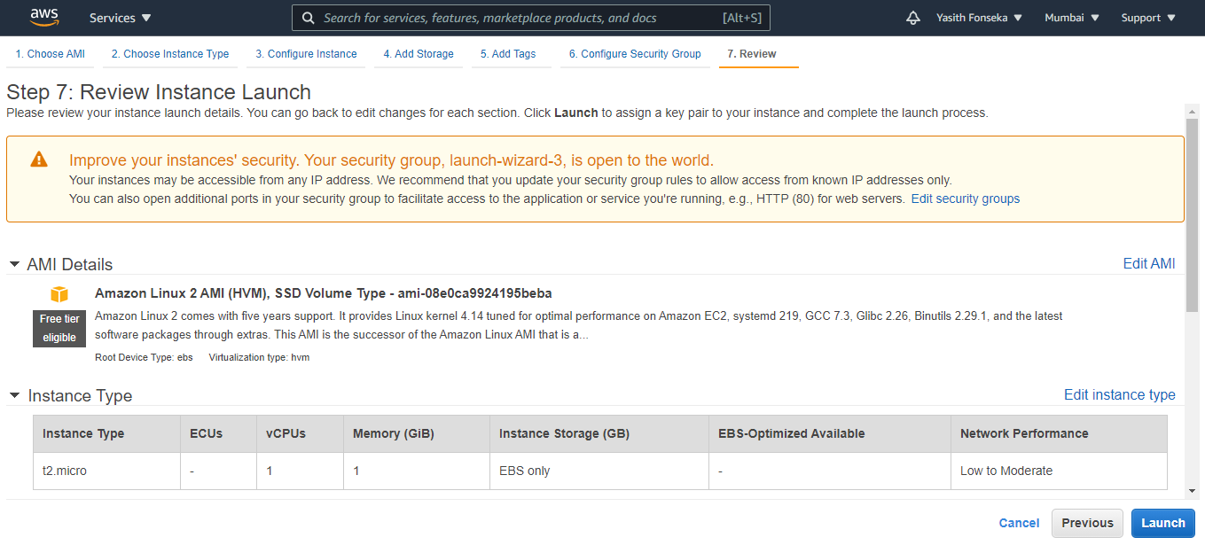

13. Here need to create a new key pair and download.

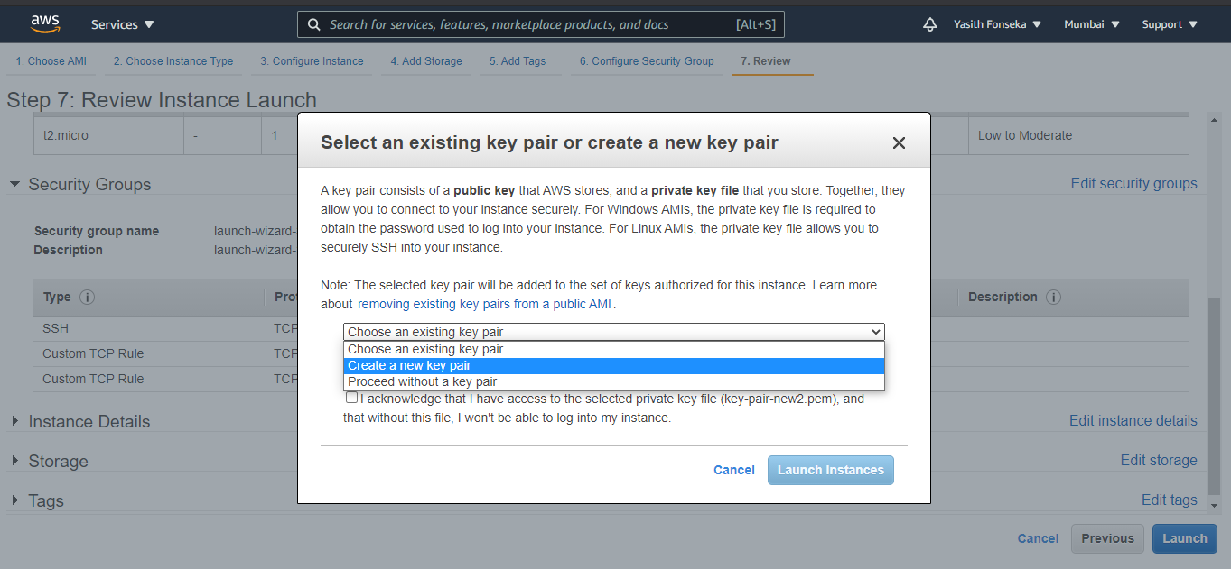

14. Click on the “Launch Instance”

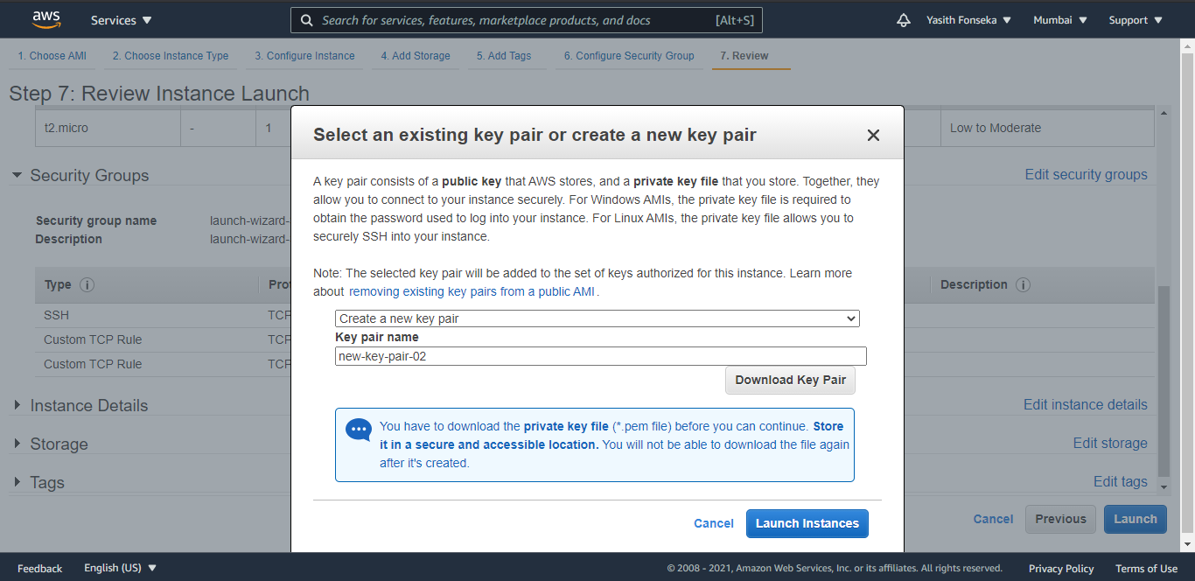

15. After few seconds ec2 instance will come to running state.

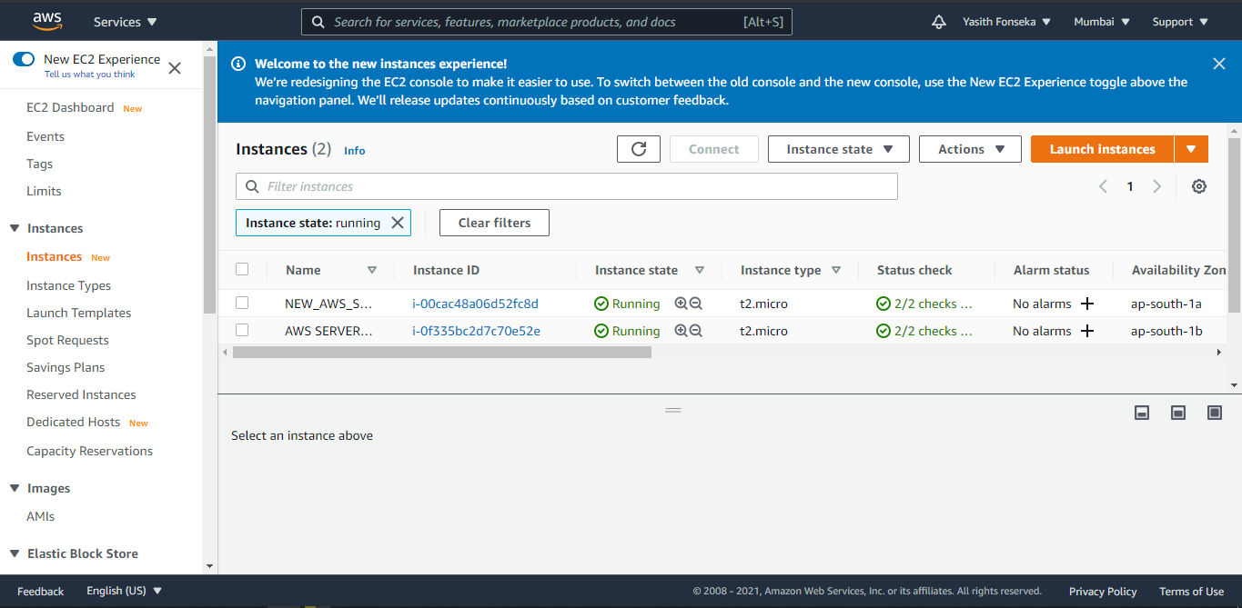

13. Then need to open PUTTYGEN

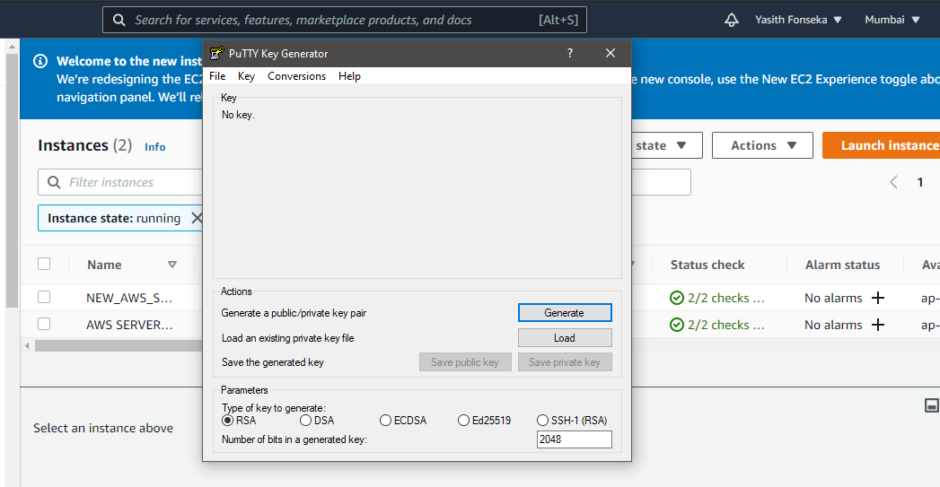

14. Here import the “.pem” key which we generated while setup setup ec2 instance.

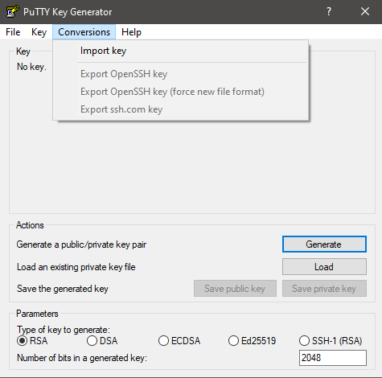

15. After importing your key click on the “Save private key” in order to save private key.

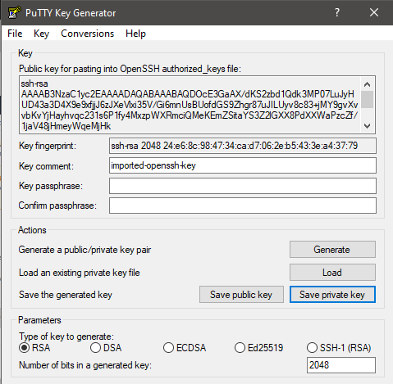

16. Then Search for “PuTTY” and open it. Give your ec2 instance’s public ipv4 address as given below.

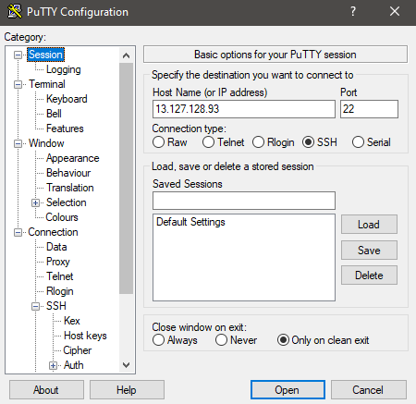

17. Then click on “SSH” in the left side panel and click on “Auth”. Browse you saved private key in give it here. After given your private key click on “OPEN” button.

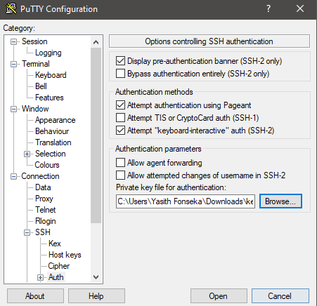

18. You will get this kind terminal. Here type “ec2-user” and hit enter. Go to the root.

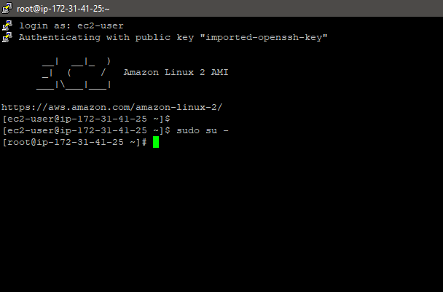

19. In order to install apache do as below.

Reference(<https://docs.aws.amazon.com/AmazonRDS/latest/AuroraUserGuide/CHAP_Tutorials.WebServerDB.CreateWebServer.html>)

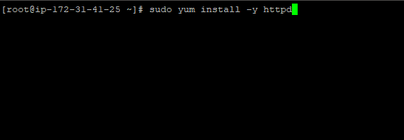



20. You can start apache service using below command.

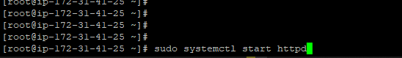

21. For further configuration need to do as follows.

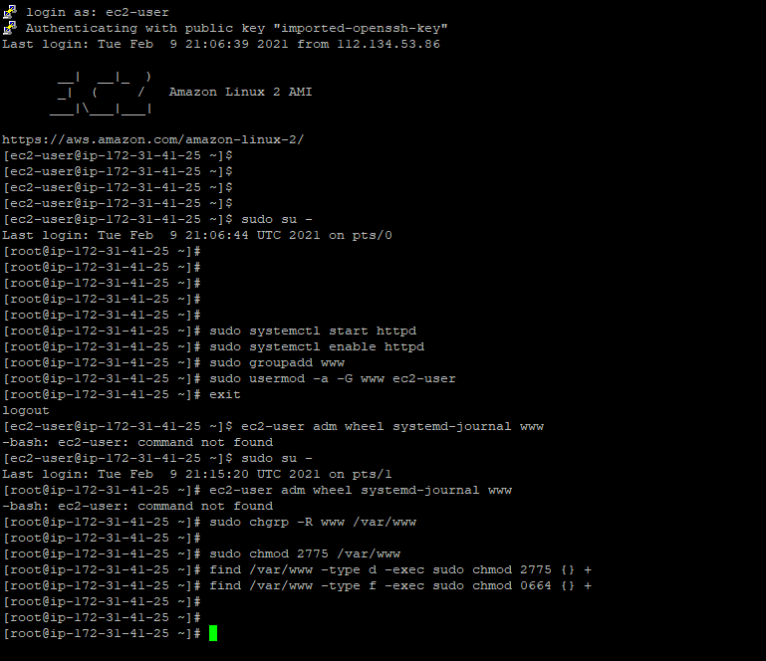

22. After done all of this as mentioned go to the dashboard and copy your “Public IPv4 DNS” and paste it as below. Then you will get page like this. Which mean you have successfully installed Apache server on you server.

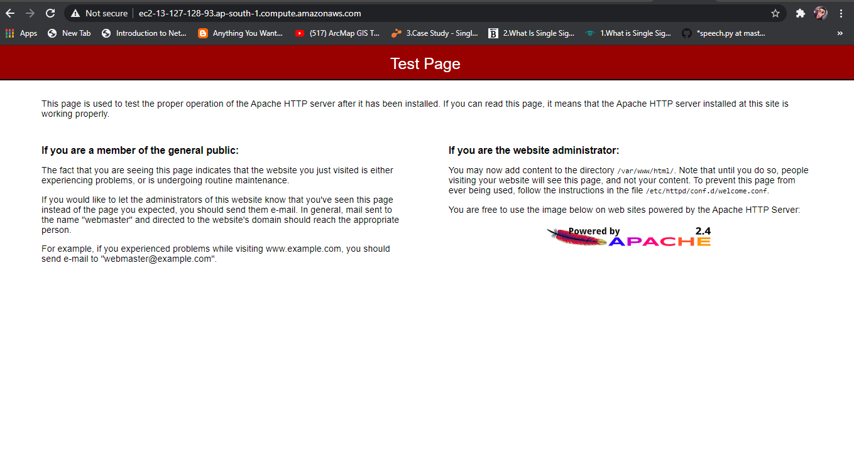

23. Go to /var/www/html. Create your own page like below.

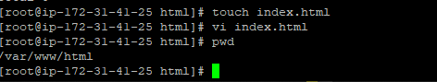

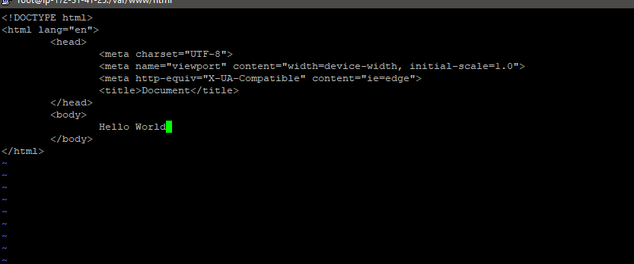

24. Then reload your page again and you will get this kind a page.

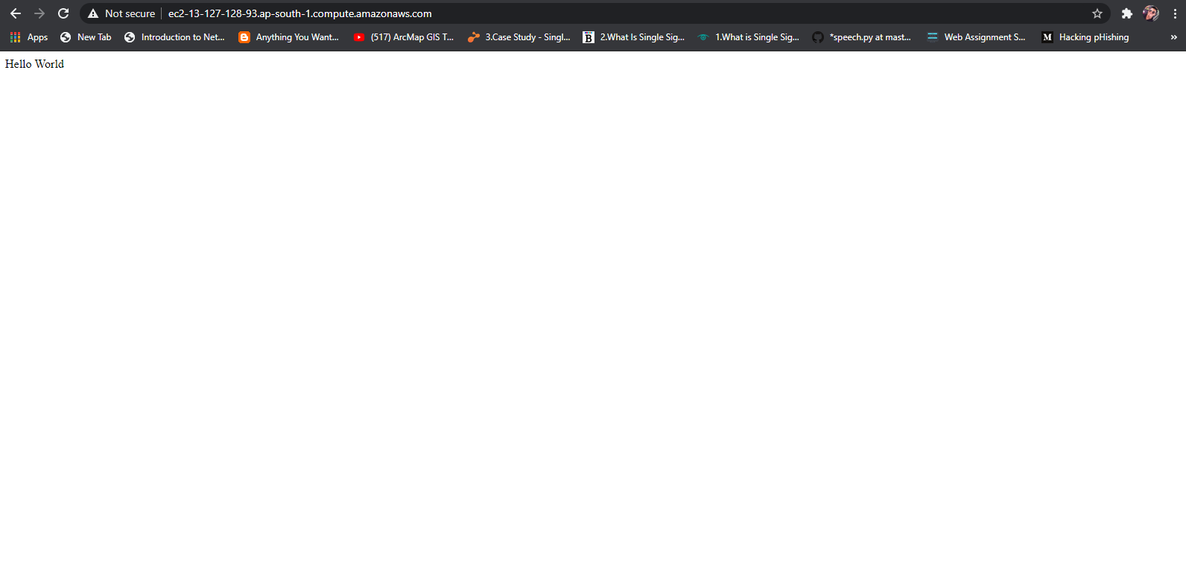

Here is the URL for public server:

(ec2-13-126-4-143.ap-south-1.compute.amazonaws.com)

Question 3

3.1

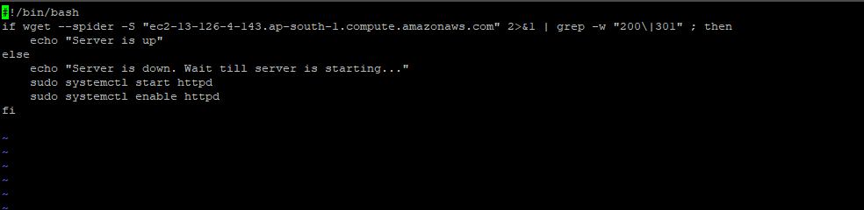

3.2 – 3.4

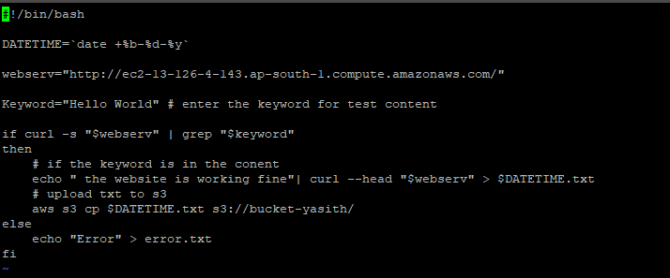

Question 4

4.1 – 4.4

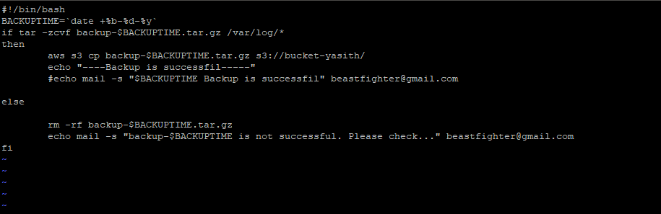

4.1 Setup to take one compress file daily.



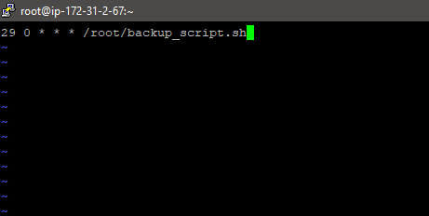

Git link for scripts -: https://github.com/yasithfonseka/assignment.git

Setup s3 bucket.

1. First need to search s3 and load the s3 dashboard
2. You will get dashboard like below and click on the “Create Bucket” .

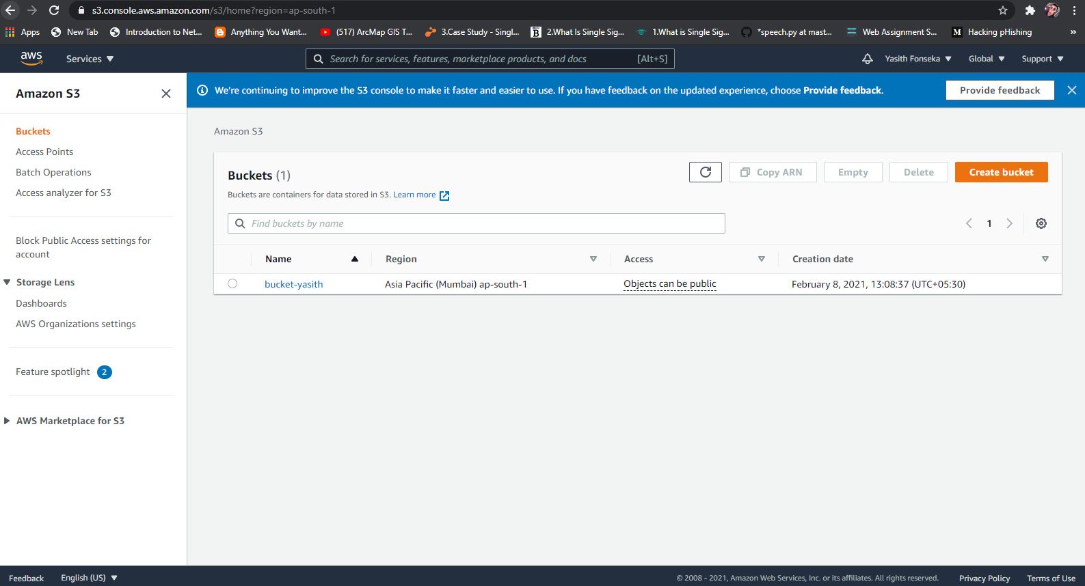

1. Here gives a unique name for bucket and click on “Create Bucket”

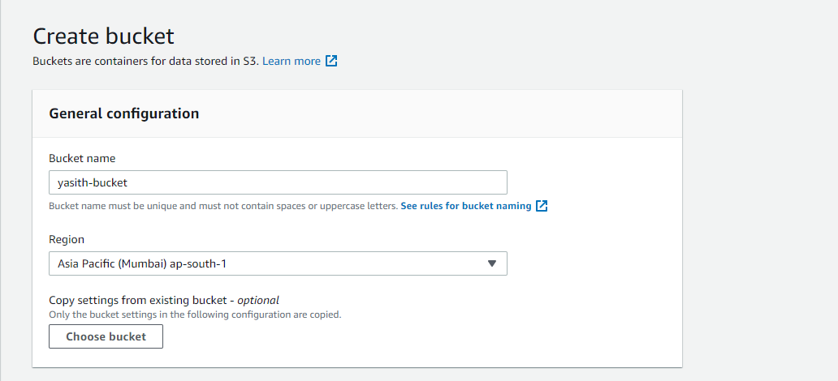

1. Then you can upload your files/ backups to the s3 bucket. In my case I used

“aws s3 cp $BACKUPTIME.tar.gz s3://bucket-yasith/” command to upload files. But before that you need to configure S3 bucket in your terminal.

1. After that will be able to upload files like below

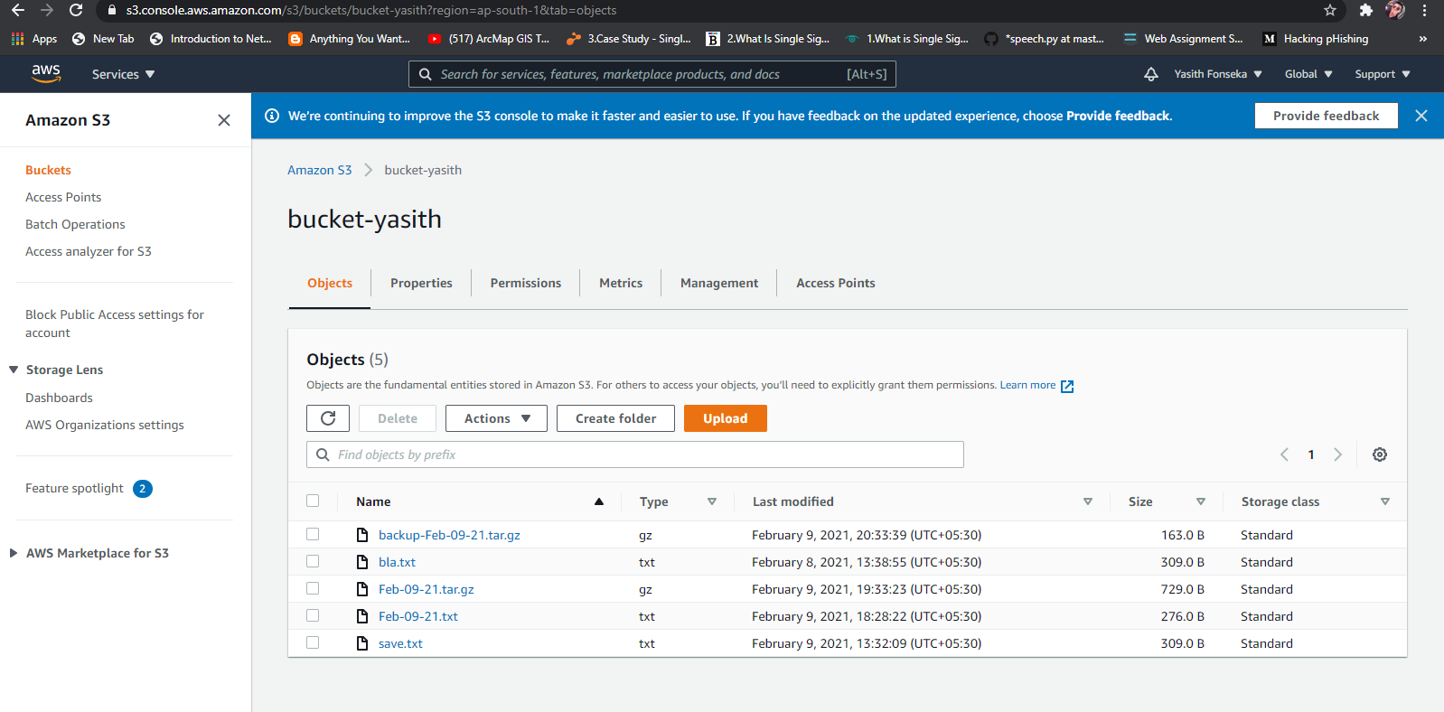

Setup git for upload files

1. Here I have attached screenshots that how I proceeded with that task.

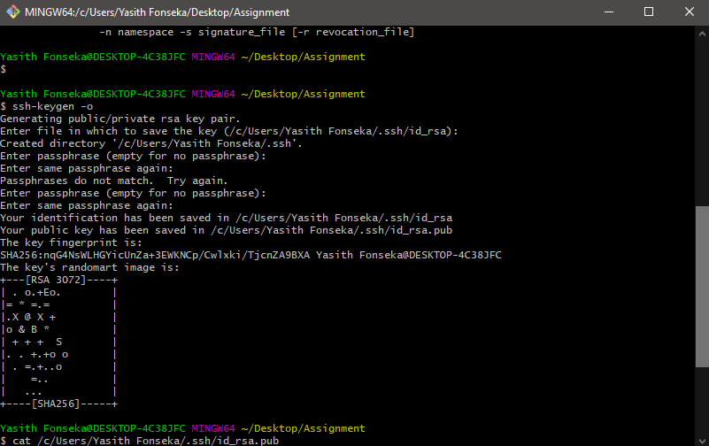

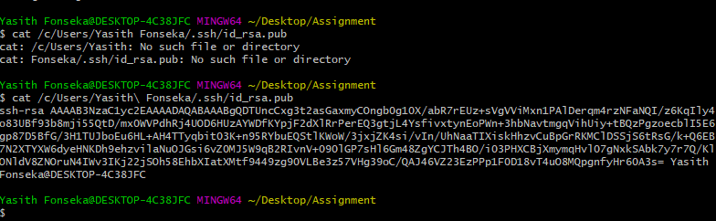

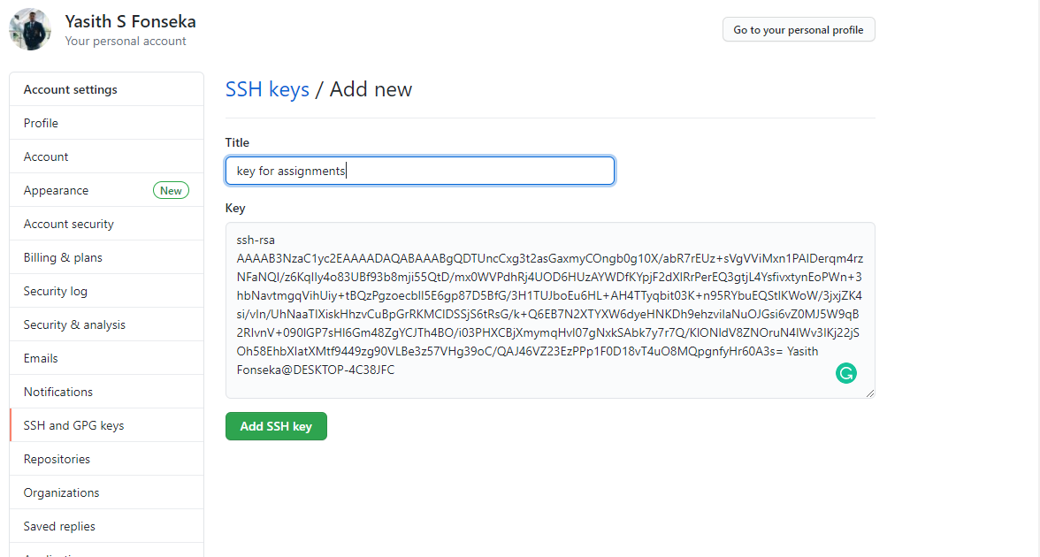

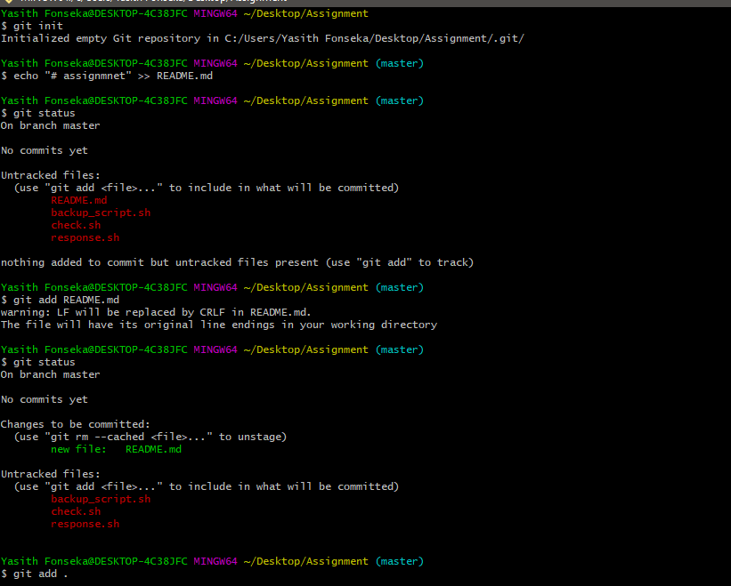

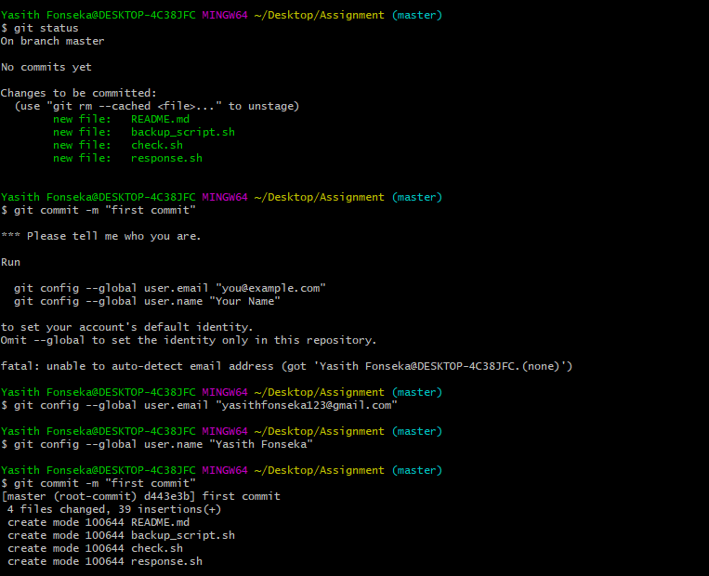

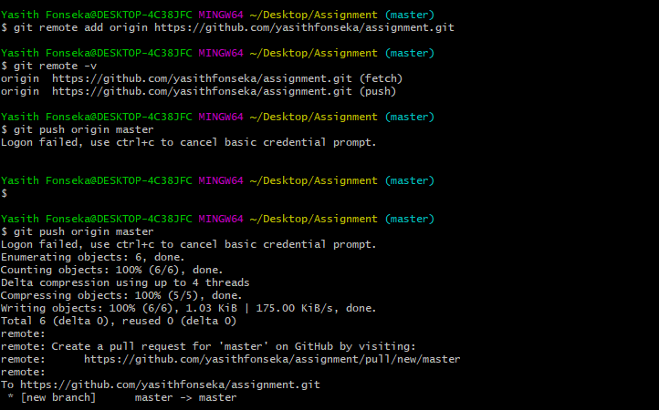

https://github.com/yasithfonseka/assignment/compare/master?expand=1