ESSENTIALS OF ARTIFICIAL INTELLIGENCE

INDIVIDUAL CONTRIBUTION SHEET

Student Name | Yasith Nirmal Peiris | Registration No. | D/BSE/25/0018
Degree / Intake | Information Technology / 2024 | Group No. | 44
Project Title | Scam Sentry: An Intelligent Fake Job Advertisement Detection System

Technical Contributions:
Task / Component | My Contribution | Tools / AI Technique Used | Evidence / Output
1. Risk Engine & indicators | Designed the rule-based Risk Engine: graded indicators (C1-C4 critical, H1-H6 high, M1-M5 medium, L1-L3 low), first-match-wins determination rules, evidence-based confidence, language discipline (never claims 'fake'), employer verification, freshness / ghost-job signals and a deterministic safety net so a Critical indicator can never be averaged away by the ML score. | Rule-based reasoning  Python  pytest (test_engine, test_risk_floor) | 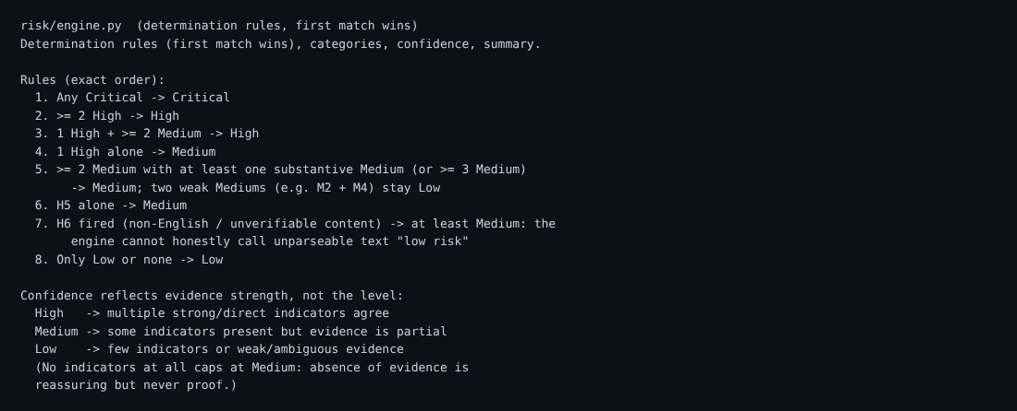  Fig 1 - risk/engine.py determination rules  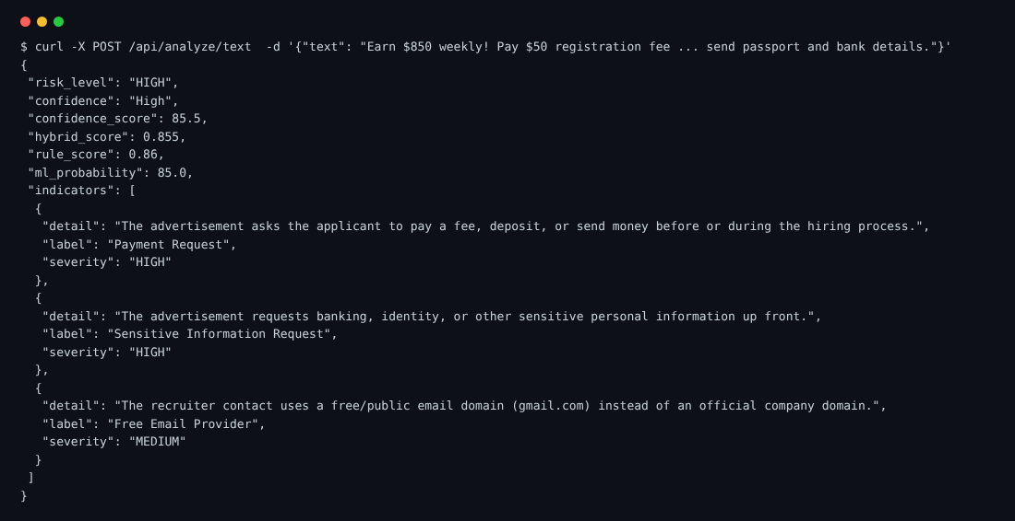  Fig 2 - Analysis API response
2. Job board scanner & scheduler | Built the scanner framework with a plug-in registry and ten public-source scanners (RemoteOK, Remotive, Arbeitnow, Jobicy, Himalayas, Working Nomads, LaraJobs, Greenhouse, Lever, Ashby), URL de-duplication, per-source error isolation and the scheduled scan service that runs every listing through the Risk Engine. | Python, requests  Python threading scheduler  Public JSON / RSS APIs | 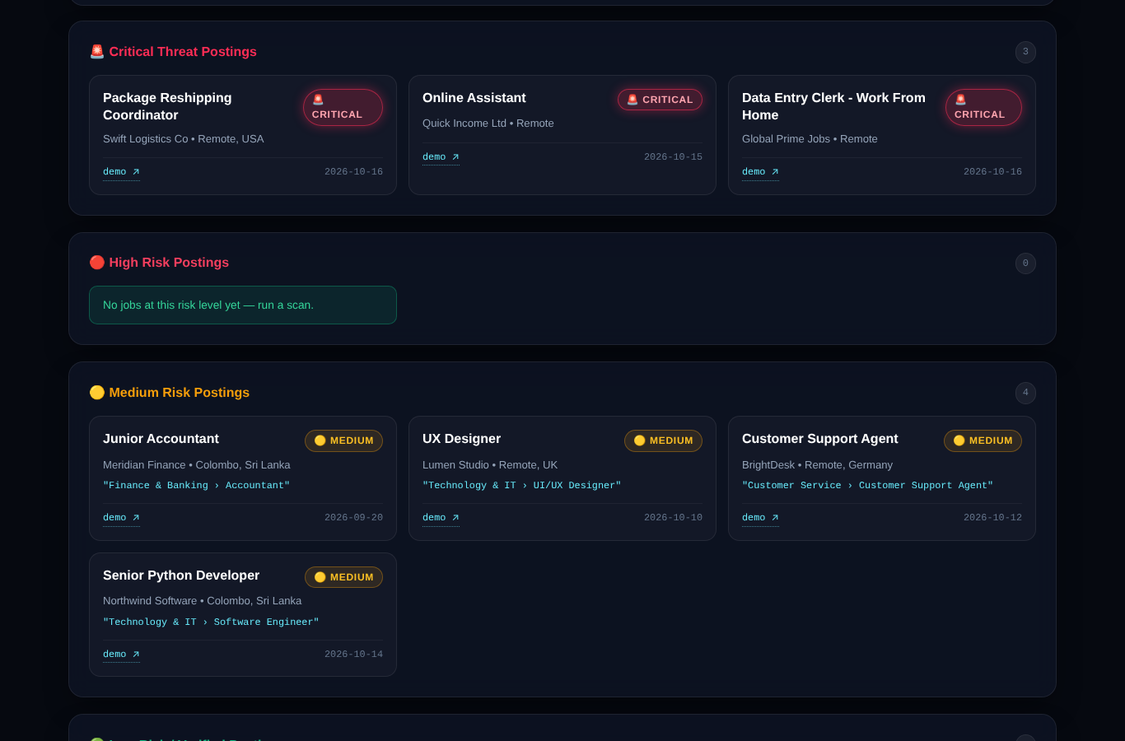  Fig 3 - Scanned jobs grouped by risk level
3. Storage, security & API | Implemented the storage layer (SQLite and PostgreSQL behind one API, location backfill) and the REST endpoints for scanning, jobs, history and sources. Added scan-token auth, per-IP rate limits, CSP headers and fail-closed LLM start-up; added the optional LLM explanation layer. | Flask, Flask-Limiter  SQLite / PostgreSQL  Render deployment | 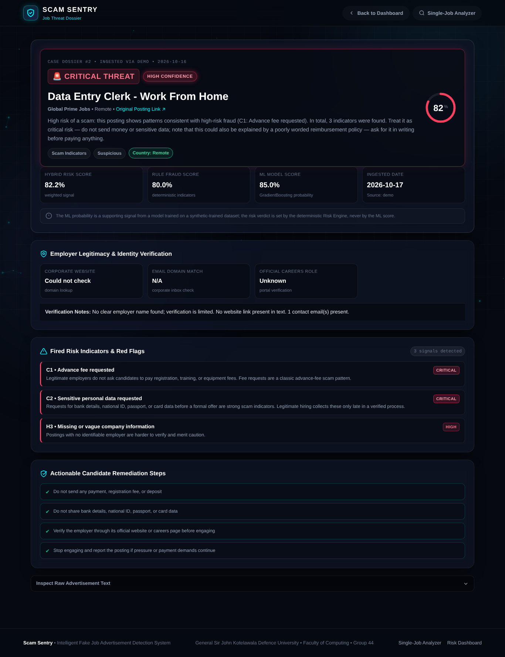  Fig 4 - Job dossier served from stored data
4. ML calibration, taxonomy, location & CV matching | Calibrated the ML probability and labelled it honestly as a supporting signal trained on synthetic data. Built the industry / job-role taxonomy, country and region resolution (including bare city names), dashboard filters and the CV matcher that ranks jobs by relevance, never as a risk verdict. | scikit-learn calibration  Python, JavaScript  Keyword / taxonomy matching | 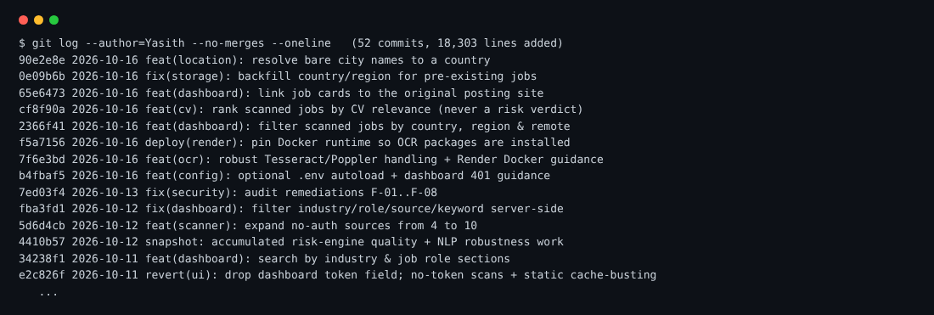  Fig 5 - Commit history (git log)
5. Testing & CI | Wrote the large automated test suite (indicators, risk floor, scanners, abuse control, NLP robustness, location, CV matcher, dashboard, scan API) and CI workflow, and recreated the project documentation. All 403 tests pass. | pytest  GitHub Actions  Python | 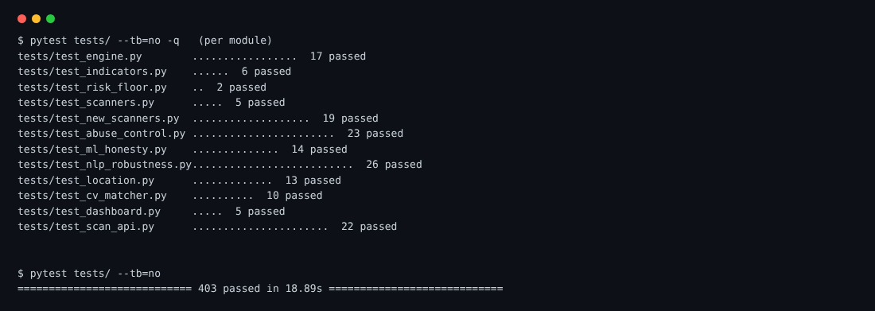  Fig 6 - pytest results (403 passed)

Declaration
I confirm that the contributions listed above accurately represent my individual work in this group project, and I can explain or demonstrate the stated work if required.
Student Signature: | ________________________ | Date: | 17/10/2026
Evidence may include source code, model/notebook, diagram, dataset work, test results, screenshots, report section or presentation slides.

