**GO SETUP** 

1. Download and install Go: <https://go.dev/dl/>

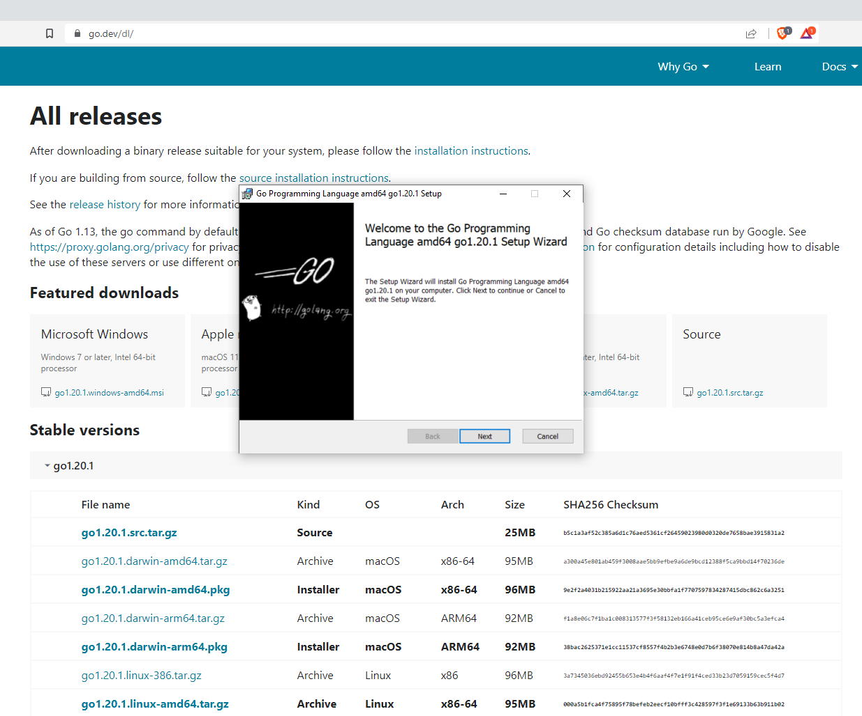

1. After installing it, open a terminal, type “**go**”, and press enter.

- You can also use “**go version**” to check the version installed.

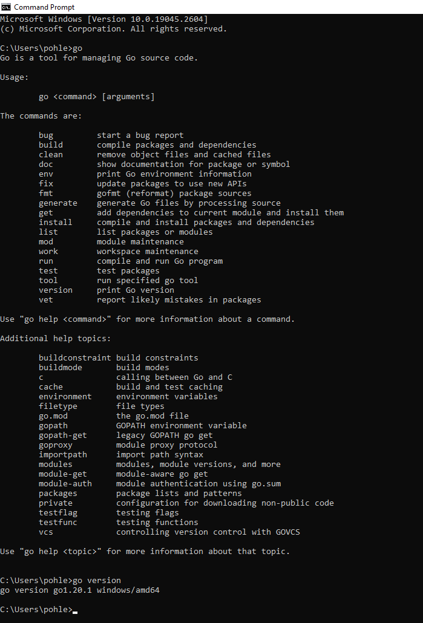

1. Create a folder in your source folder to save your go files and open it on Visual Studio Code.
2. Install the Go extension for VS Code.

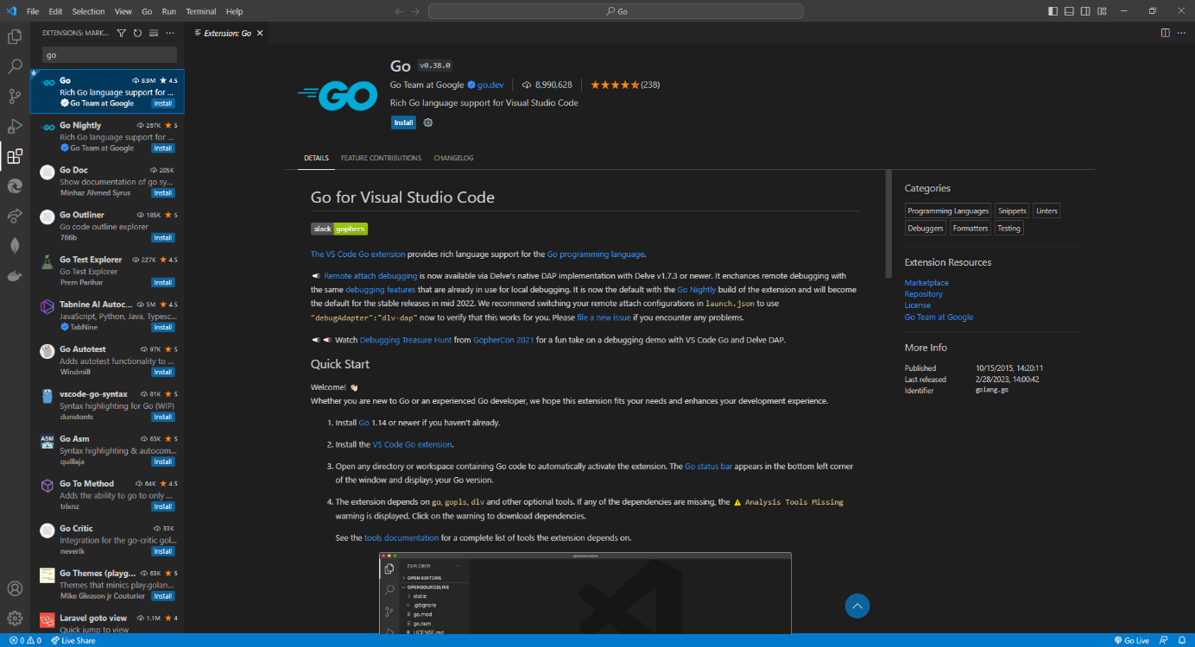

1. Create a new go file (I named it test.go, but you can name it whatever you want as long as it has the .go extension). When you create this file, you are going to see one or more pop-us on the bottom-right-corner of your screen. Click on “**Install all**”.

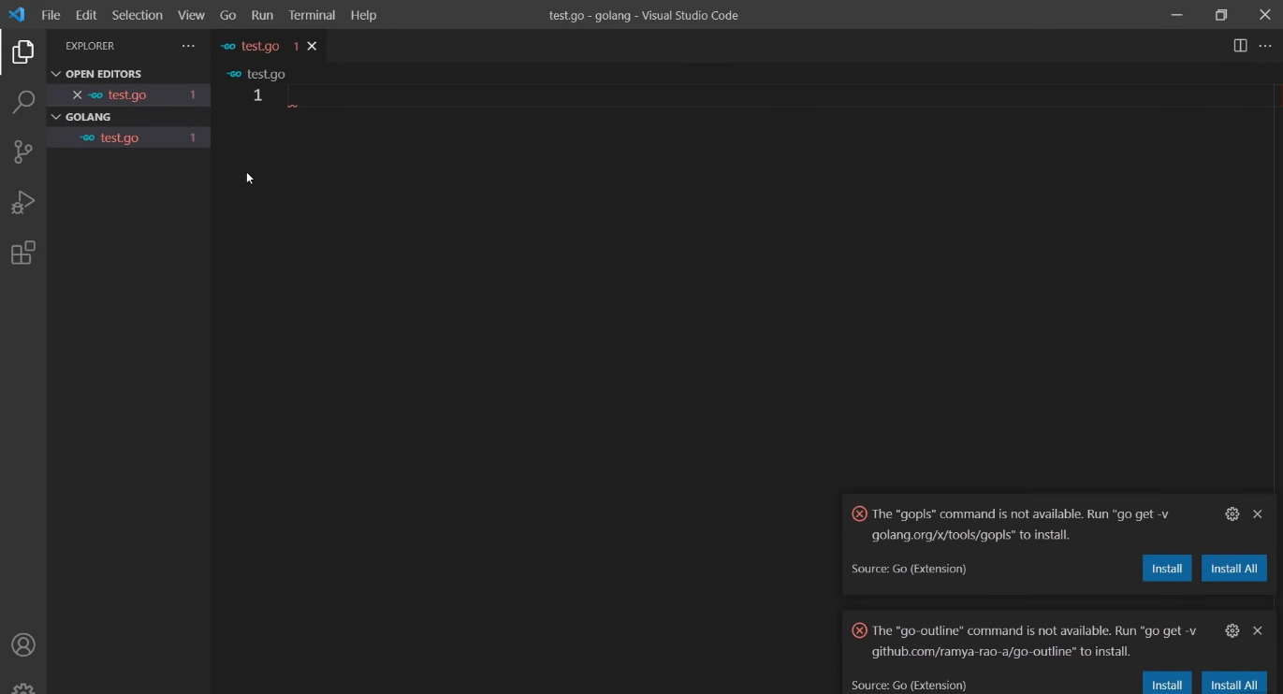

1. The previous step will install all the Go tools required to get the full support inside vs code for Go files.
2. Once it is completed, your VS Code will be ready and set up to work with go files!

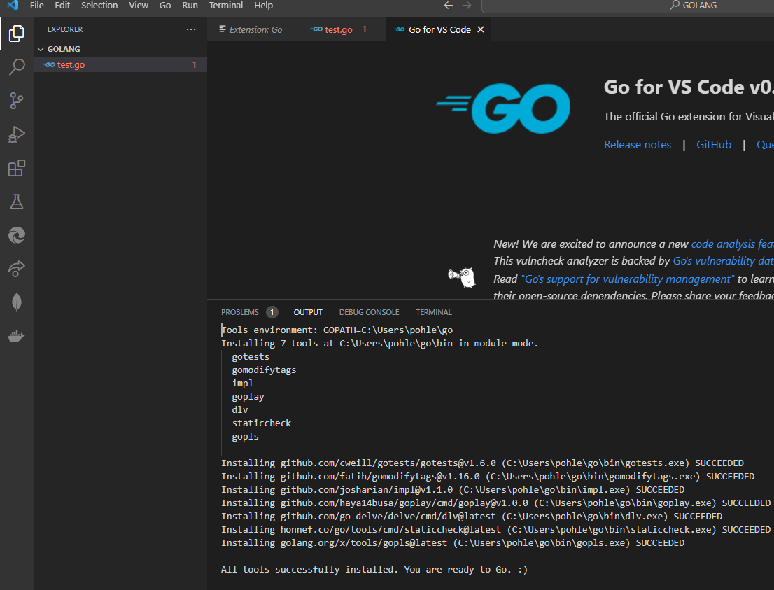

* Don't worry about the error on the test.go file. That happens because it is an empty file. If you got to this point, you are good to Go!
* If there is any issue setting it up, don't hesitate to get in touch with Eduardo and Yasmin; we will be happy to help you.
* This set up is also available on: <https://youtu.be/etSN4X_fCnM?t=188>

