

**An-Najah National University**

**Faculty of Engineering**

**Dos Project Report**

|  |
| --- |
| **Student Name** |
| **1. yasmeen nassar** |

In our project (book store) we have implemented mainly three web microservices which are:

1- front-end server which is located at the host machine

2-catalog server which is located at a virtual machine

3-oreder server which is located at another virtual machine

# Front-end Server

it is functionality just to take the request that have been sent by the client and then re route it to the catalog server or to the order server depending on the operation of the request. If the operation is search or info it resends it to the catalog server but if the operation is purchase it resends it to the order server.  **Catalog Server** this server is dealing with two operations :

info: it takes the topic and returns all the books that belong to this topics(a title and an item number for each book).

search: it takes the book id and returns the related information of this book ( number of items in stock and cost).

This server dealing with a json file which stores the books and all the information related with them.

# Order Server

This server supports just a single operation which is purchase operation, it takes the id of the book which the client wants to buy, The order server sends a query to the catalog server which decrease the number of this book by one then it checks if the number becomes negative it returns to the order server the process fails otherwise it retunes the process success .

the order server also can send an update request to the catalog server to update the cost of the book .

# Possible improvements and extensions to our program

We can add a delete operation that takes the book id then deletes the related entry of this book from the store this operation can be assigned to the catalog server and can be ordered from the owner of the

store.

Another operation can be added which is add new book ,it takes all the related information for the new book(id ,title , topic, cost, number of items in stock) and added them as new entry in the json file this operation can be ordered from the owner of the store.

**this picture shows the possible additions.**

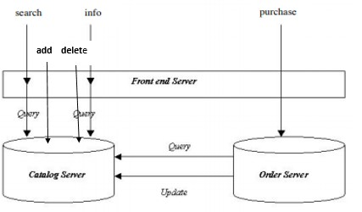

**how we can run the program?**

1- We gave each machine an ip address to make it possible for severs to communicate with each others,

(this option is not work in my device)

2- we give each server port number and the same id (local)>>this option is work .

.