**2.Infrastructure as Code Using Terraform (Modules)**

Module main.tf

Terraform init

Terraform plan

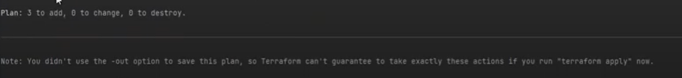

Checking vpc

Terraform apply



Again checking Check vpc

Checking ec2

Output.tf

Adding new instance

Terraform plan

=====================================================