StudySpot — Software Design Specification
StudySpot Team · October 25, 2026
Version 0.3, Milestone 2 (Sprint 1). StudySpot is built as a mobile client talking to one modular-monolith backend through a REST API, with every AI, map, e-mail and push service behind adapters in that backend; the two AI adapters are protected by circuit breakers.
Note. This Software Design Specification (SDS) holds the architecture. Requirements, the product backlog, the implementation scope and project risks are in the SRS v0.5; the use cases are in Section 12.

1. Introduction

1.1 Purpose
This document describes the architecture of StudySpot: its components, what each is responsible for, how they connect, the patterns used, and why this design meets the requirements in the SRS v0.5. It is the Milestone 1 design baseline and will be extended every sprint with class and sequence diagrams and lower-level design.

1.2 Scope
Covered: the use cases, the mobile app, the backend, the staff console, the venue code-generator page, the database, and the external services they use. New in v0.3: the big picture (1.4), the module dependencies checked in the code (5.2), the database schema (6.7), the deployment diagram (10.2) and the Sprint 1 detailed design (14: class diagrams, sequence diagrams and screen designs for the features built this sprint). Later sprints extend Section 14.

1.3 Relation to the SRS
Every component lists the SRS requirement IDs it realizes (Section 6). Requirement IDs refer to SRS v0.5. Design decisions the SRS had left open (noise trigger, refresh mechanism, last-known-value rule, crowd mapping) were made during this design and are now recorded in the SRS (SEN-009, RT-006, RT-016, RT-020). The details the SRS assigns to this document (combining rules, historical estimate, ranking, anti-abuse rules, registration and review fields, code generation, AI operations, coupon e-mail retry) are in Section 6.6.

1.4 Big picture
StudySpot is one loop (Figure 0). Students contribute conditions through receipt-QR surveys, in-app surveys, noise snippets and presence. Conditions turns those inputs into crowd, noise and Wi-Fi values that always carry their status. Discovery (search, map and StudyMatch) uses those values to send students to a café, where they study, earn points for surveys and redeem coupons, and get a new receipt code. Every backend module in Figure 2 sits on this loop; the module names are given under each step.
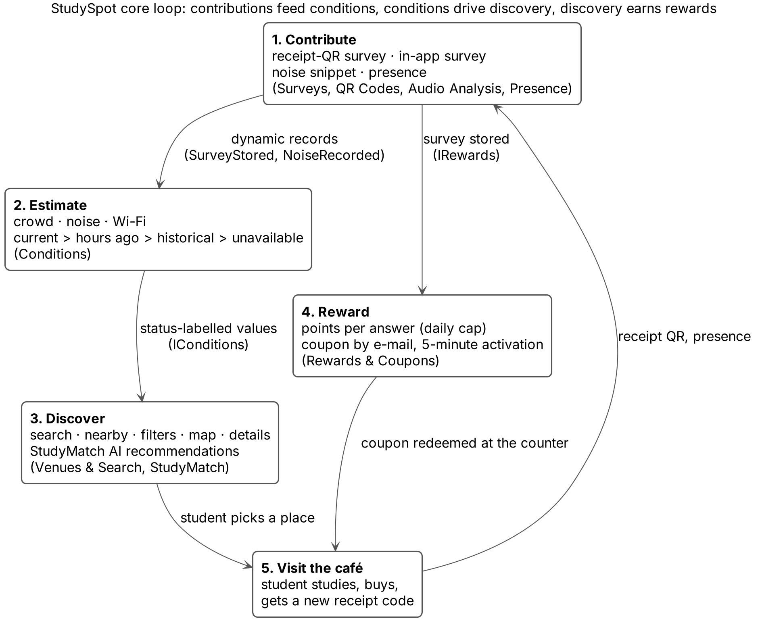
Figure 0. The StudySpot core loop and the modules behind each step.

2. Architectural Drivers
The requirements below shape the architecture most. Each one forces a structural choice.
Table 1. 2. Architectural Drivers
Driver | SRS source | What it forces in the design
AI may reach data only through approved operations | DC-003, AI-005 to AI-010 | StudyMatch runs in the backend behind a fixed set of read-only tool operations; the LLM never sees the database.
No raw audio is stored anywhere | DC-004, PRIV-001 | Audio goes straight from the request to the AI adapter in memory and is dropped; no file storage component exists for audio.
Secrets never on the phone | SEC-005, EIR-009 | All AI, geocoding and e-mail keys live only in the backend; the app talks to one API. The map-display key inside the app is a restricted client key (10.1).
Current → historical → unavailable | RT-001 to RT-019 | A single Conditions module owns freshness and fallback, so the app and StudyMatch always get the same answer.
Time-based rules (10 min, 24 h, 5 min, 2 h, 90 days) | QR-007, QR-009, RWD-018, PRIV-013, PRIV-016 | Expiry is checked on every read, and a scheduler cleans up and purges records.
Points must never double-count or go negative | RWD-007 to RWD-011, QR-006, QR-008 | Code use, point award and balance change happen in one database transaction.
Venues create codes without accounts | EIR-012, SEC-011 | A separate venue API, authenticated by API key, alongside the user API.
Features keep working when a service or permission fails | EIR-011, AI-019, PRIV-004 | Adapters return a clean failure; the two AI adapters add a time limit and a circuit breaker so an AI outage fails fast; search and filters never depend on AI.
StudyMatch answers within 10 s even when the AI is slow or down | PERF-003, AI-019, AI-028, AI-029, EIR-015 | A time limit on every AI call, a 9-second deadline for the whole request, a circuit breaker per AI adapter, and a fallback chosen by the calling module (5.1).
Small student team, deadline December 1 | Rubric, Milestone 1 | One deployable backend, managed services, no microservices.

2.1 Quality attributes, in priority order
- Privacy and security — location, audio and staff functions are the highest-risk parts.
- Feasibility / modifiability — the team must finish by December 1 and change the design each sprint.
- Availability with graceful degradation — an AI or map outage must not take the app down. Time limits and circuit breakers on the AI adapters keep a slow or failing AI service from tying up the backend (5.1).
- Performance — search and details must feel instant; StudyMatch may take a few seconds.
- Usability — clear current/historical labels, short QR survey.
- Scalability — modest; a campus-scale user base.

3. Architecture Decision
Decision: a client–server architecture with a layered modular monolith backend. One backend application, split internally into modules with clear interfaces (accounts, venues, conditions, surveys, QR, rewards, StudyMatch, audio, notifications, administration). Each module is layered as API → service → repository. Every outside service sits behind an adapter, and the two AI adapters add a circuit breaker.
Why this fits StudySpot:
- The AI-access, secrets and audio rules (Section 2) all require a trusted server between the phone and everything else; a backend is mandatory.
- One deployable unit is something a student team can build, test and demo by December 1, while the module boundaries still let each member own a unique part (a course rule).
- Modules can later be split into services if needed, because they only talk through interfaces.
- One deployable unit does not make every outside service a single point of failure: the two AI adapters, the slowest and least predictable dependencies, have time limits and circuit breakers, so an AI outage degrades two features instead of the whole backend (5.1).

3.1 Alternatives considered
Table 2. 3.1 Alternatives considered
Option | Strength | Why not chosen
Microservices (one service per module) | Independent scaling and deployment | Many deployments, network calls and failure points for a small team and a campus-scale load; slows every sprint.
Backend-as-a-Service only (for example Firebase with app-side logic) | Fast start, built-in auth | Business rules (points, expiry, AI tool limits) would run on the phone or in scattered functions; hard to enforce AI-005 to AI-010 and the no-negative-balance rule; harder to show a clear component architecture.
Serverless functions per endpoint | Low cost when idle | Scheduled expiry, LLM tool loops and transactions spread across many functions; cold starts hurt StudyMatch latency.
Layered modular monolith (chosen) | Simple to build, test and deploy; strong boundaries; one transaction scope for points | Must keep module boundaries disciplined; scales vertically first (enough for the expected load). One process is one failure domain; for the outside services it calls, the circuit breakers in 5.1 contain the risk.

4. System Component Diagram
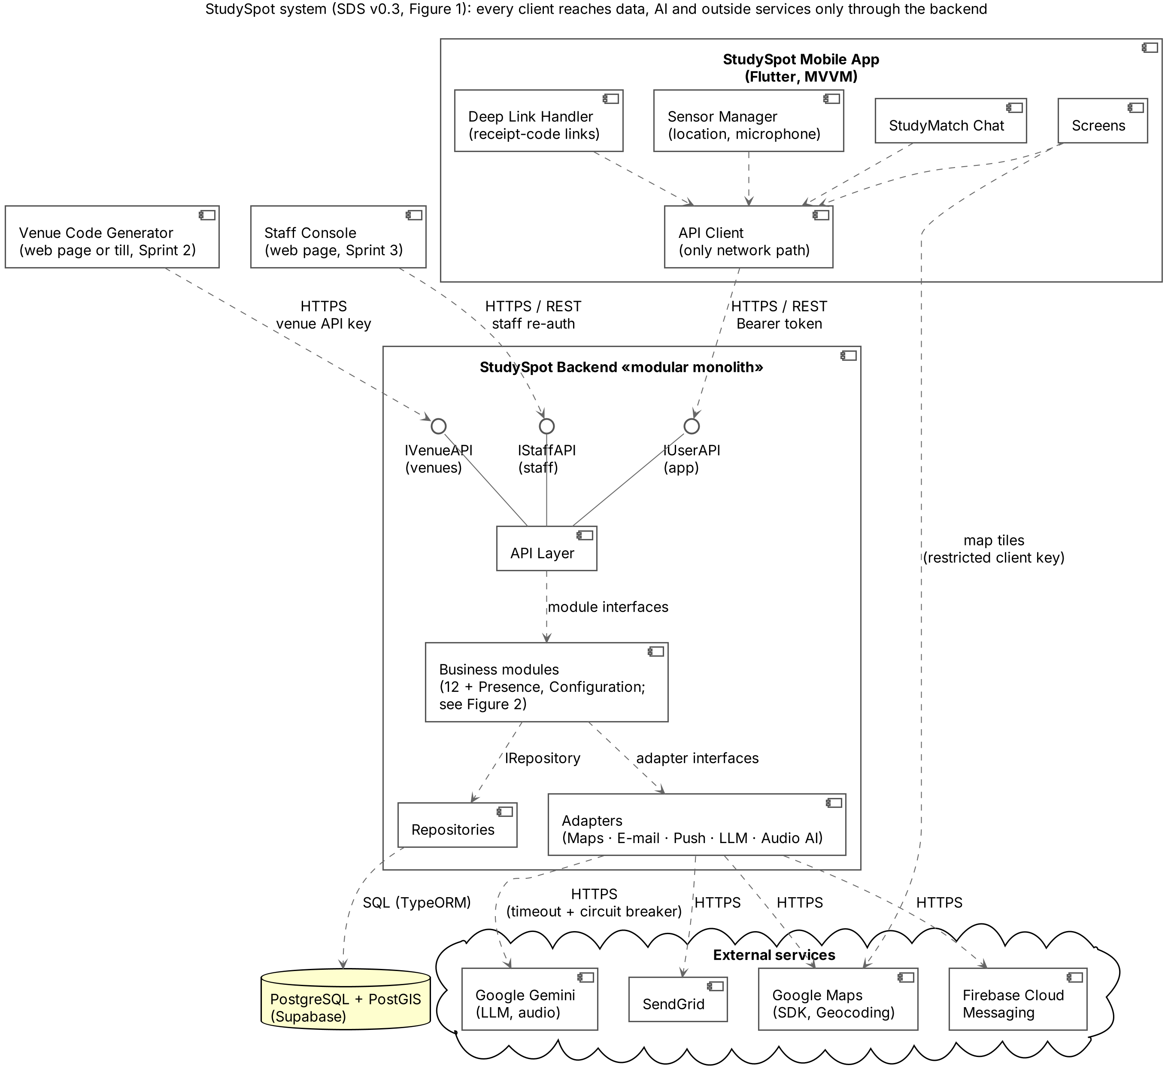
Figure 1. UML component diagram: system level. The three provided interfaces of the API Layer (lollipops) are the only way into the backend; dashed arrows are «use» dependencies.
The app, the staff console and venues each use their own provided interface on the API Layer. Only the adapters talk to outside services, and only the repositories touch the database. The LLM and Audio AI adapters are wrapped in circuit breakers (Section 5.1). Lollipops are provided interfaces; dashed arrows are «use» dependencies.

5. Backend Component Diagram
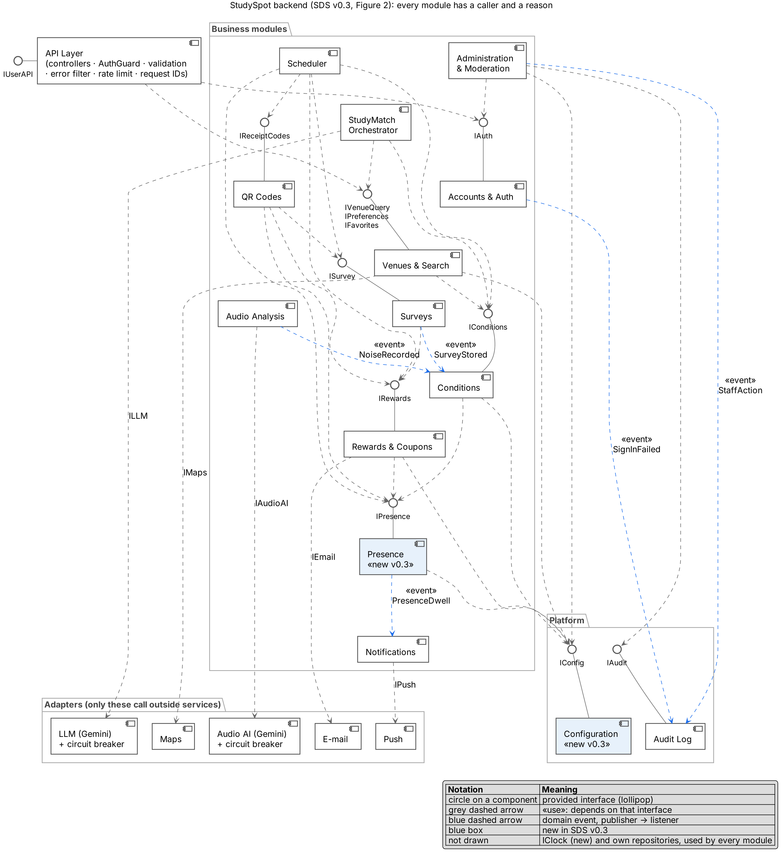
Figure 2. UML component diagram: backend modules, their provided interfaces (lollipops), «use» dependencies and domain events (blue).
Arrows are «use» dependencies through the named interface; every module also uses IRepository, and modules that need outside services use their adapter. A stored survey raises an event that refreshes Conditions. The LLM and Audio AI adapters are drawn as resilient adapters: a circuit-breaker decorator in front of the Gemini client (Section 5.1). In v0.2 some modules had no links (Audio Analysis, Notifications) or only part of them (Accounts and Auth); v0.3 draws every dependency the requirements need, and the code has the same links (5.2). Two components are new (blue): Presence receives location reports and receipt-scan check-ins and counts present users (RT-007, RT-008, PRIV-016), and Configuration holds every tunable value with its history (DATA-012). Domain events are blue dashed arrows: the publisher emits the event and the listener reacts without importing the publisher (Observer). Every module also uses IClock (new, for testable time rules) and its own repositories, which are not drawn.

5.1 Resilience of the AI adapters (circuit breaker)
The LLM and Audio AI adapters call Gemini, a third-party service whose speed and availability the team does not control. Left unprotected, a slow or failing call would hold a request open, and enough of them would tie up the single backend process and slow every feature, including search. Each of the two adapters is therefore wrapped in a resilience decorator (the amber parts of Figure 2). The business modules still call ILLM and IAudioAI exactly as before; only the place where the adapters are assembled changes.
- Time limit. Every provider call has a time limit, and the HTTP request is cancelled when it expires (Table 3).
- Circuit breaker. Each adapter has its own breaker. After five failures in a row it opens and calls fail at once for 30 seconds; then one trial call decides whether it closes again (Figure 3). A failure of one AI adapter does not open the other.
- One error type. A timeout, an open circuit, a provider error and an unusable answer all leave the adapter as the same AdapterUnavailableError. The adapter never decides what happens next.
- Fallback in the module. StudyMatch returns standard results, which are nearby study locations that match the user's stored preferences, taken through IVenueQuery and flagged as degraded. Audio Analysis creates no noise record and drops the snippet; Conditions keeps resolving noise from surveys, the last known value and the historical estimate.
- Visible to the user. The IStudyMatch response carries a degraded flag and the reason code AI_UNAVAILABLE, so the chat can say "Smart matching is unavailable, showing standard results" instead of an error (USE-008). The noise operation answers "unavailable" and the app shows a short notice that does not block the screen. Every breaker state change is written to the log.
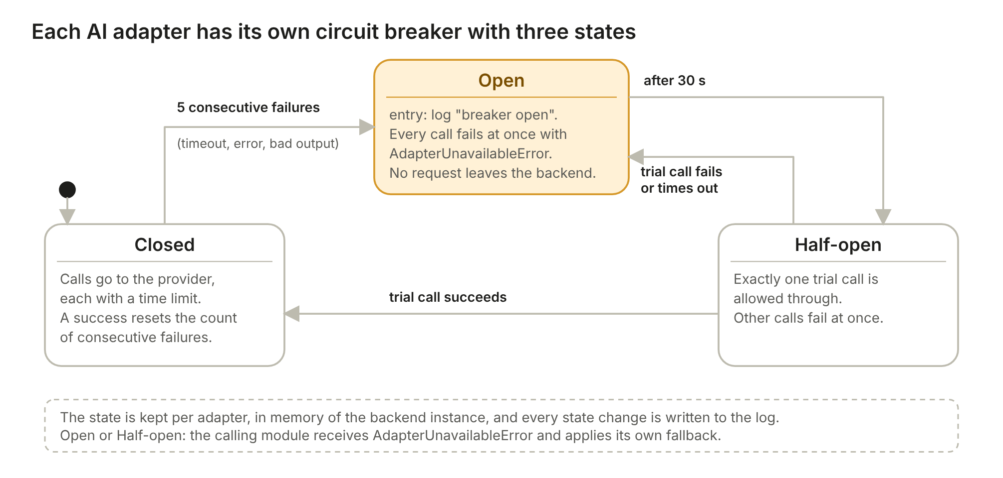
Figure 3. UML state machine of the circuit breaker kept by each AI adapter (EIR-015).
Table 3 gives the starting values. They are configuration, not code, and are tuned with real response times during Sprint 3.
Table 3. 5.1 Circuit breaker settings for the two AI adapters
Setting | LLM adapter (StudyMatch) | Audio AI adapter (noise)
Provider call | Gemini text model with function calling | Gemini model with audio input
Time limit per call | 5 s. The whole StudyMatch request has a 9 s deadline (PERF-003 allows 10 s); each call gets 5 s or the time left, whichever is smaller. | 8 s
Retries | None. A retry would not fit the 10 s target. | None. The snippet exists only in memory and is never queued or sent again from storage (PRIV-001).
Counted as a failure | Timeout, network error, HTTP 5xx, quota or rate-limit answer (429), empty or invalid output. | Same, and output that is not Quiet, Moderate or Noisy.
Not counted | Requests rejected for our own bad input (HTTP 400) and tool calls refused by the allow-list (AI-007). | Same, and a result the model marks as inconclusive (AI-026).
Breaker opens after | 5 consecutive failures | 5 consecutive failures
Open period | 30 s, then one trial call | 30 s, then one trial call
Fallback, chosen by | StudyMatch Orchestrator: nearby locations matching stored preferences through IVenueQuery, flagged degraded. | Audio Analysis: no noise record, audio discarded, "unavailable" returned to the app.
Error raised | AdapterUnavailableError | AdapterUnavailableError
Maps, E-mail and Push stay plain adapters that return a clean failure (EIR-011); they have no breaker. The breaker state is held in memory of the single backend instance; if the backend is ever scaled out, each instance keeps its own state, which is acceptable because each learns of an outage within a few calls. The app's own request timeout for StudyMatch is set above 10 s (12 s), so the app receives the degraded answer instead of timing out first.

5.2 Module dependencies, checked in the code
Figure 2 is not only a drawing. In the code, each module is a NestJS module that may reach another module only through the interfaces and injection tokens in backend/src/contracts. The CI pipeline runs dependency-cruiser and fails the build if a module imports another module's internals, if an adapter imports a business module, or if any import is circular. Figure 7 is generated from the code by the script backend/scripts/module-graph.mjs and shows the same links as Figure 2; Table 25 lists them.
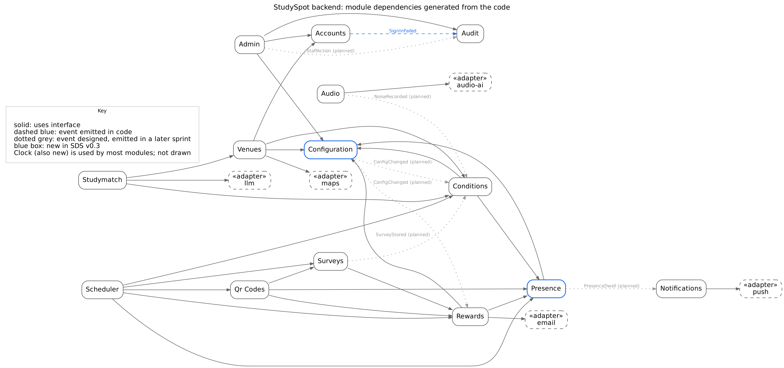
Figure 7. Module dependencies generated from the code (solid: uses an interface; blue dashed: event emitted in code; grey dotted: event designed, emitted when the module is built in Sprint 2 or 3).
Table 25. 5.2 Module dependency matrix
Module | Uses (interface, provider) | Events published or heard
API Layer | IAuth (Accounts, through the AuthGuard); IVenueQuery, IPreferences, IFavorites (Venues & Search) | —
Accounts & Auth | IClock | SignInFailed → Audit Log
Venues & Search | IConditions (Conditions), IMaps (Maps adapter), IConfig (Configuration), IAuth (guard on /me routes) | —
Conditions | IPresence (Presence), IConfig, IClock | listens to SurveyStored, NoiseRecorded
Presence | IConfig, IClock | PresenceDwell → Notifications
Surveys | IRewards (Rewards & Coupons), IClock | SurveyStored → Conditions
QR Codes | ISurvey (Surveys), IRewards, IPresence, IClock | —
Rewards & Coupons | IPresence, IConfig, IEmail (E-mail adapter), IClock | —
Audio Analysis | IAudioAI (Audio AI adapter), IClock | NoiseRecorded → Conditions
Notifications | IPush (Push adapter) | listens to PresenceDwell
StudyMatch | IVenueQuery, IPreferences (Venues & Search), IConditions, ILLM (LLM adapter) | —
Administration | IAuth, IAudit (Audit Log), IConfig | StaffAction → Audit Log
Configuration | IClock | ConfigChanged → Conditions, Rewards
Scheduler | IPresence, IReceiptCodes (QR Codes), IRewards, IConditions, ISurvey | —
Every error leaves the API Layer in one shape, { code, message, details, requestId }. The codes are the four of 6.6.8 (INVALID_INPUT, NOT_FOUND, NOT_ALLOWED, UNAVAILABLE) plus UNAUTHENTICATED, CONFLICT, RATE_LIMITED, NOT_IMPLEMENTED and INTERNAL. Every log line carries the same request ID, which is also returned in the X-Request-Id header, so one request can be followed through API → module → module → repository.

6. Components
Each component has one owner on the team. "Provides" and "Requires" match the interfaces in the diagrams of Sections 4 and 5.

6.1 Clients
Table 4. 6.1 Clients
Component | Responsibility | Provides / requires | SRS
Mobile App — Screens | Search, map, venue details with current/historical labels, preferences, favorites, reviews, points, coupons, settings, terms at first launch. | Requires IUserAPI | FR-001 to FR-034, USE-*, PRIV-011
Mobile App — StudyMatch Chat | Free-text chat screen; shows recommendations with reasons and a progress indicator. | Requires IUserAPI | AI-001, USE-005, USE-006, PERF-007
Mobile App — Sensor Manager | Location and background location, presence detection against venue radius, microphone snippet capture with on-screen indicator, permission explanations and fallbacks. | Requires IUserAPI | SEN-*, PRIV-003, PRIV-004, USE-007
Mobile App — Deep Link Handler | Receives receipt-code links from the OS camera, routes to sign-in and back, opens the QR survey. | Requires IUserAPI | QR-003 to QR-005, EIR-014, DC-007
Staff Console (web page) | Sign-in with re-authentication; staff, user and venue management; configuration; security log; statistics; moderation queue. | Requires IStaffAPI | FR-029, FR-035 to FR-044
Venue Code Generator (web page) / venue till | "New code" button or till integration that prints the receipt QR. | Requires IVenueAPI | QR-001, QR-002, EIR-012

6.2 Backend — interface layer
Table 5. 6.2 Backend — interface layer
Component | Responsibility | Provides / requires | SRS
API Layer | Three REST APIs (user, venue, staff); token or API-key authentication; role checks; input validation; rate limiting; maps each call to one module. | Provides IUserAPI, IVenueAPI, IStaffAPI | EIR-008, SEC-001, SEC-004, SEC-007, SEC-011, SEC-013

6.3 Backend — business modules
Table 6. 6.3 Backend — business modules
Component | Responsibility | Provides / requires | SRS
Accounts & Auth | Registration, sign-in, password hashing, sessions and inactivity timeout, staff roles and re-authentication, suspension, account deletion. | Provides IAuth; requires IRepository, IAudit | FR-001 to FR-008, FR-035 to FR-038, SEC-002, SEC-009
Venues & Search | Venue records, search by name/area, nearby search by distance, filters, favorites, reviews, preferences. | Provides IVenueQuery; requires IConditions, IRepository, IMaps | FR-009 to FR-027, DATA-001, DATA-002
Conditions (estimation engine) | For each venue and attribute, returns value + status (current, historical, unavailable) + last-updated time; counts present users; combines inputs; applies freshness limits and the 90-day historical fallback. | Provides IConditions; requires IRepository | RT-001 to RT-022, FR-020, FR-021
Surveys | Stores in-app and QR survey answers, validates scales, feeds Conditions. | Provides ISurvey; requires IRepository | CON-001 to CON-008, QR-011, QR-012
QR Codes | Creates tokens for venues, binds a code on first scan, enforces 10-minute and 24-hour expiry, marks codes used, calls Rewards in the same transaction. | Provides IReceiptCodes; requires ISurvey, IRewards, IRepository | QR-001 to QR-013, SEC-012
Rewards & Coupons | Points per category, daily cap, balance, redemption, coupon creation, activation, 5-minute expiry, coupon e-mail with its sent or failed status. | Provides IRewards; requires IRepository, IEmail | RWD-001 to RWD-021
StudyMatch Orchestrator | Sends the user's text to the LLM with the tool list; runs only allowed read-only tool operations; returns ranked recommendations with reasons and status labels; logs every tool call. If the LLM is unavailable (AdapterUnavailableError) or the 9-second request deadline passes, it returns standard results through IVenueQuery, flagged degraded. | Provides IStudyMatch; requires ILLM, IVenueQuery, IConditions | AI-001 to AI-020, AI-024, AI-028, AI-029
Audio Analysis | Receives a snippet, sends it to the audio AI, maps the result to Quiet/Moderate/Noisy, stores only level + time + venue, discards audio. If the audio AI is unavailable it creates no record and drops the snippet. | Provides INoise; requires IAudioAI, IRepository | AI-023, AI-025 to AI-027, PRIV-001, SEN-005 to SEN-007
Notifications | Decides when to send the "are you here?" message (once per visit) and sends push messages. | Provides INotify; requires IPush | SEN-013, SEN-014, SEN-016
Administration & Moderation | Staff and user account management, reward and freshness configuration, venue API keys, statistics, moderation removals. | Provides IAdmin; requires IAuth, IRepository, IAudit | FR-029, FR-036 to FR-044, DATA-012
Audit Log | Records failed sign-ins, staff actions and security events. | Provides IAudit | SEC-010, FR-044
Scheduler | Periodic jobs: delete raw presence records after 2 hours, purge records older than 90 days, mark expired codes and coupons, refresh cached estimates, retry coupon e-mails that failed to send (6.6.9). | Requires IConditions, IReceiptCodes, IRewards, IRepository | PRIV-013, PRIV-016, QR-007, QR-009, RWD-018, EIR-013
Presence (new in v0.3) | Receives location reports and receipt-scan check-ins; keeps raw presence records for 2 hours; counts distinct present users per venue (15-minute location window, 10-minute scan window); emits PresenceDwell after 15 minutes at a venue. | Provides IPresence; requires IConfig, IClock, IRepository | RT-007, RT-008, PRIV-006, PRIV-007, PRIV-016, SEN-014

6.4 Backend — data and adapters
Table 7. 6.4 Backend — data and adapters
Component | Responsibility | Provides / requires | SRS
Repositories (data access) | The only code that talks to the database; one repository per aggregate (users, venues, conditions, codes, coupons, logs). | Provides IRepository | SEC-006, DATA-*
Database | Relational store with geospatial support for distance and radius queries. | — | DATA-*, PRIV-013
LLM Adapter | Wraps the LLM provider (Gemini) and holds its key. Built as a Gemini client inside a circuit-breaker decorator: 5 s limit per call, no retry, breaker opens after 5 consecutive failures for 30 s. Every failure becomes AdapterUnavailableError. | Provides ILLM; requires Resilience Policy | AI-005, AI-019, AI-028, EIR-009, EIR-011, EIR-015
Audio AI Adapter | Wraps the audio-capable AI provider and sends audio in memory only. Same decorator: 8 s limit, no retry (the snippet is never queued or stored), breaker opens after 5 consecutive failures for 30 s. | Provides IAudioAI; requires Resilience Policy | AI-023, AI-026, PRIV-001, EIR-015
Resilience Policy (shared) | Reusable wrapper that applies the time limit, circuit breaker and error conversion to an adapter. Settings come from configuration per adapter. Logs every breaker state change. Used by the two AI adapters only. | Provides ResiliencePolicy (internal) | EIR-011, EIR-015, AI-019, AI-028
Maps Adapter | Geocoding of typed areas; holds the geocoding key. Map display uses the Maps SDK in the app with a restricted client key. | Provides IMaps | EIR-003, FR-011
E-mail Adapter | Sends coupon e-mails. No retry of its own: a failure is returned to Rewards, and the Scheduler retries. | Provides IEmail | EIR-013, RWD-014
Push Adapter | Sends push notifications through the platform push services. | Provides IPush | EIR-007
Configuration (new in v0.3) | Holds every tunable value (points per category, daily cap, freshness limits, venue radius, search radius) with defaults from the SRS; stores who changed what and when; emits ConfigChanged. | Provides IConfig; requires IClock, IRepository | DATA-012, FR-039, FR-040, RT-001
Clock (new in v0.3) | The single source of the current time, so every time rule (10 minutes, 24 hours, 5 minutes, 14 days, 90 days) can be tested at its boundary with a fake clock. | Provides IClock | SDS 9 (testability), QR-007, QR-009, RWD-018, SEC-009

6.5 Traceability to the Product Backlog
The architecture is derived from the product backlog (SRS Section 4): every backlog item (PB-01 to PB-46) is built by at least one component below.
Table 8. 6.5 Traceability to the Product Backlog
Component | Backlog items (SRS 4)
Mobile App — Screens | PB-03 to PB-05, PB-07 to PB-15, PB-17, PB-25 to PB-28, PB-39, PB-42, PB-44
Mobile App — StudyMatch Chat | PB-29, PB-30, PB-46
Mobile App — Sensor Manager | PB-08, PB-18, PB-19, PB-31, PB-39, PB-46
Mobile App — Deep Link Handler | PB-22
Staff Console | PB-32 to PB-37
Venue Code Generator | PB-21
API Layer | PB-01, PB-40, PB-42
Accounts & Auth | PB-03 to PB-06, PB-32, PB-33
Venues & Search | PB-02, PB-07 to PB-11, PB-13 to PB-16
Conditions | PB-12, PB-18, PB-20
Surveys | PB-17, PB-23
QR Codes | PB-21 to PB-23
Rewards & Coupons | PB-24 to PB-28
StudyMatch Orchestrator | PB-29, PB-30, PB-46
Audio Analysis | PB-19, PB-46
Notifications | PB-31
Administration & Moderation | PB-33 to PB-37
Audit Log | PB-36
Scheduler | PB-38
Repositories and Database | PB-01, PB-02, PB-38
Adapters (LLM, Audio AI, Maps, E-mail, Push) | PB-09, PB-19, PB-26, PB-29, PB-31, PB-42, PB-46
Resilience Policy | PB-42, PB-46
All components | PB-41 (performance), PB-43 (usability), PB-45 (testing)
Presence | PB-18, PB-31
Configuration | PB-12, PB-24, PB-34
Clock | PB-38, PB-45

6.6 Detailed design rules
These rules complete the requirements that the SRS assigns to this document. Every number below is a configuration value kept outside the code, so the team can tune it without a new release. Levels are numbered Low or Quiet or Poor = 1, Moderate or Average = 2, High or Noisy or Good = 3 wherever a rule averages them.

6.6.1 Crowd level (RT-009, RT-020)
Present-user input. The Conditions module counts the distinct users who are present at the venue under RT-008. A user who reported a location inside the radius counts while that report is not older than 15 minutes; a user who scanned a receipt code counts for 10 minutes after the scan. A user is counted once. Reports come from the app's location updates; a user who allowed foreground location only (SEN-015) counts only while the app is open, and the last report expires after the same 15 minutes. The count is mapped to a level with the thresholds of the venue's size class (RT-020). A count of 0 gives no present-user input, because most people in a venue do not use the app (A-003). The size class is a field of the venue record, set by the System Administrator; the default is medium.
Survey input. The crowd answers of surveys submitted in the last 60 minutes are mapped as in RT-020 and averaged; a half rounds up. Only the newest answer of each user for the venue counts, so one person cannot outweigh others by submitting several surveys.
Combination. When both inputs are current, the crowd level is the higher of the two. The present-user level is a lower bound, because it only sees app users, so a survey can raise the level but never lower it. When only one input is current, that one is used. The result is labeled with the inputs it used (RT-012) and carries the time of the newest input (RT-013).

6.6.2 Noise level and Wi-Fi quality (RT-021, RT-022)
Inputs are the audio-analysis results and the survey noise answers of the last 60 minutes. Each audio result has weight 2, because it is a measurement taken at the venue; each survey answer has weight 1. Only the newest audio result and the newest survey answer of each user for the venue are used, so one person who opens the venue several times counts once. The noise level is the weighted average, rounded half up. Example: one Quiet audio result and two Noisy survey answers give (2×1 + 1×3 + 1×3) / 4 = 2.0, so Moderate. Audio results never feed the crowd level (RT-015). Wi-Fi quality uses the same method on the Wi-Fi answers of the last 6 hours, each with weight 1; the answer "did not use it" is ignored.

6.6.3 Historical estimate (RT-017)
The estimate uses the records the system keeps for 90 days: survey crowd answers for crowd level (raw presence records are deleted after 2 hours, PRIV-016), audio results and survey answers for noise level, and survey answers for Wi-Fi quality. Weekday and hour are taken in Africa/Cairo time. The module picks the first of these sets that holds at least 3 records:
1. records of the same weekday and the same clock hour as the request;
2. records of the same day type (Sunday to Thursday, or Friday and Saturday) within one hour of the request time;
3. all records of that type from the last 90 days.
If no set reaches 3 records, set 3 is used with whatever records exist, so a value is shown as unavailable only when there is no record at all in the last 90 days (RT-018, FR-021). The estimate is the median of the record values, using the weights of 6.6.2; when the median falls between two levels, the higher one is taken. It is labeled "Estimate based on historical data".

6.6.4 Ranking (AI-012)
The backend ranks, not the LLM. The LLM extracts the criteria (AI-002) and writes the reasons; the order and the scores come from Venues & Search, so the same request gives the same order and every reason can be checked against retrieved data (AI-014). The steps are:
1. Candidates: the venues within the search radius (the stated one, otherwise 2 km) of the user's location or the given area, at most the 30 nearest.
2. Required and preferred criteria: the LLM marks each criterion as required (the user said need, must or with) or preferred. A candidate that fails a required criterion is dropped. If none is left, the reply says that nothing meets every requirement and shows the 5 best candidates with the unmet requirement named.
3. Match score per criterion, from 0 to 1, as in the table below.
4. Status factor for dynamic values: a current value counts fully (1.0), an "X hours ago" value 0.9, a historical estimate 0.75; the match score is multiplied by it.
5. Weights: every criterion in the request has weight 1.0, and every stored preference (FR-022) that the request does not already cover has weight 0.5. The score is the weighted average of the match scores.
6. Order: by score, highest first; ties go to the higher average rating, then to the nearer venue. The top 5 are returned with their per-criterion values, statuses and times.
Criterion | Match score
Noise, crowd, Wi-Fi level | Same level as requested 1.0; one level away 0.5; two levels away 0; unavailable 0
Distance | 1 minus distance divided by the search radius, not below 0
Price | Within the stated budget 1.0; up to 25 percent over 0.5; otherwise 0
Opening hours | Open at the requested time (now if none given) 1; otherwise 0
Outlets, individual or group study | Offered 1; otherwise 0
Missing data (any criterion) | 0; the venue is never described as matching on a condition the data does not show

6.6.5 Anti-abuse rules for points (RWD-013)
Rewards applies these rules after the survey is stored (RWD-010) and before it awards points, for in-app and QR surveys alike. They come on top of the once-per-survey rule (RWD-011) and the daily cap (RWD-016).
1. A user earns points from at most one survey per venue per calendar day (Africa/Cairo time).
2. At least 5 minutes must pass between two points-earning surveys of the same user, at any venue.
3. An in-app survey earns points only if the user counts as present at that venue under RT-008 when it is submitted. A QR survey counts as present through the scan.
When a rule blocks the points, the survey is still stored and still feeds the dynamic values, the user is told that no points were awarded and why, and the reason is written to the points history (RWD-012).

6.6.6 Registration and review fields (FR-001, FR-025)
Registration. E-mail address (valid format, unique, not case-sensitive; coupons are sent there); password (at least 8 characters with at least one letter and one digit, stored only as a salted hash, SEC-002); display name (2 to 30 characters, shown with reviews); acceptance of the terms and privacy notice (required, PB-03; the time of acceptance is stored). Nothing else is asked. The e-mail address is not verified in this version; if it is wrong the coupon is still in the app.
Review. Star rating, a whole number from 1 to 5 (required); text of up to 1000 characters (optional). The system adds the author, the study location and the submission time (DATA-007). A user has one review per venue; submitting again replaces the earlier one. Other users can report a review (FR-034).

6.6.7 Code generation (SEC-012)
All codes come from the operating system's cryptographically secure random generator, never from the venue, the time or a counter. Each is checked for uniqueness in the database when it is stored.
Code | Form
Receipt-code token | 128 random bits, written in URL-safe base64 (22 characters), carried in the receipt-code link. The venue and creation time are stored with it on the server, not encoded in it (QR-001).
Coupon code | 8 characters from a 32-character alphabet without 0, O, 1 and I (40 random bits), shown as two groups of four (for example K7QM-4TXD) so it is easy to read at a till. It is unique among all coupons, valid only after activation (RWD-017), checked on the server, and wrong attempts are rate limited by the API Layer.
Activation link token | 128 random bits in URL-safe base64, separate from the coupon code, one use only.

6.6.8 Operations available to the AI agent (EIR-010)
Rules for all operations: they only read data (AI-008); the user is taken from the session and is never an input (AI-009); the backend validates every input (SEC-007), rejects any operation not on the list (AI-007) and logs every call. An error is returned as a code and a short message, with one of four codes: INVALID_INPUT, NOT_FOUND, NOT_ALLOWED, UNAVAILABLE. Dynamic values are returned as in RT-004: a level or null, a status (current, hours_ago, historical, unavailable) and the time of the newest input.
Operation | Input | Output | Errors
find_venues | Area text, or latitude and longitude; radius in meters (at most 5000, default 2000); optional filters from FR-013; limit (at most 30) | Venues with id, name, distance, open now and price information | INVALID_INPUT, NOT_FOUND (area), UNAVAILABLE (maps)
get_venue_details | Venue id | Name, location, opening hours, price information, outlets, study type, average rating and number of reviews | INVALID_INPUT, NOT_FOUND
get_conditions | Venue id | Crowd, noise and Wi-Fi, each with level, status and time of newest input | INVALID_INPUT, NOT_FOUND
get_my_preferences | None | The signed-in user's saved preferences (an empty list if none) | NOT_ALLOWED (not signed in)
recommend_venues | List of criteria, each with name, requested value and required flag; location or area; radius; whether to include stored preferences | Up to 5 ranked venues, each with the value, status and time per criterion (6.6.4) | INVALID_INPUT, NOT_FOUND, UNAVAILABLE

6.6.9 Coupon e-mail retry (EIR-013, RWD-014)
The coupon is always listed in the app, so a failed e-mail never blocks the user. The Scheduler runs a job every minute that picks up coupons whose e-mail has failed. It retries 1, 5, 15 and 60 minutes after the first failure. If the fourth retry fails, the coupon is marked "e-mail failed" and the Scheduler stops; the user can still use the coupon from the app. The E-mail Adapter itself does not retry (5.1); it returns the failure to Rewards, which records the status and the time of the next attempt.

6.7 Database schema
Figure 8 shows the schema created by the first migration (backend/src/db/migrations). It has 19 tables on PostgreSQL 16 with PostGIS. Venue locations are geography points with a GiST index for distance and radius queries; venue names have a trigram index for search (FR-009). The database itself enforces three rules: a points balance is never negative (RWD-009), a survey earns points at most once (a partial unique index, RWD-011), and ratings and price levels stay in range. The schema changes only through migrations, and CI fails if the entities and the migrations differ.
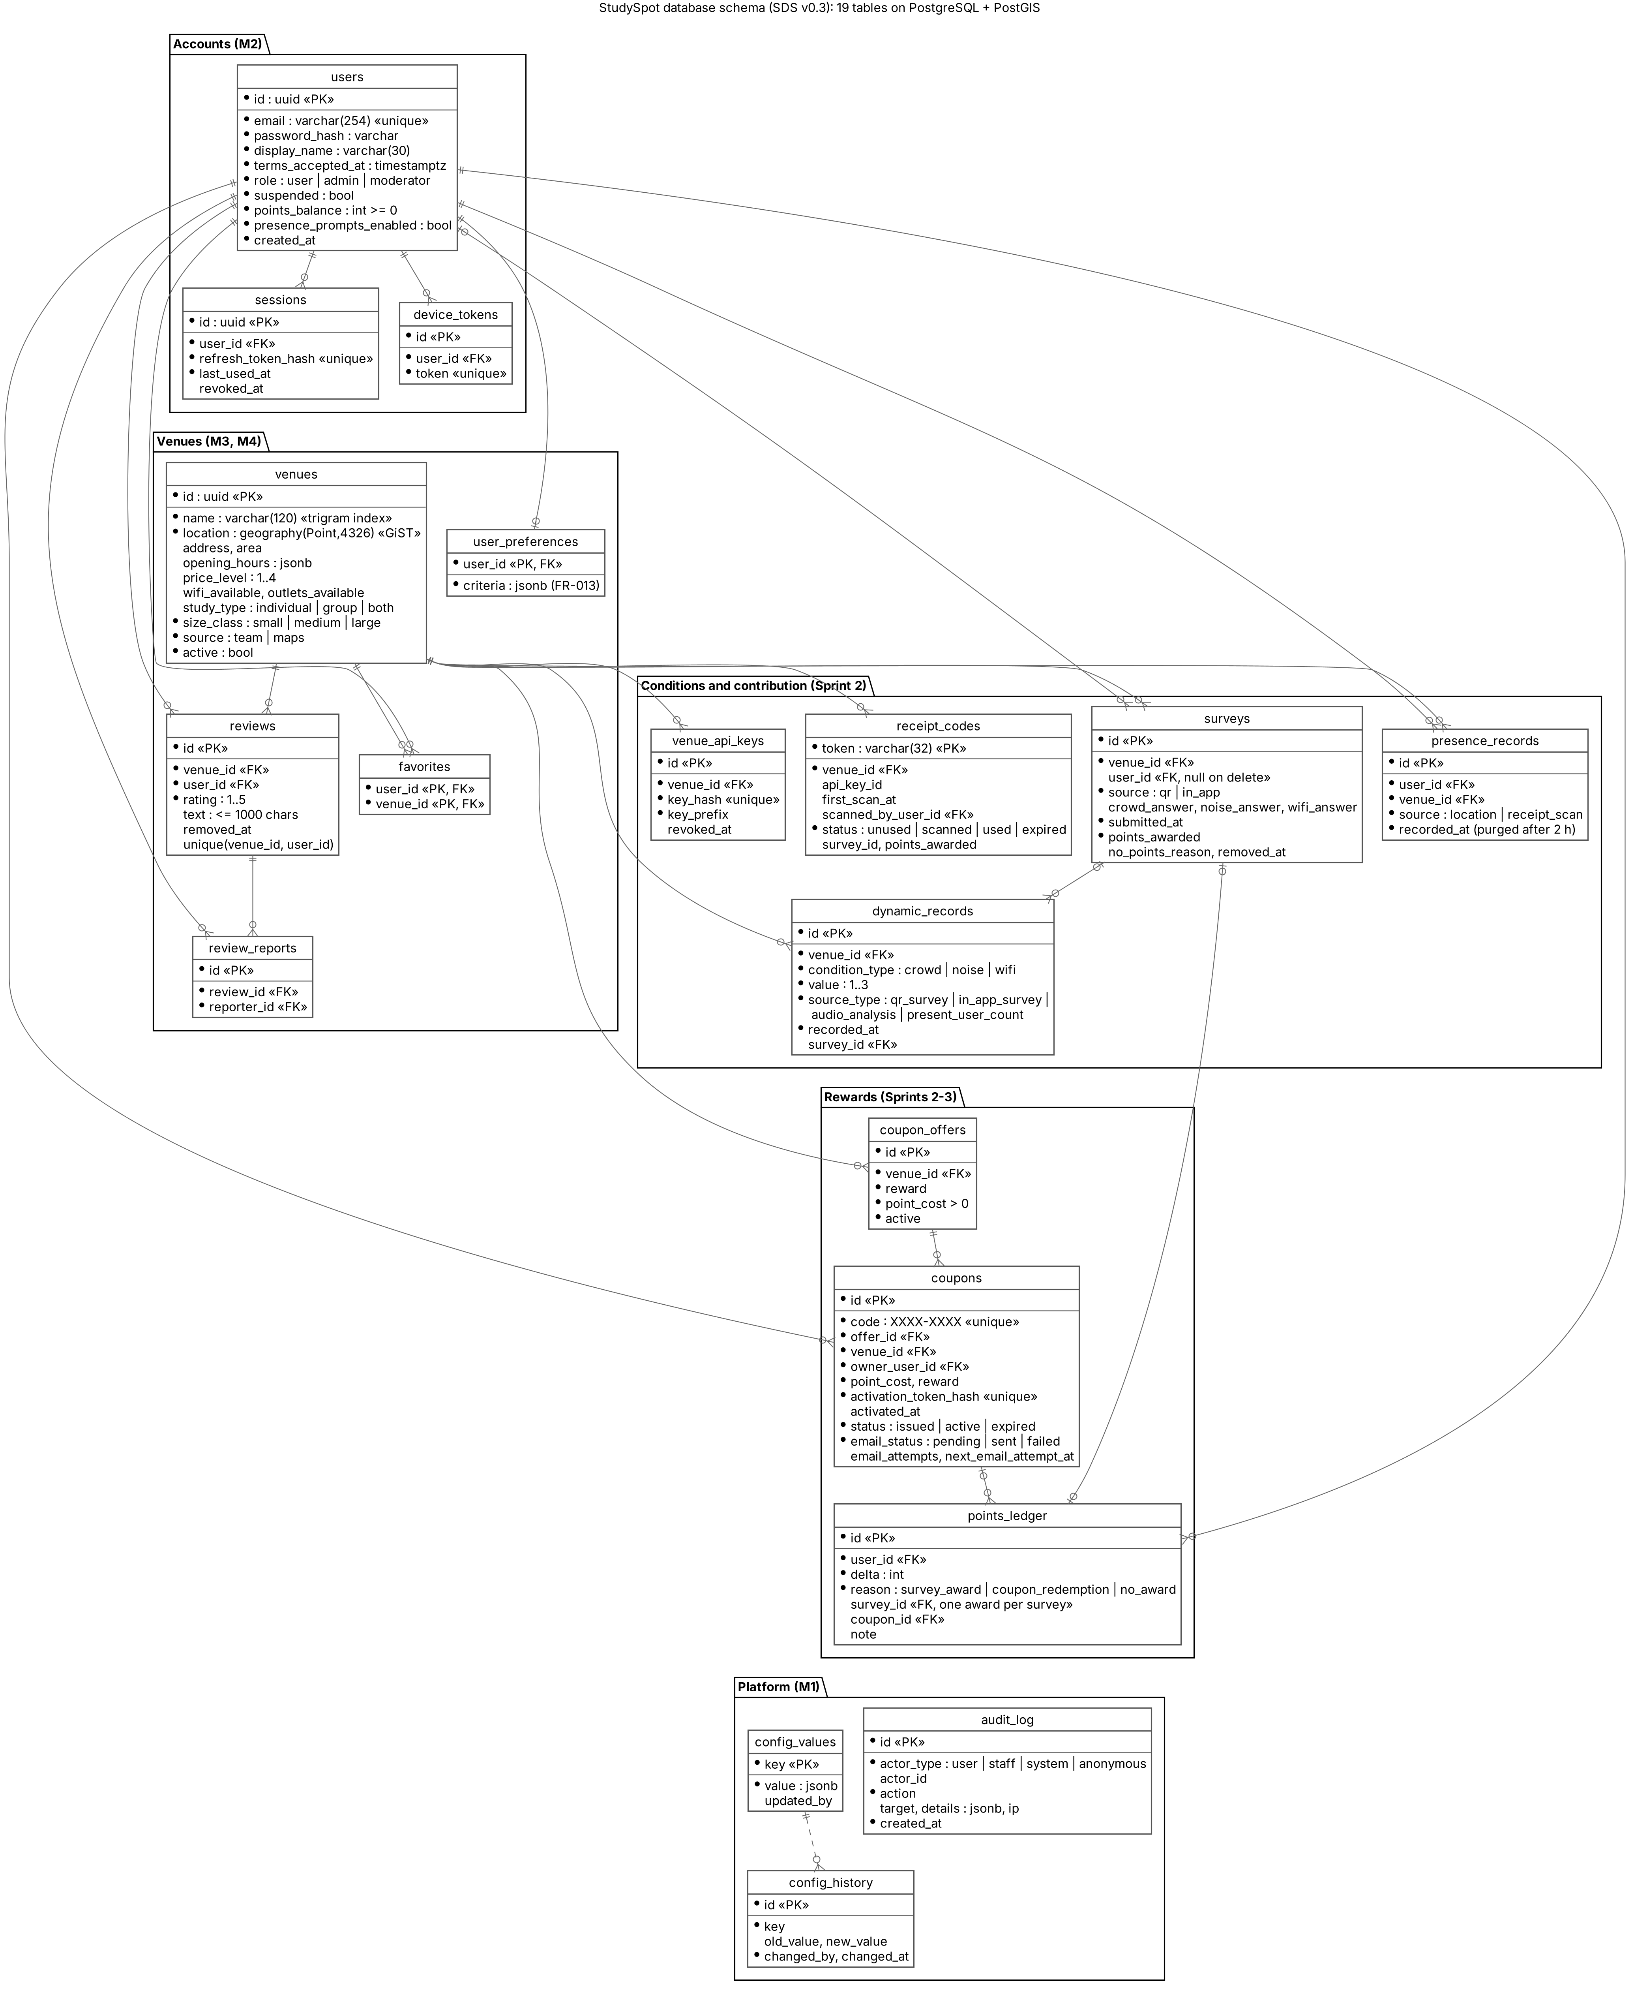
Figure 8. Entity-relationship diagram of the StudySpot database (SDS v0.3).

7. Key Interactions
Short walk-throughs of how the components cooperate. Full UML sequence diagrams follow in the sprint where each feature is built.

7.1 QR receipt survey
- Venue till or Code Generator → Venue API (API key) → QR Codes creates a token and returns the link; the venue prints it.
- The phone camera opens the link → Deep Link Handler opens the app (sign-in first if needed) → User API → QR Codes binds the code to the user and starts the 10-minute window.
- The user submits the survey → QR Codes checks the window, then in one transaction: Surveys stores the answers, Rewards adds points under the daily cap, the code becomes "used".
- Conditions sees the new survey on the next read; the venue shows a current value.

7.2 StudyMatch request
- Chat → User API → StudyMatch Orchestrator, with the user's text and location (if granted).
- The orchestrator calls the LLM Adapter with the text and the list of allowed tools. Each call has a 5-second limit inside a 9-second deadline for the whole request.
- The LLM asks for tools (for example "nearby venues", "conditions of venue X"); the orchestrator checks each against the allow-list and runs it through Venues & Search or Conditions; the result carries status and last-updated time.
- The LLM writes the ranked answer with reasons; the orchestrator returns it to the app and logs every tool call.
- If the LLM Adapter raises AdapterUnavailableError (time limit, open circuit or provider error) or the deadline passes, the orchestrator asks Venues & Search for nearby locations that match the user's stored preferences and returns them flagged degraded; the chat tells the user that smart matching is unavailable.

7.3 Noise snippet
- Trigger (SRS SEN-009): when the user opens the details of a venue they are present at, or confirms presence after the "are you here?" notification, and microphone permission is granted.
- Sensor Manager records a short snippet (indicator visible) → User API → Audio Analysis → Audio AI Adapter.
- The level is stored with time and venue; the audio is released from memory and never written.
- If the Audio AI Adapter raises AdapterUnavailableError, Audio Analysis creates no record, drops the snippet and answers "unavailable"; the app shows a short notice and carries on.

7.4 Coupon
- Redeem → Rewards checks balance and deducts points in one transaction → creates a coupon → E-mail Adapter sends it. If sending fails, the coupon stays in the app marked "e-mail pending" and the Scheduler retries the send.
- At the venue the user taps Activate (e-mail link or app) → Rewards stamps the activation time → the app shows a live 5-minute countdown → after 5 minutes the coupon reads as expired.

7.5 AI outage and recovery
- A Gemini call times out or fails. The adapter counts the failure and raises AdapterUnavailableError; the module uses its fallback (7.2 step 5, 7.3 step 4).
- After five failures in a row the breaker opens. For 30 seconds every call fails at once, without waiting for the provider, so requests stay fast and the backend is not tied up.
- After 30 seconds one trial call goes through. If it succeeds the breaker closes and the AI features resume; if it fails the breaker opens for another 30 seconds.
- Every state change is written to the log, so the team can see when an outage began and ended.

8. Design Patterns
The architecture uses four architectural patterns (one of them on the client) and several design patterns, each tied to a requirement.
Table 9. 8. Design Patterns
Pattern | Type | Where | Why (requirement)
Client–Server | Architectural | Mobile app, web pages ↔ backend | Secrets, AI access and business rules stay on the server (SEC-005, AI-005).
Layered | Architectural | Each backend module: API → service → repository | Separates validation, rules and data access; each layer testable alone (SEC-007, SEC-006).
Modular monolith | Architectural | Backend split into modules behind interfaces | One deployment for a small team; clear ownership per member.
MVVM | Architectural (client) | Mobile app screens | Screen state (permissions, loading, current/historical labels) testable without the UI.
Adapter | Design (structural) | LLM, Audio AI, Maps, E-mail, Push adapters | Swapping a provider changes one class; failures become one clean error (EIR-011, AI-019).
Decorator | Design (structural) | Resilience wrapper around the LLM and Audio AI adapters | Adds the time limit, breaker and error conversion without changing the modules or the Gemini client (EIR-011, EIR-015).
Circuit Breaker | Design (resilience) | LLM and Audio AI adapters | An AI outage fails fast instead of holding requests open, and the provider gets time to recover (AI-028, EIR-015).
Fallback (graceful degradation) | Design (resilience) | StudyMatch Orchestrator, Audio Analysis | The module, not the adapter, picks the substitute behavior: standard results, or no noise record (AI-019, AI-029, AI-026).
Facade | Design (structural) | StudyMatch tool operations over Venues and Conditions | The LLM sees a small, safe, read-only surface (AI-007, AI-008).
Repository | Design | Data access per aggregate | Only repositories touch the database; easy to mock in tests (SEC-006).
Strategy | Design (behavioral) | Conditions: one strategy per input (present users, surveys, audio) and per historical method | Thresholds and methods change without touching callers (RT-016, RT-020).
Chain of Responsibility | Design (behavioral) | Conditions resolution: current → historical → unavailable | Encodes the fallback order in one place (RT-014, RT-018).
State | Design (behavioral) | Receipt code (unused, scanned, used, expired) and coupon (issued, active, expired) | Each state allows only its valid transitions (QR-006 to QR-010, RWD-017 to RWD-020).
Observer (domain events) | Design (behavioral) | "Survey stored" → Conditions cache refresh; "Staff action" → Audit Log | Modules stay decoupled (PERF-005, SEC-010).
Unit of Work (transaction) | Enterprise | QR survey submission and coupon redemption | Points, code status and balance change together or not at all (RWD-009, RWD-011).
Where the patterns live in the code (Sprint 1): Layered and Repository in every module (controller → service → TypeORM repository); Modular monolith enforced by dependency-cruiser in CI; Adapter in backend/src/adapters (Maps, E-mail, Push, LLM and Audio AI, each with a fake for tests); Facade as VenueQueryFacade (IVenueQuery); Observer as DomainEvent with EventEmitter2 (AuthService emits SignInFailed, AuditService records it); Strategy as one IFilterCriterion class per filter in VenueFilterPipeline; Chain of Responsibility as ConditionResolver with CurrentHandler, HoursAgoHandler, HistoricalHandler and UnavailableHandler; Unit of Work as a database transaction (already used by ConfigurationService). State, Decorator and Circuit Breaker are built with the QR, rewards and AI features in Sprints 2 and 3. docs/architecture/README.md lists each pattern with its classes and files.

9. Quality Attributes and Tactics
Table 10. 9. Quality Attributes and Tactics
Quality attribute | Tactics in this architecture | SRS
Security | HTTPS everywhere; hashed passwords; short-lived access tokens; role checks in the API Layer; staff re-authentication; venue API keys with revoke and rate limit; secrets in environment variables; validation of all input including LLM tool arguments. | SEC-001 to SEC-013
Privacy | Audio processed in memory and dropped; only level + time + venue stored; present users shown only as a crowd level; minimal data to AI providers; rolling 90-day purge; terms at first launch. | PRIV-001 to PRIV-016
AI safety | Read-only tool allow-list; per-user data scoping; tool-call log; reasons checked against tool results in testing; LLM never sees credentials. | AI-005 to AI-018
Availability / graceful degradation | Time limit and circuit breaker on both AI adapters (5.1). On AI failure the module falls back: standard results for StudyMatch, no noise record for audio. On map failure the API returns a clear error. Search and filters continue; historical values cover missing current data. | EIR-011, EIR-015, AI-019, AI-028, AI-029, RT-014
Performance | Geospatial index for nearby search; short cache of computed conditions; StudyMatch limited to a few tool calls per request; progress indicator; every StudyMatch request ends within 9 s, fallback included, because AI calls have time limits and an open breaker fails at once. | PERF-001 to PERF-007, AI-028
Data integrity | One transaction for survey + points + code status, and for redemption; unique constraints on code use; balance check in the database. | RWD-007 to RWD-011, QR-006
Modifiability | Modules behind interfaces; Strategy for estimation; Adapter for providers; configurable values in the database. | FR-039, FR-040, DATA-012
Testability | Repositories and adapters can be mocked; time is read from one clock service so expiry tests can move it; a fake AI adapter with fault injection (delay, fail the next N calls) tests the time limits, the breaker and the fallbacks. | SRS verification methods (V column)
Usability | One status object (value, status, last updated) drives every label the same way; QR survey on one screen with countdown. | USE-003, USE-010, USE-011

10. Technology Mapping, Deployment and Feasibility

10.1 Technology mapping
The team's technology stack (SRS OD-01) is below. Each choice fits a component in Section 6; because every outside service sits behind an adapter, a provider can be swapped by changing one class.
Table 11. 10.1 Technology mapping
Component | Technology | Reason
Mobile app | Flutter (Dart) | One codebase for iOS 16+ and Android 10+; mature plugins for location, microphone, push and deep links.
Staff Console, Code Generator | Two small web pages served by the NestJS backend | Simple pages; no separate product to build or host.
Backend | Node.js 20 LTS with NestJS (TypeScript), TypeORM for data access | NestJS modules map one-to-one onto the modules in Section 5; built-in validation, guards and scheduling.
Database | PostgreSQL with the PostGIS extension, hosted on Supabase | Transactions for points; geospatial queries for nearby search and the venue radius; managed backups.
Scheduler | NestJS Schedule module (cron jobs inside the backend) | Expiry, 90-day purge and coupon e-mail retry jobs with no extra infrastructure.
Resilience | cockatiel (TypeScript library): timeout, retry and circuit-breaker policies | Used inside the two AI adapters. A library in the same process, so no extra infrastructure.
LLM | Google Gemini API (Flash model) with function calling | Runs the StudyMatch tool loop; understands English, Arabic and mixed input. Called through a circuit-breaker decorator (5.1).
Audio AI | Google Gemini API with audio input (same provider and key) | Classifies a short snippet as Quiet, Moderate or Noisy; one provider for both AI features keeps setup simple. Called through its own circuit breaker, so an audio failure does not open the LLM breaker.
Maps | Google Maps SDK for Flutter and the Geocoding API | Map display in the app; geocoding of typed areas in the backend. The map-display key in the app is a restricted client key; the geocoding key stays in the backend.
E-mail | SendGrid | Coupon delivery with a free tier sufficient for the course.
Push | Firebase Cloud Messaging (also delivers to iOS) | "Are you here?" notifications.
Hosting | Render for the backend container; Supabase for the database | Deploys from GitHub with no server administration.
Process tools | GitHub (code, pull requests, GitHub Actions CI), Jira (Scrum board and Kanban), PlantUML | Course requirement.
Testing | Jest (backend unit and integration tests), flutter_test (app), Postman collections for the APIs | Fault-injecting fake adapters test the breakers (PB-46). Covers PB-45 and the verification methods in the SRS.

10.2 Deployment view
- Phone: the StudySpot app.
- Managed host: one backend container (all modules, the three APIs, the scheduler, and the two web pages).
- Managed database: PostgreSQL + PostGIS.
- Third-party clouds: LLM, audio AI, maps, e-mail, push. The LLM and audio AI calls go through circuit breakers.
- Venue: a till or tablet browser calling the venue API.
Figure 9 shows the same deployment as a UML deployment diagram. Render deploys the backend automatically when a pull request is merged into main, and runs pending migrations on start.
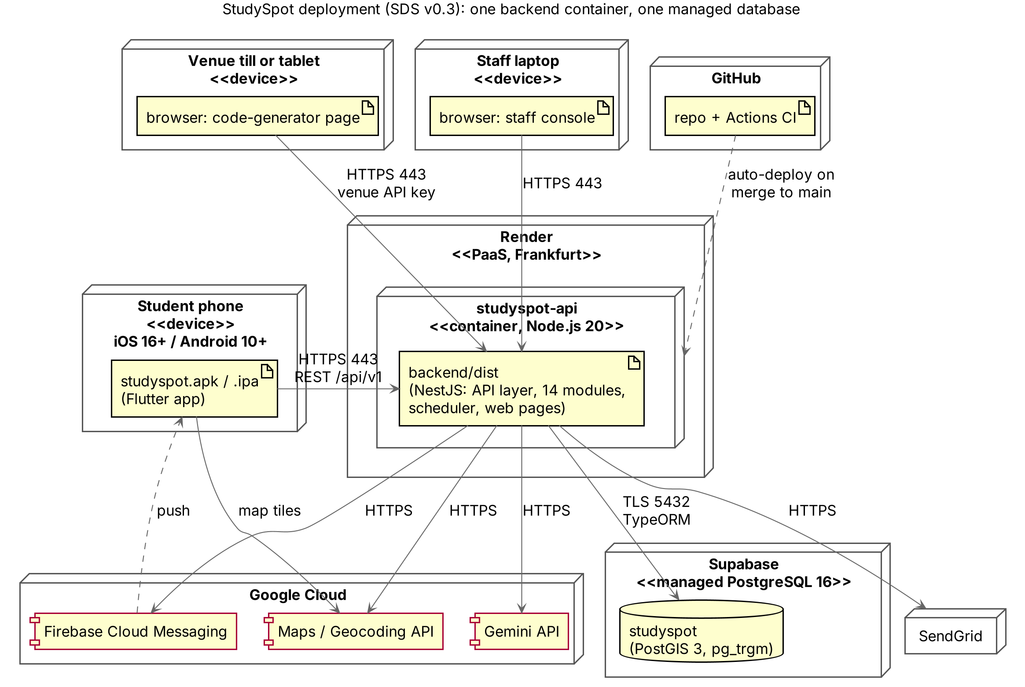
Figure 9. UML deployment diagram of StudySpot.

10.3 Feasibility
- No custom AI training. Both AI features call hosted models through adapters, so the team writes prompts, tool definitions and mapping code, not models.
- Hardest parts and how they are contained: the StudyMatch tool loop (kept to a few read-only tools), deep links from the camera (standard universal/app links), and background location (an OS feature; the app works without it).
- AI outages are contained by a small wrapper. The shared resilience wrapper is a library-based decorator, about a day of work plus a fallback in each of the two modules; it needs no extra infrastructure (PB-46).
- One codebase per tier (one app, one backend) keeps build, test and CI simple.
- Work splits cleanly by module: for example accounts + admin; venues + search + maps; conditions + audio; QR + rewards + e-mail; StudyMatch; mobile app shell + sensors. The StudyMatch owner also builds the shared resilience wrapper and the audio owner reuses it. Each member owns a unique part, as the course requires.
- Build order follows dependencies: accounts and venues first, then conditions and surveys, then QR and rewards, then StudyMatch and audio, then notifications and staff console.

11. Architecture Risks and Mitigations
Table 12. 11. Architecture Risks and Mitigations
Risk | Impact | Likelihood | Mitigation
Too few users or surveys to give current values | Most venues show historical or unavailable; demo looks empty | High | Historical fallback; seed realistic test data for the demo; QR points as incentive.
LLM gives reasons not backed by data, or is slow | Wrong recommendations; PERF-003 missed | Medium | Tools return structured data with status; prompt forbids unsupported claims; cap tool calls; 5-second call limit inside a 9-second request deadline, circuit breaker, fallback to standard results; reasons checked against tool results in testing (AI-014).
Audio AI classifies noise poorly | Misleading noise levels | Medium | Surveys also feed noise; measure agreement on a labeled set (AI-027); allow switching provider through the adapter.
AI provider outage or quota exhausted (one Gemini key serves both AI features) | StudyMatch and noise sampling stop together, possibly during the demo | Medium | A separate breaker per adapter; StudyMatch falls back to standard results and audio creates no record, so the app stays usable; quotas monitored; the provider can be swapped through the adapter. Both features still share one key, so a quota problem hits both.
Circuit breaker set too tight or too loose | A healthy AI service is blocked, or a failing one is called for too long | Low–Medium | Values are configuration; every state change is logged; tested with a fault-injecting fake; tuned with real response times in Sprint 3.
Background location and microphone refused, or blocked by OS or store review | Fewer present users and snippets | High | App fully usable without them; clear purpose screens; surveys cover all three attributes.
Deep links from the camera fail on some devices | QR survey does not open | Medium | Universal/app links tested on both platforms early; fallback web page with store links.
Point abuse (shared or reused codes) | Rewards drained | Medium | One-time token bound on first scan; 10-minute and 24-hour expiry; daily cap; venue rate limit; transaction on award.
Third-party API cost or quota limits | Features stop during the demo | Medium | Small free-tier usage; caching; quotas monitored; adapters fail cleanly, and the AI adapters stop calling a failing service (circuit breaker).
Module boundaries erode in the monolith | Harder changes later | Medium | Modules call each other only through their interfaces; code review on every pull request.
Personal data handling not compliant | Legal and ethical risk | Low–Medium | Minimal data, 90-day purge, no audio stored, terms at first launch, review against Egyptian data-protection law before release (SRS A-008).
Schedule: scope too large for December 1 | Unfinished features | Medium | Build order in 10.3; deferred items already marked in the SRS; staff console kept minimal.

12. Use Cases
StudySpot has 22 use cases across five primary actors and six supporting actors. Each use case traces to the requirements in SRS Section 3 and to the backlog in SRS Section 4.

12.1 Actors
Table 13. 12.1 Actors
Actor | Kind | User class (SRS 2.3) | Goal
Visitor | Primary | Student or secondary user, not signed in | Find and compare study places.
Student | Primary (specializes Visitor) | Student or secondary user, signed in | Everything a Visitor does, plus StudyMatch, surveys, points, coupons, favorites, reviews.
Venue | Primary | Participating venue (staff or till) | Print one-time receipt codes.
System Administrator | Primary | System Administrator | Manage accounts, configuration and monitoring.
Moderator | Primary | Moderator | Remove reported content.
Time (scheduler) | Supporting | — | Expire codes and coupons; delete records older than 90 days; retry failed coupon e-mails.
LLM Service | Supporting (external) | — | Interpret StudyMatch requests and write recommendations.
Audio AI Service | Supporting (external) | — | Classify noise from a short audio snippet.
Maps Service | Supporting (external) | — | Map display and geocoding of typed areas.
E-mail Service | Supporting (external) | — | Deliver coupons.
Push Service | Supporting (external) | — | Deliver presence notifications.
The AI agent (SRS 2.3) is part of the system behind StudyMatch, so it is not an actor here; the LLM Service it calls is.
Use case list
Table 14. 12.1 Actors: Use case list
ID | Use case | Primary actor | Supporting actors
UC-01 | Register and accept terms | Visitor | —
UC-02 | Sign in and sign out | Student | —
UC-03 | Search and filter study locations | Visitor | Maps Service
UC-04 | View location details and conditions | Visitor | Maps Service
UC-05 | Ask StudyMatch | Student | LLM Service
UC-06 | Manage study preferences | Student | —
UC-07 | Manage favorites | Student | —
UC-08 | Write or report a review | Student | —
UC-09 | Submit QR receipt survey | Student | —
UC-10 | Submit in-app survey | Student | —
UC-11 | Share a noise sample | Student | Audio AI Service
UC-12 | Confirm presence from a notification | Student | Push Service
UC-13 | Redeem points for a coupon | Student | E-mail Service
UC-14 | Activate a coupon at the venue | Student | —
UC-15 | Delete account | Student | —
UC-16 | Generate a receipt code | Venue | —
UC-17 | Staff sign-in with re-authentication | System Administrator, Moderator | —
UC-18 | Manage staff, user accounts and venue keys | System Administrator | —
UC-19 | Configure rewards and freshness limits | System Administrator | —
UC-20 | View security log and statistics | System Administrator | —
UC-21 | Moderate reported content | Moderator | —
UC-22 | Expire codes and coupons, purge old data | Time (scheduler) | —

12.2 Use Case Diagram
The use cases are shown in three diagrams, each readable on one page: discovery and account (Figure 4), contributing, StudyMatch and rewards (Figure 5), and venue, staff and scheduler (Figure 6). Hollow-triangle arrows are generalization; dashed arrows are «include» and «extend»; boxes on the right are external systems acting as supporting actors.
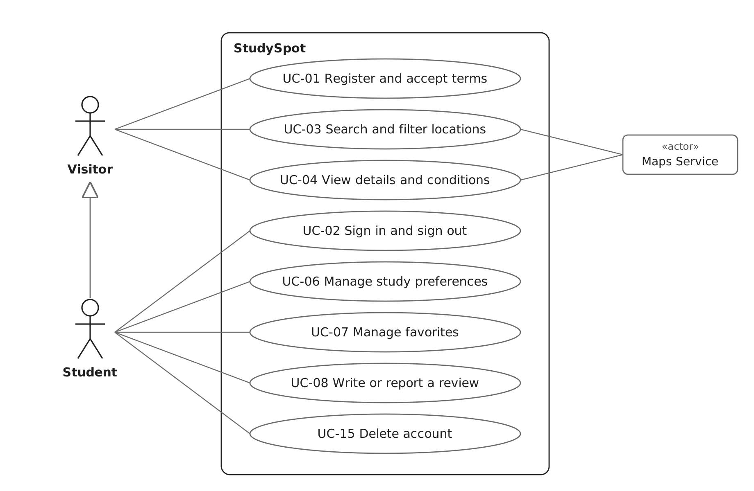
Figure 4. UML use case diagram: discovery and account. A Student is a specialized Visitor and can do everything a Visitor can.
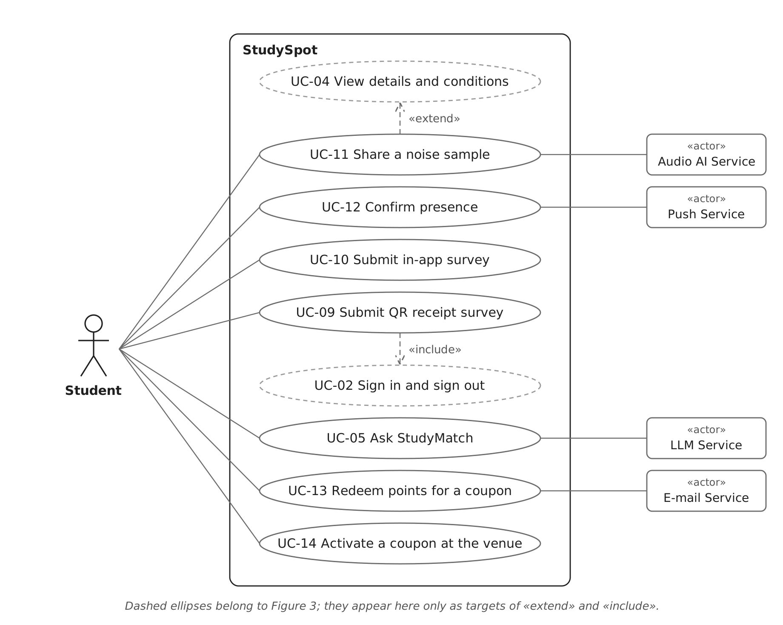
Figure 5. UML use case diagram: contributing, StudyMatch and rewards. Sharing a noise sample extends viewing a venue; the QR survey includes signing in.
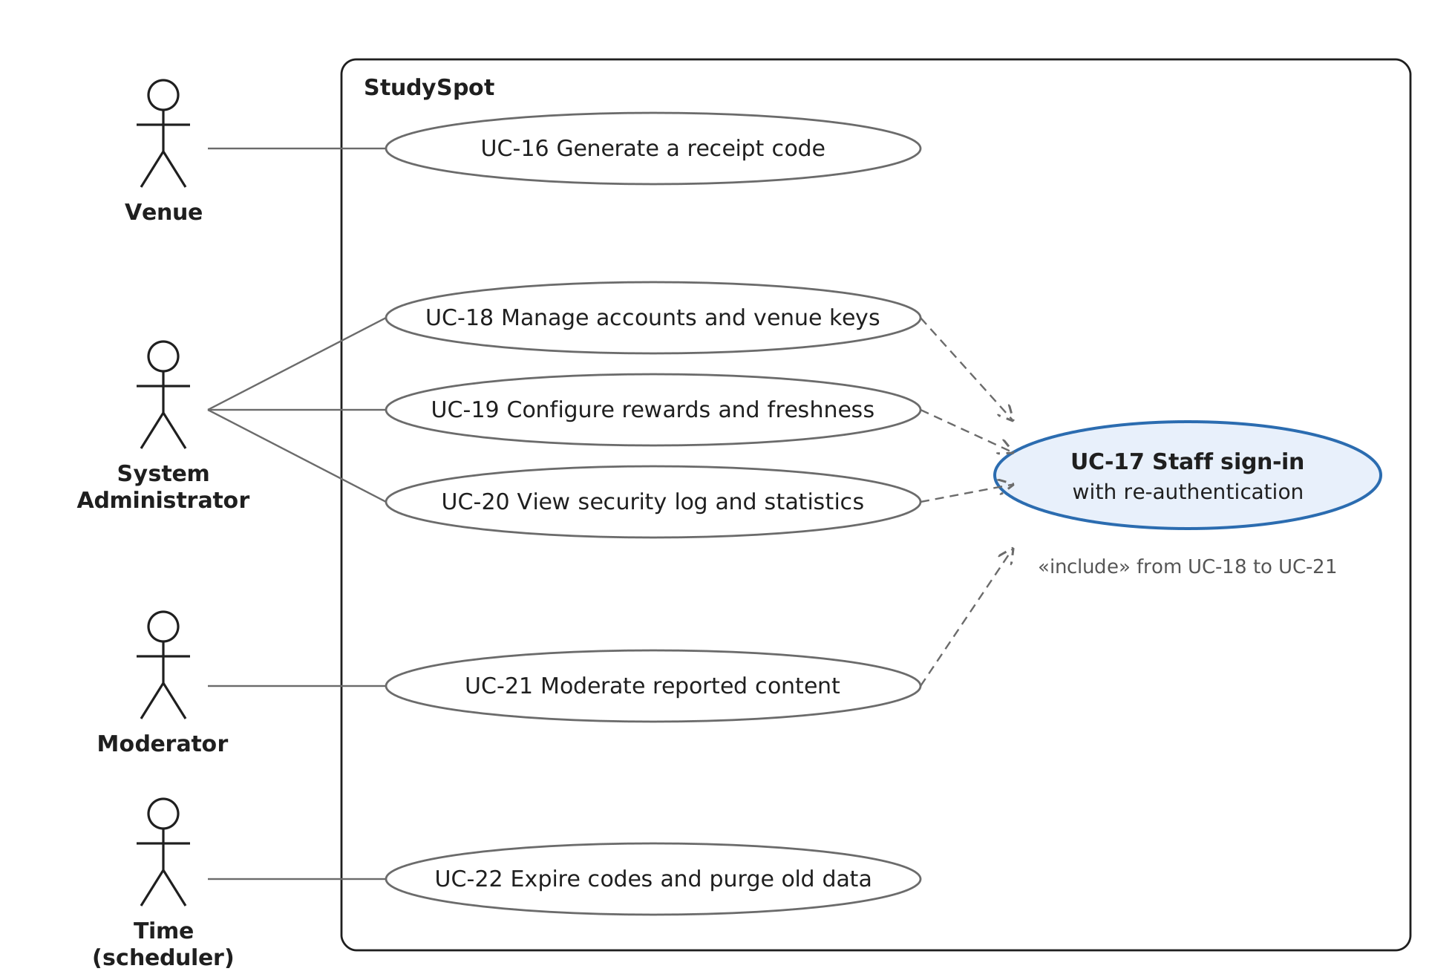
Figure 6. UML use case diagram: venue, staff and scheduler. Every staff use case includes the stronger staff sign-in (UC-17).

12.3 Use Case Descriptions
The eight use cases that carry the product are described in full. The rest follow in a short table.

UC-03 Search and filter study locations
Table 15. UC-03 Search and filter study locations
Field | Detail
Actor | Visitor (supporting: Maps Service)
Precondition | The app is open and online.
Main flow | 1. Visitor opens search. 2. If location is granted, the system lists nearby locations with distance; otherwise the Visitor types a name or area. 3. Visitor applies filters (noise, Wi-Fi, outlets, price, hours, crowd, distance, individual/group). 4. The system shows matching locations as a list and on a map.
Alternatives | 2a. Location denied: the system asks for an area and geocodes it. 4a. No match: the system says so and suggests removing a filter. 4b. Maps Service down: the list still works; the map shows an error.
Postcondition | The Visitor sees matching locations.
Requirements | FR-009 to FR-015, EIR-003, EIR-011, USE-007, PERF-001

UC-04 View location details and conditions
Table 16. UC-04 View location details and conditions
Field | Detail
Actor | Visitor
Precondition | A location was chosen from the list or map.
Main flow | 1. The system shows static details (hours, price, Wi-Fi, outlets, suitability) and reviews. 2. For crowd, noise and Wi-Fi it shows the value, "Current" or "Historical", and the last-updated time. 3. Crowd and noise are labeled as estimates.
Alternatives | 2a. No current value: a historical value from the last 90 days is shown. 2b. No record in 90 days: "unavailable". 3a. The Student is at the venue with microphone granted: UC-11 may run (extend).
Postcondition | The Visitor knows the latest known conditions.
Requirements | FR-016 to FR-021, FR-030, FR-031, RT-001 to RT-019, USE-003, USE-004, PERF-002

UC-05 Ask StudyMatch
Table 17. UC-05 Ask StudyMatch
Field | Detail
Actor | Student (supporting: LLM Service)
Precondition | Student is signed in.
Main flow | 1. Student types a request in English, Arabic or both (for example "quiet place with outlets near me"). 2. The system extracts the criteria, uses location if granted, and reads data only through read-only operations. 3. The system ranks locations, using stored preferences. 4. The system shows recommendations, each with its reasons, labeled current or historical.
Alternatives | 2a. Missing information: the system asks for it or states its assumption. 2b. Off-topic request: the system says it cannot help. 4a. Requested data unavailable: the reply says so. 4b. LLM Service down, too slow or paused by its circuit breaker: the system says smart matching is unavailable and shows standard results (nearby locations that match the Student's stored preferences); search and filters stay available.
Postcondition | Student has ranked recommendations with reasons.
Requirements | AI-001 to AI-020, AI-024, AI-028, AI-029, EIR-015, PERF-003, PERF-007

UC-09 Submit QR receipt survey
Table 18. UC-09 Submit QR receipt survey
Field | Detail
Actor | Student
Precondition | The Student holds a receipt with an unused code less than 24 hours old.
Main flow | 1. Student scans the code with the phone camera. 2. The app opens on the venue's survey (includes UC-02 if not signed in). 3. The system binds the code to the Student and shows a 10-minute countdown. 4. Student answers crowd, noise and Wi-Fi (any may be skipped) and submits. 5. The system stores the survey, awards points per answered category up to the daily cap, and marks the code used.
Alternatives | 2a. App not installed: the store page opens. 3a. Code used, expired or bound to another account: "code no longer valid", no points. 5a. 10 minutes passed: the code expires, no points. 5b. Daily cap reached: the survey is stored, no further points, and the Student is told.
Postcondition | Survey stored; points awarded; code used.
Requirements | QR-003 to QR-013, CON-002 to CON-008, RWD-001, RWD-002, RWD-010, RWD-011, RWD-016, USE-010, USE-011

UC-11 Share a noise sample
Table 19. UC-11 Share a noise sample
Field | Detail
Actor | Student (supporting: Audio AI Service)
Precondition | Student is at the venue (venue radius) and has granted microphone permission.
Main flow | 1. Triggered when the Student opens the details of a venue they are at, or confirms presence (UC-12). 2. The app records a short snippet with a visible indicator. 3. The backend classifies it as Quiet, Moderate or Noisy and discards the audio. 4. The system stores only level, time and venue.
Alternatives | 1a. Microphone denied: nothing is recorded; surveys remain available. 3a. Analysis fails, times out or is paused by its circuit breaker: no record is created, the audio is discarded and the app shows a short notice; surveys remain available.
Postcondition | A new noise record exists; no audio exists anywhere.
Requirements | SEN-004 to SEN-009, AI-023, AI-025, AI-026, PRIV-001, DATA-005, EIR-015

UC-13 Redeem points for a coupon
Table 20. UC-13 Redeem points for a coupon
Field | Detail
Actor | Student (supporting: E-mail Service)
Precondition | Student is signed in and has points.
Main flow | 1. Student views available coupons with cost and venue. 2. Student picks one. 3. The system deducts the cost and issues the coupon. 4. The system e-mails the coupon, with an "Activate" link, to the account's address.
Alternatives | 3a. Balance too low: rejected, balance unchanged. 4a. E-mail fails: the coupon is still listed in the app and the Scheduler retries the e-mail (6.3).
Postcondition | Points reduced; coupon issued.
Requirements | RWD-005 to RWD-009, RWD-014, RWD-021, EIR-013, PERF-010

UC-14 Activate a coupon at the venue
Table 21. UC-14 Activate a coupon at the venue
Field | Detail
Actor | Student
Precondition | Student holds an issued, never-activated coupon and is at the counter.
Main flow | 1. Student taps "Activate" in the e-mail or app. 2. The system shows the reward, venue, code and a live 5-minute countdown. 3. Staff check the screen and hand over the reward.
Alternatives | 2a. Coupon already activated or expired: "expired", no reactivation, no refund.
Postcondition | Coupon active, then expired after 5 minutes.
Requirements | RWD-017 to RWD-020 [OD-25]

UC-16 Generate a receipt code
Table 22. UC-16 Generate a receipt code
Field | Detail
Actor | Venue
Precondition | The venue is registered and has a valid API key.
Main flow | 1. The till calls the receipt-code API, or staff press "New code" on the generator page. 2. The system creates a one-time token and returns a link. 3. The venue prints it as a QR code on the receipt.
Alternatives | 2a. Invalid or revoked key: rejected. 2b. Rate limit exceeded: rejected until the next minute.
Postcondition | An unused code exists for 24 hours.
Requirements | QR-001, QR-002, EIR-012, SEC-011 to SEC-013, PERF-009

Other use cases
Table 23. Other use cases
ID | Main flow (short) | Key alternatives | Requirements
UC-01 | Visitor reads and accepts the terms, enters e-mail and other details, account is created. | Terms declined: no account. E-mail already used: error. | FR-001, PRIV-011, SEC-002
UC-02 | Student signs in with valid credentials; signs out later or is signed out after inactivity. | Wrong credentials: error, attempt logged. Suspended: refused. | FR-002 to FR-004, FR-038, SEC-009, SEC-010
UC-06 | Student sets, edits or removes study preferences; they persist. | — | FR-022 to FR-024
UC-07 | Student adds or removes a favorite and views the list. | — | FR-026, FR-027
UC-08 | Student writes a review, or reports someone else's review. | Review rejected by validation: error. | FR-025, FR-034
UC-10 | Student fills the same survey inside the app; it feeds conditions but earns no points. | — | CON-001 to CON-008 [OD-27]
UC-12 | After background location detects a stay, the Student gets "are you here?" and confirms; may continue to UC-10 or UC-11. | Notifications off or permission denied: none sent. | SEN-013 to SEN-016
UC-15 | Student deletes their account; personal data is removed, anonymised records kept. | — | FR-008, PRIV-012
UC-17 | Staff member signs in and re-authenticates before any staff function. | Not a staff account: refused and logged. | FR-035, SEC-010
UC-18 | Administrator creates, suspends or reactivates staff and user accounts, and issues or revokes venue API keys (includes UC-17). | — | FR-036 to FR-038, FR-043, FR-044
UC-19 | Administrator edits points per category, daily cap, freshness limits and venue radius (includes UC-17). | Invalid value: rejected. | FR-039, FR-040, DATA-012
UC-20 | Administrator views the security log and statistics for a period (includes UC-17). | — | FR-041, FR-042
UC-21 | Moderator reviews reported reviews and surveys and removes them (includes UC-17). | — | FR-029 [OD-24]
UC-22 | The scheduler marks codes and coupons expired and deletes raw presence records after 2 hours and other records older than 90 days. It also retries coupon e-mails that failed to send. | — | QR-007, QR-009, RWD-018, PRIV-013, PRIV-016

13. Conclusion
StudySpot is built as a client–server system with a layered modular-monolith backend. One backend sits between the mobile app and everything else, so secrets, business rules and AI access stay on the server, and every external service is reached through an adapter. The two AI adapters add time limits and circuit breakers, so an AI outage degrades StudyMatch and noise sensing without taking down the rest of the app.
The design is derived from the SRS and the product backlog (6.5), uses well-known patterns (Section 8), addresses the quality attributes that matter most for StudySpot (Section 9), and is feasible for the team by December 1 (10.3). It will be refined every sprint with class and sequence diagrams.

14. Sprint 1 detailed design
This section holds the lower-level design of the Sprint 1 features. Each member adds their part before the Milestone 2 merge: Accounts and Auth class and sequence diagrams for registration and sign-in (M2); Venues and Search class diagram and the "nearby search with filters" sequence diagram (M3); Conditions class diagram and the "view details" sequence diagram (M4); the app's MVVM class diagram and screen flow (M5); screen designs (M6).

Change Log
Table 24. Change Log
Version | Date | Change
0.1 | 2026-10-12 | First architecture baseline for Milestone 1, derived from SRS v0.3. A coarse-grained microservices design was drafted and evaluated; the team kept the modular monolith (see 3.1).
0.2 | 2026-10-13 | Circuit breakers added to the LLM and Audio AI adapters. New: Section 5.1 with Figure 3 and Table 3, the Resilience Policy component (6.4), patterns Decorator, Circuit Breaker and Fallback (8), backlog item PB-46, SRS requirements EIR-015, AI-028 and AI-029, risks for AI outage and breaker tuning (11), cockatiel in the technology mapping (10.1), interaction 7.5. Changed: Figures 1 and 2 redrawn; availability, performance and testability tactics (9); UC-05 and UC-11 alternatives; StudyMatch and Audio Analysis responsibilities. Corrected: Scheduler also runs the 2-hour presence purge (PRIV-016); map-display key is a restricted client key; PB-44 added to traceability; "four" architectural patterns; reference to a non-existent SRS AI test set removed; SRS version references updated to v0.4.
0.3 | 2026-10-25 | Milestone 1 feedback addressed. New: Section 1.4 and Figure 0 (big picture); Section 5.2 with Figure 7 and Table 25 (module dependencies generated from the code and enforced in CI); Presence, Configuration and Clock components (6.3, 6.4, 6.5); Section 6.7 and Figure 8 (database schema); Figure 9 (deployment diagram, 10.2); pattern locations in code (8); Section 14 for the Sprint 1 detailed design. Changed: Figures 1 and 2 redrawn in UML with every module connected; one error format and request IDs (5.2); SRS references updated to v0.5. M1 changes; other members add theirs in Section 14 and the use cases (12).

