QUERY 01

create database employeedatabase;

use employeedatabase;

create table employee

(empno int primary key,

ename varchar(50),

mgr_no int,

hiredate date,

sal decimal(10,2),

deptno int,

foreign key(deptno) references dept(deptno)

);

create table dept

(deptno int primary key,

dname varchar(60),

dloc varchar(60)

);

create table project

(

pno int primary key,

pname varchar(60),

ploc varchar(100)

);

create table assignedto

(empno int,

pno int,

jobrole varchar(50),

foreign key(empno) references employee(empno),

foreign key(pno) references project(pno)

);

create table incentives

(empno int,

incentive_date date primary key,

incentive_amount decimal(10,2),

foreign key(empno) references employee(empno)

);

QUERY 2

INSERT INTO DEPT VALUES (10, 'HR', 'Bengaluru');

INSERT INTO DEPT VALUES (20, 'Engineering', 'Hyderabad');

INSERT INTO DEPT VALUES (30, 'Sales', 'Mysuru');

INSERT INTO DEPT VALUES(40, 'Design', 'Mumbai');

INSERT INTO DEPT VALUES(50, 'IT', 'Jaipur');

INSERT INTO EMPLOYEE VALUES (101, 'Aisha', NULL, '2016-03-10', 90000.00, 20);

INSERT INTO EMPLOYEE VALUES(102, 'Bilal', 101, '2017-07-15', 60000.00, 20);

INSERT INTO EMPLOYEE VALUES (103, 'Cathy', 101, '2018-01-20', 55000.00, 20);

INSERT INTO EMPLOYEE VALUES (104, 'Dina', 101, '2019-05-01', 50000.00, 30);

INSERT INTO EMPLOYEE VALUES (105, 'Ehsan', 104, '2019-06-10', 32000.00, 30);

INSERT INTO PROJECT VALUES (1001, 'Alpha System', 'Bengaluru');

INSERT INTO PROJECT VALUES (1002, 'Beta Platform', 'Hyderabad');

INSERT INTO PROJECT VALUES (1003, 'Gamma App', 'Mysuru');

INSERT INTO PROJECT VALUES (1004, 'Delta Tool', 'Chennai');

INSERT INTO PROJECT VALUES (1005, 'Mobile App', 'Çhennai');

INSERT INTO ASSIGNEDTO VALUES (101, 1002, 'Project Manager');

INSERT INTO ASSIGNEDTO VALUES (102, 1002, 'Developer');

INSERT INTO ASSIGNEDTO VALUES (103, 1002, 'Tester');

INSERT INTO ASSIGNEDTO VALUES (105, 1003, 'Sales Rep');

INSERT INTO ASSIGNEDTO VALUES (104, 1003, 'Junior Sales');

INSERT INTO INCENTIVES VALUES (101, '2019-01-05', 5000.00);

INSERT INTO INCENTIVES VALUES (102, '2019-01-10', 3000.00);

INSERT INTO INCENTIVES VALUES (103, '2019-01-12', 2500.00);

INSERT INTO INCENTIVES VALUES (104, '2019-01-08', 2000.00);

INSERT INTO INCENTIVES VALUES (101, '2019-02-20', 4000.00);

SELECT * FROM DEPT;

SELECT * FROM EMPLOYEE;

SELECT * FROM PROJECT;

SELECT * FROM ASSIGNEDTO;

SELECT * FROM INCENTIVES;

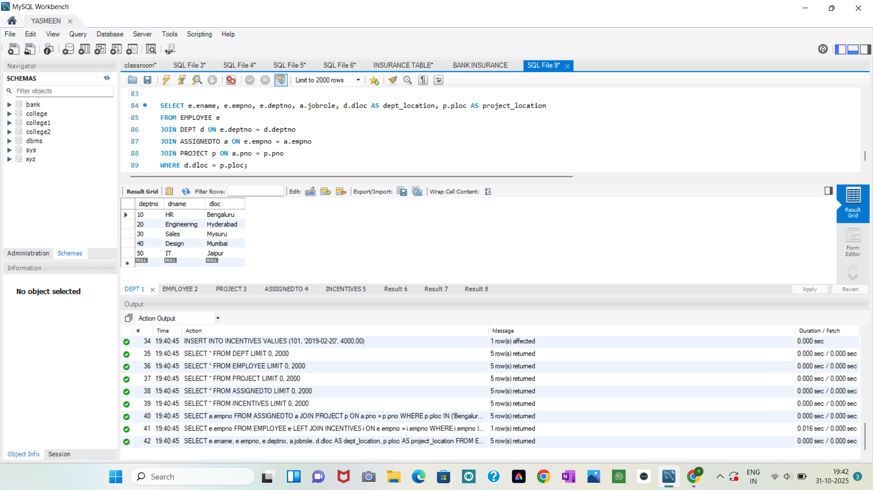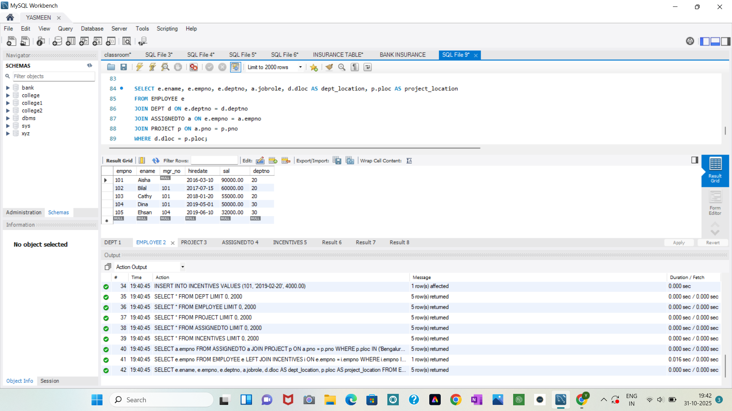

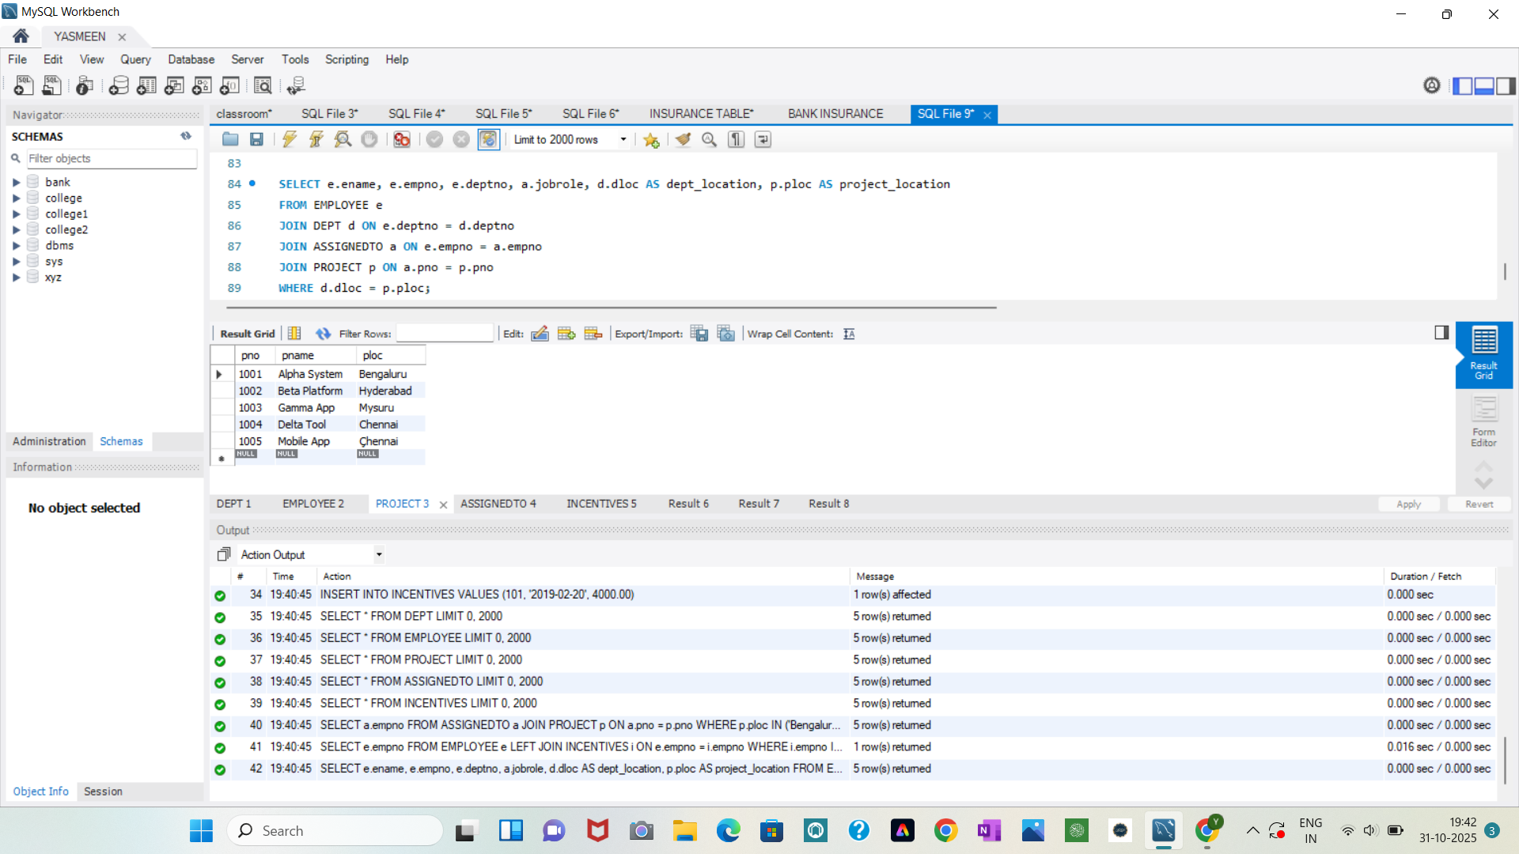

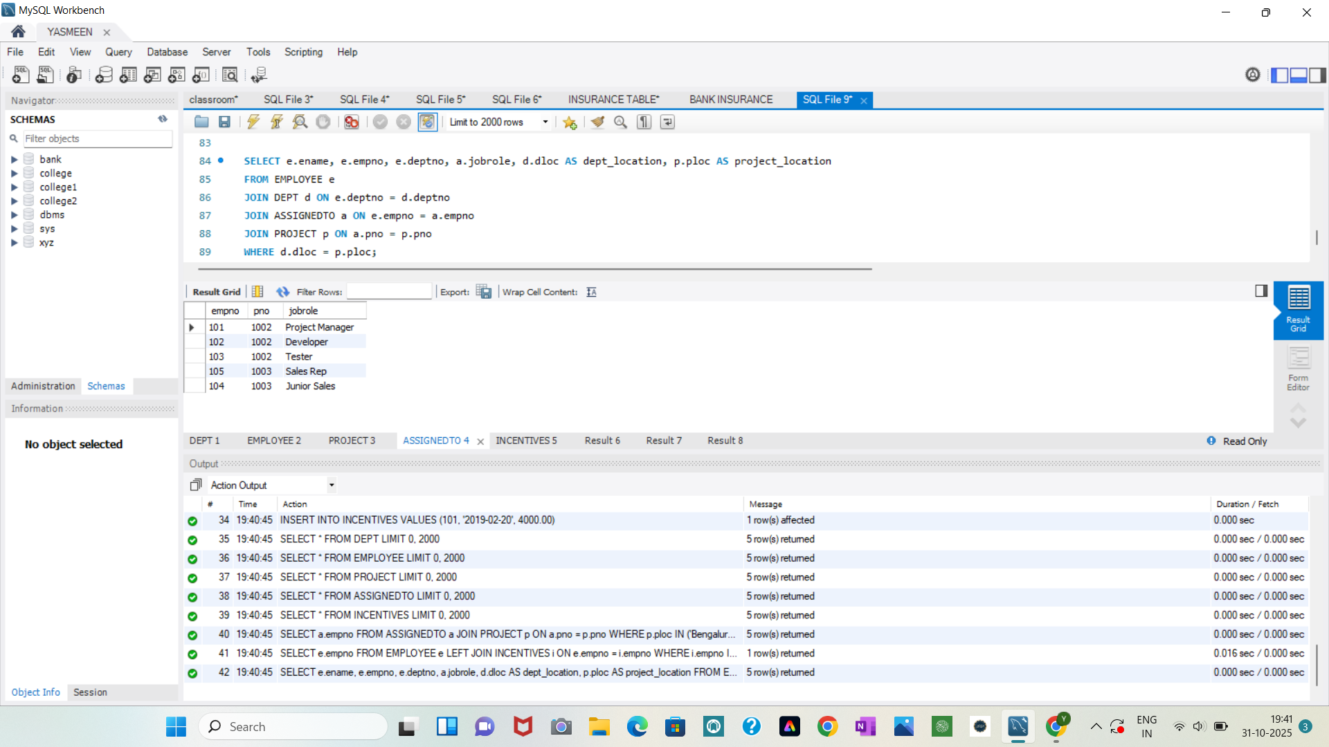

QUERY 3

SELECT a.empno

FROM ASSIGNEDTO a

JOIN PROJECT p ON a.pno = p.pno

WHERE p.ploc IN ('Bengaluru', 'Hyderabad', 'Mysuru');

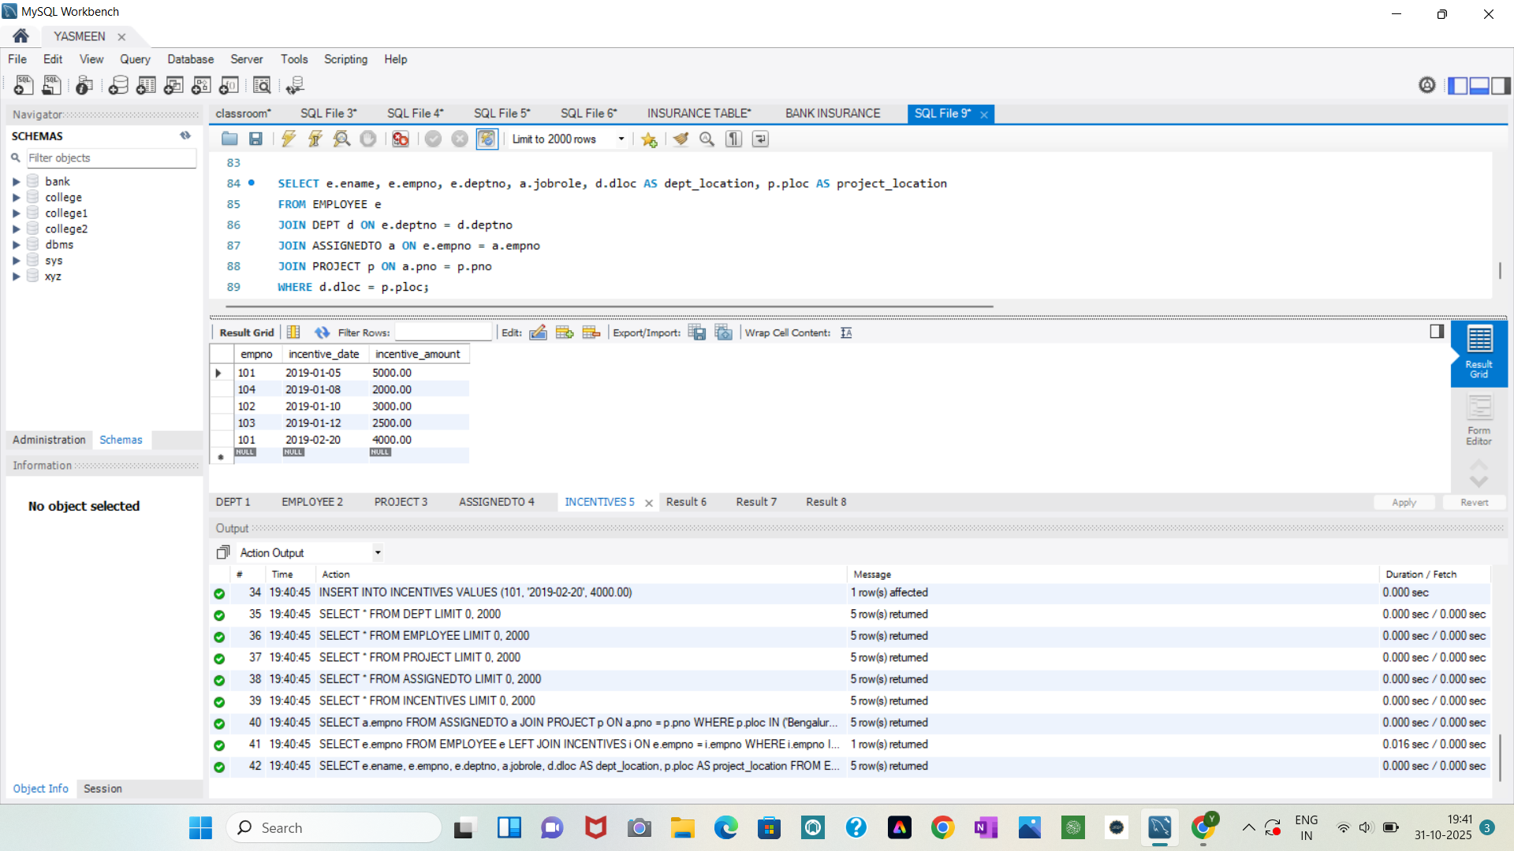

QUERY 4

SELECT e.empno

FROM EMPLOYEE e

LEFT JOIN INCENTIVES i ON e.empno = i.empno

WHERE i.empno IS NULL;

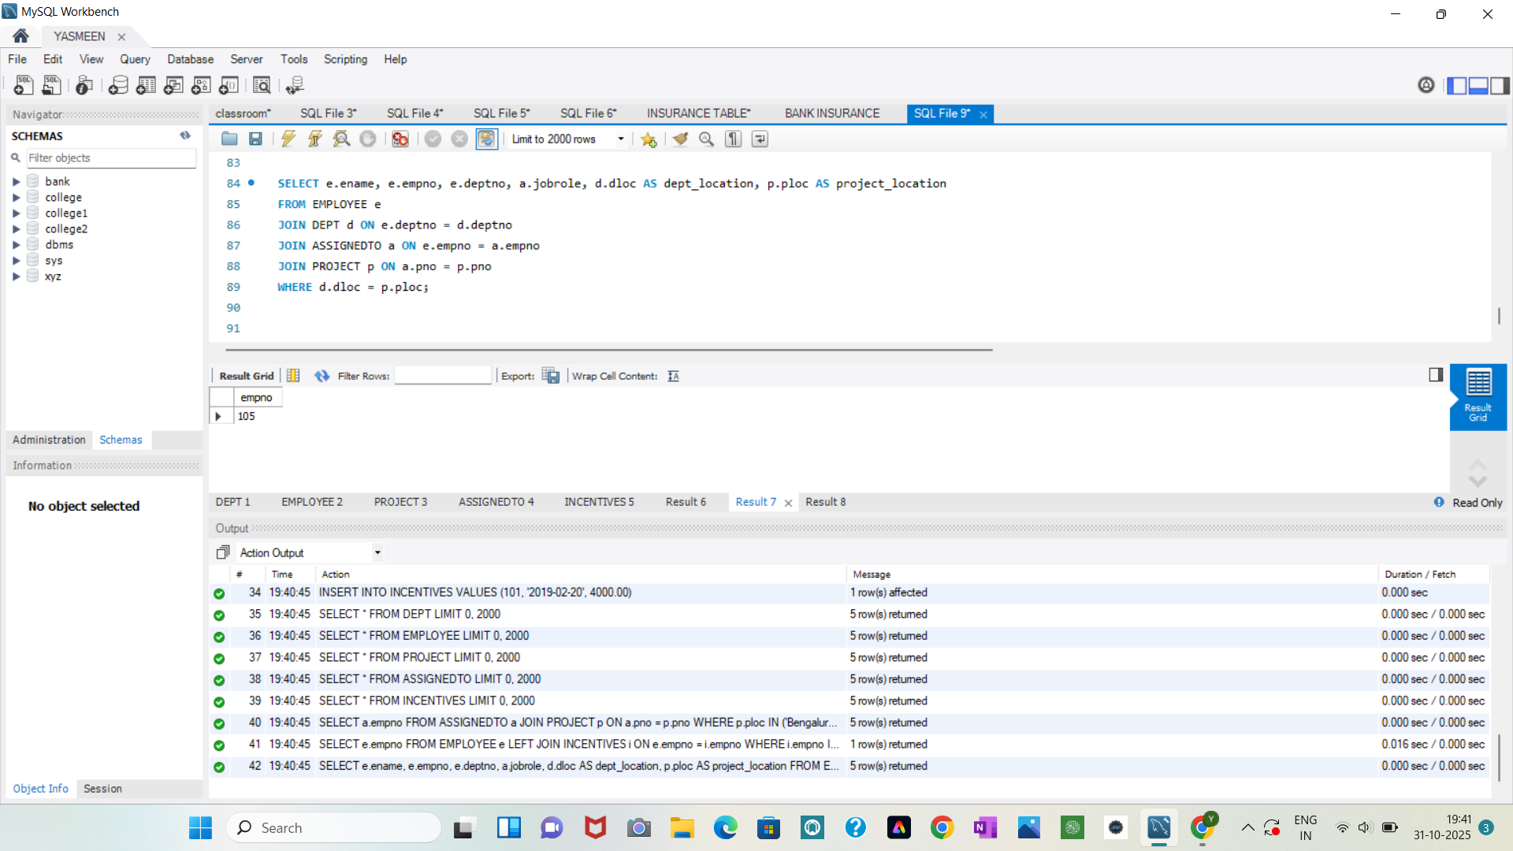

QUERY 5

SELECT e.ename, e.empno, e.deptno, a.jobrole, d.dloc AS dept_location, p.ploc AS project_location

FROM EMPLOYEE e

JOIN DEPT d ON e.deptno = d.deptno

JOIN ASSIGNEDTO a ON e.empno = a.empno

JOIN PROJECT p ON a.pno = p.pno

WHERE d.dloc = p.ploc;

