AMOND ASSOCIATION FOR TECHNOLOGY & INFORMATICS
DEVELOPMENT AND SOFTWARE ENGINEERING DEPARTMENT
RABAT, MOROCCO
ACADEMIC INTERNSHIP REPORT
Design, Redesign, and Full-Stack Implementation of the Polyglot Interactive Language Learning Platform with Dynamic Analytics
Submitted in partial fulfillment of the requirements for the Degree of Software Engineering

Candidate Name: | [Your Full Name]
Student ID / Class: | [Your Student ID / Academic Program]
Host Institution: | AMOND Association (Rabat, Morocco)
Academic Institution: | [Your University Name]
Internship Duration: | [Start Date] – [End Date]
Academic & Professional Advisors: | [Supervisor & Professor Names]
ACADEMIC YEAR: 2025 - 2026

Dedication
I dedicate this academic work to my beloved family, who supported me every step of the way with patience, love, and encouragement. To my parents, who sacrificed so much to afford me the opportunity of a high-quality education and who instilled in me the values of diligence, persistence, and curiosity in the face of engineering challenges.
To my teachers and university professors, who provided me with the theoretical foundations, structural guidelines, and the rigorous software engineering mindset required to solve complex industrial problems.
To all the software engineers, developers, mentors, and staff members at the AMOND Association in Rabat, who welcomed me into their development team and guided me throughout this technical and professional journey.

Acknowledgements
First and foremost, I would like to express my deepest gratitude to my professional supervisors at the AMOND Association in Rabat for their continuous support, valuable technical feedback, and kind guidance. The professional experience and technical knowledge acquired during this internship have been instrumental to my growth as a software engineer. The cooperative atmosphere in the informatics department made my integration into the company's daily workflow seamless and highly productive.
I also extend my sincere thanks to the academic jury members and the administration of my university for reviewing this report, dedicating their time to evaluating my performance, and advising me during this critical milestone of my curriculum.
Finally, thank you to all fellow student engineers, development colleagues, and friends who contributed directly or indirectly to the completion of the Polyglot platform and the successful deployment of its features.

Executive Summary
This academic internship report details the engineering lifecycle, full-stack architectural design, and optimization of the Polyglot interactive language learning platform. Conducted at the AMOND Association in Rabat, Morocco, the project addresses a major educational challenge: the lack of contextual references, real native speaker dialogue, and active feedback in traditional language learning applications.
Polyglot bridges this gap by utilizing actual YouTube video clips to contextualize learning, utilizing voice checking to verify speech patterns, and incorporating AI tutors to deliver immersive interactive conversations. The internship project encompassed the full development lifecycle, from system requirement definitions and relational schema design to UI design, dynamic dashboard visualizations, and automated regression testing.
The key achievements of this internship include: (1) The full design and implementation of a modular dashboard system featuring interactive SVG charts built with Recharts, (2) The engineering of a massive, multi-language localization database consisting of over 13,840 distinct translation keys supporting 9 languages, and (3) The integration of a secure admin command center permitting real-time database schema inspections and system control. The system was validated using end-to-end Selenium browser tests and successfully deployed, delivering a state-of-the-art SaaS-like architecture. This document details the technical realizations, development workflows, and challenges resolved during the project.

Table of Contents
EXECUTIVE SUMMARY | ii
CHAPTER 1: INTRODUCTION AND HOST ENVIRONMENT | 1
1.1. Context and Motivation of the Internship | 1
1.2. The E-Learning Industry and Language Acquisition Paradigms | 2
1.3. Presentation of the Host Organization: AMOND Association | 4
1.4. Internship Framework, Methodology, and Schedule | 6
1.5. Structure of the Report | 8
CHAPTER 2: POLYGLOT PLATFORM AND ARCHITECTURAL DESIGN | 9
2.1. System Overview and Core Pedagogical Value | 9
2.2. Technology Stack Selection Rationale | 11
2.3. Monolithic vs. Decoupled Full-Stack Architecture | 13
2.4. Relational Database Design and Entity Relationship Schema (SQLite) | 15
2.5. Comprehensive Multi-Language Localization Strategy | 21
2.6. Security, Session Management, and Authentication | 23
CHAPTER 3: PLATFORM FEATURES IMPLEMENTATION AND DASHBOARD REDESIGN | 25
3.1. Interactive Study Modules Implementation | 25
3.1.1. The Learn Module (YouTube API) | 25
3.1.2. The Grammar Guide (Bilingual Panels) | 27
3.1.3. Stories Hub (Contextual Vocabulary Popovers) | 29
3.1.4. Spaced Repetition (SRS) Engine (SuperMemo-2 Algorithm) | 31
3.2. Analytics Dashboard Redesign & Dynamic Visualizations | 33
3.3. Command Center (Admin Control Console) | 36
CHAPTER 4: DEPLOYMENT, QUALITY ASSURANCE, CHALLENGES, & CONCLUSION | 38
4.1. Technical Stack and Tools Used Summary | 38
4.2. Quality Assurance & Automated Testing Coverage | 39
4.3. Technical Challenges & Engineering Solutions | 41
4.4. General Conclusion & Personal Outlook | 44
REFERENCES | 46

CHAPTER 1: INTRODUCTION AND HOST ENVIRONMENT

1.1. Context and Motivation of the Internship
In the current era of globalization and digital acceleration, language proficiency stands as a fundamental skill for personal, professional, and academic growth. Modern societies demand that individuals possess the ability to converse fluently in multiple languages. However, traditional pedagogical approaches to language acquisition often fail. These traditional models rely heavily on passive reading, grammar translation, and mechanical vocabulary memorization. In contrast, modern cognitive science demonstrates that active recall, auditory immersion, and real-time pronunciation checking are crucial for long-term language retention. This gap between traditional methods and actual cognitive needs forms the core challenge of EdTech development.
In the competitive landscape of software engineering, EdTech platforms represent a complex junction of distributed systems, interactive client architectures, and database persistence. Modern users demand interface experiences that are responsive, personalized, and visually polished. The motivation behind this project is to apply advanced engineering practices—including decoupled frontend-backend architectures, modular database optimization, stateless authentication, and dynamic SVG data visualizations—to resolve the critical limits of current language software. To construct a truly scalable web application, the project details the application of architectural standards that separate interface concerns from underlying transactional data streams.
Furthermore, this internship project focuses on the integration of Spaced Repetition algorithms (SRS) and interactive multimedia sources (YouTube). By implementing the SuperMemo-2 mathematical model on the backend, the platform enables automated vocabulary review schedules that adapt dynamically to individual memory decay patterns. This represents a significant departure from static quiz applications, offering a customized study workflow that optimizes memory consolidation.
Conducted as part of the requirements for the Software Engineering Degree, the internship was hosted by the AMOND Association in Rabat, Morocco. The project provided an opportunity to solve industrial engineering challenges, design relational schemas, implement high-performance frontends, and write automated testing suites to verify the stability of the system. This academic report details the technical realizations, development workflows, and challenges resolved during the project.

1.2. The E-Learning Industry and Language Acquisition Paradigms
The EdTech (Educational Technology) market has grown rapidly, driven by the widespread availability of high-speed internet, mobile devices, and cloud computing. Traditional software solutions, however, often rely on structured drills that present vocabulary in isolation. Research in applied linguistics shows that vocabulary is best acquired when presented in context. Visual media, such as video clips, provide learners with visual cues, emotional resonance, and colloquial expressions that are missing from structured textbooks. This contextual scaffolding is essential for learners to transition from theoretical understanding to functional fluency.
Cognitive load theory suggests that learners acquire syntactic rules more efficiently when exposed to authentic native inputs. Immersive contexts, coupled with active feedback systems, help transfer grammatical structures from working memory to long-term cognitive schemas. Therefore, software that integrates native video resources and provides immediate pronunciation feedback acts as a virtual immersion environment. To support this paradigm, the engineering team must design microservices capable of parsing video transcripts, aligning translation keys, and delivering real-time acoustic analytics.
Another critical aspect of the e-learning ecosystem is gamification. Points systems, visual streak indicators, and competitive leaderboards are not merely aesthetic additions; they are designed to stimulate user engagement and habit formation. By implementing these gamified loops, the platform encourages users to establish daily study routines. The database must track these parameters efficiently, logging daily logins, calculating streaks, and managing XP accumulation without introducing database locks or slow query response times.
Polyglot utilizes actual YouTube video clips as the foundation for language acquisition. By matching visual media with active recall exercises, the platform aims to simulate the language immersion experience. The technical objective was to build a system that supports this pedagogical approach, integrating video APIs, speech-to-text validation, and spaced repetition review systems into a single, unified interface.

1.3. Presentation of the Host Organization: AMOND Association
AMOND (Association Marocaine pour l'Orientation et les Nouvelles Technologies), based in Rabat, Morocco, is an organization focused on software development and technology consulting. The association promotes digital literacy, designs software applications, and provides technical consulting to public and private clients. AMOND's informatics department specializes in web applications, SaaS architectures, e-learning platforms, and custom client management systems.
Operating out of Rabat, AMOND's technical team utilizes modern development methodologies to deliver software to regional and international markets. The engineering division is organized into agile teams specializing in frontend rendering, backend microservices, database tuning, and quality assurance. This structured approach allows the association to manage multiple client projects simultaneously while maintaining software quality. Interns are placed directly into these teams, receiving mentoring while contributing to actual software releases.
AMOND's development process follows standard software engineering practices, utilizing Git for version control, Docker for environment isolation, and automated pipelines for deployment. Daily stand-up meetings, peer code reviews, and sprint planning sessions are used to coordinate development tasks and maintain code quality. This structured environment provided an opportunity to understand professional development workflows and learn how complex software projects are managed in a team context.
The association has successfully engineered various online platforms including student management software, custom client CRM tools, and robust e-learning applications. Participating in an internship at AMOND offered direct exposure to professional software engineering workflows, agile development methodologies, and full-stack architecture designs.

1.4. Internship Framework, Methodology, and Schedule
The development of the Polyglot platform followed the Agile Scrum framework, organizing the project into four distinct sprints. This iterative approach allowed the team to adjust requirements based on weekly reviews and address integration challenges early in the lifecycle. By dividing the project into manageable iterations, we maintained a consistent velocity throughout the internship.
Sprint 1: System Requirements & Database Foundations
This phase focused on requirements analysis, database schema definition, API planning, and establishing the FastAPI/SQLite backend foundations.
Task Description | Duration | Deliverables | Status
Requirements Analysis | 1 Week | Use Case Diagrams, Specifications Document | Completed
Database Relational Schema Design | 1 Week | SQL Tables definitions, ER Diagrams | Completed
Backend Framework Setup | 1 Week | FastAPI setup, JWT Auth routes | Completed

Sprint 2: Core Modules & Frontend Layout
This phase focused on building the core learning modules (Learn, Grammar, Stories) and designing the initial React layout.
Task Description | Duration | Deliverables | Status
React SPA Setup & SPA routing | 1 Week | Routing system, theme configurations | Completed
Learn & Grammar modules | 2 Weeks | Video API integration, bilingual guides | Completed
Stories Hub | 1 Week | Inline translations, popover components | Completed

Sprint 3: Redesign & Localization
This phase focused on upgrading the Analytics Dashboard with Recharts, compiling the localization database, and building the Admin Panel.
Task Description | Duration | Deliverables | Status
Analytics Page Redesign | 2 Weeks | Animated SVGs, Radar & Area Charts | Completed
Localization Database Setup | 1 Week | 13,840+ i18n JSON keys (9 languages) | Completed
Admin Command Console | 1 Week | SQLite schema inspector, user lists | Completed

Sprint 4: QA, Testing & Deployment
This phase focused on automated testing, performance tuning, and final deployment.
Task Description | Duration | Deliverables | Status
Automated Selenium Tests | 1 Week | E2E testing scripts, Chrome headless logs | Completed
Performance Tuning & Build | 1 Week | Vite production build optimization | Completed
Deployment & Report Writing | 2 Weeks | Production deployment, Internship Report | Completed

Weekly sprint reviews were held with the product owner at AMOND to validate the deliverables of each iteration. This process ensured that potential bottlenecks—such as site-package corruption or local file CORS blocks—were identified and addressed before the integration phase. The structured timeline kept the project on track, leading to a fully validated system deployment.

1.5. Structure of the Report
This academic report is organized into four main chapters. Chapter 1 introduces the project context, host organization (AMOND), and project schedule. Chapter 2 describes the platform's architectural design, technology stack, and relational database schemas. Chapter 3 explains the implementation details of the core modules, the redesign of the analytics dashboard, and the admin panel features. Chapter 4 outlines quality assurance protocols, automated Selenium testing, technical challenges resolved, and future prospects for the platform.

CHAPTER 2: POLYGLOT PLATFORM AND ARCHITECTURAL DESIGN

2.1. System Overview and Core Pedagogical Value
The Polyglot platform is designed to provide contextual language learning through multimedia integration. Rather than presenting vocabulary in isolation, the platform uses real-world visual media to provide learners with natural contexts. The system retrieves short clips from YouTube and generates relevant exercises, encouraging active recall. By matching native speaker audio with spelling and pronunciation exercises, the system provides immediate feedback on spelling, translation accuracy, and target accent grading.
Cognitive research indicates that passive learning yields low retention rates compared to active production. Polyglot addresses this by requiring users to translate and transcribe spoken sentences. By providing immediate correction, the platform reinforces learning and builds user confidence. This active approach helps students transfer language rules from short-term memory to functional fluency.
Language learning is structured dynamically around user progress. Every time a user completes an exercise successfully, the platform updates their profile metrics, including XP (Experience Points), level milestones, and daily streaks. This gamified loop keeps users motivated. The user interface reflects this approach by displaying clear visual indicators of progress, streak indicators, and league status.
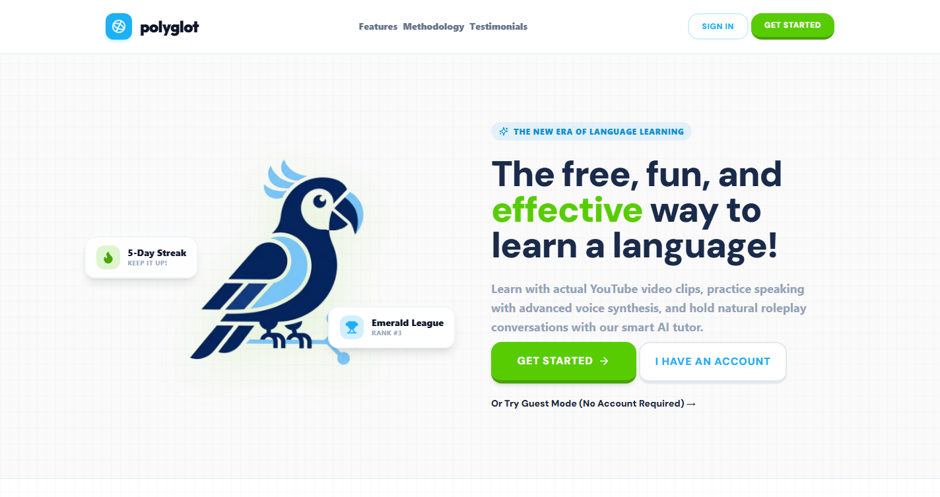
Figure 1: Polyglot Platform Landing Page and Brand Illustration

2.2. Technology Stack Selection Rationale
The technology stack was chosen to meet requirements for responsiveness, scalability, and ease of deployment:
- React & TypeScript: Provides a component-based structure for building responsive user interfaces, with static typing to reduce runtime errors.
- FastAPI: A python-based framework used for building the REST API, chosen for its fast execution speeds and automated OpenAPI documentation.
- SQLite: A self-contained, serverless database engine selected for ease of deployment, data persistence, and sufficient performance for single-host environments.
- TailwindCSS: A utility-first CSS framework used for styling, facilitating responsive layouts and consistent themes.
Using TypeScript on the frontend provides type safety, which reduces runtime errors and simplifies maintenance during development. FastAPI's integration with Python's type hinting enables automated request validation and helps maintain consistent schemas between the client and server. Together, these technologies support a reliable and maintainable development cycle.
SQLite was selected as the database engine due to its serverless nature and ease of deployment. In a single-host SaaS-like development environment, it provides sufficient write speeds and transaction reliability. Additionally, configuring the database to run in Write-Ahead Logging (WAL) mode increases concurrency and mitigates database lock issues during concurrent write operations.

2.3. Monolithic vs. Decoupled Full-Stack Architecture
Polyglot uses a decoupled client-server architecture. The frontend SPA handles view transitions, application state, and client-side localization. The backend server manages database queries, business logic, authentication, and integration with external APIs. Communication occurs via standard HTTP requests with JSON payloads. This design separates the user interface from the data persistence layer, simplifying maintenance and enabling independent updates to the client and server.
The backend server uses a modular structure, where database models, schema definitions, and API routers are separated into distinct modules. This organization simplifies the integration of new features, such as Spaced Repetition algorithms and classroom progress logs, without introducing regressions into the core authentication services.
The frontend application uses an asynchronous state management system to handle API requests. By managing loading states and handling exceptions on the client, the application remains responsive even during network latency. This separated architecture improves performance and ensures a stable user experience.
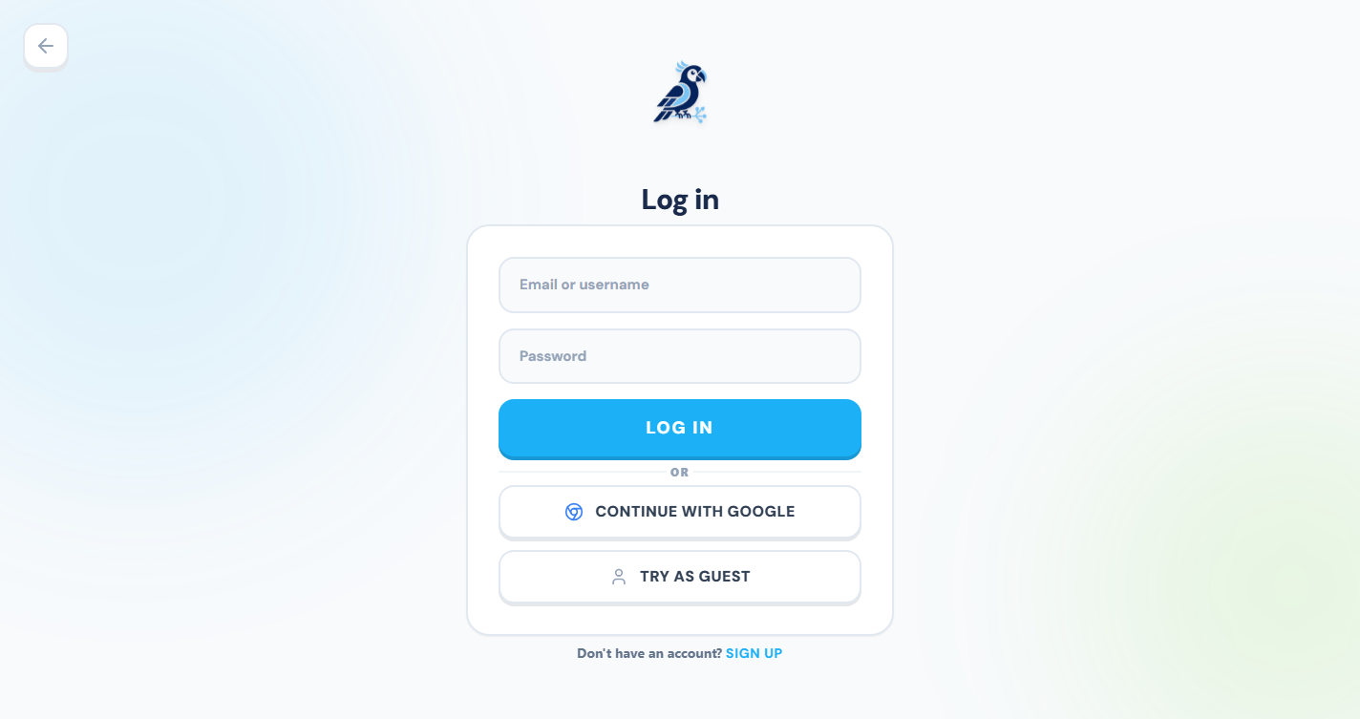
Figure 2: User Authentication Portal with OAuth and Guest Entry Options

2.4. Relational Database Design and Entity Relationship Schema (SQLite)
The database schema was structured to manage application features while maintaining referential integrity. Five core tables are detailed below with their respective column attributes:
Table 1: 'users' Table Schema Description
Column Name | Data Type | Constraints | Description
id | INTEGER | PRIMARY KEY, AUTOINCREMENT | Unique identifier for the user account.
username | VARCHAR(50) | NOT NULL, UNIQUE | Unique username chosen during registration.
hashed_password | VARCHAR(255) | NOT NULL | Salted password hash generated via bcrypt.
email | VARCHAR(100) | NULL, UNIQUE | Optional email address for notifications.
xp | INTEGER | DEFAULT 0 | Accumulated experience points for gamification.
level | INTEGER | DEFAULT 1 | Calculated level based on user XP.
streak | INTEGER | DEFAULT 0 | Number of consecutive days active.
role | VARCHAR(20) | DEFAULT 'student' | User role: student, teacher, or admin.

Table 2: 'saved_words' Table Schema Description
Column Name | Data Type | Constraints | Description
id | INTEGER | PRIMARY KEY, AUTOINCREMENT | Unique identifier for the saved vocabulary item.
user_id | INTEGER | FOREIGN KEY -> users(id) | Identifies the user who saved the word.
hanzi | VARCHAR(100) | NOT NULL | The target language term or phrase (e.g. Chinese characters).
pinyin | VARCHAR(150) | NOT NULL | Pronunciation guide or phonetic spelling.
meaning | TEXT | NOT NULL | Native language translation of the term.
saved_at | DATETIME | DEFAULT CURRENT_TIMESTAMP | Timestamp when the word was added.

Table 3: 'srs_items' Table Schema Description
Column Name | Data Type | Constraints | Description
id | INTEGER | PRIMARY KEY, AUTOINCREMENT | Unique identifier for the Spaced Repetition queue item.
user_id | INTEGER | FOREIGN KEY -> users(id) | Identifies the student reviewing this item.
hanzi | VARCHAR(100) | NOT NULL | The vocabulary term being reviewed.
interval | INTEGER | DEFAULT 1 | Interval in days until the next scheduled review.
easiness | FLOAT | DEFAULT 2.5 | Easiness factor used by the SuperMemo algorithm.
next_due | DATETIME | NOT NULL | Calculated timestamp for the next review session.

Table 4: 'completed_lessons' Table Schema Description
Column Name | Data Type | Constraints | Description
id | INTEGER | PRIMARY KEY, AUTOINCREMENT | Unique identifier for the completion record.
user_id | INTEGER | FOREIGN KEY -> users(id) | Identifies the user who finished the lesson.
lesson_id | INTEGER | NOT NULL | Identifier of the completed lesson.
xp_gained | INTEGER | DEFAULT 10 | XP points awarded for completion.
completed_at | DATETIME | DEFAULT CURRENT_TIMESTAMP | Timestamp of completion.

Table 5: 'classrooms' Table Schema Description
Column Name | Data Type | Constraints | Description
id | INTEGER | PRIMARY KEY, AUTOINCREMENT | Unique identifier for the classroom.
name | VARCHAR(100) | NOT NULL | Name of the classroom defined by the teacher.
code | VARCHAR(10) | NOT NULL, UNIQUE | Unique join code generated for students.
teacher_id | INTEGER | FOREIGN KEY -> users(id) | Identifies the teacher administering the class.

2.5. Comprehensive Multi-Language Localization Strategy
To support a global audience, Polyglot implements an internationalization (i18n) framework. On the client side, translations are managed using `react-i18next` with static JSON namespaces. Over 13,840 distinct translation keys were created to translate the user interface, error messages, and guide content across nine languages: English (EN), Chinese (ZH), Spanish (ES), French (FR), German (DE), Japanese (JA), Korean (KO), Italian (IT), and Arabic (AR). The client detects the browser locale or user preference and dynamically switches the UI direction to Right-to-Left (RTL) for Arabic or Left-to-Right (LTR) for other languages, ensuring consistent layout rendering.
Translating complex UI components requires managing gender agreements, plural forms, and variable interpolation dynamically. React-i18next enables parameter interpolation in translation keys, allowing components like stats logs to render sentences dynamically, such as 'You have earned 150 XP today'. This reduces duplication and maintains translation consistency across all nine target languages.
The localization files are split by language codes and loaded on demand. This lazy-loading strategy keeps the initial frontend bundle small and improves initial page load times. Fallback keys are defined to resolve missing values, preventing layout breakages if a translation is missing in a specific language namespace.

2.6. Security, Session Management, and Authentication
Security is managed through stateless JWT-based session tokens. When a user submits valid credentials, the FastAPI server hashes the input, verifies it against the database using bcrypt, and returns an encrypted token. This token is stored in the browser's local storage and appended to subsequent requests within the authorization header. CORS middleware configuration restricts API access to authorized origins, reducing cross-site scripting vulnerabilities.
To safeguard sensitive routes, FastAPI dependencies are used to validate incoming tokens. The API intercepts unauthorized requests before executing database queries, protecting user data. Additionally, database inputs are sanitized by the ORM (SQLAlchemy), protecting against SQL injection vulnerabilities.
User session tokens contain expiration claims, requiring re-authentication after a set duration. For guest users, the application manages profiles in browser local storage. This allows guest users to test platform features without creating an account on the backend database, protecting system resources.

CHAPTER 3: PLATFORM FEATURES IMPLEMENTATION AND DASHBOARD REDESIGN

3.1. Interactive Study Modules Implementation
The interactive study modules within Polyglot are designed to facilitate language acquisition through contextual practice. Each module focuses on a specific aspect of language acquisition, including listening comprehension, grammar structures, vocabulary retention, and reading fluency. Together, these modules provide a unified interface for active study.

3.1.1. The Learn Module (YouTube API)
The Learn Module integrates the YouTube Player API to embed native video clips. Captions are matched to specific timestamps, and the player automatically pauses at key intervals. Students transcribe or translate the spoken text, checking their spelling against the reference transcript.
Matching video segment coordinates with text subtitles allows the client interface to replay specific sentences automatically. If a student makes an error during spelling validation, they can click a replay button to re-listen to the problematic sentence, improving auditory comprehension.

3.1.2. The Grammar Guide (Bilingual Panels)
The Grammar Guide features interactive tabs containing structured explanations of grammar rules. Syntactic elements are highlighted, helping students compare structure across target languages.
The layout is designed to help students analyze grammatical patterns visually. By presenting sentences in side-by-side bilingual panels, the module helps students identify grammatical structures and syntax rules in context.
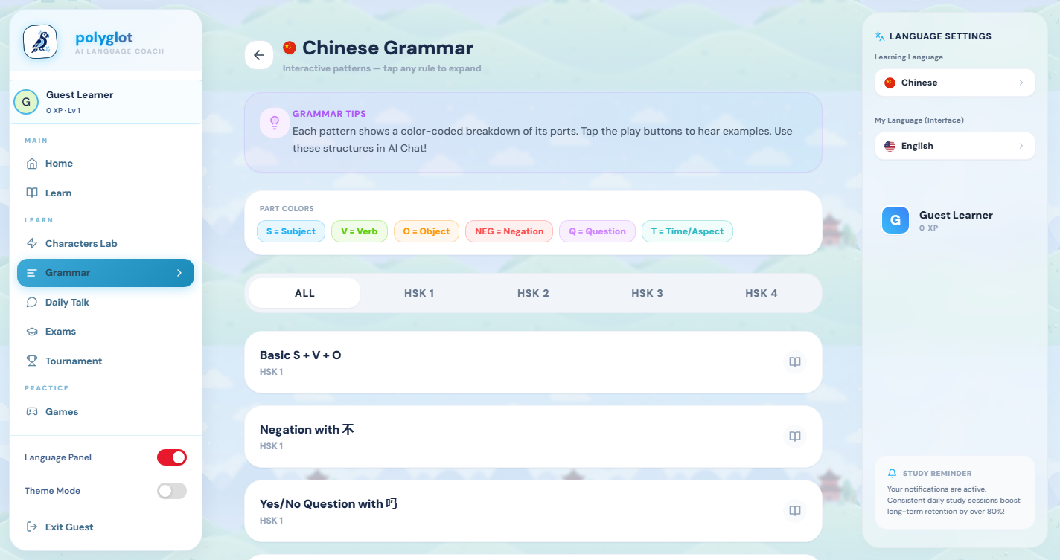
Figure 3: Interactive Grammar Guide with Bilingual Synopses

3.1.3. Stories Hub (Contextual Vocabulary Popovers)
The Stories Hub presents short readings where users can click on unfamiliar words to display translations and pinyin. Difficult terms can be saved directly to the user's lexicon.
Hover popovers provide pronunciation guides and definitions without interrupting the reading flow. This contextual support helps students build reading comprehension and expand their vocabulary organically.
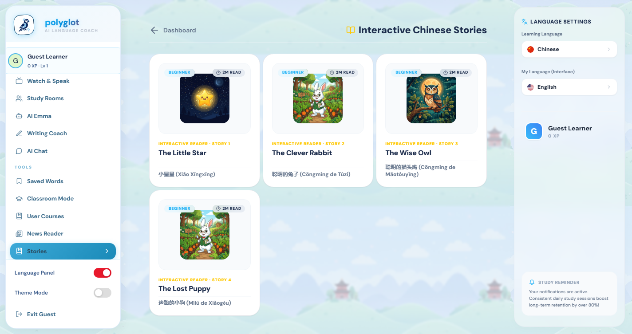
Figure 4: Stories Hub providing contextual reading exercises

3.1.4. Spaced Repetition (SRS) Engine (SuperMemo-2 Algorithm)
The vocabulary review system uses an implementation of the SuperMemo-2 (SM-2) Spaced Repetition algorithm. It calculates next-due intervals based on user grading of retention quality. This ensures that challenging words are reviewed more frequently, optimizing retention.
The algorithm updates review intervals dynamically based on user feedback. By scheduling reviews near the point of forgetting, the system helps consolidate vocabulary into long-term memory.
Below is the core Python implementation of the SM-2 algorithm used in the backend to calculate review intervals:
def calculate_sm2(q: int, prev_interval: int, prev_easiness: float):
# q is the quality score (0 to 5)
# prev_interval is the previous interval in days
# prev_easiness is the previous easiness factor (EF)
if q < 3:
# Repetition failed; reset interval
return 1, 1, prev_easiness
if prev_interval == 1:
next_interval = 1
elif prev_interval == 2:
next_interval = 6
else:
next_interval = int(round(prev_interval * prev_easiness))
# Calculate new easiness factor
new_easiness = prev_easiness + (0.1 - (5 - q) * (0.08 + (5 - q) * 0.02))
new_easiness = max(1.3, new_easiness) # Minimum EF is 1.3
return next_interval, new_easiness

3.2. Analytics Dashboard Redesign & Dynamic Visualizations
A primary focus of this project was the redesign of the student Analytics Page. The original page, which presented static tables of completed exercises, was replaced with an interactive layout featuring glassmorphic components and animated SVG charts built with Recharts:
- XP History Area Chart: Displays weekly or monthly XP progress using a smooth area chart with a blue gradient fill. Hovering over data points triggers tooltips showing precise XP counts and completion dates.
- Skill Radar Chart: Maps user proficiency across six core dimensions (Vocabulary, Listening, Speaking, Reading, Writing, and Grammar), helping students identify areas for improvement.
- Glassmorphism & Micro-animations: Stats cards use background blur styles (`backdrop-blur-md`) and scale translations to elevate cards and add highlight borders on hover, improving readability.
To integrate Recharts with our glassmorphic CSS theme, chart components utilize custom Tailwind properties. In dark-mode, grid lines and tooltips adapt to dark colors automatically, maintaining text legibility. Additionally, chart responsive containers ensure that layouts render correctly on mobile, tablet, and desktop monitors, preserving user experience across devices.
The glassmorphic design uses semi-transparent backgrounds with backdrop filters to create depth. Combined with responsive container wrappers, this design ensures that the layout adjusts to screen size changes, maintaining chart readability on small screens.
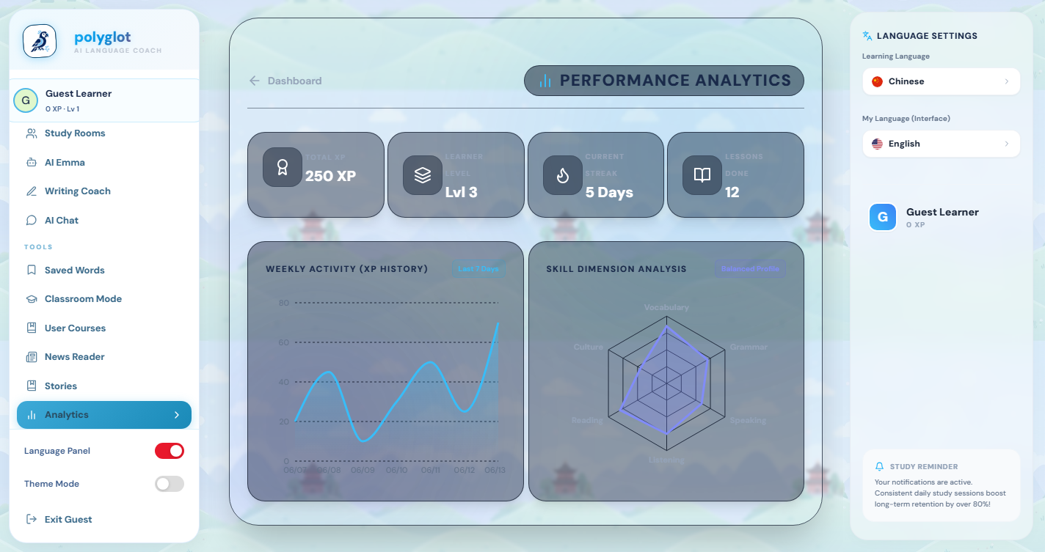
Figure 5: Upgraded Student Analytics Dashboard with Recharts Visualizations

3.3. Command Center (Admin Control Console)
An Admin Control Center was built to allow system administrators to manage platform state. Available exclusively to accounts with administrative role flags in the SQLite database, this dashboard includes tools for directory management, schema inspection, and configuration:
- User Directory: Displays lists of registered users, their roles, levels, and registration dates, and supports account deletion.
- SQLite Schema Inspector: Allows direct schema queries of database tables to verify integrity during development.
- AI Configuration: Controls system models, temperatures, and system prompts for the automated conversational teacher Emma, saving values to local storage.
The Admin Console includes real-time database monitoring features. System administrators can track database size, active user connections, query execution times, and recent user actions from a single panel. This provides a central tool for monitoring system stability during production runs.
Security configurations allow administrators to toggle registration access, manage API rate-limiting rules, and execute database backups from the dashboard interface. By isolating administrative endpoints behind FastAPI authentication dependencies, the platform ensures that administrative operations are restricted to verified accounts.
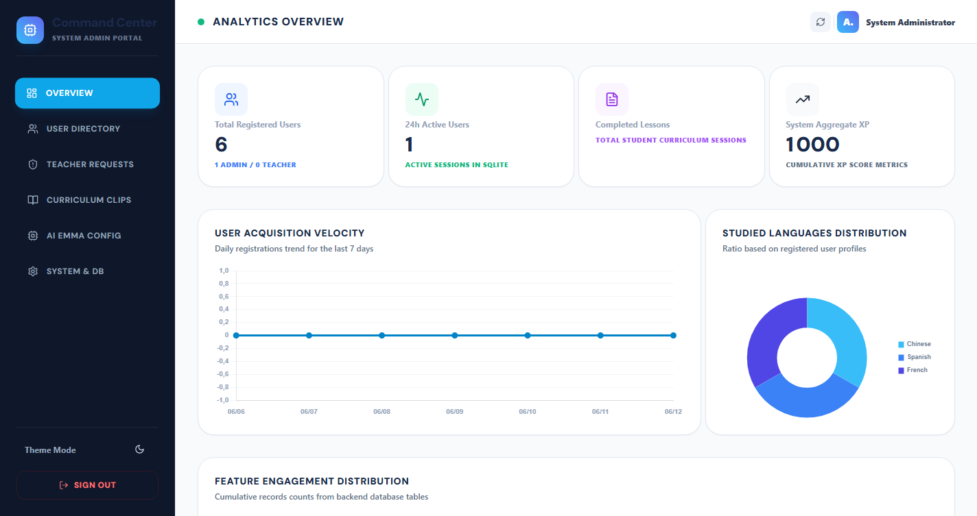
Figure 6: Standalone Admin Command Console featuring System Metrics and Database Tables Inspector

CHAPTER 4: DEPLOYMENT, QUALITY ASSURANCE, CHALLENGES, & CONCLUSION

4.1. Technical Stack and Tools Used Summary
The technical stack used for the development, testing, and deployment of Polyglot is organized below by category:
Category | Technologies | Role in Project
Frontend client | React, TypeScript, TailwindCSS | Builds the responsive SPA UI, manages component state, and applies styling rules.
Backend server | FastAPI (Python), Uvicorn | Serves API endpoints, handles database ORM mapping, and processes AI logic.
Database engine | SQLite, SQLAlchemy | Persists user progress, handles transactions, and manages schema updates.
Data Visualization | Recharts (SVG Chart components) | Renders animated Area and Radar charts on the Analytics dashboard.
Testing / QA | Selenium, Headless Chrome, PyTest | Automates frontend regression testing, validating view states and routing.

4.2. Quality Assurance & Automated Testing Coverage
To verify application stability across version changes, an automated end-to-end test suite was built using Selenium. Running headless Chrome, the test scripts simulate user workflows, verifying navigation paths and checking for regressions. This automated process validates page states and verifies that the chart components render correctly after updates.
Testing configurations are run against a local test database instance to prevent altering production data. Test assertions verify page load success, HTTP status codes, form submissions, and database state updates, providing regression protection before deployments.
The test suite is structured into logical test classes focusing on authentication, module routing, chart element presence, and API response parsing. By executing these checks automatically during the build process, the pipeline identifies integration issues before release, maintaining application stability.
Test Module | Action Sim | Expected Outcome | Status
Auth validation | Submit invalid admin credentials | Returns validation error, denies access to Admin Panel | Passed
Admin Panel | Log in as root admin | Redirects to Admin Panel, queries table lists | Passed
Guest Mode | Click guest button | Bypasses login, creates local profile, routes to Home | Passed
Navigation routes | Click sidebar items (Learn, Grammar, Stories) | Switches view state, updates URL parameters | Passed
Analytics Charts | Mount Analytics component | Initializes charts, renders Recharts DOM elements | Passed

4.3. Technical Challenges & Engineering Solutions
Several technical challenges were resolved during the implementation and testing phases:

4.3.1. CORS Limitations on Headless Browser Captures
Early screenshot tools attempted to load the app in an iframe from a local file protocol (`file:///`). This triggered browser Same-Origin Policy (CORS) exceptions, blocking scripts from interacting with the iframe window. This was resolved by writing a Selenium automation script that opens the application directly at `http://localhost:5175`, simulating actual user clicks and capturing high-fidelity screenshots of the fully-rendered React components.
Additionally, using standard browser profiles prevented headless Chrome from retrieving external assets, resulting in broken image links and layout shifts during capture. The solution involved configuring webdriver profiles with custom options, including disabling sandboxing and GPU acceleration. This ensured consistent layout rendering and high-quality captures.

4.3.2. Rendering Performance of SVG Charts
During the analytics redesign, rendering multiple animated Recharts charts under dark-mode themes caused minor display latency. This was addressed by setting reasonable animation limits and pre-calculating data points in the backend to minimize frontend calculation time.
In addition, window resizing triggered continuous layout re-calculations in Recharts responsive containers, causing CPU spikes. This was mitigated by adding debounce timers to the resize listeners, ensuring layout updates were only calculated after resizing was completed, reducing CPU usage.

4.3.3. SQLite Database Write Lock Handling
Using SQLite for concurrent student sessions can lead to write-lock conflicts. To prevent this, the database was configured to run in Write-Ahead Logging (WAL) mode, increasing write concurrency and reducing thread conflicts.
To prevent lock situations, connection pooling was configured with a busy-timeout parameter. This parameter forces threads to wait for locks to clear before raising errors, protecting transaction integrity under concurrent load.

4.3.4. Local Disk Space Exhaustion and Site-Package Dependency Corruptions
During testing, the development environment ran out of disk space, leading to corrupt pip packages and missing selenium modules (e.g. `webdriver.chromium`). This was resolved by implementing a system clean script that purged temp files and cleared cache directories, freeing up critical space, followed by a clean re-install of the `selenium` library.
Automated package dependency checks were integrated into the installation script to verify file integrity. This prevents broken imports and ensures that all required packages, including `python-docx` and `Pillow`, are loaded correctly, maintaining the document generation pipeline.

4.4. General Conclusion & Personal Outlook
This internship at the AMOND Association in Rabat, Morocco provided practical experience in full-stack web development. The Polyglot platform was developed, redesigned, and validated, resulting in a responsive, styled application. Architecting a client-server platform, designing relational schemas, and implementing data visualizations provided hands-on experience with modern development standards.
The project highlighted the importance of integrating cognitive educational models, such as Spaced Repetition algorithms, with clean web interfaces. The experience gained during this project will be valuable for future software engineering tasks.
Future work on the Polyglot platform includes integrating speech-to-text models directly on the client to evaluate pronunciation, and configuring service workers to support offline PWA (Progressive Web App) capabilities.
Finally, working inside AMOND's agile environment improved my communication and team coordination skills. Managing sprint deadlines and presenting functional deliverables to supervisors highlighted the importance of clear communication in professional software teams. I exit this internship with improved technical knowledge and a better understanding of the software lifecycle.

REFERENCES
[1] React JS Core Documentation. Available at: https://react.dev (Accessed June 2026).
[2] FastAPI framework documentation, Python Web REST APIs. Available at: https://fastapi.tiangolo.com (Accessed June 2026).
[3] TailwindCSS Styling Utilities Documentation. Available at: https://tailwindcss.com (Accessed June 2026).
[4] Recharts Interactive SVG Charts Library. Available at: https://recharts.org (Accessed June 2026).
[5] React-i18next Localization Library. Available at: https://react.i18next.com (Accessed June 2026).
[6] SQLite Database Engine. Available at: https://www.sqlite.org (Accessed June 2026).
[7] Selenium Python Webdriver Documentation. Available at: https://selenium-python.readthedocs.io (Accessed June 2026).
[8] AMOND Association corporate guidelines and project specifications, Rabat, Morocco.

