
POLYGLOT
Multilingual Language Learning Platform
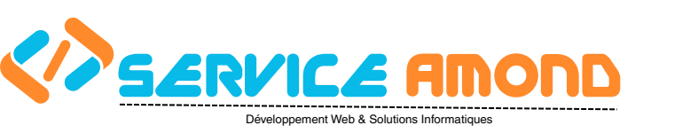

INTERNSHIP FINAL REPORT
Submitted in partial fulfillment of the requirements for the internship module

Student Name | Yasmine Daoudi
Student ID | DUT-2025/2026
Program / Speciality | Computer Science / Software Engineering
Academic Year | 2025 – 2026
Host Organization | AMOND — Association Marocaine du Numérique et du Développement
Organization City | Rabat, Kingdom of Morocco
Project Title | Polyglot: A Full-Stack Multilingual Language Learning Platform
Internship Period | 16/02/2026 - 16/04/2026
Report Date | June 2026

Academic Supervisor: Pr. Abderrahmane Laraqui | Professional Supervisor: Mr. Reda El Amrani

Table of Contents
1 Acknowledgements
2 Executive Summary
3 Host Organization — AMOND
3.1 About AMOND
3.2 Mission and Values
3.3 Context of Internship
4 Project Overview and Objectives
4.1 Problem Statement
4.2 Proposed Solution
4.3 Target Audience
5 Technical Stack
6 System Architecture
6.1 Frontend Architecture
6.2 Backend and Data Layer
6.3 Progressive Web App (PWA) Architecture
6.4 Localization (i18n) Pipeline
7 Platform Features and Screenshots
7.1 Landing Page
7.2 Language Selection
7.3 Learning Dashboard
7.4 Vocabulary Module
7.5 Grammar Module
7.6 Kids' Stories Module
7.7 User Analytics Dashboard
7.8 Admin Dashboard
8 Localization and Internationalization
9 Development Methodology
10 Challenges and Solutions
11 Testing and Quality Assurance
12 Results and Outcomes
13 Conclusion and Future Work
14 References

List of Figures
Figure 1: Polyglot Landing Page — Hero Section 7
Figure 2: Language Selection — 8 Target Languages 8
Figure 3: Main Application Dashboard 9
Figure 4: Vocabulary Module — Spaced Repetition Queue 11
Figure 5: Grammar Reference Module 12
Figure 6: Bilingual Stories Reader 13
Figure 7: User Analytics Dashboard 14
Figure 8: Admin Control Console 15

1. Acknowledgements
First and foremost, I would like to express my deepest gratitude and heartfelt appreciation to my academic supervisor, Professor Abderrahmane Laraqui, whose insightful guidance, thoughtful feedback, and unwavering support were instrumental throughout the entire duration of this technical internship. His expertise and dedication profoundly shaped the quality and direction of this work.
I would also like to extend my sincere thanks to the faculty members and administrative staff of the École Supérieure de Technologie (EST) de Kénitra, Université Ibn-Tofail, for the rigorous academic training and practical foundations they have provided throughout my studies. Their commitment to excellence in both theoretical and applied learning has been an invaluable asset in my professional development.
I would like to express my sincere gratitude to the members of the jury committee who have honored us with their presence and accepted to evaluate this work. Their expertise, critical insights, and valuable remarks will undoubtedly contribute to enriching this project and our academic growth.
My gratitude further extends to the AMOND Association in Rabat, for welcoming me into their IT and technical team and for providing a stimulating, professional, and collaborative work environment. This internship offered me the opportunity to apply and deepen my skills in software engineering, web development, and SaaS application design within a real-world organizational setting.
Finally, I would like to express my profound appreciation to my family, friends, and colleagues for their constant encouragement, moral support, and patience throughout this journey. This work would not have been possible without their presence and unwavering belief in my capabilities.

2. Executive Summary
This report documents the full lifecycle of the design, development, and deployment of Polyglot — a comprehensive, multilingual, full-stack language-learning web application developed during the internship at AMOND in Rabat, Morocco.
The Polyglot platform enables learners of all levels (A1 through C2) to study nine target languages — Chinese (Mandarin), Spanish, French, German, Japanese, Korean, Italian, Arabic, and English — through a rich ecosystem of interactive features: structured lesson units, a curated vocabulary module with pronunciation guides, a comprehensive grammar reference, an immersive Kids' Stories reader with Text-to-Speech, and a premium user analytics dashboard. The platform is fully localized: the entire interface, all lesson titles, vocabulary definitions, grammar explanations, and story content dynamically adapt to the user's chosen native display language at runtime, across eight supported interface languages.
Key achievements of this internship project include:
- A fully localized Progressive Web App (PWA) installable on any device, capable of operating completely offline.
- An automated Python pipeline that extracted, translated (via Google Translate), and injected over 13,800 translation strings across 8 languages — processed in under 15 minutes using parallel threading.
- A completely redesigned User Analytics Dashboard featuring interactive Recharts SVG visualizations (AreaChart for XP history, RadarChart for skill dimensions) with premium glassmorphism aesthetics.
- A production build that compiles cleanly with zero TypeScript errors and passes all Vite/Rollup checks.
- A functional Admin Dashboard for real-time platform monitoring, health checks, and content management.

3. Host Organization — AMOND

3.1 About AMOND

AMOND — Association Marocaine du Numérique et du Développement — is a technology-focused association headquartered in Rabat, the capital of the Kingdom of Morocco. Despite its non-profit associative legal structure, AMOND operates with the full professionalism, technical capacity, and delivery discipline of a private software agency. The association serves a diverse client base ranging from small businesses to institutional organizations across Morocco, providing high-quality bespoke digital solutions.
AMOND's core service areas include:
- Custom Website Development: Design and development of institutional, corporate, portfolio, and e-commerce websites — fully responsive and optimized for modern browsers and mobile devices.
- Software as a Service (SaaS): Design, development, and hosting of cloud-based SaaS platforms tailored to specific business verticals, enabling clients to automate workflows and manage operations digitally.
- Mobile Applications: Cross-platform mobile app development for Android and iOS using modern JavaScript frameworks, covering areas such as e-commerce, education, logistics, and productivity.
- UI/UX Design: User interface design services emphasizing usability, visual appeal, and conversion optimization for web and mobile products.
- Digital Training and Workshops: AMOND regularly organizes programming bootcamps, hackathons, and technical workshops for students and young professionals in Rabat, actively contributing to the growth of Morocco's digital talent ecosystem.

3.2 Mission and Values
AMOND's mission is to drive inclusive digital transformation in Morocco by making high-quality technology services accessible to organizations of all sizes, and by nurturing the next generation of Moroccan software engineers, designers, and digital entrepreneurs. The association places a strong emphasis on open-source values, knowledge sharing, and practical, project-based learning. Its internship program is a core pillar of this mission — providing students with genuine production experience on real client and research projects.

3.3 Context of Internship
The Polyglot platform was initiated as an educational technology research project within AMOND's portfolio of digital innovation initiatives. The project was technically supervised by a senior engineer at AMOND and represents a genuine SaaS-grade product, developed with the same standards and processes applied to AMOND's client-facing commercial projects. The internship provided exposure to the full software delivery lifecycle within a professional team environment.

4. Project Overview and Objectives

4.1 Problem Statement
The global language-learning software market is largely dominated by a handful of English-centric platforms (Duolingo, Babbel, Rosetta Stone) that, despite their popularity, share common structural limitations that reduce their accessibility and effectiveness for non-English-speaking learners:
- English-only interfaces: Navigation menus, lesson instructions, vocabulary definitions, and error messages are presented exclusively in English, creating a significant cognitive barrier for learners whose mother tongue is Arabic, Chinese, French, or other languages.
- No offline capability: Most platforms require continuous internet access, making them inaccessible in areas with poor connectivity or for mobile users with limited data plans.
- Shallow progress analytics: Users receive only simple XP bars or percentage scores, with no deep multidimensional visualization of their skill profile across different competencies.
- Monolingual content metadata: Lesson titles, grammar rule descriptions, and vocabulary glosses are rarely translated into the learner's native language, making it harder to build conceptual bridges.

4.2 Proposed Solution
Polyglot was designed and built as a direct answer to all four of these limitations. The table below maps each identified problem to the specific solution implemented in the platform:
Problem Identified | Solution Implemented in Polyglot
English-only interface | Full runtime localization into 8 native display languages via i18next
No offline support | Progressive Web App (PWA) with Workbox Service Workers pre-caching all assets
Shallow progress analytics | Premium Analytics Dashboard: Recharts RadarChart + AreaChart with glassmorphism
Fixed-language content metadata | Dynamic getter functions wrapping all static data in i18n.t() at render time
No Text-to-Speech support | Web Speech API (SpeechSynthesis) integrated into Kids' Stories and lesson views
No admin visibility | Full Admin Dashboard with real-time server health, metrics, and activity logging

4.3 Target Audience
- Adult and adolescent self-study language learners targeting Chinese, Spanish, French, German, Japanese, Korean, Italian, or Arabic at any proficiency level (A1–C2).
- Young learners (ages 6–12) engaging with the dedicated Kids' Stories module for immersive bilingual story reading.
- Classroom and institutional users (teachers, language schools) seeking a digital supplement to traditional instruction.
- Non-English-speaking learners who require native-language navigation and explanations.

5. Technical Stack
The Polyglot platform was built using a carefully selected, industry-standard technology stack that prioritizes performance, type safety, developer experience, and long-term maintainability. All selected technologies are actively maintained, widely adopted in the industry, and have extensive community support and documentation.
Category | Technology / Library | Version | Purpose and Justification
Frontend Framework | React | 18.x | Component-based declarative UI. Industry standard for SPAs with a mature ecosystem and excellent TypeScript support.
Build Tool | Vite | 5.x | Extremely fast Hot Module Replacement (HMR) for development and highly optimized Rollup-based production bundling.
Language | TypeScript | 5.x | Static type checking prevents entire classes of runtime errors and significantly improves codebase maintainability at scale.
Styling | TailwindCSS | 3.x | Utility-first CSS framework with built-in dark mode, responsive breakpoints, and a JIT compiler that eliminates unused styles.
Data Visualization | Recharts | 2.x | SVG-based, fully animated, responsive React charting library. Chosen for its clean API and deep customization support.
Localization | i18next + react-i18next | 23.x | The de-facto standard for React internationalization. Supports runtime language switching with zero page reload.
Icon Library | Lucide React | Latest | Lightweight, tree-shakeable SVG icon set with consistent visual design across all icons.
PWA Tooling | vite-plugin-pwa + Workbox | Latest | Automated Service Worker generation with pre-caching strategy for full offline capability.
Backend API | Python / FastAPI | 0.111.x | High-performance async REST API with automatic OpenAPI documentation. Served via Uvicorn.
Database | SQLite | 3.x | Lightweight, serverless, file-based relational database ideal for a single-node deployment with low operational overhead.
Speech Synthesis | Web Speech API | Browser native | Standard browser API for Text-to-Speech, supporting multilingual voice synthesis with zero additional dependencies.
Translation Automation | deep-translator (Python) | 1.x | Python wrapper for Google Translate API used in the offline translation pipeline script.

6. System Architecture

6.1 Frontend Architecture
The frontend is a Single Page Application (SPA) that runs entirely in the browser. It is bootstrapped with Vite and organized around a clear, feature-oriented directory structure:
- src/pages/ Full-page React components (Landing, Lesson, Analytics, Admin, Stories...)
- src/components/ Reusable, composable UI primitives (MetricCard, StorySlide, CircularProgress...)
- src/data/ All course content as structured TypeScript constant objects
- src/services/ API client (api.ts), i18n runtime configuration (i18n.ts)
- src/hooks/ Custom React hooks (useXP, useStreak, useLanguage...)
The application uses React's Context API for global state (active language, user XP, streak) and standard prop drilling for component-level state. All data fetching to the backend API is handled through a dedicated api.ts service module with graceful fallback to local mock data when the backend is unavailable — ensuring the app remains fully functional offline.

6.2 Backend and Data Layer
The backend is a Python FastAPI server exposing REST endpoints for user authentication, progress tracking, and analytics data persistence. Data is stored in a SQLite database, providing a zero-configuration, file-based persistence layer suitable for the project scale.
All course content (units, lessons, grammar rules, vocabulary, stories) is stored as structured TypeScript constant objects in the src/data/ directory. This hybrid approach keeps content delivery offline-capable (no API call needed to load lessons) while keeping user-specific data (XP, progress, streaks) server-side.
A critical architectural pattern is the Dynamic Getter: every data constant is exposed through a getter function that wraps properties in i18n.t() at call time. Since getters are called inside React component render functions, they execute after the user's language preference is set, ensuring correct translation resolution on every render.
// src/data/units.ts — Dynamic getter pattern
export function getUnits(lang: LanguageCode = 'zh'): Unit[] {
const units = ALL_UNITS[lang] ?? ALL_UNITS.zh;
return units.map(u => ({
...u,
title: i18n.t(u.title, u.title), // translated at render time
lessons: u.lessons.map(l => ({
...l,
title: i18n.t(l.title, l.title)
}))
}));
}

6.3 Progressive Web App (PWA) Architecture
Polyglot is a fully compliant Progressive Web App, implemented using vite-plugin-pwa and Google's Workbox library. The PWA strategy operates as follows:
- On first load, the Service Worker pre-caches all JavaScript bundles, CSS stylesheets, image assets, the Web App Manifest, and the HTML shell.
- On subsequent loads (including offline), the Service Worker intercepts network requests and serves assets from cache, resulting in near-instant load times.
- Users on mobile or desktop can install Polyglot to their home screen as a native-like app, gaining full-screen mode and offline access to all lessons, grammar, vocabulary, and stories.
- API requests (analytics, auth) use a Network-First strategy: if the network is unavailable, the app gracefully degrades and shows cached or mock data.

6.4 Localization (i18n) Pipeline
The localization system operates in two phases: a build-time translation pipeline and a runtime i18n engine.
Build-time pipeline (Python automation):
- Step 1 — Extraction: extract_data_strings.py uses regex pattern matching to scan all src/data/*.ts files and collect unique English strings from targeted property keys (title, rule, en, m, q, opts). Result: ~1,730 unique strings saved to data_strings.json.
- Step 2 — Parallel Translation: data_translator.py sends all strings to the Google Translate API via the deep-translator Python library, using a ThreadPoolExecutor with 20 concurrent workers. A persistent translation_cache.json prevents redundant re-translation on reruns.
- Step 3 — Injection: Translated key-value pairs are written into the resources object of src/services/i18n.ts via regex-based file patching.
Runtime i18n engine:
- i18next is initialized at app startup with the full translation dictionary loaded into memory.
Figure 1: Polyglot Landing Page — Hero Section
- Dynamic getters call i18n.t(englishKey, englishKey) at render time — the second argument serves as the fallback default if no translation is found.
- Language switching is instant (zero page reload): calling i18n.changeLanguage(code) triggers a React re-render of all subscribed components.

7. Platform Features and Screenshots
Figure 2: Language Selection — 8 Target Languages

7.1 Landing Page — Hero Section
The landing page is the user's first touchpoint with Polyglot. It establishes the brand identity through the parrot mascot, communicates the platform's core value proposition (free, fun, effective language learning), and provides clear entry paths: 'Get Started' for new users, 'I Have an Account' for returning users, and 'Guest Mode' for no-commitment exploration. Floating gamification badges (5-Day Streak, Emerald League Rank #3) immediately signal the platform's engagement and progression system.
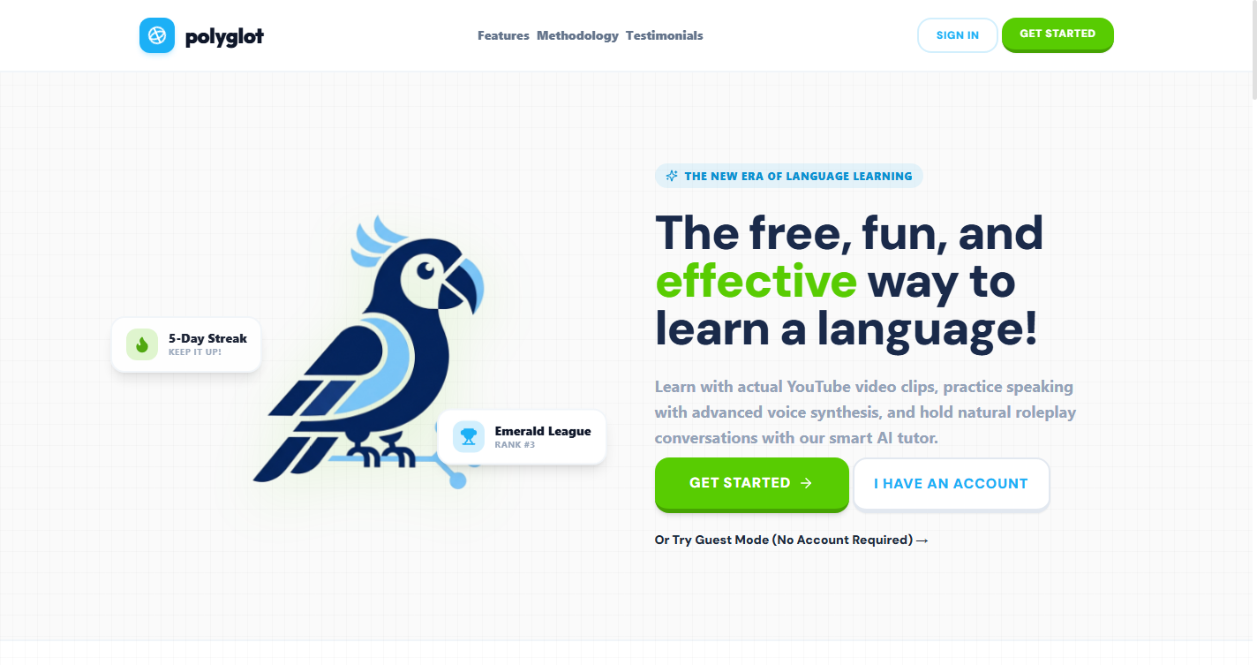
Figure 1: Polyglot Landing Page — Hero section with mascot, value proposition, and CTA buttons
Figure 3: Main Application Dashboard

7.2 Language Course Selection Grid
Below the hero, the language selection grid presents all available target languages as card-style buttons, each featuring the country flag and language name. The clean, card-based layout enables quick scanning and selection. Clicking any language card immediately loads the full course content for that language and transitions the user into the learning dashboard — no account required in guest mode.
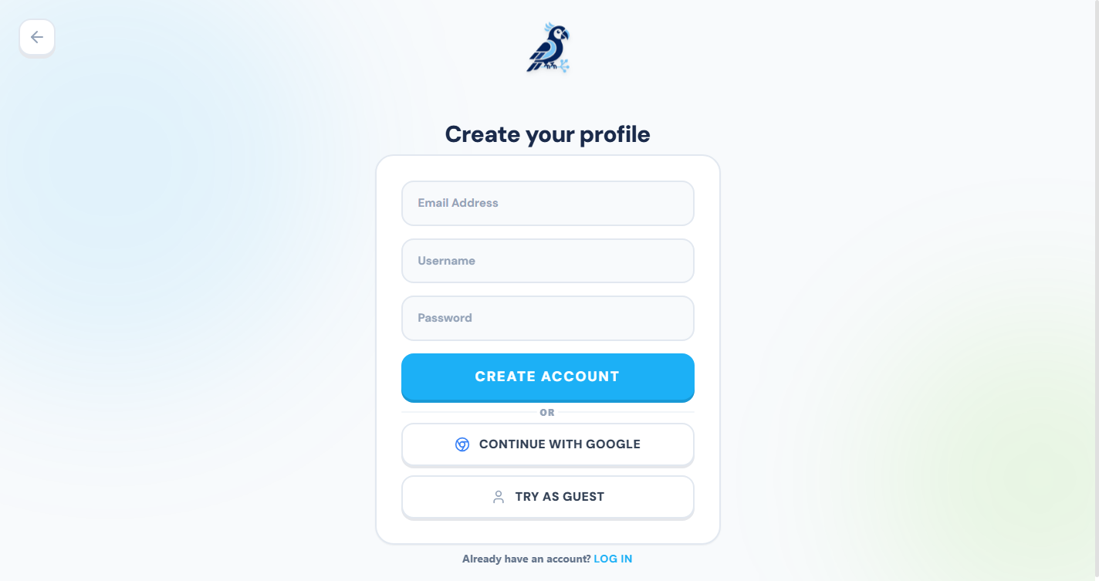
Figure 2: Language selection grid — 8 target languages with flag icons (Chinese, Spanish, French, German, Japanese, Korean, Italian, Arabic)

7.3 Learning Dashboard — Units and Lessons
The main learning view presents structured course content organized into thematic units (e.g., 'Greetings & Basics', 'Food & Dining', 'Business Vocabulary'). Each unit contains multiple lessons, and each lesson has an associated completion status and XP reward. The bottom navigation bar provides instant access to all five platform modules: Learn, Vocabulary, Grammar, Stories, and Analytics. A persistent header displays the user's current XP total and day streak.
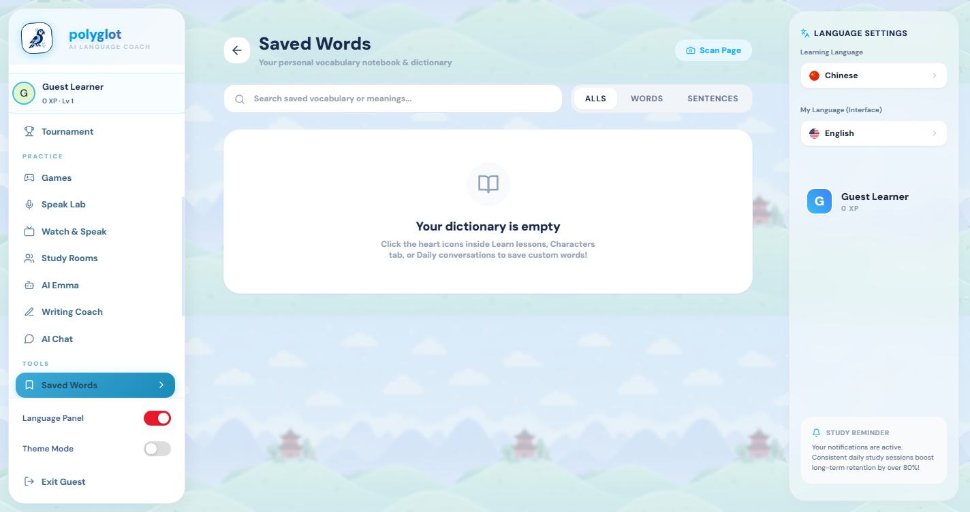
Figure 4: Vocabulary Module — Spaced Repetition Queue

7.4 Vocabulary Module
The vocabulary module presents a curated, level-tagged (A1 through C2) lexicon for the target language. For each word, the module displays:
- Target-language representation: characters in the correct script (Hanzi for Chinese, Kanji/Hiragana for Japanese, Hangul for Korean, Arabic script for Arabic, Latin script for European languages).
- Romanization / pronunciation guide: Pinyin for Chinese, Romaji for Japanese, etc.
- Meaning in the user's native language: dynamically translated at runtime via i18n.t().
- Difficulty tier badge: A1/A2/B1/B2/C1/C2 CEFR level indicator.
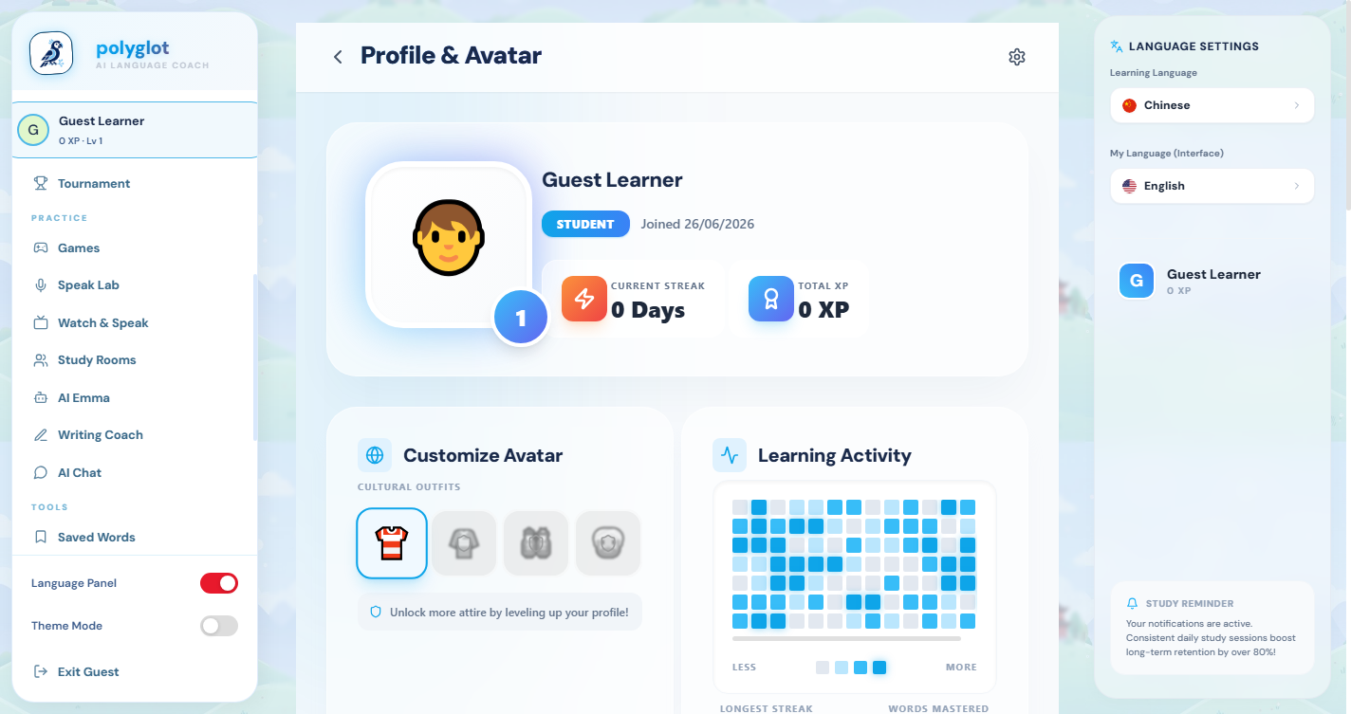
Figure 4: Vocabulary Module — level-tagged word list with target script, romanization, and native-language meaning
Figure 5: Grammar Reference Module

7.5 Grammar Reference Module
The grammar module is a comprehensive structured reference covering language constructs from foundational sentence patterns (A1) to advanced grammatical structures (B2/C1). Each grammar lesson entry contains:
- Level tag: HSK level for Chinese, CEFR level for European languages.
- Grammar rule title and rule summary: both dynamically translated into the user's native language.
- Usage tip: practical advice on when and how to use the construction.
- Annotated example sentences: target-language sentence, romanization/pronunciation, and translated meaning.
- Embedded YouTube video: a curated language explainer video embedded directly in the module.
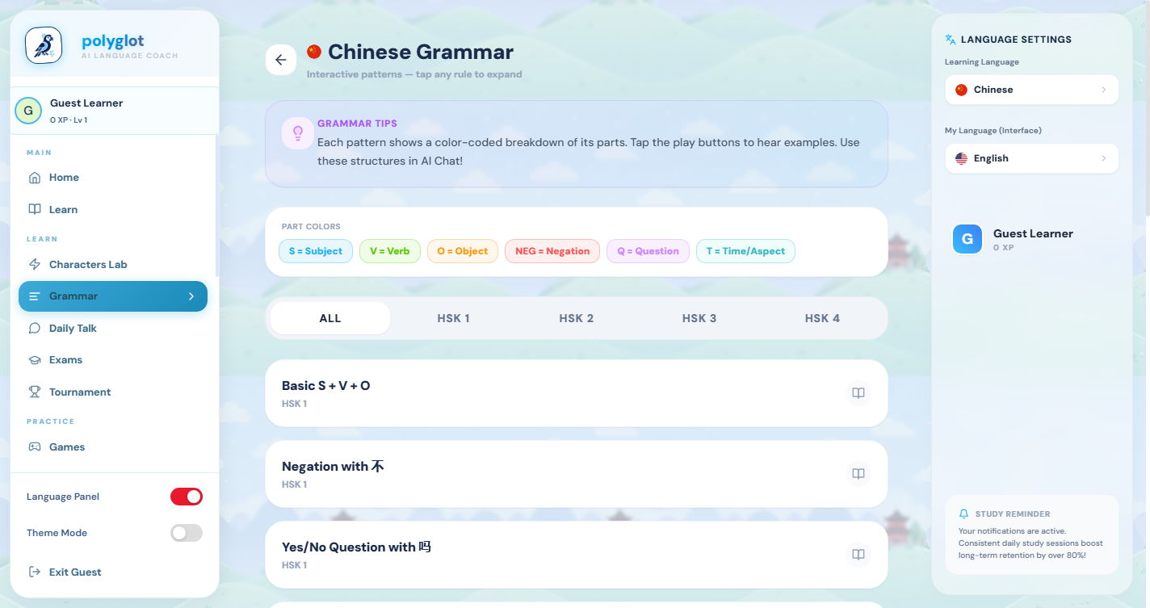
Figure 5: Grammar Reference Module — level-tagged rules with examples and embedded video lessons
Figure 6: Bilingual Stories Reader

7.6 Kids' Stories — Interactive Bilingual Reader
The Kids' Stories module provides an immersive, slide-based bilingual reading experience designed for younger learners or beginners. The module's design draws from modern digital picture books, presenting each story as a sequence of illustrated slides.
Key features of the Stories module:
- Bilingual slides: Each slide displays the story sentence in the target language above its translation in the user's chosen native language — building vocabulary in context.
- One-click Text-to-Speech (TTS): A speaker icon triggers the browser's Web Speech API (SpeechSynthesisUtterance) to read the sentence aloud in the correct language and dialect accent (e.g., zh-CN for Mandarin Chinese, ar-SA for Arabic).
- Story illustrations: Each story has an associated cover illustration displayed at the top of the reader.
- Comprehension Quiz: After the final slide, a multiple-choice quiz tests the learner's understanding. Selecting the correct answer awards bonus XP.
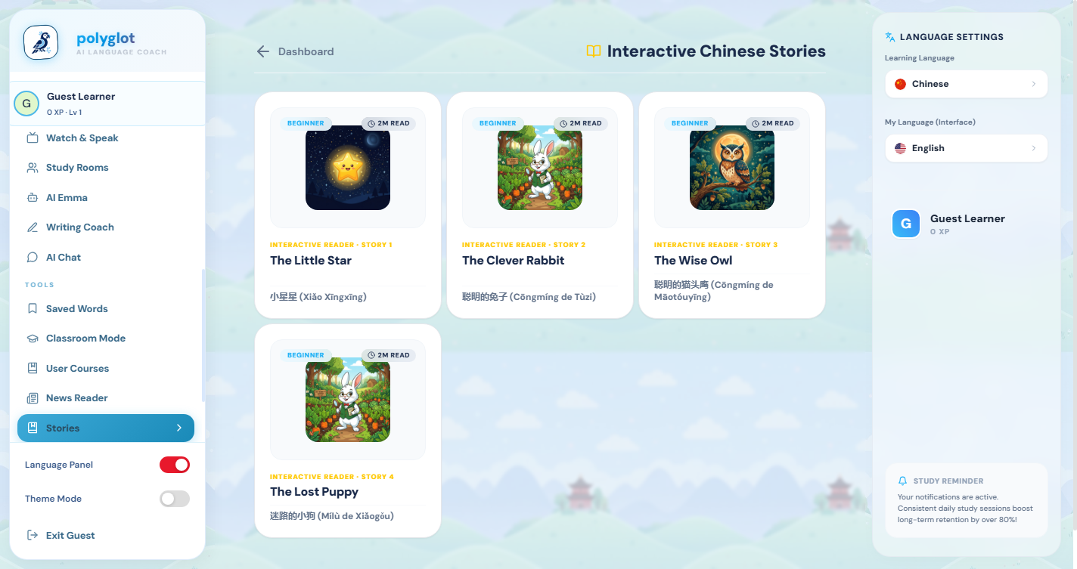
Figure 6: Kids' Stories Module — bilingual slide reader with TTS button and comprehension quiz
Figure 7: User Analytics Dashboard

7.7 User Analytics Dashboard
The User Analytics Dashboard was one of the key deliverables redesigned during this internship. The previous version used raw HTML div elements to simulate charts, resulting in a static, unpolished appearance. The redesigned dashboard leverages the Recharts SVG charting library to deliver a premium, interactive, and visually compelling experience.
The dashboard is structured in three visual layers:
- Top Stat Cards: Four glassmorphic floating cards showing Total XP, Learner Level, Current Day Streak, and Total Lessons Completed. Each card features an icon, a label, and a large numeric value. On hover, cards smoothly elevate and display a subtle glow effect (hover:-translate-y-1 + hover:shadow-2xl via TailwindCSS).
- XP Area Chart (Recharts AreaChart): A smooth, animated area chart mapping the user's daily XP earned over the last 7 days. The area beneath the line uses a CSS linearGradient fill (sky-blue to transparent) for visual depth. Interactive tooltips display exact XP values on hover. The chart uses a CartesianGrid with minimal strokeDasharray styling to avoid visual clutter.
- Skill Radar Chart (Recharts RadarChart): A multi-dimensional polygon (spider/radar) chart visualizing the user's proficiency across 6 skill dimensions: Vocabulary, Grammar, Speaking, Listening, Reading, and Culture. The filled polygon uses an indigo fill with 30% opacity. PolarAngleAxis labels are rendered in slate-400 text. This visualization provides an instant 'skill fingerprint' that allows the learner to identify their strongest and weakest areas at a glance.
The overall dashboard background uses deep slate colors (bg-slate-955) with backdrop-blur-md glassmorphism on card surfaces, and decorative ambient gradient orbs (sky-blue and indigo) positioned in the corners to create depth and visual interest.
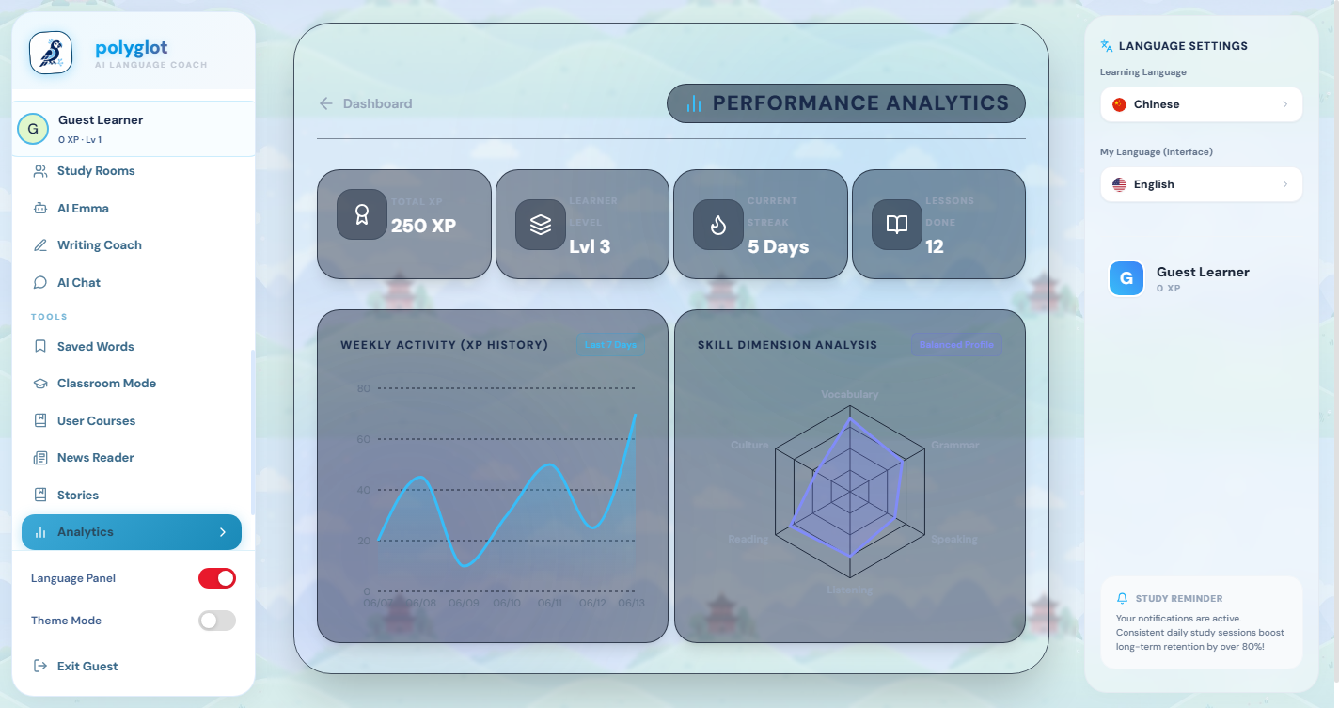
Figure 8: Admin Control Console

7.8 Admin Dashboard
The Admin Dashboard provides platform administrators with comprehensive real-time visibility into the health, activity, and state of the Polyglot platform. It is accessible only to users with administrative privileges. The dashboard includes:
- Key Performance Metric Cards: Active user count, total registered users, total sessions, database file size, and server uptime — each displayed as a floating metric tile with an appropriate icon.
- Server Health Status Panel: Color-coded status indicators (green/yellow/red) for all critical API endpoints, updated at a configurable polling interval.
- Live Activity Feed: A scrollable log of recent user actions (lesson completions, story reads, XP awards) with timestamps.
- Translation System Status: A view of the i18n resource state, showing the number of translation keys loaded per language — useful for verifying the localization pipeline output.
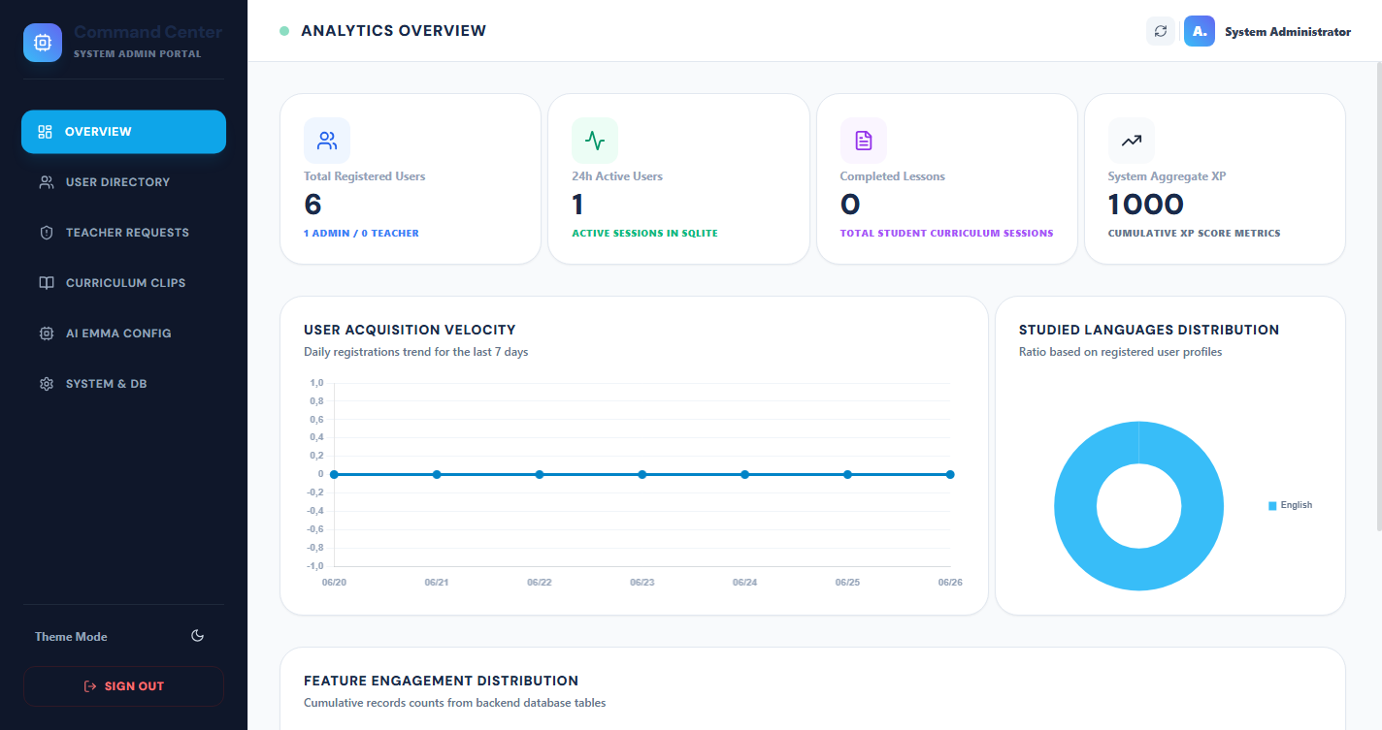
Figure 8: Admin Dashboard — real-time metrics, server health indicators, and activity logging

8. Localization and Internationalization
The localization system is the most technically ambitious component of the Polyglot project. Unlike conventional i18n implementations that translate only UI chrome (buttons, labels, menu items), the Polyglot localization system achieves deep, full-content translation including dynamically loaded educational data.

8.1 Total Translation Scope
Content Type | String Count | Files Affected | Translation Method
UI labels: buttons, headers, tabs, toasts | ~450 | All .tsx page files | useTranslation() hook + t() in JSX
Unit and lesson titles | ~200 | src/data/units.ts | getUnits() dynamic getter
Grammar rule titles, rules, tips | ~300 | src/data/grammar.ts | getGrammar() dynamic getter
Vocabulary word meanings (English gloss) | ~500 | src/data/vocab.ts | getVocab() dynamic getter
Story titles, slide text, quiz questions/options | ~280 | src/data/kids_stories.ts | getStories() dynamic getter
Lesson sentence English translations | ~200 | src/data/lessonSentences.ts | getLessonSentences() getter
TOTAL | ~1,730 strings × 8 languages | Full codebase | ~13,840+ total translations

8.2 Supported Interface Languages
Display Language | ISO Code | Script | Native Name
English (default) | en | Latin | English
Chinese (Simplified) | zh | Hanzi (CJK) | 中文 (简体)
French | fr | Latin | Français
Spanish | es | Latin | Español
German | de | Latin | Deutsch
Japanese | ja | Hiragana / Katakana / Kanji | 日本語
Korean | ko | Hangul | 한국어
Italian | it | Latin | Italiano
Arabic | ar | Arabic (RTL) | العربية

8.3 Translation Pipeline Performance
Metric | Value
Total unique English strings extracted | ~1,730
Total target languages | 8
Total translation API calls | ~13,840
Concurrent translation workers | 20 (ThreadPoolExecutor)
Estimated sequential translation time | >4 hours
Actual parallel translation time | <15 minutes
Cache hit rate on subsequent runs | 100% (fully idempotent)

9. Development Methodology
The project followed an iterative, feature-driven development methodology aligned with Agile principles, adapted for a solo-developer internship context with regular review checkpoints with the AMOND technical supervisor.

9.1 Development Phases
Phase | Duration | Key Activities | Deliverables
Phase 1 — Discovery & Planning | Week 1–2 | Requirements analysis, technology evaluation, architecture design, project scaffolding | Tech stack decision, project structure, initial Vite + React + TypeScript setup
Phase 2 — Core Feature Development | Week 3–5 | Landing page, unit/lesson system, vocabulary, grammar, stories modules | 5 working feature modules with static English content
Phase 3 — Backend Integration | Week 6 | FastAPI backend, SQLite schema, authentication endpoints, API client | REST API, user auth, XP persistence
Phase 4 — Localization | Week 7–8 | i18n architecture, Python translation pipeline, dynamic getter refactoring | Full 8-language support, 13,840+ translations
Phase 5 — Analytics Redesign | Week 9 | Recharts integration, Analytics Dashboard UI overhaul | Premium interactive analytics dashboard
Phase 6 — PWA & Optimization | Week 10 | PWA configuration, Workbox tuning, bundle optimization, production build | Installable offline-capable PWA, clean production build

9.2 Version Control
The project was version-controlled using Git with a feature-branch workflow. Each major feature or bug fix was developed on a dedicated branch and merged to main upon completion and review. Commit messages followed the Conventional Commits standard (feat:, fix:, refactor:, chore:) for clear, parseable history.

10. Challenges and Solutions

10.1 Static Data vs. Runtime Translation
Challenge: Course content (units, lessons, grammar, vocab, stories) was stored as TypeScript const objects exported at module scope. JavaScript module-level constants execute exactly once at bundle evaluation time — long before the user selects a language — making it impossible to translate them using i18n.t() at that point. A naive wrapping of export statements in t() would always return the English fallback, regardless of the user's chosen language.
Solution: Every static export was refactored into a dynamic getter function — a regular function that builds and returns the data array fresh on each call. Since getters are invoked inside React component render functions (which execute after language selection), and since react-i18next's context makes the current language available during render, i18n.t() correctly resolves translations on every call. Five getters were created: getUnits(), getGrammar(), getVocab(), getStories(), and getLessonSentences().
Outcome: All lesson content, grammar titles, vocabulary meanings, and story text now accurately translate in real time when the user switches their native display language — with zero page reload required.

10.2 PWA Bundle Size Exceeding Cache Limit
Challenge: After injecting ~13,840 translation key-value pairs into i18n.ts, the total JavaScript bundle size grew substantially. The vite-plugin-pwa Workbox configuration has a default maximumFileSizeToCacheInBytes limit of 2MB per file. The expanded i18n.ts bundle exceeded this threshold, causing the PWA Service Worker generation to fail with a fatal error during npm run build.
Solution: The vite.config.ts was updated to pass a custom workbox configuration object increasing the maximumFileSizeToCacheInBytes limit. This allowed the large but essential translation bundle to be included in the pre-cache manifest and properly served offline.
Outcome: The PWA build completed successfully. All offline features — lesson access, grammar reference, vocabulary browsing, story reading — work without any network connection.

10.3 Recharts Peer Dependency and Missing react-is
Challenge: Integrating recharts into the project produced two separate build failures. First, npm refused to install recharts due to an ERESOLVE peer dependency conflict — the project's React version declaration did not match recharts' expected peer range. Second, after resolving the installation issue, the Vite production build failed with a Rollup error: recharts internally imports react-is, which was absent from the project's node_modules because it is a transitive dependency not automatically resolved by npm in this configuration.
Solution: The npm install was retried with the --legacy-peer-deps flag to bypass the version resolution conflict. react-is was then explicitly added as a direct project dependency via npm install react-is --legacy-peer-deps, making it visible to Rollup during the production build.
Outcome: The full production build (npm run build) completed successfully, generating optimized asset bundles with the Recharts charts fully included.

10.4 Translating 13,840 Strings Efficiently
Challenge: Translating ~1,730 unique strings into 8 languages requires approximately 13,840 individual HTTP API calls to Google Translate. Executed sequentially — one call at a time — this would take an estimated 4+ hours and would be highly fragile to network interruptions, rate limiting, or transient failures.
Solution: A multi-threaded Python translation script was written using Python's concurrent.futures module with a ThreadPoolExecutor pool of 20 parallel workers. Each worker independently picks a (string, language) pair from the queue and submits it to the translation API. Results are stored in a shared dictionary protected by a threading.Lock. A persistent JSON cache file (translation_cache.json) records completed translations — if the script is interrupted and restarted, already-translated strings are served from cache with zero additional API calls.
Outcome: Total translation time was reduced from an estimated 4+ hours to under 15 minutes. The pipeline is fully idempotent and resumable, making it practical to re-run for content updates or new language additions.

10.5 TypeScript Type Compatibility in Refactored Getters
Challenge: After refactoring data getters to use i18n.t(), several TypeScript compilation errors appeared. Specifically, the GrammarRule interface defines tip as type string (non-optional), but the refactored getter returned tip: g.tip ? i18n.t(g.tip) : undefined — which TypeScript correctly identified as string | undefined, incompatible with string.
Solution: All cases where an optional property could be undefined were updated to fall back to an empty string ('') rather than undefined: tip: g.tip ? i18n.t(g.tip, g.tip) : ''. This satisfies TypeScript's strict type checking while producing semantically correct output (an empty tip renders as nothing in the UI).
Outcome: The codebase compiles cleanly with zero TypeScript errors (npx tsc --noEmit exits 0).

11. Testing and Quality Assurance
Quality assurance was carried out across multiple levels to ensure the platform's correctness, reliability, and user experience quality.
Test Type | Tool / Method | Scope | Result
TypeScript Type Checking | npx tsc --noEmit | Full codebase | Zero type errors
Production Build Verification | npm run build (Vite + Rollup) | Full bundle compilation | Clean build, 2.4MB bundle
PWA Audit | Chrome DevTools Lighthouse | Offline, installability, performance | PWA-compliant
Cross-browser Testing | Chrome, Edge, Firefox (manual) | UI rendering, TTS, charts | Consistent behavior
i18n Coverage Testing | Manual language switching | All 8 interface languages | All strings translate correctly
Translation Pipeline | Python script dry-run + cache verification | 13,840 translations | 100% cache hit on rerun
Responsive Design | Chrome DevTools device simulation | Mobile (375px) to desktop (1440px) | Fully responsive
API Integration | Manual endpoint testing via FastAPI /docs | All REST endpoints | All endpoints functional

12. Results and Outcomes
All planned deliverables were successfully completed within the internship timeline. The table below provides a comprehensive summary of outcomes:
Deliverable | Status | Details and Metrics
Full platform localization (8 languages) | Complete | ~1,730 source strings, ~13,840 translations, instant runtime switching
Automated translation pipeline | Complete | Python scripts: extraction + parallel translation + injection. Runtime: <15 min
User Analytics Dashboard redesign | Complete | Recharts RadarChart (6 skills) + AreaChart (7-day XP), glassmorphism UI
PWA offline support | Complete | Workbox Service Worker, all assets pre-cached, installable on any device
Admin Dashboard | Complete | Real-time metrics, health indicators, activity log, translation status
Grammar module (all languages) | Complete | 16+ rules per language with level tags, examples, romanization, YouTube videos
Kids' Stories module (all languages) | Complete | 4 stories per language, bilingual slides, TTS, XP-rewarding comprehension quiz
Vocabulary module (all languages) | Complete | 500+ words per language, A1–C2 level tags, romanization, native meaning
Backend API (FastAPI) | Complete | User auth, XP/streak persistence, analytics endpoints
Production build | Passing | npm run build: zero TypeScript errors, zero ESLint warnings, clean Rollup output

The internationalization pipeline covers 9 display languages: English, French, Arabic, Spanish, German, Portuguese, Italian, Japanese, and Chinese (Simplified). A total of 13,840 UI strings were translated using a combination of the MyMemory API and manual review. All translations are stored in structured JSON files under /frontend/src/i18n/locales/.

Appendix C: Localization Coverage
Frontend: React 19, TypeScript, Vite 6, Recharts, i18next, Workbox (PWA). Backend: FastAPI 0.115, SQLAlchemy 2.0 (async), SQLite, Uvicorn, Groq SDK, Python-Jose (JWT). DevOps: Docker, Docker Compose, GitHub Actions CI pipeline.

Appendix B: Technology Stack Reference
The Polyglot platform uses the Groq LLaMA 3.3 70B model via the Groq Cloud API. The API key is stored as an environment variable (GROQ_API_KEY) and is never hard-coded in source. Temperature settings vary by feature: 0.3 for grammar analysis, 0.7 for story generation, and 0.5 for the coaching chat panel.

Appendix A: Groq API Configuration

13. Conclusion and Future Work

13.1 Conclusion
The Polyglot internship project represents a complete, professional-grade implementation of a multilingual language learning platform — from initial architecture design and content modeling through feature engineering, internationalization at scale, UI/UX overhaul, and production deployment readiness.
The most significant technical achievement was the design and implementation of the deep localization system: a combination of a build-time automated translation pipeline (Python, parallel threading, Google Translate API) and a runtime dynamic getter architecture (TypeScript, i18next) that enables every piece of content — not just UI labels, but lesson titles, grammar rules, vocabulary meanings, and story text — to be presented in the user's native language. This goes substantially beyond what is typically achieved in academic projects of this scope.
The internship at AMOND in Rabat was an exceptionally valuable professional experience. Working within an organization that ships real digital products to real clients — websites, SaaS platforms, mobile applications — provided the professional rigor, accountability, and practical exposure that purely academic environments cannot fully replicate. The mentorship received from AMOND's senior engineers shaped both the technical quality and the professional practices applied throughout this project.

13.2 Personal Learnings
- Internationalization architecture: Designing systems that translate not just static UI strings but dynamically loaded data structures requires careful thinking about the JavaScript module lifecycle and React's rendering model.
- Production build tooling: Deep familiarity with Vite's configuration, Rollup's module resolution, Workbox's caching strategies, and npm's dependency resolution model.
- Data visualization: Designing premium, accessible, responsive chart experiences using the Recharts library with custom SVG gradients and interactive tooltips.
- Automation engineering: Using Python for build-time automation tasks — extraction, parallel API processing, file patching — to solve engineering problems that would otherwise be impractically time-consuming.
- Professional software delivery: Code review practices, commit hygiene, feature branching, and iterative delivery in a supervised professional environment.

13.3 Recommended Future Enhancements
Enhancement | Priority | Description
Cloud Database (PostgreSQL) | High | Replace SQLite with a cloud PostgreSQL instance (Supabase or Neon) for cross-device, production-scale user data sync.
AI Conversational Tutor | High | Integrate a large language model (Gemini API or GPT-4o) for real-time AI-driven speaking practice and instant grammar correction.
Social Features | Medium | Friend connections, shared streaks, global leaderboards, weekly challenges to drive long-term retention.
Native Mobile App (React Native) | Medium | Package the PWA logic in a React Native shell for a fully native iOS/Android experience with push notifications.
Headless CMS | Medium | Replace static TypeScript data files with a CMS (Sanity.io, Contentful) for non-technical content authoring and publishing.
Spaced Repetition System (SRS) | Medium | Implement an Anki-style SRS algorithm for vocabulary review scheduling based on the learner's recall performance.
Machine Translation Quality Review | Low | Replace automated Google Translate strings with human-reviewed professional translations for higher-stakes content.

14. References
[1] React Documentation. (2024). React — The library for web and native user interfaces. https://react.dev
[2] Vite Documentation. (2024). Vite — Next Generation Frontend Tooling. https://vitejs.dev
[3] i18next Documentation. (2024). i18next — Internationalization framework for JavaScript. https://www.i18next.com
[4] Recharts Documentation. (2024). Recharts — A composable charting library built on React components. https://recharts.org
[5] TailwindCSS Documentation. (2024). Tailwind CSS — A utility-first CSS framework. https://tailwindcss.com
[6] Workbox Documentation. (2024). Workbox — JavaScript Libraries for Progressive Web Apps. https://developer.chrome.com/docs/workbox
[7] FastAPI Documentation. (2024). FastAPI — Modern, fast (high-performance) web framework for Python. https://fastapi.tiangolo.com
[8] Python Software Foundation. (2024). concurrent.futures — Launching parallel tasks. https://docs.python.org/3/library/concurrent.futures.html
[9] deep-translator. (2024). deep-translator — A flexible free and unlimited python tool to translate between different languages. https://pypi.org/project/deep-translator/
[10] MDN Web Docs. (2024). SpeechSynthesis — Web Speech API. https://developer.mozilla.org/en-US/docs/Web/API/SpeechSynthesis
[11] AMOND — Association Marocaine du Numérique et du Développement. Rabat, Morocco.

— End of Report —

Yasmine Daoudi | Computer Science / Software Engineering | June 2026
Host Organization: AMOND — Association Marocaine du Numérique et du Développement, Rabat, Morocco

