### 14. ER Diagram

The ER diagram shows the relationship between three main entities: **User**, **Expense**, and **Category**.

* A **User** can add many **Expenses**, but each expense belongs to only one user.
* Each **Expense** includes details like date, amount, category, and notes.
* Every **Expense** is linked to one **Category**, and a **Category** can be used in multiple expenses.

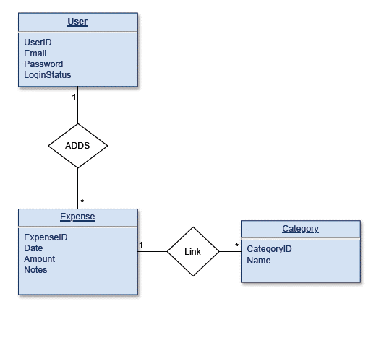

**The Figure 14:** ER Diagram