**10.1 Login page:**

**The Figure 1** Simple login form for users who want to save data.

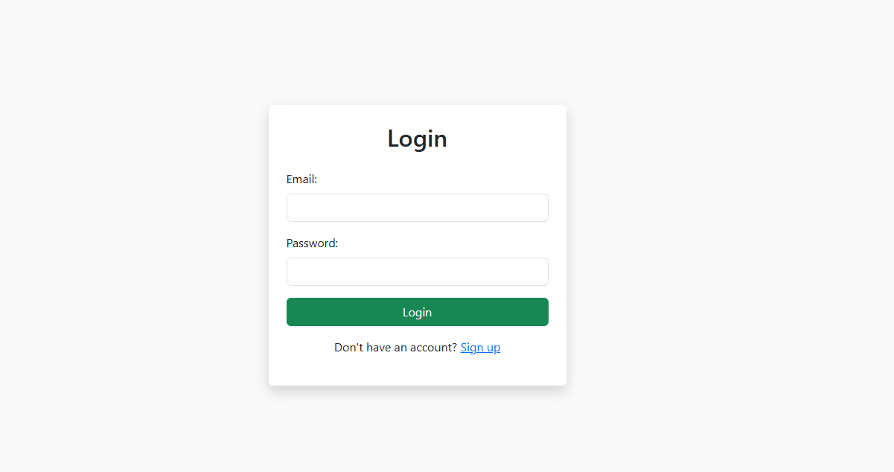

**Figure 1: Main UI Of Play Money System**

**10.2 Dashboard page:**

**The figure 2** Overview of total expenses, charts, and summary.

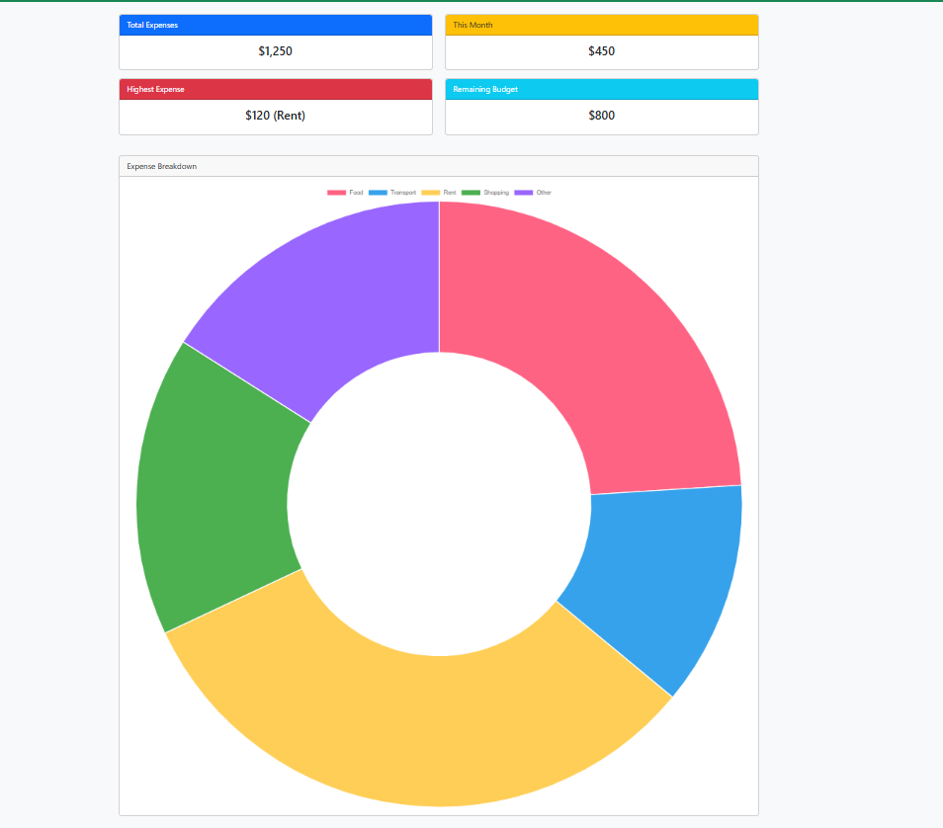

**Figure 2: Dashboard Page Of Play Money System**

**10.3 Add Expense page:**

**The figure 3** allows users to enter new expenses by selecting a date, category, amount, and adding optional notes

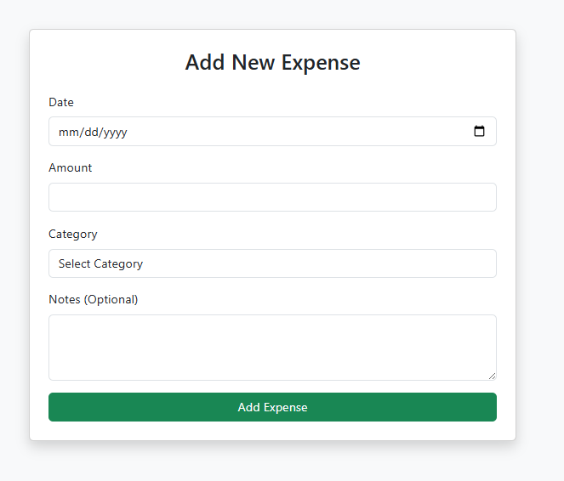

**Figure 3: Add New Expense Page Of Play Money System**

**10.4 Expense List page:**

**The figure 4** a table displaying recorded expenses with edit and delete options.

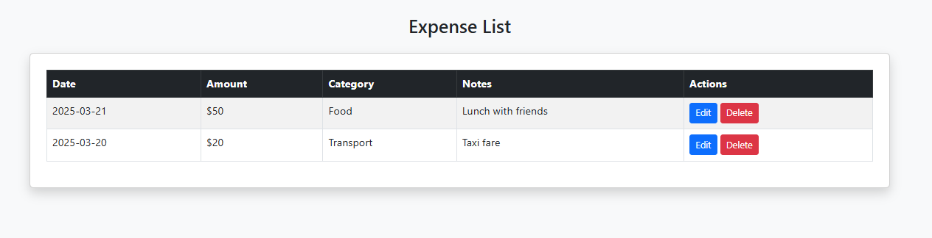

**Figure 4: Expense List Page Of Play Money System**

**10.5 Analytics List Page:**

**The figure 5** displays expense trends using a pie chart to visualize spending by category.

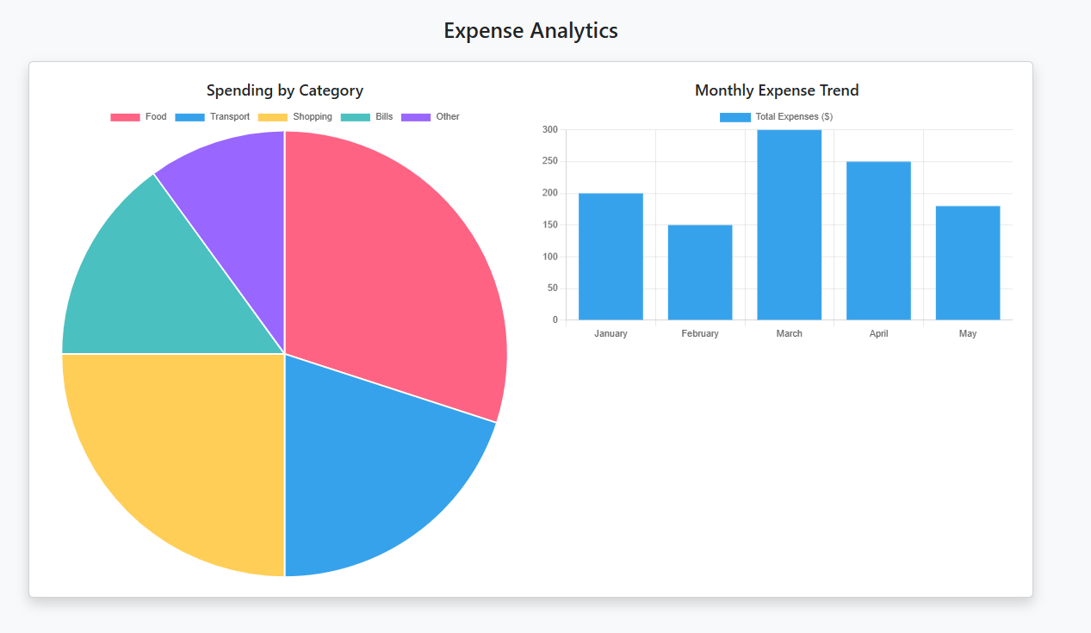

**Figure 5: Analytics List Page Of Play Money System**