**13. Class Diagram**  
  
**The Figure 13** This class diagram models the main components of the Expense Management System and how they interact:

* The **User** class represents users of the system, who can register, log in, and manage their own data. Each user has a unique ID, email, and password.
* The **Expense** class stores individual expense records. Each expense includes details like date, amount, category, and optional notes. Expenses are linked to a specific user.
* The **Category** class defines types of expenses, such as Food, Transport, or Bills. Each expense is associated with one category.
* The **Report** class is responsible for generating summaries and visual charts based on a user's expenses. It helps users understand their spending habits over time.

Relationships:

* One **User** can have multiple **Expenses**.
* Each **Expense** belongs to one **Category**.
* A **Report** summarizes multiple **Expenses** for a specific **User**.

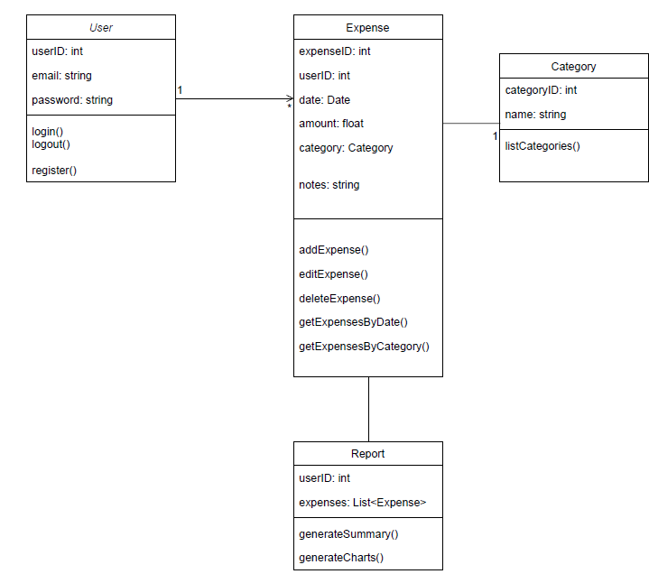  
 **Figure 13: Class Diagram**