Delivery Logistics Performance &
Delay Analytics
Data Analytics with AI
BharatCares Internship Project
Student Project Report

Student Name: Safwana Yasmin
College / Institute: SCMS School of Technology and Management
Course: Integrated MCA
Internship Period: 17 August 2026 – 30 September 2026

Abstract
This report presents the findings of a data analytics project conducted as part of the BharatCares Data Analytics with AI internship programme. The project analyses a synthetic delivery-logistics dataset of 25,000 delivery records drawn from a simulated Indian multi-partner logistics environment. The objective is to understand patterns in delivery delays and to examine how delay rates vary across delivery modes, weather conditions, distance bands, delivery partners, and geographic regions. The analysis also investigates the relationship between delivery time and customer satisfaction ratings.
The analytical workflow is implemented entirely in Python using Pandas, NumPy, and Matplotlib. It covers data loading, data inspection, data cleaning, exploratory data analysis, business KPI calculation, dimensional analysis, and visualization. Key findings include an overall delay rate of 26.68%, a substantial variation in observed delay rates across delivery modes, a positive association between distance and both delivery cost and delay rate, and a weak negative correlation between delivery time and customer rating.
Note: The dataset used in this project is synthetic. All findings are observations from this dataset only and do not represent real-world performance of any logistics company.
1. Introduction
Timely delivery is one of the most important indicators of performance in the logistics and e-commerce industry. Delays in delivery directly affect customer satisfaction, operational costs, and the reputation of logistics providers. As the volume of deliveries grows — driven by the expansion of online shopping and same-day delivery services — the ability to understand and monitor delivery performance becomes increasingly important.
Data analytics provides a structured approach to examining large volumes of delivery records and identifying patterns that may not be visible through individual inspection. By grouping data across dimensions such as delivery mode, weather conditions, distance, and geographic region, analysts can observe which factors are associated with higher or lower delay rates and where performance differs across operational segments.
This project applies a Python-based analytics workflow to a synthetic delivery-logistics dataset. The goal is to demonstrate a complete analytical pipeline — from raw data cleaning to business insight generation — and to produce visualizations and structured findings that could support operational monitoring in a logistics context.
2. Problem Statement
The central analytical question addressed by this project is:
What patterns exist in delivery delays across delivery modes, weather conditions, distance bands, delivery partners, and regions in this synthetic logistics dataset? How are delivery time and customer satisfaction ratings associated in this data?
The project does not attempt to prove that any single factor causes delivery delays. All findings are described as observed associations within this synthetic dataset.
3. Objectives
- Measure overall delivery performance across all 25,000 records.
- Calculate the overall delivery delay rate using the original delayed field.
- Analyse delay rates by delivery mode.
- Examine the association between weather conditions and observed delays.
- Analyse the relationship between delivery distance, delivery time, and cost.
- Examine the association between delivery time and customer ratings.
- Analyse delivery partner and regional delay-rate patterns.
- Visualize key findings through nine clearly labelled charts.
- Produce a reproducible, beginner-readable Python-based analytics workflow.
4. Dataset Description
The dataset used in this project is a synthetic delivery-logistics dataset containing 25,000 records and 15 columns. It simulates delivery operations across multiple Indian logistics partners, regions, delivery modes, and weather conditions. No personal information is contained in the dataset.
Table 1 describes the original columns of the dataset.

Column | Description
delivery_id | Delivery identifier (not a unique key in this dataset)
delivery_partner | Name of the logistics company handling the delivery
package_type | Category of the package (e.g. groceries, electronics, clothing)
vehicle_type | Vehicle used (e.g. bike, truck, ev van, scooter)
delivery_mode | Service tier: same day, express, two day, or standard
region | Geographic region: north, south, east, west, or central
weather_condition | Weather at delivery time: clear, cold, foggy, hot, rainy, or stormy
distance_km | Delivery distance in kilometres (range: 3.6 – 297.1 km)
package_weight_kg | Package weight in kilograms (range: 0.67 – 49.52 kg)
delivery_time_hours | Actual delivery time (stored as an encoded timestamp string)
expected_time_hours | Expected/SLA delivery time (stored as an encoded timestamp string)
delayed | Original delay label assigned to the record: yes or no
delivery_status | Final delivery outcome: delivered, delayed, or failed
delivery_rating | Customer satisfaction rating: 1 (lowest) to 5 (highest)
delivery_cost | Cost of the delivery in Indian Rupees

Table 1: Original dataset columns and their descriptions.
During the data-cleaning step, six additional derived columns were added to the working dataset: delivery_time_hours_num (numeric hours), expected_time_hours_num (numeric hours), zero_hour_flag, is_delayed_flag, delayed_original_binary, and computed_delayed. The original raw file was never modified.
5. Tools and Technologies
Tool / Library | Version | Purpose
Python | 3.8+ | Core programming language
Pandas | Latest | Data loading, cleaning, grouping, and analysis
NumPy | Latest | Numeric operations and NaN handling
Matplotlib | Latest | Chart and visualization generation

Table 2: Technologies used. All packages are listed in requirements.txt.
6. Methodology
The project follows a structured analytics pipeline implemented in a single Python script (final_project.py). The pipeline covers seven stages:
6.1 Data Loading
The raw CSV file (Delivery_Logistics.csv) is loaded into a Pandas DataFrame using pd.read_csv(). The file is opened in read-only mode and is never overwritten.
6.2 Data Inspection
The script inspects dataset shape, column data types, missing values, duplicate delivery_id values, categorical value distributions, and numerical field summaries. This step establishes data quality awareness before any analysis is performed.
6.3 Data Cleaning
Two fields (delivery_time_hours and expected_time_hours) are stored as encoded timestamp-like strings in the raw file. A custom parsing function extracts the nanosecond integer from each string to recover the hour value. 255 records where actual delivery time was zero are flagged (zero_hour_flag = 1) and treated as missing actual delivery time (NaN) in the cleaned working data. The original delayed column is preserved unchanged. Duplicate delivery_id rows are identified but not removed — all 25,000 records are retained.
6.4 Exploratory Data Analysis
The cleaned data is analysed for distributions across delivery modes, weather conditions, regions, partners, vehicle types, and package types. Pearson correlation is computed across numerical columns. SLA-tier delay rates and equal-time conflict counts are reported as data-quality observations.
6.5 Business KPI Analysis
Six overall KPIs are calculated: total deliveries, delay rate, average actual delivery time, average expected/SLA time, average delivery cost, and average rating. The original delayed field is used as the source of truth for all delay-rate calculations throughout the project.
6.6 Visualization
Nine charts are generated using Matplotlib and saved as PNG files to the business_analysis_outputs/ folder. Charts cover KPI summary, delay by mode, delay by weather, distance vs time and cost, delivery time vs rating, status distribution, and partner/region delay comparisons.
6.7 Findings Generation
A structured findings report (findings.json) is generated, containing metric values, group-level comparisons, plain-language interpretations, and analytical cautions for each section.
7. Exploratory Data Analysis
After cleaning, the working dataset has 25,000 rows and 21 columns. The raw dataset has 25,000 rows and 15 columns.
Key EDA findings:
- Missing values: 255 NaN values in delivery_time_hours_num (the 255 zero-hour records treated as missing). All other columns are complete.
- Duplicate delivery_id: 500 records are associated with 2 delivery_id values that appear multiple times. These are preserved as data-quality observations; no records are removed.
- Delivery modes: 4 modes (express: 6,233 | same day: 6,279 | standard: 6,186 | two day: 6,302).
- Weather conditions: 6 conditions, each with approximately 4,100–4,220 records.
- Regions: 5 regions (east: 4,919 | north: 4,949 | south: 4,977 | west: 5,095 | central: 5,060).
- Delivery partners: 9 partners, each with 2,700–2,830 records.
- Delivery ratings: integer scale 1–5; average 3.67.
- Distance: 3.6 – 297.1 km; average ≈ 150 km.
- Delivery cost: ₹95.67 – ₹1,632.72; average ≈ ₹864.94.
- Delivery status: delivered 18,331 | delayed 5,341 | failed 1,328.
- Original delayed field: yes: 6,669 | no: 18,331.
- Data quality note: comparing the original delayed field with a strict 'actual time > expected time' rule shows 1,203 records where the two definitions disagree. The original delayed field is used for all business delay-rate calculations.
8. Key Performance Indicators
Table 3 presents the six overall business KPIs calculated from the dataset. All values are computed from the data; delay rate uses the original delayed field.
KPI | Value
Total deliveries | 25,000
Overall delay rate (delayed = yes) | 26.68%
Delivered (status) | 18,331 (73.3%)
Delayed (status) | 5,341 (21.4%)
Failed (status) | 1,328 (5.3%)
Average actual delivery time | 6.31 hours
Average expected / SLA time | 13.11 hours
Average delivery cost | ₹864.94
Average delivery rating | 3.67 / 5

Table 3: Overall KPIs (source: kpis.json).
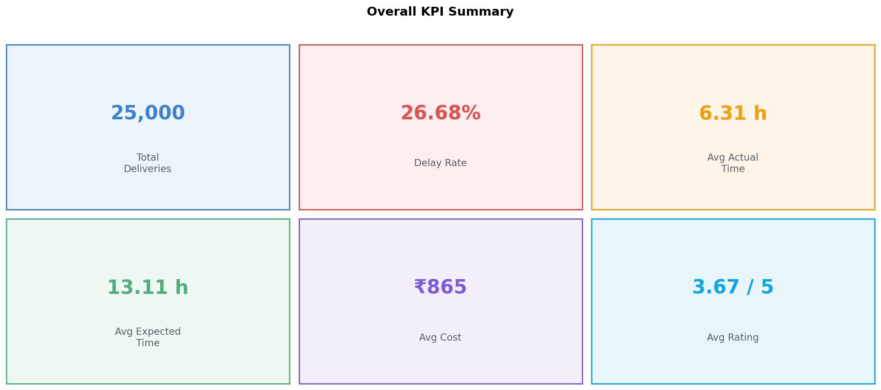
Figure 1: Overall Delivery KPI Summary.

9. Delivery Mode Analysis
Table 4 shows the delay rate and average delivery times for each of the four delivery modes.
Mode | Total | Delayed | Delay Rate | Avg Actual Time | Avg SLA Time
Express | 6,233 | 4,599 | 73.78% | 6.28 h | 4.52 h
Same Day | 6,279 | 2,043 | 32.54% | 6.33 h | 8.00 h
Two Day | 6,302 | 27 | 0.43% | 6.34 h | 16.00 h
Standard | 6,186 | 0 | 0.00% | 6.30 h | 24.00 h

Table 4: Delivery mode analysis (source: mode_analysis.csv).
The analysis observes that express mode is associated with the highest delay rate in this dataset (73.78%), while standard mode shows 0%. The wide spread of 73.78 percentage points across modes is a notable pattern. However, delivery modes differ in their SLA windows — express mode has a tighter SLA (average 4.52 hours) compared to standard mode (24 hours). This difference in SLA threshold likely contributes to the higher observed delay rate for express deliveries in this dataset. This is an association; the analysis does not conclude that the mode itself causes delays.
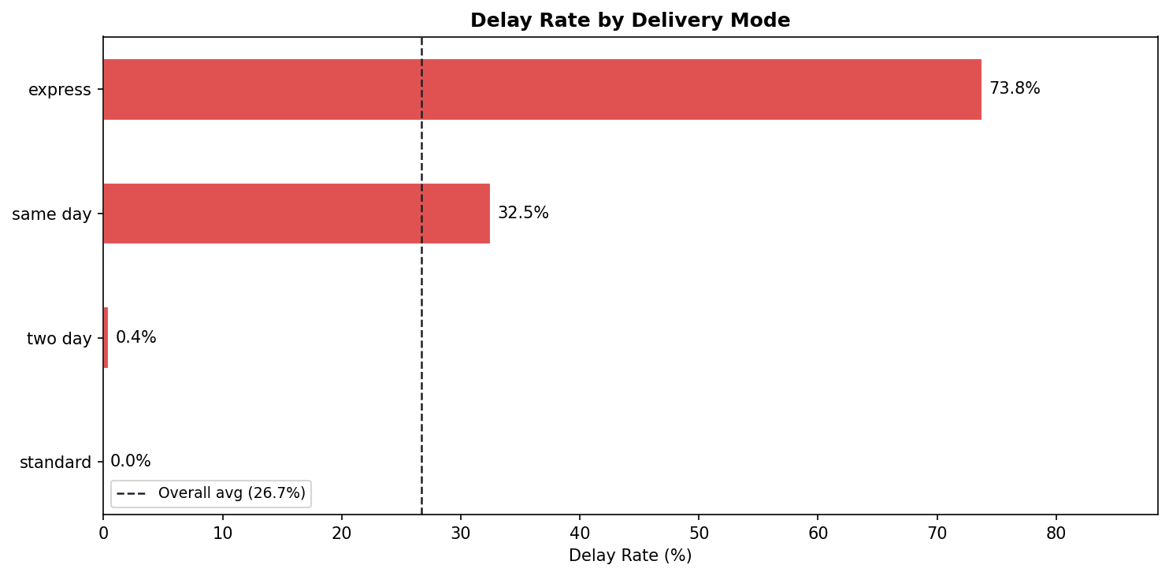
Figure 2: Delay Rate by Delivery Mode.
10. Weather Analysis
Table 5 presents delay rates and average delivery times across six weather conditions.
Condition | Total | Delayed | Delay Rate | Avg Time
Stormy | 4,198 | 1,740 | 41.45% | 8.81 h
Rainy | 4,171 | 1,558 | 37.35% | 7.80 h
Foggy | 4,219 | 1,279 | 30.32% | 6.49 h
Clear | 4,124 | 719 | 17.43% | 4.89 h
Hot | 4,130 | 707 | 17.12% | 4.87 h
Cold | 4,158 | 666 | 16.02% | 4.87 h

Table 5: Weather condition analysis (source: weather_analysis.csv).
Adverse weather conditions — stormy (41.45%), rainy (37.35%), and foggy (30.32%) — are associated with higher delay rates and longer average delivery times in this dataset. Milder conditions (clear, hot, cold) show delay rates in the range of 16–17%. The spread across conditions is 25.43 percentage points. This is an observed association in synthetic data and does not establish a causal relationship.
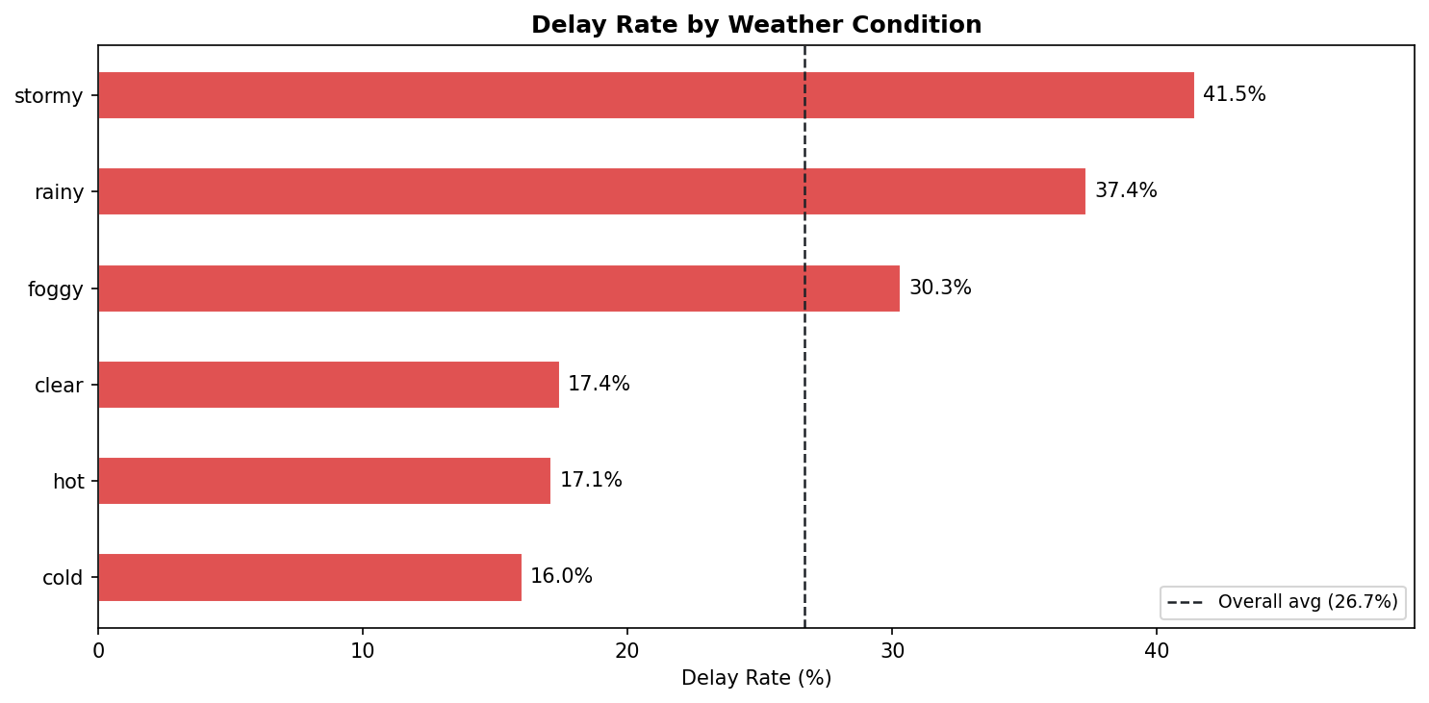
Figure 3: Delay Rate by Weather Condition.

11. Distance Analysis
Table 6 presents delay rate, average delivery time, and average cost across five distance bands.
Distance Band | Count | Delay Rate | Avg Time | Avg Cost
0–60 km | 4,920 | 17.36% | 3.42 h | ₹264.36
61–120 km | 5,044 | 19.85% | 4.74 h | ₹560.62
121–180 km | 5,053 | 26.04% | 6.29 h | ₹866.35
181–240 km | 4,960 | 31.75% | 7.69 h | ₹1,162.78
241–300 km | 5,023 | 38.28% | 9.25 h | ₹1,463.31

Table 6: Distance band analysis (source: distance_analysis.csv).
Both average delivery time and average delivery cost increase consistently with distance in this dataset. Delay rate also increases across distance bands, from 17.36% for the 0–60 km band to 38.28% for the 241–300 km band. The cost rises from ₹264.36 to ₹1,463.31 across the same bands. These are clear positive associations between distance and each of these metrics. Distance alone does not explain all delay variation, as other variables (mode, weather) are not controlled for in this analysis.
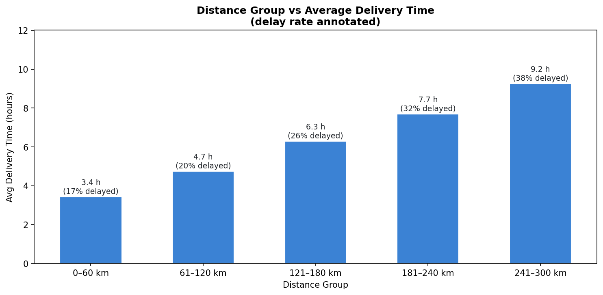
Figure 4: Distance Group vs Average Delivery Time (delay rate annotated).
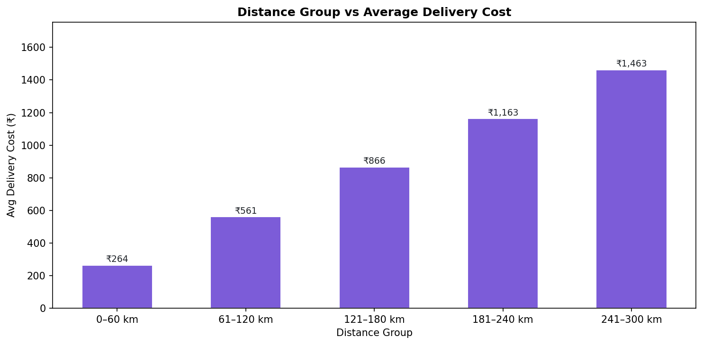
Figure 5: Distance Group vs Average Delivery Cost.
12. Customer Experience Analysis
The Pearson correlation between actual delivery time and customer rating is r = −0.2693, indicating a weak negative association. Table 7 shows average delivery time, average cost, and delay rate for each rating level.
Rating | Count | Avg Delivery Time | Avg Cost | Delay Rate
1 (lowest) | 920 | 8.13 h | ₹993.76 | 100.00%
2 | 3,602 | 8.11 h | ₹1,023.27 | 100.00%
3 | 5,773 | 6.53 h | ₹886.64 | 37.19%
4 | 7,318 | 5.64 h | ₹807.18 | 0.00%
5 (highest) | 7,387 | 5.69 h | ₹811.97 | 0.00%

Table 7: Delivery rating analysis (source: rating_analysis.csv).
Ratings 1 and 2 correspond to 100% delay rates in this dataset, while ratings 4 and 5 show 0% delay rates. This strong alignment between delay status and rating is a pattern in the data. The Pearson r = −0.2693 represents a weak negative association across all records. Correlation does not establish causation — other factors such as package condition, communication quality, and delivery cost also influence customer satisfaction but are not fully captured in this dataset.
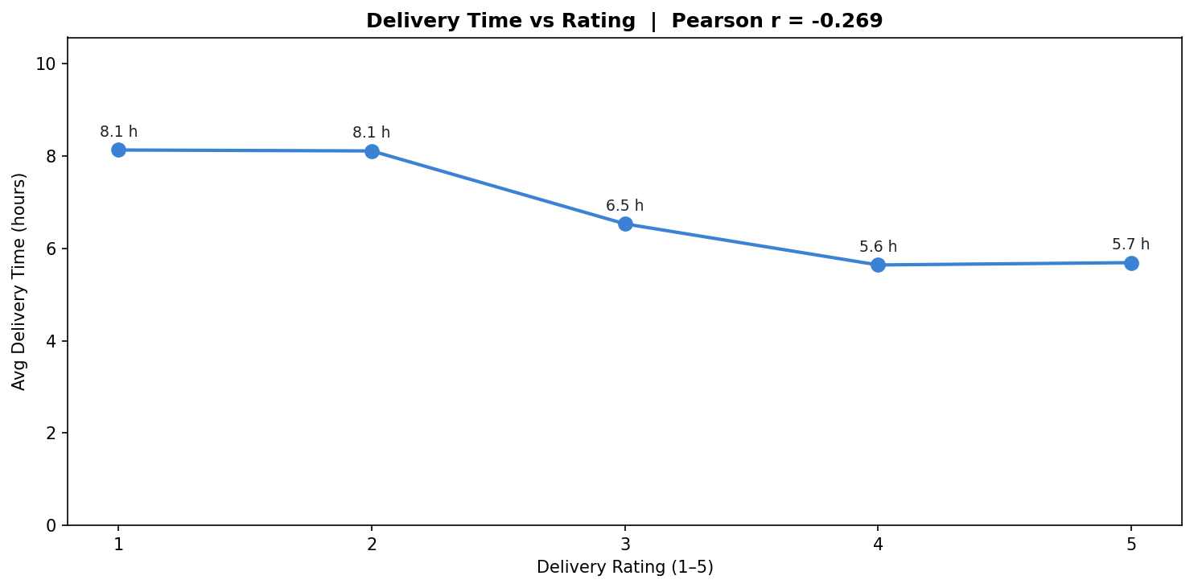
Figure 6: Delivery Time vs Customer Rating (Pearson r = −0.2693).

13. Delivery Status Analysis
The dataset records three delivery outcomes: delivered, delayed, and failed. Table 8 shows the distribution.
Status | Count | Percentage
Delivered | 18,331 | 73.3%
Delayed | 5,341 | 21.4%
Failed | 1,328 | 5.3%
Total | 25,000 | 100.0%

Table 8: Delivery status distribution.
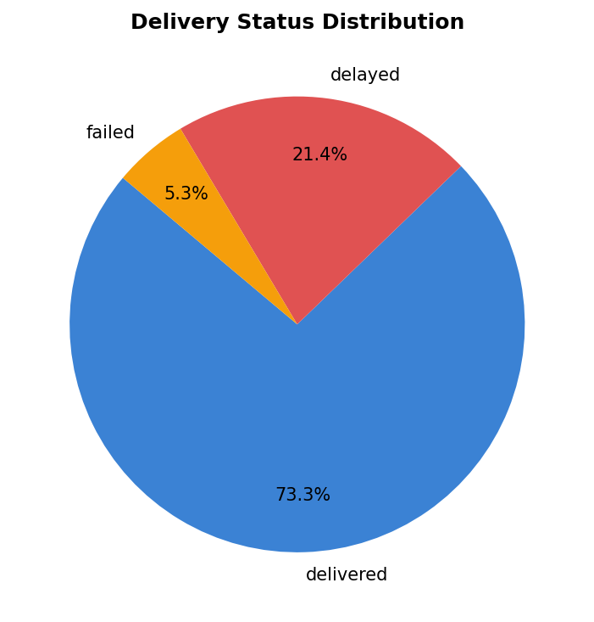
Figure 7: Delivery Status Distribution (Pie Chart).
14. Delivery Partner Analysis
Table 9 presents the observed delay rate and average customer rating for each of the nine delivery partners. Partners are listed in ascending order of delay rate.
Partner | Total | Delayed | Delay Rate | Avg Rating
Delhivery | 2,786 | 691 | 24.80% | 3.69
FedEx | 2,818 | 709 | 25.16% | 3.70
DHL | 2,802 | 738 | 26.34% | 3.69
Ecom Express | 2,722 | 725 | 26.63% | 3.67
Blue Dart | 2,798 | 754 | 26.95% | 3.68
Amazon Logistics | 2,711 | 738 | 27.22% | 3.64
Shadowfax | 2,736 | 747 | 27.30% | 3.66
Ekart | 2,801 | 768 | 27.42% | 3.66
Xpressbees | 2,826 | 799 | 28.27% | 3.61

Table 9: Delivery partner analysis (source: partner_analysis.csv). Sorted ascending by delay rate. No ranking is implied.
The delay rates across the nine partners range from 24.80% to 28.27%, a spread of 3.47 percentage points. This is a relatively narrow range in this synthetic dataset. Because partners may serve different regions, carry different package types, or operate across different delivery modes, the observed differences reflect a descriptive pattern rather than an isolated measure of each partner's performance. No partner is ranked as best or worst.
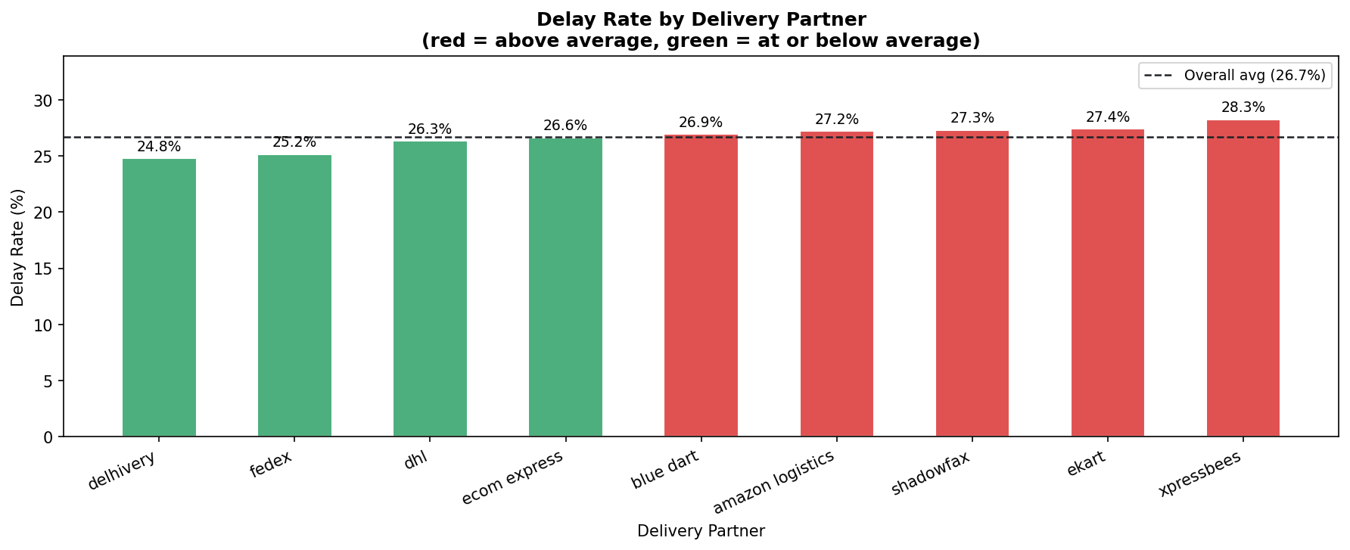
Figure 8: Delay Rate by Delivery Partner (reference line = overall average 26.68%).
15. Region Analysis
Table 10 presents observed delay rates across five geographic regions.
Region | Total | Delayed | Delay Rate | Avg Rating
East | 4,919 | 1,269 | 25.80% | 3.68
North | 4,949 | 1,315 | 26.57% | 3.68
South | 4,977 | 1,333 | 26.78% | 3.67
West | 5,095 | 1,373 | 26.95% | 3.64
Central | 5,060 | 1,379 | 27.25% | 3.66

Table 10: Region analysis (source: region_analysis.csv). Sorted ascending by delay rate. No ranking is implied.
Regional delay rates are very similar across the five regions, ranging from 25.80% to 27.25% — a spread of only 1.45 percentage points. Regional differences may reflect varying mixes of delivery partners, weather conditions, and delivery modes rather than geographic factors alone.
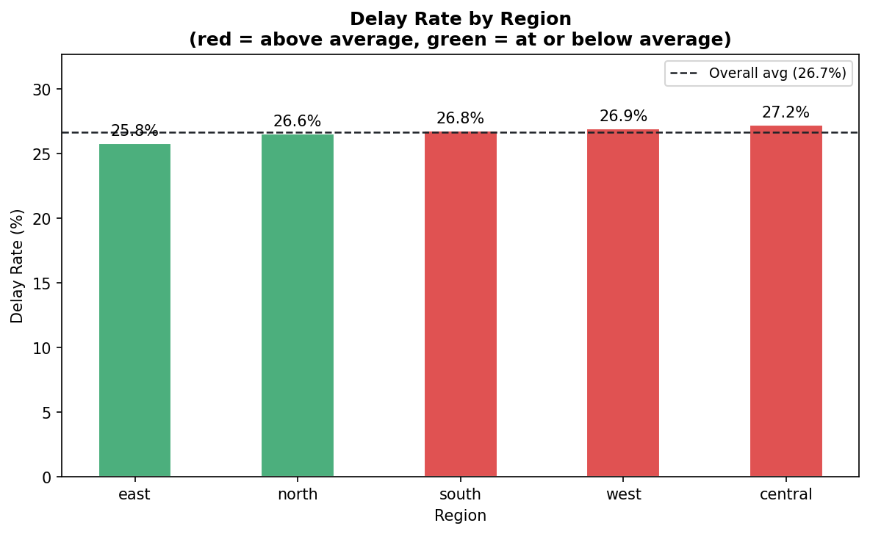
Figure 9: Delay Rate by Region (reference line = overall average 26.68%).

16. Business Insights
The following summarises the major observations from this analysis. All findings are described as patterns observed in this synthetic dataset. Association does not imply causation.
- Overall performance: The dataset records a delay rate of 26.68%, meaning approximately 1 in every 4 deliveries is recorded as delayed.
- Delivery mode: Express mode is associated with the highest observed delay rate (73.78%) and standard mode with the lowest (0%). The 73.78 pp spread is the largest dimensional difference observed in the data. This pattern is partly explained by the much tighter SLA for express deliveries.
- Weather: Stormy conditions are associated with the highest delay rate (41.45%) and cold conditions with the lowest (16.02%). A 25.43 pp spread is observed across weather conditions.
- Distance and delay: Delay rate increases across distance bands, from 17.36% (0–60 km) to 38.28% (241–300 km), a 21 pp increase over the full range.
- Distance and cost: Average delivery cost rises from ₹264.36 to ₹1,463.31 across distance bands — a clear positive association between distance and cost.
- Customer experience: A weak negative correlation (r = −0.2693) is observed between delivery time and customer rating. Deliveries rated 1 or 2 all correspond to delayed orders; deliveries rated 4 or 5 show no delays.
- Delivery partners: Partner delay rates span 24.80%–28.27% (range: 3.47 pp). This is a relatively narrow spread. Confounding variables are not controlled for.
- Regions: Regional delay rates span 25.80%–27.25% (range: 1.45 pp), indicating very similar performance across regions in this dataset.
17. Data Quality and Limitations
- Synthetic dataset: The dataset is artificially generated. Results must not be generalised to real-world logistics companies or operations.
- Correlation ≠ causation: All relationships described in this report are statistical associations. No factor is claimed to cause delivery delays.
- Zero-hour records: 255 records had an actual delivery time of zero hours. These were flagged and treated as missing actual delivery time in the cleaned working data.
- Duplicate delivery IDs: 500 records are associated with 2 delivery_id values that appear multiple times. These records are preserved in the analysis as a data-quality observation.
- Delay label disagreement: Comparing the original delayed field with a strict 'actual time exceeds expected time' rule produces 1,203 conflicting records. The original delayed field is used throughout as the established source of truth for delay-rate calculations.
- Uncontrolled confounders: Partner and region comparisons do not control for other variables such as delivery mode mix, package types, or weather conditions. Observed differences should be interpreted as descriptive patterns.
18. Conclusion
This project demonstrates a complete Python-based data analytics workflow applied to a synthetic delivery-logistics dataset. The workflow covers data loading, data cleaning, exploratory data analysis, business KPI calculation, dimensional analysis across six key dimensions, visualization generation, and structured findings reporting.
The analysis identifies several notable patterns in the dataset: a 26.68% overall delay rate, wide variation in delay rates across delivery modes, associations between adverse weather and higher delays, a consistent positive relationship between distance and both delivery cost and delay rate, and a weak negative correlation between delivery time and customer satisfaction rating.
The project does not apply machine learning or make predictions about future deliveries. All findings are observations from this synthetic dataset and should not be extrapolated to real-world logistics performance.
19. Future Scope
The following extensions are identified as potential future work and have not been implemented in the current project:
- Apply the same analytical workflow to a validated real-world logistics dataset to test whether the observed patterns hold.
- Build predictive delay models (e.g. classification) using the cleaned dataset if a prediction requirement is introduced.
- Develop interactive dashboards (e.g. using Streamlit or Dash) to allow dynamic exploration of the findings.
- Investigate additional operational factors such as vehicle type, package type, and time of day.
- Extend the partner and region analysis to control for confounding variables using stratification or regression.
20. References and Data Source
Dataset:
- Kaggle – Delivery Logistics Dataset (India – Multi-Partner). Source: Kaggle (exact URL not recorded in project files).
Libraries and documentation:
- Python Software Foundation. Python Programming Language. https://www.python.org/
- The Pandas Development Team. pandas: Python Data Analysis Library. https://pandas.pydata.org/
- Harris, C.R. et al. Array programming with NumPy. Nature, 585, 357–362 (2020). https://numpy.org/
- Hunter, J.D. Matplotlib: A 2D Graphics Environment. Computing in Science & Engineering, 9(3), 90–95 (2007). https://matplotlib.org/

Appendix: Project Output Files
All output files are stored in the business_analysis_outputs/ folder.
A.1 Generated Charts
- 01_kpi_summary.png — Figure 1: Overall Delivery KPI Summary
- 02_delay_rate_by_mode.png — Figure 2: Delay Rate by Delivery Mode
- 03_delay_rate_by_weather.png — Figure 3: Delay Rate by Weather Condition
- 04_distance_vs_delivery_time.png — Figure 4: Distance Group vs Average Delivery Time
- 05_distance_vs_delivery_cost.png — Figure 5: Distance Group vs Average Delivery Cost
- 06_delivery_time_vs_rating.png — Figure 6: Delivery Time vs Customer Rating
- 07_delivery_status_distribution.png — Figure 7: Delivery Status Distribution
- 08_partner_delay_rate.png — Figure 8: Delay Rate by Delivery Partner
- 09_region_delay_rate.png — Figure 9: Delay Rate by Region
A.2 Analysis Result Files
- kpis.json — Overall KPI values
- findings.json — Structured findings with metrics, interpretations, and cautions
- mode_analysis.csv — Delay and time metrics by delivery mode
- weather_analysis.csv — Delay and time metrics by weather condition
- distance_analysis.csv — Delay, time, and cost metrics by distance band
- rating_analysis.csv — Delivery time, cost, and delay rate by customer rating
- partner_analysis.csv — Delay rate and average rating by delivery partner
- region_analysis.csv — Delay rate and average rating by region
A.3 Project Scripts
- final_project.py — Complete analysis workflow (single runnable script)
- requirements.txt — Required Python packages
- README.md — Project documentation for GitHub
- process_logistics.py — Original data-cleaning script
- eda_logistics.py — Original EDA script
- eda_report.py — Original data-inspection script

