# AI-Based MCQ Generator from Notes

## 1. Project Title
**AI-Based MCQ Generator from Notes**

## 2. Problem Statement
Students often spend a lot of time manually creating practice questions from their study notes to test their own understanding. This project solves that problem by allowing a student to paste or upload their notes and automatically generate a multiple-choice quiz from that content using AI — at a difficulty level they choose — so they can immediately test themselves and review their results.

## 3. Assigned Feature Set
**Feature Set B** — AI-Based MCQ Generator from Notes, with the following mandatory features:
1. Upload/Paste Notes
2. Generate MCQs
3. Display Answers
4. Question Review
5. Difficulty Selection

## 4. Features Implemented
- ✅ Paste notes into a text area
- ✅ Upload notes as a `.txt` or `.pdf` file, with text automatically extracted and displayed
- ✅ Select difficulty: Easy / Medium / Hard, which changes the style of AI-generated questions
- ✅ Select number of questions (1–20)
- ✅ Generate MCQs using the Google Gemini AI API (free tier), based only on the supplied notes
- ✅ Each question has exactly 4 options with exactly one correct answer
- ✅ Duplicate questions are filtered out
- ✅ Quiz attempt mode: answers are hidden until the user submits
- ✅ Submit quiz → automatic score calculation
- ✅ Full review screen: shows the user's answer, the correct answer, and correct/incorrect status per question
- ✅ Restart button to generate a brand-new quiz
- ✅ Loading indicators for file upload and AI generation
- ✅ Friendly error messages for all failure cases (empty notes, empty file, bad file type, API failure, invalid AI response, invalid input)
- ✅ Frontend and backend validation
- ✅ API key stored only in a backend `.env` file, never exposed to the browser

## 5. Technologies Used

| Layer | Technology |
|-------------------|------------------------------------------|
| Frontend | HTML5, CSS3, Vanilla JavaScript (no framework) |
| Backend | Node.js + Express.js |
| File Upload | Multer |
| PDF Text Extraction | pdfjs-dist (Mozilla's PDF.js library) |
| AI Model | Google Gemini API (`gemini-3.1-flash-lite`) |
| Config/Secrets | dotenv (`.env` file) |
| Cross-Origin Requests | cors |

### Why this stack?
- **Plain Node.js + Express** was chosen over a heavier framework (like Next.js or NestJS) because it is simple to read, simple to explain in a viva/demo, and does not hide what is happening behind "magic" folder conventions.
- **Vanilla JS frontend** (no React/Vue) was chosen so that a 3rd-year student can understand every line without needing to explain a build tool, JSX, or virtual DOM — it's just HTML, CSS, and DOM manipulation.
- **One server for both frontend and backend** (Express serves the static frontend files) removes the need to run two separate dev servers or deal with CORS during local development — simpler to run and demo.
- **pdfjs-dist** is Mozilla's own, actively maintained PDF library (used inside Firefox) — more reliable at extracting text from real-world PDFs than many small wrapper packages. It ships as an ES Module only, so it's loaded from the CommonJS backend using a dynamic `import()` inside `fileParser.js`.
- **A `.npmrc` file** (`omit=optional`) is included in `backend/` so a plain `npm install` never pulls in `pdfjs-dist`'s optional `canvas` dependency, which is only needed for rendering PDF pages as images (not for our text extraction) and has historically pulled in vulnerable transitive packages. An `overrides` entry in `package.json` also pins `qs` (a dependency of Express) to a patched version. Running `npm audit` after `npm install` should report **0 vulnerabilities**.
- **Google Gemini API** was chosen as the AI model because it offers a genuinely free tier (no credit card required to start), a simple single-endpoint REST API (`generateContent`) that is easy to call with `fetch`, and a built-in JSON response mode that reduces parsing errors.

## 6. AI Tools Used
- **Google Gemini API** (model: `gemini-3.1-flash-lite`) — used at runtime by the application itself to generate the MCQs from the user's notes.
- **Claude (Anthropic's assistant)** — used during development to help scaffold the project structure and write/debug the code in this repository.

## 7. Important AI Prompts / AI Usage
The application builds a structured prompt for every quiz generation request. The prompt (see `backend/utils/aiPrompt.js`) instructs the model to:
- Use **only** information present in the supplied notes (no outside knowledge).
- Generate **exactly** the number of questions requested.
- Follow the **selected difficulty** (Easy = basic recall, Medium = understanding + application, Hard = deeper reasoning/connections).
- Create **exactly 4 options** per question with **exactly 1 correct answer**.
- **Avoid duplicate** or near-duplicate questions.
- Return the result as **strict JSON only** (no explanations, no markdown fences), in this shape:
```json
{
"questions": [
{
"question": "string",
"options": ["string", "string", "string", "string"],
"correctAnswerIndex": 0
}
]
}
```
The backend also re-validates this JSON structure after it comes back (correct types, exactly 4 options, valid answer index) and removes any duplicate question text as an extra safety net before sending it to the frontend.

## 8. Project Folder Structure
```
mcq-generator/
├── backend/
│ ├── controllers/
│ │ └── mcqController.js # Route handler logic (upload + generate quiz)
│ ├── middleware/
│ │ └── validateRequest.js # Input validation before calling the AI
│ ├── routes/
│ │ └── mcqRoutes.js # API endpoint definitions + multer config
│ ├── utils/
│ │ ├── aiPrompt.js # Prompt builder + Gemini API call + JSON parsing
│ │ └── fileParser.js # .txt / .pdf text extraction
│ ├── uploads/ # Temporary storage for uploaded files
│ ├── .env.example # Template for required environment variables
│ ├── package.json
│ └── server.js # Express app entry point
├── frontend/
│ ├── css/
│ │ └── style.css
│ ├── js/
│ │ └── app.js # All frontend logic (quiz flow, API calls, DOM)
│ └── index.html
├── .gitignore
└── README.md
```

## 9. Installation Steps
**Prerequisites:** Node.js v18 or later installed (v18+ is required for the built-in `fetch` API used to call Gemini).

```bash
# 1. Navigate into the backend folder
cd mcq-generator/backend

# 2. Install dependencies
npm install
```

## 10. Environment Variable Setup
1. Inside the `backend` folder, copy the example file:
```bash
cp .env.example .env
```
2. Open `.env` and fill in your real Gemini API key:
```
GEMINI_API_KEY=your_actual_api_key_here
AI_MODEL=gemini-3.1-flash-lite
PORT=5000
MAX_FILE_SIZE_BYTES=5242880
```
3. Get a **free** API key from https://aistudio.google.com/app/apikey (sign in with a Google account, click "Create API key" — no credit card required for the free tier).
4. **Never commit your `.env` file** — it is already excluded via `.gitignore`.

## 11. Instructions to Run the Project
```bash
cd mcq-generator/backend
npm start
```
You should see:
```
✅ MCQ Generator server running at http://localhost:5000
```
Then open your browser and go to:
```
http://localhost:5000
```
The frontend and backend both run from this single server — no separate frontend server is needed.

## 12. How to Use the Application
1. **Add notes** — paste text into the box, or click "Upload .txt or .pdf file" to extract text from a file.
2. **Choose a difficulty** — Easy, Medium, or Hard.
3. **Choose the number of questions** — between 1 and 20.
4. Click **"Generate MCQs"** and wait for the AI to build your quiz.
5. **Attempt the quiz** — select one option per question. Answers are hidden until you submit.
6. Click **"Submit Quiz"**.
7. View your **score** and then scroll down to **review** each question — see your answer, the correct answer, and whether you got it right.
8. Click **"Generate New Quiz"** to start over with new notes.

## 13. Testing Performed
See the full **Testing Checklist** section below (or `TESTING_CHECKLIST.md`). Summary of what was manually verified during development:
- Pasting notes and generating a quiz
- Uploading a `.txt` file and a `.pdf` file and confirming correct text extraction
- Rejecting empty notes, empty files, and unsupported file types
- Difficulty selection changing the style/complexity of generated questions
- Validating question count boundaries (below 1, above 20, non-integer)
- Full quiz attempt → submit → score → review flow
- Simulated AI API failure (invalid API key) to confirm a friendly error is shown instead of a crash
- Confirmed API key is never sent to or visible in the frontend/browser

## 14. Screenshots
> Add your screenshots here after running the project locally.

- **Screenshot 1:** Notes input screen (paste/upload, difficulty, question count)

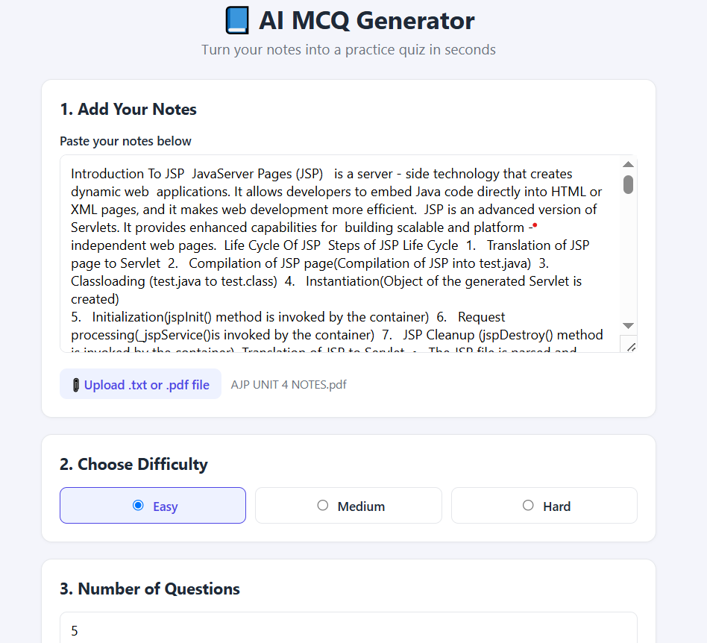

- **Screenshot 2:** Loading indicator while AI generates the quiz
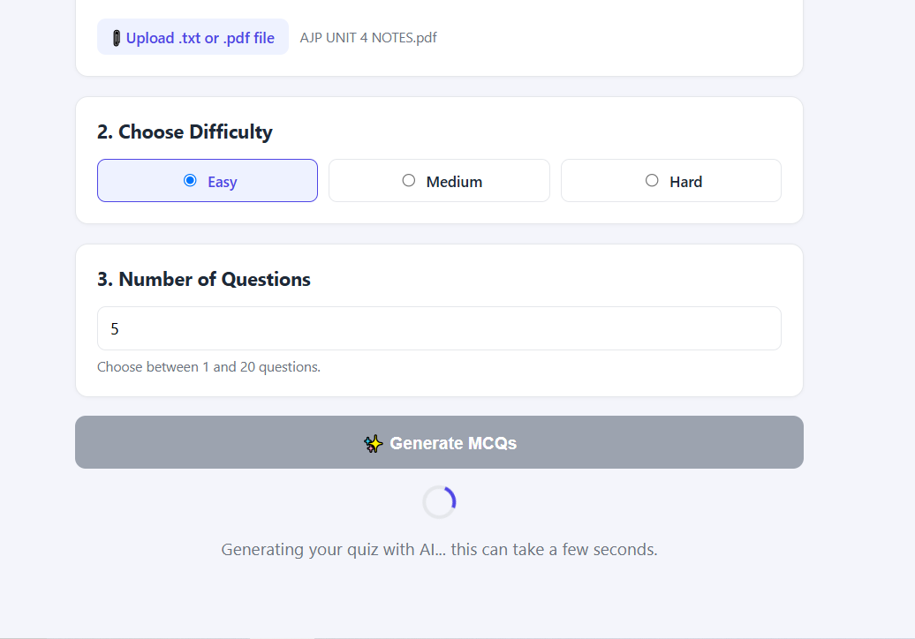

- **Screenshot 3:** Quiz attempt screen with a question and 4 options
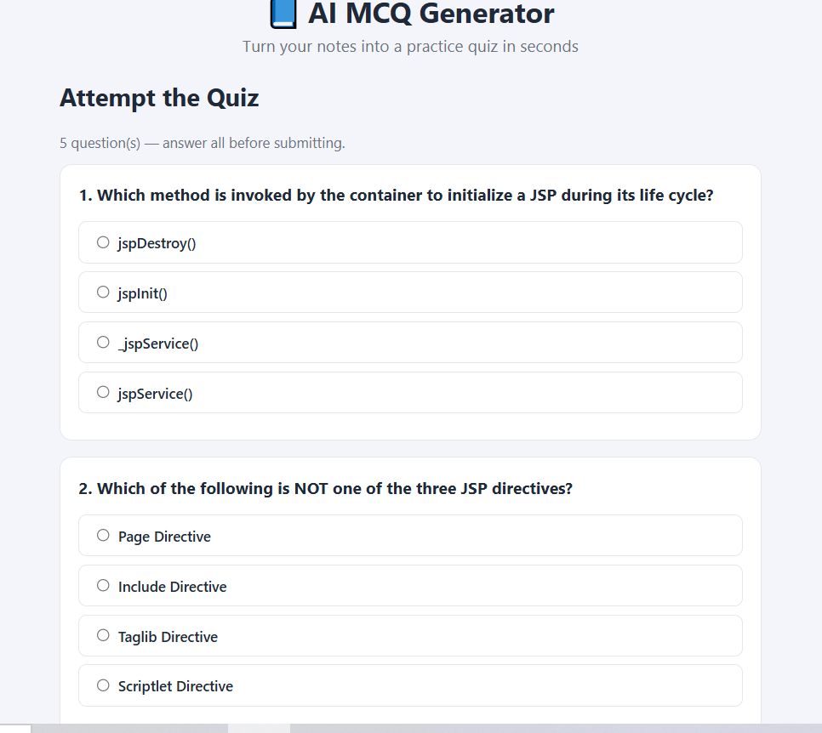

- **Screenshot 4:** Score screen after submission


- **Screenshot 5:** Question review screen showing correct/incorrect answers
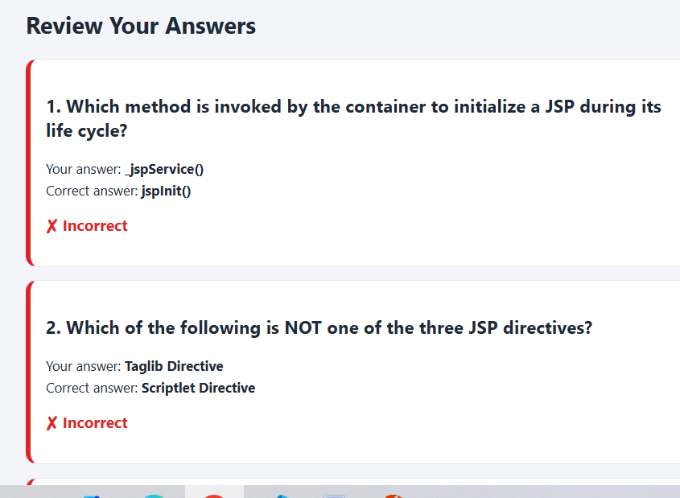

## 15. Future Improvements
- Add user accounts to save quiz history and track progress over time
- Support additional file formats (.docx, .pptx)
- Allow exporting the generated quiz as a PDF for offline practice
- Add a timer/timed-quiz mode
- Allow re-generating a single question the user found unclear
- Add topic tagging so questions can be grouped by sub-topic within long notes

