**MQT Lab 6**

1. **Get cluster id**

Request : GET http://localhost:8082/v3/clusters

Response:

{

"kind": "KafkaClusterList",

"metadata": {

"self": "http://rest-proxy:8082/v3/clusters",

"next": null

},

"data": [

{

"kind": "KafkaCluster",

"metadata": {

"self": "http://rest-proxy:8082/v3/clusters/jdrIHaMCSSmt4Y0nX0ECcA",

"resource_name": "crn:///kafka=jdrIHaMCSSmt4Y0nX0ECcA"

},

"cluster_id": "jdrIHaMCSSmt4Y0nX0ECcA",

"controller": {

"related": "http://rest-proxy:8082/v3/clusters/jdrIHaMCSSmt4Y0nX0ECcA/brokers/1"

},

"acls": {

"related": "http://rest-proxy:8082/v3/clusters/jdrIHaMCSSmt4Y0nX0ECcA/acls"

},

"brokers": {

"related": "http://rest-proxy:8082/v3/clusters/jdrIHaMCSSmt4Y0nX0ECcA/brokers"

},

"broker_configs": {

"related": "http://rest-proxy:8082/v3/clusters/jdrIHaMCSSmt4Y0nX0ECcA/broker-configs"

},

"consumer_groups": {

"related": "http://rest-proxy:8082/v3/clusters/jdrIHaMCSSmt4Y0nX0ECcA/consumer-groups"

},

"topics": {

"related": "http://rest-proxy:8082/v3/clusters/jdrIHaMCSSmt4Y0nX0ECcA/topics"

},

"partition_reassignments": {

"related": "http://rest-proxy:8082/v3/clusters/jdrIHaMCSSmt4Y0nX0ECcA/topics/-/partitions/-/reassignment"

}

}

]

}

1. **Set cluster id**

**"cluster_id": "jdrIHaMCSSmt4Y0nX0ECcA"**

1. **Create topic**

Body --> raw --> JSON  
{ "topic_name" : "my_topic" }  
  
Headers  
key --> Content-Type value --> application/json

Request: POST http://localhost:8082/v3/clusters/jdrIHaMCSSmt4Y0nX0ECcA/topics

Response:

{

"kind": "KafkaTopic",

"metadata": {

"self": "http://rest-proxy:8082/v3/clusters/jdrIHaMCSSmt4Y0nX0ECcA/topics/my_topic",

"resource_name": "crn:///kafka=jdrIHaMCSSmt4Y0nX0ECcA/topic=my_topic"

},

"cluster_id": "jdrIHaMCSSmt4Y0nX0ECcA",

"topic_name": "my_topic",

"is_internal": false,

"replication_factor": 0,

"partitions_count": 0,

"partitions": {

"related": "http://rest-proxy:8082/v3/clusters/jdrIHaMCSSmt4Y0nX0ECcA/topics/my_topic/partitions"

},

"configs": {

"related": "http://rest-proxy:8082/v3/clusters/jdrIHaMCSSmt4Y0nX0ECcA/topics/my_topic/configs"

},

"partition_reassignments": {

"related": "http://rest-proxy:8082/v3/clusters/jdrIHaMCSSmt4Y0nX0ECcA/topics/my_topic/partitions/-/reassignment"

}

}

1. **List all topics**

Request: GET http://localhost:8082/v3/clusters/jdrIHaMCSSmt4Y0nX0ECcA/topics

Response:

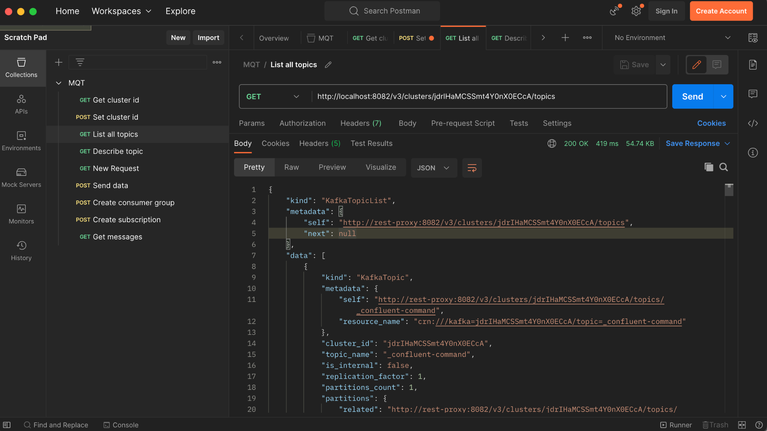

1. **Describe topic**

Request: GET <http://localhost:8082/v3/clusters/jdrIHaMCSSmt4Y0nX0ECcA/topics/my_topic>

Response:

{

"kind": "KafkaTopic",

"metadata": {

"self": "http://rest-proxy:8082/v3/clusters/jdrIHaMCSSmt4Y0nX0ECcA/topics/my_topic",

"resource_name": "crn:///kafka=jdrIHaMCSSmt4Y0nX0ECcA/topic=my_topic"

},

"cluster_id": "jdrIHaMCSSmt4Y0nX0ECcA",

"topic_name": "my_topic",

"is_internal": false,

"replication_factor": 1,

"partitions_count": 1,

"partitions": {

"related": "http://rest-proxy:8082/v3/clusters/jdrIHaMCSSmt4Y0nX0ECcA/topics/my_topic/partitions"

},

"configs": {

"related": "http://rest-proxy:8082/v3/clusters/jdrIHaMCSSmt4Y0nX0ECcA/topics/my_topic/configs"

},

"partition_reassignments": {

"related": "http://rest-proxy:8082/v3/clusters/jdrIHaMCSSmt4Y0nX0ECcA/topics/my_topic/partitions/-/reassignment"

}

}

1. **Send data**

Body --> raw --> JSON  
{ "key": { "type": "JSON", "data": "key1" },  
 "value": { "type": "JSON", "data": "value1 Buna" }  
}  
  
Headers  
key --> Content-Type value --> application/json

Request: POST http://localhost:8082/v3/clusters/jdrIHaMCSSmt4Y0nX0ECcA/topics/curl_topic/records

Response:

{

"cluster_id": "jdrIHaMCSSmt4Y0nX0ECcA",

"topic_name": "curl_topic",

"partition_id": 0,

"offset": 1,

"timestamp": "2023-10-31T07:00:24.535Z",

"key": {

"type": "JSON",

"size": 6

},

"value": {

"type": "JSON",

"size": 13

}

}

1. **Create consumer group**

Body --> raw --> JSON  
 {"name": "FirstConsumer", "format": "json", "auto.offset.reset": "earliest"}  
  
 Headers  
 key --> Content-Type value --> application/vnd.kafka.v2+json

Request: POST http://localhost:8082/consumers/HappyGroup

Response:

{

"instance_id": "FirstConsumer",

"base_uri": "http://rest-proxy:8082/consumers/HappyGroup/instances/FirstConsumer"

}

1. **Create subscription**

Body --> raw --> JSON  
{"topics": ["my_topic"]}  
  
Headers  
key --> Content-Type value --> application/vnd.kafka.v2+json

Request: POST http://localhost:8082/consumers/HappyGroup/instances/FirstConsumer/subscription

Response:

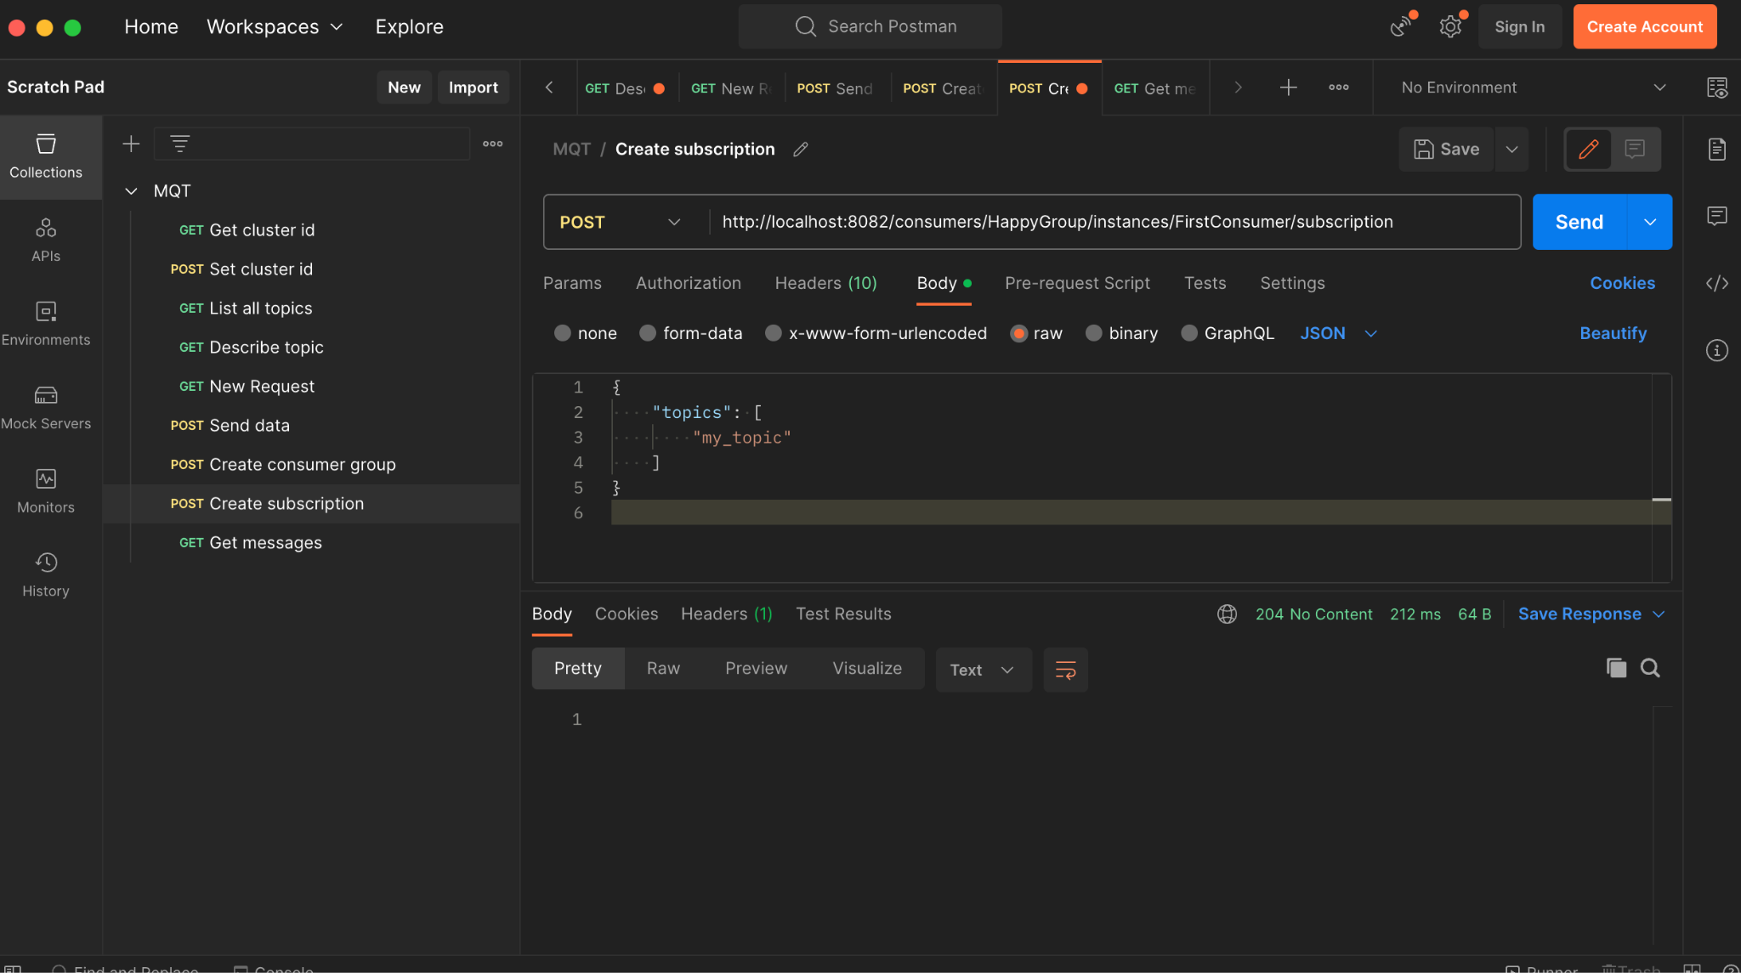

1. **Get messages**

Headers  
key --> Content-Type value --> application/vnd.kafka.v2+json  
key --> Accept --> application/vnd.kafka.json.v2+json

Request: GET <http://localhost:8082/consumers/HappyGroup/instances/FirstConsumer/records>

Response:

[

{

“topic”: “test”,

“key” : “key1”,

“value” : “value 1 Buna”,

“partition” : 0,

“offset” : 6

},

{

“topic”: “test”,

“key” : “key1”,

“value” : “value 1 Buna”,

“partition” : 0,

“offset” : 7

},

…..

]

.