LABORATORY WORK No. 6
APPROXIMATE SOLUTIONS OF NONLINEAR ALGEBRAIC EQUATIONS (BISECTION, NEWTON, CHORD METHOD)

Purpose: to study the basic methods of approximate solution of nonlinear equations using the Smath Studio application, as well as in the Excel environment.
Questions for self-control
1. What are the ways to study the function?
2. What methods are used to find the roots of the equation?
3. What is the root separation procedure used for?
4. What is the essence of the dichotomy method?
5. What is the essence of the Newton, Chord method?
6. Criteria for stopping the iterative process.
7. What is the difference between numerical and analytical finding of the roots of an equation?

Individual tasks
Find approximate solutions of nonlinear algebraic equations. Separate the roots of a given equation. If there are several roots, then refine one of them using the methods of half division, Newton, chords in the Smath Studio environment, using programming elements, built-in functions, as well as in the Excel environment. Compare the results obtained in different environments.
Table 1– Job options
Option | Equation | Option | Equation
1 |  | 14
2 |  | 15
3 |  | 16
4 |  | 17
5 |  | 18
6 |  | 19
7 |  | 20
8 |  | 21
9
10
11
12
13

Methodological recommendations:
Find the root of the equation $$x^{3}+4x-3=0$$
Solving a nonlinear equation by Newton's method

1) In the Smath Studio application

1. Consider Newton's method.
1.1. We set the calculations of the first and second derivatives of the function.
1.2. Using the conditional operator, check the sign of the expression f(a)f’’(a).
1.3. Using while loop, specify the root. Using the formula, we calculate the intersection point of the tangent with the axis of the abscissa.
Listing the program in SMath Studio:
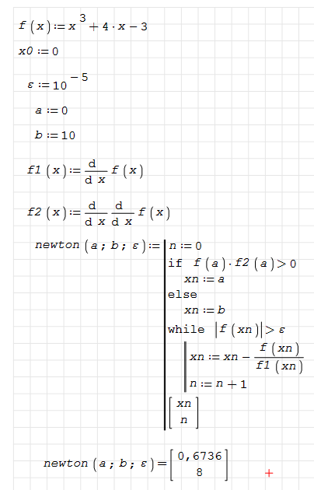
2) In the Microsoft Excel application

Chord method algorithm shown in this flowchart was implemented in Excel:
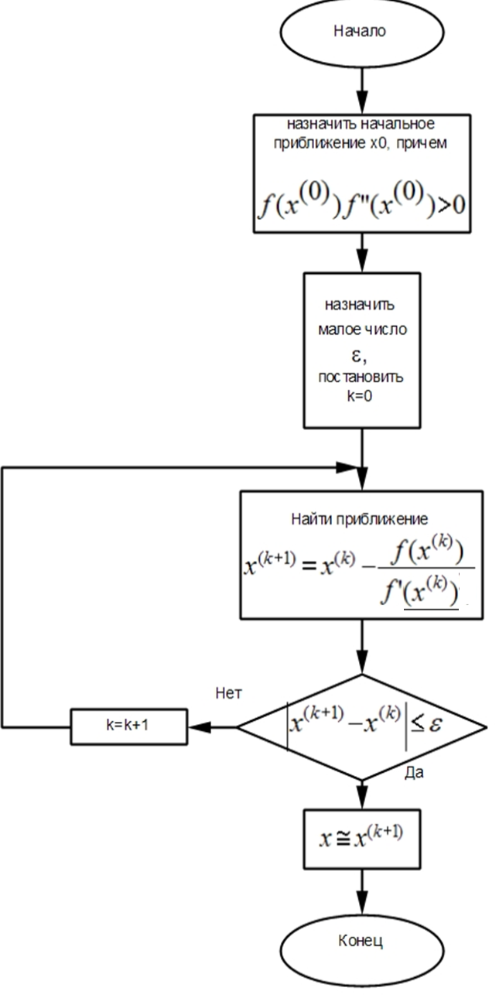
The value 2 is taken as the initial approximation, since it satisfies the conditions set in the flowchart.
$$f(2)=13$$$f'(2)=12$ $⇒f(2)f''(2)>0$
