Laboratory work 8
Solving systems of linear equations by Kramer’s method
Task: solve a system of linear algebraic equations using Kramer’s method.
Provide the results of both the manual solution and the solution implemented in Smath Studio in the report.
Purpose: to explore the main features of Smath Studio application for finding solutions to systems of linear equations.
Questions for self-control
1. What is called a system of linear equations?
2. What is the solution of a system of linear equations?
3. Matrix notation of a system of linear equations?
4. Why do I need to find the determinant of the coefficient matrix?
Table 1 Task options
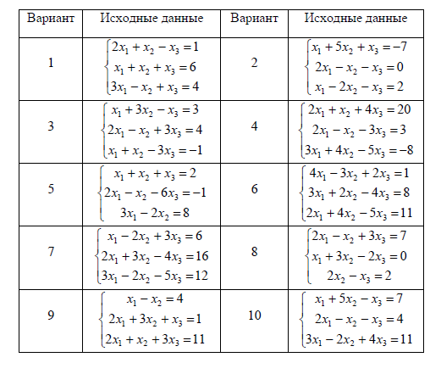
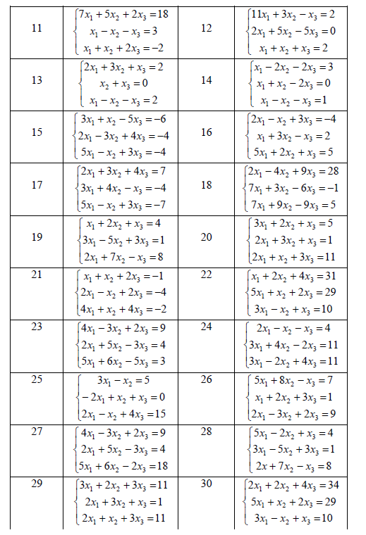
An example of completing a task in Smath Studio
Solve a system of linear equations using Kramer’s method:
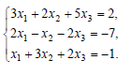
- Enter the matrix A, made up of th e coefficients of the system:

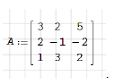
- Calculate its determinant by denoting it as : 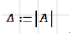
The symbol can be entered from the Symbols sidebar (Figure 1)
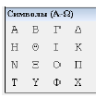
Figure 1. View of the Symbols sidebar
- If, then the system has a single solution. Display the value by typing
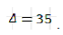
- Form three matrices: A1 is obtained from matrix A by replacing the 1st column with a column of free members of the system, that is, the right-hand sides of the equation of the system:
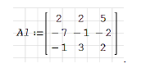
Matrix A2 is obtained from matrix A by replacing the 2nd column with a column of free terms of the system, that is, the right-hand sides of the equations of the system:
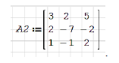
Matrix A3 is obtained from matrix A by replacing the 3rd column with a column of free terms of the system, that is, the right-hand sides of the equations of the system:
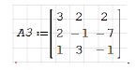
- Calculate the determinants of these matrices 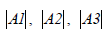 by denoting them as and respectively:
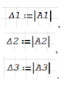
- Enter the received values on the screen by typing and :
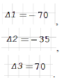
- Find a solution to the system using the formulas:
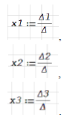
- Display the values on the screen by typing . You should be able to do it:
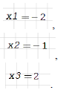
The answer is a triple of numbers (-2, -1, 2).

