Laboratory work №1
By Zhantassova Adina Serikovna
ISU (24)-1-1
Topic: Tools for implementing computational algorithms (mathematical packages)

Purpose/Introduction of this Laboratory Work
I supposed that, this laboratory work aims to learn how to create and analyze function graphs using SMath Studio. The main goals are:
- Understanding how to use SMath Studio for working with functions.
- Plotting graphs from data tables and formulas.
- Studying different types of functions (logarithmic, square root, trigonometric, and tabular).
- Learning to visualize and interpret mathematical graphs.
In general, this work helps students better understand functions and how to represent them graphically. For instance, for me this work helps to understand function and I have become more aware of this subject and this app.

Materials Used
For this laboratory work, the following materials and tools were used:
- Software: SMath Studio
- Mathematical Functions:
  - Logarithmic function: y1(x)=log10(33⋅x)
  - Square root function: y2(x)=sqrt(x+33)
  - Trigonometric function: y3(x)=sin(33+x)
  - Tabular data for multiple functions
- Graphing Tools: Built-in plotting features of SMath Studio
- Computer or Laptop for running the software
I used these materials to create, analyze, and visualize function graphs.

Results
1. Plot the function y1(x)=lg(33*x)
2. Build graphs of functions in one coordinate system
y2(x)=sqrt(x+33), y3(x)=sin(33+n)
3. Build the lines shown in Fig.
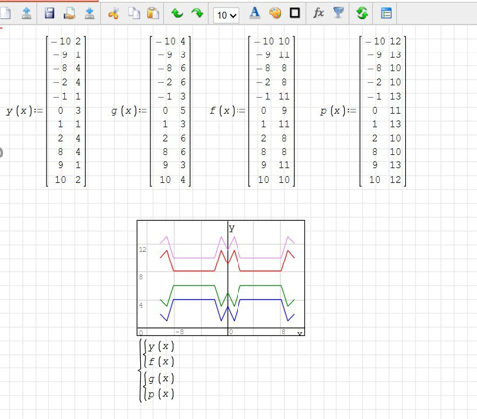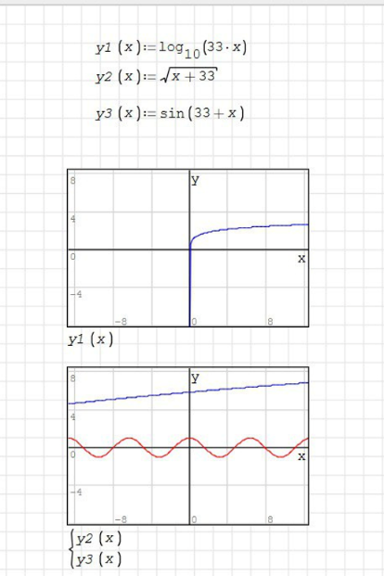

Discussion
This lab demonstrated function visualization using SMath Studio. The graphs matched theoretical expectations, confirming the behaviors of logarithmic, square root, and trigonometric functions. Tabular data helped compare datasets, while graphical analysis simplified interpretation. Minor variations may be due to rounding errors. This experiment reinforced key mathematical concepts and their practical applications.
Conclusion
In this experiment, functions were plotted using SMath Studio Online, matching theoretical expectations. This highlights the value of computational tools in math. Visualizing functions improves understanding and helps solve complex problems. Future work could include studying more functions and using symbolic computation for deeper analysis.

