Laboratory work №8
Topic: Solving sustem of linear equations via Kramer’s Rule in Smath Studio
Questions for self-control:
- It is a set of two or more first-degree equations where the same variables must satisfy all equations simultaneously
- A solution is a set of values for the variables (vector X) that makes every equation in the system a true statement when substituted
- The system is represented as A * X = B, where A is the coefficient matrix, X is the column vector of variables, and B is the column vector of constant terms
- The determinant determines the nature of the solution, If the answer is equal zero, the only one, in all of other cases we will get infinity decisions
Given:
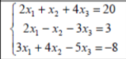
Solution:
- Convert: Convert equations into Matrix form
- Check: If det isn’t equal 0 then system has only one solution
- Cramer’s Rule: I formed additional Matrixes A1,A2,A3
- Det1,2,3: Find additional det after find roots using formula x_n=det_n/det(main)
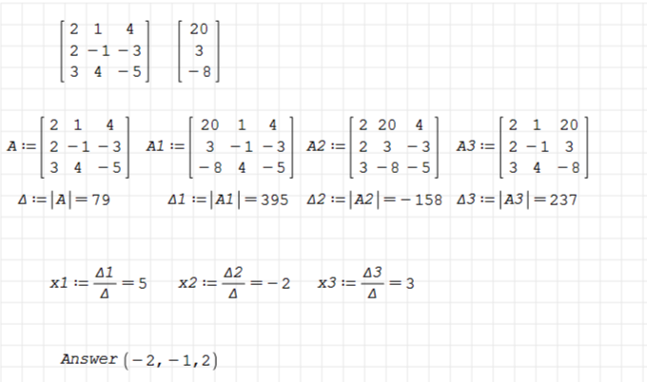
Conclusion:
The answer: x1 = -2, x2 = -1, x3 = 2
The results obtained have confirmed the efficiency of using computational methods for solving linear algebra problems, significantly reducing calculation time and eliminating the risk of human error.

